Commonwealth of Massachusetts
Executive Office of Health and Human Services

Office of Medicaid
www.mass.gov/masshealth
MassHealth
Transmittal Letter PHY-153
July 2017

TO: Physicians Participating in MassHealth
FROM: Daniel Tsai, Assistant Secretary for MassHealth 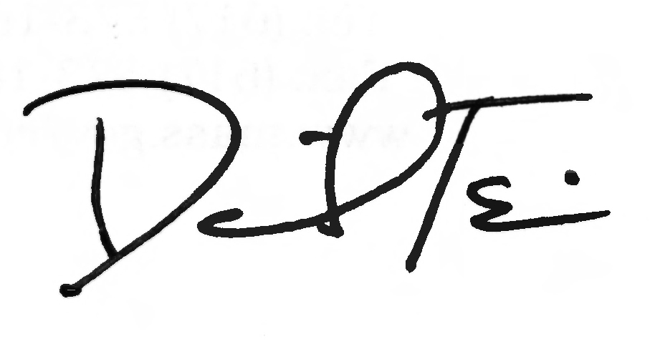

RE: Physician Manual: (Revised Subchapter 6, Additional Behavioral Health Screening Tools and Revised Coding for Postpartum Depression Screening)

This letter transmits updates to Subchapter 6 of the Physician Manual to conform to recent updates to MassHealth’s list of approved, standardized, behavioral-health screening tools for children younger than 21 years of age, listed in Appendix W of all provider manuals. Transmittal Letter ALL-219, issued in March 2017, describes these updates in detail.

The revised service codes are effective for dates of service on or after April 17, 2017.

Developmental and Behavioral Health Screens

MassHealth includes developmental and behavioral health (mental health and substance use disorder) screens in its list of Early Periodic Screening, Diagnosis and Treatment (EPSDT) services and Preventive Pediatric Healthcare Screening and Diagnosis (PPHSD) services, in accordance with 130 CMR 450.140 through 450.150.

The revised Appendix W (EPSDT/PPHSD Periodicity Schedule) requires providers to choose a clinically appropriate, behavioral-health screening tool from a menu of approved, standardized tools when conducting a behavioral-health screen at a periodic or interperiodic visit. MassHealth has added three more tools to its list of approved, standardized, behavioral-health screening tools for children younger than age 21. These tools are the:

- Pediatric Symptom Checklist, 17-question version (PSC-17);

- Modified Checklist for Autism in Toddlers, Revised (M-CHAT-R); and

- Edinburgh Postnatal Depression Scale (EPDS).

Instructions for Claims for Postpartum Depression Screening by Infant’s Provider

Subchapter 6 of the Physician Manual has been updated to reflect changes to the modifiers and codes used for claiming by providers for postpartum depression screening performed by an infant’s provider who is employed or contracted by the physician.

Instructions for Claims for Postpartum Depression Screening (cont.)

Effective for dates of service on or after April 17, 2017, physicians who submit claims for the Edinburgh Postnatal Depression Scale administered by infants’ providers employed or
contracted by the physician must bill for these screenings using CPT code 96110 with the appropriate modifiers identifying the type of clinician administering the screen and whether or not a behavioral health need is identified (U1 through U8).

When the provider submits a claim for 96110 for the administration of the EPDS, the provider must also include an additional, second modifier, UD, signifying that the EPDS is the behavioral health screen administered. Section 605 of Subchapter 6 has been updated to include this new modifier.

Effective for dates of service on or after April 17, 2017, such postpartum depression screens administered to caregivers of infants younger than six months by an infant’s medical provider may no longer be claimed using code S3005.

For a single date of service, providers may file only one claim for CPT code 96110.

No Code Change for Perinatal Depression Screens by a Caregiver’s Provider

There is no change for the code used by physicians to bill for perinatal (prenatal and postpartum) depression screens administered to an infant’s caregiver by the caregiver’s provider who is employed or contracted by the physician. For such perinatal depression screens, physicians should continue to use CPT code S3005. The modifiers for S3005 applicable to screens performed by a caregiver’s medical provider, U1 and U2, are not changed. Effective for dates of service on or after April 17, 2017, modifiers previously applicable to screens administered to caregivers of infants younger than six months by an infant’s medical provider (U3 and U4) are discontinued.

MassHealth Website

This transmittal letter and attached pages are available on the MassHealth website at www.mass.gov/masshealth.

For more information about the standardized behavioral-health screening tools, visit www.mass.gov/masshealth/cbhi and click on “Screening for Behavioral Health Conditions.”

Questions

If you have any questions about the information in this transmittal letter, please contact the MassHealth Customer Service Center at 1-800-841-2900, email your inquiry to providersupport@mahealth.net, or fax your inquiry to 617-988-8974.

NEW MATERIAL
(The pages listed here contain new or revised language.)

Physician Manual

Pages 6-27 through 6-30

OBSOLETE MATERIAL
(The pages listed here are no longer in effect.)

Physician Manual

Pages 6-27 through 6-30 — transmitted by Transmittal Letter PHY-152

605 Modifiers (cont.)

Modifier Modifier Description

T1 Left foot, second digit
T2 Left foot, third digit
T3 Left foot, fourth digit
T4 Left foot, fifth digit
T5 Right foot, great toe
T6 Right foot, second digit
T7 Right foot, third digit
T8 Right foot, fourth digit
T9 Right foot, fifth digit
TA Left foot, great toe
TC Technical component. Under certain circumstances, a charge may be made for the
technical component alone. Under those circumstances the technical component
charge is identified by adding modifier ‘TC’ to the usual procedure number. Technical component charges are institutional charges and not billed separately by physicians. However, portable x-ray suppliers only bill for technical component and should utilize modifier TC. The charge data from portable x-ray suppliers will then be used to build customary and prevailing profiles
XE Separate encounter, a service that is distinct because it occurred during a separate encounter
XP Separate practitioner, a service that is distinct because it was performed by a different practitioner
XS Separate structure, a service that is distinct because it was performed on a separate organ/structure
XU Unusual non-overlapping service, the use of a service that is distinct because it does not overlap usual components of the main service

Modifiers for Tobacco-Cessation Services

The following modifiers are used in combination with Service Code 99407 to report tobacco-cessation counseling. Service Code 99407 (smoking and tobacco-use cessation counseling visit; intensive, greater than 10 minutes) may also be billed without a modifier to report an individual smoking and tobacco-use cessation counseling visit of at least 30 minutes.

Modifier Modifier Description

HQ Group counseling, at least 60–90 minutes in duration, provided by a physician
TD Individual counseling provided by a registered nurse (RN)
TF Individual counseling, intermediate level of care (intake/assessment counseling, at least 45 minutes in duration) provided by a physician
U1 Individual counseling services provided by a tobacco-cessation counselor
U2 Individual intake/assessment counseling, at least 45 minutes in duration, provided by a nurse practitioner, nurse midwife, physician assistant, registered nurse, or a
605 Modifiers (cont.)

tobacco-cessation counselor, under the supervision of a physician
U3 Group counseling, at least 60-90 minutes in duration, provided by a nurse practitioner, nurse midwife, physician assistant, registered nurse, or a tobacco-cessation counselor, under the supervision of a physician

Modifiers for Behavioral Health Screening

The administration and scoring of standardized behavioral health-screening tools selected from the approved menu of tools found in Appendix W of your provider manual is covered for members (except MassHealth Limited) from birth to 21 years of age. Service Code 96110 must be accompanied by one of the modifiers listed below to indicate whether a behavioral health need was identified. “Behavioral health need identified” means the provider administering the screening tool, in his or her professional judgment, identified a child with a potential behavioral health services need.

U1 Completed behavioral health screening using a standardized behavioral health-screening tool selected from the approved menu of tools found in Appendix W
of your provider manual with “no behavioral health need identified” when administered by a physician, independent nurse midwife, or independent nurse
practitioner.
U2 Completed behavioral health screening using a standardized behavioral health screening tool selected from the approved menu of tools found in Appendix W of your provider manual and a behavioral health need was identified when administered by a physician, independent nurse midwife, or independent nurse practitioner.
U3 Completed behavioral health screening using a standardized behavioral health-screening tool selected from the approved menu of tools found in Appendix W of your provider manual with “no behavioral health need identified” when administered by a nurse midwife employed by a physician.
U4 Completed behavioral health screening using a standardized behavioral health-screening tool selected from the approved menu of tools found in Appendix W of your provider manual and a behavioral health need was identified when administered by a nurse midwife employed by a physician.
U5 Completed behavioral health screening using a standardized behavioral health-screening tool selected from the approved menu of tools found in Appendix W of your provider manual with “no behavioral health need identified” when administered by a nurse practitioner employed by a physician.
U6 Completed behavioral health screening using a standardized behavioral health-screening tool selected from the approved menu of tools found in Appendix W of your provider manual and a behavioral health need was identified when administered by a nurse practitioner employed by a physician.
U7 Completed behavioral health screening using a standardized behavioral health-screening tool selected from the approved menu of tools found in Appendix W of your provider manual with “no behavioral health need identified” when administered by a physician assistant employed by a physician.
U8 Completed a behavioral health screening using a standardized behavioral health-
screening tool selected from the approved menu of tools found in Appendix W of your provider manual and a behavioral health need was identified when administered by a physician assistant employed by a physician.
UD Covered for members birth to 6 months for the administration and scoring of the Edinburgh Postnatal Depression Scale. UD must be used together with one of the above modifiers, U1–U8.
Modifiers for Administration of MassHealth-Approved Screening Tools

Service Code S3005, used for the performance measurement and evaluation of patient self-assessment and depression, must be accompanied by one of the modifiers below to indicate whether a behavioral health need was identified.

Modifier Modifier Description

U1 Perinatal Care Provider - Positive Screen: completed prenatal or postpartum
depression screening and behavioral health need identified.
U2 Perinatal Care Provider - Negative Screen: completed prenatal or postpartum depression screening with no behavioral health need identified.

Please refer to the Massachusetts Department of Public Health’s (DPH) postpartum depression (PPD) screening-tool grid for any revisions to the list of MassHealth-approved screening tools at www.mass.gov/eohhs/gov/departments/dph/programs/family-health/postpartum-depression/postpartum-depression-tools.html.

Modifier for Child and Adolescent Needs and Strengths (CANS)

Modifier Modifier Description

HA Service Code 90791 must be accompanied by this modifier to indicate that the Child and Adolescent Needs and Strengths (CANS) is included in the psychiatric diagnostic interview examination. This modifier may be billed only by psychiatrists.

Modifiers for Provider Preventable Conditions That Are National Coverage Determinations

Modifier Modifier Description

PA Surgical or other invasive procedure on wrong body part
PB Surgical or other invasive procedure on wrong patient
PC Wrong surgery or other invasive procedure on patient

For more information on the use of these modifiers, see Appendix V of your provider manual.

This publication contains codes that are copyrighted by the American Medical Association. Certain terms used in the service descriptions for HCPCS are defined in the Current Procedural Terminology (CPT) Professional codebook.

This page is reserved.

