The Commonwealth of Massachusetts
Executive Office of Health and Human Services
Department of Public Health
250 Washington Street, Boston, MA 02108-4619
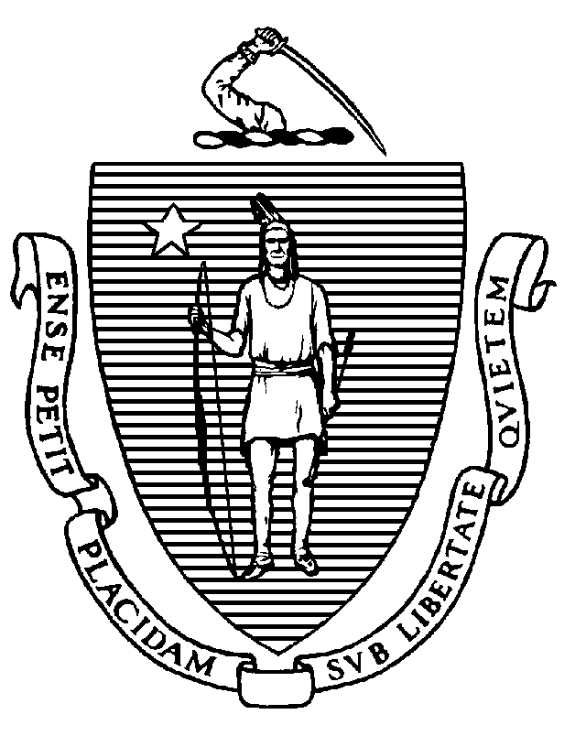

KATHLEEN E. WALSH
Secretary
ROBERT GOLDSTEIN, MD, PhD Commissioner

Tel: 617-624-6000
www.mass.gov/dph

MAURA T. HEALEY
Governor
KIMBERLEY DRISCOLL
Lieutenant Governor

IMPORTANT CHANGES TO THE MCSR RENEWAL PROCESS

Dear Physician Assistant:

Section 9 of chapter 260 of the acts of 2020 requires the Department of Public Health’s (DPH) Drug Control Program (DCP) to synchronize the term and expiration dates of your Massachusetts Controlled Substance Registration (MCSR) with your Board issued Physician Assistant license. For Physician Assistants this means the next time you renew your MCSR, it will now have a term of 2 years instead of 1 year and will be synchronized with your Board issued Physician Assistant license.

To implement this requirement, the next time you renew your Physician Assistant MCSR, it will have a term of at least 2 years and expire on March 1, 2027. Therefore, you will pay $300.00 for a 2-year MCSR as outlined below.

As set forth in the Executive Office of Administration and Finance’s rate regulation, 801 CMR 4.02, the fee for MCSR registration and renewal is $150 annually. Certain practitioners have been paying a fee of $150 for a 3-year MCSR, while others have been paying $150 annually. Henceforth all practitioners will be paying the annual fee of $150.

We are pleased to announce one stop shopping! You will now renew your MCSR on-line through the same portal as your Board issued Physician Assistant license.

You will be receiving registration instructions and a link to the DPH eLicensing system via email.

