Commonwealth of Massachusetts
Executive Office of Health and Human Services

Office of Medicaid
www.mass.gov/masshealth

MassHealth
Physician Bulletin 98
February 2015

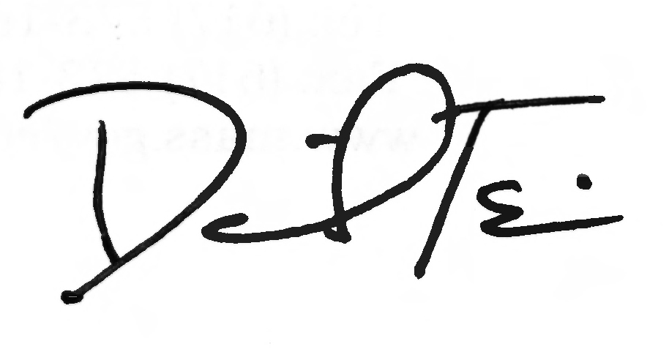

TO: Physicians Participating in MassHealth

FROM: Daniel Tsai, Assistant Secretary and Director of MassHealth

RE: Section 1202 Rates for Hospital-Based Physicians and Physicians Working in Group Practices Who Provide Primary Care Services

Background

For dates of service in calendar years 2013 and 2014, Section 1202 of the federal Affordable Care Act (ACA) requires Medicaid agencies to provide payment for certain primary care services delivered by eligible physicians (including osteopathic physicians), consistent with rules set forth in 42 CFR Part 447, Subpart G (Section 1202 rates) and 101 CMR 317.00: Medicine. Please note that Congress has not extended Section 1202, so physicians are being paid the standard, unenhanced MassHealth rates for dates of service beginning in January 2015.

Section 1202 applies to physicians who are salaried and contracted by hospitals (“hospital-based physicians”) and physicians working in group practices, in addition to individual MassHealth participating physicians. Hospitals and group practices must pass along the direct benefit of the Section 1202 payment to the eligible physician providing the service.

This bulletin updates All Provider Bulletin 235, issued in August 2013 (which in turn had updated All Provider Bulletin 230, issued in December 2012). All Provider Bulletins 230 and 235 remain in effect for claims with dates of service in calendar years 2013 and 2014 with the following clarification.
- For hospital-based physicians and physicians working in group practices, the 60%-of-claims attestation for eligibility to receive Section 1202 rates will include claims paid to the hospital or group practice for services provided by the rendering physician.

Hospital-Based Nonbilling Provider Enrollment

In order for hospitals to be paid Section 1202 rates for services provided by their hospital-based Section 1202-eligible physicians, those physicians must be enrolled with MassHealth and must attest to Section 1202 eligibility. Section 1202-eligible hospital-based physicians who are not already enrolled with MassHealth should work with their primary hospital to complete the Hospital-Based Nonbilling Provider Enrollment Form and the MassHealth Nonbilling Provider Contract for Individuals (Contract). Section 1202-eligible hospital-based physicians who are already enrolled with MassHealth should complete the Hospital-Based Nonbilling Provider Enrollment Form in order to attest to Section 1202 eligibility and to show hospital affiliations, but should not complete the Contract. Completed enrollment materials must be submitted to MassHealth by April 1, 2015.
(continued on next page)

MassHealth

Physician Bulletin 98

February 2015

Page 3

Hospital-Based Nonbilling Provider Enrollment (cont.)

In addition to using the Hospital-Based Nonbilling Provider Enrollment Form to attest to Section 1202 eligibility, hospital-based physicians, as well as hospital-based dentists and podiatrists, will use this form to enroll with MassHealth as nonbilling providers for other purposes, including ordering, referring, or prescribing medications, equipment, supplies, or services to MassHealth members. MassHealth will be issuing further information about nonbilling provider enrollment for purposes other than Section 1202 eligibility.

Hospital-based physicians need to complete only one Hospital-Based Nonbilling Provider Enrollment Form to cover all the hospitals that bill for their services. Physicians must list the Provider Identification/Service Location (PID/SL) of their primary affiliated hospital on the form, and should also list each location PID/SL at which they provide services billed by hospitals. Physicians in hospital-affiliated group practices should not complete the Hospital-Based Nonbilling Provider Enrollment Form.

Hospital-based nonbilling physicians will also need to sign and return the Contract. The Hospital-Based Nonbilling Provider Enrollment Form and Contract may not be used to newly enroll as a MassHealth billing provider. A provider wishing to enroll with MassHealth as a billing provider should contact the MassHealth Customer Service Center at 1-800-841-2900.

In addition to the information provided in this bulletin, acute hospitals will receive the Hospital-Based Nonbilling Provider Enrollment Form by e-mail.

These enrollment materials must be submitted to MassHealth on or before April 1, 2015, for a hospital-based physician to be eligible for Section 1202 rates. Once enrollment is complete, payments to the hospital can then be made for dates of service starting with January 1, 2013, or the physician’s date of eligibility for Section 1202 rates, whichever is later.

Section 1202 Requirements for Hospitals and Group Practices

Hospitals and group practices must ensure that the physicians for whose professional services the entities are billing receive the direct benefit of the entire payment increase for each of the Section 1202 primary care services they provide. Options for meeting this requirement include increasing salaries or providing additional or bonus payments to Section 1202 eligible physicians. In the event of a state or federal audit, hospitals and group practices must be prepared to demonstrate that they have met the requirements of Section 1202.

Section 1202 Hospital Claiming Instructions

Hospitals will be eligible to receive Section 1202 payments for services provided starting on January 1, 2013, by an eligible nonbilling hospital-based physician only after MassHealth receives the Hospital-Based Nonbilling Provider Enrollment Form and a signed Contract for that physician and MassHealth has processed these documents. MassHealth will send a welcome letter to each physician containing his or her provider number when the physician is enrolled.

(continued on next page)

MassHealth

Physician Bulletin 98

February 2015

Page 5

Section 1202 Hospital Claiming Instructions (cont.)

In order for hospitals to be paid Section 1202 rates for previously paid claims for services provided by a Section 1202-eligible physician, hospitals must adjust the claims for any dates of service starting with January 1, 2013, or the physician’s date of eligibility for Section 1202 rates, whichever is later.

Physicians should note that hospitals can begin to receive 1202 payments by submitting a file of only Section 1202-eligible claims for their hospital-based physicians whose enrollment has been completed. Adjusted claims for Section 1202-eligible services rendered by Section 1202-eligible, hospital-based physicians must include the rendering physician information on the claim. All adjusted claims must be submitted by September 1, 2015. Detailed claiming instructions are being provided to hospitals in a separate provider bulletin.

Questions

If you have any questions about the information in this bulletin, please contact the MassHealth Customer Service Center at 1-800-841-2900, e-mail your inquiry to providersupport@mahealth.net, or fax your inquiry to 617-988-8974.

Follow us on Twitter @MassHealth.

