

OMG…That Piercing Can Do What?

Oral Health and Piercings: What you need to know

Oral Health in Massachusetts: A Fact Sheet


Piercings- they’re cool, right? Tongue, cheek and lip piercings have become a popular form of self-expression among teens, but did you know they have health risks? If you are considering a piercing take a few minutes to fully understand some of the health risks involved. It might make you question where or not it’s really the “cool” thing to do.
?

Piercing Related Risks
- Infection: Your mouth is filled with millions of bacteria. An oral piercing creates an opportunity for these bacteria to infect the piercing site. Handling jewelry once it has been placed also increases the chances of developing an infection. In serious cases, this infection can even affect your heart.
- Swelling: Swelling is common after an oral piercing. If swelling becomes too great, it could cause problems breathing.

- Nerve Damage: It’s possible to puncture a nerve during a tongue piercing, causing a numb tongue. This is sometimes temporary, but can be permanent. Nerve damage can affect your sense of taste, and ability
to move your mouth
- Infections Disease: Oral piercing has been identified as a possible factor in the
transmission of hepatitis B, C, D and G, which can cause serious liver problems.

Oral Health Risks
- Injury to Gums: Metal in jewelry can injure you gums and can cause them to recede or move away from the tooth.
- Damage to Teeth: Oral jewelry can easily chip or crack your teeth and fillings.
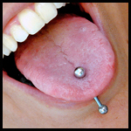
- Problems Eating: Oral jewelry can cause excessive saliva production, can affect your ability to speak clearly and may cause problems with chewing and swallowing.
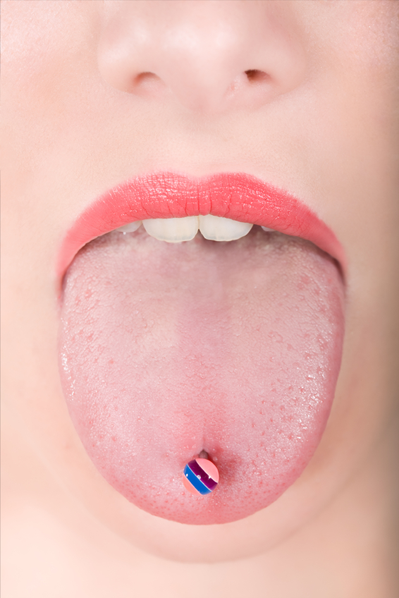
- Dental Exams: Oral jewelry can interfere with dental professionals’ ability to take clear x-rays, which could affect their ability to detect signs of problems or disease.

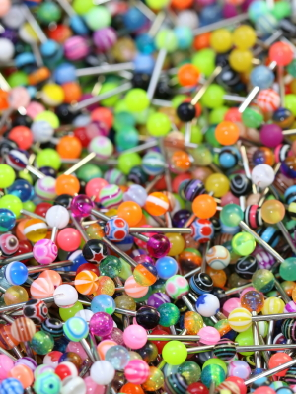

What you can do...

If you decide to get an oral health piercing, first check with your physician, dentist
or dental hygienist. Get it done
professionally. Do not ever pierce
yourself or get a friend to do it.

Immediately after a piercing:
- Drink cold liquids and sleep with your head
slightly elevated to reduce swelling.
- Rinse your mouth with anti-bacterial mouthwash regularly, especially after eating.
- Avoid smoking and eating spicy foods until the piercing site is fully healed.
- Clean your hands before touching the piercing and try not to pick or tug at it.
- If pain and/or swelling continues after several days, or if you have severe redness, bleeding, pain or pus around your piercing, visit a dentist immediately.

After healing:
- Keep your tongue from your teeth and gums to minimize damage.
- Ask for jewelry alternatives that are less damaging to the teeth and gums.

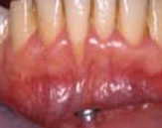
Gum recession due to
oral piercing

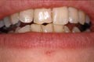
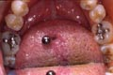
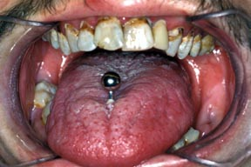

Chipped teeth due
to lip piercing
Tear in tongue from lip ring
Dental plaque around tongue ring
Source: RJG De Moor, et al. (2005). Dental complications of lip and tongue piercings. British Dental Journal. 199, 506-509.

References
American Dental Association. (2001). Oral Piercings and Health. JADA, 132.

For more information
Office of Oral Health
Massachusetts Department of Public Health
250 Washington Street
Boston, MA 02108
Oral.Health@state.ma.us

