INDOOR AIR QUALITY ASSESSMENT

Pittsfield City Hall
70 Allen Street
Pittsfield, MA 01201



Prepared by:
Massachusetts Department of Public Health
Bureau of Environmental Health
Indoor Air Quality Program
December 2009

Background/Introduction
At the request of the Pittsfield Health Department, the Massachusetts Department of Public Health (MDPH), Bureau of Environmental Health (BEH) provided assistance and consultation regarding indoor air quality and health concerns at Pittsfield City Hall (PCH), 70 Allen Street, Pittsfield, Massachusetts. The primary concern about indoor environmental issues at the PCH was related to a suspected increase in cancer incidence among staff and whether opportunities for exposure to radon may be associated with cancers reported among staff. Other environmental concerns included musty or moldy odors, poor ventilation and the possible presence of asbestos.
The PCH is a two-story building constructed during the 1930s as a post office. The PCH was converted into a municipal building in the mid-1950s. At that time, cement block walls were constructed in the basement of the building to create a finished basement that now houses interior rooms, offices, and the vault. The building has undergone periodic renovation, the latest being the installation of an energy-efficient window system in 1995. Windows are openable and consist of double-paned glass in metal window frames. An elevator shaft near the center of the building connects the first, second and basement levels.
The MDPH/BEH (then the Bureau of Environmental Health Assessment) had previously conducted an indoor air quality assessment of PCH on February 2, 1994, based on IAQ and health complaints. The report found that employees’ respiratory symptoms were consistent with the indoor air conditions at PCH. With respect to cancer concerns at that time, the types and variety of cancers reported as well as length of employment and risk factor information did not suggest an unusual pattern of cancer that would lead one to suspect a common environmental or non-environmental factor. The 1994 BEH report recommended the following:
- Provide each office with supply and exhaust ventilation;
- Maintain office temperatures between 70º F to 78º F;
- Investigate the cause of water damaged ceiling tiles; and
- Inspect materials containing asbestos periodically (MDPH, 1994).
In 2003, PCH “MIS” Department offices (i.e. basement IT area) were examined by an environmental consultant, ATC Associates, Inc., due to issues related to a humidification component of the HVAC system. ATC recommended the removal of the humidification system; relocating the fresh air intake for the MIS HVAC system; operating the HVAC system continuously during occupancy; and changing HVAC system filters in accordance with manufacturer’s recommendations (ATC, 2003).
This report includes an evaluation of the general indoor air quality and heating, ventilating and air-conditioning (HVAC) system, conducted by the BEH’s Indoor Air Quality (IAQ) Program; an evaluation of cancer and other health concerns, conducted by the BEH’s Community Assessment Program (CAP); and an evaluation of radon levels, conducted by BEH’s Radiation Control Program (RCP). The report summarizes the findings of all BEH investigative efforts. The BEH/RCP is continuing to provide assistance to the City regarding radon remediation devices.
On August 22, 2008, a visit to conduct a general IAQ assessment was made to the PCH by Michael Feeney, Director of BEH’s IAQ Program. Mr. Feeney was accompanied by Lisa Hébert and James Tobin, Environmental Analysts/Inspectors within BEH’s IAQ Program. Also accompanying IAQ staff was Christine Gorwood, an Environmental Analyst/Risk Communication Specialist in BEH’s CAP. On November 4 – 6, 2008, BEH/RCP staff evaluated the building for radon.
Methods
In the August 2008 IAQ evaluation, air tests for carbon monoxide, carbon dioxide, temperature and relative humidity were conducted with the TSI, Q-Trak, IAQ Monitor, Models 7565/8551. Air tests for airborne particle matter with a diameter less than 2.5 micrometers were taken with the TSI, DUSTTRAK™ Aerosol Monitor Model 8520. Screening for total volatile organic compounds (TVOCs) was conducted using a MiniRAE 2000 Portable VOC Monitor, Model PGM 7600. MDPH staff also performed visual inspection of building materials for water damage and/or microbial growth.
BEH/CAP staff accompanied IAQ staff on the August 2008 visit. All PCH employees were offered the opportunity to be interviewed in relation to health and IAQ concerns. Participating employees provided information and were asked question by CAP staff.
In the November 2008 RCP evaluation, radon samples were collected and analyzed by BEH/RCP staff using EPA Method #402-R-92-004 Liquid Scintillation (LS), NEHA Device Code 8008 and NRSB Device Code 12193. The EPA sampling protocol notes that sampling devices should be in a location where the detector will not be disturbed during the measurement period and where there is adequate room for the device. Furthermore:
- The measurement should not be made near drafts caused by heating, ventilating and air conditioning vents, doors, fans, and windows. Locations near heat, such as on appliances, near fireplaces or in direct sunlight, and areas of high humidity should be avoided.
- Because some detectors are sensitive to increased air motion, fans should not be operated in the test area. Forced air heating or cooling systems should not have the fan operating continuously unless it is a permanent setting.
- The measurement location should not be within 90 centimeters (three feet) of the doors and windows or other potential openings to the outdoors. If there are no doors or windows to the outdoors, the measurement should not be within 30 centimeters (one foot) of the exterior wall of the building.
- The detector should be at least 50 centimeters (20 inches) from the floor, and at least 10 centimeters (four inches) from other objects. For those detectors that may be suspended, an optimal height is in the general breathing zone, such as two to 2.5 meters (about six to eight feet) from the floor.
BEH/RCP staff placed radon sampling devices throughout the PCH basement area, which were retrieved after a 48 hour period. Once retrieved, samples were sent for radon analysis to AccuStar Labs, Medway, MA.
Results
The PCH has an employee population of approximately 80 and is visited by over a hundred members of the public on a daily basis. IAQ tests were taken under normal operating conditions and results appear in Table 1. Table 2 and Maps 1 to 3 summarize radon results.
Discussion
Ventilation
It can be seen from Table 1 that carbon dioxide levels were above 800 parts per million parts of air (ppm) in 30 of 61 areas sampled, indicating adequate air exchange in about half of the areas surveyed at PCH. It is important to note, however, 51 of 61 areas surveyed had no occupant or one occupant, and the max number of occupants in any area was four. The low number of occupants can result in reduced carbon dioxide levels. Carbon dioxide levels would be expected to rise with increased occupancy.
Fresh air is introduced into the building via openable windows. Openable windows originally controlled ventilation in the building. The PCH was configured in a manner to use cross-ventilation during the summer months to provide comfort for building occupants. Windows are situated on the exterior wall opposing a passive vent in the hallway door (Picture 1). With this design, air enters an open window, passes through the room and subsequently the door vent. Air then enters the hallway, passes through the opposing door vent into the opposing room and exits through the window on the leeward side (opposite the windward side) (Figure 1). With all windows and door vents open, airflow can be maintained in the building regardless of wind direction. The system fails if the windows and door vents are closed (Figure 2). Most doors with vents were replaced during subsequent renovations to the PCH (Picture 2); therefore, airflow cannot be maintained using cross-ventilation as originally designed.
Fan coil units (FCUs) below the windows in each room facilitate airflow and temperature control (Pictures 3 and 4). FCUs do not provide fresh air to rooms; rather, they re-circulate air and provide heating and/or cooling. A FCU draws air from the room through an intake located at the base of the unit. Air passes through the filter, is conditioned by the coils, and then distributed to the room through an air diffuser atop the unit (Figure 3). In a number of areas, FCUs were found obstructed by furniture, books and other stored materials (Picture 5). In order for FCUs to facilitate airflow as designed, air intakes and diffusers must remain free of obstructions. Importantly, these units must be allowed to operate while rooms are occupied to provide adequate air exchange.
A rooftop air handling unit supplies fresh air to interior offices through ceiling diffusers (Picture 6). These areas include the City Clerk’s Suite and Tax Collector’s office on the first floor, the City Council Chamber on the second floor, and the IT office in the basement. Return air is ducted back to the AHU via ceiling/wall-mounted grills (Picture 7).
BEH staff noted a mechanical exhaust system in the Assessor’s office. Ductwork observed in the ceiling was in disrepair; it was not sealed properly and had holes (Picture 8). Further, the ductwork appeared to terminate within the ceiling plenum near the window (Picture 9). It is likely that this duct was not reconnected to an exterior wall vent when the window system was replaced in 1995. This is problematic for several reasons: 1) it can pressurize the ceiling plenum, forcing any accumulated dust, debris, fiberglass fibers, etc. into occupied areas; 2) the ceiling plenum is designed to be depressurized to provide exhaust ventilation; and 3) it interferes with the proper balance of the system, creating uneven heating/cooling conditions in other areas and decreasing overall comfort in the building.
BEH staff also found a deactivated fan in the exterior wall of basement room 03, which exhausts air outside at the base of the back stairs of the PCH (Picture 10). The fan was sealed on the outside with glass. In addition, tape was observed on the switch, indicating that the fan was not operating (Pictures 11 and 12).
The Massachusetts Building Code requires that each room have a minimum ventilation rate of 20 cubic feet per minute (cfm) per occupant of fresh outside air or openable windows (SBBRS, 1997; BOCA, 1993). The ventilation must be on at all times that the room is occupied. Providing adequate fresh air ventilation with open windows and maintaining the temperature in the comfort range during the cold weather season is impractical. Mechanical ventilation is usually required to provide adequate fresh air ventilation.
Carbon dioxide is not a problem in and of itself. It is used as an indicator of the adequacy of the fresh air ventilation. As carbon dioxide levels rise, it indicates that the ventilating system is malfunctioning or the design occupancy of the room is being exceeded. When this occurs a buildup of common indoor air pollutants can occur, leading to discomfort or health complaints. The Occupational Safety and Health Administration (OSHA) standard for carbon dioxide is 5,000 parts per million parts of air (ppm). Workers may be exposed to this level for 40 hours/week based on a time weighted average (OSHA, 1997).
The MDPH uses a guideline of 800 ppm for publicly occupied buildings. A guideline of 600 ppm or less is preferred in schools due to the fact that the majority of occupants are young and considered to be a more sensitive population in the evaluation of environmental health status. Inadequate ventilation and/or elevated temperatures are major causes of complaints such as respiratory, eye, nose and throat irritation, lethargy and headaches. For more information concerning carbon dioxide, consult Appendix A.
Indoor temperature readings ranged from 65° F to 78° F, which were, for the most part, within the MDPH recommended comfort range (Table 1). The MDPH recommends that indoor air temperatures be maintained in a range of 70° F to 78° F in order to provide for the comfort of building occupants. In many cases concerning indoor air quality, fluctuations of temperature in occupied spaces are typically experienced, even in a building with an adequate fresh air supply. Concerns about lack of control over heat in office spaces during winter months and complaints of excessive heat during summer months were expressed to BEH staff.
As mentioned previously, in 1995 an energy-efficient window system was installed at the PCH. These windows are openable and consist of double-paned glass in metal window frames. Without a mechanical ventilation system, the installation of energy efficient windows can lead to increased discomfort from heat accumulation in offices, particularly on the south side of the building. Adding to the heat load within the building is the introduction of computers, LaserJet® printers, photocopiers, refrigerators and facsimile machines in the building. Each piece of equipment produces waste heat. The PCH was not designed to handle modern office equipment; the lack of exhaust ventilation combined with equipment that produces waste heat and double-paned, metal-framed window systems can make temperature control difficult. Temperature readings outside the recommended comfort range are generally not a health concern; however, they can affect the relative humidity in a building.
The relative humidity in the building ranged from 43 to 67 percent; however, most relative humidity levels were within the MDPH recommended comfort range in the areas surveyed (Table 1). The MDPH recommends a comfort range of 40 to 60 percent for indoor air relative humidity. Relative humidity levels in the building would be expected to drop during the winter months due to heating. The sensation of dryness and irritation is common in a low relative humidity environment. Low relative humidity is a very common problem during the heating season in the northeast part of the United States.
Microbial/Moisture Concerns
BEH staff performed a visual inspection of building materials for water damage and/or microbial growth. Several PCH employees reported to BEH staff that musty odors emanate from the FCUs when activated; therefore, BEH staff examined the interior of several units (Pictures 4 and 13).
When a FCU operates in the cooling mode, drip pans collect and drain the condensation that accumulates on the coils. A drip pan below the coils directs the water through a drain pipe to an auxiliary drain pan (Picture 14). Over time, drip pans can collect debris and deteriorate as a result of oxidation (i.e. rusting). Drip pans should be cleaned to prevent accumulation of debris, and ensure proper drainage. Drip pans should also be maintained to prevent deterioration and ensure integrity of the drip pans.
BEH staff observed drip pans and found accumulated debris that can serve as a source of microbial growth and suggests that the units have not been routinely cleaned and maintained (Pictures 15 and 16). BEH staff noted a FCU that did not have a drain pipe. As a replacement, a piece of aluminum foil was sculpted to bridge the drip pans (Picture 17). In an effort to control microbial growth, an antimicrobial agent was placed in the drip pans of each FCU throughout the PCH (Pictures 13 to 15). This antimicrobial agent is discussed further in the “Volatile Organic Compounds” section of this report.
Insulation within the FCUs was found damaged and deteriorated. In this condition, condensation can form on the metal housing of the unit (Picture 18). BEH staff also found water-stained carpet around a FCU indicating that the unit is not properly draining water (Picture 3). Water damaged carpet can serve as mold growth media. Porous building materials can result in microbial growth. Several areas in the PCH had water-damaged ceiling tiles which can indicate leaks from either the roof or plumbing system (Picture 19). Water-damaged ceiling tiles can provide a source of mold and should be replaced after a water leak is discovered and repaired.
The US Environmental Protection Agency (US EPA) and the American Conference of Governmental Industrial Hygienists (ACGIH) recommend that porous materials be dried with fans and heating within 24 to 48 hours of becoming wet (US EPA, 2001; ACGIH, 1989). If not dried within this time frame, mold growth may occur. Once mold has colonized porous materials, they are difficult to clean and should be removed.
Water-damaged plaster, peeling paint and efflorescence was noted in a few areas (Pictures 20 and 21). Efflorescence is a characteristic sign of water damage, but it is not mold growth. As moisture penetrates and works its way through porous building materials (e.g., brick, plaster, cement), water-soluble compounds in the material dissolves, creating a solution. As this solution moves to the surface of the material, the water evaporates, leaving behind white, powdery mineral deposits. This condition indicates that moisture is penetrating through the building envelope in this area. The area should be cleaned, sealed, re-painted and monitored for further damage. If evidence of water penetration recurs, an evaluation of the building envelope/exterior should be conducted for possible sources of water penetration.
Plants were observed in a number of rooms, many without drip pans (Pictures 22 and 23). Plants, soil, and drip pans can serve as sources for mold growth and should be properly maintained. Over-watering of plants should be avoided and drip pans should be inspected periodically for mold growth. In addition, flowering plants can be a source of pollen. Therefore, plants should be located away from the air stream of ventilation sources to prevent aerosolization of mold, pollen and particulate matter.
A number of conditions within the PCH exist that can allow for moisture, odors, and other pollutants to accumulate. These include the following:
- A large crack exists in the floor of the basement vault. When the building was converted into PCH, it appears that the interior walls of the vault were constructed with cement blocks. It is likely that the weight of these cement blocks on the pre-existing basement floor caused the crack.
- FCUs in each room that draw air from the floor level. As the FCU operates, it creates depressurization on the floor, which in turn can draw air from floor drains, cracks and other penetrations that can allow for subfloor air to be drawn into occupied areas. This depressurization may also draw air from the basement vault area, since the door to the vault contains passive vents.
- Missing/damaged exterior brick and mortar (Picture 24). Breaches in the building envelope represent potential pathways for air and moisture to enter the building. Over time, this condition can undermine the integrity of the building envelope and provide a means of water entry into the building via capillary action through foundation concrete and masonry (Lstiburek and Brennan, 2001). In addition, these breaches may provide a means of egress for pests/rodents into the building.
- Drip pan drains within the FCU are plumbed into a drain pipe that does not have a trap. Spaces in the FCU internal walls can allow for air to be drawn from the drains into the fans and distributed to occupied areas. This lack of a drain trap may also be the source of sewer odors reported in some basement offices.
- The basement level offices (excluding the IT office), lack mechanical fresh air supply that would aid in optimally pressurizing the basement level. At best, the basement is at neutral pressurized or depressurized due to heated air from the basement rising up the elevator shaft and/or the stairwells.
Each of these conditions likely plays a role in allowing water vapor, odors, and pollutants to enter the basement level. When a basement becomes depressurized, air containing moisture and other naturally occurring pollutants can be pulled into the basement through random cracks, holes or gaps.

Radon Gas
BEH/RCP staff from the Radon Unit (RU) conducted radon testing in the PCH basement on November 4 – 6, 2008 (48 hour samples). The US EPA large building (school) testing guidance recommends testing all frequently occupied rooms with ground contact since radon enters buildings from the ground (US EPA, 1993). The testing was conducted in occupied offices (Rooms B-01, B-02, B-03, B-04, B-05, B-06, B-07 and B-IT Rooms), and lunch room, restrooms, and storage/mechanical rooms. Radon testing results for samples taken on November 4 – 6, 2008 showed 30 of 42 locations in the basement above 4 picocuries/liter (pCi/L), with a range of 0.6 to 17.1 pCi/L of air (Map 1). The radon levels were above US EPA guidelines for radon in schools and homes.
Radon concentrations are typically highest at the point where radon enters the building, which is usually through basement rooms. Therefore, the locations of most concern, and where all testing was conducted at PCH, were occupied areas in the basement. Other basement areas were also tested, including hallways, lavatories and storage rooms. The BEH/RCP RU tests storage and utility rooms if they are large enough to accommodate a desk and could be reasonably occupied; this was the case for the storage and utility rooms in the PCH basement. Areas that could serve as pathways for radon, such as the elevator shaft and elevator mechanical room, were also tested during the November screening. Radon concentrations are expected to be considerably lower on upper floors due to distance from the point source and dilution.
BEH/RCP staff conducted further radon testing from November 18, 2008 to November 30/December 1, 2008 in specific areas (Rooms B-02, B-03, B-04, B-05, B-19 and B-IT) in order to better characterize the radon levels in occupied space during work hours. With the exception of the B-IT, all locations had at least one radon level above 4 pCi/L during normal work hours (Table 2). Radon levels tended to be higher during non-work hours or days, likely due to reduced air movement when the building is not occupied. Based on the radon air testing results, the BEH/RCP RU staff determined that a number of occupied areas [Rooms B-03 (all), B-04 (all), B-05, B-06, and B-07] should be targeted for remediation. B-19, an unoccupied storage room, was included because of its proximity to the adjacent occupied areas. In addition, RU staff recommended that B-01, B-02, the conference room and Comm PWL should be re-evaluated following the mitigation of the targeted locations.
BEH/RCP RU staff collaborated with City health and facilities staff in the investigation of mitigation options. Three separate temporary active soil depressurization (ASD) systems were installed in Rooms B03 reception, B04B and B06 between November 2008 and January 2009 (Map 2; Pictures 25 and 26).
To assess the overall effectiveness of the mitigation efforts, a second comprehensive (LS) screening of radon in air was conducted on February 25 – 27, 2009. All areas targeted by the temporary ASD systems were found to be less than 2 pCi/L. Overall, the post mitigation screening results showed 5 of 40 locations above 4 pCi/L, with a range of 0.4 to 8.4 pCi/L of air (Map 3). All five rooms (B11, B12, B13, B14 and B15) were unoccupied and had not been targeted by this mitigation effort.
BEH staff were provided with radon test results that were conducted in the basement level of PCH by various consultants during the period 1994 through October 2008. The historical results are unclear as to specific locations in the building that were sampled, and results do indicate that radon levels were likely elevated in the basement. Nonetheless, at least qualitatively, the details provided in the reports were insufficient for BEH staff to assess whether proper sample collection methods were used (e.g. in accordance with EPA guidance).
Other IAQ Evaluations
Indoor air quality can be negatively influenced by the presence of respiratory irritants, such as products of combustion. The process of combustion produces a number of pollutants. Common combustion emissions include carbon monoxide, carbon dioxide, water vapor and smoke (fine airborne particle material). Of these materials, exposure to carbon monoxide and particulate matter with a diameter of 2.5 micrometers (μm) or less (PM2.5) can produce immediate, acute health effects upon exposure. To determine whether combustion products were present in the indoor environment, BEH staff obtained measurements for carbon monoxide and PM2.5.
Carbon Monoxide
Carbon monoxide is a by-product of incomplete combustion of organic matter (e.g., gasoline, wood and tobacco). Exposure to carbon monoxide can produce immediate and acute health affects. Several air quality standards have been established to address carbon monoxide and prevent symptoms from exposure to these substances. The MDPH established a corrective action level concerning carbon monoxide in ice skating rinks that use fossil-fueled ice resurfacing equipment. If an operator of an indoor ice rink measures a carbon monoxide level over 30 ppm, taken 20 minutes after resurfacing within a rink, that operator must take actions to reduce carbon monoxide levels (MDPH, 1997).
The American Society of Heating Refrigeration and Air-Conditioning Engineers (ASHRAE) has adopted the National Ambient Air Quality Standards (NAAQS) as one set of criteria for assessing indoor air quality and monitoring of fresh air introduced by HVAC systems (ASHRAE, 1989). The NAAQS are standards established by the US EPA to protect the public health from six criteria pollutants, including carbon monoxide and particulate matter (US EPA, 2006). As recommended by ASHRAE, pollutant levels of fresh air introduced to a building should not exceed the NAAQS levels (ASHRAE, 1989). The NAAQS were adopted by reference in the Building Officials & Code Administrators (BOCA) National Mechanical Code of 1993 (BOCA, 1993), which is now an HVAC standard included in the Massachusetts State Building Code (SBBRS, 1997). According to the NAAQS, carbon monoxide levels in outdoor air should not exceed 9 ppm in an eight-hour average (US EPA, 2006).
Carbon monoxide should not be present in a typical, indoor environment. If it is present, indoor carbon monoxide levels should be less than or equal to outdoor levels. On the day of assessment, outdoor carbon monoxide concentrations were non-detect (ND). No measurable levels of carbon monoxide were detected in the building (Table 1).
Particulate Matter (PM2.5)
The US EPA has established NAAQS limits for exposure to particulate matter. Particulate matter is airborne solids that can be irritating to the eyes, nose and throat. The NAAQS originally established exposure limits to particulate matter with a diameter of 10 μm or less (PM10). According to the NAAQS, PM10 levels should not exceed 150 microgram per cubic meter (μg/m³) in a 24-hour average (US EPA, 2006). These standards were adopted by both ASHRAE and BOCA. Since the issuance of the ASHRAE standard and BOCA Code, US EPA established a more protective standard for fine airborne particles. This more stringent PM2.5 standard requires outdoor air particle levels be maintained below 35 μg/m³ over a 24-hour average (US EPA, 2006). Although both the ASHRAE standard and BOCA Code adopted the PM10 standard for evaluating air quality, MDPH uses the more protective PM2.5 standard for evaluating airborne particulate matter concentrations in the indoor environment.
Outdoor PM2.5 concentrations the day of the assessment were measured at 15 μg/m3. PM2.5 levels measured inside the building ranged from 5 to 23 μg/m3 (Table 1). Both indoor and outdoor PM 2.5 levels were below the NAAQS PM2.5 level of 35 μg/m3. Frequently, indoor air levels of particulates (including PM2.5) can be at higher levels than those measured outdoors. A number of mechanical devices and/or activities that occur indoors can generate particulates during normal operations. Sources of indoor airborne particulates may include but are not limited to particles generated during the operation of fan belts in the HVAC system, cooking in the cafeteria stoves and microwave ovens; use of photocopiers, fax machines and computer printing devices; operation of an ordinary vacuum cleaner and heavy foot traffic indoors.
Volatile Organic Compounds
Indoor air concentrations can be greatly impacted by the use of products containing volatile organic compounds (VOCs). VOCs are carbon-containing substances that have the ability to evaporate at room temperature. For example, solvent-based chemicals that rapidly evaporate at room temperature would most likely contain VOCs. Frequently, exposure to low levels of total VOCs (TVOCs) may produce eye, nose, throat and/or respiratory irritation in some sensitive individuals.
BEH staff conducted TVOC sampling in offices and all common areas throughout PCH (Table 1). On the day of assessment, outdoor TVOC levels were non-detect (ND). No measurable levels of TVOCs were detected in offices or the basement. However, elevated VOC levels were detected in an unvented foyer at the rear entrance of the PCH (Picture 27). VOCs were emanating from a mat on the floor in the foyer. It is likely the adhesive used for this mat had not adequately cured prior to installation, resulting in the release of VOCs and a strong odor.
As mentioned previously, BEH staff found an antimicrobial agent (StaClean® Antimicrobial) in drip pans examined (Pictures 13 to 15). The StaClean® Antimicrobial product contains an organic ammonium chloride compound, alkyl dimethyl benzyl ammonium chloride, which is an alkaline chemical (Appendix B; State Chemical, 2007). As condensation contacts the StaClean® Antimicrobial tablet surface, a solution of organic ammonium chloride compound is formed in water. This solution likely becomes aerosolized during FCU operation if standing water remains in drip pans. This solution may also stain carpeting as water overflows from leaking drip pans. Exposure to this product may cause irritation to the eyes, skin and respiratory tract (State Chemical, 2007).
Generally, this product is used to prevent bacterial growth in large AHUs that produce a substantial amount of condensation. In order to support bacteria growth such as L. pneumophila, moisture within a temperature range must be achieved. The ideal temperature for this microorganism to grow is at temperatures between 80 to 120º F (27 to 49º C) in the presence of sunlight, oxygen, and nutrients such as phosphorous, nitrogen, sulfate and carbon dioxide (Lane, R.W., 1993). Organisms such as algae, mold, Legionella pneumophila (Gold, D. 1992), and other microbes have been found to grow within HVAC equipment that reuse water, such as cooling towers. The purpose of cooling towers in an HVAC system is to remove heat from coolant, which warms water to the requisite temperature for microbial growth. The purpose of drip pans is to drain moisture generated by cooling coils. The temperature of FCU coils in the cooling mode during the summer is less than 60º F. Lower temperature and removal of moisture through proper drainage would limit microbial growth in FCUs, rendering the use of the StaClean® Antimicrobial product unnecessary.
Air fresheners and deodorizers were observed in several areas (Picture 28). Air deodorizers contain chemicals that can be irritating to the eyes, nose and throat of sensitive individuals. Many air fresheners contain 1,4-dichlorobenzene, a VOC which may cause reductions in lung function (NIH, 2006). Deodorizing agents do not remove materials causing odors, but rather mask odors that may be present in the area.
Cleaning products were found in several offices (Picture 29). Cleaning products contain VOCs and other chemicals that can be irritating to the eyes, nose and throat of sensitive individuals. Material safety data sheets (MSDS’) should be obtained for each chemical utilized at PCH and stored/posted in a central location within the facility.
A number of offices contained dry erase boards and related materials. Materials such as dry erase markers and dry erase board cleaners may contain VOCs, such as methyl isobutyl ketone, n-butyl acetate and butyl-cellusolve (Sanford, 1999), which can be irritating to the eyes, nose and throat.
Many offices at PCH contain photocopiers. These areas are not equipped with local exhaust ventilation to help reduce excess heat and odors. VOCs and ozone can be produced by photocopiers, particularly if the equipment is older and in frequent use. Ozone is a respiratory irritant (Schmidt Etkin, 1992). Without mechanical exhaust ventilation, excess heat, odors and pollutants produced by office equipment can build up and lead to indoor air quality complaints.
Other Conditions
BEH staff noted the filters for the FCUs had spaces around them (Picture 30). Without filters in place, spaces around filters can allow for unfiltered air to bypass the filters and be distributed to occupied areas the by units.
Fluorescent light bulbs are utilized in several locations throughout PCH. BEH staff observed a number of fluorescent light bulbs in a basement storage area. When fluorescent light bulbs are broken or leak, however, mercury vapor can be released into the air. The amount of mercury is small, typically measured in milligrams, and varies by lamp type, date of manufacture, manufacturing plant, and manufacturer. However, to avoid exposure risk to mercury that can be released when such bulbs break, fluorescent light bulbs should be handled carefully and stored in areas where bulbs cannot be broken easily.
Periodic rodent sightings were also reported to BEH staff by occupants of the PCH. Rodent infestation can result in indoor air quality related symptoms due to materials in their wastes. Mouse urine contains a protein that is a known sensitizer (US EPA, 1992). A sensitizer is a material that can produce symptoms readily in sensitive individuals. A three-step approach is necessary to eliminate rodent infestation:
- removal of the rodents;
- cleaning of waste products from the interior of the building; and
- reduction/elimination of pathways/food sources that are attracting rodents.
To eliminate exposure to allergens, rodents must be removed from the building. Please note that removal, even after cleaning, may not provide immediate relief since allergens can exist in the interior for several months after rodents are eliminated (Burge, H.A., 1995). A combination of cleaning, with an increase in ventilation and filtration should serve to reduce rodent associated allergens once the infestation is eliminated.

Health Concerns
During the August 22, 2008, BEH visit, an environmental analyst/risk communication specialist from BEH/CAP met individually with all PCH employees who wanted to discuss their health concerns. In addition to sharing their concerns, each employee was asked relevant questions, such as location of office or work space in the building. Personally identifying information shared by employees is confidential, under both state and federal regulations; thus, the following discussion provides summary information that does not contain any identifying information.
Employee Interview Results
In all, 14 PCH employees were interviewed. Each interview lasted approximately 10 to 20 minutes. Three other individuals, who were unable to meet with BEH staff on August 22^{nd,} provided written information regarding their health concerns to PCH employees which was then forwarded to MDPH.
Interview data were reviewed to identify the types of diseases (e.g., cancer types) and symptoms reported, their frequency of occurrence, and whether any unusual patterns emerged suggestive of a possible association with environmental conditions at the PCH. Symptoms were also grouped by respiratory and central nervous system (CNS) effects. Respiratory symptoms included: sore or dry throat, stuffy or runny nose, and sinus congestion. CNS symptoms included: headache, dizziness or lightheadedness; difficulty remembering things; or unusual tiredness or fatigue.
Cancer Discussion
Two of the 17 individuals reported a cancer diagnosis. These individuals were diagnosed with the same type of cancer approximately seven years apart. Based on the length of employment information obtained during the interview, both individuals were diagnosed within two years of employment at PCH. Because of the long development time of cancer (i.e., latency period), it is highly unlikely that these diagnoses could be associated with employment at PCH.
Symptoms Discussion
Seven of the 17 individuals reported experiencing at least one CNS symptom. The predominant symptom in this category was headaches, with five of the seven individuals reporting this symptom. Nine of the 17 individuals reported experiencing at least one respiratory effect. The predominant symptom in this category was sinus congestion/infection. Two of these nine individuals reported: cough or bronchitis, shortness of breath, or asthma. Five of the nine individuals reported a diagnosis of some type of allergy. Two of the nine individuals reported that their symptoms improved when they left the building.
Symptomology and Building Location
The locations where the respondents worked in the building were evaluated with respect to the testing results collected by BEH/IAQ staff. Of the individuals who reported respiratory or CNS health symptoms, the majority worked in areas with carbon dioxide levels over the recommended 800 ppm. These results are consistent with lack of fresh air, which can result in these types of health symptoms.
Cancer Diagnoses for Other Employees and Radon Concerns
In addition to the two individuals who reported cancer directly to MDPH/BEH, many other employees expressed concerns about cancer incidence among present and past employees of PCH and the presence of radon. The Pittsfield Health Department provided MDPH/BEH with the names of current or former PCH staff members who had been diagnosed with cancer. The list included 36 individuals and gave some information about which department the person worked in or the location where the individual worked in the building. It is important to note that this list may not necessarily be complete. CAP staff reviewed the most recent data available from the Massachusetts Cancer Registry (MCR) to obtain more information (such as cancer type and date of diagnosis) about the cancer diagnoses reported among PCH employees and to determine whether these diagnoses may represent an unusual pattern of cancer incidence.
The MCR, a division within the MDPH Bureau of Health Information, Statistics, Research and Evaluation (BHISRE), is a population-based surveillance system that began collecting information in 1982 on Massachusetts residents diagnosed with cancer in the state. All new diagnoses of invasive cancer, along with several types of in situ (localized) cancer, occurring among Massachusetts residents are required by law to be reported to the MCR within six months of the date of diagnosis (M.G.L. c.111. s 111b). This information is collected and kept in a confidential database. Data are collected on a daily basis and reviewed for accuracy and completeness on an annual basis. Information reported to the MCR for an individual is based on their residence at diagnosis and not their workplace.
CAP staff were able to confirm cancer diagnoses for 24 of the 36 individuals through the MCR. In an effort to obtain cancer incidence information for the remaining 12 individuals, MDPH staff reviewed the death certificate file for seven of the eight individuals reported to MDPH as deceased by PCH staff; a death certificate was not available for one individual who died out-of-state. Death certificates are available through BHISRE’s Registry of Vital Records and Statistics. Although this search was based on the limited information for each individual provided to DPH (e.g. no date of birth), it appears that five of the seven individuals may have had cancer, as determined by cause of death or other significant conditions reported on their death certificate. Death certificates do not contain information on year of diagnosis of the cancer and hence that information was not available for these five individuals.
The 29 individuals were diagnosed with 15 different types of cancer. These cancer types are: cancer of the bladder, breast, colon, kidney, liver, lung, melanoma, oral, ovary, pancreas, stomach, testes and uterus; non-Hodgkin lymphoma and multiple myeloma. Although some of these 15 different cancer types share some common risk factors related to their development (e.g., cigarette smoking is linked to both bladder and lung cancer), each cancer type is a unique disease with its own set of risk factors. It is important to note however that approximately 10-14% of lung cancer deaths occurring nationally are thought to be related to radon exposure. Cigarette smoking in combination with radon exposure results in a multiplicative risk of developing lung cancer.
Among the 29 employees, no atypical pattern of any one cancer type was noted. The types of cancer diagnosed were not unusual nor were the numbers of individuals diagnosed with similar cancer types unusual. In addition, the distribution of year at diagnosis among the 24 individuals for which date of diagnosis was available (as mentioned, date of cancer diagnosis was not reported on death certificates) was spread fairly evenly across a 24-year period, from the 1980s to present.
There were however four diagnoses of lung cancer among the 29 individuals confirmed to be diagnosed with cancer. All four individuals reported to the MCR that they were current or former smokers. Limited information on where the individuals worked in the PCH was available. It appears that one individual worked in the basement. Two of the other three worked on upper levels and information on job location was not available for the fourth individual. Thus, it is possible that radon exposure combined with smoking history, may have played a role in this diagnosis.
Health Discussion
The non-cancer health symptoms reported among participants of this health investigation are generally those most commonly experienced in buildings with indoor air problems. The symptoms most frequently reported by individuals at the PCH were respiratory/irritant effects including allergies, sinus congestion or sore, hoarse or dry throat as well as headaches. These symptoms are commonly associated with ventilation problems in buildings, although other factors (e.g., odors, microbiological contamination) may also contribute (Stolwijk et al. 1991; Burr et al. 1996; Nordstrom et al. 1995).
Five of the 17 individuals surveyed reported having allergies. The onset of allergic reactions to mold/moisture can be either immediate or delayed. Allergic responses include hay fever-type symptoms such as runny nose and red eyes. Although it is unknown how many of the individuals were diagnosed with allergies prior to being at the City Hall, exposure to mold/moisture can exacerbate pre-existing symptoms.
PCH employees expressed concerns about the incidence of cancer among current and former employees. From the information provided, overall there does not appear to be an unusual pattern of cancer. There were many different types of cancer diagnosed over a long period of time. MDPH staff focused more specifically on the reports of lung cancer among City Hall employees due to the concern of radon exposure. In at least one individual, based on limited employment information, radon exposure, in combination with tobacco use, may possibly have resulted in an earlier lung cancer diagnosis.
Conclusions/Recommendations
The conditions observed in the PCH are somewhat complex. The combination of less than optimal fresh air and exhaust ventilation and other environmental problems provide conditions that can degrade indoor air quality. In order to address the conditions listed in this assessment, the recommendations made to improve indoor air quality are divided into short-term and long-term corrective measures. The short-term recommendations can/should be implemented as soon as possible. Long-term measures are more complex and will require planning and resources to adequately address overall indoor air quality concerns. In view of the findings at the time of the visit, the following recommendations are made:

Short Term Recommendations
- It is recommended that the temporary active soil depressurization systems installed to control radon entry at the PCH be made permanent.
- Remove antimicrobial tablets from all FCU drip pans.
- The building was designed to use windows to provide fresh air. Since no mechanical ventilation is available in most offices, the opening of windows is recommended to temper room temperature and provide fresh air during the heating season only. Opening windows during hot weather during summer months will introduce moisture into the building, resulting in condensation generation on chilled water pipes during operation of the chiller.
- Operate FCUs and HVAC system continuously during periods of occupancy to maximize air exchange.
- Restore the mechanical exhaust system in the Assessor’s office. Ensure that the ductwork is properly sealed and exhausts air to the outdoors.
- Clean accumulated debris from FCU drip pans.
- Remove obstructions from FCU air intakes and diffusers. Reconfigure office furniture to prevent blockage of FCUs. In order for FCUs to facilitate air as designed, air diffusers and return vents must remain free of obstructions.
- Have an HVAC engineering firm evaluate the building’s ventilation system for proper operation and/or repair/replacement considerations.
- Seal all penetrations (e.g., pipes, holes and open conduit) that extend through walls and floors to eliminate pathways of pollutant migration.
- Change filters for air-handling equipment (e.g., FCUs, AHUs and ACs) as per the manufacturer’s instructions or more frequently if needed. Vacuum interior of units prior to activation to prevent the aerosolization of dirt, dust and particulates. Ensure filters fit flush in their racks with no spaces in between allowing bypass of unfiltered air into the unit.
- Refer to the Renovations section of this assessment for recommendations for prevention of migration of renovation-generated pollutants into occupied areas.
- For buildings in New England, periods of low relative humidity during the winter are often unavoidable. Therefore, scrupulous cleaning practices should be adopted to minimize common indoor air contaminants whose irritant effects can be enhanced when the relative humidity is low. To control for dusts, a high efficiency particulate arrestance (HEPA) filter equipped vacuum cleaner in conjunction with wet wiping of all surfaces is recommended. Drinking water during the day can help ease some symptoms associated with a dry environment (throat and sinus irritations).
- Consider having exterior walls re-pointed and waterproofed to prevent water intrusion. This measure should include a full building envelope evaluation.
- Remove/replace water damaged ceiling tiles. Examine the areas above and around for mold growth. Disinfect areas of water leaks with an appropriate antimicrobial.
- Refrain from using air fresheners and deodorizers to prevent exposure to VOCs.
- Install means to vent restroom air outdoors.
- Store and dispose of fluorescent light bulbs in accordance with Massachusetts Department of Environmental Protection guidelines.
- It is highly recommended that the principles of integrated pest management (IPM) be used to rid this building of pests. A copy of the IPM recommendations can be obtained from the Massachusetts Department of Food and Agriculture (MDFA) website at the following website: http://www.mass.gov/agr/pesticides/publications/docs/IPM_kit_for_bldg_mgrs.pdf. Activities that can be used to eliminate pest infestation include the following:
  - Rinse out recycled food containers. Seal recycled containers with a tight fitting lid to prevent insect/rodent access.
  - Remove non-food items that pests may be consuming.
  - Store foods in tight fitting containers.
  - Avoid eating at work stations. In areas were food is consumed, periodic vacuuming to remove crumbs is recommended.
  - Regularly clean crumbs and other food residues from toasters, toaster ovens, microwave ovens, coffee pots and other food preparation equipment.
  - Examine each room and the exterior walls of the building for means of egress and seal. If doors do not seal at the bottom, install a weather strip as a barrier to pests.
  - Reduce harborages (cardboard boxes) where pests may reside.
- Refer to resource manuals and other related indoor air quality documents for further building-wide evaluations and advice on maintaining public buildings. Copies of these materials are located on the MDPH’s website: http://mass.gov/dph/indoor_air

Long Term Recommendations
- Following the completion of the permanent ASD radon mitigation systems serving the currently occupied spaces in the PCH, the efforts should continue to evaluate and reduce radon levels in rooms B11, B12, B13, B14 and B15 .
- An evaluation of FCUs should be done to ascertain whether this HVAC system component can be repaired to prevent condensation generation. If not repairable, consideration should be given to replacing FCUs.
- Consider providing mechanical ventilation for all offices and rooms in PCH. Examine the feasibility of using the abandoned exhaust system as fresh air ductwork. Return air ventilation may be done with ducting or by using the interior hallways as a plenum return system.
- Examine the feasibility of installing local exhaust ventilation for photocopiers or move to a well-ventilated area.
- Inspect woodwork in close proximity to sub-flooring for mold growth or water damage. If mold contaminated, remove in accordance with recommendations in the US Environmental Protection Agency’s Mold Remediation in Schools and Commercial Buildings guide (US EPA, 2001).

Renovations
The following recommendations should be implemented prior to any future renovations to reduce/eliminate the migration of pollutants into occupied areas. For additional information, please consult Appendix C. We suggest that these steps be taken on any renovation project within a public building:
- Establish communications between all parties involved with building renovations to prevent potential IAQ problems. Develop a forum for occupants to express concerns about renovations as well as a program to resolve IAQ issues.
- Develop a notification system for building occupants immediately adjacent to construction activities to report construction/renovation related odors and/or dusts problems to the building administrator. Have these concerns relayed to the contractor in a manner to allow for a timely remediation of the problem.
- When possible, schedule projects which produce large amounts of dusts, odors and emissions during unoccupied periods or periods of low occupancy.
- Disseminate scheduling itinerary to all affected parties, this can be done in the form of meetings, newsletters or weekly bulletins.
- Obtain Material Safety Data Sheets (MSDS) for all construction materials used during renovations and keep them in an area that is accessible to all individuals during periods of building operations as required by the Massachusetts Right-To-Know Act (MGL, 1983).
- Consult MSDS’ for any material applied to the effected area during renovation(s). Provide proper ventilation and allow sufficient curing time as per the manufacturer’s instructions concerning these materials.
- Develop a means to create local exhaust ventilation and use isolation techniques to control for renovation pollutants. Precautions should be taken to avoid the re-entrainment of these materials into the building’s ventilation system (SMACNA, 1995).
- Seal utility holes, spaces in roof decking and temporary walls to eliminate pollutant paths of migration. Seal holes created by missing tiles in ceilings to prevent renovation pollutant migration.
- If possible, relocate susceptible persons and those with pre-existing medical conditions (e.g., hypersensitivity, asthma) away from areas of renovations.
- Implement prudent housekeeping and work site practices to minimize exposure to renovation pollutants. This may include constructing barriers, sealing off areas, and temporarily relocating furniture and supplies. To control for dusts, a HEPA equipped vacuum cleaner in conjunction with wet wiping of all surfaces is recommended.
References
American Cancer Society (ACS). 2006. Prevention and Early Detection; Radon. Available at: http://www.cancer.org/docroot/ped/content/ped_1_3x_radon.asp
ACGIH. 1989. Guidelines for the Assessment of Bioaerosols in the Indoor Environment. American Conference of Governmental Industrial Hygienists, Cincinnati, OH.
ASHRAE. 1989. Ventilation for Acceptable Indoor Air Quality. American Society of Heating, Refrigeration and Air Conditioning Engineers. ANSI/ASHRAE 62-1989
ATC. 2003. Summary of the limited Indoor Air Quality Investigation: MIS Department offices. ATC Associates Inc. East Longmeadow, MA.
BOCA. 1993. The BOCA National Mechanical Code-1993. 8th ed. Building Officials & Code Administrators International, Inc., Country Club Hills, IL. M-308.1
Burge, H.A. 1995. Bioaerosols. Lewis Publishing Company, Boca Raton, FL.
Burr G and R Malkin. 1996. Case studies - investigations into the indoor environment quality of a school: a two-year educational experience. Appl. Occup. Environ. Hyg. 11(6):513-521
Gold, D. 1992. Indoor Air Pollution. Occupational Lung Diseases. 13(2):224-225.
IICRC. 1999. IICRC S500 Standard and Reference Guide for Professional Water Damage Restoration. 2nd ed. The Institute of Inspection, Cleaning and Restoration Certification, Vancouver, WA.
Lane, R.W. 1993. Control of Scale and Corrosion in Building Water Systems. McGraw-Hill, Inc. New York, NY.
Lstiburek, J. & Brennan, T. 2001. Read This Before You Design, Build or Renovate. Building Science Corporation, Westford, MA. U.S. Department of Housing and Urban Development, Region I, Boston, MA.
MDFA. 1996. Integrated Pest Management Kit for Building Managers. Massachusetts Department of Food and Agriculture, Pesticide Bureau, Boston, MA.
MDPH. 1997. Requirements to Maintain Air Quality in Indoor Skating Rinks (State Sanitary Code, Chapter XI). 105 CMR 675.000. Massachusetts Department of Public Health, Boston, MA.
MDPH. 1994. Indoor Air Quality Assessment. Pittsfield City Hall, Pittsfield, MA. Massachusetts Department of Public Health, Bureau of Environmental Health Assessment, Boston, MA. May, 1994.
MGL. 1983. Hazardous Substances Disclosure by Employers. Massachusetts General Laws. M.G.L. c. 111F.
NIH. 2006. Chemical in Many Air Fresheners May Reduce Lung Function. NIH News. National Institute of Health. July 27, 2006. http://www.nih.gov/news/pr/jul2006/niehs-27.htm
Nordstrom K, et al. 1995. Influence of indoor air quality and personal factors on the sick building syndrome (SBS) in Swedish geriatric hospitals. Occupational and Environmental Medicine 52:170-1976
OSHA. 1997. Limits for Air Contaminants. Occupational Safety and Health Administration. Code of Federal Regulations. 29 C.F.R. 1910.1000 Table Z-1-A.
Sanford. 1999. Material Safety Data Sheet (MSDS No: 198-17). Expo® Dry Erase Markers Bullet, Chisel, and Ultra Fine Tip. Sanford Corporation. Bellwood, IL.
SBBRS. 1997. Mechanical Ventilation. State Board of Building Regulations and Standards. Code of Massachusetts Regulations. 780 CMR 1209.0
Schmidt Etkin, D. 1992. Office Furnishings/Equipment & IAQ Health Impacts, Prevention & Mitigation. Cutter Information Corporation, Indoor Air Quality Update, Arlington, MA.
SMACNA. 1995. IAQ Guidelines for Occupied Buildings Under Construction. 1st ed. Sheet Metal and Air Conditioning Contractors’ National Association, Inc., Chantilly, VA.
State Chemical. 2007. Material Safety Date Sheet (MSDS No: 104485). STACLEAN Antimicrobial. State Industrial Products. Cleveland, OH.
Stolwijk J. 1991. Sick-building syndrome. Environmental Health Perspectives 95:99-100.
US EPA. 1992. Indoor Biological Pollutants. US Environmental Protection Agency, Environmental Criteria and Assessment Office, Office of Health and Environmental Assessment, Research Triangle Park, NC. ECAO-R-0315. January 1992.
US EPA. 1993. Radon Measurements in Schools. Revised Edition. US Environmental Protection Agency, Air and Radiation, Washington, DC. EPA 42-R-92-014. July 1993.
US EPA. 2001. Mold Remediation in Schools and Commercial Buildings. US Environmental Protection Agency, Office of Air and Radiation, Indoor Environments Division, Washington, DC. EPA 402-K-01-001. March 2001.
US EPA. 2006. National Ambient Air Quality Standards (NAAQS). US Environmental Protection Agency, Office of Air Quality Planning and Standards, Washington, DC. http://www.epa.gov/air/criteria.html.
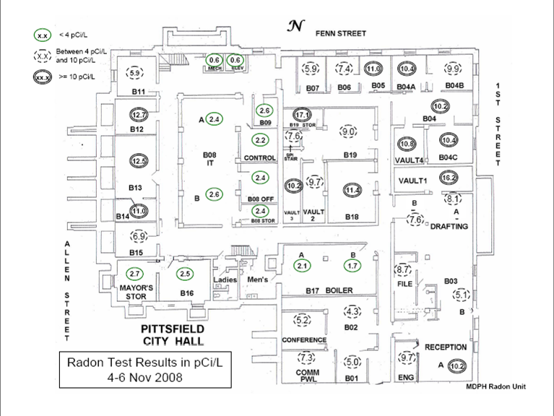
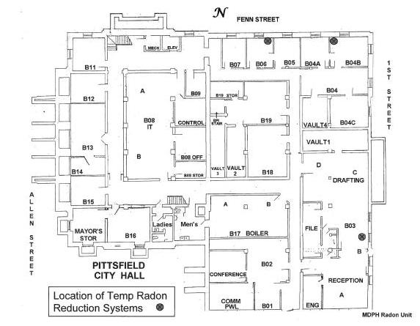

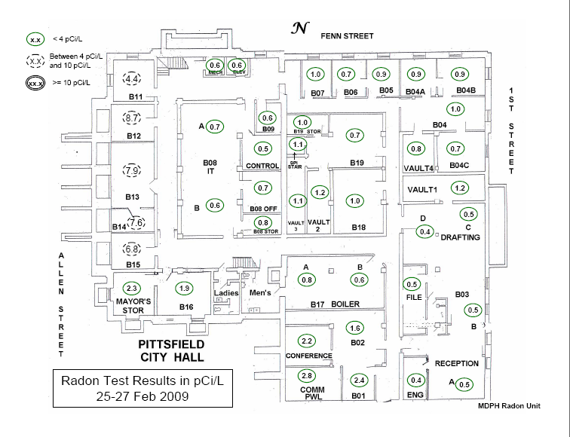
Picture 1

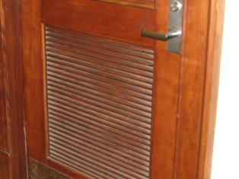

Hallway Door with Passive Vent

Picture 2

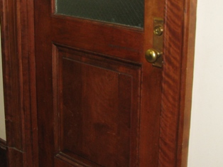

Hallway Door without Passive Vent

Picture 3

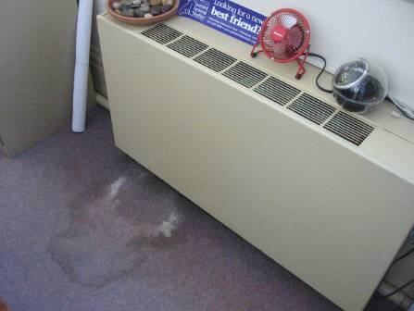

Fan Coil Unit, Note Water Damaged Carpet

Picture 4

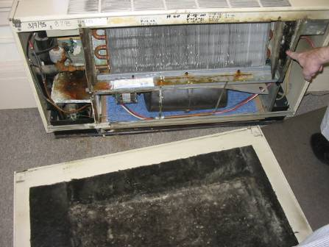

Fan Coil Unit, Front Panel Removed

Picture 5

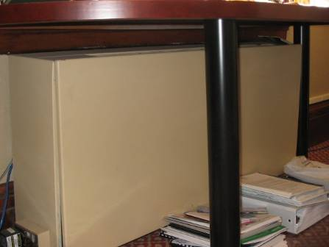

Fan Coil Unit Air Diffuser Blocked by Table and Return Blocked by Books

Picture 6

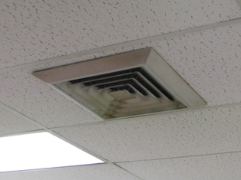

Ceiling Air Diffuser

Picture 7

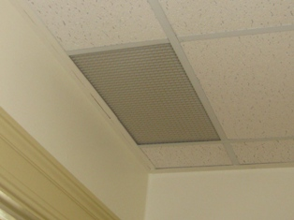

Ceiling-mounted Exhaust Grill

Picture 8

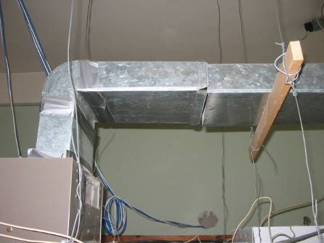

Exhaust Ductwork in Assessor’s Office

Picture 9

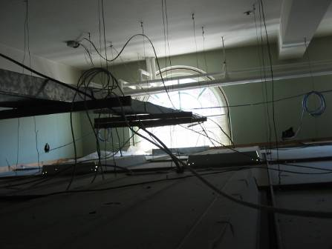

Ductwork Terminates inside Ceiling Plenum at Window

Picture 10

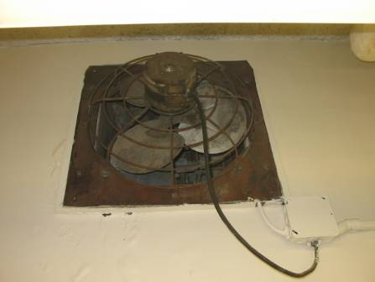

Fan on Exterior Wall in Basement Room 03

Picture 11

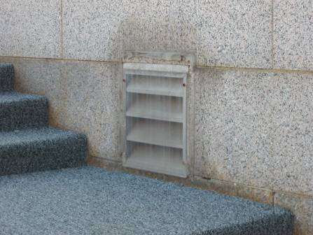

Fan on Exterior Wall Sealed

Picture 12

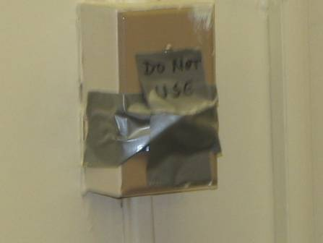

Fan Switch Covered with Duct-tape

Picture 13

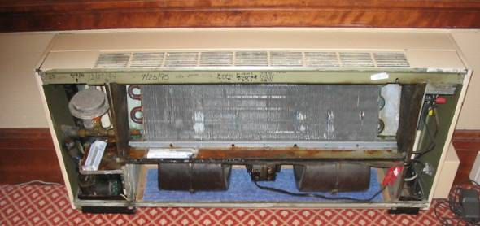

Interior of Fan Coil Unit

Picture 14

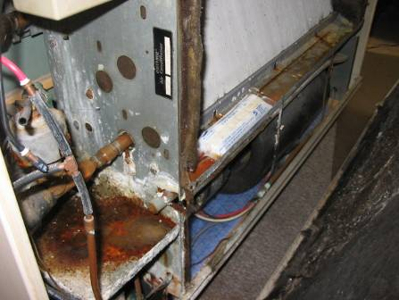

Fan Coil Unit Drip Pans Connected by Drain Pipe
Note Antimicrobial Tablets in Drip Pan

Picture 15

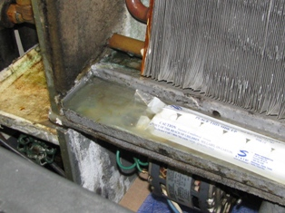

Accumulated Debris in Drip Pan, Note Antimicrobial in Drip Pan

Picture 16

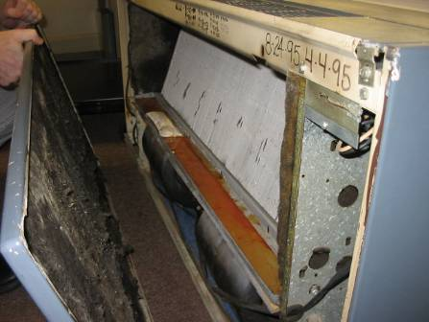

Accumulated Debris in Drip Pan

Picture 17

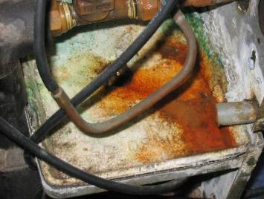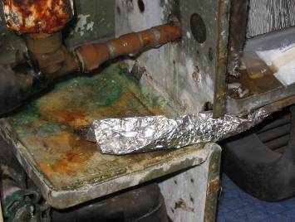

Aluminum Foil Sculpted as Drain Pipe
Note Intact Drain Pipe on Left

Picture 18

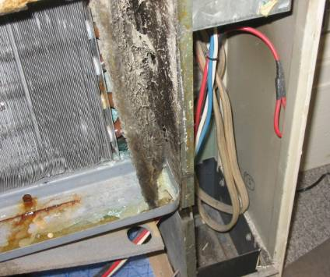

Damaged Insulation within Fan Coil Unit
Picture 19

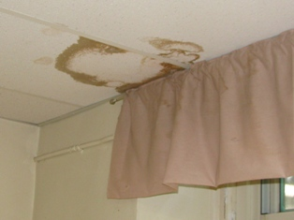

Water-Damaged Ceiling Tiles

Picture 20

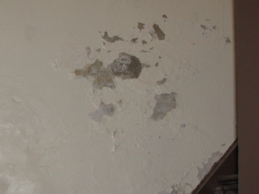

Peeling Paint and Efflorescence on Wall

Picture 21

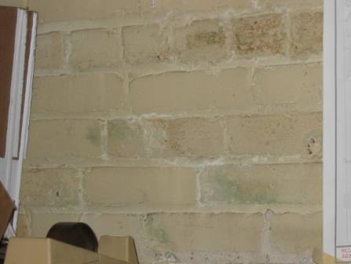

Peeling Paint and Efflorescence on Wall

Picture 22



Plants on Cabinet

Picture 23

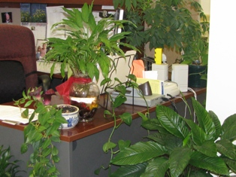

Plants on Desk and Floor

Picture 24

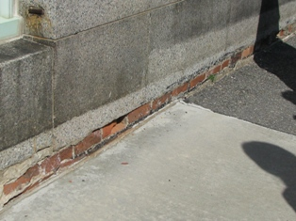

Damaged Exterior Brick and Mortar

Picture 25

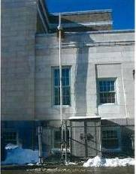

Exterior View of Temporary Radon Reduction System Room B-03
(Picture by BEH Radon Unit)

Picture 26



Exterior View of Temporary Radon Reduction System, Rooms B-04 (near) and B-06
(Picture by BEH Radon Unit)
Picture 27

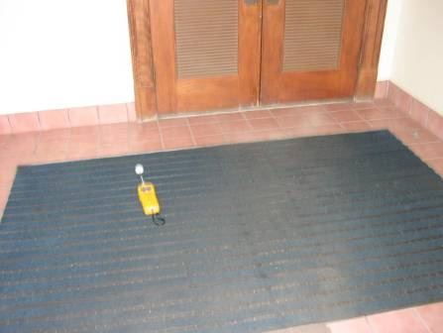

Floor Mat in Foyer of Rear Entrance of PCH

Picture 28

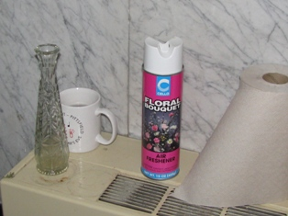

Air Freshener

Picture 29

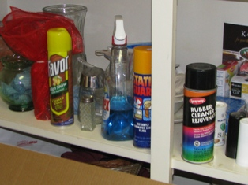

Cleaning Products

Picture 30

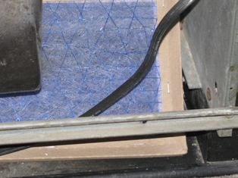

Space around Filters where Unfiltered Air can bypass
Location/ Room | Occupants  in Room | Temp  (°F) | Relative  Humidity  (%) | Carbon  Dioxide  (ppm) | Carbon Monoxide  (ppm) | TVOCs  (ppm) | PM2.5  (µg/m³) | Windows  Openable | Ventilation |  | Remarks
 |  |  |  |  |  |  |  |  | Supply | Exhaust | Remarks
background |  | 78 | 61 | 427 | ND | ND | 15
Solicitor’s Office | 2 | 72 | 51 | 741 | ND |  | 7 | Y  0 of 2 open | N | N | FCU; DO; peeling paint on exterior wall
Solicitor’s Outer Office | 0 | 72 | 51 | 781 | ND |  | 8 | Y  0 of 1 open | N | N | FCU (damaged insulation, accumulated debris in drip pan, evidence of leak on carpet); DO; Plant
Law Library | 4 | 72 | 51 | 777 | ND |  | 6 | Y  0 of 2 open | N | N | FCU (Styrofoam insert, large holes in casing)
202 | 1 | 73 | 55 | 1027 | ND |  | 10 | Y  0 of 1 open | N | N | FCU; PC
202 Inner Room | 0 | 75 | 50 | 840 | ND |  | 10 | Y | N | N | DO; WD CTs; WD plaster on walls; Plants
203 | 0 | 72 | 62 | 858 | ND | ND | 13 | Y  0 of 3 open | N | N | 2 FCU (aluminum foil to direct water, accumulated debris in drip pan); 2 WD CTs,
206 City Council Chamber | 0 | 65 | 66 | 602 | ND | ND | 8 | N | Y | Y | Vinyl wallpaper
205 Front Office | 1 | 74 | 49 | 695 | ND |  | 13 | Y  0 of 1 open | N | N | Plants; FCU
City Clerk Suite Clerk’s Office | 0 | 74 | 59 | 852 | ND | ND | 11 | N | N | N | PF
City Clerk Suite Front desk | 3 | 74 | 56 | 1241 | ND |  | 13 | N | N | N | DO
City Clerk Suite Office Area | 1 | 75 | 52 | 961 | ND |  | 13 | N | Y | Y  Off | DO; PFs; FCUs; CFs (dirt and debris); Plants
Comm. Dev bathroom |  |  |  |  |  |  |  |  |  |  | Strong odor of air deodorizer (wall mounted)
Comm. Dev Inner Office 1 | 0 | 73 | 47 | 851 | ND |  | 10 | Y  0 of 1 open | N | N | DO; FCU
Comm. Dev Inner Office 2 | 0 | 73 | 49 | 770 | ND |  | 12 | Y  0 of 1 open | N | N | DO; FCU
Comm. Dev Large Office with exam room | 0 | 74 | 49 | 878 | ND |  | 11 | Y | N | N | DO; Plant; PF; FCU
Comm. Dev Outer Office 1 | 0 | 74 | 59 | 824 | ND | ND | 12 | Y  0 of 2 open | N | N | DEM; Plants
Comm. Dev Outer Office 2 | 0 | 74 | 62 | 694 | ND | ND | 13 | Y  2 of 3 open | N | N | PF
Community Develop | 0 | 73 | 59 | 812 | ND | ND | 12 | N | N | N | CF
Health Department, Director’s Office | 1 | 74 | 56 | 547 | ND |  | 16 | Y  0 of 2 open | N | N | DO; FCU; AP; grates in ceiling
Health Department, rear office | 1 | 74 | 67 | 485 | ND | ND | 15 | Y  1 of 2 open | N | N | Abandoned drain
Health Department, Room 216, Inspector | 3 | 74 | 54 | 784 | ND |  | 15 | Y  0 of 2 open | N | N | DO; DEM; 2 FCUs; peeling paint on exterior wall; penetrations in ceiling
Vault Basement Storage Area | 0 | 73 | 45 | 687 | ND |  | 10 | N | N | N | DO; Crack in Floor
Vault Upstairs | 0 | 75 | 51 | 969 | ND |  | 13 | N | N | N | DO
Voter Registration | 1 | 75 | 59 | 749 | ND | ND | 12 | Y  1 of 3 open | N | N | CPs; 2 PCs; PF; Plants
Mayor’s Suite Admin. Asst. | 1 | 74 | 57 | 478 | ND | ND | 15 | Y  1 of 1 open | N | N | PC; FCU grill broken, microwave
Mayor’s Suite Mayor Office | 0 | 73 | 57 | 434 | ND | ND | 15 | Y  0 of 3 open | N | N | FCU under wood table; CF
Mayor’s Suite Office (left) | 0 | 73 | 50 | 485 | ND |  | 13 | Y  0 of 1 open | N | N | CF; 2 computers; DO; FCU
Mayor’s Suite Waiting area | 0 | 73 | 51 | 537 | ND |  | 15 | Y  0 of 1 open | N | N | DO; CF; FCU
Treasurers front counter | 0 | 74 | 55 | 1345 | ND |  | 8 | Y  0 of 3 open | N | N | grates in ceiling
Treasurers front office | 4 | 75 | 53 | 1103 | ND |  | 9 | Y  0 of 3 open | N | N
Treasurers  Finance Dir | 0 | 75 | 51 | 926 | ND |  | 10 | Y  0 of 2 open | N | N | WD CTs; Plant; FCU
Coffee Room | 0 | 74 | 53 | 1159 | ND |  | 8 | Y  0 of 1 open | N | N | DO
Benefits Analyst | 0 | 74 | 52 | 987 | ND |  | 9 | Y  0 of 1 open | N | N | DO
Asst. Treasurer | 1 | 74 | 52 | 911 | ND |  | 9 | Y  0 of 1 open | N | N | DO; PF; Plant; FCU
Finance Dir. Bathroom | 0 | 74 | 54 | 913 | ND |  | 12 | Y  0 of 1 open | N | N | AD (strong odor)
Treasurers vault | 0 | 75 | 52 | 1086 | ND |  | 9 | N | N | N | DO
Tax Collector | 4 | 76 | 49 | 714 | ND |  | 13 | N | Y  off | Y  off | Plants; water cooler on carpet
Retirement | 1 | 78 | 47 | 630 | ND |  | 14 | Y  0 of 1 open | N | N | Plant; WD CT; water cooler on carpet
Employee Lounge | 0 | 74 | 43 | 555 | ND |  | 12 | Y  0 of 1 open | N | Y  off | strong kitchen odor
107 | 1 | 76 | 55 | 473 | ND | ND | 11 | Y  1 of 1 open | N | N | AP; PC; PF; Plants
107 Office | 0 | 75 | 57 | 445 | ND | ND | 12 | Y  0 of 2 open | N | N | 2 WD CTs
108  Assessors | 3 | 78 | 53 | 748 | ND | ND | 7 | Y  0 of 1 open | N | Y | AP; PFs; Tile floor
109 Office | 0 | 77 | 54 | 421 | ND | ND | 14 | Y  0 of 1 open | N | N | DO; WD CTs near window
111 Accounting | 2 | 73 | 51 | 805 | ND |  | 11 | N | N | N | 3 PFs; CTs missing with grates into plenum; cooler on carpet; FC
B02 DPW | 1 | 72 | 56 | 1060 | ND |  | 13 | Y  0 of 1 open | N | N | DO; plant; CPs; PF; WD CT (mold)
B02 DPW  (Inner) | 0 | 72 | 56 | 1071 | ND |  | 13 | N | N | N | DO; DEM; PF
B03 | 1 | 71 | 61 | 701 | ND |  | 14 | Y  1 of 4 open | N | Y  off | Water fountain abandoned
B03 Front Office | 1 | 73 | 54 | 745 | ND |  | 15 | Y  1 of 2 open | N | N | DO; Smoke Master on ceiling
B04  1st Office | 0 | 71 | 62 | 937 | ND | ND | 19 | Y  0 of 1 open | N | N | AP off
B04 Office | 0 | 70 | 62 | 1022 | ND | ND | 18 | Y  0 of 1 open | N | N
B07 | 1 | 71 | 63 | 686 | ND | ND | 21 | Y  0 of 1 open | N | N
B08 IT | 2 | 71 | 54 | 719 | ND |  | 8 | N | Y | Y | AP; water cooler on carpet; PC, 7 computers; 3 batteries; DEM
B18 | 0 | 70 | 50 | 597 | ND | ND | 5 | N | N | N | Building plans, blueprints
Basement Hallway | 0 | 70 | 54 | 1094 | ND
Basement Ladies room |  |  |  |  |  |  |  |  |  |  | Strong odor of deodorizer
Building Insp. | 1 | 70 | 53 | 1077 | ND |  | 19 | Y  0 of 2 open | N | N | DO; FCU
Building Insp.  Front Office | 2 | 70 | 55 | 1106 | ND |  | 21 | Y  0 of 1 open | N | N | DO
Building Insp.  Office 2 | 1 | 71 | 56 | 1051 | ND |  | 22 | Y  0 of 1 open | N | N | DO
Building Insp. Vault | 0 | 70 | 54 | 1075 | ND |  | 18 | N | N | N | DO
Chief Engineer | 0 | 73 | 54 | 721 | ND |  | 16 | Y  1 of 1 open | N | N | DO; CD; grate in ceiling
DPW rear | 1 | 73 | 52 | 757 | ND |  | 14 | Y  0 of 2 open | N | Y  off | Blueprint machine
DPW vault | 0 | 73 | 52 | 764 | ND |  | 13 | N | N | N | DO, Efflorescence on wall
Plumbing Insp. | 1 | 71 | 56 | 928 | ND |  | 23 | Y  0 of 1 open | N | N | DO; dehumidifier; FCU
Foyer (Retirement Office) |  |  |  |  |  | 2.4 on the floor |  |  |  |  | Strong chemical odor in this area
Foyer (Retirement Office) |  |  |  |  |  | 0.6 above ceiling tile
Foyer Outdoor Stairs |  |  |  |  |  | 0.2  Outside on landing

Location | Workday Average Radon Measurement  (pCi/L) | Range Workday Daily Average Radon Measurement  (pCi/L) | Number of Workday Average Radon measurements  > = 4 pCi/L | Number of Workday Average Radon measurements
B-02 | 2.5 | 1.7 - 4.0 | 1 | 7
B-03 Reception | 10.9 | 7.7 - 13.6 | 8 | 8
B-03 Vault end | 9.8 | 8.2 - 12.0 | 7 | 7
B-04 | 7.6 | 6.0 - 9.6 | 7 | 7
B-05 | 5.8 | 4.6 - 6.9 | 7 | 7
B-19 | 7.6 | 6.7 - 9.0 | 7 | 7
B-IT | 2.1 | 1.9 - 2.3 | 0 | 7

MCR data may not include individuals who were recently diagnosed with cancer, who were diagnosed with cancer outside of Massachusetts, who were diagnosed with a non-cancerous (benign) tumor, or who were diagnosed with cancer prior to 1982.

