**INDOOR AIR QUALITY**

**ASSESSMENT**

**Pittsfield Police Department**

**39 Allen Street**

**Pittsfield, Massachusetts**

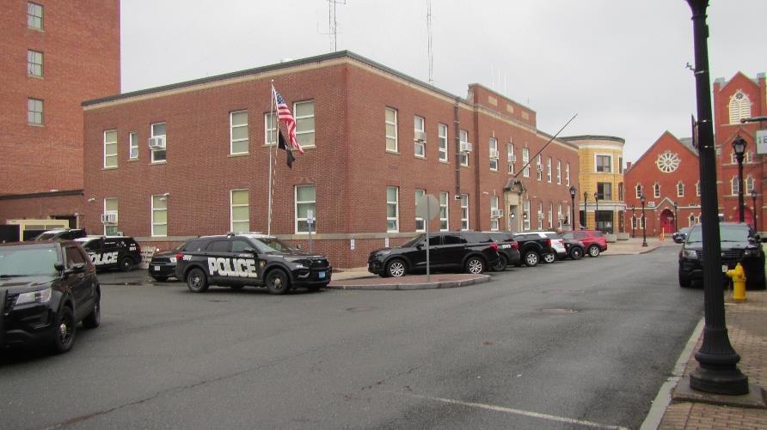

Prepared by:

Massachusetts Department of Public Health

Bureau of Environmental Health

Indoor Air Quality Program

April 2024

# BACKGROUND

|  |  |
| --- | --- |
| Building: | Pittsfield Police Department (PPD) |
| Address: | 39 Allen Street, Pittsfield, MA |
| Assessment Requested by: | Thomas Dawley, Chief of Police, PPD |
| Reason for Request: | Water damage and possible condensation impact |
| Date of Assessments: | March 15, 2024 |
| Massachusetts Department of Public Health/Bureau of Environmental Health (MDPH/BCEH) Staff Conducting Assessment: | Michael Feeney, Director, Indoor Air Quality (IAQ) Program |
| Building Description: | The PPD occupies a two-story building that was constructed in 1939. The lowest level, which is below grade, was designated as a nuclear fall-out shelter, but has no associated specialized mechanical ventilation system. |
| Windows: | Windows are openable |

# INTRODUCTION

The IAQ Program visited the PPD on March 15, 2024, to assess reports of water damage/condensation in the building, particularly in below-grade space. Results of this visit are reflected in Table 1. This assessment was done to identify mold and moisture-related conditions in the basement that can be addressed prior to the occurrence of hot, humid weather during summer months.

Based on these observations, the IAQ Program has offered to return to the PPD during hot, humid weather in summer months to assess the PPD when water accumulation/condensation is most likely to occur.

# METHODS

Air tests for temperature, relative humidity, carbon dioxide carbon monoxide and fine particulate matter (PM2.5) were taken with the TSI, Q-Trak, IAQ Monitor 7565. BCEH/IAQ staff also performed a visual inspection of building materials for water damage and/or microbial growth and examined the space for the presence of odors or other environmental concerns. Please refer to the IAQ Manual for methods, sampling procedures, and interpretation of results (MDPH, 2015).

# RESULTS AND DISCUSSION

The following is a summary of indoor air testing results (Table 1).

* ***Carbon dioxide*** levels were below the MDPH guideline of 800 parts per million (ppm), in all areas of the building, indicating adequate air exchange for the building population at the time of assessment.
* ***Temperature*** was within the MDPH recommended range of 70°F to 78°F in all areas tested.
* ***Relative humidity*** was within or close to the MDPH recommended range of 40 to 60% in all locations.
* ***Carbon monoxide*** levels were non-detectable (ND) in all areas tested.
* ***Fine particulate matter (PM2.5)*** concentrations measured were below the National Ambient Air Quality Standard (NAAQS) limit of 35 μg/m3 in all areas tested. In addition, indoor levels were all lower than background (outside).

## Ventilation

A heating, ventilating, and air conditioning (HVAC) system has several functions. First it provides heating and, if equipped, cooling. Second, it is a source of fresh air. Finally, an HVAC system will dilute and remove normally occurring indoor environmental pollutants by not only introducing fresh air, but by filtering the airstream and ejecting stale air to the outdoors via exhaust ventilation. Even if an HVAC system is operating as designed, point sources of respiratory irritation may exist and cause symptoms in sensitive individuals.

The PPD has ducts and radiators that appear to have been installed when the building was constructed. An air handling unit (AHU) was noted in the basement (Picture 1) that may be connected to air diffusers on the first floor (Picture 2). However, this unit was not operating at the time of the visit. IAQ staff were not able to identify any operating HVAC system equipment for other floors of the building. The existing radiators supply heat. While carbon dioxide levels were below 800 ppm during the visit, without mechanical ventilation, carbon dioxide and other pollutants would be expected to rise with increased population.

The PPD has openable windows. Due to security concerns, opening windows that are on the first floor or ground level in not advised. Windows appear to be energy efficient, with double-glass panes that have a vacuum seal. A vacuum seal insulates the windows to increase thermal comfort and energy efficiency. It is likely that this window system was installed sometime in the 1980s. Many windows were cloudy between the panes, indicating that the vacuum seal between the panes was breached, rendering the window system no longer able to provide insulation (Picture 3 and 4). In this condition, window frames in direct sunlight become a source of radiant heat and allow outdoor temperatures into the building in hot and cold weather.

A variety of air chilling equipment exists in the buildings, including window-mounted air conditioners (Picture 5), ceiling-mounted air-conditioners (Picture 6), and ductless (mini-split) air conditioning units (Picture 7).

In addition, despite ongoing maintenance and replacement of parts/components by PPD facilities staff, many of the HVAC units are at the end of their life cycle. Efficient function of ductwork and air louvers of this age (~ 85 years old) are difficult to maintain, since compatible replacement parts are often unavailable. According to the American Society of Heating, Refrigeration, and Air-Conditioning Engineering (ASHRAE, 1991), the following are the expected service life of various components of the HVAC system:

* Ductwork 30 years
* Air diffusers 27 years
* Heating/coiling coils 20 years
* Insulation 20 years
* Window-mounted air conditioners 10 years

The operation of mechanical exhaust vents is necessary to vent pollutants from the interior of the building, including water vapor from restrooms, kitchens, and showering facilities. If exhaust vents are not operating, water vapor is not removed from the building, which then can accumulate indoors to increase relative humidity.

The PPD fingerprint area is shared by the lockup area. Each lockup cell contains an exhaust vent. As reported by PPD staff, the configuration of the cellblock ventilation system appears to only recirculate air (Picture 8). A typical design of lock up cell exhaust ventilation is to use ducted, mechanical exhaust ventilation that is separate from the general HVAC system. Lockup cells should be designed to draw air from the hall or main room, and then exhaust air out of each cell via an exhaust duct connected to a fan to expel air directly outdoors. IAQ staff could not identify any exhaust fan on the PPD exterior walls that could provide exhaust ventilation for the lockup cells. It appears that the design in the PPD does not exhaust air from each cell to outside and therefore allows any odors and moisture from the cells to remain and be recirculated into the building.

Window-mounted air conditioners (WAC) are the sole source of chilled air in offices. While the typical WAC can bring in some fresh outdoor air, the use of WAC also renders each window unopenable. In addition, windows should not be opened in a room with air conditioning operating for the following reasons:

* With windows open, AC units cannot maintain temperatures.
* With a continual influx of hot air, AC equipment cannot properly drain accumulated condensation from each unit and can overflow to cause water damage.
* AC equipment will continuously operate in chill mode if its set point temperature is not able to be achieved, which increases wear on machinery that can lead to breakdown.
* With increased operation, building materials in contact with or beneath AC equipment can become moistened due to temperatures at or below the dew point, which can result in mold growth.

One location has a WAC installed in an interior window, with the compressor section releasing waste heat into a stairwell (Picture 9). As noted, some areas have mini-split air-conditioners. Both air chilling devices did not have an obvious means to drain condensation. Although no water damage was noted around any unit, if condensation accumulates inside either unit, mold growth or related odors are possible when these devices are operating.

## Microbial/Moisture Concerns

Concerns regarding moisture and microbial growth were one of the reasons for this assessment. Water-damaged ceiling tiles were noted in several locations throughout the PPD (Table 1). Water-damaged ceiling tiles should be replaced once the source of the water has been controlled.

### Building Materials Prone to Condensation

The key to managing condensation in hot, humid weather indoors is understanding dew point. Condensation is the collection of moisture on a surface at or below the dew point. The dew point is the temperature that air must reach for saturation to occur. If a building material/component has a temperature below the dew point, condensation will accumulate on that material. Over time, condensation can collect and form water droplets.

Given that the PPD was constructed in 1939 without a method to provide chilled air, it is highly likely the building experiences condensation on below grade floors and walls, particularly in areas where walls and floors have direct contact with soil, or where plumbing pipes with chilled water are present without adequate insulation. While IAQ staff did not observe moisture on lower-level walls and floors, PPD staff report the use of dehumidifiers in the basement to reduce condensation during hot, humid weather. The basement had a significant number of materials stored directly on floors including porous materials that are susceptible to or have become mold colonized (Pictures 10 and 11).

Part of the basement has a dirt floor which appears to be covered over with a plastic material with seams covered with duct tape (Picture 12). This covering appears to be meant to prevent water vapor from entering the basement. While the plastic flooring may limit water vapor from soil, cardboard materials on the plastic are mold colonized from becoming moistened by condensation.

In general, any material that is porous and capable of supporting mold growth should not be stored on floors and against walls capable of becoming moistened by condensation. Such materials include: cardboard, cloth, paper, books, porous, soft plastics (e.g., polyurethane), leather, upholstered furniture, jute or latex-backed carpeting.

The ground floor areas would appear to be prone to condensation if exposed to hot, humid weather for extended periods of time as noted previously. In addition, according to American Society of Heating, Refrigerating and Air-Conditioning Engineers (ASHRAE), if relative humidity exceeds 70% for extended periods of time, mold growth may occur due to wetting of building materials even in the absence of liquid water (ASHRAE, 2022).

Where materials have become moistened, either due to leaks or condensation or other causes, it is recommended that porous material be dried with fans and heating within *24 to 48 hours of becoming wet* (US EPA, 2008, ACGIH, 1989). If porous materials are not dried within this time frame, mold growth may occur. Water-damaged porous materials cannot be adequately cleaned to remove mold growth.

### Sources of Moisture to the Building Interior

One significant source of excess indoor humidity in this building is from high outdoor relative humidity. Hot humid summers are becoming more frequent due to climate change. Massachusetts experienced hot, humid, and rainy summers in 2018, 2021, and 2023. July of 2021 was the wettest ever recorded in Massachusetts, and the three-month period from that June through August, known as the meteorological summer, was the fourth wettest on record, according to the National Oceanic and Atmospheric Administration’s (NOAA) Centers for Environmental Information (NOAA, 2021). The summer of 2023 was also hot, and wet, being measured as the second rainiest on record (WBUR, 2023). These conditions are challenging for buildings, particularly those without air conditioning.

During these hot and wet summers, extended periods of outdoor relative humidity above 70% occurred. Under these weather periods, public buildings experienced extended periods of water vapor exposure from high relative humidity. When exposed to these conditions, porous materials such as gypsum wallboard, cardboard, and other materials may develop mold colonization, particularly if located in areas that are prone to condensation on floors and walls (e.g., below grade space).

This weather resulted in condensation issues in a number of publicly owned or operated buildings with below-grade space with walls or floors in direct contact with soil or cement slab floors. In these instances, the floors in direct contact with soil may have temperatures that would result in condensation wetting floors during periods of high relative humidity.

One sign of past exposure to high humidity in the PPD is the presence of bowed ceiling tiles (Picture 13). If a building experiences high relative humidity over an extended period of time, moisture exposure may cause ceiling tiles to bow. While bowed ceiling tiles are not moldy, they are an indication that other materials stored in those areas during periods of high humidity may become water-damaged or mold-colonized.

Due to the lack of central air conditioning in this building, only a low or moderate level of humidity reduction can be achieved. When outdoor humidity is high for a significant period of time, indoor humidity can rise to uncomfortable levels and remain elevated.

Another possible source of moisture is water penetration through below-grade windows inside window wells (Picture 14) and/or migration through below-grade brick and mortar. The PPD has window wells that are filled with debris which prevent ready draining of rainwater. In addition, several mulch-covered gardens are in direct contact with the base of the PPD exterior walls (Picture 15). Mulch can hold water against the building and prevent drying of wall and foundation seams which may lead to water penetration. Removal of mulch and repairs to the seam of the sidewalk and exterior wall of the building as needed is recommended.

Lockup cells were examined for signs of mold growth or related odors. No visible mold growth or odors were observed. As required by Massachusetts regulations, the holding cells were inspected DPH Community Sanitation Program staff, most recently on November 3, 2023. Attached is the report of that inspection included as Attachment 1.

## Other IAQ Evaluations

The PPD has carpeting which was noted to be worn and had lifting seams covered with duct tape (Picture 16). Wall-to-wall carpeting appears to have been installed over ten years ago. In some areas, carpeting was installed directly onto the basement floor slab (Pictures 17 and 18). It is likely that this carpeting is routinely exposed to high relative humidity and possibly to condensation.

In general, it is not recommended for police departments and other emergency response agencies to have carpeted floors due to the possible cross-contamination that may occur from footwear contact with automotive products, chemicals, or biological contamination. In addition, the Institute of Inspection, Cleaning and Restoration Certification (IICRC) discusses floor covering in its guideline, “Reference Guideline for Professional On-Location Cleaning of Textile Floor Covering Materials.” (IICRC, 2000). Based on this standard, the IICRC recommends twice-daily vacuuming and/or pile-lifting cleaning for commercial carpeting in heavy traffic areas. This frequency of cleaning of the building as well as the use of vacuum cleaners equipped with high-efficiency particulate arrestance (HEPA) filters would remove respirable dust from the indoor air. Carpets in these areas should also be thoroughly cleaned annually (or semi-annually in soiled/high traffic areas) in accordance with Institute of Inspection, Cleaning and Restoration Certification IIRC recommendations, (IICRC, 2012).

It is important to note that the carpeting in the PPD may have been installed on top of asbestos-containing floor tile. If this is the case, removal of carpet would require compliance with Massachusetts and federal laws and regulations related to asbestos remediation and disposal practices.

The basement has a number of locations where large holes exist in the plaster ceiling (Pictures 19 and 20). These holes were likely made to install and/or replace plumbing, electrical, or computer-related utilities. Such openings can allow for pollutants from equipment such as furnace/water heaters to enter the building wall cavities and travel to the upper floors of the building under certain circumstances. Such holes also allow for debris from wall interiors to enter the rooms from wall and ceiling areas and can serve as pathways for odors and water vapor to migrate between locations.

### Radon

# Due to the installation of a radon mitigation system in the Pittsfield City Hall located across the street, concerns were raised about elevated radon inside the PPD. Radon is a naturally occurring radioactive gas that seeps into buildings from the surrounding soil and at elevated levels can increase the risk of lung cancer. While the IAQ program does not offer radon testing, the MDPH does recommend that the PPD be tested for radon and, if necessary, mitigated. Radon measurement should be conducted during the heating season while the building is operating in a normal manner consistent with USEPA radon testing guidelines. Radon measurement specialists and other information can be found at [www.nrsb.org](http://www.nrsb.org) and <http://aarst-nrpp.com/wp>, with additional information at: <https://www.mass.gov/radon>.

# CONCLUSIONS AND RECOMMENDATIONS

The PPD has a number of issues related to moisture in the building. Due to the age and design of mechanical ventilation equipment, the ability to provide adequate chilled air and reduce relative humidity indoors is limited. It is important to note that with extreme relative humidity and rain of many recent summers, management of the building can be challenging. The following documents can provide guidance that can be used to reduce the impact of hot, humid weather in buildings.

* Mold growth Prevention during Hot, Humid Weather <https://www.mass.gov/service-details/preventing-mold-growth-in-massachusetts-schools-during-hot-humid-weather>
* Remediation and Prevention of Mold Growth and Water Damage in Public Schools <https://www.mass.gov/service-details/remediation-and-prevention-of-mold-growth-and-water-damage-in-public-schools-and>
* Methods for Increasing Comfort in Non-air-conditioned Schools <https://www.mass.gov/doc/methods-for-increasing-comfort-in-non-air-conditioned-schools/download>

To address the building’s problems, two sets of recommendations are made: **short-term** measures that may be implemented as soon as practicable and **long-term** measures that will require planning and resources to address overall IAQ concerns.

In view of the findings at the time of assessment, the following recommendations are made:

## Short Term Recommendations

### Ventilation recommendations

1. Determine if the AHU noted in the basement is capable of operating. If so, operate it during occupied periods. Ensure the unit is cleaned periodically and has any filters replaced at least twice a year using the best quality filters the unit can handle.
2. Clean and maintain mini-split and WACs including cleaning the filters in accordance with manufacturer’s instructions.
3. Ensure all WAC installations are tightly fitted into windows and sealed to prevent outdoor air, moisture, and pests entering the building. Materials used to seal WAC installations should be mold-resistant and provide some means of insulation to reduce heat transmission.
4. Consider replacing the stairwell window WAC with a mini-split, if feasible. Examine this WAC to ensure that condensation is drained appropriately.
5. Examine all other mini-splits installed in the building to determine if each unit has sufficient condensation drainage. Periodically monitor any tubing or pumps draining condensation from WAC and mini-splits to prevent clogs and leaks.

### Water damage recommendations

1. Due to the likelihood of condensation on basement floors and walls, removal of all basement wall-to-wall carpeting is recommended. Before any carpet removal, determine if wall-to-wall carpeting is installed over asbestos-containing tile/flooring. If flooring contains asbestos, removal and dispose of materials in a manner consistent with Massachusetts and federal asbestos mitigation and disposal laws and regulations. In addition, if carpeting is removed in the basement, remediate in accordance with the EPA guideline “Mold Remediation in Schools and Commercial Buildings” (US EPA, 2008).
2. Ensure that all windows are closed when air conditioning/chilling is occurring.
3. Work with an HVAC contractor to determine if the HVAC system can be operated or modified to provide additional dehumidification while in chilling mode.
4. Use dehumidifiers in the building whenever outdoor conditions including heavy rain and/or high relative humidity. Maintain all dehumidifiers and regularly remove water and clean receptacles to avoid stagnant water, odors, and the potential for leaks. During cool, dry weather when dehumidifiers are not collecting much water, they can be turned off.
5. Avoid storing porous materials (e.g., cloth, paper, porous plastic, leather) on the floor, particularly on the lower level, to avoid moistening through condensation. This includes the area with the plastic-covered dirt floor. Discard water-damaged boxes. Limit storage of other materials to allow for airflow to dry floors and walls.
6. Consider installing shelving that is made of material that does not support mold growth (e.g., hard plastic). If metal shelving is used, avoid storing materials on the lowest shelf.
7. Clean non-porous water-stained surfaces, including walls and floors and remove any debris.
8. Remove water-stained ceiling tiles and replace.
9. Consider replacing bowed ceiling tiles.
10. Remove accumulated debris from window wells. If drains exist in window wells, clean to improve drainage. If drains cannot sufficiently remove accumulated rainwater at a rate to prevent wetting of windowsills, install covers over the window wells to divert rain.

### Other Recommendations

1. Repair all holes in the basement ceiling to prevent water vapor and other pollutant migration between rooms.
2. Replace carpeting with an appropriate material that is readily cleanable and not susceptible to mold growth in all locations in the PPD. Clean any carpet that remains annually or semi-annually in accordance with IICRC recommendations (IICRC, 2012). Before any carpet removal, determine if wall-to-wall carpeting is installed over asbestos-containing tile/flooring. If flooring contains asbestos, remove and dispose of materials in a manner consistent with Massachusetts and federal asbestos mitigation and disposal laws and regulations.
3. Have the PPD tested for radon by a certified radon measurement specialist during the heating season during normal occupancy. Radon measurement specialists and other information can be found at: <https://nrsb.org/> and <http://aarst-nrpp.com/wp>. To learn more about radon, review the MDPH’s Radon web page at: <https://www.mass.gov/radon>.

## Long Term Recommendations

1. Consult with a building engineering firm for advice and to conduct a building-wide ventilation systems assessment of all ductwork, HVAC air handling equipment, HVAC insulation, and air diffusers. Based on historical issues with air exchange/indoor air quality complaints, age, physical deterioration, and availability of parts for ventilation components, such an evaluation is necessary to determine the operability and feasibility of replacing or repairing the equipment.
2. Have a ventilation engineer examine the lock up exhaust ventilation system to determine the most appropriate method to vent exhaust air directly outdoors. Once determined, install the necessary duct work and exhaust vent system. If such work were to be done, corrections outlined in Attachment 1 should also be done.
3. Replace all WACs that are older than the expected service life (10 years).
4. In order to reduce water vapor in the basement, remove mulch-covered garden plots that are against the foundation wall. Cover or seal the soil with a water-resistant material so the rainwater drains away from the foundation.
5. Due to the conditions of the window systems, consideration should be made to replace these with new, energy efficient windows.

# REFERENCES

ACGIH. 1989. Guidelines for the Assessment of Bioaerosols in the Indoor Environment. American Conference of Governmental Industrial Hygienists, Cincinnati, OH.

ASHRAE. 1991. ASHRAE Applications Handbook, Chapter 33 “Owning and Operating Costs”. American Society of Heating, Refrigeration and Air Conditioning Engineers, Atlanta, GA.

ASHRAE, 2022. American Society of Heating, Refrigeration and Air Conditioning Engineers (ASHRAE) Ventilation for Acceptable Indoor Air Quality. ANSI/ASHRAE Standard 62.1-2022. Atlanta, GA.

IICRC. 2000. IICRC S001. Reference Guideline for Professional On-Location Cleaning of Textile Floor Covering Materials. Institute of Inspection, Cleaning and Restoration Certification. Institute of Inspection Cleaning and Restoration, Vancouver, WA.

IICRC. 2012. Institute of Inspection, Cleaning and Restoration Certification. Carpet Cleaning: FAQ. <https://iicrc.org/>

MDPH. 2015. Massachusetts Department of Public Health. Indoor Air Quality Manual: Chapters I-III. Available at: <https://www.mass.gov/lists/indoor-air-quality-manual-and-appendices>

NOAA. 2021. Summer 2021 neck and neck with Dust Bowl summer for hottest on record. National Oceanic and Atmospheric Administration, 1401 Constitution Avenue NW, Room 5128, Washington, DC 20230: <https://www.noaa.gov/news/summer-2021-neck-and-neck-with-dust-bowl-summer-for-hottest-on-record>

US EPA. 1993. Radon Measurement in Schools, Revised Edition. Office of Air and Radiation, Office of Radiation and Indoor Air, Indoor Environments Division (6609J). EPA 402-R-92-014.

US EPA. 2008. “Mold Remediation in Schools and Commercial Buildings”. Office of Air and Radiation, Indoor Environments Division, Washington, DC. EPA 402-K-01-001. September 2008. Available at: <http://www.epa.gov/mold/mold-remediation-schools-and-commercial-buildings-guide>.

WBUR. 2023. “It's been a summer of rain and flooding misery in Mass.” WBUR local news. September 12, 2023. <https://www.wbur.org/news/2023/09/12/summer-flooding-rain-massachusetts>.

**Picture 1**

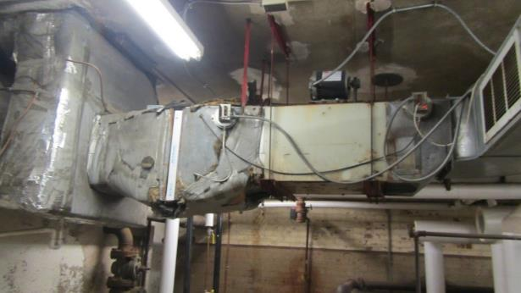

**AHU in basement that is possibly connected to 1st floor ceiling-mounted air diffusers**

**Picture 2**

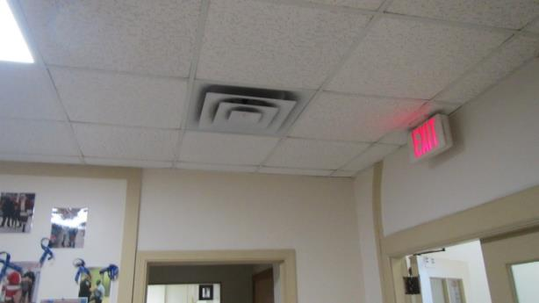

**First floor ceiling-mounted air diffuser**

**Picture 3**

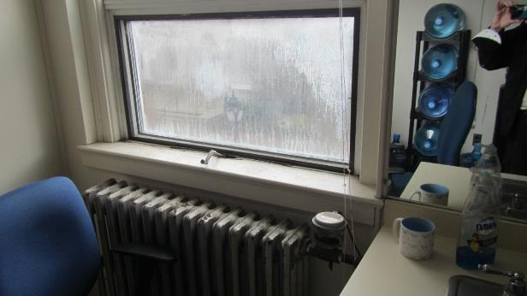

**Condensation inside windowpanes**

**Picture 4**

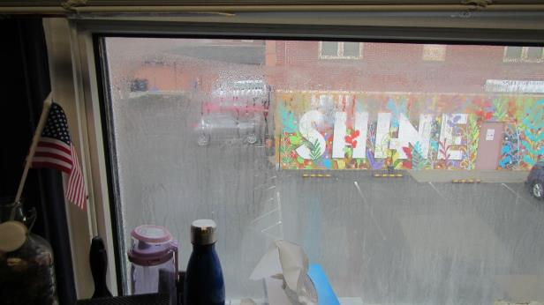

**Condensation inside windowpanes**

**Picture 5**

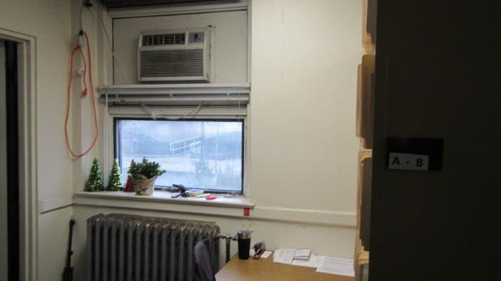

**Window-mounted air-conditioner**

**Picture 6**

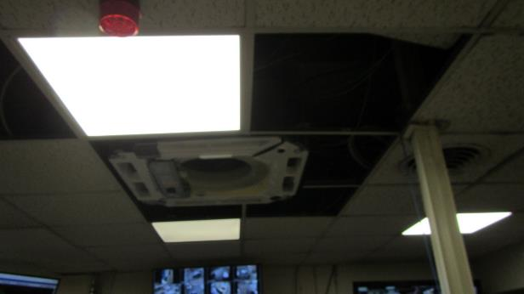

**Ceiling-mounted air-conditioner**

**Picture 7**

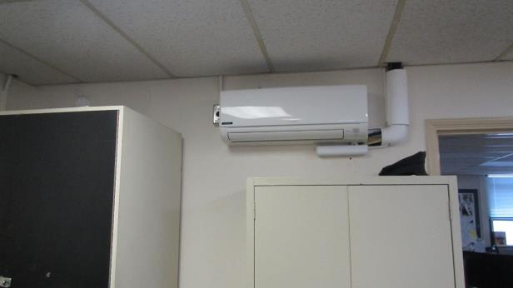

**Ductless air conditioner (mini-split), condensation drainage could not be identified**

**Picture 8**

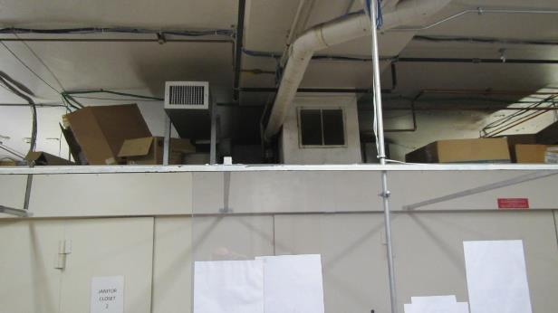

**Holding cells ventilation system not connected to any exhaust venting**

**Picture 9**

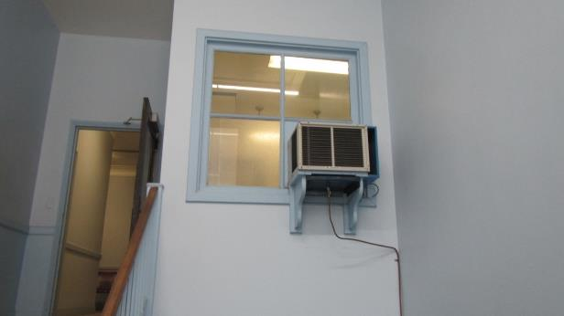

**Window-mounted air-conditioner installed in interior stairwell window**

**Picture 10**

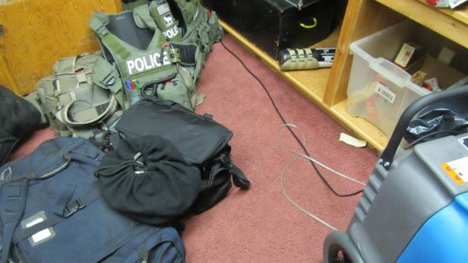

**Police training equipment on basement floor, note wall-to-wall carpeting**

**Picture 11**

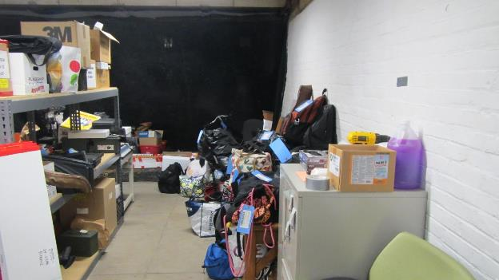

**Cloth and other materials capable of mold growth stored on basement floor**

**Picture 12**

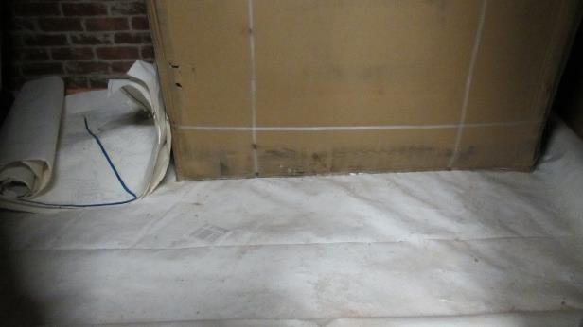

**Mold-colonized cardboard on plastic-covered dirt floor**

**Picture 13**

**Bowed ceiling tiles on first floor
Likely moistened when main entrance door opened. During hot, humid weather
**

**Bowed ceiling tiles on first floor, likely moistened when main entrance door opened during hot, humid weather**

**Picture 14**

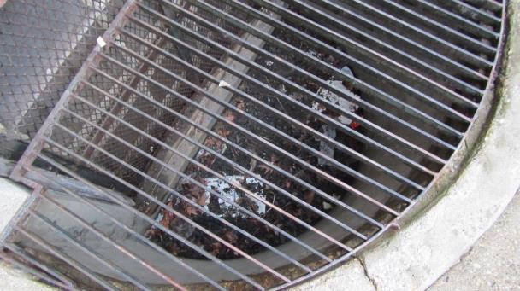

**Window well floor filled with debris**

**Picture 15**

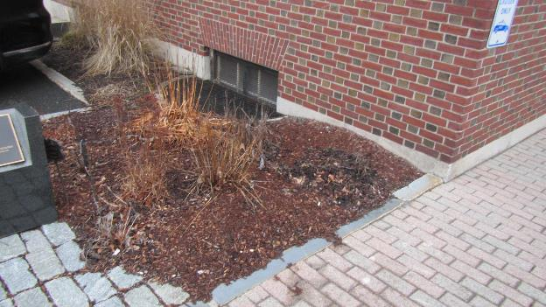

**Mulch-covered gardens in direct contact with foundation**

**Picture 16**

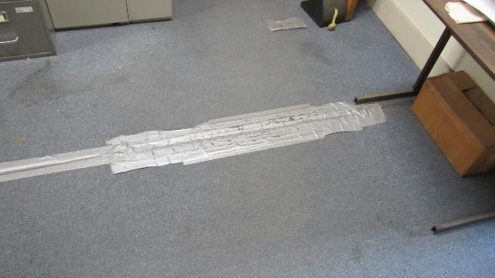

**Duct tape on carpet seam**

**Picture 17**

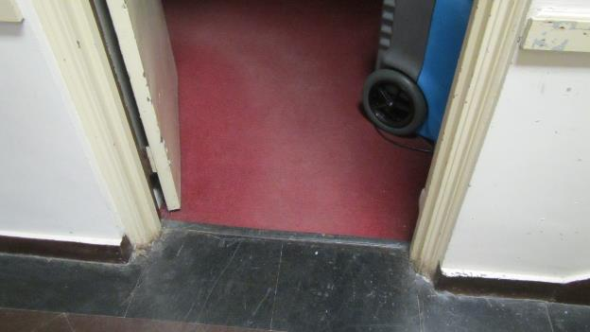

**Wall-to-wall carpeting in basement; note hallway tile that likely contains asbestos**

**Picture 18**

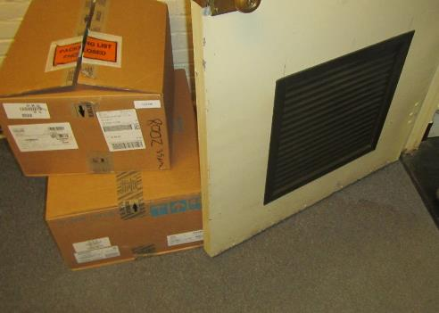

**Wall-to-wall carpet in basement**

**Picture 19**

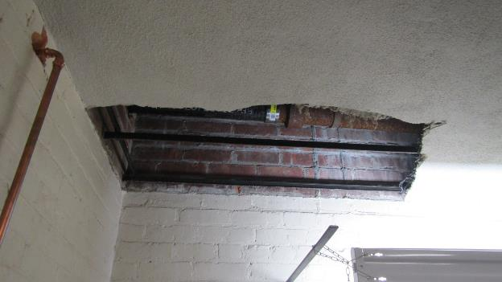

**Hole in basement plaster ceiling**

**Picture 20**

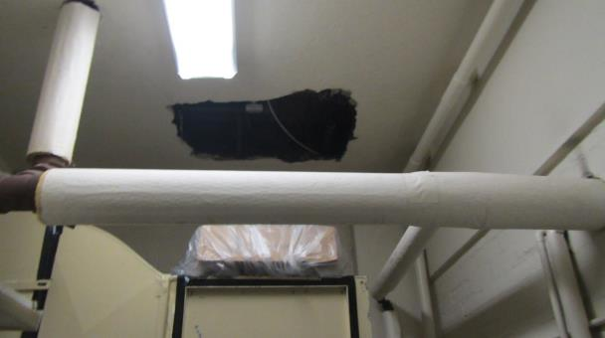

**Holes in basement plaster ceiling**

| Location | **Carbon**  **Dioxide**  **(ppm)** | **Carbon Monoxide**  **(ppm)** | **Temp**  **(°F)** | **Relative**  **Humidity**  **(%)** | **PM2.5**  **(µg/m3)** | **Occupants**  **in Room** | **Windows**  **Openable** | **Ventilation** | | **Remarks** |
| --- | --- | --- | --- | --- | --- | --- | --- | --- | --- | --- |
| **Supply** | **Exhaust** |
| Background | 391 | ND | 43 | 89 | 13 | 0 |  |  |  | Raining |
| Gang unit | 495 | ND | 71 | 41 | 7 | 1 | N | Y | Y |  |
| Shift commander | 595 | ND | 72 | 40 | 4 | 2 | N | Y | N |  |
| Sgt room | 630 | ND | 73 | 41 | 5 | 0 | Y | N | N | 4 water-damaged ceiling tiles |
| Capt. Office | 664 | ND | 72 | 41 | 7 | 0 | Y | N | N | Carpeting, WAC |
| Booking | 506 | ND | 71 | 41 | 6 | 0 | Y | Y | Y | WAC broken, odors |
| Records | 672 | ND | 72 | 41 | 7 | 3 | Y | Y | Y | WAC, carpeting, bowing ceiling tiles |
| Records desk | 736 | ND | 71 | 42 | 4 | 3 | Y | Y | N | WAC, carpeting |
| Lobby | 519 | ND | 72 | 43 | 2 | 2 | N | Y | Y | Bowing ceiling tiles |
| Matron | 472 | ND | 72 | 42 | 3 | 0 | N | Y | Y | WAC |
| Finance | 786 | ND | 72 | 42 | 6 | 0 | N | Y |  | WAC |
| Chief reception | 782 | ND | 72 | 40 | 7 | 2 | Y | N |  | WAC |
| Chief | 795 | ND | 72 | 43 | 5 | 1 | Y | N |  | WAC, carpeting |
| Detective supervisor | 608 | ND | 71 | 41 | 7 | 1 | Y | N |  | WAC, carpeting |
| Detective office 1 | 501 | ND | 72 | 40 | 4 | 0 | N | N |  | WAC, bowing ceiling tiles,  carpeting |
| Detective office 2 | 522 | ND | 73 | 39 | 4 | 0 | Y | N |  | Mini-split, carpeting |
| Crime Lab | 518 | ND | 71 | 37 | 3 | 0 | Y | N |  | Mini-split |
| Operations service command | 658 | ND | 71 | 42 | 5 | 1 | Y | N |  | WAC |
| Kitchen | 474 | ND | 72 | 42 | 4 | 0 | Y | Y |  | Plants |

Inspection Report of Lockup Facility

The Massachusetts Department of Public Health Community Sanitation Program (CSP) conducted this inspection in accordance with M.G.L. c. 111, §§ 3, 20, 21, and 22, as well as 105 CMR 470.000: Maintenance and Construction of Lockup Facilities; and 105 CMR 480.000: Minimum Requirements for the Management of Medical or Biological Waste (State Sanitary Code, Chapter VIII).

|  |  |
| --- | --- |
| **Insp Date:** 11/9/2023 **Business ID:** 644 | **Inspection:** M7001686 |
| **Business:** Pittsfield Police Department | **Facility:** Lockup |
| 39 Allen Street | **Phone:** 413-448-9702  **Inspector:** 04 Scott Koczela |
| Pittsfield, MA 01073 | **Reason:** 1. Routine  **Results:** Violations Noted |

Accompanied during the inspection by:

|  |
| --- |
| Lieutenant Jacob Barbour |

¤

|  |
| --- |
| Health and Safety Violations |

Violation No Violation N/A

Violations found during the inspection are noted below. Citations that are noted as "Repeat" indicate where the same violation was noted during the previous inspection.

Physical Facility ¤ ¡ ¡

*105 CMR 470.405 Finish of Cell Walls and Ceilings: Wall not easily cleanable, area where floor and wall join rusted*

*[in cell # M2, M3, and M8]*

*105 CMR 470.405 Repeat; Finish of Cell Walls and Ceilings: Wall not easily cleanable, area where floor and wall join rusted [in cell # M1]*

Audio and Security Devices ¤ ¡ ¡

*105 CMR 470.409 Security Devices: Electronic security device readout not available at the time of inspection*

Observations & Recommendations Yes No

Observation(s) ¤ ¡

*Please provide a readout of the times each cell check was conducted during the inspection on a signed Department letterhead.*

*Bed paint damaged*

*[in cell # F2, M1, and M2]*

*Bed was dirty*

*[in cell # M2 and M3]*

*Door paint damaged [in cell # M1]*

Closing Yes No

Compliance Statement ¤ ¡

Page 1 of 2

470-23-Pittsfield-Report 11-13-23

Inspection Report of Lockup Facility

Closing Yes No

*This facility does not comply with the Department’s Regulations cited above. In accordance with 105 CMR 470.520, please submit a plan of correction within 21 days of receipt of this notice, indicating what action has been, or will be taken to correct the areas of non-compliance. If violations noted have not yet been corrected, an estimated date of correction shall be provided. Please submit a signed Plan of Correction on your Department letterhead preferably by email or, to my attention, at the address listed above.*

*To review the specific regulatory requirements please visit our website at www.mass.gov/dph/dcs and click on "Look up regulations" then “Lock Up Facilities”.*

Suicide Hazards Yes No

|  |  |
| --- | --- |
| Hazards Statement | ¤ ¡ |
| *As part of the inspection, I also looked for the presence of “potential” suicide hazards beyond the provisions outlined at 105 CMR 470.000. Below is a list of conditions I observed that could possibly contribute to the commission of a suicide. While these conditions are not a violation of any law or regulation, you should be aware of their existence.*  Suicide Hazards  *Door guide is accessible from inside cell*  *[F1, F2, M1, M2, M3, M4, M5, M6, M7, and M8]*  *Exposed door hinges*  *[in the juvenile cell ]*  *Exposed toilet pipes*  *[in the juvenile cell bathroom ]*  *Faucet fixture*  *[in the juvenile cell bathroom ]*  *Gap between handwash sink and wall*  *[in cell # M7]*  *Gap between Lexan and door frame*  *[in cell # F1]*  *Handwash sink fixture*  *[in the juvenile cell bathroom ]*  *Toilet fixtures are not equipped with anti-suicide skirts [in all cells]*  *Wall mounted phones not flush to wall [in cell # M8]*  *[Radiator cover in the juvenile cell*  *Thermostat cover in the juvenile cell*  *Bathroom door ventilation cover in the juvenile cell*  *Radiator in the juvenile cell bathroom]* | ¤ ¡ |

Inspector Signature

|  |  |  |  |  |  |
| --- | --- | --- | --- | --- | --- |
|  | |  |  |  |  | | --- | --- | --- | --- | | Yes | ¤ | No | ¡ | |

Signed under the pains and penalties of perjury:

Scott Koczela

Environmental Analyst, CSP, BCEH

Report Distribution Yes No

Chief (electronic copy) Thomas Dawley

¤¡

Nalina Narain

¤¡

Steven Hughes

¤¡

Andy Cambi, Health Director

¤¡

Pittsfield Health Department

¤¡

Monica King

¤¡

Bureau Director, BCEH

Director, CSP, BCEH

Board of Health (electronic copy)

Board of Health

DYS Director of ALPS (electronic copy)

Page 2 of 2

470-23-Pittsfield-Report 11-13-23