*Note: Grantee to insert information in yellow highlights and edit other information as needed when drafting*

**MVP Planning 2.0 Contract with Planning Vendor**

[*Insert date*]

[Insert name of Grantee] hereby contracts with [insert name of Planning vendor], the “Planning vendor,” to complete the MVP 2.0 process and deliver outputs of the process to EEA. The Grantee agrees to reimburse the Planning vendor for the tasks associated with this contract.

This project will run from the effective date of this contract through [insert date]**.**

**Overview of MVP 2.0 Scope of Work**

Cities, towns, and Tribes throughout Massachusetts are identifying climate vulnerabilities and investing in community resilience. The MVP 2.0 program, run by the Massachusetts Executive Office of Energy and Environmental Affairs, expands on the work communities have done to date and supports communities with new methods, tools, and resources for building climate resilience. MVP 2.0 is a way for grantees to revisit their community resilience priorities with a focus on equity and translate those priorities into action through project development and implementation.

The Planning vendor will support the Grantee in revisiting their community resilience priorities with a focus on equity and translating those priorities into action through project development and implementation. The MVP 2.0 program does this through: 

* Convening a community team to lead equitable climate resilience work;
* Providing training on strategies for building climate resilience, equity, and climate justice;
* Revisiting resilience priorities with the involvement of the wider community and a stronger assessment of social vulnerability and resilience;
* Helping the municipality and community to co-develop and implement a project that builds community resilience, with guaranteed funding for implementation; and
* Providing a process that can be replicated for future, competitive MVP Action Grants.

This work will be different than the original MVP Planning Grant (MVP 1.0) approach. It focuses less on understanding how extreme weather events will impact infrastructural and environmental assets in the community, and more on building social resilience. This includes exploring the factors that create vulnerability or resilience for people living or working in the community. It involves digging deeper into issues like food security and housing affordability and understanding how those factors shape what is needed for building resilience to climate change. The MVP 2.0 process calls on a Core Team with strong connections to communities that will be most impacted by climate change, and vendors that bring different skill sets than in MVP 1.0 (see skill sets listed below). In addition, every municipality or region in the MVP 2.0 Program is paired with an Equity Partner. The Equity Partner helps provide coaching and guidance on things like inclusive engagement and how to measure the equity impacts of projects. Together this team will focus on connecting with and collaborating with community members, and expanding the voices who are involved in climate resilience efforts.

The MVP 2.0 process is broken down into three phases. It’s designed to be completed over two years, knowing that it takes time to build new relationships, expand the involvement of the broader community, and work together to develop and implement a project. Grantees may also continue to apply for Action Grants while participating in MVP 2.0. The Planning Vendor will be hired in Step 1 of the process, and will be responsible for helping the community implement Steps 2-8 in the MVP 2.0 Process Guide.

Phase 1 - Develop a Core Team.The Core Team is a team of municipal staff/volunteers and community members who will lead the MVP 2.0 process. Half of the Core Team members will be **community liaisons** – members of the community or region who have strong connections with Environmental Justice (EJ)[1] and other priority populations[2] who will lead outreach to these communities throughout the process and who will be compensated for their time with grant funding. As part of Phase 1, the Grantee, Equity Partner, and Planning Vendor will investigate lived expertise in the community to identify perspectives that will be important to include on the Core Team. It’s expected that Phase 1 will take about five months.

Phase 2 - Revisit resilience priorities.Building on MVP 1.0 and any climate resilience planning since, the Core Team facilitated by the Planning Vendor and Equity Partner, will dig deeper into the factors that contribute to social vulnerability and resilience for people who live and work in the community. This step will kick off collaboration of the Core Team with team-building activities and then involve connecting with EJ and other priority populations in the community or region and investigating community and climate data to identify community resilience needs. Finally, the Core Team will revisit their community resilience priorities from MVP Planning 1.0 to make sure they reflect any progress, new information, as well as updated understanding of community resilience needs. Throughout, the Equity Partner will provide coaching on how to think about climate equity in the community and inclusive engagement. It’s expected that Phase 2 will take about six months.

Phase 3 - Implement a Seed Project.A Seed Project is a project selected by the Core Team that will advance the community’s resilience priorities, and that can be completed in 9-10 months. In Phase 3, the Core Team will develop a project idea, vet that idea with the community, develop an implementation plan (including a session led by the Equity Partner on equity metrics), and implement the Seed Project. The MVP 2.0 process finishes by reflecting on what went well and how it will adjust the approach for future Action Grants or other resilience efforts. The actual implementation of the Seed Project will be covered under separate procurement and will be allotted $50,000 of grant funding per community with no local match required. The responsibility of the Planning Vendor being hired through this RFP will be to help the community select a Seed Project and build out the implementation plan. It does not include actual implementation of the Seed Project unless specified by the Grantee. It’s expected that Phase 3 will take about 13 months.

**Experience & Skill Sets Required of the Planning Vendor/ Vendor Team**

The Planning vendor or vendor team brings capability and experience in the following three areas:

1. Equity-Centered Project Facilitation*–* This skill set is important for managing the process, and guiding and facilitating decision-making within the Core Team. Equity-centered project facilitation requires skills and experience in consensus building, equitable community processes, managing various types of power dynamics, anti-racism education, cultural sensitivity, project management, and organizational development to support diversity, equity, and inclusion. Ideally, the person or team bringing this experience would be a neutral entity without prior stake in the issues.
2. Community-Driven Processes *–* This skill set is important for supporting municipal staff in recruiting a Core Team, and for guiding and supporting the Core Team in community outreach and engagement. This area requires experience and expertise in developing and implementing equitable and inclusive approaches to outreach, engagement, and community-led processes, and particularly processes designed with and for EJ and other priority populations. Strong local knowledge and connections within the community are a significant asset. This role could be filled by someone who has strong relationships with communities throughout the town, city, or region.
3. Climate and Community Resilience *–* This skill set is important for supporting the Core Team in identifying the root causes of climate and social vulnerability, developing actions for building community resilience, and in designing a Seed Project. This area requires experience and expertise in climate and community data, assessing climate and social vulnerability, approaches to building climate resilience, equity and climate justice, and project design and development. Strong local climate data and impacts knowledge is a significant asset. This role should be filled by someone that has strong experience with climate-related work.

Additional Experience

In addition to the qualifications listed above, the Planning Vendor/ vendor team should have demonstrated experience in the following areas:

* Experience with facilitation or consensus building.
* Experience working in multi-racial, multicultural, or socially vulnerable groups.
* Experience managing projects.
* Local expertise.

**Resources & Support**

The Grantee will work with the Planning vendor to help manage and facilitate the process and will be provided with a set of guidance documents and tools for completing the process. Additionally, the project team will use the [Guides for Equitable and Actionable Resilience (GEAR)](https://resilientma.mass.gov/gear) online tool which provides access to community data, downscaled climate projections, and guidance for investigating and understanding local climate vulnerability. The MVP Program’s team of Regional Coordinators (RCs) will also provide support and guidance in the process (see list of MVP checkpoints below).

**Deliverables & Checkpoints**

The Planning vendor will work with the Grantee to conduct the following tasks to complete the MVP 2.0 process.

|  |  |
| --- | --- |
| **Phase 1: Developing a Core Team** | |
| **Step 1: Starting to Build Yor Team (1-2 Months)** | |
| **Goals:**   * Hire a Planning Vendor (or vendor team) to support the MVP 2.0 process * Recruit the municipal staff who will be on the Core Team. | **MVP Checkpoints:**   * **Just after award** - The Municipal Project Manager will receive an award letter, a timeline, a contract, and the name and contact information of the Equity Partner (EP) assigned to the community from the MVP team. The **MVP Regional Coordinator (RC)** for your region will contact you to schedule quarterly check-ins. * **Just after award** - The community’s EP will be in contact to set up a meeting between the Municipal Project Manager, RC, and EP to kick off the process and to discuss Planning Vendor selection. * **After selecting a Planning Vendor** - Email the contract, contact information, and qualifications for your selected Planning Vendor to your RC, EP, and the MVP inbox (mvp@mass.gov). |
| **Step 2: Identifying Lived Expertise (1 Month)** | |
| **Goal:**   * Identify lived expertise of people who live and work in the community and perspectives that will be important to include on the Core Team. | **MVP Checkpoints:**   * **Upon completion-** Email your completed [Community Exploration](https://www.mass.gov/doc/community-exploration/download) to your RC and the MVP inbox ([mvp@mass.gov](mailto:mvp@mass.gov)) before moving on to Step 3. |
| **Step 3: Recruiting the Rest of Your Team (2 Months)** | |
| **Goal:**   * Recruit and onboard the Community Liaison Core Team Members. | **MVP Checkpoints:**   * **Upon completion-** Email a list of your Core Team members to your RC and the MVP inbox ([mvp@mass.gov](mailto:mvp@mass.gov)) before moving on to Step 4. Note which members are Community Liaisons, the community(ies) they are connected to, and how much they will be compensated. |
| **Phase 2: Revisiting Resilience Priorities** | |
| **Step 4: Kicking off Collaboration (1 Month)** | |
| **Goal:**   * Create a foundation for working together through team building, orientation, and discussion. | **MVP Checkpoints:**   * **Upon completion-** Email your completed Discussion Guide to your RC and the MVP inbox ([mvp@mass.gov](mailto:mvp@mass.gov)) before moving on to Step 5. |
| **Step 5: Uncovering Social Resilience (3 Months)** | |
| **Goal:**   * To identify factors that contribute to vulnerability and resilience for people who live and work in the community and region. | **MVP Checkpoints:**   * **Upon completing your Engagement Plan-** Email your completed [Engagement Plan](https://www.mass.gov/doc/engagement-plan/download) to your RC and the MVP inbox ([mvp@mass.gov](mailto:mvp@mass.gov)) before starting on your engagement activities. * **Upon completion of Step 5 -** Email your completed [Social Resilience Roadmap](https://www.mass.gov/doc/social-resilience-roadmap-0/download) to your RC and the MVP inbox (mvp@mass.gov) before moving on to Step 6. |
| **Step 6: Revisiting Resilience Priorities (2 Months)** | |
| **Goals:**   * Revisit and update community resilience priorities (from MVP 1.0) based on what was learned in Step 5. * Vet the updated priorities with the community. | **MVP Checkpoints:**   * **Upon completion of Step 6 -** Email your completed [Resilience Priorities Guide](https://www.mass.gov/doc/resilience-priorities-guide/download) to your RC and the MVP inbox ([mvp@mass.gov](mailto:mvp@mass.gov)) before moving on to Step 7. |
| **Phase 3: Implementing a Seed Project** | |
| **Step 7: Selecting a Seed Project (1 Month)** | |
| **Goals:**   * Identify a Seed Project idea(s) that will advance one or more of the community resilience priorities. * Vet the project idea(s) with the community. | **MVP Checkpoints:**   * **Once you have identified a few Seed Project ideas -** Email your preliminary Seed Project ideas to your RC for feedback before vetting the Seed Project ideas with the community. * **Upon completion -** Email your completed [Seed Project Plan Part A](https://www.mass.gov/doc/seed-project-plan-part-a/download) to your RC and the MVP inbox ([mvp@mass.gov](mailto:mvp@mass.gov)) before moving on to Step 8. Submitting Part A and approval from your RC will unlock funding for Seed Project implementation. |
| **Step 8: Developing an Implementation Plan (1 Month)** | |
| **Goal:**   * Develop an implementation plan for the Seed Project that will help translate the idea into action. | **MVP Checkpoints:**   * **Upon completion -** Email your completed [Seed Project Plan Part B](https://www.mass.gov/doc/seed-project-plan-part-b/download) to your RC and the MVP inbox ([mvp@mass.gov](mailto:mvp@mass.gov)) before moving on to Step 9. * **Upon completion -** Submit the [MVP 2.0 Interim Submission Form](https://massgov.formstack.com/forms/mvp_2_0_interim_submission_form), which includes answering some summary questions about the process and uploading all completed deliverables thus far (Steps 1-8). |
| **Step 9: Implementing the Seed Project (Ten months) - TO BE LED BY SEPARATE IMPLEMENTATION VENDOR UNLESS OTHERWISE SPECIFIED BY THE GRANTEE** | |
| **Goal:**   * Implement the Seed Project, and in doing so, build resilience and capability within the community or region. | **MVP Checkpoints:**   * **Halfway through Seed Project implementation** - Email or set up a call with your RC to provide a progress update. |
| **Step 10: Reflecting, Adjusting, and Next Steps (1 Month) - TO BE LED BY CORE TEAM** | |
| **Goals:**   * Reflect on the process in order to evolve and improve it for future resilience building efforts. * Close out the MVP 2.0 Process. | **MVP Checkpoints:**   * **Upon completion-** Submit the [MVP 2.0 Final Submission Form](https://massgov.formstack.com/forms/mvp_2_0_final_submission_form_2), which includes uploading the completed deliverables from Steps 9 and 10, including documentation of the Seed Project. |

**Roles & Responsibilities**

The [MVP 2.0 Roadmap](https://www.mass.gov/doc/mvp-20-process-roadmap/download) is an example resource that breaks down the process meeting-by-meeting, outlining roles, responsibilities, and time commitments. In summary:

Planning Vendor/Vendor Team

* Project management
* Help to recruit and onboard community liaisons
* Facilitate working sessions and meetings with the Core Team
* Coordinate and support community outreach and engagement
* Coordinate and support in investigating community and climate data
* Facilitate discussions with the Core Team to unpack community vulnerability and resilience, and to update resilience priorities
* Help develop a Seed Project and draft an implementation plan to build equitable community resilience
* Take notes, draft content, incorporate feedback, and oversee the completion of deliverables

Equity Partner

* Help the municipal project manager select a Planning Vendor and select municipal staff to serve on the Core Team
* Lead learning sessions about equity and climate justice
* Provide guidance and support in recruiting Community Liaisons
* Lead onboarding of Community Liaisons
* Help the Core Team think through, plan, and execute inclusive and equitable outreach and engagement
* Assist in developing Seed Project ideas with an eye to how they are advancing equity goals

Grantee/Municipal Staff

* Complete a contract with the Commonwealth and maintain all necessary reporting
* Procure a Planning Vendor based on the provided vendor qualifications
* Recruit municipal staff to participate in the Core Team
* Work with an EEA-procured and assigned Equity Partner to ensure equity and Environmental Justice is central to the process
* Help to recruit Community Liaisons
* Participate in working sessions and meetings of the Core Team
* Help implement community outreach and engagement
* Participate in learning sessions about equity and climate justice
* Identify/procure an Implementation Vendor to lead or support the implementation of the Seed Project; work with the Implementation Vendor and community stakeholders to implement the Seed Project (Step 9)
* Reflect on the MVP 2.0 process, and submit the MVP 2.0 Final Submission form with all associated deliverables to the MVP team (Step 10)

Community Liaisons

Community Liaisons will make up approximately half of the members on your Core Team, be compensated for their time through the grant funding, and play an important role in making sure the insight, needs, and priorities of those most impacted by climate change inform decisions throughout the process. Community Liaisons (approximately five) will help implement the MVP 2.0 process. Community Liaisons will be paid out of the grant funding and responsibilities will include the following activities:

* Work closely with the other members of the Core Team (other Community Liaisons and Grantee staff) for unified project coordination
* Participate in learning sessions about equity and climate justice
* Attend and participate in regular Core Team meetings
* Organize, promote, and facilitate engagement activities with members of the community
* Gather insight from the community about community needs and factors that contribute to social vulnerability
* Work with other Core Team members to update the community’s priorities for building climate resilience
* Work with other Core Team members to identify, develop, and implement a project that supports community resilience
* Develop and maintain trusting relationships in the community

**Reporting & Final Deliverables**

Please see “checkpoints” column in the table above for required actions and deliverables. After Step 8, the Planning Vendor will help the community submit the [MVP 2.0 Interim Submission Form](https://massgov.formstack.com/forms/mvp_2_0_interim_submission_form) with deliverables from Steps 1-8. The Grantee will submit the [MVP 2.0 Final Submission Form](https://massgov.formstack.com/forms/mvp_2_0_final_submission_form_2) in Step 10.

Other close-out materials not listed in checkpoints above:

* Final invoice(s) demonstrating all grant funding was spent according to the contract scope of work.

**Details on Materials that Result from this Contract**

All materials, software, maps, reports, and other products produced through the grant program shall be considered in the public domain and thus available at the cost of production. All materials created through this opportunity and as a result of this award should credit the Executive Office of Energy and Environmental Affairs Municipal Vulnerability Preparedness (MVP) program.

**Budget – edit this section with final budget details as agreed to with Planning vendor**

Upon admittance to the MVP 2.0 Program the Grantee was awarded a funding amount of $50,000. Below is a sample budget for the completion of the MVP 2.0 Process. The budget below provides a sample breakdown of this grant funding across Community Liaisons, the Planning Vendor, a Subject Matter Advisor, and direct costs for engagement. The Planning Vendor will work with the community to determine the means of distribution of funding to the Community Liaisons or any additional project components the community may want to pay for directly from the budget. The Planning Vendor and Grantee may decide the Planning Vendor will pay the Community Liaisons as sub-contractors or that they will be paid directly by the Grantee. An [Excel version of this budget](https://www.mass.gov/doc/mvp-20-sample-budget/download) is available here with additional details.

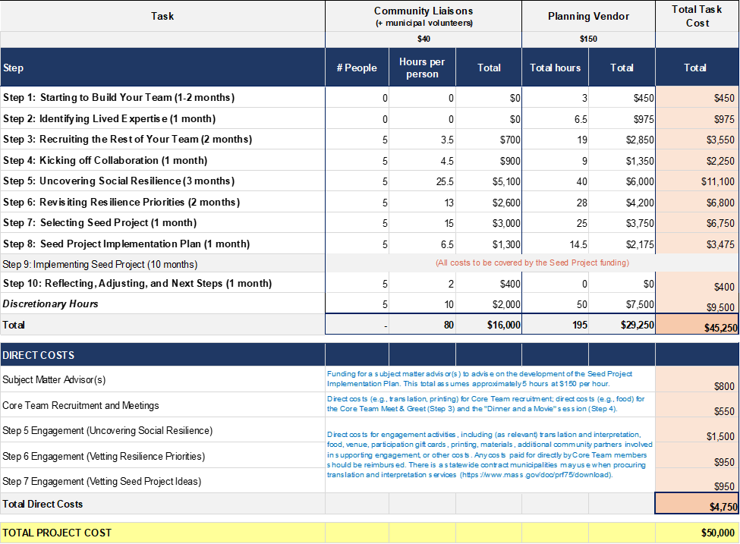

1. Environmental Justice (EJ) Populations are defined in the [2021 EJ Policy](https://www.mass.gov/doc/environmental-justice-policy6242021-update/download) and can be viewed in the [MA EJ viewer](https://mass-eoeea.maps.arcgis.com/apps/webappviewer/index.html?id=1d6f63e7762a48e5930de84ed4849212).
2. Other priority populations are people or communities in addition to mapped EJ populations who may be disproportionately impacted by climate change due to life circumstances that systematically increase their exposure to climate hazards or make it harder to respond. In addition to factors that contribute to EJ status (i.e., income, race, and language), other factors like physical ability, access to transportation, health status, and age shape whether someone or their community will be disproportionately affected by climate change.