INDOOR AIR QUALITY ASSESSMENT

Pleasant Street School
1060 Pleasant Street
Athol, Massachusetts

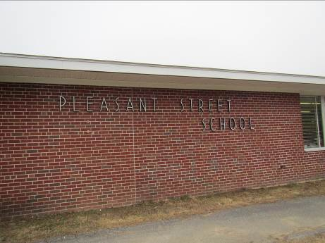

Prepared by:
Massachusetts Department of Public Health
Bureau of Environmental Health
Indoor Air Quality Program
March 2016

BACKGROUND
Building: | Pleasant Street School
Address: | 1060 Pleasant St, Athol, MA 01331
Assessment Requested by: | Athol Health Department
Reason for Request: | General IAQ and specific health concerns
Date of Assessment: | January 29, 2016
Massachusetts Department of Public Health/Bureau of Environmental Health (MDPH/BEH) Staff Conducting Assessment: | Michael Feeney, Director and Ruth Alfasso Environmental Engineer/Inspector, Indoor Air Quality (IAQ) Program
Date of Building Construction: | 1960s
Building Description: | One-story brick/concrete block building with sloped roof
Building Population: | 240 students pre K through 4 and 90 staff
Windows: | Openable

METHODS
Please refer to the IAQ Manual and appendices for methods, sampling procedures, and interpretation of results (MDPH, 2015).

RESULTS and DISCUSSION
The following is a summary of indoor air testing results (Table 1).
- Carbon dioxide levels were above the MDPH recommended level of 800 parts per million (ppm) in all areas surveyed, indicating inadequate air exchange in the building.
- Temperature was within the MDPH recommended range of 70°F to 78°F in all areas tested.
- Relative humidity was below the MDPH recommended range of 40 to 60% in all areas tested.
- Carbon monoxide levels were non-detectable in all areas tested. Trace levels of 0.7 ppm were detected outside.
- Particulate matter (PM2.5) concentrations measured were above the National Ambient Air Quality (NAAQS) limit of 35 μg/m³ in three of the areas tested, ranging from 8-54 μg/m³. Note that outdoor levels of PM2.5 were measured at 40 which was also above the NAAQS limits. The elevated particulate matter levels in some classrooms are reflective of outdoor conditions, and may also result from classroom activity and ineffective filtration.

Ventilation
The HVAC system consists of unit ventilators (univents) located in classrooms along the outside wall of the building (Picture 1). Although most of these were functioning at the time of the visit, many were obstructed by items on top or in front of the units, which can restrict airflow (Picture 2). The outside of most of the fresh air vents was also obstructed with a plastic material (Picture 3) that was likely placed on them to save energy at some point in the past. Another univent fresh air intake has louvers arranged in such a way that debris can accumulate in them (Picture 4) restricting airflow and potentially contributing particulates and odors to the classrooms.
The specific univent design in this building includes two filters, one that can be fairly readily accessed at the bottom of the unit, and one that is located between the bulk of the unit and the fresh air intake. A typical unit was opened and examined and no filter at the back of the unit was in place. This means that any particulates drawn into the fresh air intake are not filtered out and removed before entering the airstream.
Exhaust of stale air from classrooms is provided by vents typically located near the door which are tied to vents on the roof. In most classrooms these vents were obstructed by furniture and items (Picture 5). A few that were accessible were not functioning. Lack of exhaust ventilation can allow pollutants and odors to build up in occupied spaces. Exhaust vents were also located in toilet rooms both inside classrooms and off of hallways. Those examined also had a lack of draw from the exhaust vents.
The Learning Center is a former stockroom/closet that has been turned into an occupied area. This room has an exhaust vent that may not have been drawing air and no source of supply air. It is possible that the original door on this room, when it functioned for storage, had a vent in it such that air could be drawn in from the hallway and then exhausted via the vent, providing airflow (Picture 6). However, a solid door is now in place and to avoid noise, this door is typically kept closed (Picture 7). This door should be undercut by approximately two inches to allow for airflow into the room with the door closed.

Microbial/Moisture Concerns
In order for building materials to support mold growth, a source of water exposure is necessary.
- Water-damaged ceiling tiles were observed in classrooms, particularly but not solely above window areas where roof dams had been reported in this and previous winters (Pictures 8 and 9; Table 1). Although none of the tiles appeared to be mold-colonized, the number of stained tiles indicate that the roof, flashing, and drainage systems are not functioning well.
- Missing/damaged caulking was observed between sink countertop and sinks in some classrooms. This can cause water damage to the cabinet and may lead to mold colonization. Porous items were also observed stored under sinks, which is a moist environment and can lead to water damage and mold colonization.
- Window and wall-mounted air conditioners were found in many classrooms (Picture 1; Table 1). These appliances were not always sealed well against the window or wall, which can allow moisture into the building. In one location, fabric material was observed around an air conditioner, presumably to block drafts or leaks. Porous materials used in this manner can become mold-colonized.
- Water dispensers were observed in carpeted areas (Picture 10). Spills/leaks from this equipment can moisten carpeting and lead to odors/mold colonization.
- A number of refrigerators of various sizes are located in the school. Improperly maintained refrigerators can be a source of mold, odors and spills.
- Plants were observed in classrooms (Picture 11). If not maintained properly or overwatered, plants can be a source of pollen, mold and odors.
- Aquariums were observed in a few classrooms (Picture 12). These can be a source of water spills and odors if not maintained properly.

Volatile Organic Compounds (VOCs)
Exposure to low levels of total VOCs (TVOCs) may produce eye, nose, throat, and/or respiratory irritation in some sensitive individuals. To determine if VOCs were present, BEH/IAQ staff examined rooms for products containing VOCs. BEH/IAQ staff noted air fresheners, hand sanitizers, cleaners, and dry erase materials in use within the building (Table 1). All of these products have the potential to be irritants to the eyes, nose, throat, and respiratory system of sensitive individuals.

Other Conditions
Other conditions that can affect IAQ were observed during the assessment. In a few classrooms, tennis balls were found sliced open and placed around chair legs to reduce noise (Picture 13). Tennis balls are made of a number of materials that are a source of respiratory irritants. Constant wearing of tennis balls can produce fibers and off-gas VOCs. Tennis balls are made with a natural rubber latex bladder, which becomes abraded when used as a chair leg pad. Use of tennis balls in this manner may introduce latex dust into the school environment. Some individuals are highly allergic to latex (e.g. spina bifida patients) (SBAA, 2001). It is recommended that the use of materials containing latex be limited to reduce the potential for symptoms in sensitive individuals (NIOSH, 1997). Latex-free glides should be used for this purpose. Some areas of the school already had glides.
Food and food preparation equipment was found in many areas of the school (Table 1). Unsealed food and food debris can be attractive to pests. Debris left on food preparation equipment can also smoke or cause odors when the equipment is used.
Some areas of the school are carpeted and most classrooms have area rugs. Carpeting should be cleaned annually or semi-annually in soiled high traffic areas as per the recommendations of the Institute of Inspection, Cleaning and Restoration Certification (IICRC, 2012). Worn area rugs should be discarded if they cannot be effectively cleaned.
Floors and other flat surfaces in many classrooms had dirt and debris on them. Aerosolization of this material can lead to irritation. Note that many flat surfaces had accumulations of items, such as books, papers, art supplies and other materials (Pictures 13 and 14). This can make cleaning more difficult.
Window and wall-mounted air conditioners were observed in classrooms (Picture 1; Table 1). These appliances have filters that need to be cleaned regularly to prevent the build-up of dust and debris.
The door to the mechanical room, which contains the boilers as well as maintenance equipment and supplies, is located near occupied areas. This door had a hole next to the door knob (Picture 15) that could allow pollutants from the mechanical room to penetrate into other areas. This hole should be sealed.

CONCLUSIONS and RECOMMENDATIONS
Because the programs currently contained in this building are scheduled to be moved to a new building being constructed nearby at the beginning of the 2016/2017 school year, this building’s operation as the Pleasant Street Elementary School is limited to the next four months. However the building is likely to be repurposed at some point afterwards for use by the Town. Therefore, these recommendations are split into two parts: the first is short-term recommendations that can be done now to improve IAQ in the school immediately, while the second is long-term recommendations that can be referenced when the building is undergoing renovations prior to its reuse.

Short-term Recommendations
- Operate all ventilation systems in the building during occupied periods. Supplement fresh air with openable windows when possible. Be sure to close windows tightly at the end of the day.
- Remove the plastic over the fresh air vents as shown in Picture 3 to allow adequate fresh air exchange.
- Change the filters in the univents and clean the interior of each unit with a vacuum cleaner.
- Investigate the functioning of the exhaust vents for the building and repair if possible.
- Remove all blockages from univents and, most importantly, exhaust vents to allow for proper functioning.
- Undercut the door to the Learning Center (Picture 7) by approximately two inches to allow for airflow from the hallway.
- For buildings in New England, periods of low relative humidity during the winter are often unavoidable. Therefore, scrupulous cleaning practices should be adopted to minimize common indoor air contaminants whose irritant effects can be enhanced when the relative humidity is low. To control for dusts, a high efficiency particulate arrestance (HEPA) filter equipped vacuum cleaner in conjunction with wet wiping of all surfaces is recommended. Avoid the use of feather dusters. Drinking water during the day can help ease some symptoms associated with a dry environment (throat and sinus irritation).
- Investigate the areas of roof/window leaks leading to stained ceiling tiles and repair. Replace stained tiles. Check above ceiling for microbial growth and clean with an antimicrobial solution as needed.
- Repair sink backsplashes using sealant. Remove porous materials from under sinks.
- Remove porous materials from around window/wall air conditioners and seal with an appropriate non-porous material.
- Consider placing a waterproof mat under water dispensing equipment or removing carpeting in these areas.
- Ensure that all refrigerators are cleaned regularly to avoid odors and microbial growth.
- Properly maintain plants or remove them.
- Properly maintain aquariums.
- Reduce the use of products containing volatile organic compounds including hand sanitizer, dry erase materials and cleaners. Ensure that only school-issued products are used to avoid product interactions.
- Replace tennis balls with latex-free glides.
- Ensure that food is properly stored and clean all food preparation equipment (microwaves, toasters, coffee makers, etc.) to prevent odors and pests. Consider reducing the number of location where food is stored and prepared.
- Clean carpeting annually or semi-annually in soiled high traffic areas as per the recommendations of the Institute of Inspection, Cleaning and Restoration Certification (IICRC, 2012). Discard any area rugs too worn or soiled to be cleaned.
- Clean flat surfaces regularly; consider removing or better organizing materials to make areas easier to clean, including in the Learning Center.
- In preparation for moving to the new school, all items should be sorted and purged to remove items that are water-damaged or dusty and any other items that are no longer needed. This will assist in maintaining good IAQ in the new space.
- Refer to resource manual and other related indoor air quality documents located on the MDPH’s website for further building-wide evaluations and advice on maintaining public buildings. These documents are available at http://mass.gov/dph/iaq.

Long-term recommendations
- Repair the roof to reduce/eliminate leaks. Investigate/repair drainage and insulation to reduce the potential for ice dams. Replace all ceiling tiles once this work is completed.
- Univents are beyond their service life and will become increasingly difficult to maintain. Consider replacing univents with modern units or with a centralized HVAC system. Ensure that every area to be occupied has a source of fresh air and exhaust. Consider how space is to be used (e.g., occupancy load and type of activities) when planning any new or replacement system such that sufficient ventilation is provided in areas with high occupancy, and direct exhaust out of the building is provided for areas such as kitchens, restrooms and copy rooms to remove the pollutants created in those areas.
- Repair or replace all exhaust motors if the existing system is to be used.
- If the univents are replaced with similar units, consider having fresh air vent grills with the slats facing horizontally to better shed water and debris installed in place of the current ones.

REFERENCES
IICRC. 2012. Institute of Inspection, Cleaning and Restoration Certification. Carpet Cleaning: FAQ. Retrieved from http://www.iicrc.org/consumers/care/carpet-cleaning/#faq.
Massachusetts Department of Public Health (MDPH). 2015. Indoor Air Quality Manual: Chapters I-III. Available at: http://www.mass.gov/eohhs/gov/departments/dph/programs/environmental-health/exposure-topics/iaq/iaq-manual/.
NIOSH. 1997. NIOSH Alert Preventing Allergic Reactions to Natural Rubber latex in the Workplace. National Institute for Occupational Safety and Health, Atlanta, GA.
SBAA. 2001. Latex In the Home And Community Updated Spring 2001. Spina Bifida Association of America, Washington, DC.
US EPA. 2000. Tools for Schools. Office of Air and Radiation, Office of Radiation and Indoor Air, Indoor Environments Division (6609J). EPA 402-K-95-001, Second Edition. http://www.epa.gov/iaq/schools/tools4s2.html.

Picture 1
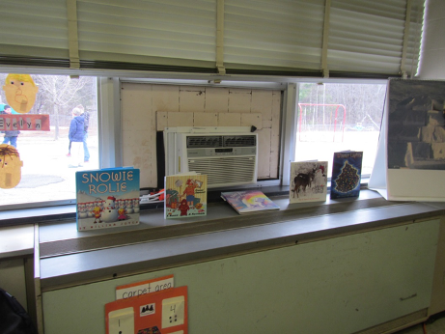
Unit ventilator (univent) and window air conditioner
Picture 2
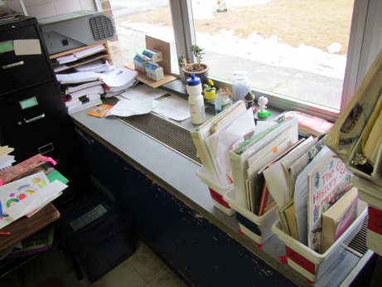
Univent with items on top
Picture 3
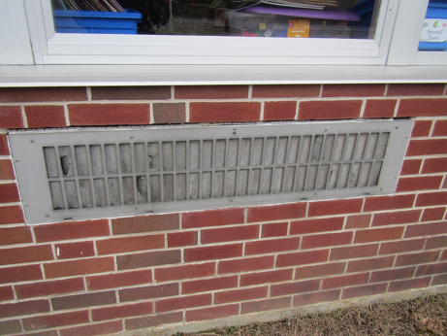
Fresh air intake on outside of building with plastic covering
Picture 4
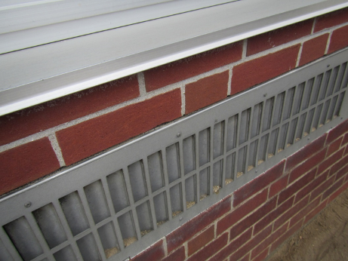
Debris in univent intake louvers
Picture 5
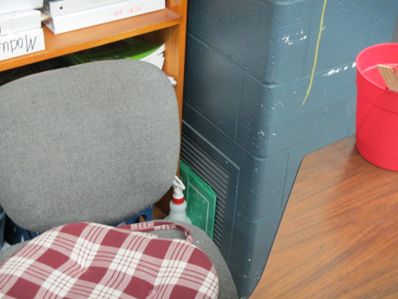
Exhaust vent (arrow) obstructed by furniture and other items
Picture 6
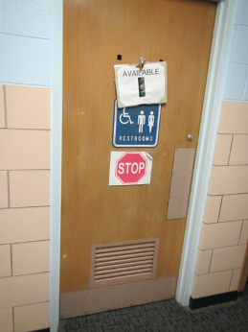
Restroom door with vent, similar to the door that used to be on the Learning Center
Picture 7
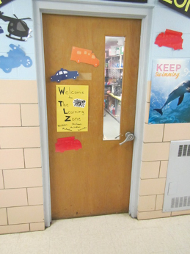
Current Learning Center door with no vent
Picture 8
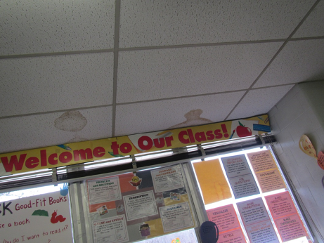
Water-damaged ceiling tiles
Picture 9
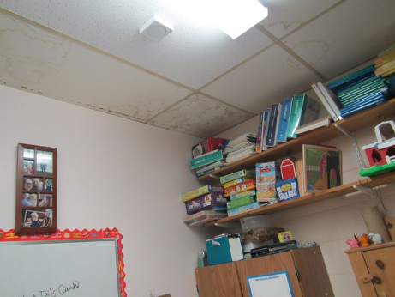
Water-damaged ceiling tiles
Picture 10
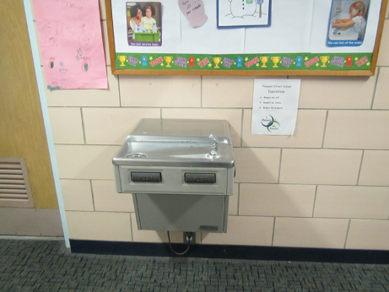
Water cooler over carpet
Picture 11
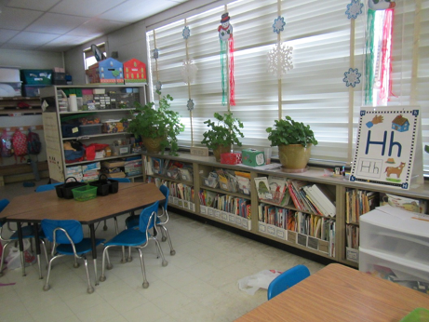
Plants in a classroom
Picture 12
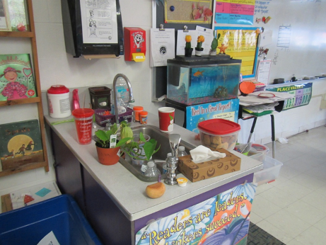
Aquarium in a classroom
Picture 13
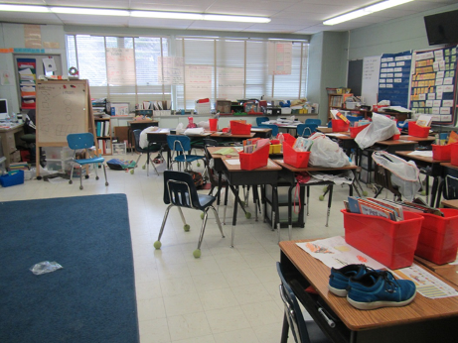
Tennis balls used as glides, also note items on desks and other flat surfaces
Picture 14
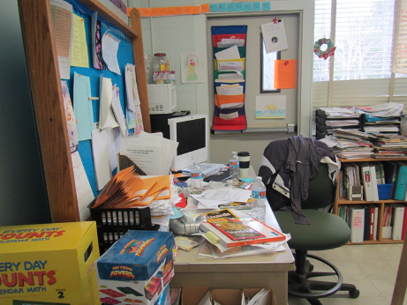
Accumulated items in a classroom
Picture 15
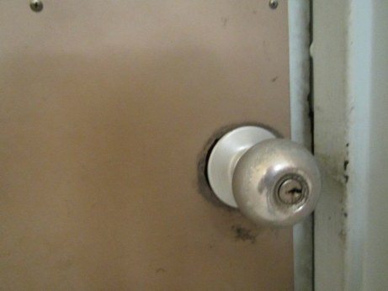
Hole around doorknob for mechanical room

Location | Carbon  Dioxide  (ppm) | Carbon Monoxide  (ppm) | Temp  (°F) | Relative  Humidity  (%) | PM2.5  (µg/m³) | Occupants  in Room | Windows  Openable | Ventilation |  |  | Remarks
 |  |  |  |  |  |  |  | Supply | Exhaust
Background | 422 | 0.7 | 50 | 27 | 40
Learning center | 1255 | ND | 74 | 23 | 21 | 1 | N | N |  | Y | DEM, area rug, microwave, PF, HS
Nurse’s office | 1278 | ND | 74 | 23 | 29 | 2 | N | Y |  | Y
Former library, now kindergarten | 1488 | ND | 74 | 24 | 14 | 1 | Y | Y |  | Y | All carpeted, WD CT, DEM
Office inside old library | 1780 | ND | 74 | 26 | 8 | 1 | N | N |  |  | Carpet, DEM, HS
Custodian | 1005 | ND | 74 |  |  | 0 | N | Y
Main office | 1235 | ND | 76 | 21 | 21 | 1 | Y | Y |  |  | PC in hallway
Cafeteria, lunchtime | 1446 | ND | 73 | 31 |  | ~100 | Y | Y |  | Y
Principal’s Office | 1862 | ND | 70 | 32 | 41 | 6 | Y | N |  | N | Carpet
Stage area | 1500 | ND | 75 | 25 | 26 | 4 | N |  |  |  | WD CT, area rug, items
Teacher’s lounge | 1384 | ND | 74 | 22 | 26 | 5 | Y | Y |  | N | WD CT, fridge, vending, microwave, PC, sink
Speech | 1388 | ND | 73 | 22 | 26 | 0 | N | N |  | N | WD CT, DEM, dusty exhaust
Guidance | 1572 | ND | 73 | 28 | 42 | 5 | N | N |  | N | Not a regular office (built out walls), items, water cooler on carpet in hallway
Occupational therapy | 939 | ND | 70 | 27 | 10 | 4 | N | Y |  | N
1 | 1414 | ND | 72 | 25 | 48 | 0 | Y | Y |  |  | WD CT, sink has open backsplash, area rug, plants, HS, CP under sink and porous items, dusty exhausts
2 | 1163 | ND | 72 | 20 | 20 | 5 | Y | Y |  |  | WAC, area rug, fridge and microwave, sink backsplash open
Storage/bathroom area between 2 and 3 |  |  |  |  |  |  |  | N |  | N | CP, items
3 | 1078 | ND | 70 | 23 | 23 | 0 | Y | Y |  |  | Area rug, sink, microwave, WD CT, WAC
4 | 1480 | ND | 70 | 28 | 54 | 6 | Y | Y |  |  | Aqua, DEM, PF, area rug, sink (dripping, and backsplash open)
5 | 1108 | ND | 71 | 24 | 25 | 0 | Y | Y |  |  | TBs, sink, DEM, PF, WD CT, AI, area rug, refrigerator and microwave
6 | 1092 | ND | 72 | 23 | 26 | 0 | Y | Y |  |  | DEM, fridge and microwave, area rug, WD CT, AI
7 | 913 | ND | 72 | 21 | 28 | 1 | Y | Y |  |  | Items on UV, TB, sink, HS, area rug, DEM, Aqua, WD CT, WAC
8 | 901 | ND | 73 | 20 | 34 | 1 | Y | Y |  |  | Area rug, DEM, HS, WAC
9 | 1083 | ND | 72 | 22 | 33 | 0 | Y | T |  |  | WD CT, area rug, DEM, sink, WAC, WD CT
10 | 1620 | ND | 72 | 24 | 26 | 0 | Y | Y |  |  | WAC, area rug, WD CT (many), sink, DEM, PF, fridge and microwave
11 | 1232 | ND | 73 | 24 | 15 | 4 | Y | Y |  |  | UV obstructed
12 | 1826 | ND | 72 | 32 | 26 | 8 | Y | Y |  |  | Area rug, microwave and fridge, WD and ajar CT, sink
Toilet inside room 12 |  |  |  |  |  |  |  |  |  | Weak or off | WD CT
13 | 1148 | ND | 72 | 23 | 23 | 0 | Y | Y |  |  | TB, DEM, area rug, WD CT, AI on UV

