INDOOR AIR QUALITY ASSESSMENT
Plymouth Community Intermediate School
117 Long Pond Road
Plymouth, Massachusetts

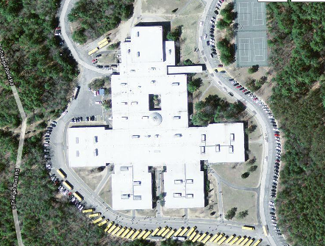

Prepared by:
Massachusetts Department of Public Health
Bureau of Environmental Health
Indoor Air Quality Program
February 2010

Background/Introduction
In response to a request from State Representative Viriato Manuel deMacedo’s office, the Massachusetts Department of Public Health (MDPH), Bureau of Environmental Health (BEH) provided assistance and consultation regarding indoor air quality concerns at the Plymouth Community Intermediate School (PCIS), 117 Long Pond Road, Plymouth, Massachusetts. On December 10, 2009, Cory Holmes and James Tobin, Environmental Analysts/Inspectors in BEH’s Indoor Air Quality (IAQ) Program visited the PCIS to conduct an assessment. The assessment was prompted by parental concerns regarding exacerbation of asthma symptoms and the presence/condition of carpeting in the building and was coordinated through the Plymouth Board of Health and Plymouth School Department.
The PCIS is a one-story brick building that was built in 1973. Classrooms are located in four houses (Ranger, Apollo, Gemini and Mercury) configured around a central area that contains the theater, planetarium, computer and science labs, cafeteria, media center, band/chorus rooms, living center and administrative offices. The gymnasium and locker rooms make up the rest of the building. The majority of areas in the building contain wall to wall carpeting; however, carpeting in several areas has been replaced with non-porous floor tile. It is also important to note that the heating, ventilation and air conditioning (HVAC) system has been completely replaced within the last year. The school contains no openable windows.

Method
Air tests for carbon dioxide, temperature, relative humidity and carbon monoxide were conducted with the TSI, Q-Trak, IAQ Monitor, Model 7565. Air tests for airborne particle matter with a diameter less than 2.5 micrometers were taken with the TSI, DUSTTRAK™ Aerosol Monitor Model 8520. BEH staff also performed a visual inspection of building materials for water damage and/or microbial growth.

Results
The school houses approximately 1250 students in grades 5 through 8 with approximately 120 staff members. Tests were taken during normal school operations and results appear in Table 1.

Discussion

Ventilation
It can be seen from Table 1 that carbon dioxide levels were below 800 parts per million (ppm) in 98 of 99 areas surveyed, indicating adequate air exchange throughout the building at the time of the assessment. As previously mentioned, the HVAC system and its controls were replaced over the last year. The HVAC system consists of a number of computer-controlled rooftop air handling units (AHUs) (Pictures 1 and 2). Fresh air is distributed via ceiling-mounted air diffusers and ducted back to AHUs via ceiling-mounted return vents (Pictures 3 and 4). These units were operating at the time of the assessment.
In several classrooms, return vents are located near hallway doors (Picture 5). When these classroom doors are open, the return vents will tend to draw air from both the hallway and the classroom, reducing the effectiveness of the system to remove common environmental pollutants.
To maximize air exchange, the MDPH recommends that both supply and exhaust ventilation operate continuously during periods of school occupancy. In order to have proper ventilation with a mechanical supply and exhaust system, the systems must be balanced to provide an adequate amount of fresh air to the interior of a room while removing stale air from the room. It is recommended that HVAC systems be re-balanced every five years to ensure adequate air systems function (SMACNA, 1994).
The Massachusetts Building Code requires a minimum ventilation rate of 15 cubic feet per minute (cfm) per occupant of fresh outside air or have openable windows in each room (SBBRS, 1997; BOCA, 1993). The ventilation must be on at all times that the room is occupied. Providing adequate fresh air ventilation with open windows and maintaining the temperature in the comfort range during the cold weather season is impractical. Mechanical ventilation is usually required to provide adequate fresh air ventilation.
Carbon dioxide is not a problem in and of itself. It is used as an indicator of the adequacy of the fresh air ventilation. As carbon dioxide levels rise, it indicates that the ventilating system is malfunctioning or the design occupancy of the room is being exceeded. When this happens, a buildup of common indoor air pollutants can occur, leading to discomfort or health complaints. The Occupational Safety and Health Administration (OSHA) standard for carbon dioxide is 5,000 parts per million parts of air (ppm). Workers may be exposed to this level for 40 hours/week, based on a time-weighted average (OSHA, 1997).
The MDPH uses a guideline of 800 ppm for publicly occupied buildings. A guideline of 600 ppm or less is preferred in schools due to the fact that the majority of occupants are young and considered to be a more sensitive population in the evaluation of environmental health status. Inadequate ventilation and/or elevated temperatures are major causes of complaints such as respiratory, eye, nose and throat irritation, lethargy and headaches. For more information concerning carbon dioxide, consult Appendix A.
Temperature measurements in the school ranged from 68° F to 76° F, which were within or close to the lower end of the MDPH recommended range (Table 1). The MDPH recommends that indoor air temperatures be maintained in a range of 70° F to 78° F in order to provide for the comfort of building occupants. In many cases concerning indoor air quality, fluctuations of temperature in occupied spaces are typically experienced, even in a building with an adequate fresh air supply.
The relative humidity measured in the building ranged from 15 to 28 percent, which was below the MDPH recommended comfort range (Table 1). The MDPH recommends a comfort range of 40 to 60 percent for indoor air relative humidity. Relative humidity levels in the building would be expected to drop during the winter months due to heating. The sensation of dryness and irritation is common in a low relative humidity environment. Low relative humidity is a very common problem during the heating season in the northeast part of the United States.

Microbial/Moisture Concerns
In order for building materials to support mold growth, a source of water exposure is necessary. A few water-damaged ceiling tiles were observed in the building (Table 1). Periodic roof leaks were reported by staff during heavy wind/rain conditions. At the time of the assessment, all areas appeared dry and no mold growth and/or associated odors were observed/detected. Water damaged ceiling tiles can provide a source of mold and should be replaced after a leak is discovered and repaired.
The US Environmental Protection Agency (US EPA) and the American Conference of Governmental Industrial Hygienists (ACGIH) recommend that porous materials be dried with fans and heating within 24 to 48 hours of becoming wet (US EPA, 2001; ACGIH, 1989). If not dried within this time frame, mold growth may occur. Once mold has colonized porous materials, they are difficult to clean and should be removed/discarded.
Plants were noted in several areas (Table 1). Plants should be properly maintained and equipped with drip pans. Plants should be located away from ventilation sources to prevent aerosolization of dirt, pollen or mold. Plants should also not be placed on porous materials, since water damage to porous materials may lead to microbial growth.

Other IAQ Evaluations
Indoor air quality can be negatively influenced by the presence of respiratory irritants, such as products of combustion. The process of combustion produces a number of pollutants. Common combustion emissions include carbon monoxide, carbon dioxide, water vapor and smoke (fine airborne particle material). Of these materials, exposure to carbon monoxide and particulate matter with a diameter of 2.5 micrometers (μm) or less (PM2.5) can produce immediate, acute health effects upon exposure. To determine whether combustion products were present in the school environment, BEH staff obtained measurements for carbon monoxide and PM2.5.

Carbon Monoxide
Carbon monoxide is a by-product of incomplete combustion of organic matter (e.g., gasoline, wood and tobacco). Exposure to carbon monoxide can produce immediate and acute health affects. Several air quality standards have been established to address carbon monoxide and prevent symptoms from exposure to these substances. The MDPH established a corrective action level concerning carbon monoxide in ice skating rinks that use fossil-fueled ice resurfacing equipment. If an operator of an indoor ice rink measures a carbon monoxide level over 30 ppm, taken 20 minutes after resurfacing within a rink, that operator must take actions to reduce carbon monoxide levels (MDPH, 1997).
The American Society of Heating Refrigeration and Air-Conditioning Engineers (ASHRAE) has adopted the National Ambient Air Quality Standards (NAAQS) as one set of criteria for assessing indoor air quality and monitoring of fresh air introduced by HVAC systems (ASHRAE, 1989). The NAAQS are standards established by the US EPA to protect the public health from six criteria pollutants, including carbon monoxide and particulate matter (US EPA, 2006). As recommended by ASHRAE, pollutant levels of fresh air introduced to a building should not exceed the NAAQS levels (ASHRAE, 1989). The NAAQS were adopted by reference in the Building Officials & Code Administrators (BOCA) National Mechanical Code of 1993 (BOCA, 1993), which is now an HVAC standard included in the Massachusetts State Building Code (SBBRS, 1997). According to the NAAQS, carbon monoxide levels in outdoor air should not exceed 9 ppm in an eight-hour average (US EPA, 2006).
Carbon monoxide should not be present in a typical, indoor environment. If it is present, indoor carbon monoxide levels should be less than or equal to outdoor levels. Outdoor carbon monoxide concentrations ranged from non-detect (ND) to 1.5 ppm at the time of the assessment (Table 1). No measureable levels of carbon monoxide were detected inside the building during the assessment (Table 1).

Particulate Matter (PM2.5)
The US EPA has established NAAQS limits for exposure to particulate matter. Particulate matter is airborne solids that can be irritating to the eyes, nose and throat. The NAAQS originally established exposure limits to particulate matter with a diameter of 10 μm or less (PM10). According to the NAAQS, PM10 levels should not exceed 150 micrograms per cubic meter (μg/m³) in a 24-hour average (US EPA, 2006). These standards were adopted by both ASHRAE and BOCA. Since the issuance of the ASHRAE standard and BOCA Code, US EPA established a more protective standard for fine airborne particles. This more stringent PM2.5 standard requires outdoor air particle levels be maintained below 35 μg/m³ over a 24-hour average (US EPA, 2006). Although both the ASHRAE standard and BOCA Code adopted the PM10 standard for evaluating air quality, MDPH uses the more protective PM2.5 standard for evaluating airborne particulate matter concentrations in the indoor environment.
Outdoor PM2.5 concentrations the day of the assessment were measured at 10 μg/m³. PM2.5 levels measured inside the school ranged from 5 to 12 μg/m³ (Table 1). Both indoor and outdoor PM 2.5 levels were below the NAAQS PM2.5 level of 35 μg/m³. Frequently, indoor air levels of particulates (including PM2.5) can be at higher levels than those measured outdoors. A number of mechanical devices and/or activities that occur in schools can generate particulate during normal operations. Sources of indoor airborne particulates may include but are not limited to: particles generated during the operation of fan belts in the HVAC system; cooking in the cafeteria stoves and microwave ovens; use of photocopiers, fax machines and computer printing devices; operation of an ordinary vacuum cleaner; and, heavy foot traffic indoors.

Volatile Organic Compounds
Indoor air concentrations can be greatly impacted by the use of products containing volatile organic compounds (VOCs). VOCs are carbon-containing substances that have the ability to evaporate at room temperature. Frequently, exposure to low levels of total VOCs (TVOCs) may produce eye, nose, throat and/or respiratory irritation in some sensitive individuals. For example, chemicals evaporating from a paint can stored at room temperature would most likely contain VOCs. In an effort to identify materials that can potentially increase indoor VOC concentrations, BEH staff examined rooms for products containing these respiratory irritants.
Cleaning products were found in several rooms throughout the building. Cleaning products contain chemicals that can be irritating to the eyes, nose and throat of sensitive individuals. These products should be properly labeled and stored in an area that is not accessible to children. Additionally, a Material Safety Data Sheet (MSDS) for each product should be available at a central location in the event of an emergency. Consideration should be given to providing teaching staff with school issued cleaning products and supplies to prevent any potential for adverse chemical interactions between residues left from cleaners used by the school’s facilities staff and those left by cleaners brought in by others.
The majority of classrooms contained dry erase boards and related materials. Materials such as dry erase markers and dry erase board cleaners may contain VOCs, such as methyl isobutyl ketone, n-butyl acetate and butyl-cellusolve (Sanford, 1999), which can be irritating to the eyes, nose and throat.
Plug-in air deodorizers (Picture 6), air fresheners and scented oils were found in several areas (Table 1). Air deodorizers contain chemicals that can be irritating to the eyes, nose and throat of sensitive individuals. Many air deodorizers contain 1,4-dichlorobenzene, a VOC which may cause reductions in lung function (NIH, 2006). Further, air deodorizers do not remove materials causing odors, but rather, mask odors which may be present in the area.

Other Conditions
Other conditions that can affect indoor air quality were observed during the assessment. In several classrooms, items were observed on windowsills, tabletops, counters, bookcases and desks. The large number of items stored in classrooms provides a source for dusts to accumulate. These items (e.g., papers, folders, boxes) make it difficult for custodial staff to clean. Items should be relocated and/or be cleaned periodically to avoid excessive dust build up. In addition, these materials can accumulate on flat surfaces (e.g., desktops, shelving and carpets) in occupied areas and subsequently be re-aerosolized causing further irritation.
A number of return vents and personal fans in classrooms were observed to have accumulated dust/debris. If return vents are not functioning, backdrafting can occur, which can re-aerosolize dust particles. Re-activated personal fans can aerosolize dust accumulated on fan blades/housing. The majority of classrooms contain cloth curtains, which are likely not cleaned on a regular basis. Textiles can be a source of dust and allergens, which can be irritating to the eyes, nose and throat.
Portable air purifiers were in use in several areas. An air purifier has a filter that should be cleaned or changed as per the manufacturer’s instructions to avoid the reaerosolization of dusts and particulates. The “change filter” indicator light for the air purifier in classroom R-7 was on (Picture 7) indicating it was saturated with dust and debris.
Upholstered furniture, pillows/cushions and large stuffed animals were seen in several classrooms (Pictures 8 and 9). Upholstered furniture, pillows and cushions are covered with fabric that comes in contact with human skin. This type of contact can leave oils, perspiration, hair and skin cells. Dust mites feed upon human skin cells and excrete waste products that contain allergens. In addition, if relative humidity levels increase above 60 percent, dust mites tend to proliferate (US EPA, 1992). In order to remove dust mites and other pollutants, frequent vacuuming of upholstered furniture is recommended (Berry, M.A., 1994). It is also recommended that upholstered furniture (if present in schools), be professionally cleaned on an annual basis. If outdoor conditions or indoor activities (e.g., renovations) create an excessively dusty environment, cleaning frequency should be increased (every six months) (IICRC, 2000).
Finally, as stated, the majority of floor surfaces in the school are covered by wall to wall carpeting. In several areas, the carpeting is reportedly to be original to the building (over 30 years old). Carpeting was observed stained and/or damaged in a number of areas; in some cases the carpet had been repaired with duct tape (Pictures 10 and 11). The Institute of Inspection, Cleaning and Restoration Certification (IICRC), recommends that carpeting be cleaned annually (or semi-annually in soiled high traffic areas) (IICRC, 2005). PCIS officials reported that carpets are cleaned on an annual basis and that hallways are cleaned several times a year, usually during vacations. Since the average lifespan of a carpet in a school environment is approximately eleven years, consideration should be given to planning for the installation of new flooring (Bishop, 2002).

Asthma Prevalence
In 2003, the MDPH began school based surveillance of pediatric asthma. A review of the most recent surveillance data demonstrates that the pediatric asthma prevalence rate for the PCIS is statistically significantly lower than the statewide pediatric asthma prevalence rate (i.e. 9.07% vs 10.85%; MDPH, 2010).

Conclusions/Recommendations
In view of the findings at the time of the assessment, the following recommendations are made to improve indoor air quality in the building:
- Continue to operate all ventilation systems (e.g., AHUs) throughout the building continuously during occupied periods.
- Close classroom doors to maximize air exchange.
- Consider adopting a balancing schedule of every 5 years for all mechanical ventilation systems, as recommended by ventilation industrial standards (SMACNA, 1994).
- Change filters for air-handling equipment (e.g., AHUs and air purifiers) as per the manufacturer’s instructions or more frequently if needed.
- For buildings in New England, periods of low relative humidity during the winter are often unavoidable. Therefore, scrupulous cleaning practices should be adopted to minimize common indoor air contaminants whose irritant effects can be enhanced when the relative humidity is low. To control for dusts, a high efficiency particulate arrestance (HEPA) filter equipped vacuum cleaner in conjunction with wet wiping of all surfaces is recommended. Avoid the use of feather dusters. Drinking water during the day can help ease some symptoms associated with a dry environment (throat and sinus irritations).
- Continue to monitor areas of the building for roof leaks, make repairs and change ceiling tiles as necessary.
- Store cleaning products properly and out of reach of students. Ensure spray bottles are properly labeled. All cleaning products used at the facility should be approved by the school department with MSDS’ available at a central location.
- Relocate or consider reducing the amount of materials stored in classrooms to allow for more thorough cleaning of classrooms. Clean items regularly with a wet cloth or sponge to prevent excessive dust build-up.
- Clean personal fans, air diffusers and return vents periodically of accumulated dust.
- Refrain from using air fresheners and deodorizers to prevent exposure to VOCs.
- Clean upholstered furniture, cloth curtains, stuffed animals, pillows and curtains on a regular schedule. If not possible/practical, consider removing from classrooms.
- Continue to clean carpeting annually or semi-annually in soiled high traffic areas as per the recommendations of the Institute of Inspection, Cleaning and Restoration Certification (IICRC). Copies of the IICRC fact sheet can be downloaded at: http://www.cleancareseminars.com/carpet_cleaning_faq4.htm (IICRC, 2005)
- Consider a long-term plan to replace all carpeting in the building as funds become available. Consider replacing carpeting with a non-porous surface such as vinyl tile.
- Consider adopting the US EPA (2000) document, “Tools for Schools”, as an instrument for maintaining a good indoor air quality environment in the building. This document is available at: http://www.epa.gov/iaq/schools/index.html.
- Refer to resource manual and other related indoor air quality documents located on the MDPH’s website for further building-wide evaluations and advice on maintaining public buildings. These documents are available at: http://mass.gov/dph/iaq.

References
ACGIH. 1989. Guidelines for the Assessment of Bioaerosols in the Indoor Environment. American Conference of Governmental Industrial Hygienists, Cincinnati, OH.
ASHRAE. 1989. Ventilation for Acceptable Indoor Air Quality. American Society of Heating, Refrigeration and Air Conditioning Engineers. ANSI/ASHRAE 62-1989
Berry, M.A. 1994. Protecting the Built Environment: Cleaning for Health, Michael A. Berry, Chapel Hill, NC.
Bishop, J. & Institute of Inspection, Cleaning and Restoration Certification. 2002. A Life Cycle Cost Analysis for Floor Coverings in School Facilities.
BOCA. 1993. The BOCA National Mechanical Code/1993. 8th ed. Building Officials and Code Administrators International, Inc., Country Club Hill, IL.
IICRC. 2000. IICRC S001 Reference Guideline for Professional On-Location Cleaning of Textile Floor Covering Materials Institute of Inspection, Cleaning and Restoration Certification. Institute of Inspection Cleaning and Restoration, Vancouver, WA.
IICRC. 2005. Carpet Cleaning FAQ 4 Institute of Inspection, Cleaning and Restoration Certification. Institute of Inspection Cleaning and Restoration, Vancouver, WA.
MDPH. 1997. Requirements to Maintain Air Quality in Indoor Skating Rinks (State Sanitary Code, Chapter XI). 105 CMR 675.000. Massachusetts Department of Public Health, Boston, MA.
MDPH, 2010. Pediatric Asthma Surveillance in Massachusetts 2007-2008 (Draft Report). Data available Spring, 2010: http://matracking.ehs.state.ma.us/#
NIH. 2006. Chemical in Many Air Fresheners May Reduce Lung Function. NIH News. National Institute of Health. July 27, 2006. http://www.nih.gov/news/pr/jul2006/niehs-27.htm
OSHA. 1997. Limits for Air Contaminants. Occupational Safety and Health Administration. Code of Federal Regulations. 29 C.F.R 1910.1000 Table Z-1-A.
Sanford. 1999. Material Safety Data Sheet (MSDS No: 198-17). Expo® Dry Erase Markers Bullet, Chisel, and Ultra Fine Tip. Sanford Corporation. Bellwood, IL.
SBBRS. 1997. Mechanical Ventilation. State Board of Building Regulations and Standards. Code of Massachusetts Regulations. 780 CMR 1209.0
SMACNA. 1994. HVAC Systems Commissioning Manual. 1st ed. Sheet Metal and Air Conditioning Contractors’ National Association, Inc., Chantilly, VA.
US EPA. 1992. Indoor Biological Pollutants. US Environmental Protection Agency, Environmental Criteria and Assessment Office, Office of Health and Environmental Assessment, research Triangle Park, NC. EPA 600/8-91/202 January 1992.
US EPA. 2000. Tools for Schools. Office of Air and Radiation, Office of Radiation and Indoor Air, Indoor Environments Division (6609J). EPA 402-K-95-001, Second Edition. http://www.epa.gov/iaq/schools/tools4s2.html
US EPA. 2001. “Mold Remediation in Schools and Commercial Buildings”. Office of Air and Radiation, Indoor Environments Division, Washington, DC. EPA 402-K-01-001. March 2001. Available at: http://www.epa.gov/iaq/molds/mold_remediation.html
US EPA. 2006. National Ambient Air Quality Standards (NAAQS). US Environmental Protection Agency, Office of Air Quality Planning and Standards, Washington, DC. http://www.epa.gov/air/criteria.html.
Picture 1

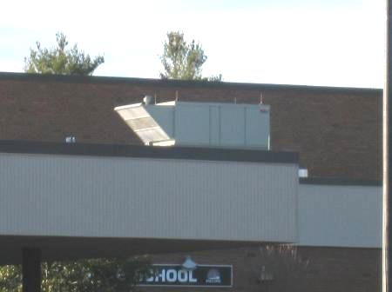

Rooftop Air Handling Unit

Picture 2

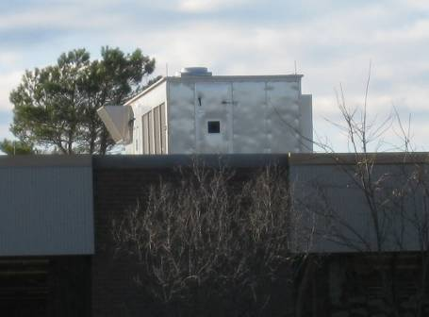

Rooftop Air Handling Unit

Picture 3

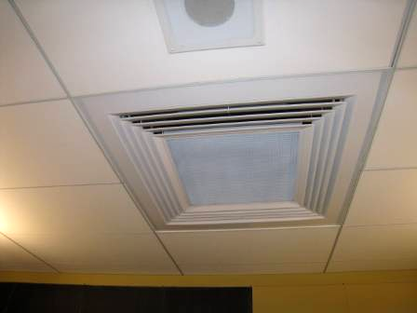

Ceiling-Mounted Air Diffuser

Picture 4

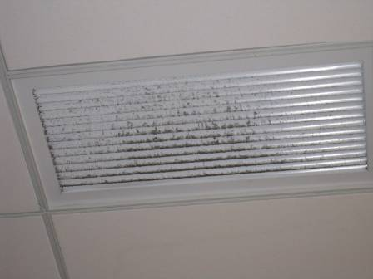

Ceiling-Mounted Return Vent, Note Dust/Debris Accumulation

Picture 5

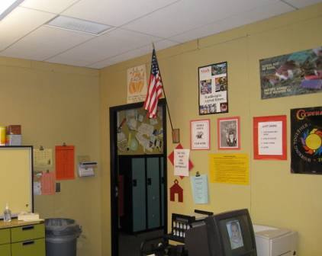

Proximity of Ceiling-Mounted Return Vent to Open Classroom Door

Picture 6

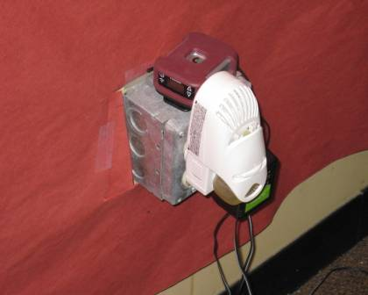

Plug-in Air Deodorizer

Picture 7

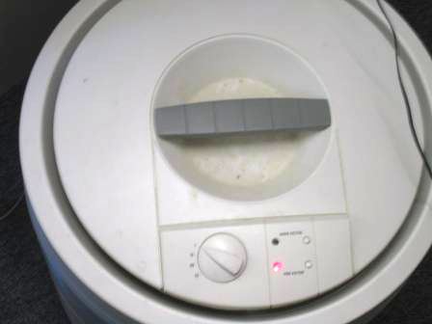

“Change Filter” Indicator Light on for Air Purifier

Picture 8

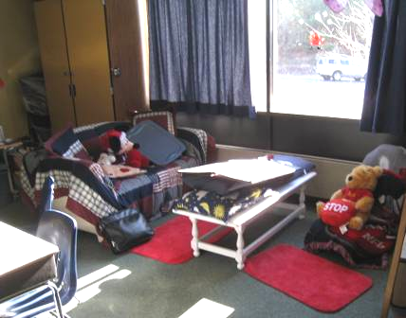

Upholstered Furniture, Pillows, Stuffed Animals and Curtains in Classroom

Picture 9

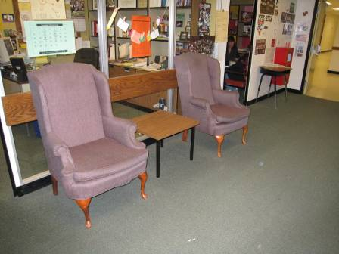

Upholstered Furniture in Hallway

Picture 10

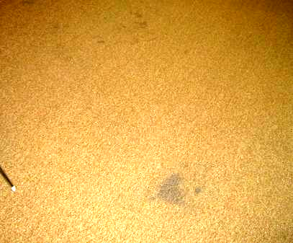

Stained Carpeting

Picture 11

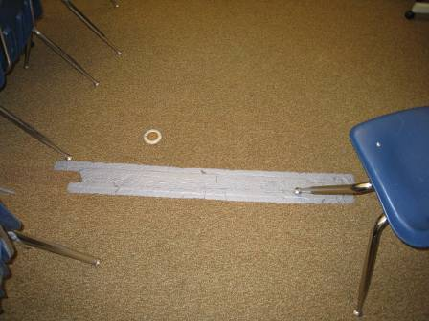

Classroom Carpet Repaired With Duct Tape
Location/ Room | Occupants  in Room | Temp  (°F) | Relative  Humidity  (%) | Carbon  Dioxide  (ppm) | Carbon Monoxide  (ppm) | PM2.5  (µg/m³) | Windows  Openable | Ventilation |  | Remarks
 |  |  |  |  |  |  |  | Supply | Exhaust | Remarks
background |  | 48 | 33 | 337 | ND – 1.5 | 10 |  |  |  | Clear skies, cool, winds WSW 13-20 mph, gusts up to 29 mph
Ranger House
1 | 22 | 71 | 27 | 798 | ND | 9 | N | Y | Y | DO, PF
2 | 19 | 72 | 27 | 726 | ND | 9 | N | Y | Y
3 | 21 | 71 | 25 | 733 | ND | 9 | N | Y | Y | AP
4 | 17 | 70 | 25 | 675 | ND | 9 | N | Y | Y
5 | 23 | 71 | 26 | 740 | ND | 8 | N | Y | Y | DO
6 | 28 | 71 | 28 | 765 | ND | 9 | N | Y | Y | DO
7 | 10 | 70 | 24 | 633 | ND | 8 | N | Y | Y | AP-filter light “on”, DO
8 | 12 | 70 | 23 | 613 | ND | 6 | N | Y | Y | Accumulated items, carpet stains
9 | 27 | 70 | 24 | 862 | ND | 8 | N | Y | Y
10 | 20 | 70 | 23 | 736 | ND | 6 | N | Y | Y | CPs, plants, carpet taped
11 | 21 | 70 | 23 | 702 | ND | 6 | N | Y | Y | DEM
12 | 0 | 70 | 19 | 374 | ND | 5 | N | Y | Y | Carpet stain, DEM
13 | 17 | 72 | 21 | 595 | ND | 5 | N | Y | Y | DO, DEM, plants
14 | 20 | 71 | 23 | 679 | ND | 9 | N | Y | Y | DEM, plants
15 | 15 | 73 | 21 | 567 | ND | 5 | N | Y | Y | 2 DO, DEM
16 | 0 | 72 | 20 | 434 | ND | 8 | N | Y | Y | PC, DO
17 | 10 | 70 | 24 | 558 | ND | 8 | N | Y | Y | AP, plant
19 | 8 | 70 | 22 | 514 | ND | 5 | N | Y | Y | DEM
21 | 10 | 71 | 23 | 723 | ND | 7 | N | Y | Y | DEM – in use and odors
22 | 10 | 71 | 25 | 725 | ND | 6 | N | Y | Y | DEM, accumulated items
IMC
7 | 0 | 69 | 21 | 433 | ND | 8 | N | Y | Y | Occupants at lunch, carpet stained/discolored
9 | 0 | 69 | 21 | 396 | ND | 8 | N | Y | Y | Occupants at lunch, AP, dusty vents
11 Computer Lab | 0 | 70 | 20 | 382 | ND | 8 | N | Y | Y
CL 4 | 0 | 72 | 21 | 474 | ND | 8 | N | Y | Y | DO, 1 WD CT
IMC | 12 | 71 | 22 | 488 | ND | 9 | N | Y | Y
CL 3 | 1 | 72 | 22 | 590 | ND | 9 | N | Y | Y | 13 occupants gone 2 mins, DO
CL 2 | 17 | 73 | 22 | 590 | ND | 10 | N | Y | Y | DO, plant
IMC 5 | 1 | 72 | 21 | 505 | ND | 8 | N | Y | Y | 12 occupants gone 3 mins, aqua
ICM 2 | 0 | 72 | 22 | 619 | ND | 8 | N | Y | Y
IMC 1 | 0 | 71 | 18 | 395 | ND | 7 | N | Y | Y
8 | 1 | 70 | 20 | 385 | ND | 6 | N | Y | Y | DEM, DO
10 | 0 | 71 | 20 | 389 | ND | 5 | N | Y | Y | DEM with particulates in tray, DO
CL 1 | 21 | 72 | 21 | 541 | ND | 6 | N | Y | Y | AP off/not in use, PF
3 | 10 | 71 | 20 | 564 | ND | 6 | N | Y | Y | DEM, accumulated stored items
4 | 4 | 71 | 19 | 404 | ND | 5 | N | Y | Y | DEM, accumulated stored items
Apollo
House
15 | 0 | 71 | 20 | 482 | ND | 10 | N | Y | Y | plants
13 | 20 | 71 | 24 | 703 | ND | 12 | N | Y | Y | DO, AP
14 | 21 | 71 | 22 | 723 | ND | 10 | N | Y | Y | Upholstered furniture, dusty exhaust vents, plants
12 | 22 | 71 | 25 | 800 | ND | 9 | N | Y | Y | Dusty exhaust vent
11 | 24 | 71 | 23 | 790 | ND | 10 | N | Y | Y | Aqua
10 | 1 | 70 | 21 | 490 | ND | 8 | N | Y | Y | Dust/debris along ceiling wall/windows, aqua-standing water/unplugged
9 | 23 | 71 | 25 | 753 | ND | 9 | N | Y | Y
8 | 16 | 71 | 24 | 633 | ND | 8 | N | Y | Y | DO
7 | 0 | 71 | 22 | 425 | ND | 8 | N | Y | Y | Curtains, upholstered furniture, stuffed animals, DO
16 | 6 | 71 | 19 | 507 | ND | 8 | N | Y | Y | DEM
1 | 19 | 70 | 22 | 704 | ND | 6 | N | Y | Y | Plants, DEM, PF, DO, space around sink
2 | 16 | 69 | 23 | 683 | ND | 6 | N | Y | Y | DEM, DO, PF
3 | 21 | 68 | 21 | 632 | ND | 5 | N | Y | Y
4 | 14 | 69 | 24 | 705 | ND | 6 | N | Y | Y | DEM
5 | 1 | 70 | 21 | 478 | ND | 6 | N | Y | Y
6 | 25 | 70 | 23 | 688 | ND | 6 | N | Y | Y | Chalk dust in tray
7 | 0 | 70 | 21 | 357 | ND | 5 | N | Y | Y | Upholstered furniture, DEM, accumulated stored items
Gemini House
Hallway |  |  |  |  |  |  |  |  |  | Spaces under exterior doors
1 | 18 | 71 | 23 | 639 | ND | 8 | N | Y | Y
2 | 20 | 71 | 24 | 659 | ND | 9 | N | Y | Y
3 | 17 | 70 | 21 | 555 | ND | 8 | N | Y | Y
4 | 13 | 70 | 23 | 585 | ND | 8 | N | Y | Y
5 | 22 | 71 | 26 | 698 | ND | 9 | N | Y | Y | DO
6 | 29 | 72 | 28 | 795 | ND | 9 | N | Y | Y | DO, accumulated items
7 | 18 | 71 | 25 | 629 | ND | 9 | N | Y | Y
8 | 22 | 71 | 26 | 775 | ND | 10 | N | Y | Y
9 | 24 | 70 | 24 | 679 | ND | 6 | N | Y | Y | PF, microwave
10 | 23 | 71 | 25 | 672 | ND | 9 | N | Y | Y | CPs, soil in pots, DO
11 | 10 | 71 | 21 | 525 | ND | 7 | N | Y | Y | DEM
12 | 17 | 70 | 22 | 639 | ND | 6 | N | Y | Y | CPs, DEM
13 | 0 | 70 | 20 | 408 | ND | 6 | N | Y | Y | DEM
14 | 0 | 70 | 21 | 404 | ND | 5 | N | Y | Y | AD, DEM, plants, MT, space around sink
15 | 14 | 71 | 22 | 648 | ND | 5 | N | Y | Y | DEM
16 | 4 | 69 | 21 | 443 | ND | 8 | N | Y | Y | Accumulated items, PF, carpet damaged/duct tape
Mercury House
1 | 21 | 71 | 25 | 719 | ND | 10 | N | Y | Y | DO
2 | 2 | 70 | 23 | 415 | ND | 8 | N | Y | Y
3 | 17 | 70 | 21 | 529 | ND | 9 | N | Y | Y | DO, upholstered furniture
4 | 5 | 69 | 19 | 433 | ND | 8 | N | Y | Y
5 | 26 | 68 | 23 | 625 | ND | 8 | N | Y | Y
6 | 20 | 69 | 27 | 753 | ND | 11 | N | Y | Y
7 | 0 | 69 | 22 | 401 | ND | 8 | N | Y | Y | DO, air deodorizer-spray
8 | 19 | 70 | 27 | 712 | ND | 9 | N | Y | Y | DO, exhaust near open door
9 | 26 | 72 | 22 | 622 | ND | 7 | N | Y | Y | DEM, DO
10 | 24 | 72 | 22 | 643 | ND | 7 | N | Y | Y | CPs, DEM
11 | 23 | 72 | 22 | 675 | ND | 7 | N | Y | Y | CPs, DEM
12 | 15 | 72 | 20 | 508 | ND | 6 | N | Y | Y | CPs, DEM, 2 DO
13 | 16 | 72 | 22 | 567 | ND | 5 | N | Y | Y | DEM
14 | 20 | 72 | 23 | 554 | ND | 7 | N | Y | Y | Plants, DEM
15 | 0 | 71 | 21 | 489 | ND | 6 | N | Y | Y | 2 DO, CPs, DEM
16 | 14 | 70 | 21 | 560 | ND | 10 | N | Y | Y | DO
19 | 7 | 72 | 23 | 650 | ND | 8 | N | Y | Y
20 | 2 | 73 | 21 | 524 | ND | 7 | N | Y | Y | DEM
Cafeteria | ~300 | 71 | 22 | 543 | ND | 10 | N | Y | Y
E 03 | 15 | 76 | 17 | 577 | ND | 7 | N | Y | Y | PF, DO
E 07 | 5 | 72 | 17 | 400 | ND | 7 | N | Y | Y | Bean bag chairs (some cloth), DO
E 06 | 4 | 71 | 17 | 400 | ND | 7 | N | Y | Y
Little Theatre | 0 | 70 | 21 | 537 | ND | 7 | N | Y | Y
Band Room | 1 | 70 | 22 | 651 | ND | 8 | N | Y | Y | ~300 occupants gone 15 mins (lockdown drill)
Chorus | 23 | 70 | 21 | 585 | ND | 9 | N | Y | Y | 1 CT
Gym | 40+ | 71 | 24 | 542 | ND | 9 | N | Y | Y
Teacher planning | 0 | 75 | 15 | 418 | ND | 5 | N | Y | Y | PC, 2 DO, DEM, microwave
Drafting | 0 | 74 | 15 | 408 | ND | 5 | N | Y | Y | CPs, DEM, 2 DO
E 05 | 1 | 72 | 15 | 351 | ND | 5 | N | Y | Y | Plants, DO, space exterior door
Band practice 2 | 0 | 71 | 21 | 605 | ND | 7 | N | Y | Y | DO
Band office | 1 | 71 | 19 | 493 | ND | 6 | N | Y | Y | PC

