Background

INDOOR AIR QUALITY
WATER DAMAGE ASSESSMENT

Plymouth County District Attorney’s Office
32 Belmont Street and 231 Main Street
Brockton, MA

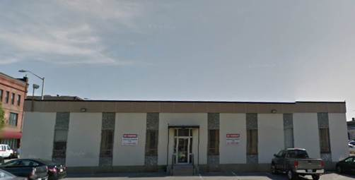

Prepared by:
Massachusetts Department of Public Health
Bureau of Environmental Health
Indoor Air Quality Program
November 2015

Building: | Plymouth County District Attorney’s (DA’s) Office
Address: | 32 Belmont Street and 231 Main Street, Brockton, MA
Assessment Requested by: | Virginia Platt, Division of Capital Maintenance and Management
Date of Assessment: | November 6, 2015
Bureau of Environmental Health/Indoor Air Quality (BEH/IAQ) Program Staff Conducting Assessment: | Sharon Lee, Environmental Analyst
Date of Building Construction: | 32 Belmont Street: 1965  231 Main Street: 1890
Reason for Request: | Water infiltration and mold concerns
Building Description: The DA’s office occupies the entire footprint of the single-story 32 Belmont Street (main) building and a portion of the 231 Main Street (satellite) building. The spaces contain offices, open workstations, conference rooms, and kitchen areas. Windows are openable in the main building. This assessment focuses on the two basement areas of the buildings, where files and other artifacts are stored.

Methods
BEH/IAQ staff performed a visual inspection of building materials for water damage and/or microbial growth. Indoor temperature and relative humidity measurements were taken.

Results/Discussion

Temperature and Relative Humidity
Temperature and relative humidity measurements were 74˚F and 47% in the main building and 74˚F and 63% in the satellite building. While temperature is mainly a comfort concern, elevated temperature in conjunction with relative humidity in excess of 70 percent for extended periods of time can provide an environment for mold and fungal growth (ASHRAE, 1989).

Microbial/Moisture Concerns
As mentioned, the visit was prompted by reports of water-damaged materials observed in the basements at each location (Picture 1), which are unfinished spaces consisting of concrete floors and cement walls. It was reported by DA’s office staff that the main building experiences chronic leakage as a result of runoff from the building’s parking lot. Measures have been taken to reduce runoff impacts to the basement; however, leaks are still experienced periodically. Staff regularly examine basement conditions in the main building after rain events.
Staff reported that a pipe leak likely resulted in the damage observed to files stored in the basement of the satellite building (Picture 2). The timeframe of the pipe leak was unknown; a number of files were found damaged by staff retrieving items from the storage area.
The US EPA and the American Conference of Governmental Industrial Hygienists (ACGIH) recommend that porous materials be dried with fans and heating within 24 to 48 hours of becoming wet (US EPA, 2001; ACGIH, 1989). If porous materials are not dried within this period, mold growth may occur. Once mold has colonized porous materials, they are difficult to clean and should be removed and discarded.
Water-damaged materials that cannot be discarded should be carefully examined in a well-ventilated area to determine whether it is salvageable. In instances where a substitute can be made for an original file, measures should be taken to scan or copy the item to reduce any potential for re-aerosolizing mold spores during future use.
The DA’s office is reportedly planning to relocate during 2016. In preparation for the relocation, measures should be taken to examine all materials stored in the basements for water damage. Examination of materials should be conducted in a well-ventilated area. When possible, operate an air purifier equipped with a high efficiency particulate arrestance (HEPA) filter in the breathing zone to remove respiratory irritants. Gloves should be worn to prevent any irritation from ink dusts and other fine materials that can settle on paper files. A coordinated approach to managing water-damaged materials may include wiping surfaces with a slightly damp cloth, microfiber rag, or vacuuming materials with a vacuum equipped with a HEPA filter to reduce aerosolizing particulate matter, which can irritate the eyes, nose, and respiratory tract.

Conclusions/Recommendations
In view of the findings at the time of the visit, the following recommendations are made:
- Water-damaged/mold-colonized building materials should be removed in a manner consistent with recommendations found in “Mold Remediation in Schools and Commercial Buildings” published by the US Environmental Protection Agency (US EPA, 2001). Wallboard that has become mold-colonized should be removed to a level of a foot above where it was moistened.
- Consider systematically performing building walk-throughs following any severe weather to check for and remediate any leaks promptly.
- Examine all files in the basement.
  - Examine files in a well-ventilated area, particularly where air can be removed from the space. Take appropriate precautions when examining files, including usage of gloves to prevent skin irritation and operating a HEPA-filtered air purifier in the breathing zone to remove respiratory irritants.
  - Discard any materials that no longer need to be maintained. Consider scanning or duplicating files in instances where a copy can be saved in place of an original.
  - Clean the surfaces of boxes and other materials with a slightly wet rag, microfiber cloth, or HEPA-filtered vacuum.
- Take measures to protect materials from further damage.
  - Move files away from areas with known water leaks.
  - Cover files with plastic sheeting, particularly files near water pipes, to provide a barrier to moisture.
  - Remove items that are placed directly on the floor, which can result in damage since water may wick into porous products. Elevate items to prevent damage.
  - Move shelving away from walls. Ensure a gap between the wall and the shelves/stored materials to prevent damage to items from condensation that may form on walls.
  - Operate a dehumidifier to reduce indoor relative humidity in the area.
- Refer to resource manuals and other related indoor air quality documents for further building-wide evaluations and advice on maintaining public buildings. Copies of these materials are located on the MDPH’s website: http://mass.gov/dph/iaq.

References
ACGIH. 1989. Guidelines for the Assessment of Bioaerosols in the Indoor Environment. American Conference of Governmental Industrial Hygienists, Cincinnati, OH.
US EPA. 2001. Mold Remediation in Schools and Commercial Buildings. US Environmental Protection Agency, Office of Air and Radiation, Indoor Environments Division, Washington, D.C. EPA 402-K-01-001. http://www.epa.gov/mold/mold_remediation.html
Picture 1
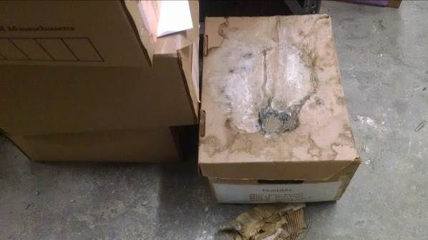
Water-damaged box and files

Picture 2
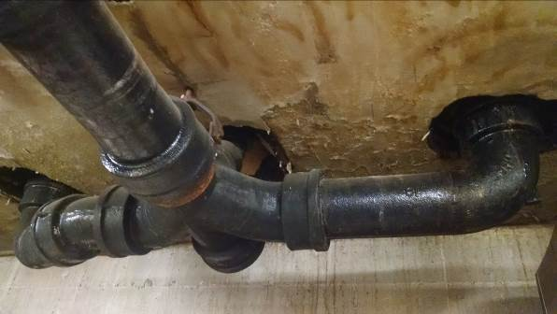
Pipe leak resulting in water damage in the satellite basement

