Background/Introduction

INDOOR AIR QUALITY ASSESSMENT

Plymouth River Elementary School
200 High Street
Hingham, Massachusetts



Prepared by:
Massachusetts Department of Public Health
Center for Environmental Health
Emergency Response/Indoor Air Quality Program
April 2007

At the request of David Killory, Business Manager, Hingham Public Schools (HPS), the Massachusetts Department of Public Health (MDPH), Center of Environmental Health (CEH) provided assistance and consultation regarding indoor air quality concerns at the Plymouth River Elementary School (PRES), 200 High Street, Hingham Massachusetts. The assessment was prompted by reports of dry/irritant symptoms of the eye, specifically in classrooms 1, 18 and the library/media center. On January 16, 2007, Cory Holmes, an Environmental Analyst in CEH’s Emergency Response/Indoor Air Quality (ER/IAQ) Program, conducted an assessment at the PRES. During the assessment, Mr. Holmes was accompanied by Paul E. Field, Supervisor of Buildings and Grounds, HPS.
The PRES is a single-story, L-shaped, brick building that was constructed in 1969. No major renovations have reportedly taken place in the building. The school contains general classrooms, a kitchen, cafeteria, gymnasium, library/media center, music room, computer lab, specialty rooms, boiler room and office space. Windows are openable throughout the building.

Methods
Air tests for carbon dioxide, carbon monoxide, temperature and relative humidity were taken with the TSI, Q-TRAK™ IAQ Monitor, Model 8551. Air tests for airborne particle matter with a diameter less than 2.5 micrometers were taken with the TSI, DUSTTRAK™ Aerosol Monitor Model 8520. Screening for total volatile organic compounds (TVOCs) was conducted using an HNu, Model 102 Snap-on Photo Ionization Detector (PID). In addition to taking various IAQ tests, CEH staff performed a visual inspection of building materials for water damage and/or microbial growth.
Results
The building houses approximately 675 students in kindergarten through fifth grade and has approximately 85 staff members. Tests were taken under normal operating conditions and results appear in Table 1.

Discussion
Ventilation
It can be seen from Table 1 that carbon dioxide levels were elevated above 800 parts per million (ppm) in 16 of 28 areas surveyed, indicating less than optimal air exchange in these areas. It is important to note that the assessment was conducted on a day with below-freezing temperatures (30ºF) and wind gusts up to 25 mph, creating wind chills close to 0ºF. During periods of temperature extremes, fresh air drawn into the mechanical ventilation system is often reduced to prevent freezing/damage of system components. Limiting fresh air intake either by mechanical and/or natural means (e.g., closing of windows) can contribute to an increase in carbon dioxide levels. It is important to note that several areas were unoccupied or sparsely occupied at the time that carbon dioxide measurements were taken. Low classroom occupancy can greatly reduce carbon dioxide levels. Carbon dioxide levels would be expected to be higher with full occupancy.
Fresh air in classrooms is supplied by unit ventilator (univent) systems (Picture 1). Univents are designed to draw air from outdoors through a fresh air intake located on the exterior walls of the building (Picture 2) and return air through an air intake located at the base of each unit (Figure 1). Fresh and return air are mixed, filtered, heated and provided to classrooms through a fresh air diffuser located in the top of the unit. Obstructions to airflow such as items on univents and/or furniture in front of univent returns were observed in several classrooms (Picture 3). In order for univents to provide fresh air as designed, intakes must remain free of obstructions. Importantly, these units must remain activated and allowed to operate during periods of occupancy. Please note that ventilation equipment was likely installed when the building was constructed, therefore it is approximately 40 years old. Equipment of this age is difficult to maintain, since compatible replacement parts are often unavailable.
The mechanical exhaust system in classrooms consists of grated vents located on the front of coat closets ducted to rooftop motors (Picture 4). Unlike the univents which are original equipment, Mr. Field reported that the exhaust motors were replaced approximately 6 to 7 years ago.
Mechanical ventilation and air-conditioning for office areas, the library/media center and computer lab is provided by rooftop air handling units (AHUs). Ceiling-mounted air diffusers ducted to the AHUs distribute fresh tempered air to the spaces (Picture 5). Return air is drawn into ceiling-mounted vents and ducted back to the AHUs (Picture 6).
To maximize air exchange, the MDPH recommends that both supply and exhaust ventilation operate continuously during periods of school occupancy. In order to have proper ventilation with a univent and exhaust system, the systems must be balanced to provide an adequate amount of fresh air to the interior of a room while removing stale air from the room. It is recommended that HVAC systems be re-balanced every five years to ensure adequate air systems function (SMACNA, 1994). The date of the last balancing of these systems was not available at the time of the assessment.
The Massachusetts Building Code requires a minimum ventilation rate of 15 cubic feet per minute (cfm) per occupant of fresh outside air or have openable windows in each room (BOCA, 1993; SBBRS, 1997). The ventilation must be on at all times that the room is occupied. Providing adequate fresh air ventilation with open windows and maintaining the temperature in the comfort range during the cold weather season is impractical. Mechanical ventilation is usually required to provide adequate fresh air ventilation.
Carbon dioxide is not a problem in and of itself. It is used as an indicator of the adequacy of the fresh air ventilation. As carbon dioxide levels rise, it indicates that the ventilating system is malfunctioning or the design occupancy of the room is being exceeded. When this happens a buildup of common indoor air pollutants can occur, leading to discomfort or health complaints. The Occupational Safety and Health Administration (OSHA) standard for carbon dioxide is 5,000 parts per million parts of air (ppm). Workers may be exposed to this level for 40 hours/week based on a time-weighted average (OSHA, 1997).
The MDPH uses a guideline of 800 ppm for publicly occupied buildings. A guideline of 600 ppm or less is preferred in schools due to the fact that the majority of occupants are young and considered to be a more sensitive population in the evaluation of environmental health status. Inadequate ventilation and/or elevated temperatures are major causes of complaints such as respiratory, eye, nose and throat irritation, lethargy and headaches (Appendix A).
Temperature readings the day of the assessment ranged from 63 º F to 75 º F, with most of the measurements within or close to the lower end of the MDPH comfort guidelines. The lowest temperature (63 º F), was measured in room 1, in which the occupant reported that they prefer the room cool. The MDPH recommends that indoor air temperatures be maintained in a range between 70 º F to 78 º F in order to provide for the comfort of building occupants. In many cases concerning indoor air quality, fluctuations of temperature in occupied spaces are typically experienced, even in a building with an adequate fresh air supply.
The relative humidity ranged from 22 to 31 percent, which was below the MDPH recommended comfort range in all areas surveyed on the day of the assessment. The MDPH recommends a comfort range of 40 to 60 percent for indoor air relative humidity. Relative humidity would be expected to drop below comfort levels during the heating season. The sensation of dryness and irritation is common in a low relative humidity environment. Low relative humidity is a very common problem during the heating season in the northeast part of the United States. Following the IAQ assessment, Mr. Killory discussed the possibility of using portable humidifiers in certain areas to help alleviate occupant symptoms (i.e., dry/irritated eyes). Although the CEH does not advocate the use of such equipment (e.g., humidifiers), it is recommended that when such equipment is used that it be emptied/cleaned regularly, as per the manufacturer’s instructions (or more frequently if needed) to prevent microbial and/or bacterial growth.

Microbial/Moisture Concerns
Water-stained ceiling tiles were observed in a few areas (Table 1), which can indicate leaks from the roof or plumbing system. Mr. Field reported that stained tiles in planning room B are from an active leak that the school department is currently investigating. Water-damaged ceiling tiles can provide a source for mold growth and should be replaced after a water leak is discovered and repaired.
The American Conference of Governmental Industrial Hygienists (ACGIH) and the US Environmental Protection Agency (US EPA) recommends that porous materials be dried with fans and heating within 24 to 48 hours of becoming wet (ACGIH, 1989; US EPA, 2001). If porous materials are not dried within this time frame, mold growth may occur. Water-damaged porous materials cannot be adequately cleaned to remove mold growth. The application of a mildewcide to moldy porous materials is not recommended.
Plants were located in a number of areas (Table 1). Plants, soil and drip pans can serve as sources of mold growth, thus should be properly maintained. Over-watering of plants should be avoided and drip pans should be inspected periodically for mold growth. Plants should also be located away from univents to prevent aerosolization of dirt, pollen or mold.

Other IAQ Evaluations
Indoor air quality can be negatively influenced by the presence of respiratory irritants, such as products of combustion. The process of combustion produces a number of pollutants. Common combustion emissions include carbon monoxide, carbon dioxide, water vapor and smoke (fine airborne particle material). Of these materials, exposure to carbon monoxide and particulate matter with a diameter of 2.5 micrometers (μm) or less (PM2.5) can produce immediate, acute health effects upon exposure. To determine whether combustion products were present in the school environment, CEH staff obtained measurements for carbon monoxide and PM2.5.
Carbon monoxide is a by-product of incomplete combustion of organic matter (e.g., gasoline, wood and tobacco). Exposure to carbon monoxide can produce immediate and acute health affects. Several air quality standards have been established to address carbon monoxide and prevent symptoms from exposure to these substances. The MDPH established a corrective action level concerning carbon monoxide in ice skating rinks that use fossil-fueled ice resurfacing equipment. If an operator of an indoor ice rink measures a carbon monoxide level over 30 ppm, taken 20 minutes after resurfacing within a rink, that operator must take actions to reduce carbon monoxide levels (MDPH, 1997).
The American Society of Heating Refrigeration and Air-Conditioning Engineers (ASHRAE) has adopted the National Ambient Air Quality Standards (NAAQS) as one set of criteria for assessing indoor air quality and monitoring of fresh air introduced by HVAC systems (ASHRAE, 1989). The NAAQS are standards established by the US EPA to protect the public health from six criteria pollutants, including carbon monoxide and particulate matter (US EPA, 2006). As recommended by ASHRAE, pollutant levels of fresh air introduced to a building should not exceed the NAAQS levels (ASHRAE, 1989). The NAAQS were adopted by reference in the Building Officials & Code Administrators (BOCA) National Mechanical Code of 1993 (BOCA, 1993), which is now an HVAC standard included in the Massachusetts State Building Code (SBBRS, 1997). According to the NAAQS, carbon monoxide levels in outdoor air should not exceed 9 ppm in an eight-hour average (US EPA, 2006).
Carbon monoxide should not be present in a typical, indoor environment. If it is present, indoor carbon monoxide levels should be less than or equal to outdoor levels. On the day of assessment, outdoor carbon monoxide concentrations were non-detect (ND). Carbon monoxide levels measured in the school were also ND (Table 1).
The US EPA has established NAAQS limits for exposure to particulate matter. Particulate matter is airborne solids that can be irritating to the eyes, nose and throat. The NAAQS originally established exposure limits to particulate matter with a diameter of 10 μm or less (PM10). According to the NAAQS, PM10 levels should not exceed 150 microgram per cubic meter (μg/m³) in a 24-hour average (US EPA, 2006). These standards were adopted by both ASHRAE and BOCA. Since the issuance of the ASHRAE standard and BOCA Code, US EPA proposed a more protective standard for fine airborne particles. This more stringent PM2.5 standard requires outdoor air particle levels be maintained below 35 μg/m³ over a 24-hour average (US EPA, 2006). Although both the ASHRAE standard and BOCA Code adopted the PM10 standard for evaluating air quality, MDPH uses the more protective proposed PM2.5 standard for evaluating airborne particulate matter concentrations in the indoor environment.
Particulate matter is composed of airborne solids that can be irritating to the eyes, nose and throat. Outdoor PM2.5 concentrations were measured at 14 μg/m³. PM2.5 levels measured in the school ranged from 8 to 23 μg/m³, which were below the NAAQS of 35 μg/m³ (Table 1). Frequently, indoor air levels of particulates can be at higher levels than those measured outdoors. A number of mechanical devices and/or activities that occur in schools can generate particulates during normal operation. Sources of indoor airborne particulate may include but are not limited to particles generated during the operation of fan belts in the HVAC system, cooking in the cafeteria stoves and microwave ovens; use of photocopiers, fax machines and computer printing devices, operating an ordinary vacuum cleaner and heavy foot traffic indoors.
Indoor air quality can also be negatively influenced by the presence of materials containing volatile organic compounds (VOCs). VOCs are carbon-containing substances that have the ability to evaporate at room temperature. Frequently, exposure to low levels of total VOCs (TVOCs) may produce eye, nose, throat and/or respiratory irritation in some sensitive individuals. For example, chemicals evaporating from a paint can stored at room temperature would most likely contain VOCs. In an effort to determine whether VOCs were present in the building, air monitoring for TVOCs was conducted. An outdoor air sample was taken for comparison. Outdoor TVOC concentrations were ND. Indoor TVOC concentrations were also ND.
Please note, TVOC air measurements are only reflective of the indoor air concentrations present at the time of sampling. Indoor air concentrations can be greatly impacted by the use TVOC containing products (e.g., the concentration of TVOCs within a classroom increases when the product is in use). Dry erase markers were observed in several classrooms. Materials such as dry erase markers and dry erase board cleaners may contain VOCs, (e.g. methyl isobutyl ketone, n-butyl acetate and butyl-cellusolve) (Sanford, 1999). Cleaning products and air deodorizers were found under sinks and on countertops in some classrooms (Picture 7). Like dry erase materials, cleaning products contain VOCs and other chemicals that can be irritating to the eyes, nose and throat of sensitive individuals.
Several other conditions that can potentially affect indoor air quality were also identified. Univents are general equipped with filters that provide filtration to strain particulates from airflow. Univents at the PRES had metal/mesh filters (Picture 8), which provide minimal filtration and are difficult and time consuming to clean. In order to decrease aerosolized particulates, disposable filters with an increased dust spot efficiency should be installed. The dust spot efficiency is the ability of a filter to remove particulates of a certain diameter from air passing through the filter. Filters that have been determined by ASHRAE to meet its standard for a dust spot efficiency of a minimum of 40 percent (Minimum Efficiency Reporting Value equal to 9) would be sufficient to reduce many airborne particulates (Thornburg, 2000; MEHRC, 1997; ASHRAE, 1992). Note that increasing filtration can reduce airflow, a condition known as pressure drop, which can reduce efficiency due to increased resistance. Prior to any increase of filtration, a ventilation engineer should be consulted as to whether the univents can maintain function with more efficient filters.
Several personal fans in classrooms and exhaust/return vents had accumulated dust and debris. If exhaust vents are not functioning (deactivated, broken belts, etc.), backdrafting can occur, which can re-aerosolize dust particles. Dust can also become aerosolized from personal fans when activated.
Finally, of note was the amount of materials stored in some classrooms. Items were observed on windowsills, tabletops, counters, bookcases and desks (Pictures 3 and 9). The large number of items stored in classrooms provides a source for dusts to accumulate. These items, (e.g., papers, folders, boxes) make it difficult for custodial staff to clean. Items should be relocated and/or be cleaned periodically to avoid excessive dust build up.

Conclusions/Recommendations
At the time of the assessment, CEH staff did not detect any measurable levels of TVOCs or elevated levels of particulates (PM 2.5) that could provide sources for eye irritation. However, several issues regarding general building conditions, design and routine maintenance that can affect indoor air quality were observed. The majority of issues listed in the report have been observed in other elementary school environments (clutter, dust control, building maintenance), particularly those built several decades ago. These factors can be associated with a range of IAQ related health and comfort complaints (e.g., eye, nose, and respiratory irritations).
In view of the findings at the time of assessment, the following recommendations are made:
- For buildings in New England, periods of low relative humidity during the winter are often unavoidable. Therefore, scrupulous cleaning practices should be adopted to minimize common indoor air contaminants whose irritant effects can be enhanced when the relative humidity is low. To control for dusts, a high efficiency particulate arrestance (HEPA) filter equipped vacuum cleaner in conjunction with wet wiping of all surfaces is recommended. Avoid the use of feather dusters. Drinking water during the day can help ease some symptoms associated with a dry environment (throat and sinus irritations).
- Relocate or consider reducing the amount of materials stored in classrooms to allow for more thorough cleaning. Clean items regularly with a wet cloth or sponge to prevent excessive dust build-up.
- Clean and disinfect humidifiers as per manufacturer’s instructions (or more frequently as needed) to prevent microbial growth.
- Operate mechanical ventilation systems (e.g., gym, cafeteria, classrooms) continuously to maximize air exchange during periods of school occupancy.
- Remove all blockages from univents and exhaust vents to ensure adequate airflow. Consider reconfiguring the layout of some classrooms to facilitate airflow.
- Use openable windows in conjunction with mechanical ventilation to facilitate air exchange. Care should be taken to ensure windows are properly closed at night and weekends to avoid the freezing of pipes and potential flooding.
- Consider adopting a balancing schedule of every 5 years for mechanical ventilation systems, as recommended by ventilation industrial standards (SMACNA, 1994).
- Ensure leaks are repaired. Remove/replace water damaged ceiling tiles. Examine the areas above and around for mold growth. Disinfect areas of water leaks with an appropriate antimicrobial.
- Move plants away from univents in classrooms. Avoid over-watering and examine drip pans periodically for mold growth. Disinfect with an appropriate antimicrobial where necessary.
- Store cleaning products properly and out of reach of students. Ensure spray bottles are properly labeled. All cleaning products used at the facility should be approved by the school department with MSDS’ available at a central location.
- Consider replacing metal HVAC filters with higher efficiency disposable filters. Note that increased filtration can reduce airflow produced through increased resistance. Prior to any increase of filtration, the univents should be evaluated by a ventilation engineer to determine whether they can maintain function with more efficient filters.
- Change filters for HVAC equipment as per manufacturer’s instructions, or more frequently if needed. Clean and vacuum interior of units prior to operation to avoid the re-aerosolization of accumulated dirt, dust and debris.
- Clean air diffusers, exhaust/return vents and personal fan blades periodically of accumulated dust.
- Consider adopting the US EPA document, “Tools for Schools” to maintain a good indoor air quality environment on the building (US EPA, 2000). This document can be downloaded from the Internet at: http://www.epa.gov/iaq/schools/index.html.
- Refer to resource manuals and other related indoor air quality documents for further building-wide evaluations and advice on maintaining public buildings. These materials are located on the MDPH’s website: http://mass.gov/dph/indoor_air.

References
ACGIH. 1989. Guidelines for the Assessment of Bioaerosols in the Indoor Environment. American Conference of Governmental Industrial Hygienists, Cincinnati, OH.
ASHRAE. 1989. Ventilation for Acceptable Indoor Air Quality. American Society of Heating, Refrigeration and Air Conditioning Engineers. ANSI/ASHRAE 62-1989
ASHRAE. 1992. Gravimetric and Dust-Spot Procedures for Testing Air-Cleaning Devices Used in General Ventilation for Removing Particulate Matter. American Society of Heating, Refrigeration and Air Conditioning Engineers. ANSI/ASHRAE 52.1-1992.
BOCA. 1993. The BOCA National Mechanical Code/1993. 8th ed. Building Officials & Code Administrators International, Inc., Country Club Hills, IL.
MDPH. 1997. Requirements to Maintain Air Quality in Indoor Skating Rinks (State Sanitary Code, Chapter XI). 105 CMR 675.000. Massachusetts Department of Public Health, Boston, MA.
MEHRC. 1997. Indoor Air Quality for HVAC Operators & Contractors Workbook. Mid Atlantic Environmental Hygiene Resource Center, Philadelphia, PA.
OSHA. 1997. Limits for Air Contaminants. Occupational Safety and Health Administration. Code of Federal Regulations. 29 C.F.R 1910.1000 Table Z-1-A.
Sanford. 1999. Material Safety Data Sheet (MSDS No: 198-17). Expo® Dry Erase Markers Bullet, Chisel, and Ultra Fine Tip. Sanford Corporation, Bellwood, IL.
SBBRS. 1997. Mechanical Ventilation. State Board of Building Regulations and Standards. Code of Massachusetts Regulations. 780 CMR 1209.0
SMACNA. 1994. HVAC Systems Commissioning Manual. 1st ed. Sheet Metal and Air Conditioning Contractors’ National Association, Inc., Chantilly, VA.
Thornburg, D. 2000. Filter Selection: a Standard Solution. Engineering Systems 17:6 pp. 74-80.
US EPA. 2000. Tools for Schools. Office of Air and Radiation, Office of Radiation and Indoor Air, Indoor Environments Division (6609J). EPA 402-K-95-001, Second Edition. http://www.epa.gov/iaq/schools/tools4s2.html
US EPA. 2001. “Mold Remediation in Schools and Commercial Buildings”. Office of Air and Radiation, Indoor Environments Division, Washington, DC. EPA 402-K-01-001. March 2001. Available at: http://www.epa.gov/iaq/molds/mold_remediation.html
US EPA. 2006. National Ambient Air Quality Standards (NAAQS). . US Environmental Protection Agency, Office of Air Quality Planning and Standards, Washington, DC. http://www.epa.gov/air/criteria.html.
Picture 1

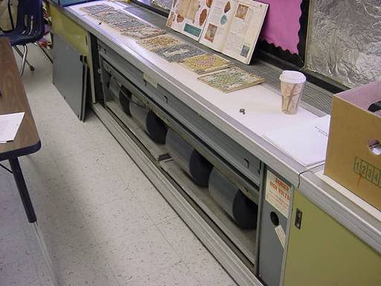

Classroom Univent 1960’s Vintage

Picture 2

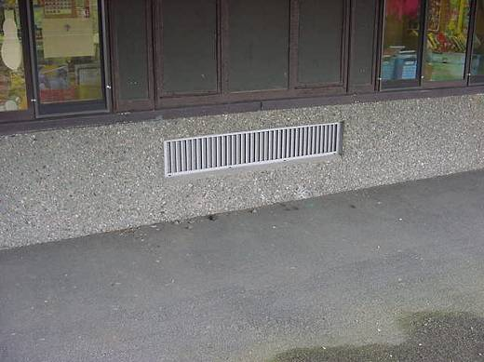

Univent Fresh Air Intake
Picture 3

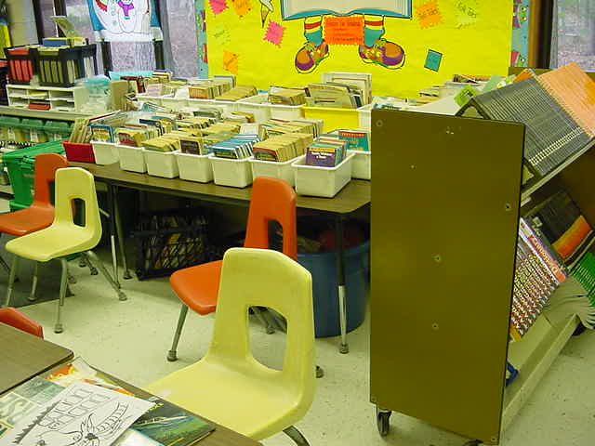

Univent Obstructed by Various Items

Picture 4

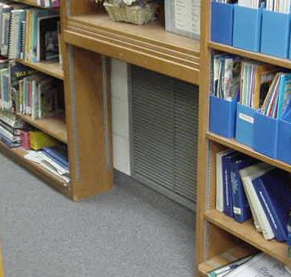

Wall-Mounted Exhaust Vent
Picture 5

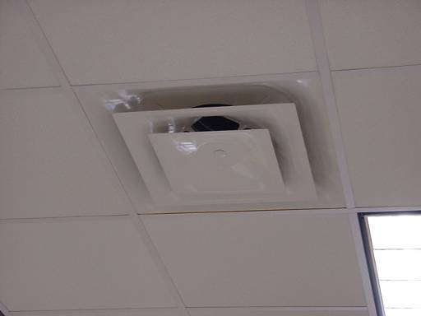

Ceiling-Mounted Air Diffuser

Picture 6

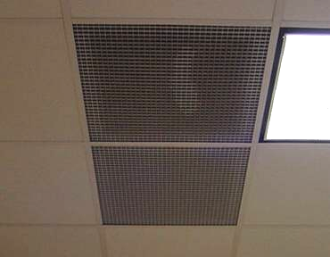

Ceiling-Mounted Return Vents, Note Dust Accumulation,
(Indicated by clear spot disturbed by CEH staff)
Picture 7

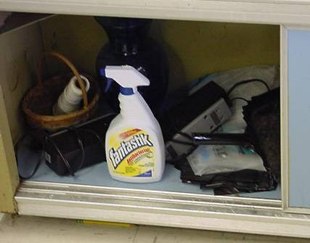

Spray Cleaning Product in Unlocked Cabinet under Sink

Picture 8

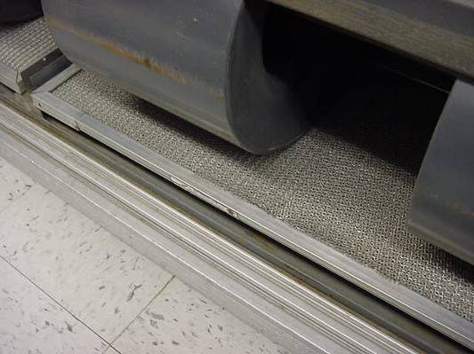

Metal/Mesh Filters Installed in Univents
Picture 9

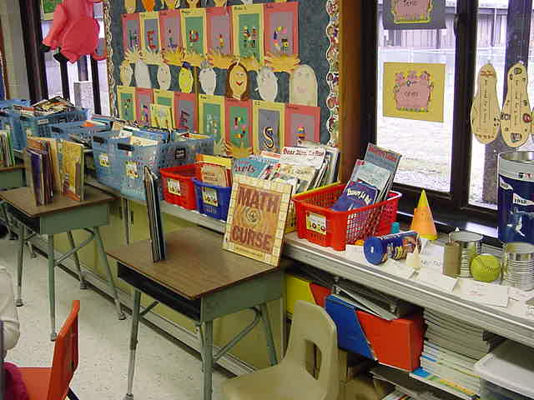

Accumulated Items in Classroom
Location/ Room | Occupants  in Room | Temp  (°F) | Relative  Humidity  (%) | Carbon  Dioxide  (ppm) | Carbon Monoxide  (ppm) | TVOCs  (ppm) | PM2.5  (µg/m3) | Windows  Openable | Ventilation |  | Remarks
 |  |  |  |  |  |  |  |  | Supply | Exhaust | Remarks
background |  | 30 | 38 | 340 | ND | ND | 14 |  |  |  | Cold, cloudy, winds NNW 15-25 mph
1 | 21 | 65 | 31 | 1154 | ND | ND | 12 | Y  # open: 0  # total: 4 | Y  univent | Y  wall | DEM, CP, accumulated items
2 | 0 | 69 | 27 | 699 | ND | ND | 14 | Y  # open: 0  # total: 4 | Y  univent | Y  wall | DO, CP, DEM, PF
Planning Room A | 2 | 71 | 26 | 765 | ND | ND | 19 | N | Y  ceiling | Y  ceiling | DO, table under vents, CP, 2 CT
LMC | 22 | 71 | 22 | 589 | ND | ND | 13 | Y  # open: 0  # total: 4 | Y  univent  ceiling | Y  wall | Dusty exhaust grill, two mech vent systems-airflow may increase dryness
LMC Classroom | 0 | 72 | 22 | 549 | ND | ND | 8 | Y  # open: 0  # total: 4 | Y  univent  ceiling | Y  wall | 20 occupants gone 2 minutes, UV-clutter/plants
18 | 20 | 70 | 26 | 1089 | ND | ND | 15 | Y  # open: 0  # total: 4 | Y  univent | Y  wall | Old books on UV, PF, CP, plants
19 | 0 | 70 | 24 | 701 | ND | ND | 16 | Y  # open: 0  # total: 4 | Y  univent | Y  wall | Occupants at lunch, DEM
Planning Room B | 0 | 72 | 26 | 838 | ND | ND | 22 | N | Y  univent  ceiling | Y  ceiling | 4 CT: Roof leak-reportedly being investigated, DEM
27 | 20 | 69 | 24 | 985 | ND | ND | 20 | Y  # open: 0  # total: 4 | Y  univent | Y  wall | DO, DEM, PF
24 | 24 | 70 | 30 | 1399 | ND | ND | 23 | Y  # open: 0  # total: 4 | Y  univent | Y  wall | CP
28 | 22 | 71 | 24 | 750 | ND | ND | 18 | Y  # open: 0  # total: 4 | Y  univent | Y  wall | UV obstructed by accumulated items, PF
1 | 24 | 63 | 26 | 1323 | ND | ND | 16 | Y  # open: 0  # total: 4 | Y  univent | Y  wall | Occupant prefers room cool
6 | 16 | 68 | 28 | 1126 | ND | ND | 18 | Y  # open: 0  # total: 4 | Y  univent | Y  wall | DEM
3 | 19 | 72 | 28 | 1084 | ND | ND | 12 | Y  # open: 0  # total: 4 | Y  univent | Y  wall | DEM, PF
2 | 23 | 68 | 23 | 674 | ND | ND | 13 | Y  # open: 0  # total: 4 | Y  univent | Y  wall | DEM, PF
17 | 21 | 69 | 24 | 828 | ND | ND | 12 | Y  # open: 0  # total: 4 | Y  univent  off | Y  wall | PF, DO
15 | 0 | 75 | 25 | 696 | ND | ND | 10 | Y  # open: 0  # total: 4 | Y  univent | Y  wall | PF, accumulated items, DEM, DO
14 | 1 | 71 | 22 | 596 | ND | ND | 13 | Y  # open: 0  # total: 4 | Y  univent | Y  wall | 20 occupants gone 30 mins, PF, dehumidifier, CP
4 | 26 | 70 | 25 | 1107 | ND | ND | 23 | Y  # open: 0  # total: 4 | Y  univent | Y  wall | DEM, PF
8 | 2 | 68 | 24 | 990 | ND | ND | 14 | Y  # open: 0  # total: 4 | Y  univent | Y  wall | DO, 20 occupants gone 5 mins, DEM
7 | 24 | 71 | 27 | 1305 | ND | ND | 14 | Y  # open: 0  # total: 4 | Y  univent | Y  wall
22 | 23 | 70 | 27 | 1145 | ND | ND | 15 | Y  # open: 0  # total: 4 | Y  univent | Y  wall | UV obstructed by furniture, DEM, PF, DO
25 | 23 | 68 | 24 | 741 | ND | ND | 17 | Y  # open: 0  # total: 4 | Y  univent | Y  wall | DO, DEM, PF
21 | 0 | 70 | 27 | 842 | ND | ND | 19 | Y  # open: 0  # total: 4 | Y  univent | Y  wall | UV obstructed by furniture, DEM, occupants at lunch
16 | 42 | 72 | 26 | 721 | ND | ND | 12 | Y  # open: 0  # total: 4 | Y  univent | Y  wall | Double occupied-classroom divider open, DEM
11 | 1 | 70 | 22 | 682 | ND | ND | 10 | Y  # open: 0  # total: 4 | Y  univent | Y  wall | 19 occupants gone 15 mins, CP, DEM
9 | 18 | 69 | 25 | 920 | ND | ND | 13 | Y  # open: 0  # total: 6 | Y  univent | Y  wall | DEM, plants
Main Office | 6 | 70 | 27 | 888 | ND | ND | 15 | Y | Y | Y | Photocopier, 1 CT

