INDOOR AIR QUALITY REASSESSMENT

South Elementary School
178 Bourne Road
Plymouth, Massachusetts



Prepared by:
Massachusetts Department of Public Health
Bureau of Environmental Health
Indoor Air Quality Program
June 2011

Background/Introduction
In response to a referral from the Massachusetts Division of Occupational Safety (DOS), the Massachusetts Department of Public Health (MDPH), Bureau of Environmental Health (BEH) provided assistance and consultation regarding indoor air quality concerns at the South Elementary School (SES), located at 178 Bourne Road, Plymouth, MA. The SES building was first evaluated by BEH staff in 2001. A report was issued detailing conditions observed at the time and provided recommendations to improve IAQ (MDPH, 2001). On April 26, 2011, Cory Holmes, Environmental Analyst/Regional Inspector for BEH’s Indoor Air Quality (IAQ) Program conducted a reassessment of the SES in response to the DOS referral. This most recent assessment was prompted by concerns of water-damaged ceiling tiles and possible mold growth in the building.

Actions on Previous Recommendations
As mentioned, BEH staff had previously visited the building and issued a report with recommendations to improve indoor air quality based upon an IAQ assessment in 2001 (MDPH, 2001). A summary of actions taken on previous recommendations is included as Appendix A.

Methods
Air tests for carbon dioxide, carbon monoxide, temperature and relative humidity were taken with the TSI, Q-Trak, IAQ Monitor. Air tests for airborne particle matter with a diameter less than 2.5 micrometers were taken with the TSI, DUSTTRAK™ Aerosol Monitor Model 8520. BEH staff also performed visual inspection of building materials for water damage and/or microbial growth. Moisture content of porous building materials (ceiling tiles and pipe insulation) was measured with a Delmhorst, BD-2000 Model, Moisture Detector equipped with a Delmhorst Standard Probe.

Results
The school houses approximately 735 students in grades pre-K through 4th with approximately 85 staff members. Tests were taken during normal operations, and results appear in Table 1.

Discussion

Ventilation
It can be seen from Table 1 that carbon dioxide levels were below 800 parts per million (ppm) in all but two of thirty-nine areas surveyed, indicating adequate air exchange in most of the building at the time of the assessment. Mechanical ventilation is provided by rooftop air-handling units (AHUs) (Picture 1). Fresh air is drawn into the AHU through a bank of pleated air filters, where it is heated/cooled and delivered to occupied areas via ducted supply diffusers. Return air is drawn into the ceiling plenum and ducted back to rooftop AHUs.
To maximize air exchange, the MDPH recommends that both supply and exhaust ventilation operate continuously during periods of occupancy. In order to have proper ventilation with a mechanical supply and exhaust system, the systems must be balanced to provide an adequate amount of fresh air to the interior of a room while removing stale air from the room. It is recommended that HVAC systems be re-balanced every five years to ensure adequate air systems function (SMACNA, 1994).
The Massachusetts Building Code requires a minimum ventilation rate of 15 cubic feet per minute (cfm) per occupant of fresh outside air or have openable windows in each room (SBBRS, 1997; BOCA, 1993). The ventilation must be on at all times that the room is occupied. Providing adequate fresh air ventilation with open windows and maintaining the temperature in the comfort range during the cold weather season is impractical. Mechanical ventilation is usually required to provide adequate fresh air ventilation.
Carbon dioxide is not a problem in and of itself. It is used as an indicator of the adequacy of the fresh air ventilation. As carbon dioxide levels rise, it indicates that the ventilating system is malfunctioning or the design occupancy of the room is being exceeded. When this happens, a buildup of common indoor air pollutants can occur, leading to discomfort or health complaints. The Occupational Safety and Health Administration (OSHA) standard for carbon dioxide is 5,000 parts per million parts of air (ppm). Workers may be exposed to this level for 40 hours/week, based on a time-weighted average (OSHA, 1997).
The MDPH uses a guideline of 800 ppm for publicly occupied buildings. A guideline of 600 ppm or less is preferred in schools due to the fact that the majority of occupants are young and considered to be a more sensitive population in the evaluation of environmental health status. Inadequate ventilation and/or elevated temperatures are major causes of complaints such as respiratory, eye, nose and throat irritation, lethargy and headaches. For more information concerning carbon dioxide, please see Appendix B.
Temperatures ranged from 69º F to 74 º F during the assessment, which were within or very close to the lower end of the MDPH recommended comfort guidelines. The MDPH recommends that indoor air temperatures be maintained in a range of 70 º F to 78 º F in order to provide for the comfort of building occupants. In many cases concerning indoor air quality, fluctuations of temperature in occupied spaces are typically experienced, even in a building with an adequate fresh air supply.
The relative humidity measured during the assessment ranged from 54 to 59 percent, which was within the MDPH recommended comfort range in all areas surveyed the day of the assessment. The MDPH recommends a comfort range of 40 to 60 percent for indoor air relative humidity. Relative humidity levels in the building would be expected to drop during the winter months due to heating. The sensation of dryness and irritation is common in a low relative humidity environment. Low relative humidity is a common problem during the heating season in the northeast part of the United States.

Microbial/Moisture Concerns
In order for building materials to support mold growth, a source of water exposure is necessary. Identification and elimination of the source of water moistening building materials is necessary to control mold growth. As indicated previously, the assessment was prompted by concerns of the presence of mold related to water-damaged ceiling tiles. Signs of plumbing/roof leaks were observed in several areas throughout the school (Table 1). Water-damaged ceiling tiles can provide a source of moisture/microbial growth and should be replaced after a water leak is discovered and repaired. In most cases the cause of water-damaged ceiling tiles appeared to be leaks from the plumbing system and/or roof drains that have been repaired (Pictures 2 through 4). An active leak was reported in room 7 beneath a roof drain, where ceiling tiles had been removed and buckets were stationed to catch water (Pictures 5 and 6).
To determine if ceiling tiles and pipe insulation had elevated moisture content that would be conducive to mold growth, MDPH/IAQ staff conducted moisture testing of these materials. All materials tested were dry/had low moisture content at the time of the assessment (Table 1), which would indicate that the water damage was from historic plumbing/roof leaks. However, visible mold growth was observed in two areas; on the surface of a ceiling tile in the hallway outside room 3 (Pictures 7 and 8); and on the surface of a ceiling tile and on the wall above the tile in room 25 (Pictures 9 and 10). Also of note were two particular ceiling tiles in the hallway (outside cafeteria and outside rooms 1 & 2) that had a “pink” tinge to them (Pictures 11 and 12). The staining did not appear to be mold growth but resembled a tinted additive to the heating/cooling system that is used as a marker to indicate the source of leaks.
The US Environmental Protection Agency (US EPA) and the American Conference of Governmental Industrial Hygienists (ACGIH) recommend that porous materials (e.g., GW) be dried with fans and heating within 24 to 48 hours of becoming wet (US EPA, 2001; ACGIH, 1989). If not dried within this time frame, mold growth may occur. Once mold has colonized porous materials, they are difficult to clean and should be removed.

Other IAQ Evaluations
Indoor air quality can be negatively influenced by the presence of respiratory irritants, such as products of combustion. The process of combustion produces a number of pollutants. Common combustion emissions include carbon monoxide, carbon dioxide, water vapor and smoke (fine airborne particle material). Of these materials, exposure to carbon monoxide and particulate matter with a diameter of 2.5 micrometers (μm) or less (PM2.5) can produce immediate, acute health effects upon exposure. To determine whether combustion products were present in the indoor environment, BEH staff obtained measurements for carbon monoxide and PM2.5.

Carbon Monoxide
Carbon monoxide is a by-product of incomplete combustion of organic matter (e.g., gasoline, wood and tobacco). Exposure to carbon monoxide can produce immediate and acute health effects. Several air quality standards have been established to address carbon monoxide and prevent symptoms from exposure to these substances. The MDPH established a corrective action level concerning carbon monoxide in ice skating rinks that use fossil-fueled ice resurfacing equipment. If an operator of an indoor ice rink measures a carbon monoxide level over 30 ppm, taken 20 minutes after resurfacing within a rink, that operator must take actions to reduce carbon monoxide levels (MDPH, 1997).
The American Society of Heating Refrigeration and Air-Conditioning Engineers (ASHRAE) has adopted the National Ambient Air Quality Standards (NAAQS) as one set of criteria for assessing indoor air quality and monitoring of fresh air introduced by HVAC systems (ASHRAE, 1989). The NAAQS are standards established by the US EPA to protect the public health from six criteria pollutants, including carbon monoxide and particulate matter (US EPA, 2006). As recommended by ASHRAE, pollutant levels of fresh air introduced to a building should not exceed the NAAQS levels (ASHRAE, 1989). The NAAQS were adopted by reference in the Building Officials & Code Administrators (BOCA) National Mechanical Code of 1993 (BOCA, 1993), which is now an HVAC standard included in the Massachusetts State Building Code (SBBRS, 1997). According to the NAAQS, carbon monoxide levels in outdoor air should not exceed 9 ppm in an eight-hour average (US EPA, 2006).
Carbon monoxide should not be present in a typical, indoor environment. If it is present, indoor carbon monoxide levels should be less than or equal to outdoor levels. On the day of the assessment, outdoor carbon monoxide concentrations were non-detect (ND) (Table 1). No measurable levels of carbon monoxide were detected inside the building (Table 1).

Particulate Matter
The US EPA has established NAAQS limits for exposure to particulate matter. Particulate matter is airborne solids that can be irritating to the eyes, nose and throat. The NAAQS originally established exposure limits to particulate matter with a diameter of 10 μm or less (PM10). According to the NAAQS, PM10 levels should not exceed 150 micrograms per cubic meter (μg/m³) in a 24-hour average (US EPA, 2006). These standards were adopted by both ASHRAE and BOCA. Since the issuance of the ASHRAE standard and BOCA Code, US EPA established a more protective standard for fine airborne particles. This more stringent PM2.5 standard requires outdoor air particle levels be maintained below 35 μg/m³ over a 24-hour average (US EPA, 2006). Although both the ASHRAE standard and BOCA Code adopted the PM10 standard for evaluating air quality, MDPH uses the more protective PM2.5 standard for evaluating airborne particulate matter concentrations in the indoor environment.
Outdoor PM2.5 concentrations were measured at 9 μg/m³ (Table 1). PM2.5 levels measured indoors ranged from 6 to 10 μg/m³ (Table 1), which were below the NAAQS PM2.5 level of 35 μg/m³. Frequently, indoor air levels of particulates (including PM2.5) can be at higher levels than those measured outdoors. A number of activities that occur indoors and/or mechanical devices can generate particulate during normal operations. Sources of indoor airborne particulates may include but are not limited to particles generated during the operation of fan belts in the HVAC system, use of stoves and/or microwave ovens in kitchen areas; use of photocopiers, fax machines and computer printing devices; operation of an ordinary vacuum cleaner and heavy foot traffic indoors.

Other Conditions
Other conditions that can affect indoor air quality were observed during the assessment. In several classrooms, items were observed on the floor, windowsills, tabletops, counters, bookcases and desks (Picture 13). The large number of items stored in classrooms provides a source for dusts to accumulate. These items (e.g., papers, folders, boxes) make it difficult for custodial staff to clean. Items should be relocated and/or be cleaned periodically to avoid excessive dust build up. In addition, these materials can accumulate on flat surfaces (e.g., desktops, shelving and carpets) in occupied areas and subsequently be re-aerosolized causing further irritation.
A number of air diffusers, exhaust/return vents and personal fans were observed with accumulated dust/debris. If exhaust vents are not functioning, backdrafting can occur, which can re-aerosolize accumulated dust particles. Re-activated supply vents and fans can also aerosolize dust accumulated on vents/fan blades.
Finally, the PPS/SES uses a computerized work order program to generate maintenance requests. Due to the issues raised and conditions observed by MDPH/IAQ staff during the assessment (e.g., water-damaged/missing ceiling tiles), it appears that occupants are either unaware of, or are not using, the system in place to report building-related issues for prompt and satisfactory response.

Conclusions/Recommendations
PPS officials, working in conjunction with school administration, maintenance personnel, private contractors and SES staff, have improved indoor environmental conditions in the building by implementing the majority of MDPH’s previous recommendations. At the time of the current MDPH assessment complaints primarily focused on mold concerns due to water-damaged ceiling tiles. In view of the findings at the time of this visit, the following additional recommendations are made to further improve indoor air quality:
- Staff should be instructed on how to use the maintenance reporting procedure and encouraged to use it for prompt remediation of building needs (e.g., active leaks, replacement of ceiling tiles).
- Ensure plumbing leaks and roof drains are repaired.
- Remove/discard any water-damaged/mold-colonized ceiling tiles and pipe insulation (e.g., hallway outside cafeteria and rooms 1 & 2) (Table 1). Any mold-colonized building materials should be sealed in plastic bags for transport. Examine the area above these tiles for mold growth. Disinfect areas of water leaks with a mild detergent or an appropriate antimicrobial, as needed.
- Remove small portion of water-damaged/mold colonized drywall above ceiling tiles shown in Pictures 9 and 10.
- Examine if fresh air supply can be increased/intake adjusted in areas that measured over 800 ppm carbon dioxide (Table 1).
- Use openable windows in conjunction with mechanical ventilation to facilitate air exchange. Care should be taken to ensure windows are properly closed at night and weekends to avoid the freezing of pipes; as well as during periods of elevated relative humidity while the AC system is in operation to avoid condensation/mold issues.
- Relocate or consider reducing the amount of materials stored in classrooms to allow for more thorough cleaning of classrooms. Clean items regularly with a wet cloth or sponge to prevent excessive dust build-up.
- Clean accumulated dust and debris periodically from the surface of air diffusers, exhaust vents and blades of personal and ceiling fans.
- For more information on mold/remediation consult “Mold Remediation in Schools and Commercial Buildings” published by the US Environmental Protection Agency (US EPA, 2001) for more information on mold. This document can be downloaded from the US EPA website at: http://www.epa.gov/iaq/molds/mold_remediation.html.
- Refer to resource manuals and other related indoor air quality documents for further building-wide evaluations and advice on maintaining public buildings. Copies of these materials are located on the MDPH’s website: http://mass.gov/dph/iaq.

References
ACGIH. 1989. Guidelines for the Assessment of Bioaerosols in the Indoor Environment. American Conference of Governmental Industrial Hygienists, Cincinnati, OH.
ASHRAE. 1989. Ventilation for Acceptable Indoor Air Quality. American Society of Heating, Refrigeration and Air Conditioning Engineers. ANSI/ASHRAE 62-1989.
BOCA. 1993. The BOCA National Mechanical Code/1993. 8th ed. Building Officials and Code Administrators International, Inc., Country Club Hill, IL.
MDPH. 1997. Requirements to Maintain Air Quality in Indoor Skating Rinks (State Sanitary Code, Chapter XI). 105 CMR 675.000. Massachusetts Department of Public Health, Boston, MA.
MDPH. 2001. Indoor Air Quality Assessment. South Elementary School, Plymouth, MA. Massachusetts Department of Public Health, Bureau of Environmental Health Assessment, Boston, MA.
OSHA. 1997. Limits for Air Contaminants. Occupational Safety and Health Administration. Code of Federal Regulations. 29 C.F.R 1910.1000 Table Z-1-A.
SBBRS. 1997. Mechanical Ventilation. State Board of Building Regulations and Standards. Code of Massachusetts Regulations. 780 CMR 1209.0
SMACNA. 1994. HVAC Systems Commissioning Manual. 1st ed. Sheet Metal and Air Conditioning Contractors’ National Association, Inc., Chantilly, VA.
US EPA. 2001. “Mold Remediation in Schools and Commercial Buildings”. Office of Air and Radiation, Indoor Environments Division, Washington, DC. EPA 402-K-01-001. March 2001. Available at: http://www.epa.gov/iaq/molds/mold_remediation.html.
US EPA. 2006. National Ambient Air Quality Standards (NAAQS). US Environmental Protection Agency, Office of Air Quality Planning and Standards, Washington, DC. http://www.epa.gov/air/criteria.html.
Picture 1

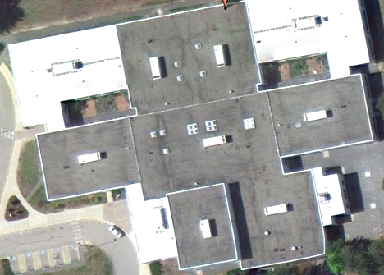

Rooftop Air Handling Units

Picture 2

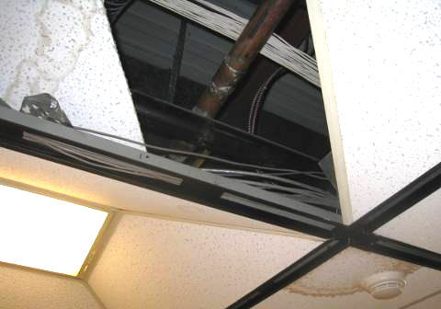

Water-Damaged Ceiling Tiles in Guidance Hallway below Uninsulated Metal Pipes

Picture 3

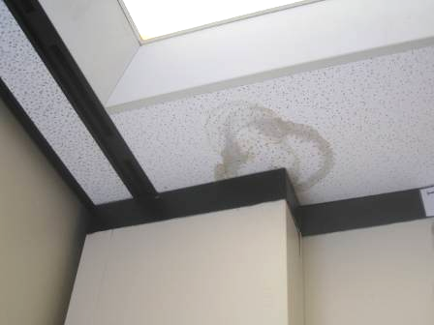

Water-Damaged Ceiling Tile Rear Corner of Room 1 below Roof Drain

Picture 4

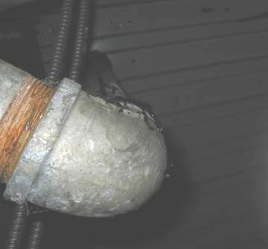

Roof Drain above Water-Damaged Ceiling Tile Rear Corner of Room 1

Picture 5

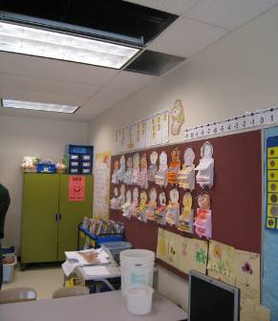

Buckets Stationed under Leaking Roof Drain in Room 7

Picture 6

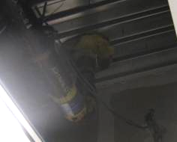

Leaking Roof Drain in Room 7

Picture 7

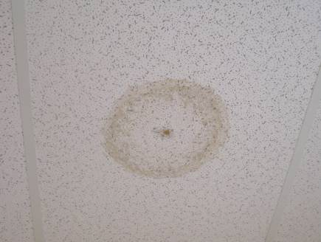

Water-Damaged Ceiling Tile in Hallway outside Room 3, Staining at Center
Indicates Light Mold Growth

Picture 8

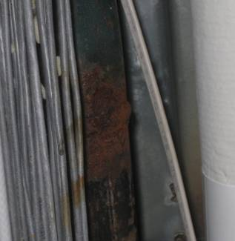

Rusted/Leaking Pipe above Ceiling Tile in Hallway outside Room 3
Picture 9

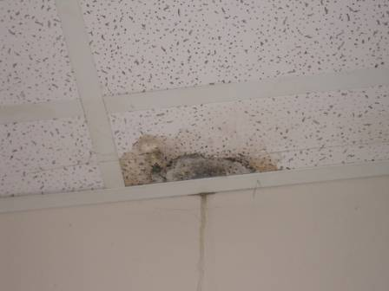

Water-Damaged/Mold-Colonized Ceiling Tile in Room 25

Picture 10

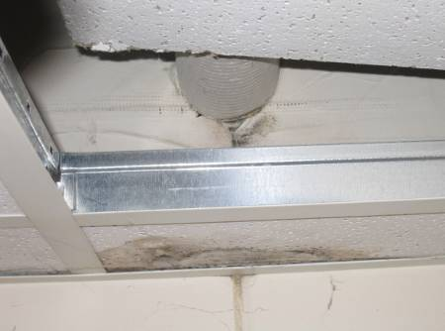

Water-Damaged/Mold-Colonized Ceiling Tile and Drywall (above Ceiling Tile System/below Pipe) in Room 25
Picture 11

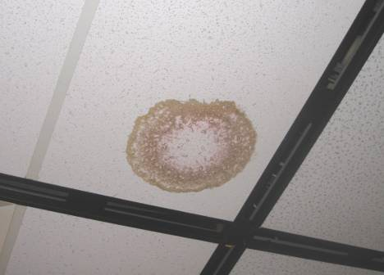

Water-Damaged Ceiling Tile with Pink Staining in Hallway outside Rooms 1 and 2

Picture 12

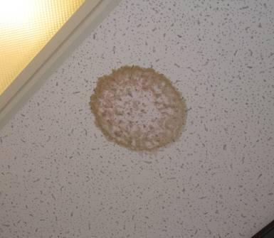

Water-Damaged Ceiling Tile with Pink Staining in Hallway outside Cafeteria

Picture 13

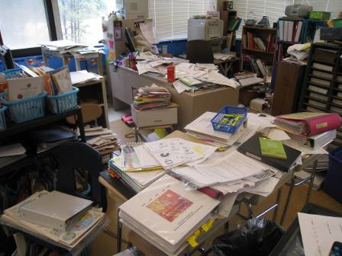

Accumulated Items in Classroom
Location | Carbon  Dioxide  (ppm) | Carbon Monoxide  (ppm) | Temp  (°F) | Relative  Humidity  (%) | PM2.5  (µg/m3) | Occupants  in Room | Windows  Openable | Ventilation |  | Remarks
 |  |  |  |  |  |  |  | Supply | Exhaust | Remarks
Background | 353 | ND | 59 | 75 | 9 |  |  |  |  | Warm, overcast (fog), winds SSW 7-16 mph, gusts up to 23 mph
Hallway outside guidance office |  |  |  |  |  |  |  |  |  | WD CTs-dry/low moisture measurement, no visible mold-copper pipes above CT (possible condensation)
Art Room | 651 | ND | 72 | 59 | 7 | 20 | N | Y | Y | Bubbling paint on skylights
Barry’s Office/Room | 577 | ND | 72 | 54 | 7 | 1 | N | Y | Y
Speech Therapy Room | 607 | ND | 73 | 54 | 8 | 0 | N | Y | Y | WD CT
Media Center | 526 | ND | 74 | 54 | 7 | 20 | N | Y | Y | 10+ WD CT, active leak reported center
Computer Lab | 520 | ND | 74 | 54 | 7 | 0 | N | Y | Y | 3 WD CT
Speech & Language A | 534 | ND | 71 | 57 | 8 | 0 | N | Y | Y
Speech & Language B | 530 | ND | 71 | 56 | 7 | 0 | N | Y | Y
Hallway outside cafeteria |  |  |  |  |  |  |  |  |  | WD CT (pink/brown stained) dry/low moisture measurement, WD pipe insulation above CT
Cafeteria | 665 | ND | 69 | 58 | 9 | 7 | Y | Y | Y | ~150 occupants gone 5 minutes
Guidance | 541 | ND | 73 | 55 | 6 | 0 | N | Y | Y | 1 WD CT/MT around skylight
Nurse’s Suite | 589 | ND | 74 | 54 | 9 | 3 | Y | Y | Y | 2 WD CT, dust/debris on vents
K-4 | 467 | ND | 71 | 55 | 7 | 1 | Y | Y | Y | 20 occupants gone 8 minutes
K-3 | 435 | ND | 70 | 56 | 8 | 0 | Y | Y | Y
K-2 | 545 | ND | 72 | 54 | 7 | 1 | Y | Y | Y | 2 WD CT, (2 WD CT in bathroom)
K-1 | 522 | ND | 72 | 55 | 8 | 0 | Y | Y | Y | 4 WD CT
Room 1 | 732 | ND | 72 | 58 | 8 | 22 | Y | Y | Y | WD CT back corner near microwave, and near TV, dry/low moisture measurement, roof drain-possible leak/condensation, feather duster
SPED Room 1 | 642 | ND | 72 | 56 | 7 | 0 | Y | Y | Y
Room 2 | 790 | ND | 72 | 56 | 8 | 23 | Y | Y | Y | WD CT near corner near sink, roof drain leak/condensation, dry/low moisture measurement
SPED Room 2 | 751 | ND | 72 | 57 | 8 | 2 | Y | Y | Y
Hallway outside Rooms 1 & 2 |  |  |  |  |  |  |  |  |  | WD CTs one brown/pink staining, WD pipe insulation above CT
Room 3 | 823 | ND | 73 | 57 | 8 | 17 | Y | Y | Y | Green algal growth in aquarium, accumulated items on flat surfaces, WD CT corner-dry/low moisture measurement, roof drain leak/condensation
Hallway outside Room 3 |  |  |  |  |  |  |  |  |  | 3 WD CT-dry/low moisture measurement-slight mold growth/staining on surface of CT, WD pipe insulation above CT
SPED 3 | 544 | ND | 71 | 56 | 8 | 1 | Y | Y | Y
SPED 4 | 534 | ND | 72 | 56 | 9 | 2 | Y | Y | Y | Plant, air freshener
Room 5 | 896 | ND | 72 | 57 | 9 | 19 | Y | Y | Y | Rusted metal wall near sink, WD CT near TV
Room 7 | 629 | ND | 73 | 54 | 9 | 18 | Y | Y | Y | Active leak at rear of room reported (buckets), roof drain leak, WD CT near front of classroom
Hallway outside SPED 3&4 |  |  |  |  |  |  |  |  |  | 2 WD CT dry/low moisture
Room 8 | 672 | ND | 74 | 54 | 9 | 20 | Y | Y | Y
Room 9 | 767 | ND | 74 | 54 | 10 | 25 | Y | Y | Y
Room 13 | 652 | ND | 73 | 55 | 8 | 0 | Y | Y | Y | WD CT near TV
Room 16 | 511 | ND | 71 | 56 | 8 | 0 | Y | Y | Y
Hallway outside Rooms 8&9 |  |  |  |  |  |  |  |  |  | WD CT rusty pipes above CT, dry/low moisture measurement
Room 17 | 511 | ND | 72 | 56 | 7 | 3 | N | Y | Y | 7 WD CT
Room 18 | 438 | ND | 71 | 57 | 7 | 0 | Y | Y | Y
Room 20 | 549 | ND | 73 | 55 | 10 | 21 | Y | Y | Y
Room 22 | 569 | ND | 72 | 57 | 10 | 24 | Y | Y | Y
Room 23 | 467 | ND | 73 | 55 | 9 | 22 | Y | Y | Y | Window open, plants, terrarium
Room 24 | 431 | ND | 72 | 54 | 9 | 1 | Y | Y | Y
Room 25 | 472 | ND | 73 | 55 | 8 | 1 | Y | Y | Y | 23 occupants gone 2 minutes, WD CT-visible mold growth on CT and wall above CT near pipe (leak/condensation)-CT sealed in plastic bag and removed
Room 26 | 486 | ND | 72 | 56 | 7 | 1 | Y | Y | Y | 24 occupants gone 15 minutes
Room 27 | 533 | ND | 73 | 55 | 8 | 1 | Y | Y | Y | 23 occupants gone 20 minutes
Room 28 | 498 | ND | 73 | 54 | 8 | 1 | Y | Y | Y | 24 occupants gone 30 minutes, plants
Room 29 | 467 | ND | 73 | 54 | 7 | 0 | Y | Y | Y
Room 30 | 470 | ND | 73 | 54 | 8 | 0 | Y | Y | Y
Hallway outside Rooms 20&22 |  |  |  |  |  |  |  |  |  | 4 WD CT

Actions on MDPH Recommendations, South Elementary School,
Plymouth, MA

The following is a status report of action(s) taken on MDPH recommendations (in bold) based on reports from school officials, maintenance staff, documents, photographs and MDPH staff observations.
Operate the gymnasium AHU for twenty-four hours a day to dissipate the residual gymnasium floor odor. Once odors dissipate the AHU should run continuously during periods of occupancy.
Action: AHU was reportedly run continuously to dissipate odors and scheduled to run continuously during occupied periods.
Adjust the AHUs to introduce more fresh air into classrooms.
Action: The AHU intake louvers were adjusted from 20% to 50% outside air, which is reportedly monitored/ and adjusted as required.
Once operating, both supply and exhaust ventilation should operate continuously during periods of school occupancy.
- Action: Supply and exhausts were operating continuously during the current MDPH inspection.
- Consider algae treatment of fish tanks to reduce possible algae growth.
- Action: Building Administration reportedly instructed staff to reduce the amount of plants, animals and other items from home to a minimum to help reduce the effects on indoor air quality.
- For buildings in New England, periods of low relative humidity during the winter are often unavoidable. Therefore, scrupulous cleaning practices should be adopted to minimize common indoor air contaminants whose irritant effects can be enhanced when the relative humidity is low. To control for dusts, a high efficiency particulate arrestance (HEPA) filter equipped vacuum cleaner in conjunction with wet wiping of all surfaces is recommended. Avoid the use of feather dusters. Drinking water during the day can help ease some symptoms associated with a dry environment (throat and sinus irritations).
- Action: Buildings and Grounds personnel have reportedly been instructed on proper cleaning procedures which will help to reduce the amount of dirt, dust, odors and re-aerosolization of particulates.
- Consider reducing the number of plants in the foyer and classrooms. Ensure that the remaining plants have drip pans. Examine drip pans for mold growth and disinfect areas with an appropriate antimicrobial where necessary.
- Action: Building Administration reportedly removed plants from foyer. Building Administration also reportedly instructed staff to reduce the amount of plants, animals and other items from home to a minimum to help reduce the effects on Indoor Air Quality.
- Acquire current Material Safety Data Sheets for all products that contain hazardous materials and are used within the building, including office supplies, in conformance with the Massachusetts Right-To-Know Law, M.G.L. c. 111F (MGL, 1983).
- Action: All items purchased by the School Department reportedly have MSDS sheets on file which are required to be supplied as a bid requirement. Building Administration has also reportedly instructed staff that any materials they bring from home must also have an MSDS sheet.
- Repair/replace loose/broken windowpanes and missing or damaged window gaskets building-wide to prevent water penetration through window frames.
- Action: Buildings and Grounds has reportedly contracted to have the windows repaired.
- Discontinue the use of artificial snow and spray paint within the SES.
- Action: Building Administration has reportedly instructed staff not to bring these items into the building.
- Consider replacing art and school supplies containing materials that require labeling under LHAMA with water-based materials to reduce VOCs in classrooms.
- Action: Building Administration has reportedly instructed staff on purchasing appropriate supplies and materials.
- Reduce the use of cleaning materials that contain respiratory irritants (ammonia related compounds) in classrooms. Do not use these materials to disinfect equipment that comes into close contact with the respiratory system (e.g., telephones). Substitute plain soap and hot water for bleach or ammonia related cleaning products. Only use ammonia related cleaning products where necessary. If ammonia or bleach containing cleaning products are used, rinse the area of application with water to remove residue.
- Action: Custodial and Maintenance employees have reportedly been instructed on the appropriate use of bleach and ammonia products. These products are only used on a very limited basis.
- Discard milk bottle caps.
- Action: No caps were observed at the time of the MDPH inspection.
- Consider reducing the number of animal pelts, examples of taxidermy and other potential sources of allergenic materials or seal in clear plastic when not in use.
- Action: Building Administration reportedly instructed staff to reduce the amount of plants, animals and other items from home to a minimum to help reduce the effects on indoor air quality.

