WATER DAMAGE/MOLD INVESTIGATION

South High School
490 Long Pond Road
Plymouth, Massachusetts

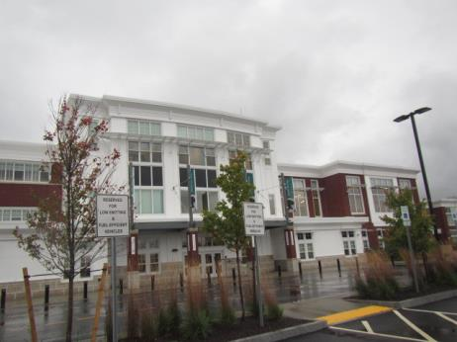

Prepared by:
Massachusetts Department of Public Health
Bureau of Environmental Health
Indoor Air Quality Program
November 2018

BACKGROUND
Building: | South High School (SHS)
Address: | 490 Long Pond Road, Plymouth, Massachusetts
Assessment Requested by: | Referral from Massachusetts Division of Labor Standards
Reason for Request: | Water damage/mold growth
Date of Assessment: | October 12, 2018
Massachusetts Department of Public Health/Bureau of Environmental Health (MDPH/BEH) Staff Conducting Assessment: | Cory Holmes, Environmental Analyst/Inspector Indoor Air Quality (IAQ) Program
Date of Building Construction: | 2017
Building Description: | Newly constructed/modern high school.
Windows: | Openable

METHODS
Please refer to the IAQ Manual and appendices for methods, sampling procedures, and interpretation of results (MDPH, 2015).

RESULTS and DISCUSSION
The investigation consisted of detailed observation of specific areas listed by the complainants, which are listed below. The origin of leaks/water concerns were reported to be from both the building envelope (e.g., roof leaks) as well as from HVAC equipment (i.e., condensation). It is important to note that the assessment occurred after several days of moderate to heavy rain in southeast MA.
- Auditorium: A previous leak was reportedly fixed in this area by the roofing manufacturer, Sarnafil, which is on warranty. Water damage in the form of peeling paint and stained ceiling was observed (Picture 1). School maintenance personnel reported that the work was on a repair list with a private contractor, RebuildEx Damage Restoration. No further damage was reported and no active water penetration/wet conditions were observed/measured via moisture meter on porous materials (i.e., carpet, upholstered seats) beneath the area (Picture 2).
- Gymnasium: At the time of assessment, water was noted dripping from the ceiling into buckets in two places. Although, rain was heavy at times, the amount collected in the buckets appeared minimal. No porous building materials (e.g., carpet, ceiling tiles, gypsum drywall) are located in areas of leaks. The water impacted materials are wooden floor (semi-porous) and metal building components (Pictures 3 through 6).
- Weight Room: Previous water damage had reportedly occurred and was repaired by the roofing manufacture. No evidence of leaks was observed in the weight room at the time of assessment. However, water-damaged/dark staining; which may be mold growth on ceiling material in the mezzanine outside the weight room was observed (Picture 7). School maintenance officials reported that the stain is likely due to condensation on a metal duct that traverses the area above it. BEH/IAQ staff recommended cutting out this section of drywall and investigating source of moisture.
- Loading dock area: The cafeteria loading dock area was known to have a leak in flashing, which has since been repaired. Although staining/debris from the previous leak remained on top of the lockers below (Picture 8), no current water penetration/further damage was reported or observed.
- Solar panels: A concerned was raised about leaks from the installation of rooftop solar panels. As reported by school maintenance officials, the solar panels did not breach the roof membrane, unlike electrical conduits. A roofing manufacture was on-site to monitor the project and that no roof leaks were directly related to the solar panel project.
- HVAC units: The units in use at the SHS are called chilled induction units, which are located above the suspended ceiling (Pictures 9 through 11). The number of units in each room depends on size. It was reported in the complaint, that school staff must physically drain each unit with a hand-held wet/dry vac (Picture 12). This was confirmed by Mr. Arthur Montrond, Facilities Director, who explained that instead of each unit being piped/drained to the exterior, the units collect water in a small cylinder equipped with a float/trigger. Unlike a conventional drip pan that collects a large amount of water that can overflow/spill above ceiling tiles, the cylinder is small in nature and enclosed (Picture 11), which prevents spillage/water damage. The trigger is set to deactivate the unit at less than an inch of water. A computerized monitoring system indicates when the units need service (e.g., draining).
Other water damage sources included:
- Winter Storm Riley in March 2018, water had leaked through rooftop ventilation units causing water damage;
- June 2018, the sprinkler system was triggered by excessive heat from a kiln; and
- Leaks through rooftop ventilation units that were not properly sealed.
At the time of this assessment, water damage from these incidents had since been remediated.

CONCLUSIONS and RECOMMENDATIONS
In view of the findings at the time of the visit, the following recommendations are made:
- Continue with plans to make repairs to water-damaged building materials in the auditorium.
- If not already done, remove water-damaged section of drywall in mezzanine outside of weight room. Investigate why condensation is forming in this area and make repairs to prevent further water damage.
- Work with roofing contractor/manufacture to determine source of leaks in the gym and make repairs as needed.
- In the interim, monitor for continued leaks and catch in containers (e.g., buckets/mop) to prevent damage to the floor. Post “hazard/wet floor” signs as needed, to prevent injury to occupants/staff.
- Clean lockers in cafeteria loading dock area and monitor for any further leakage.
- Encourage staff to use existing reporting systems in place (e.g., School Dude) to report issues such as leaks, repairs and general maintenance needs.
- For more information about mold consult the US EPA’s “Mold Remediation in Schools and Commercial Buildings” published by the US Environmental Protection Agency (US EPA, 2008) (https://www.epa.gov/mold/mold-remediation-schools-and-commercial-buildings-guide).
- Refer to resource manual and other related IAQ documents located on the MDPH’s website for further building-wide evaluations and advice on maintaining public buildings. These documents are available at: http://mass.gov/dph/iaq.

REFERENCES
MDPH. 2015. Massachusetts Department of Public Health. Indoor Air Quality Manual: Chapters I-III. Available at: http://www.mass.gov/eohhs/gov/departments/dph/programs/environmental-health/exposure-topics/iaq/iaq-manual/.
US EPA. 2008. “Mold Remediation in Schools and Commercial Buildings”. Office of Air and Radiation, Indoor Environments Division, Washington, DC. EPA 402-K-01-001. September 2008. Available at: http://www.epa.gov/mold/mold-remediation-schools-and-commercial-buildings-guide.
Picture 1
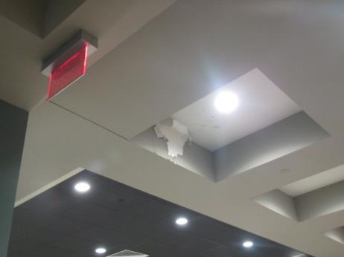
Peeling paint and stained ceiling in auditorium
Picture 2
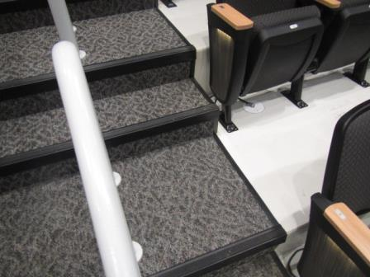
Carpet, seats and floor directly beneath area of previous leak in auditorium, showing no signs of current leaks or water damage
Picture 3
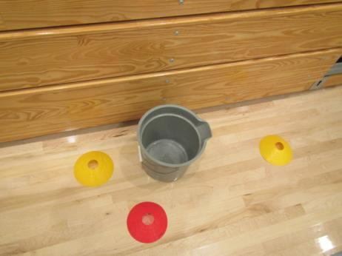
Bucket in gym collecting dripping rainwater, note minimal amount
Picture 4
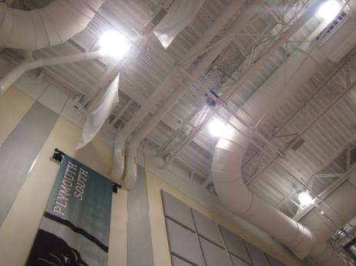
Ceiling/area above bucket in preceding picture
Picture 5
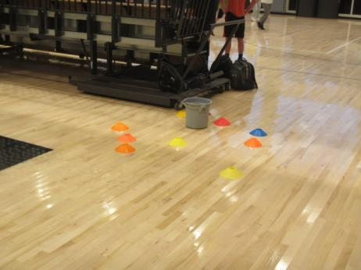
2nd bucket in gym collecting dripping rainwater
Picture 6
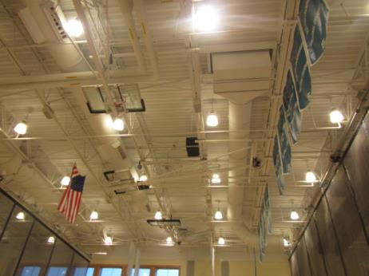
Area above 2nd bucket in preceding picture
Picture 7
Dark staining/possible mold growth (arrow) on ceiling outside of weight room
Picture 8
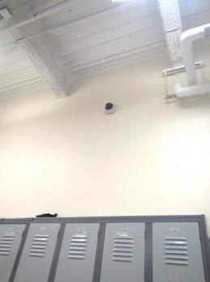
Cafeteria loading dock area of previous leaks
Picture 9
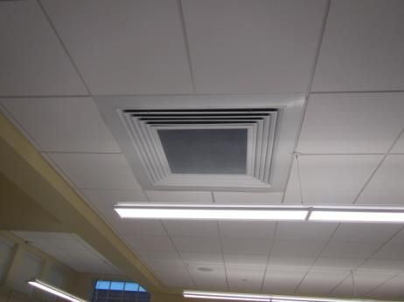
Induction unit in classroom
Picture 10
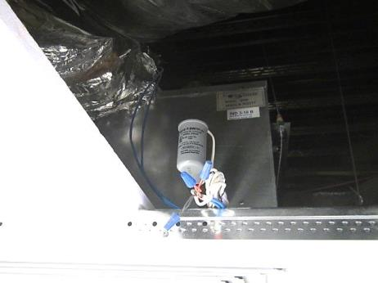
Induction unit above ceiling tile system, note plastic cylinder for water collection
Picture 11
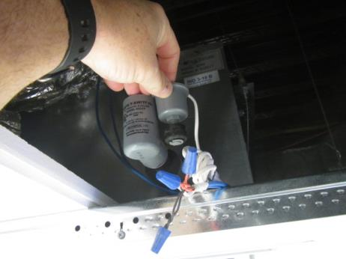
Float/trigger mechanism inside water collection cylinder
Picture 12
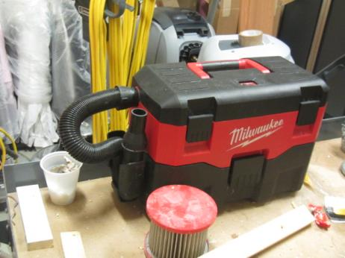
Hand-held wet/dry vac used to drain induction units

