INDOOR AIR QUALITY ASSESSMENT

Plymouth Town Hall
11 Lincoln Street
Plymouth, Massachusetts

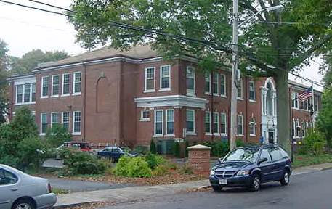

Prepared by:
Massachusetts Department of Public Health
Bureau of Environmental Health
Indoor Air Quality Program
January 2016

Background
Building: | Plymouth Town Hall (PTH)
Address: | 11 Lincoln Street, Plymouth, MA
Assessment Requested by: | Derek Brindisi, Assistant Town Manager
Date of Assessment: | December 11, 2015
Bureau of Environmental Health/Indoor Air Quality (BEH/IAQ) Program Staff Conducting Assessment: | Cory Holmes, Environmental Analyst/Inspector
Date of Building Construction: | 1892, 1914 addition
Reason for Request: | General IAQ concerns

Building Description
The PTH is a three-story, brick-faced building with occupied basement. The building has undergone interior renovations over the years, most recently from 1995-1998. The building contains town offices and public meeting rooms. The boiler plant is located in the basement. Windows are openable throughout the building. PTH reported that ground had recently been broken for the construction of a new town hall; therefore occupancy of this building is limited to the estimated 1 to 2 year completion of construction. The PTH has an employee population of approximately 40 and can be visited by up to several hundred individuals daily.

Results and Discussion
The tests were taken during normal operations. Test results appear in Table 1. Methods and indoor air related sampling information can be found in the IAQ Manual and Appendices for IAQ Reports at:
http://www.mass.gov/eohhs/gov/departments/dph/programs/environmental-health/exposure-topics/iaq/iaq-rpts/general-appendices-for-iaq-reports.html

Ventilation
It can be seen from Table 1 that carbon dioxide levels were below 800 parts per million (ppm) in but one area tested, indicating adequate air exchange at the time of assessment. The heating, ventilation and air conditioning (HVAC) system consists of five rooftop air handling units (AHUs) equipped with pleated air filters (Pictures 1 and 2). Conditioned outside air is provided through ducted wall or ceiling vents (Picture 3) and is returned to the AHUs by ducted ceiling-mounted return vents (Picture 4). It was not clear if a preventative maintenance plan/regular filter changes were implemented to service the AHUs.

Temperature and Relative Humidity
Temperature readings in occupied areas during the assessment were within the MDPH recommended comfort guidelines (Table 1). The MDPH recommends that indoor air temperatures be maintained in a range of 70ºF to 78ºF in order to provide for the comfort of building occupants. Thermal comfort complaints were expressed throughout the building. In a few areas, supply vents were blocked with cardboard in an attempt to maintain comfort (Picture 5). The heating/cooling system is controlled remotely at an off-site location. In addition, it is often difficult to maintain comfort in a vintage building (late 1800s) with a modern mechanical ventilation system. A complaint regarding a draft from a crawlspace door was expressed in the 3rd floor “Brinkman” office. The frame around the door should be sealed with weather stripping to prevent drafts.
The relative humidity measurements during the assessment were within the MDPH recommended comfort range. The MDPH recommends a comfort range of 40 to 60 percent for indoor air relative humidity. Relative humidity levels in the building would be expected to drop during the winter months due to heating. The sensation of dryness and irritation is common in a low relative humidity environment. Low relative humidity is a very common problem during the heating season in the northeast part of the United States.

Microbial/Moisture Concerns
Water-damaged ceiling tiles were observed in some areas (Pictures 4 and 6; Table 1), which can indicate a current/historic leak. A dehumidifier was observed in the basement that had a lit indicator light that read “bucket full” (Picture 7). These reservoirs are designed to collect condensation during operation and should be emptied/cleaned regularly to prevent microbial and/or bacterial growth. A number of areas also had water coolers installed over carpeting (Picture 8). Water spillage or overflow of cooler catch basins can result in the wetting of the carpet, which can lead to mold growth, especially if wetted repeatedly.
Cardboard boxes were observed placed directly on the floor of the basement and other areas (Picture 9). Cardboard boxes and other porous materials should be elevated off the floor in basement areas to prevent wetting from condensation/humidity, which can lead to water damage and mold growth.

Other IAQ Evaluations
IAQ can be negatively influenced by the presence of respiratory irritants, such as products of combustion. The process of combustion produces a number of pollutants. Common combustion emissions include carbon monoxide, carbon dioxide, water vapor, and smoke (fine airborne particle material). Of these materials, exposure to carbon monoxide and particulate matter with a diameter of 2.5 micrometers (μm) or less (PM2.5) can produce immediate, acute health effects upon exposure. To determine whether combustion products were present in the indoor environment, BEH/IAQ staff obtained measurements for carbon monoxide and PM2.5.

Carbon Monoxide
Carbon monoxide should not be present in a typical, indoor environment. If it is present, indoor carbon monoxide levels should be less than or equal to outdoor levels. On the day of assessment, outdoor carbon monoxide concentrations ranged from non detect (ND) to 1.0 ppm (Table 1). This low level detected outside is most likely attributable to vehicle exhaust from local/downtown traffic. No measureable levels of carbon monoxide were detected inside the building during the assessment (Table 1).

Particulate Matter
Outdoor PM2.5 concentrations were measured at 28 μg/m³ (Table 1). Indoor PM2.5 levels ranged from 7 to 17 μg/m³ (Table 1), which were below the NAAQS PM2.5 level of 35 μg/m³. PTH staff expressed concerns regarding the periodic operation of the emergency generator, which is in close proximity to the exterior of the building (Picture 10). The operation of this equipment, although necessary, can be a source of carbon monoxide and airborne particulates.

Other Conditions
Other conditions that can affect IAQ were observed during the assessment. Most occupied areas are carpeted, however it was reported that there was not a routine preventative maintenance plan in place. The Institute of Inspection, Cleaning and Restoration Certification (IICRC) recommends that carpeting be cleaned annually (or semi-annually in soiled high traffic areas) (IICRC, 2012). Regular cleaning with a high efficiency particulate air (HEPA) filtered vacuum in combination with an annual cleaning will help to reduce accumulation and potential aerosolization of materials from carpeting.
Several areas utilize air purifiers. The filters in one of the basement units were in need of attention, as indicated by the “pre-filter” alert light on the unit (Picture 11). Air purifiers/cleaners are typically equipped with filters that should be cleaned/changed as per manufacturer’s instructions.
Several supply, exhaust and return vents were observed to have accumulated dust/debris (Pictures 3 and 4). If exhaust vents are not functioning, backdrafting can occur, which can re-aerosolize accumulated dust particles. Supply vents can aerosolize accumulated dust once activated.
In a number of areas, items were observed on the floor, windowsills, tabletops, counters, bookcases and desks. The large number of items stored provides a source for dusts to accumulate. These items (e.g., papers, folders, boxes) make it difficult for custodial staff to clean. Items should be relocated and/or be cleaned periodically to avoid excessive dust build up. In addition, these materials can accumulate on flat surfaces (e.g., desktops, windowsills and carpets) in occupied areas and subsequently be re-aerosolized causing further irritation.
It is important to note that at the time of assessment, cleaning/maintenance staff had been short-handed due to staff turnover. It was reported that replacement personnel were in the process of being hired.

Conclusions/Recommendations
In view of the findings at the time of the visit, the following recommendations are made:
- Consider setting fan settings for the mechanical ventilation system to “on” for continuous airflow/filtration.
- To avoid comfort complaints, consider working with staff (who have complaints/sealed their vents) to relocate air diffusers.
- Seal with weather stripping around crawlspace door in 3rd floor Brinkman office to prevent drafts.
- Develop a system/direct line of communication to respond to temperature complaints/adjust HVAC system.
- For buildings in New England, periods of low relative humidity during the winter are often unavoidable. Therefore, scrupulous cleaning practices should be adopted to minimize common indoor air contaminants whose irritant effects can be enhanced when the relative humidity is low. To control for dusts, a high efficiency particulate arrestance (HEPA) filter equipped vacuum cleaner in conjunction with wet wiping of all surfaces is recommended. Avoid the use of feather dusters. Drinking water during the day can help ease some symptoms associated with a dry environment (throat and sinus irritation).
- Ensure leaks are repaired and replace water-damaged ceiling tiles.
- Consider placing water dispensers on non-carpeted areas or place a waterproof mat underneath them.
- Do not store porous materials (e.g., cardboard boxes) directly on floors; elevate/place on pallets or shelving to prevent water damage and mold growth.
- Empty, clean and maintain dehumidifiers as per the manufacturer’s instructions.
- Clean supply, exhaust and return vents periodically of accumulated dust.
- Change AHU filters a minimum of twice per year (e.g. between heating/cooling seasons) or as per the manufacturer’s instructions.
- Consider testing the generator after work hours or on weekends to prevent/reduce potential exposure to exhaust emissions.
- Maintain air purifiers as per the manufacturer’s instructions.
- Clean carpeting annually or semi-annually in soiled high traffic areas as per the recommendations of the Institute of Inspection, Cleaning and Restoration Certification (IICRC, 2012).
- Relocate or consider reducing the amount of stored materials to allow for more thorough cleaning. Clean items regularly with a wet cloth or sponge to prevent excessive dust build-up.
- Continue with plans to hire full-time custodial/maintenance personnel.
- Consider creating a log book for staff to submit specific cleaning/maintenance requests. Make log book available for staff/management in a central location. Cleaning/Maintenance requests should include date, requester, a detailed description of where and what the issue is as well as a section for cleaning/maintenance personnel to sign off or document progress of request.
- Refer to resource manual and other related indoor air quality documents located on the MDPH’s website for further building-wide evaluations and advice on maintaining public buildings. These documents are available at http://mass.gov/dph/iaq.

References
IICRC. 2012. Institute of Inspection, Cleaning and Restoration Certification. Carpet Cleaning: FAQ. Retrieved from http://www.iicrc.org/consumers/care/carpet-cleaning/#faq.
Picture 1
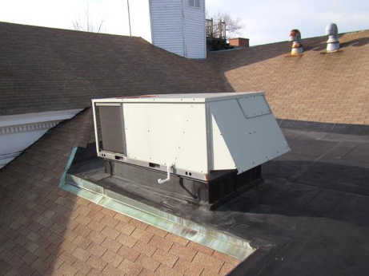
Rooftop air handling unit
Picture 2
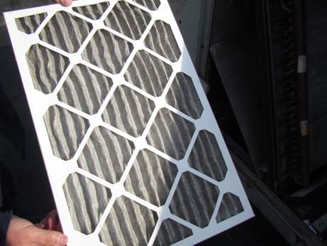
Pleated filter in air handling unit
Picture 3
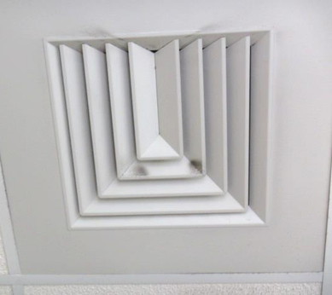
Supply diffuser, note accumulated dust/debris on louvers
Picture 4
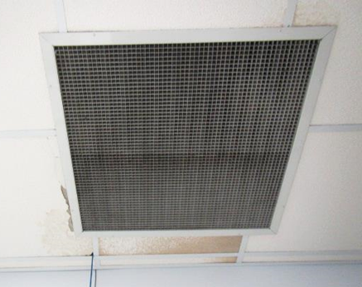
Return vent, note water-damaged ceiling tiles
Picture 5
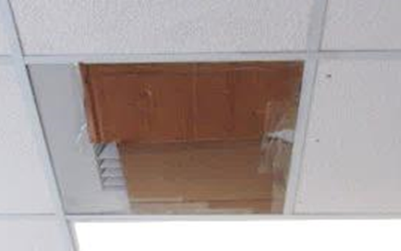
Supply vent sealed with cardboard
Picture 6
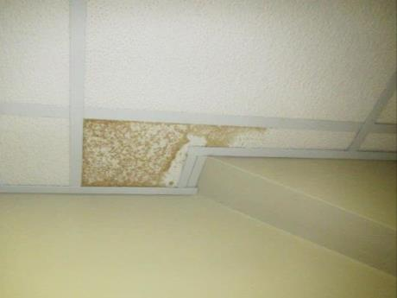
Water-damaged ceiling tiles
Picture 7
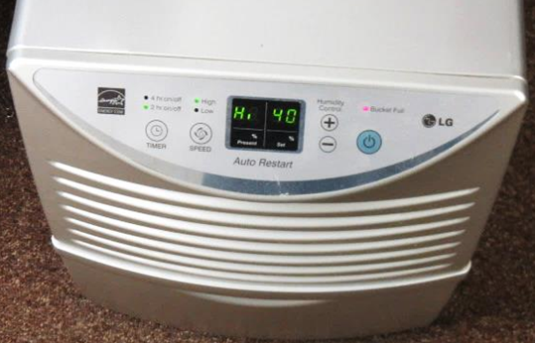
Dehumidifier in basement with lit indicator light "Bucket Full" (arrow)
Picture 8
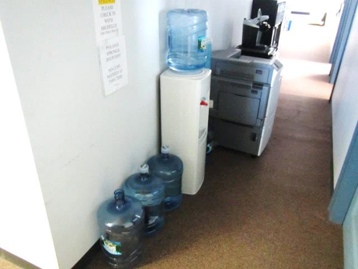
Water cooler on carpeting
Picture 9
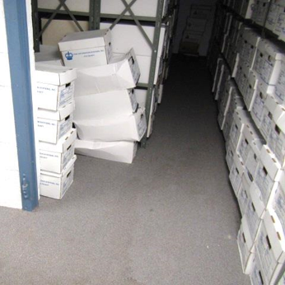
Cardboard boxes directly on floor of basement
Picture 10
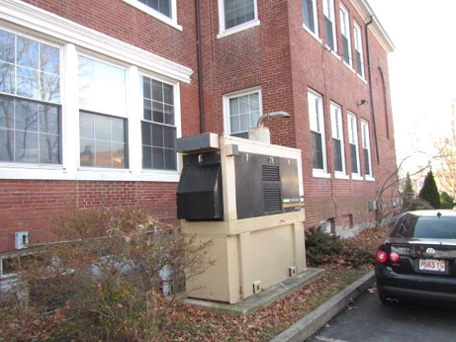
Emergency generator
Picture 11
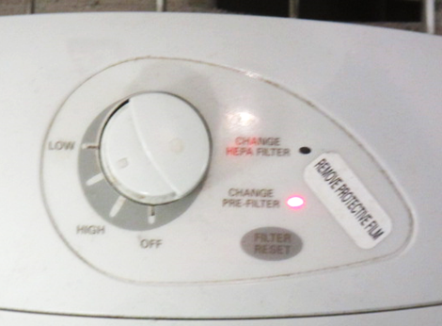
Close up of air purifier in the basement, note “CHANGE PRE-FILTER” alert light

Location | Carbon  Dioxide  (ppm) | Carbon Monoxide  (ppm) | Temp  (°F) | Relative  Humidity  (%) | PM2.5  (µg/m³) | Occupants  in Room | Windows  Openable | Ventilation |  |  | Remarks
 |  |  |  |  |  |  |  | Intake | Exhaust
Background (outside) | 423 | ND-1 | 61 | 70 | 28 |  |  |  |  |  | Warm, sunny, winds SSW 5-13 mph, gusts up to 21 mph
3rd Floor
Assistant Town Manager | 680 | ND | 74 | 49 | 8 | 1 | Y | Y |  | Y | DO
Town Manager | 606 | ND | 74 | 48 | 7 | 0 | Y | Y |  | Y | Plants, dust/debris vents, DO
File Room | 623 | ND | 75 | 46 | 7 | 0 | N | Y |  | Y | DO
Gurney Office | 653 | ND | 75 | 46 | 7 | 0 | N | Y |  | Y | DO
Brinkman Office | 653 | ND | 75 | 47 | 7 | 1 | N | Y |  | Y | Drafts around crawlspace door-recommend sealing
HR/Selectmen | 614 | ND | 75 | 44 | 8 | 2 | N | Y |  | Y
Johnson Office | 608 | ND | 75 | 46 | 8 | 0 | N | Y |  | N
Break Room | 620 | ND | 75 | 46 | 7 | 0 | N | Y |  | N | WD CT, water cooler on carpet
Brewster Garden Room | 620 | ND | 74 | 46 | 8 | 0 | N | Y |  | Y | DO
2nd Floor
Engineering | 873 | ND | 73 | 46 | 9 | 2 | Y | Y |  | Y | Large printer
Engineering (inner room) | 778 | ND | 73 | 44 | 10 | 0 | N | N |  | N
Downey Office | 617 | ND | 73 | 46 | 11 | 1 | Y  Open | Y |  | N | DO
Almeida | 600 | ND | 73 | 45 | 12 | 0 | N | Y |  | Y | DO
Planning & Development | 587 | ND | 74 | 45 | 12 | 1 | Y | Y |  | Y | WD CT 6-leak reportedly repaired, plants
Conservation Commission | 555 | ND | 74 | 44 | 11 | 0 | N | Y |  | N | WD CT, DO
Director | 505 | ND | 74 | 44 | 15 | 0 | Y  Open | Y |  | N | DO, plant
Town Planner | 512 | ND | 74 | 44 | 13 | 0 | Y | Y |  | N | DO, plants
Comm of Development | 525 | ND | 75 | 44 | 14 | 0 | Y  Open | Y |  | N | DO
Comm Development Main Area | 586 | ND | 75 | 44 | 12 | 2 | Y  Open | Y |  | Y | Dust/debris vents, DO
1st Floor
Inspectional Services | 474 | ND | 77 | 42 | 17 | 2 | Y  Open | Y |  | Y | Poor airflow complaints, dust/debris vents, water cooler on carpet
Town Clerk Main Area | 686 | ND | 77 | 43 | 11 | 2 | Y  Open | Y |  | Y
Town Clerk | 606 | ND | 78 | 42 | 11 | 0 | Y  Open | Y |  | N | Plants, dust/debris vents, DO
Town Meeting Room | 548 | ND | 76 | 40 | 11 | 0 | N | Y |  | Y
Assessors Main Area | 602 | ND | 76 | 43 | 15 | 4 | Y  Open | Y |  | Y | Plants, DO, AI
Assessors Office | 581 | ND | 76 | 43 | 13 | 14 | Y | Y |  | N | DO
Collectors Main Area | 557 | ND | 77 | 40 | 15 | 3 | Y | Y |  | Y
Collectors Office | 521 | ND | 77 | 40 | 15 | 0 | Y | Y  Sealed |  | Y | DO, AI
Health Department Main Area | 568 | ND | 77 | 42 | 15 | 3 | Y | Y |  | Y | DO, plants
Roberts Office | 524 | ND | 77 | 41 | 16 | 0 | Y | Y |  | N | Plants, DO
Basement
Finance Committee | 500 | ND | 76 | 42 | 11 | 0 | Y | Y |  | N | Dust/debris vents, wrinkled wall to wall carpet
Archives | 564 | ND | 75 | 42 | 9 | 0 | Y | Y |  | Y | Dust/debris vents, boxes on carpet, WD carpet
Closet/sump pump |  |  |  |  |  |  |  |  |  |  | Boxes on floor, dehumidifier-“bucket full”
Women’s Restroom |  |  |  |  |  |  | N | Y  Passive door vent |  | Y | Bathroom exhaust not operating, missing/damaged caulking around sink, 3 WD CT
Recreation | 574 | ND | 74 | 43 | 10 | 1 | Y | Y  Sealed |  | Y | AP, generator odor complaints
Payroll | 571 | ND | 74 | 43 | 10 | 1 | Y | Y |  | N | DO, plants
Director of Finance | 565 | ND | 74 | 43 | 10 | 1 | Y | Y |  | N | DO
Procurement | 587 | ND | 74 | 44 | 9 | 2 | N | Y |  | Y | AI

