Data Submission Guide for Dispensers
Massachusetts Prescription Monitoring Program
May 2023
Version 5.2

Table of Contents
1 Reporting Requirements 1
2 Guidelines for Data Submitters 3
2.1 Prescription Records and File Upload Specifications 3
3 Accessing Clearinghouse 4
3.1 Creating Your Account 4
3.2 Logging In to PMP Clearinghouse 9
4 Data Delivery Methods 10
4.1 Secure FTP 10
4.2 Web Portal Upload 11
4.3 Manual Entry (UCF) 12
4.4 Zero Reports 15
4.4.1 Submit a Single-Click Zero Report 16
4.4.2 Create a New Zero Report 19
5 Data Compliance 21
5.1 File Listings 21
5.2 UCF Listings 22
5.3 Error Correction 24
5.3.1 View Records with Errors 25
5.3.2 Error Correction via PMP Clearinghouse 25
5.3.3 Error View and Correction on MassPAT 26
5.3.4 Error Correction via File Submission 26
6 Email Reports 28
6.1 File Failed Report 28
6.2 File Status Report 28
6.3 Zero Report Confirmation 32
7 Managing Your Upload Account 33
7.1 Adding Users to Your Upload Account 33
7.1.1 Changing Another User’s Password 34
7.2 Adding PMPs to Your Upload Account 36
7.3 Adding SFTP Access to an Upload Account 37
7.4 Editing Your Upload Account 39
7.5 Changing Administrator Account 41
8 Managing Your User Profile 42
8.1 Editing Your Profile 42
8.2 Changing Your Password 43
8.3 Resetting Your Password 44
9 Assistance and Support 47
9.1 Technical Assistance 47
9.2 Administrative Assistance 47
10 Document Information 48
10.1 Disclaimer 48
10.2 Change Log 48
Appendix A: ASAP 4.2A Specifications 51
Appendix B: Data Entry Guidance 67
AIR03, AIR04, AIR05: ID of Person Picking Up Prescription 67
Exceptions to AIR03, AIR04, and AIR05 68
Deliveries 68
DSP06: Refill Number 69
DSP13 Partial Fills 69
DSP18–21: Electronic Prescriptions 70
PAT22: Country of Non-U.S. Resident 70
PRE02 and PRE09: Prescriber DEA and XDEA Numbers 70
Guidance on Metric Quantity Reporting 71
Reporting Compounded Prescriptions 71
Reporting Gabapentin Prescriptions 71
Reporting Naloxone Dispensations 72
Appendix C: ASAP Zero Report Specifications 74
Sample Zero Report 75
Appendix D: SFTP Configuration 76
SFTP Connection Details 76
PMP Subfolders 77
Public (SSH/RSA) Key Authentication 78
Appendix E: Data Submission Waivers 80
Annual Data Submission Waiver 80
Days of Operation Waiver 80
Temporary Waiver 80
Appendix F: Correct Use of Codes in DSP01 81
Error Correction 81
Submit a New Record 81
Revise a Record 81
Void a Record 82

Reporting Requirements
The Massachusetts Prescription Monitoring Program (MA PMP), authorized by M.G.L. Chapter 94C §24A, collects dispensing information on Schedule II through V (M.G.L. Chapter 94C §3) controlled substances and DPH-designated drugs (105 CMR 700.012(7)) dispensed pursuant to a prescription. The Massachusetts Department of Public Health (MA DPH) analyzes PMP data to:
- Determine prescribing and dispensing trends;
- Provide patient prescription history information to prescribers and dispensers;
- Provide educational information to healthcare providers and the public; and
- Provide case information to regulatory and law enforcement agencies concerning drug distribution and diversion.
Pharmacies are required to submit dispensing information on federally controlled substances in Schedules II through V and gabapentin, a Massachusetts Schedule VI substance, within 24 hours or the next business day to the State of Massachusetts through the PMP Clearinghouse application provided by Bamboo Health, Inc. (Bamboo). For more information on the reporting requirements, please visit the PMP website.
The MA PMP reporting requirements apply to all pharmacies registered with the Massachusetts Board of Pharmacy and to all pharmacies in health facilities registered with the MA DPH that dispense federally controlled substances in Schedules II–V and gabapentin. In addition, the MA PMP reporting requirements apply to any pharmacy located in another state, commonwealth, district, or territory that delivers a prescription (via U.S.P.S. or common carrier) in Schedules II─V and gabapentin to a person who is located in Massachusetts. This includes, but is not limited to, mail-order pharmacies.
This Data Submission Guide provides the guidelines, specifications, and instructions for submitting prescription data to the MA PMP. The Department is committed to working with pharmacies to comply with these requirements. Pharmacies are a critical partner in the accuracy of the data in the PMP and should ensure that their pharmacists are reporting the right information into the system.
At the micro-level, the PMP is a clinical tool that assists doctors, other prescribers, and dispensers in safely caring for their patients. Pain is subjective, and healthcare providers want to balance the real need for pain management with the potential risks of opioid misuse. The PMP helps them do that, and it is important that they have accurate, timely information.
On the macro-level, the PMP is a powerful analytical tool that allows MA DPH to look at trends so that MA DPH can understand different patterns of prescribing and use. The MA DPH can then use that data to make evidence-based decisions on public health policies and interventions.
Without accurate and timely information, none of these objectives can be achieved. The MA DPH appreciates all of your assistance in meeting our shared goals of providing critical prescription information.
MA PMP Reporting Requirements
Drug Schedule | PMP Reporting Requirement | Frequency of Reporting Requirement
Schedule 1 | No | N/A
Schedule 2 | Yes | Within 24 hours or the next business day
Schedule 3 | Yes | Within 24 hours or the next business day
Schedule 4 | Yes | Within 24 hours or the next business day
Schedule 5 | Yes | Within 24 hours or the next business day
Schedule 6 | Gabapentin | Within 24 hours or the next business day
MA DPH and Bamboo Health have made every effort to ensure the accuracy of the information in this document at the time of printing. However, information may change without notice. Please see the Change Log section of this document for a complete list of changes.

Guidelines for Data Submitters

Prescription Records and File Upload Specifications
- All data required within M.G.L. Chapter 94C §24A must be reported to the MA PMP through PMP Clearinghouse within 24 hours or the next business day following the most recent transmission.
- Files should be in ASAP 4.2A format.
- The primary email account in the User Profile must be monitored for communications from Clearinghouse by the data submitter.
- Reports for multiple pharmacies can be in the same upload file in any order.
- If a pharmacy does not dispense any federally controlled Schedule II–V substances or gabapentin for the preceding reporting period, it must file a Zero Report for that reporting period or it will be considered noncompliant. See Zero Reports for additional details.
- A Data Submission Waiver may be requested to avoid filing a Zero Report on days of the week the pharmacy is closed or for other specified reasons—see Appendix E: Data Submission Waivers.
- Prescription records that contain errors and are rejected by PMP Clearinghouse must be corrected and resubmitted.

Accessing Clearinghouse
This chapter describes how to create your PMP Clearinghouse account and how to log in to the PMP Clearinghouse web portal.

Creating Your Account
Prior to submitting data, you must create an account. If you are currently registered with the Bamboo Health PMP Clearinghouse system, you do not need to register for a new account—you will be able to add Massachusetts to your existing account for data submissions. A single account holder can submit to multiple PMPs. If you have an existing PMP Clearinghouse account, please refer to Adding PMPs to Your Upload Account to add PMPs to your account.
Notes:
- Data from multiple pharmacies can be uploaded in the same file. For example, chain pharmacies may send in one file containing controlled substance dispensing information for all their pharmacies licensed in the PMP. Therefore, chains with multiple stores need only to set up one account to upload a file.
- PMP Clearinghouse allows users to submit data through the web portal via manual entry (UCF) or upload of ASAP files. For users who prefer an encrypted transfer method, SFTP access is also available. You may set up your SFTP account during the account creation process.
- If you need to make changes to an existing PMP Clearinghouse upload account, please refer to Managing Your Upload Account.
Perform the following steps to create an account:
- Open an internet browser window and navigate to the PMP Clearinghouse Account Registration page located at https://pmpclearinghouse.net/registrations/new.
The Account Registration page is displayed as shown on the following page.
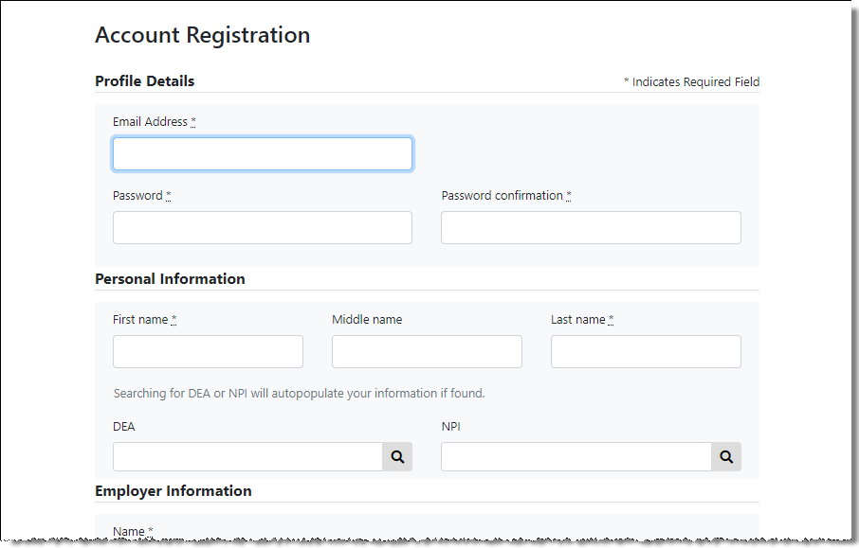
- Complete your Profile Details.
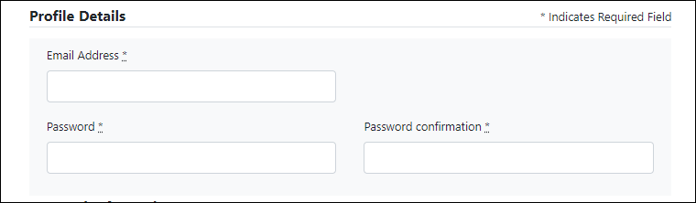
- Enter your current, valid email address in the Email Address field.
Note: The email address you provide here will act as your username when logging into the PMP Clearinghouse system.
- Enter a password for your account in the Password field, then re-enter it in the Password Confirmation field. The password requirements are provided below.
Passwords must contain:
- At least eight (8) characters
- One (1) uppercase letter
- One (1) lowercase letter
- One (1) number
- One (1) special character, such as !, @, #, $, etc.
- Complete your Personal and Employer information, noting the following:
Required fields are marked with a red asterisk (*).
You may be able to auto-populate your Personal and/or Employer information by entering your (or your employer’s) DEA, NPI, and/or NCPDP number, then clicking the search icon (). If the number you entered is found, your information will automatically be populated.
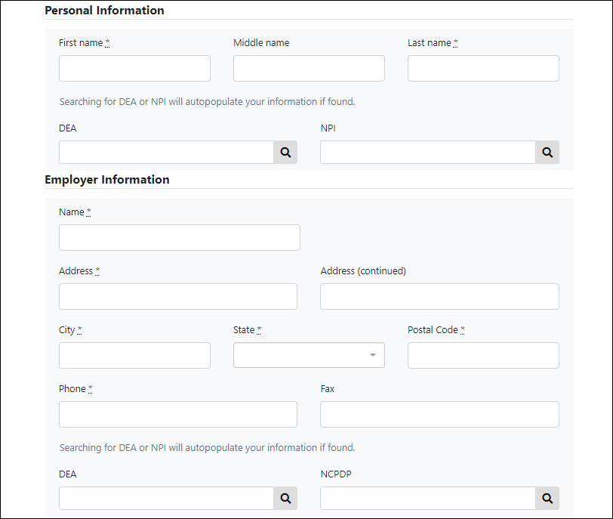
- If secure file transfer protocol (SFTP) is required, complete the Data Submission section of the page.
Notes:
- If SFTP access is not required, you do not need to complete the Data Submission section and you may continue to step 5.
- You may add SFTP access to an existing account. Please refer to Adding SFTP Access to an Upload Account for complete instructions.
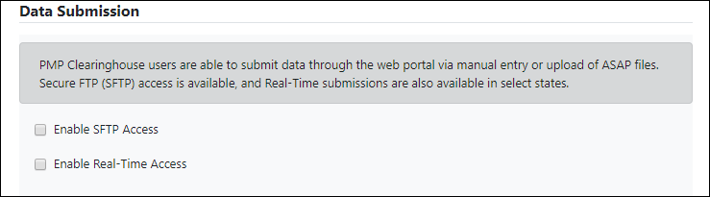
- Click to select the Enable SFTP Access checkbox.
The SFTP access fields are displayed.
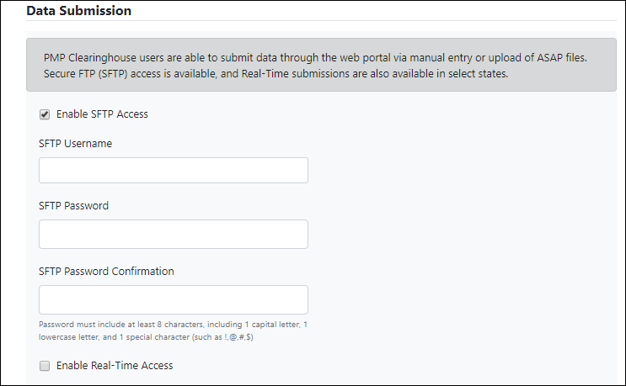
- Your SFTP Username is automatically generated using the first five characters of your employer’s name + your employer’s phone number + @prodpmpsftp. For example, if you entered “Test” as your employer’s name and “555-555-5555” as your employer’s phone number, your SFTP username would be test5555555555@prodpmpsftp.
- Enter a password for your SFTP account in the SFTP Password field, then re-enter it in the SFTP Password Confirmation field. The password requirements are provided below.
Passwords must contain:
- At least eight (8) characters
- One (1) uppercase letter
- One (1) lowercase letter
- One (1) number
- One (1) special character, such as !, @, #, $, etc.
This password will be input into the pharmacy software so that submissions can be automated.
Notes:
- This password can be the same as the one previously entered under Profile.
- Unlike the Profile password (i.e., your user account password), the SFTP password does not expire.
- The URL to connect via SFTP is sftp://sftp.pmpclearinghouse.net.
- Additional details on SFTP configuration can be found in Appendix D: SFTP Configuration.
- In the Submission Destinations section of the page, select the PMP(s) for which you will be submitting data.
- Click Submit.
The request is submitted to the PMP administrator for each of the PMPs you selected for data submission, and the Registration Information Overview page is displayed.
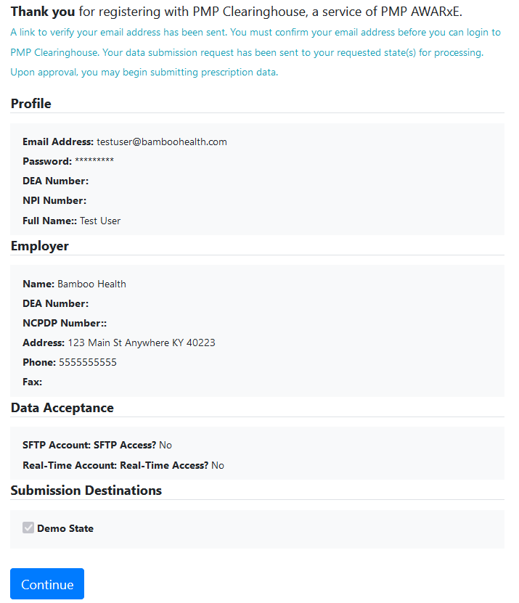
- Click Continue.
The PMP Clearinghouse Login page is displayed; however, you will not be able to log in until your account has been approved. Once the PMP administrator has approved your request, you will receive a welcome email instructing you to confirm your account. Follow the instructions in the email to confirm your account and begin submitting data to PMP AWARxE.

Logging In to PMP Clearinghouse
- Open an internet browser window and navigate to the PMP Clearinghouse Login page located at https://pmpclearinghouse.net/users/sign_in.
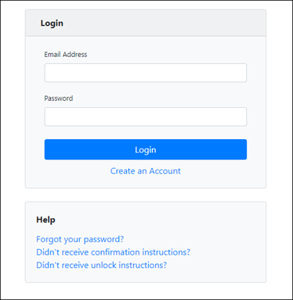
- Enter the email address you used to create your account in the Email Address field.
- Enter your password in the Password field.
Note: If you have forgotten your password, have completed your registration but did not receive the account confirmation email, or your account has been locked and you did not receive the email with instructions for unlocking your account, please refer to the links in the Help section of the page. For detailed instructions on resetting your password, refer to Resetting Your Password.
- Click Login.
The PMP Clearinghouse home page is displayed.
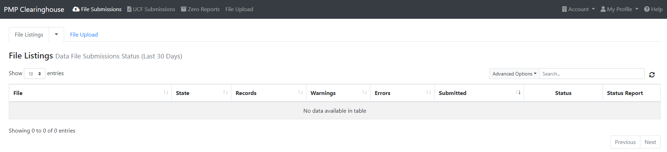

Data Delivery Methods
This chapter provides information about data delivery methods you can use to upload your controlled substance reporting data file(s) to PMP Clearinghouse.
For quick reference, you may click the desired hyperlink in the following table to view the step-by-step instructions for your chosen data delivery method:
Delivery Method | Page
Secure FTP | 10
Web Portal Upload | 11
Manual Entry (UCF) | 12
Zero Reports | 15

Secure FTP
If you are submitting data to PMP Clearinghouse using SFTP, you must configure individual subfolders for the PMP systems to which you are submitting data. These subfolders must be created in the homedir/directory folder, which is where you are directed once authenticated, and should be named using the PMP abbreviation (e.g., AK, DC, GU, KS, MA, PR, etc.). Data files not submitted to a PMP subfolder will be required to have a manual PMP assignment made on the File Listings page. Please refer to PMP Subfolders for additional details on this process.
- If you do not have a PMP Clearinghouse account, perform the steps in Creating Your Account.
Or
- If you have a PMP Clearinghouse account but have not enabled SFTP access, perform the steps in Adding SFTP Access to an Upload Account.
- Prepare the data file(s) for submission, using the ASAP specifications described in Appendix A: ASAP 4.2A Specifications.
- SFTP the file to sftp://sftp.pmpclearinghouse.net.
- When prompted, enter the username and password you created when setting up the SFTP account.
- Place the file in the appropriate PMP-abbreviated directory.
- You can view the results of the transfer/upload on the Submissions page in PMP Clearinghouse.
Note: If you place the data file in the root directory and not a PDMP sub-folder, a symbol with a mouse over hint of “Determine PMP” is displayed on the File Status page, and you will be prompted to select a destination PMP to which the data should be sent.

Web Portal Upload
- If you do not have an account, perform the steps in Creating Your Account.
- Prepare the data file(s) for submission, using the ASAP specifications described in Appendix A: ASAP 4.2A Specifications.
Note: Files for upload should be named in a unique fashion, with a prefix constructed from the date (YYYYMMDD) and a suffix of “.dat”. An example file name would be “20220415.dat”.
- Log in to PMP Clearinghouse.
- From the home page, click the File Upload tab.
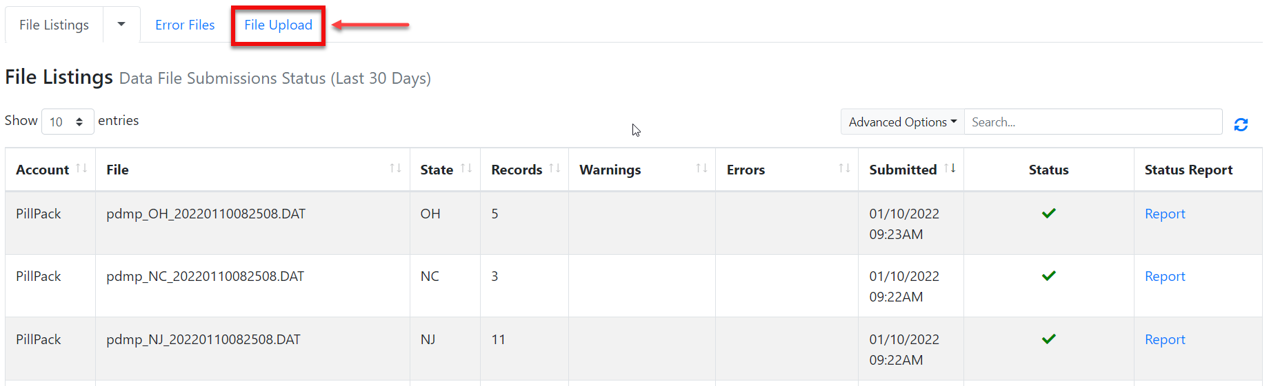
The File Upload page is displayed.
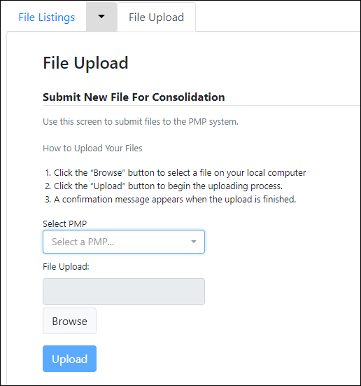
- Select the PMP to which you are submitting the file from the drop-down list in the Select a PMP field.
- Click the Browse button, located next to the File Upload field, and select the file you created in step 2.
- Click Upload.
A message is displayed prompting you to confirm the submission.
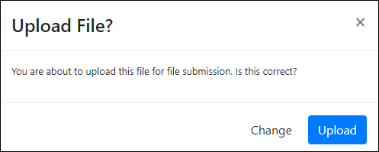
- Click Upload to continue with the file submission.
Your file is uploaded, and you can view the results of the upload on the File Submissions page.
Note: When uploading a file, the file name must be unique. If the file name is not unique, a message is displayed indicating that the file name has already been taken.

Manual Entry (UCF)
You can manually enter your prescription information into the PMP Clearinghouse system using the Universal Claim Form (UCF) within the PMP Clearinghouse web portal. This form allows you to enter patient, prescriber, dispenser, and prescription information.
- If you do not have an account, perform the steps in Creating Your Account.
- Log in to PMP Clearinghouse.
- Click UCF Submissions.
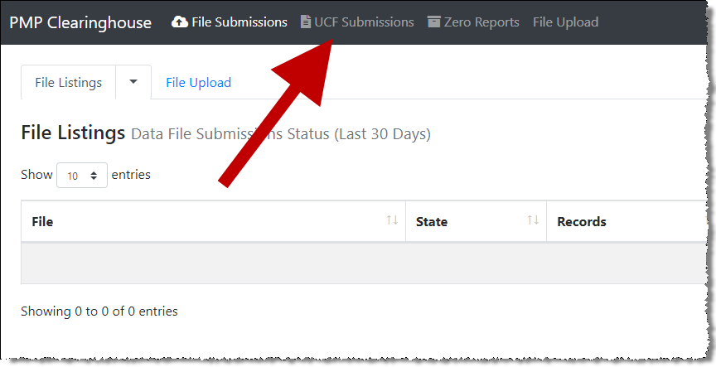
The UCF Listings page is displayed.
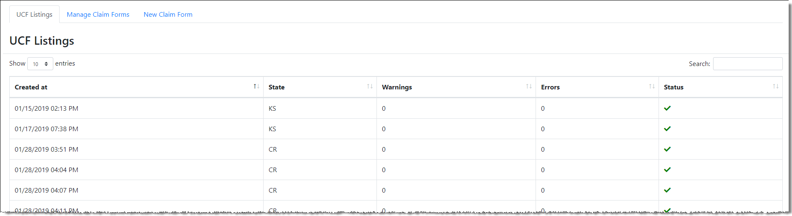
- Click the New Claim Form tab, located at the top of the page.
The Create Universal Claim Form page is displayed.
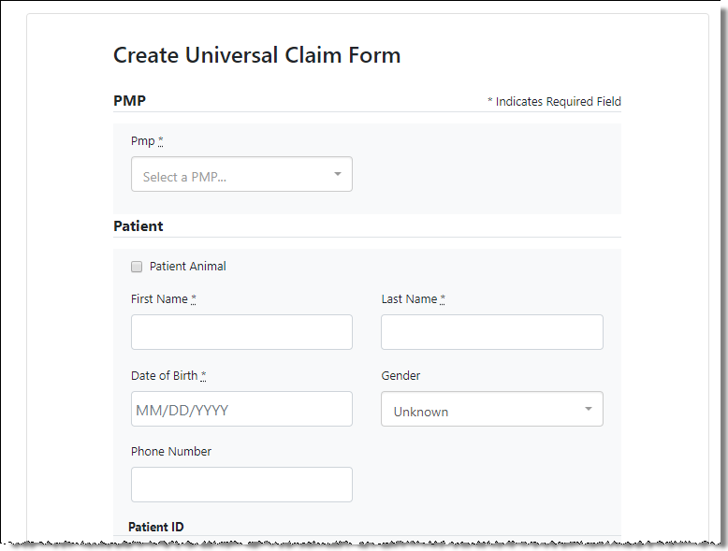
- Select the PMP to which you are submitting data from the drop-down list in the Select a PMP field.
- Complete the required fields.
Notes:
- An asterisk (*) indicates a required field.
- If you are entering a compound, click the Compound checkbox in the Drug Information section of the page, complete the required fields for the first drug ingredient, then click Add New to add additional drug ingredients.
- Once you have completed all required fields, click Save.
The Submit Now button is displayed at the top of the page.
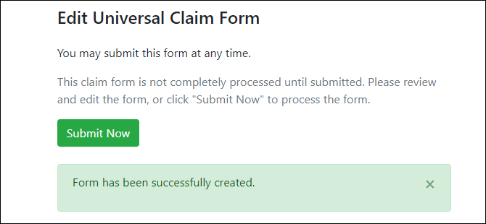
- Click Submit Now to continue with the data submission process.
A message is displayed prompting you to confirm the data submission.
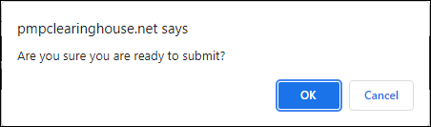
- Click OK.
Your data will be validated upon submission. If there are any errors on the UCF form, they are displayed at the top of the page.
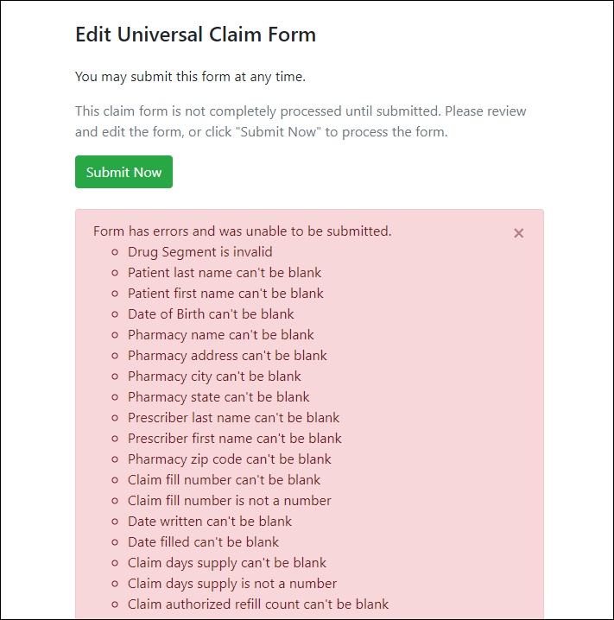
Note: If there are no errors, you are returned to the Submitted Claim Forms page and your report is listed there.
- Correct the indicated errors, then repeat steps 7–9.
Once your data has been successfully submitted, your report is listed on the UCF Listings page.

Zero Reports
If you have no dispensations to report for the preceding reporting period, you must report this information to the MA PMP.
You may submit your zero report through the PMP Clearinghouse web portal by following the steps below or via SFTP using the ASAP Standard for Zero Reports. For additional details on submitting via SFTP, please refer to Appendix C: ASAP Zero Report Specifications.
You may submit zero reports through the PMP Clearinghouse web portal using one of the following methods:
- Submit a single-click zero report
- Create a new zero report

Submit a Single-Click Zero Report
Single-click zero reporting allows you to create a profile for the pharmacy that includes its identifiers (e.g., DEA, NPI, NCPDP), so you do not have to enter it each time you submit a zero report.
To create a pharmacy profile and begin submitting single-click zero reports:
- If you do not have an account, perform the steps in Creating Your Account.
- Log in to PMP Clearinghouse.
- Click Zero Reports.
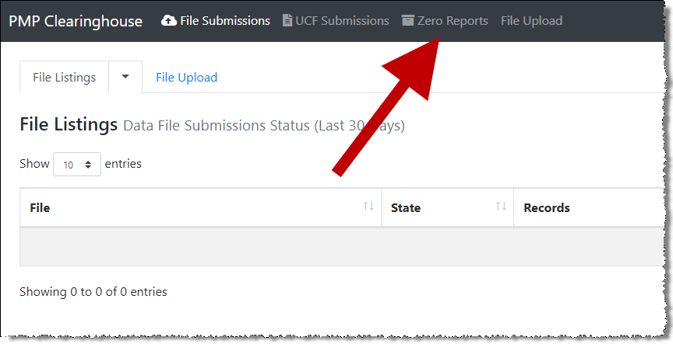
The Zero Report Listings page is displayed.
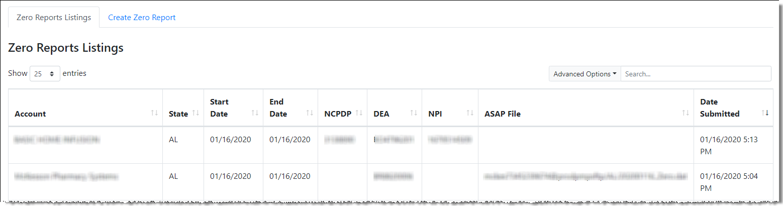
- Click the Create Zero Report tab.
The Create Zero Report page is displayed. Note that Submit a Single Click Zero Report is selected by default.
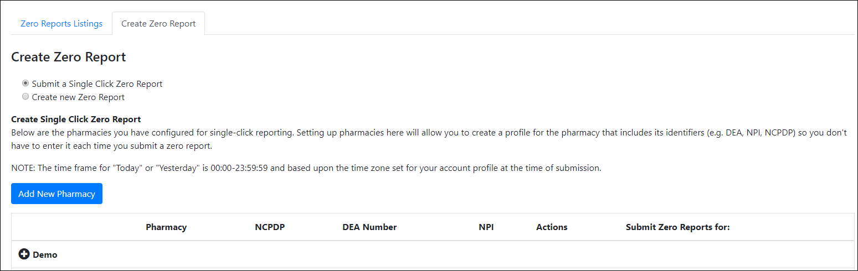
Any pharmacies you have already configured for single-click zero reporting are displayed at the bottom of the page. Continue to Step 10 to submit a zero report for those pharmacies.
If you have not configured your pharmacy for single-click zero reporting, continue to Step 5.
- Click Add New Pharmacy.
The New Pharmacy page is displayed.
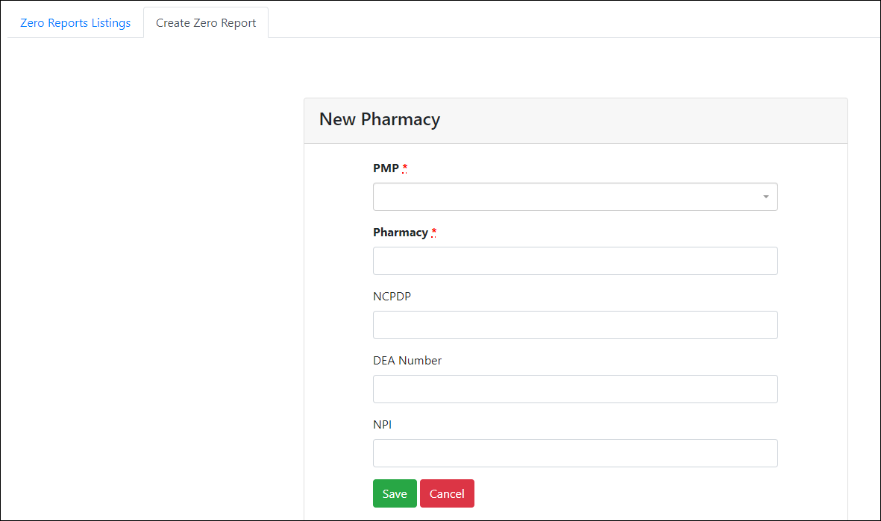
- Select the PMP for which you are submitting a zero report from the drop-down list in the PMP field.
- Enter the pharmacy’s name in the Pharmacy field.
- Populate the NCPDP, DEA Number, and/or NPI fields as required by the PMP you selected in step 6. If any of these fields are required, a red asterisk (*) will be displayed next to that field once you have selected a PMP.
- Click Save.
The pharmacy is saved and will be listed under the drop-down for the selected PMP, which is located at the bottom of the page.
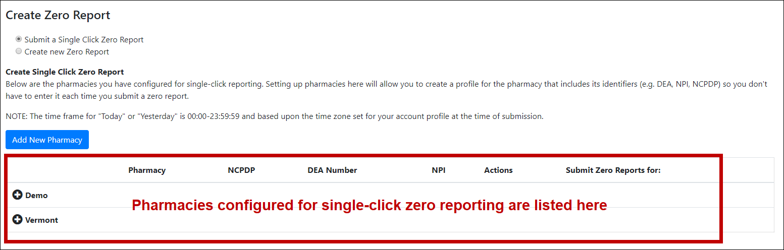
- Click the plus sign (“+”) next to the PMP for which you wish to submit a zero report.
The list of pharmacies you have configured for single-click zero reporting for that PMP is displayed. Note that this page allows you to submit a zero report for the current date (Today) or the previous day (Yesterday).
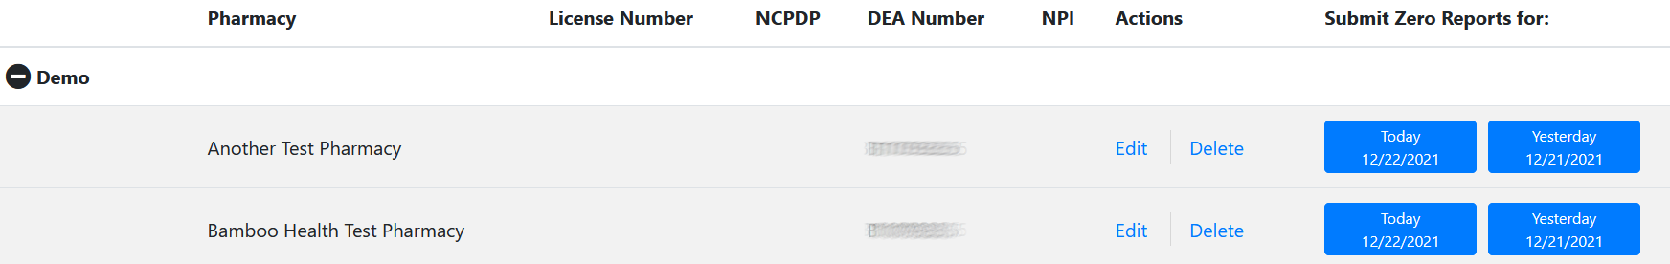
- Click Today to submit a zero report for the current date;
Or
- Click Yesterday to submit a zero report for the previous date.
Once the report is submitted, the submission is indicated on the screen, and the zero report is displayed on the Zero Report Listings tab.
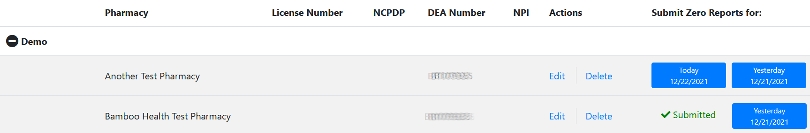
Note: You may edit or delete a pharmacy from this page.
- To edit a pharmacy, click Edit to display the Edit Pharmacy page and make any necessary changes. Refer to steps 6–9 for guidance on entering pharmacy information.
- To delete a pharmacy, click Delete. You will be prompted to confirm the deletion. Once you confirm the deletion, the pharmacy configuration will be removed.

Create a New Zero Report
- If you do not have an account, perform the steps in Creating Your Account.
- Log in to PMP Clearinghouse.
- Click Zero Reports.
The Zero Report Listings page is displayed.
- Click the Create Zero Report tab.
The Create Zero Report page is displayed. Note that Submit a Single Click Zero Report is selected by default.
- Click the button to select Create new Zero Report.
The Create Zero Report page is displayed.
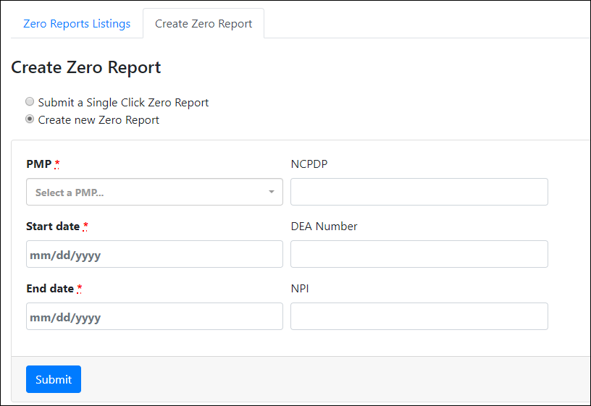
- Select the PMP for which you are submitting a zero report from the drop-down list in the Select a PMP field.
- Enter the start date and end date for the zero report in the Start date and End date fields using the MM/DD/YYYY format. You may also select the dates from the calendar that is displayed when you click in these fields.
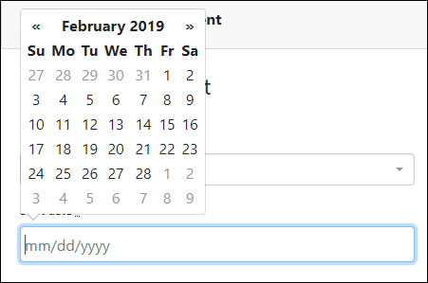
- Enter your NCPDP, DEA, and/or NPI numbers, if required by your PMP.
Note: If any of these fields are required by your PMP, they will be marked with a red asterisk (*).
- Click Submit.
Your zero report is submitted to PMP Clearinghouse and will be displayed on the Zero Report Listings tab.

Data Compliance
This chapter describes how to view the status of your submitted data files and how to correct errors.

File Listings
The File Listings page displays information extracted from the data files submitted to PMP Clearinghouse, including the file name, number of records identified within the data file, number of records that contain warnings, number of records that contain errors, and the date and time of submission. Click File Submissions to access this page.
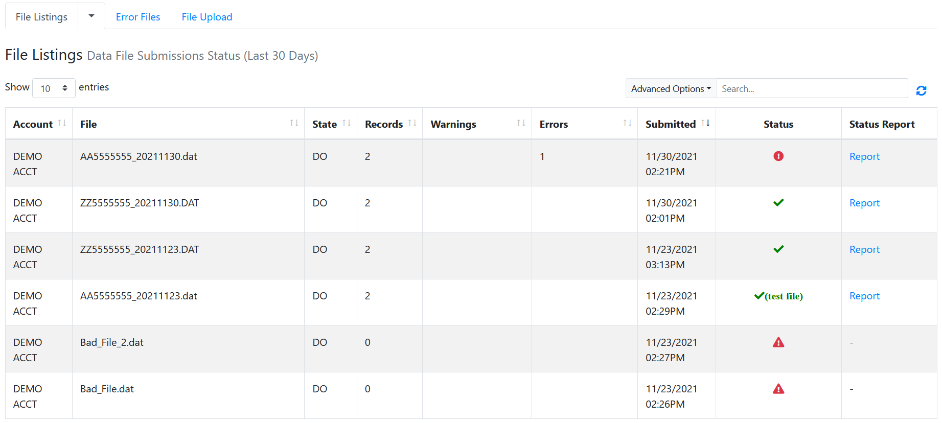
- The Status column, located at the end of each row, displays the file status via color-coded icon. Hovering over the icon will display the status message.
- The Status Report column, located next to the Status column, contains a link to the status report for that file. Please refer to File Status Report for more information on how to read and interpret this report.
If a file contains errors, it will have a 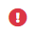 symbol with a mouse over hint of “Pending Dispensation Error” within the status column. You can click the error icon in the Status column to display the Error Correction page, which allows you to view the records containing errors (see View Records for more information). Please refer to Error Correction for instructions on how to correct errors.
If a file is unable to be parsed into the PMP Clearinghouse application, it will have an symbol with a mouse over hint of “ASAP Errors.” Clicking the icon will display the detailed error, which indicates what element was missing or malformed. To correct these errors, a new file must be submitted to PMP Clearinghouse. It is not necessary to void a file that failed parsing since it was not successfully submitted to PMP Clearinghouse.
If you submitted a file via SFTP without using a PMP-specific sub-folder, the file will be displayed, and symbol will be displayed in the status column with a mouse over hint of “Determine PMP.” Clicking the icon will prompt you to select a destination PMP to which the data file will be transferred.
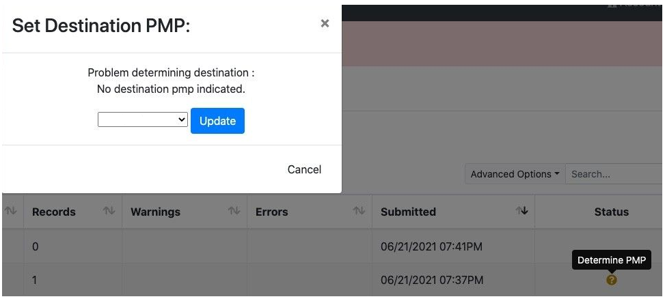
If you submitted a zero report via file upload or SFTP that is malformed or missing information, the file will be displayed, and an exclamation mark icon inside a red triangle will be displayed in the status column. Hovering over the icon will display the “Invalid Zero Report” error. Clicking on the icon will display the detailed error message. To correct these errors, a new zero report must be submitted. Error example:
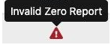

UCF Listings
The UCF Listings page displays information about the UCFs submitted to PMP Clearinghouse, including the number of warnings and errors. Click UCF Submissions to access this page.
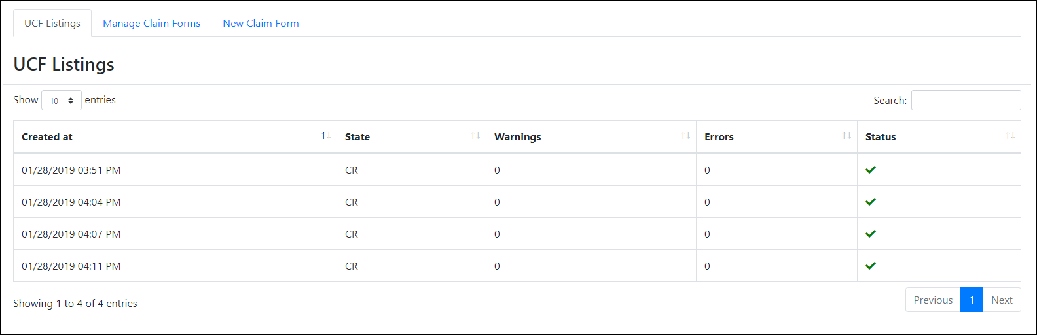
The Status column, located at the end of each row, displays the UCF’s status. Data entered into the UCF is validated upon submission; therefore, successfully submitted UCFs should not contain errors. However, if you have attempted to submit a UCF with errors and did not immediately correct those errors and submit the record, you have 30 days to make updates to these records in Clearinghouse.
- To view pending or incomplete submissions, click the Manage Claim Forms tab.
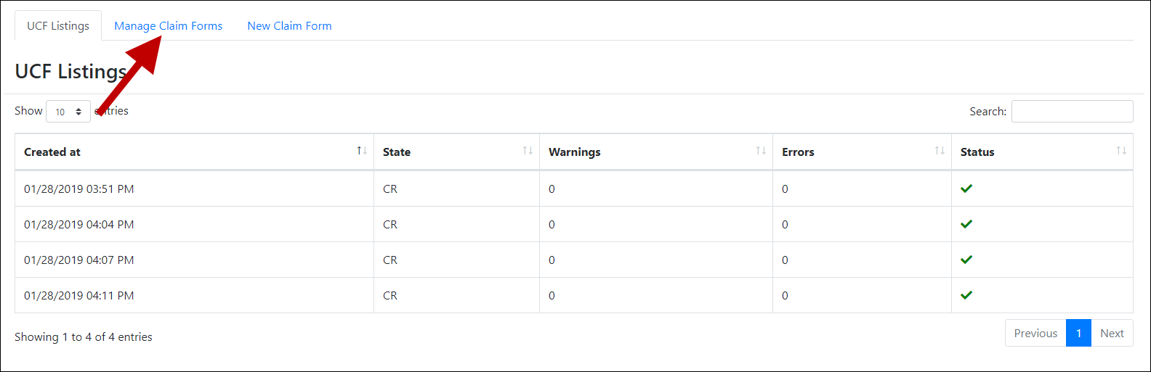
The Pending Claim Forms page is displayed.
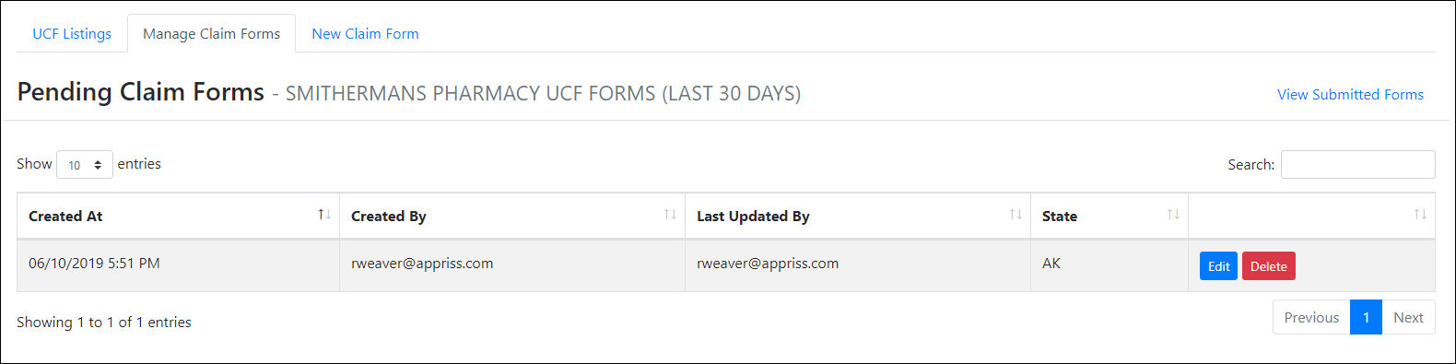
- Click Edit next to the form you wish to update.
Note: If it has been longer than 30 days, the Edit option will not be available. You must click Delete to delete the record and start over.
The Edit Universal Claim Form page is displayed.
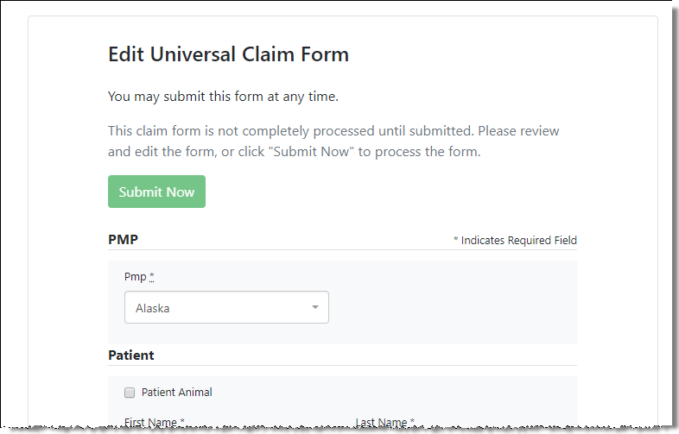
- Make the necessary corrections or changes, and then click Submit Now, located at the top of the page.
A message is displayed prompting you to confirm the data submission.
- Click OK.
Your data will be validated upon submission. If there are any remaining errors on the UCF form, they are displayed at the top of the page.
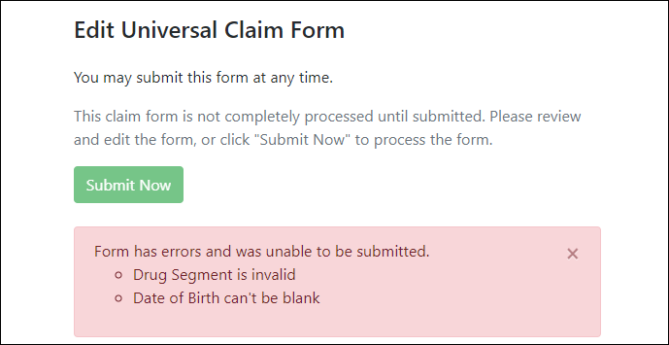
Note: If there are no errors, you are returned to the UCF Listings page and your report is listed there.
- Correct the indicated errors, then repeat steps 3-4.
Once your data has been successfully submitted, your report is listed on the UCF Listings page.

Error Correction
Clearinghouse account administrators and sub-submitters receive an email receipt upon submission of dispensations. This receipt will include any warnings or errors for that specific submission. Clearinghouse account administrators and sub-submitters are authorized to correct any errors or warnings that may occur when dispensations are submitted. Please be sure Clearinghouse account email addresses are kept current to ensure receipt of notices.

View Records with Errors
The Error Correction page displays more information about the records within a selected data file that need correcting, including Prescription Number, Segment Type, Warning Count, and Error Count. To access this page, click the “Pending Dispensation Error” message in the Status column of the File Listings page.
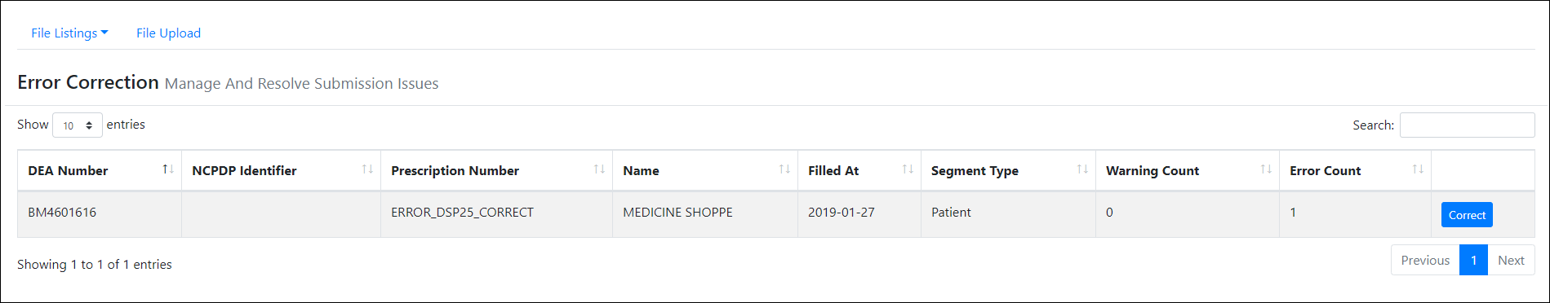
The Correct button, located at the end of each row, allows you to make corrections to the record.

Error Correction via PMP Clearinghouse
Once you click Correct on the Error Correction page, the Errors page is displayed. This page displays detailed information about the records within a selected data file that need correcting, including all the fields contained within the record and the originally submitted value, and allows you to correct those records.
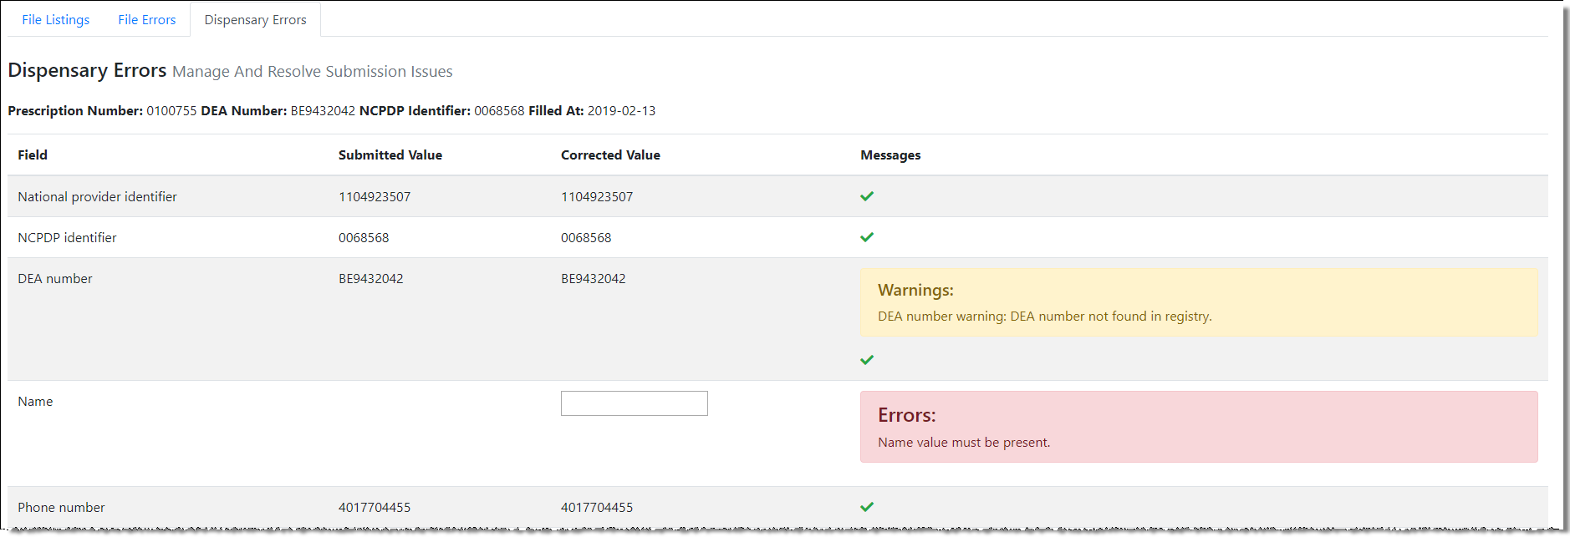
- The Corrected Value column allows you to enter a new value to correct the error.
- The Message column displays the relevant error message explaining why the value entered in that field did not pass the validation rules.
For files that failed to parse, the error identified is "best effort" and any information we could not parse is listed as "unparseable" in the file. In this case, you must submit a corrected file.
To correct records:
- Identify the fields that require corrections. Fields containing errors are highlighted in red, as shown in the screenshot above.
- Enter the corrected value in the Corrected Value column.
- Click Submit.
The error is processed through the validation rules.
- If the changes pass the validation rules, the record is valid, and a message is displayed indicating that the errors have been corrected. The File Listings and Error Correction pages are also updated.
- If the changes fail the validation rules, a message is displayed indicating that there was a problem correcting the errors, and the Message column is updated with any new error message. Repeat steps 2–3 until the errors have been corrected and the file can be successfully submitted.

Error View and Correction on MassPAT
Pharmacists who are responsible for data submission for a pharmacy or pharmacies can request access to the Error Correction and Rx Maintenance features in their personal MassPAT account.
These convenient features allow the pharmacist to view and correct records that have failed to parse and correct records that have been accepted into MassPAT but contain inaccuracies that need to be fixed. For more information contact the MA PMP at: mapmp.dph@mass.gov.

Error Correction via File Submission
The ASAP 4.2A standard requires a pharmacy to select an indicator in the DSP01 (Reporting Status) field. These indicators allow you to submit new records, revise and resubmit records, and void (delete) erroneous records. These actions are indicated by supplying one of the following values in the DSP01 field:
- 00 New Record – indicates a new record
- 01 Revise – indicates that one or more data elements in a previously-submitted record have been revised
- 02 Void – indicates that the original record should be removed
To revise a record:
- Create a record with the value 01 in the DSP01 field.
- Populate the following fields with the same information originally submitted in the erroneous record:
NCPDP/NABP Provider ID (PHA02)
DEA Number (PHA03)
Prescription number (DSP02)
Date Filled (DSP05)
Refill number (DSP06)
Quantity (DSP09)
Note: If you need to revise any of the fields listed above, you must delete the original record and submit a new one with the correct information. Otherwise, a duplicate record will be created.
- Fill in all other data fields with the correct information. This information will override the original data linked to the fields referenced in step 2.
- Submit the record.

Email Reports
Email status reports are automatically sent to all users associated with a specific data submitter account. These reports are used to identify errors in files that have been submitted and to confirm zero report submissions. Please be sure that the primary email account in the User Profile will be monitored for communications from Clearinghouse by the data submitter.

File Failed Report
You will receive the File Failed Report if a submitted file was not able to be parsed and was not processed into PMP Clearinghouse. The report contains a description of the error encountered within the file. In the event of a failed file, a new file should be submitted with the necessary corrections.
Note: Failed files are not parsed into Clearinghouse and do not require a voided ASAP file to remove it from the system.
An example File Failed Report is provided below.
SUBJ: Massachusetts ASAP file: fake-test3.txt - Parse Failure

BODY:
Error Message
-----------------------------------------------------------------------------
Failed to decode the value '04' for the bean id 'transactionControlType'.

Summary:
* File Name: fake-test3.txt
* ASAP Version: 4.2A
* Transaction Control Number: unparseable
* Transaction Control Type: unparseable
* Date of Submission: January 30, 2022

NOTE: This file could not be received into the system because the system could not recognize its content as a valid ASAP format. Action is required to resolve the issues and a subsequent file should be submitted. As such the information provided in this report is "best effort" and any information we could not parse is listed as "unparseable" in the fields above.

File Status Report
The File Status Report serves as notification that a data file is currently being parsed by the PMP system.
This report identifies specific records in the submitted data file and returns identifying information about the record, including specific errors identified during the validation process. It uses fixed-width columns and contains a summary section after the error listings. Each column contains a blank two-digit pad at the end of the data.
The columns are set to the following lengths:
Column | Length
DEA | 11 (9 + pad)
NCPDP | 9 (7 + pad)
NPI | 12 (10 + pad)
Prescription | 27 (25 + pad)
Filled | 10 (8 + pad)
Segment | 18 (16 + pad)
Field | 18 (16 + pad)
Type | 9 (7 + pad)
Message | Arbitrary
The File Status Report notifies you of the following scenarios:
- Total records: The total number of records contained in the submitted data file.
- Duplicate records: The number of records that were identified as already existing within the PMP system. Duplicate records are not imported to prevent improper patient information.
- Records in process: The number of records remaining to be processed into the system (usually only displays a number if the file has not finished loading at the time the report is sent out).
Note: Records remaining to be processed will continue to be processed even after the status report is sent.
- Records with errors: The number of records that contain errors. These errors must be corrected for the record to be imported into the system. If a zero (0) is displayed, there are no errors in the data. Please refer to Error Correction for instructions on correcting errors.
- Records with warnings: The number of records that contain warnings. These warnings do not need to be corrected for the record to be imported into the system. If a zero (0) is displayed, there are no warnings in the data.
- Records imported with warnings: The number of records with warnings that were imported. If a record contains both warnings and errors, the errors must be corrected to be submitted to the system. Please refer to Error Correction for instructions on correcting errors.
- Records imported without warnings: The number of records without warnings that were imported.
Note: The initial File Status Report is sent out two (2) hours after the file has been submitted to the system. Additional reports will be sent out every 24 hours if errors continue to be identified within a submitted data file.
An example File Status Report is provided on the following page.

SUBJ: Massachusetts ASAP file: fake-test3.txt - Status Report

BODY:
DEA NCPDP NPI Prescription Filled Segment Field Type Message
--------------------------------------------------------------------------------------------------------------------------------
BE1234567 1347347 9034618394 123486379596-0 20220808 Dispensation refill_number WARNING message example
DE9841394 3491849 4851947597 357199504833-345 20220808 Dispensation days_supply ERROR message example

Summary:
* File Name: fake-test3.txt
* ASAP Version: 4.2A
* Transaction Control Number: 23489504823
* Transaction Control Type: send
* Date of Submission: August 9, 2022
* Total Record Count: ###
* Duplicate Records: ###
* In Process Count: ###
* Records with Error Count: ###
* Imported Records Count: ###
* Records Imported with Warning Count: ###

Zero Report Confirmation
You will receive a Zero Report Confirmation after successfully submitting a zero report to PMP Clearinghouse. This report displays the PMP to which the zero report was submitted, date range for the zero report, date the zero report was submitted to PMP Clearinghouse, and date the report was originally created.
An example Zero Report Confirmation is provided below.
SUBJ: ASAP Zero Report: zero_reports_20220306KSMCPS.DAT

BODY:
Summary:
* File Name: zero_reports_20220306KSMCPS.DAT
* PMP Name: Mass
* Date Range: 2022-03-06 - 2022-03-06
* Submission Date: 2022-03-07
* ASAP Creation Date: 2022-03-07

Managing Your Upload Account
The Account menu option allows you to manage the information associated with your organization’s upload account, including adding users, PMPs, and SFTP access to your account as well as editing your organization’s account information.
Note: This chapter contains information for managing the upload account with which your user account is associated. For information about editing and managing your individual user account, including how to change your password, please refer to Managing Your User Profile.

Adding Users to Your Upload Account
PMP Clearinghouse allows data submitters to add new users to the system who have the same rights and access to submitting data and viewing file status. This practice allows you to create an account to be used for a backup individual.
- Log in to PMP Clearinghouse.
- Click Account.
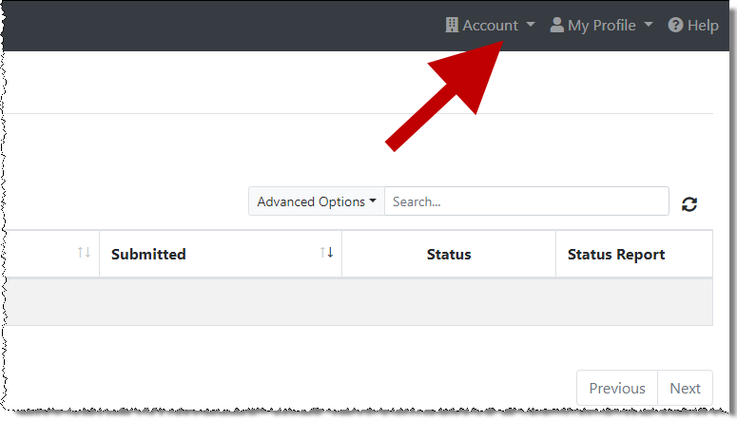
- Select Users from the Account drop-down menu.
The Account Users page is displayed.
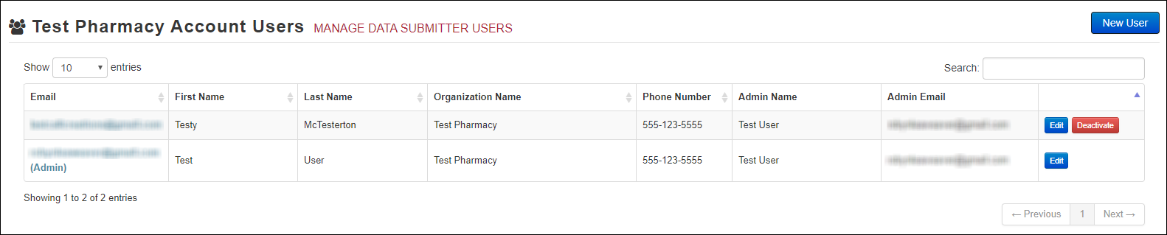
- Click New User, located in the top right corner of the page.
The New Data Submitter User page is displayed.
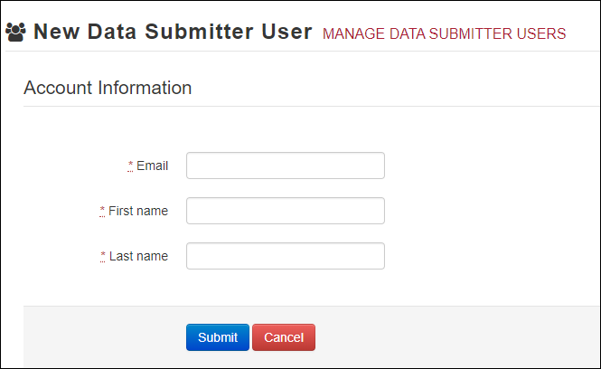
- Enter the new data submitter’s email address, first name, and last name in the appropriate fields. Note that all fields are required.
- Click Submit.
The user is added to the list of data submitters for your organization, and you are returned to the Account Users page.
- Please inform the new user of the account creation.
- The user will receive an email with a link for them to confirm their account.
- Once the account has been confirmed, the user will need to navigate to the PMP Clearinghouse Login page and click Forgot your password? to create a password for their account and log in.
- Upon logging in, the user will be able to view all files submitted for your organization’s upload account.

Changing Another User’s Password
If a user is unable to update their own password, a data submitter can update a password for any additional users linked to the admin account.
- Log in to PMP Clearinghouse.
- Click Account.
- Select Users from the Account drop-down menu.
The Account Users page is displayed.
- Click the Edit button, located to the right of the user’s information.
The Edit Data Submitter User page is displayed.
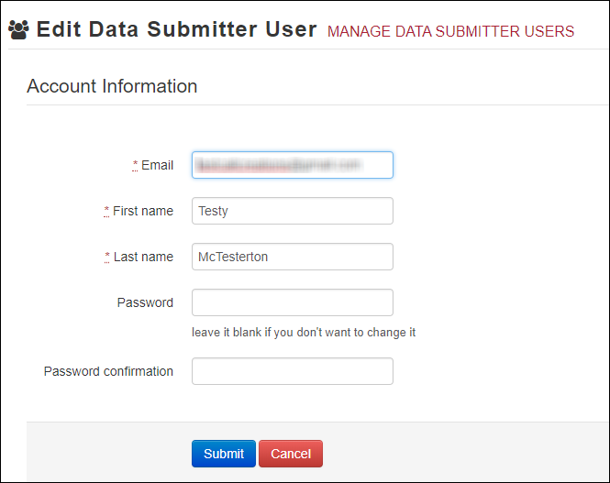
- Enter a new password for the user in the Password field, then re-enter it in the Password confirmation field. The password requirements are provided below.
Passwords must contain:
- At least eight (8) characters
- One (1) uppercase letter
- One (1) lowercase letter
- One (1) number
- One (1) special character, such as !, @, #, $, etc.
- Click Submit.
The password is changed.

Adding PMPs to Your Upload Account
If your organization needs to submit data files to an additional PMP that uses PMP AWARxE, you can submit the request through PMP Clearinghouse.
- Log in to PMP Clearinghouse.
- Click Account.
- Select Multi State Approval from the Account drop-down menu.
The Multi State Approval page is displayed. This page displays all PMPs currently using the PMP AWARxE system as well as your data sharing status with each PMP.
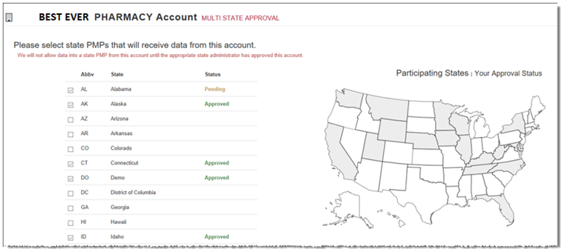
- To request to submit data to another PMP, click to select the checkbox next to that PMP.
PMP Clearinghouse automatically saves your changes, and your request is submitted to the PMP administrator for review and approval. Once the request has been approved, the status for that PMP will change from “Pending” to “Approved,” and you may begin submitting data to that PMP.
Notes:
- If you are submitting data via SFTP, the file must be located in the proper subfolder to ensure delivery to the desired PMP.
- To cancel data submission to a PMP, uncheck the box for that PMP. Note that if you need to submit data to that PMP again in the future, you will have to go through the approval process again.

Adding SFTP Access to an Upload Account
If a registered upload account did not request an SFTP account during the account creation process, you can request one at any time using the Account menu option.
- Log in to PMP Clearinghouse.
- Click Account.
- Select SFTP Details.
The SFTP Account page is displayed.
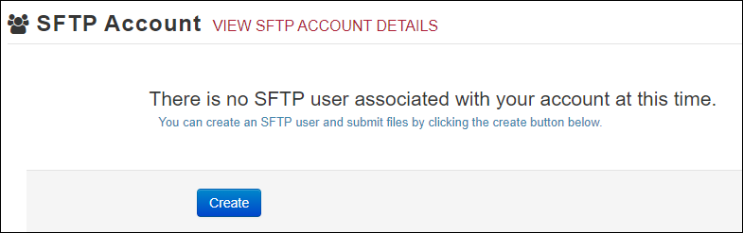
Note: If an SFTP account already exists for the upload account, the username is displayed on the SFTP Account page.
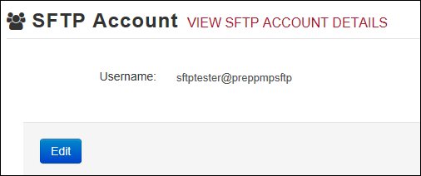
You cannot change the SFTP account username; however, you can update the password by clicking Edit.
- Click Create.
The Create a New SFTP Account page is displayed.
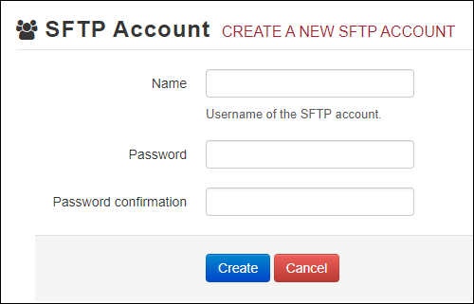
- Enter a username for the account in the Name field.
Notes:
- The username must contain a minimum of eight (8) characters.
- Once the SFTP account has been created, you cannot change the username.
- Enter a password for the account in the Password field, then re-enter it in the Password confirmation field. The password requirements are provided below.
Passwords must contain:
- At least eight (8) characters
- One (1) uppercase letter
- One (1) lowercase letter
- One (1) number
- One (1) special character, such as !, @, #, $, etc.
Once the account has been successfully created, this password will be input into the pharmacy software so that submissions can be automated.
Notes:
- This password can be the same as the one used when the upload account was created.
- Unlike your Profile password (i.e., your user account password), the SFTP password does not expire.
- The URL to connect via SFTP is sftp://sftp.pmpclearinghouse.net.
- Additional details on SFTP configuration can be found in Appendix D: SFTP Configuration.
- Click Create.
The account is created, and the username is displayed.
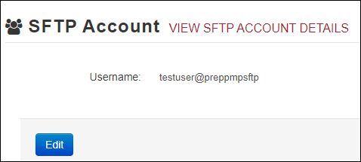

Editing Your Upload Account
Note: This function only allows you to edit your organization’s upload account. If you need to edit your individual profile information, please refer to Editing Your Profile.
- Log in to PMP Clearinghouse.
- Click Account.
- Select Account Details.
The Account page is displayed as shown on the following page.
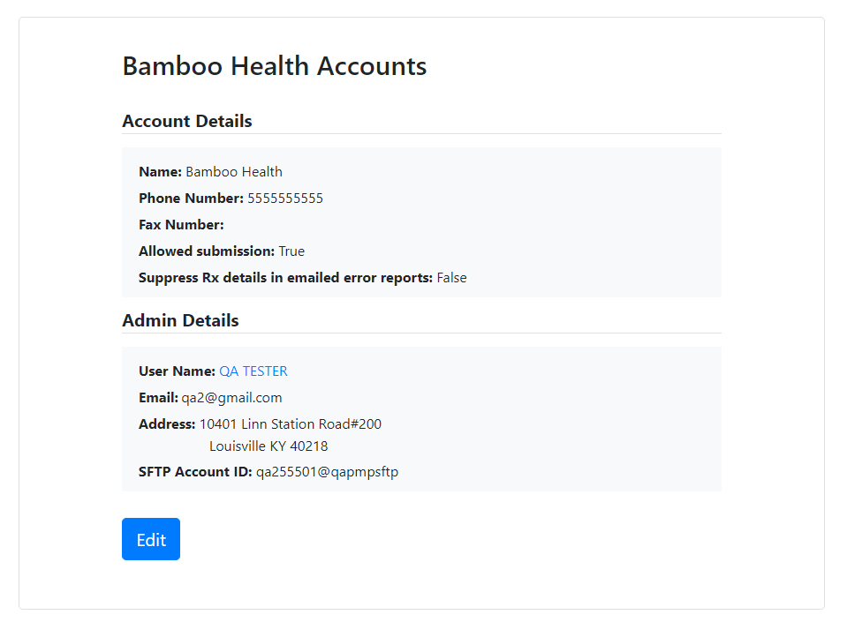
- Click Edit.
The Edit Account page is displayed.
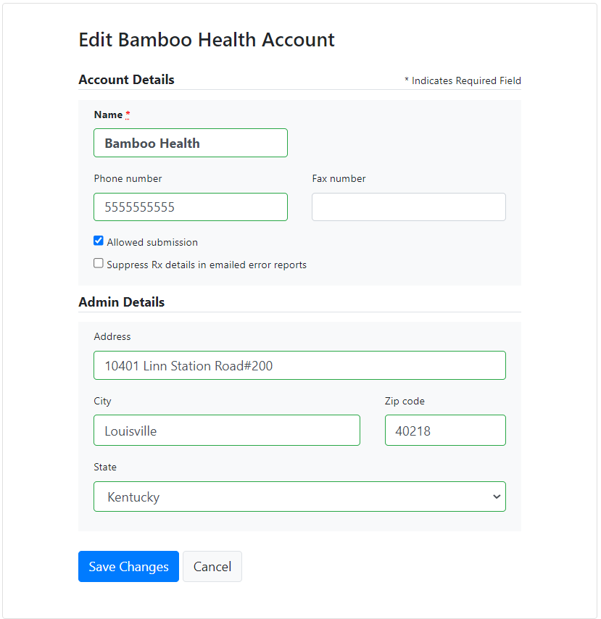
- Update the information as necessary, then click Submit.
The account information is updated.

Changing Administrator Account
If the Clearinghouse administrator account needs to be transferred from one user to another, please contact PMP Clearinghouse directly at 1-855-5MA-4PMP (1-855-562-4767).

Managing Your User Profile
This chapter describes how to manage your individual user profile, including how to edit your profile and manage your password.
Note: This chapter contains information for managing your individual user profile. For information about managing your organization’s upload account, including how to add users, please refer to Managing Your Upload Account.

Editing Your Profile
Note: This function only allows you to edit your individual profile information. If you need to edit the Organization Information, please refer to Editing Your Upload Account.
- Log in to PMP Clearinghouse.
- Click My Profile.
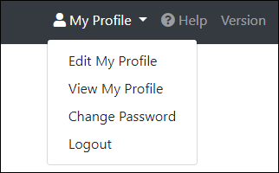
- Select Edit My Profile.
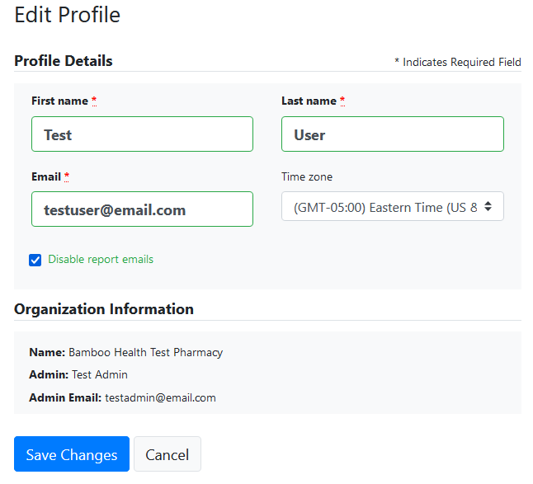
- Update your information as necessary, then click Submit.
Your changes are saved, and your updated profile is displayed.

Changing Your Password
Note: Clearinghouse passwords expire every 90 days. You can use this function to proactively change your password before it expires. If your password has already expired, or you have forgotten your password, navigate to the PMP Clearinghouse Login page and click Forgot your password? to reset it. Please refer to Resetting Your Password for more information.
- Log in to PMP Clearinghouse.
- Click My Profile.
- Select Change Password.
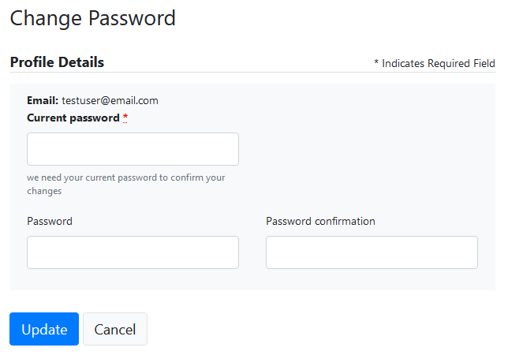
- Enter your current password in the Current Password field.
- Enter your new password in the Password field, then re-enter it in the Password confirmation field. The password requirements are provided below.
Passwords must contain:
- At least eight (8) characters
- One (1) uppercase letter
- One (1) lowercase letter
- One (1) number
- One (1) special character, such as !, @, #, $, etc.
- Click Update.
Your password is updated, and you will use it the next time you log in to PMP Clearinghouse.

Resetting Your Password
If you have forgotten your password or your password has expired, perform the following steps to reset it.
- Open an internet browser window and navigate to the PMP Clearinghouse Login page located at https://pmpclearinghouse.net/users/sign_in.
- Click the Forgot your password? link, located in the Help section of the page.
The Forgot your password page is displayed.
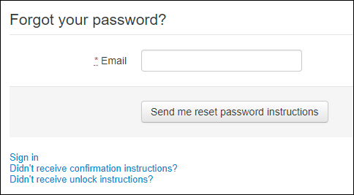
- Enter the email address associated with your user account, then click Send me reset password instructions.
- Once you receive the reset password email, click the Change my password link within the email.
The Change your password page is displayed.
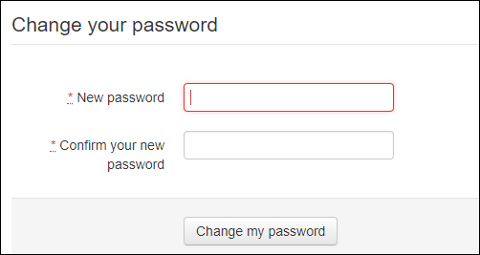
- Enter your new password in the New password field, then re-enter it in the Confirm your new password field. The password requirements are provided below.
Passwords must contain:
- At least eight (8) characters
- One (1) uppercase letter
- One (1) lowercase letter
- One (1) number
- One (1) special character, such as !, @, #, $, etc.
- Click Change my password.
Your password is changed, and you can now use it to log in to PMP Clearinghouse.

Assistance and Support

Technical Assistance
If you need additional help with any of the procedures outlined in this guide, you can:
- Contact Bamboo Health at 1-855-5MA-4PMP (1-855-562-4767);
OR
- Create a support request at the following URL: https://pmpclearinghouse.zendesk.com/hc/en-us/
Technical assistance is available 24 hours per day, 7 days per week, 365 days per year.

Administrative Assistance
If you have non-technical questions regarding the MA PMP, please contact:
Phone: 617-753-7310
E-mail: mapmp.dph@mass.gov
Website: http://www.mass.gov/dph/dcp/pmp

Document Information

Disclaimer
Bamboo Health has made every effort to ensure the accuracy of the information in this document at the time of printing; however, information is subject to change.

Change Log
Version | Date | Chapter/Section | Change Made
1.0 | 02/16/2016 | N/A | N/A; initial publication
1.1 | 02/26/2016 | Global | Updated per Pharmacy Kickoff Meeting feedback
1.2 | 04/05/2016 | File Status Report | Added additional compliance language
 |  | ASAP 4.2 Specifications | Changed DSP18–DSP21 from conditional to optional
 |  |  | Modified condition of AIR07/AIR08
2.0 | 06/21/2016 | Deliveries | Updated language regarding AIR06
 |  | Appendix D | Added appendix
3.0 | 05/10/2017 | Global | Added requirement for pharmacies to submit gabapentin (effective 08/01/2017); for details, refer to Reporting Gabapentin Prescriptions
 |  | ASAP 4.2 Specifications | AIR fields (customer ID):  - AIR11 – customer ID must be collected at pick-up only (effective 08/01/2017)  - AIR03, 04, 05 – customer ID must be collected for refills (effective 08/01/2017)  - AIR03, 04, 05 – customer ID must be collected for gabapentin (effective 08/01/2017)
 |  |  | Added requirement for PRE01 (prescriber NPI) to be submitted in each record (effective 08/01/2017)
 |  |  | Changed PRE02 (prescriber DEA) to be conditionally required (effective 08/01/2017)
 |  |  | Changed PRE03 (DEA suffix) to optional (effective 08/01/2017)
4.0 | 08/01/2018 | Error Correction | Clarified error correction process
 |  | Error Correction in MassPAT | Added new section
 |  | Appendix E/Data Submission Waivers | Added appendix
5.0 | 08/01/2022 | Global | Updated to current document template
 |  |  | Updated screenshots to reflect updated user interface (note that this is only a cosmetic change; no functionality changes are included)
 |  | 6.2/UCF Listings | Added clarification on correcting UCF errors
 |  | 6.3.3/Error Correction via File Submission | Added section on correcting errors by submitting a revision file using 01 (revise) in the DSP01 field
 |  | 4.4/Zero Reports | Separated into two sections (Submit a Single-Click Zero Report and Create a New Zero Report) to reflect the addition of the single-click zero report submission functionality
 |  | 4.4.1/Submit a Single-Click Zero Report | Added new section with instructions for submitting a single-click zero report.
 |  | Appendix A | Updated to accommodate new fields for ASAP 4.2A:  - PHA13 - Pharmacy License Number is optional  - DSP01 – Reporting Status has a new limited data set option  - DSP05 – Date Filled has been changed to Date Prepared  - DSP22 – Quantity Prescribed is conditionally required  - DSP24 – Treatment Type is optional  - DSP25 – Diagnosis Code is conditionally required  - PRE09 – XDEA Number is conditionally required  Clarified fields required for Veterinary Prescriptions (PAT07, PAT08, and PAT23)  DSP18-21 are now conditionally required for electronic prescriptions  Added clarifications to AIR05-08  Added clarifications to Deliveries
 |  | Appendix F | Added new appendix to correspond with upgrade to ASAP 4.2A
 |  | Global | Updated guide to reflect Bamboo Health branding.
5.1 | 10/05/2022 | Error Correction | Clarified error correction process
 |  | Naloxone | Naloxone submission guidance added.
5.2 | 05/09/2023 | ASAP AIR Section | Added AIR11

- ASAP 4.2A Specifications
The following table lists the required definitions for submitting ASAP 4.2A records to the MA PMP. Please refer to Appendix B: Data Entry Guidance for more information on those fields that may require extra guidance for proper data entry.
The Requirement column uses the following codes:
- R = Required submission
- C = Conditional submission; please refer to notes
- O = Optional submission; please submit if available
Note: For additional details or examples, please consult the full Implementation Guide for the ASAP Standard for Prescription-Monitoring Programs, Version 4 Release 2. That document is available from the American Society for Automation in Pharmacy at www.asapnet.org or by phone at (610) 825-7783.
Segment | Element ID | Element Name | Requirement | Notes
TH: Transaction Header (required)
Used to indicate the start of a transaction. It also assigns the data element separator, segment terminator, and control number.
 | TH01 | Version/Release Number  Code uniquely identifying the transaction.  Format = xx.x | R
 | TH02 | Transaction Control Number  Sender assigned code uniquely identifying a transaction. | R
 | TH03 | Transaction Type  Identifies the purpose of initiating the transaction.  - 01 Send/Request Transaction  - 02 Acknowledgement (used in Response only)  - 03 Error Receiving (used in Response only)  - 04 Void (used to void a specific Rx in a real-time transmission or an entire batch that has been transmitted) | R
 | TH04 | Response ID  Contains the Transaction Control Number of a transaction that initiated the transaction. Required in response transaction only. | O
 | TH05 | Creation Date  Date the transaction was created. Format: CCYYMMDD. | R
 | TH06 | Creation Time  Time the transaction was created. Format: HHMMSS or HHMM. | R
 | TH07 | File Type  - P = Production  - T = Test | R
 | TH08 | Routing Number  Reserved for real-time transmissions that go through a network switch to indicate, if necessary, the specific PMP the transaction should be routed to. | O
 | TH09 | Segment Terminator Character  This terminates the TH segment and sets the actual value of the data segment terminator for the entire transaction. | R
IS: Information Source (required)
Used to convey the name and identification numbers of the entity supplying the information.
 | IS01 | Unique Information Source ID  Reference number or identification number.  (Example: phone number) | R
 | IS02 | Information Source Entity Name  Entity name of the Information Source. | R
 | IS03 | Message  Free-form text message. | O
PHA: Pharmacy Header (required)
Used to identify the pharmacy or dispensing prescriber.
Note: It is required that information be provided in at least one of the following fields: PHA01, PHA02, or PHA03.
 | PHA01 | National Provider Identifier (NPI)  Identifier assigned to the pharmacy by CMS. | O
 | PHA02 | NCPDP/NABP Provider ID  Identifier assigned to pharmacy by the National Council for Prescription Drug Programs. | R
 | PHA03 | DEA Number  Identifier assigned to the pharmacy by the Drug Enforcement Administration. | R
 | PHA04 | Pharmacy Name  Free-form name of the pharmacy. | R
 | PHA05 | Address Information – 1  Free-form text for address information. | O
 | PHA06 | Address Information – 2  Free-form text for address information. | O
 | PHA07 | City Address  Free-form text for city name. | R
 | PHA08 | State Address  U.S. Postal Service state code or other regional jurisdiction code. | R
 | PHA09 | ZIP Code Address  U.S. Postal Service ZIP Code. | R
 | PHA10 | Phone Number  Complete phone number including area code. Do not include hyphens. | O
 | PHA11 | Contact Name  Free-form name. | O
 | PHA12 | Chain Site ID  Store number assigned by the chain to the pharmacy location. Used when the PMP needs to identify the specific pharmacy from which information is required. | C | If the pharmacy has multiple locations, submit the chain site ID (location ID).
 | PHA13 | Pharmacy Permit/License Number  This field helps identify the sending pharmacy. | O
PAT: Patient Information (required)
Used to report the patient’s name and basic information as contained in the pharmacy record.
 | PAT01 | ID Qualifier of Patient Identifier  Code identifying the jurisdiction that issues the ID in PAT03. | O
 | PAT02 | ID Qualifier  Code to identify the type of ID in PAT03. If PAT02 is used, PAT03 is required.  - 01 Military ID  - 02 State Issued ID  - 04 Permanent Resident Card (Green Card)  - 05 Passport ID  - 06 Driver’s License ID  - 08 Tribal ID  - 99 Other (agreed upon ID) | O | Do not submit 03 Unique System ID or 07 Social Security Number.
 | PAT03 | ID of Patient  Identification number for the patient as indicated in PAT02.  An example would be the driver’s license number. | O
 | PAT04 | ID Qualifier of Additional Patient Identifier  Code identifying the jurisdiction that issues the ID in PAT06.  Used if the PMP requires such identification. | O
 | PAT05 | Additional Patient ID Qualifier  Code to identify the type of ID in PAT06 if the PMP requires a second identifier. If PAT05 is used, PAT06 is required.  - 01 Military ID  - 02 State Issued ID  - 04 Permanent Resident Card  - 05 Passport ID  - 06 Driver’s License ID  - 08 Tribal ID  - 99 Other (agreed upon ID) | O | Do not submit 03 Unique System ID or 07 Social Security Number.
 | PAT06 | Additional ID  Identification that might be required by the PMP to further identify the individual. An example might be that in PAT03 driver’s license is required and in PAT06 another form of ID is also required. | O
 | PAT07 | Last Name  Patient’s last name. | R | For veterinary scripts (PAT20 = 02), use the owner’s last name.
 | PAT08 | First Name  Patient’s first name. | R | For veterinary scripts (PAT20 = 02), use the animal’s name.
 | PAT09 | Middle Name  Patient’s middle name or initial if available. | O
 | PAT10 | Name Prefix  Patient’s name prefix such as Mr. or Dr. | O
 | PAT11 | Name Suffix  Patient’s name suffix such as Jr. or the III. | O
 | PAT12 | Address Information – 1  Free-form text for street address information. | R
 | PAT13 | Address Information – 2  Free-form text for additional address information. | O
 | PAT14 | City Address  Free-form text for city name. | R
 | PAT15 | State Address  U.S. Postal Service state code or other regional jurisdiction code. | R
 | PAT16 | ZIP Code Address  U.S. Postal Service ZIP code.  Populate with zeros if patient address is outside the U.S. | R
 | PAT17 | Phone Number  Complete phone number including area code. Do not include hyphens. For situations in which the patient does not have a phone number, submit ten 9s (i.e., 9999999999). | O
 | PAT18 | Date of Birth  Date patient was born.  Format: CCYYMMDD | R | If PAT20 = 02 (Veterinary Patient) and the animal’s date of birth is unknown, enter the best estimate.
 | PAT19 | Gender Code  Code indicating the sex of the patient.  - F Female  - M Male  - U Unknown | R
 | PAT20 | Species Code  Used if required by the PMP to differentiate a prescription for an individual from one prescribed for an animal.  - 01 Human  - 02 Veterinary Patient | R
 | PAT21 | Patient Location Code  Code indicating where patient is located when receiving pharmacy services.  - 01 Home  - 02 Intermediary Care  - 03 Nursing Home  - 04 Long-Term/Extended Care  - 05 Rest Home  - 06 Boarding Home  - 07 Skilled-Care Facility  - 08 Sub-Acute Care Facility  - 09 Acute Care Facility  - 10 Outpatient  - 11 Hospice  - 98 Unknown  - 99 Other | R
 | PAT22 | Country of Non-U.S. Resident  Used when the patient’s address is a foreign country. | C | Submit if the patient is not a U.S. resident.
 | PAT23 | Name of Animal  Used if required by the PMP for prescriptions written by a veterinarian and the pharmacist has access to this information at the time of dispensing the prescription. | O | If providing an entry, submit the name of the animal as Animal’s First Name and Owner’s Last Lame (e.g., Fluffy Smith).
DSP: Dispensing Record (required)
Used to identify the basic components of a dispensing of a given prescription order including the date and quantity.
 | DSP01 | Reporting Status  DSP01 requires one of the following codes, and an empty or blank field no longer indicates a new prescription transaction:  - 00 New Record (indicates a new prescription dispensing transaction)  - 01 Revise (indicates that one or more data element values in a previously submitted transaction are being revised)  - 02 Void (message to the PMP to remove the original prescription transaction from its data, or to mark the record as invalid or to be ignored).  Note: For prescriptions voided with a code 02, a limited data set is being offered as an option PDMPs can elect to use rather than requiring the entire prescription to be voided. This option is offered in order to streamline the process in the pharmacy when voiding a prescription. See Appendix F. | R | To void a record, rather than sending all fields exactly the same as the original record, pharmacies can optionally instead send the following Limited Data Set when DPS01 = 02:  - PHA02 (NCPDP/ NABP Provider ID)  - PHA03 (DEA Number)  - DSP02 (Prescription Number)  - DSP03 (Date Written)  - DSP05 (Date Filled)  - DSP06 (Refill Number)  - DSP13 (Partial Fill Indicator)
 | DSP02 | Prescription Number  Serial number assigned to the prescription by the pharmacy. | R
 | DSP03 | Date Written  Date the prescription was written (authorized).  Format: CCYYMMDD | R
 | DSP04 | Refills Authorized  The number of refills authorized by the prescriber. | R
 | DSP05 | Date Filled  Date prescription was prepared.  Format: CCYYMMDD | R
 | DSP06 | Refill Number  Number of the fill of the prescription.  0 indicates New Rx; 01-99 indicates the explicit fill after that original fill. | R
 | DSP07 | Product ID Qualifier  Used to identify the type of product ID contained in DSP08.  - 01 NDC  - 06 Compound (indicates a compound; if used, the CDI segment becomes a required segment) | R
 | DSP08 | Product ID  Full 11-digit NDC number, as indicated in DSP07, created by adding a leading zero to the appropriate segment to result in a 5-4-2 formatted NDC number, without punctuation. If 06 Compound is indicated in DSP07, use 99999 as the first five characters; CDI then becomes required. | R
 | DSP09 | Quantity Dispensed  Number of metric units dispensed in metric decimal format.  Example: 2.5  Note: For compounds, show the first quantity in CDI04. | R
 | DSP10 | Days’ Supply  Estimated number of days the medication will last. | R
 | DSP11 | Drug Dosage Units Code  Identifies the unit of measure for the quantity dispensed in DSP09.  - 01 Each  - 02 Milliliters (ml)  - 03 Grams (gm) | R
 | DSP12 | Transmission Form of Rx Origin Code  Code indicating how the pharmacy received the prescription.  - 01 Written Prescription  - 02 Telephone Prescription  - 03 Telephone Emergency Prescription  - 04 Fax Prescription  - 05 Electronic Prescription  - 06 Transferred/Forwarded  - 99 Other | R | Do not submit 06 value of “Transferred/ Forwarded RX.”
 | DSP13 | Partial Fill Indicator  Used when the quantity in DSP 09 is less than the metric quantity per dispensing authorized by the prescriber. This dispensing activity is often referred to as a split filling.  - 00 Not a Partial Fill  - 01 First Partial Fill  Note: For additional fills per prescription, increment by 1. So, the second partial fill would be reported as 02, up to a maximum of 99. | R
 | DSP14 | Pharmacist National Provider Identifier (NPI)  Identifier assigned to the pharmacist by CMS. This number can be used to identify the pharmacist dispensing the medication. | O
 | DSP15 | Pharmacist State License Number  This data element can be used to identify the pharmacist dispensing the medication.  Assigned to the pharmacist by the Licensing Board. | O
 | DSP16 | Classification Code for Payment Type  Code identifying the type of payment (i.e., how it was paid for).  - 01 Private Pay (cash, check, debit, credit)  - 02 Medicaid  - 03 Medicare  - 04 Commercial Insurance  - 05 Military Installations and VA  - 06 Workers’ Compensation  - 07 Indian Nations  - 99 Other | R
 | DSP17 | Date Sold  Usage of this field depends on the pharmacy management system having the ability to capture the sale event date.  Format: CCYYMMDD | R | For deliveries, enter the date delivered to the patient. See Deliveries on page 688.
 | DSP18 | RxNorm Code Qualifier  RxNorm Code that is populated in the DRU-010-09 field in the SCRIPT transaction.  - 01 Semantic Clinical Drug (SCD)  - 02 Semantic Branded Drug (SBD)  - 03 Generic Package (GPCK)  - 04 Branded Package (BPCK) | C | If DSP12 = 05 (electronic), provide DSP18–21.
 | DSP19 | RxNorm Code  Used for electronic prescriptions to capture the prescribed drug product identification. | C
 | DSP20 | Electronic Prescription Reference Number  This field should be populated with the Initiator Reference Number from field UIB-030-01 in the SCRIPT transaction. | C
 | DSP21 | Electronic Prescription Order Number  This field should be populated with the Initiator Control Reference from field UIH-030-01 in the SCRIPT standard. | C
 | DSP22 | Quantity Prescribed  This field adds clarity to the value reported in DSP13, Partial Fill Indicator. | C | If DSP13 is populated, DSP22 is required.
 | DSP23 | Rx Sig  This field captures the actual directions printed on the prescription vial label. | O
 | DSP24 | Treatment Type  This field indicates that the prescription is for opioid dependency treatment.  - 01 – Not used for Opioid Dependency Treatment  - 02 – Used for Opioid Dependency Treatment  - 03 – Pain Associated with Active and Aftercare Cancer Treatment  - 04 – Palliative Care in Conjunction with a Serious Illness  - 05 – End-of-Life and Hospice Care  - 06 – A Pregnant Individual with a Pre-existing Prescription for Opioids  - 07 – Acute Pain for an Individual with an Existing Opioid Prescription for Chronic Pain  - 08 – Individuals Pursuing an Active Taper of Opioid Medications  - 09 – Patient is Participating in a Pain Management Contract  - 99 – Other (trading partner agreed upon reason)  Note: Codes 03–99 can only be reported if provided by the prescriber. | O | This should only be reported if provided by the provider with the prescription.
 | DSP25 | Diagnosis Code  This field is used to report the ICD-10 code. If required by a PDMP. | C | Required if DSP12 = 05 Electronic Prescription.  Include when the ICD-10 code is available.
PRE: Prescriber Information (required)
Used to identify the prescriber of the prescription.
 | PRE01 | National Provider Identifier (NPI)  Identifier assigned to the prescriber by CMS. | R | See Reporting Gabapentin Prescriptions page 71 for guidance on veterinarians.
 | PRE02 | DEA Number  Identifying number assigned to a prescriber or an institution by the Drug Enforcement Administration (DEA). | C | Required for all Schedule II–V prescriptions. Required for Schedule VI prescriptions when the prescriber has a DEA number – For Gabapentin, see Reporting Gabapentin Prescriptions on page 71.  Do not enter XDEA in this field. XDEA number should now be reported in PRE09.
 | PRE03 | DEA Number Suffix  Identifying number assigned to a prescriber by an institution when the institution’s number is used as the DEA number. | C | Enter when a DEA suffix is present.
 | PRE04 | Prescriber State License Number  Identification assigned to the prescriber by the Licensing Board. | O
 | PRE05 | Last Name  Prescriber’s last name. | R
 | PRE06 | First Name  Prescriber’s first name. | R
 | PRE07 | Middle Name  Prescriber’s middle name or initial. | O
 | PRE08 | Phone Number  Complete phone number including area code. Do not include hyphens. | O
 | PRE09 | XDEA Number  This field is in addition to Treatment Type in the DSP segment. | C | Enter when dispensing MAT products containing buprenorphine. See page 70 for further details on XDEA entry.
CDI: Compound Drug Ingredient Detail (situational)
Use of this segment is required when medication dispensed is a compound and one of the ingredients is a PMP reporting drug. If more than one ingredient is for a prescription monitoring program reporting drug, then this would be incremented by one for each compound ingredient being reported.
If CDI is filled in, the NDC of DSP08 must begin with 99999. The other 6 digits can be comprised of the digits of choice by the submitter.
 | CDI01 | Compound Drug Ingredient Sequence Number  First reportable ingredient is 1; each additional reportable ingredient is incremented by 1. | C | If DSP07 = 06 (compound), all elements of CDI are required.
 | CDI02 | Product ID Qualifier  Code to identify the type of product ID contained in CDI03.  - 01 NDC | C
 | CDI03 | Product ID  Full 11-digit NDC Number, as indicated in CDI02, created by adding a leading zero to the appropriate segment to result in a 5-4-2 formatted NDC number, without punctuation. | C
 | CDI04 | Compound Ingredient Quantity  Metric decimal quantity of the ingredient identified in CDI03.  Example: 2.5 | C
 | CDI05 | Compound Drug Dosage Units Code  Identifies the unit of measure for the quantity dispensed in CDI04.  - 01 Each (used to report as package)  - 02 Milliliters (ml) (for liters, adjust to the decimal milliliter equivalent)  - 03 Grams (gm) (for milligrams, adjust to the decimal gram equivalent) | C
AIR: Additional Information Reporting (situational)
Used when issued serialized Rx pads are used, the PMP requires information on the person dropping off or picking up the prescription, or for data elements not included in other detail segments.
Note: If this segment is used, at least one of the data elements (fields) will be required.
 | AIR01 | State Issuing Rx Serial Number  U.S.P.S. state code or other regional jurisdiction code that issued serialized prescription blank. This is required if AIR02 is used. | O
 | AIR02 | State Issued Rx Serial Number  Number assigned to issued serialized prescription blank. | O
 | AIR03 | Issuing Jurisdiction  Code identifying the jurisdiction that issues the ID in AIR04. Used if required by the PMP and AIR04 is equal to 02 or 06. | C | Please note that the code for “Other” in the List of Jurisdictions is now “99”.  For exceptions to AIR03, 04, and 05, please refer to Appendix B.
 | AIR04 | ID Qualifier of Person Dropping Off or Picking Up Rx  Used to identify the type of ID contained in AIR05 for person dropping off or picking up the prescription.  - 01 Military ID  - 02 State Issued ID  - 04 Permanent Resident Card (Green Card)  - 05 Passport ID  - 06 Driver’s License ID  - 08 Tribal ID  - 99 Other (agreed upon ID) | C | Please do not submit 03 Unique System ID or 07 Social Security Number.  Use code “99” to indicate “other” for the MA Commission for the Blind ID.
 | AIR05 | ID of Person Picking Up Rx  ID number of patient or person picking up or dropping off the prescription. | R | If an acceptable ID is not available for entry, enter “cust signed Rx” and follow instructions detailed in Exceptions to AIR03, AIR04, and AIR05, page 68.  For deliveries, enter ”delivery.” See page 688, Deliveries.  For Naloxone dispensations, enter “Naloxone”. See additional guidance in Appendix B
 | AIR06 | Relationship of Person Picking Up Rx  Code indicating the relationship of the person.  - 01 Patient  - 99 Other | R | Do not choose from all available ASAP relationship codes. Choose “01” if the customer is the patient, or “99” if the customer is not the patient.  For Deliveries, choose “99” Other.
 | AIR07 | Last Name of Person Picking Up Rx  Last name of person picking up the prescription. | C | Required if the person picking up is not the patient (AIR06 = 99).  For deliveries, leave blank.
 | AIR08 | First Name of Person Picking Up Rx  First name of person picking up the prescription. | C
 | AIR09 | Last Name or Initials of Pharmacist  Last name or initials of pharmacist dispensing the medication. | O
 | AIR10 | First Name of Pharmacist  First name of pharmacist dispensing the medication. | O
 | AIR11 | Dropping Off/Picking Up Identifier Qualifier  Additional qualifier for the ID contained in AIR05.  - 01 Person Dropping Off  - 02 Person Picking Up  - 03 Unknown/Not Applicable | O
TP: Pharmacy Trailer (required)
Used to identify the end of data for a given pharmacy and provide the count of the total number of detail segments reported for the pharmacy, including the PHA and TP segment.
 | TP01 | Detail Segment Count  Number of detail segments included for the pharmacy including the pharmacy header (PHA) and the pharmacy trailer (TP) segments. | R
TT: Transaction Trailer (required)
Used to indicate the end of the transaction and provide the count of the total number of segments included in the transaction.
 | TT01 | Transaction Control Number  Identifying control number that must be unique.  Assigned by the originator of the transaction.  Must match the number in TH02. | R
 | TT02 | Segment Count  Total number of segments included in the transaction including the header and trailer segments. | R

- Data Entry Guidance
This section is designed to address those fields that may require extra guidance for proper data entry.
Please note: The names used for data fields in this section may differ from the labels assigned by software providers programming pharmacy systems.
The comprehensive list of specific data elements that pharmacies are required to collect and submit to the MA PMP is provided in Appendix A of this document.
Pharmacies and pharmacy corporations are advised to consult their software providers regarding the alphanumeric code values, drop-down list choices, and terminology to use for data entry screens.
AIR03, AIR04, AIR05: ID of Person Picking Up Prescription
The pharmacy is required to obtain and submit to the MA PMP the information from the customer’s government-issued ID for all federally controlled Schedule II–V drugs and gabapentin (Schedule VI), including refill prescriptions for these medications. The pharmacy is required to check that the photo ID matches the customer taking possession of the prescription and that the ID is valid and not out of date. Obtaining and reporting the customer ID is mandatory except in the limited circumstances described in the Exceptions to AIR03, AIR04, AIR05 section of this document.
The customer and patient may or may not be the same person. For example, the customer may be a parent picking up a prescription for a child, a relative picking up a prescription for a housebound family member, or the customer may be a pet owner.
Important Note: A previously stored ID should never be automatically entered. With each new prescription, the pharmacy must inspect and data-enter the specific valid ID information of the customer who receives the filled prescription. A Social Security Number is not an acceptable form of customer ID and therefore should not be submitted.
Currently acceptable forms of customer ID are:
- Military ID
- State Issued ID
- Motor Vehicles Identification
- Permanent Resident Card (Green Card)
- Passport ID
- Driver’s License ID
- Tribal ID
- Other (agreed-upon ID)
- MA Commission for the Blind Identification Card
The customer ID field must contain only the alphanumeric characters of the ID number that has been issued by the governmental agency. Do not add punctuation marks (e.g., dashes, question marks) or additional information (e.g., MA, NO CHECKS, MOTHER, LIC#, NH LIC, or any text other than the ID number itself).
For Massachusetts Registry of Motor Vehicles license numbers that begin with the letter “S,” please be careful when entering the “S.” Transcription errors have caused the “S” to be mistakenly entered as a “3,” “5,” or “8.”
For Permanent Resident Card ID numbers, enter the Alien number. Include the leading letter “A” as part of the number if it is printed as part of or preprinted in front of the Alien number. Permanent Resident Cards are typically composed of nine characters. However, some have been issued with eight characters and some with ten characters. Enter the exact number as it appears on the card.
Exceptions to AIR03, AIR04, and AIR05
The exceptions to the collecting and reporting requirements for customer ID information are:
- On a case-by-case basis, a pharmacist is permitted to dispense a controlled substance in Schedules II through V and gabapentin without obtaining positive ID provided that:
- The pharmacist has reason to believe that the failure to dispense the Schedule II–V substance or gabapentin at this time would result in a serious hardship for the ultimate user or agent of the ultimate user; and
- The pharmacist documents the reason; and
- The ultimate user or agent of the ultimate user prints his or her name and address on the reverse side of the prescription and signs his or her name thereto, or in the case of an electronic prescription, provides an electronic signature; and
- The pharmacist enters “cust signed rx” in the customer ID field (AIR05) rather than leaving the field blank.
MA DPH does not require the collection of customer ID for deliveries. The term “delivery” should be entered in the customer ID field (AIR05). See further guidance on deliveries below.
Deliveries
When a pharmacy delivers in person or through a common carrier to a private residence or to a facility where the patient is located, the MA PMP does not require the pharmacy to collect and report a customer ID. The pharmacy will use its internal procedures for tracking deliveries.
When submitting data utilizing the “deliveries exception,” pharmacies should populate the relevant ASAP fields as follows:
Field | Description | Value
PAT21 | Patient Location Code | The pharmacist should use his/her professional judgment to determine which of the available ASAP location codes applies. Be as accurate as possible in selecting the code. Do not leave the field blank.
DSP17 | Date Sold | Enter the date delivered to the patient.
AIR03 | Issuing Jurisdiction of the Customer ID | Leave blank.
AIR04 | ID Qualifier | Leave blank.
AIR05 | Customer ID | Enter the word “delivery”.
AIR06 | Relationship of the customer to the patient | Choose “Other” for relationship to patient; ASAP code 99.
AIR07 | Last Name of Person Picking Up Rx | Leave blank.
AIR08 | First Name of Person Picking Up Rx | Leave blank.
DSP06: Refill Number
An original prescription is a prescription that upon dispensing is issued/assigned a new prescription number by the dispensing pharmacy. Prescriptions that constitute continuation of drug therapy and that are issued/assigned a new prescription number are original prescriptions. The code for an original prescription is “0” (zero).
Refills of prescriptions are those prescriptions dispensed in accordance with the refill indication on a prescription having a previously issued/assigned prescription number. The codes indicating the fill number correspond to that dispensing (e.g., “01” for first fill after the initial dispensing, “02” for second fill, etc.). PRN is not an acceptable code to indicate a refill.
Partial fills are entered in DSP13. See guidance on entry of DSP06 and DSP13 for partially filled dispensations in DSP13 Partial Fills below.
DSP13 Partial Fills
Please see the table below for guidance on entry of DSP06 and DSP13 for partial fills:
First fill: | DSP06 | DSP13
First partial fill | DSP06 = 0 | DSP13 = 01
Second partial fill | DSP06 = 0 | DSP13 = 02
First refill: | DSP06 | DSP13
First partial fill | DSP06 = 01 | DSP13 = 01
Second partial fill | DSP06 = 01 | DSP13 = 02
DSP18–21: Electronic Prescriptions
DSP18–21 are the fields that must be populated from the NCPDP script transmission for electronic prescriptions. It is anticipated that the pharmacy software will be constructed such that these fields will be automatically populated behind the scenes without the pharmacy personnel performing the data entry. For electronic prescriptions, DSP12 (Transmission Form of Rx Origin Code) must be coded as “05.”
When any of this information comes across in the NCPDP SCRIPT transmission from the prescriber, the pharmacy software needs to insert the information into the respective data elements for the data submission to the MA PMP. The electronic prescription fields are:
- DSP18 RxNorm Qualifier: (See the comment regarding DSP19 below.)
- DSP19 RxNorm: ASAP 4.2A specifies that DSP18 and DSP19 should not be required until RxNorm becomes an industry standard. Therefore, until greater than 50% of the electronic prescriptions begin coming across in the NCPDP feed as actual RxNorm values, the MA PMP is permitting pharmacies to either omit or include DSP18 and DSP19 values. When greater than 50% of the NCPDP feeds begin coming across as actual RxNorm values, pharmacies must populate those fields.
PAT22: Country of Non-U.S. Resident
If the patient does not have a U.S. address, enter the country name in PAT22. If the patient has a U.S. address, leave this field blank. If your pharmacy software is set up for you to enter non-U.S. country information in a different address field that is submitted to the MA PMP (for example, in the zip code field), it is permissible to continue using that field instead.
PRE02 and PRE09: Prescriber DEA and XDEA Numbers
The pharmacy is required to submit the prescriber’s personal DEA number in PRE02, if the prescriber has a DEA number. For guidance on how to report records for prescribers of gabapentin (Schedule VI) who do not have a DEA number, please see the Reporting Gabapentin Prescriptions section of this document.
For prescription drug products containing buprenorphine, when both the physician’s primary DEA number and the DATA 2000 waiver ID (“X”) number appears on the prescription, the MA PMP requires the physician’s primary DEA number in PRE02. XDEA entry is optional and should only be entered in PRE09.
Guidance on Metric Quantity Reporting
Accurate reporting of metric quantities is essential for providers who review patient records and MA PMP staff who perform data analyses. To aid in accurate and consistent reporting of metric quantities, the following guidance has been developed using information from the commercial databases most frequently used in pharmacy data entry:
- Use “each” when referring to the following dosage forms: capsule, diaphragm, disc, patch, plaster, suppository, suture, tablet, troche, and wafer.
- Use “mL” when referring to the following dosage forms: aerosol liquids (note: some formulations are powders; use “gm”), elixirs, emulsions, extracts, mouthwash, oils, shampoos, liquid soaps, solutions, sprays, suspensions, syrups, and tinctures.
Example: For 1 package of 10 morphine sulfate syringes, each syringe containing 2 mL of 10 mg/mL morphine, the total volume dispensed is 20 mL, and the metric quantity reported will be “20.”
- Use “gm” when referring to the following dosage forms: aerosol powders (note: some formulations are liquids; use “mL”), creams, crystals, gels, jellies, granules, ointments, and powders.
In cases where NCPDP Billing Unit standard offers specific guidance on particular product formulations, the MA PMP will accept such guidance as an acceptable basis of metric quantity calculation and will not consider it to be a conflict with ASAP or the instructions above.
Reporting Compounded Prescriptions
Enter code “06” in DSP07. In the DSP08 field, where the National Drug Code (NDC) number is normally entered for the prescription, the pharmacy will either enter (a) the number “9” eleven times (i.e.,“99999999999”), or (b) an in-house assigned eleven-character compound code, provided the first five characters are nines. Also, enter code “06” in DSP07. The specific NDC number, the metric quantity, and the unit of measure (gm, mL, or each) of each reportable ingredient must also be submitted to the MA PMP. Pharmacies and pharmacy corporations are advised to consult with their software providers for guidance on how to enter this data.
Reporting Gabapentin Prescriptions
Typically, records submitted to the MA PMP requires a prescriber’s DEA. Gabapentin is a Schedule VI drug and as such may be obtained from prescribers who do not have a DEA registration and from veterinarians who have neither a DEA registration nor NPI. Refer to the scenarios below for guidance.
Scenario 1: Prescriber does not prescribe Schedule II–V controlled substances but does prescribe gabapentin. Prescriber does not have a DEA number.
Guideline: Leave the prescriber DEA number field blank and input the prescriber NPI number in the appropriate data submission field.
Scenario 2: Prescriber is a veterinarian who does not prescribe drugs in Schedules II–V but does prescribe gabapentin. Because CMS will not issue an NPI to a veterinarian, the prescriber does not have an NPI.
Guideline: Leave the prescriber DEA number field blank and insert “1234567893” in the prescriber NPI field and “02” in the species code field.
If there are any other circumstances for which reporting of gabapentin presents issues for your pharmacy, please contact the MA PMP at mapmp.dph@mass.gov.
Reporting Naloxone Dispensations
Updated October 5, 2022: Reporting Naloxone Dispensations to the Massachusetts Prescription Monitoring Program

To satisfy the pharmacy reporting requirements in M.G.L. c. 94C section 19B, please include naloxone dispensing information with daily submissions to the Massachusetts Prescription Monitoring Program (PMP). This preferred reporting mechanism will replace the annual report to the Department. Submission of naloxone dispensation data to the PMP is for data collection purposes only and will not appear on a patient’s PMP profile. Please work with your vendor or pharmacy software administrator to ensure that naloxone products are added to the list of reported drugs within 30 days of the date of this notice. See below for additional guidance on naloxone data submission to the PMP:

- If collecting and entering patient identifying data for naloxone dispensation, you may enter and submit fields as usual, except AIR 05- ID of Person Picking Up Rx. Please enter “Naloxone” in this field as seen below. The collection of a patient ID is not required. The PMP will suppress identifying information for aggregate reporting.

- If you are not collecting and entering patient identifying data for naloxone dispensation, you may submit the following to the PMP:

ASAP Field | Description | Entry
PAT07 | Last Name | Rescue Kit
PAT08 | First Name | Naloxone
PAT12 | Address | Naloxone Rescue Kit
PAT14 | City Address | Pharmacy City
PAT15 | State Address | Pharmacy State
PAT16 | ZIP Code Address | Pharmacy Zip Code
AIR04 | ID Qualifier of Person Picking Up Rx | 99
AIR05 | ID of Person Picking Up Rx | Naloxone
AIR06 | Relationship of Person Picking Up Rx | Other
AIR07 | Last Name of Person Picking Up Rx | Rescue Kit
AIR08 | First Name of Person Picking Up Rx | Naloxone

- ASAP Zero Report Specifications
The following table contains the required definitions for submitting zero reports via SFTP or manual upload to the MA PMP. It lists the Segment and Element ID with pre-populated data to be used as an example for constructing a zero report. For more details regarding these Segment or Elements IDs, or for details on reporting actual dispensations, please refer to Appendix A: ASAP 4.2A Specifications.
Segment | Element ID | Element Name | Requirement
TH: Transaction Header (required)
 | TH01 | 4.2A | R
 | TH02 | 123456 | R
 | TH05 | 20220401 | R
 | TH06 | 223000 | R
 | TH07 | P | R
 | TH09 | \\ | R
IS: Information Source (required)
 | IS01 | 7705555555 | R
 | IS02 | PHARMACY NAME | R
 | IS03 | Date Range of Report  #YYYYMMDD#-#YYYYMMDD# | R
PHA: Pharmacy Header (required)
 | PHA03 | ZZ1234567 | R
PAT: Patient Information (required)
 | PAT07 | REPORT | R
 | PAT08 | ZERO | R
DSP: Dispensing Record (required)
 | DSP05 | 20220401 | R
PRE: Prescriber Information (required; can be null as follows: PRE*******\)
CDI: Compound Drug Ingredient Detail
AIR: Additional Information Reporting
TP: Pharmacy Trailer (required)
 | TP01 | 7 | R
TT: Transaction Trailer (required)
 | TT01 | 123456 | R
 | TT02 | 10 | R

Sample Zero Report
The following example illustrates a zero report using the above values.

TH*4.2A*123456*01**20220108*223000*P**\\
IS*7705555555*PHARMACY NAME*#20220101#-#20220107#\
PHA*** ZZ1234567\
PAT*******REPORT*ZERO************\
DSP*****20220108******\
PRE*\
CDI*\
AIR*\
TP*7\
TT*123456*10\
- SFTP Configuration
This appendix describes the SFTP configurations required to upload your data to PMP Clearinghouse.
Note: Submitting data via SFTP requires that you have an existing PMP Clearinghouse account with SFTP access.
- If you need to create a PMP Clearinghouse account, please refer to Creating Your Account. You will be able to set up your SFTP account during the account creation process.
- If you have an existing PMP Clearinghouse account but do not have SFTP access, please refer to Adding SFTP Access to an Upload Account.
SFTP Connection Details
Hostname: sftp.pmpclearinghouse.net
Bamboo Health recommends that you use the hostname when configuring the connection rather than the IP address, as the IP address is subject to change.
Port: 22
Note: The port will always be 22.
- Credentials: Your SFTP account credentials (username and password) can be found within the PMP Clearinghouse website. To locate your credentials, log in to PMP Clearinghouse, then click Account > SFTP Details > Edit.
- Your username cannot be modified; however, you can update your password.
Note: Your current SFTP password cannot be seen or recovered. If you have forgotten or lost it, you will need to create a new one. For more information on changing the SFTP password, please refer to Adding SFTP Access to an Upload Account.
- Once you have established SFTP access, you can test the SFTP connection, but you will not be able to submit data to a PMP until your account has been approved by the PMP administrator.

PMP Subfolders
PMP Clearinghouse is the data repository for numerous PMPs. As such, data submitted via SFTP must be placed in the appropriate folder for the state for which you are submitting data so that it can be properly imported to that PMP. The creation of subfolders must be done outside of the PMP Clearinghouse website using third-party software, such as an SSH client or a command line utility. Files placed in the root/home directory of the SFTP server will not be imported, as this will cause the dispensing entity to appear as noncompliant/delinquent.
Your pharmacy software will need to be configured to place files in the appropriate PMP folder when submitting. You may need to contact your software vendor for additional assistance with this process.
NOTE: Capitalization of the abbreviated PMP folders’ names has no bearing on whether or not Clearinghouse processes the files; however, some pharmacy systems, especially *nix-based systems, will require that the exact case is used when specifying the target folder.
There are two methods by which to create PMP subfolders for SFTP submissions:
- Via SSH client (e.g., WinSCP, FileZilla, etc.)
- Log in to your SFTP account.
- Create the required directories under /homedir.
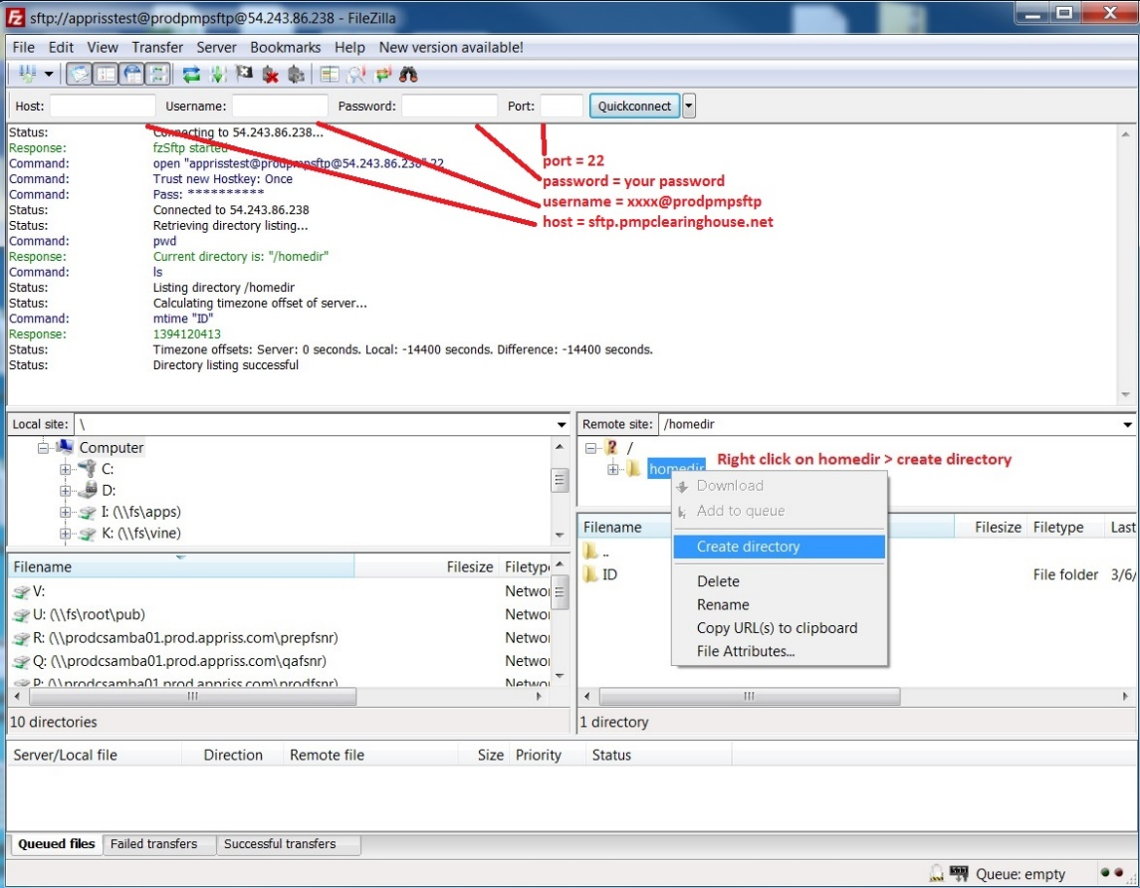
- Via command prompt
- Log in to your SFTP account using command prompt.
- Type “mkdir” followed by a space and then the PMP abbreviation you are using (e.g., mkdir MA).
NOTE: The PMP folder must be titled with the two-letter abbreviation as specified above.
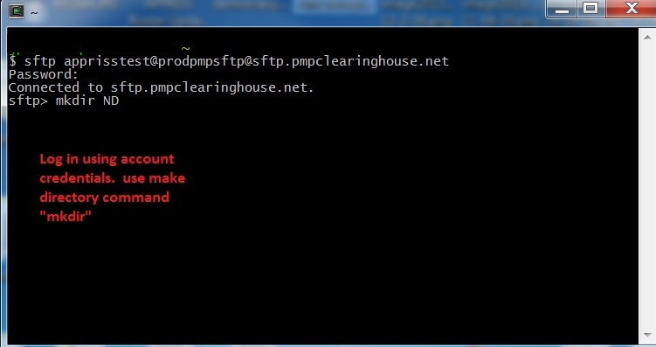
Public (SSH/RSA) Key Authentication
PMP Clearinghouse supports SSH key authentication. The generation of the key is outside the scope of this document; however, general guidelines about the key, along with how to import/load it, are provided below.
Note: PGP Encryption is not supported.
- Supported Key Types:
- SSH-2 RSA 2048 bit length
- Unsupported Key Types:
- SSH-1 RSA
- SSH-2 DSA
- Correct Public Key Format: If opened in a text editor, the key should look like the screenshot below.
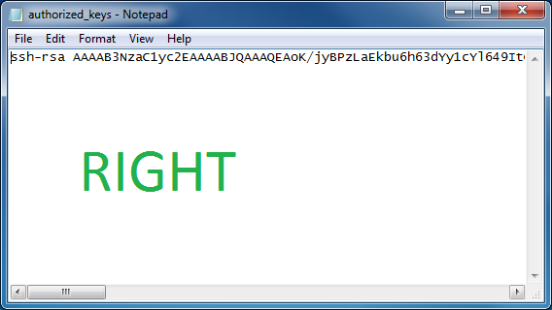
- Incorrect Public Key Format: If opened in a text editor, the key SHOULD NOT look like the screenshot below.
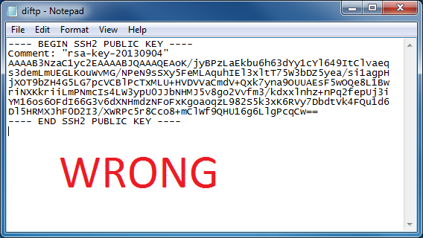
- Once the key has been generated, it should be named “authorized_keys”.
Notes:
There is no file extension.
There is an underscore between the words authorized and keys.
- A .ssh subfolder needs to be created in the SFTP account’s home directory. The “authorized_keys” file must be placed in the .ssh folder. The creation of this folder follows the same process as creating a PMP subfolder. Please refer to PMP Subfolders for steps on creating subfolders.
- Data Submission Waivers
The MA PMP has three types of Data Submission Waivers available to pharmacies to waive them of their requirement to report to the PMP. These waivers are available on the Pharmacy Reporting and Data Submission section of the MA PMP website and must be returned via email to mapmp.dph@mass.gov.
Annual Data Submission Waiver
Pharmacies that do not dispense Controlled Substances in Schedules II–V, gabapentin, or any additional drugs that the Department has determined must be reported to the PMP may complete an Annual Reporting Waiver Request Form to request a waiver of the requirement that pharmacies must report to the PMP. If a pharmacy receiving this waiver nevertheless dispenses from Schedules II–V or any additional drug required for submission to the PMP by the Department, the waiver will not apply to such activity. The pharmacy will be required to report such dispensing to the PMP.
Days of Operation Waiver
Pharmacies that are not open seven (7) days a week to dispense Controlled Substances in Schedules II–V, gabapentin, or any additional drugs that the Department has determined must be reported to the PMP may complete a Days of Operation Waiver Request Form to waive the requirement that pharmacies must report to the PMP every day.
Temporary Waiver
Pharmacies that experience unforeseen circumstances preventing them from submitting to the PMP for an extended period of time can submit a Temporary Pharmacy Waiver Request Form from daily submissions.
- Correct Use of Codes in DSP01
Error Correction
The ASAP 4.2A standard requires a dispenser to select a code in the DSP01 field. Dispensers may submit new records, revise and resubmit records, and void (delete) records. This is communicated by supplying one of the following values in the DSP01 field:
- “00” New Record – indicates a new record.
- “01” Revise – indicates that one or more data elements in a previously submitted record have been revised.
- “02” Void – indicates that the original record should be deleted.
Submit a New Record
Perform the following steps to submit a new record:
- Create a record with the value “00” in the DSP01 field.
- Populate all other required fields and submit the record.
Note: These steps are used to submit new records or to submit records that were previously submitted but received a fatal status on the dispenser’s error report. Records with fatal errors are not loaded into the PDMP system. The errors in these records must be corrected in the dispenser’s system and resubmitted using the “00” status in the DSP01 field.
Revise a Record
Perform the following steps to revise a record:
- Create a record with the value “01” in the DSP01 field.
- Populate the following fields with the same information originally submitted in the record that is being revised:
- PHA02 (NCPDP/NABP Provider ID)
- PHA03 (DEA Number)
- DSP02 (Prescription Number)
- DSP05 (Date Filled)
- DSP06 (Refill Number)
- DSP09 (Quantity Dispensed)
- Fill in all other data fields with the correct information. This information will override the original data linked to the fields referenced in step 2.
- Submit the record.
Important Note: If any of the fields referenced in Step 2 are part of the correction, the record should first be voided and then resubmitted using the value “00” in the DSP01 field.
Void a Record
Perform the following steps to void (delete) a record:
- Send a record with the value “02” in the DSP01 field.
- Fill in all other data identical to the original record. This will void the original record.
- An option to sending all the identical data in the prescription is to send a limited data set. The reason for a limited data set to void a prescription is to simplify the process in the pharmacy. This data set would be an option that a PDMP could require, rather than the identical data of the entire original prescription. The entire limited data set would be sent and if a PDMP does not require a data element, it would be ignored by the PDMP.
Limited Data Set to Void a Prescription
- PHA02 (NCPDP/NABP Provider ID)
- PHA03 (DEA Number)
- DSP02 (Prescription Number)
- DSP05 (Date Filled)
- DSP06 (Refill Number)
- DSP09 (Quantity Dispensed)

