Chlorine Dioxide MRDL Template 1-8

Instructions: (template on following page)

If a system exceeds the chlorine dioxide MRDL when one or more of the samples taken in the distribution system on the day after exceeding the MRDL at the entrance to the distribution system or if a system does not take required samples in the distribution system, Tier 1 notification is required. You must provide public notice to persons served as soon as practical but within 24 hours after you learn of the violation ((310 CMR 22.16(2)(b). (Exceeding the chlorine dioxide MRDL at the entry point to the distribution system only is a Tier 2 violation; modify this template or Template 2-3 to create a Tier 2 notice.) You must also contact your regional MassDEP office within 24 hours of learning of the violation or situation. You should also coordinate with your local health department.

Mandatory Language - Mandatory language on health effects (310 CMR 22.16(5)(d)) for your public notification (PN), which must be included exactly as written, is presented in italics in the template.

You must also include the following italicized language in all notices, where applicable. Use of this language does not relieve you of your obligation to take steps reasonably calculated to notify all persons served:

Please share this information with all the other people who drink this water, especially those who may not have received this notice directly (for example, people in apartments, nursing homes, schools, and businesses). You can do this by posting this notice in a public place or distributing copies by hand or mail.

Alternative Sources of Water - If you are providing alternative sources of water, your notice should say where it could be obtained. Remember that bottled water can be contaminated. If you are providing bottled water, make sure it meets the standards by contacting the Massachusetts Department of Public Health and the bottler and asking for the most recent test results.

Delivery - You must use one or more of the following methods to deliver the notice to consumers (310 CMR 22.16(2)(c)):
- Radio
- Television
- Hand or direct delivery
- Posting in conspicuous locations
- In addition to one (or more) of the above methods, you must publish the Tier 1 public notice within your local newspaper as a one-day advertisement no later than 14 days after the violation. A copy must be submitted to MassDEP no later than the time published.

You may need to use additional methods (e.g., newspaper, reverse 911 phone calls, e-mail, web posting, delivery of multiple copies to hospitals, clinics, or apartment buildings) since notice must be provided in a manner reasonably calculated to reach all persons served. If you post or hand deliver, print your notice on your system’s letterhead, if you have it.

The template is appropriate for hand delivery or a newspaper notice. However, you may wish to modify it before using it for a radio or TV notice. If you do, you must still include all required elements and leave the health effects language in italics unchanged. This language is mandatory (310 CMR 22.16(5)(d)). See Chapter 8 of the EPA/ASWDA Public Notification Handbook for a notice designed for posting. If you post or hand-deliver, print your notice on letterhead, if available.

Population at Risk – The language on the following template lists “young children” as one of the groups at increased risk. Because the potential health effects of chlorine dioxide are based on tests on laboratory animals, there is no way to determine at exactly what age the water is safe to drink. If your consumers have questions, encourage them to err on the side of caution.

Corrective Action - In your notice, describe corrective actions you are taking. Listed below are some steps commonly taken by water systems with chlorine dioxide violations. Use one or more of the following actions, if appropriate, or develop your own:

- We are resetting the generator to generate the correct amount of chlorine dioxide.
- We are repairing the generator.
- We have already fixed the problem but it will take additional time for the extra chlorine dioxide to be flushed from the distribution system (pipes).

After Issuing the Notice - Send a copy of each type of notice and a certification that you have met all the public notice requirements to your regional MassDEP office and local board of health within ten days from the time you issue the notice (310 CMR 22.15(3)(b)).

It is recommended that you notify health professionals in the area of the violation. People may call their doctors with questions about how the situation may affect their health, and the doctors should have the information they need to respond appropriately. In addition, health professionals, including dentists, use tap water during their procedures and need to know of contamination so they can use bottled water.

It is a good idea to issue a "problem corrected notice" when the violation is resolved. See Template 1-6.

Note - The EPA/ASDWA Public Notification Handbook provides additional aids to help water systems develop notices for outbreak situations. An electronic copy of the Public Notification Handbook is available at EPA's web site (www.epa.gov/safewater/pn.html). Please note that the EPA/ASDWA Handbook templates are non-state specific so Massachusetts water suppliers are required to use the Massachusetts version of the templates for compliance purposes. Electronic copies of the Massachusetts public notification templates are available on the MassDEP website http://www.mass.gov/dep/water/drinking/systems.htm#pubnot.
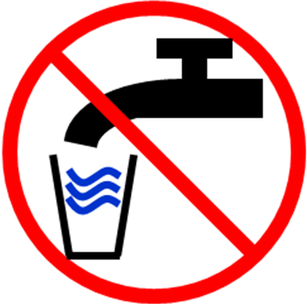
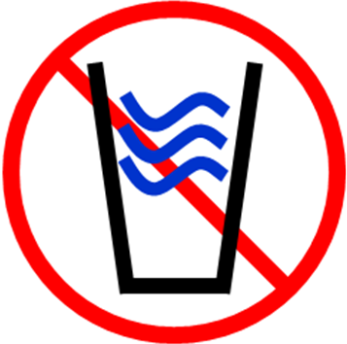

DRINKING WATER WARNING

PREGNANT WOMEN AND YOUNG CHILDREN
SHOULD NOT DRINK THE WATER

Sampling results received [date] showed chlorine dioxide levels of [level and units]. This is above the standard or maximum residual disinfectant level (MRDL) of 0.8 milligrams per liter. Chlorine dioxide is used for disinfection, but too much of it over a short period of time may harm the development of children, infants, and fetuses.

What should I do? What does this mean?

- DO NOT USE THIS WATER IF YOU ARE PREGNANT. DO NOT GIVE IT TO YOUNG CHILDREN. Bottled water should be used until further notice. Some infants and young children who drink water containing chlorine dioxide in excess of the MRDL could experience nervous system effects. Similar effects may occur in fetuses of pregnant mothers who drink water containing chlorine dioxide in excess of the MRDL. Some people may experience anemia.

- The chlorine dioxide violations reported today include exceedances of the EPA standard within the distribution system which delivers water to consumers. Violations of the chlorine dioxide standard within the distribution system may harm human health based on short-term exposures. Certain groups, including fetuses, infants, and young children, may be especially susceptible to nervous system effects from excessive chlorine dioxide exposure. There are no obvious symptoms, but chlorine dioxide can affect development of the nervous system.

- Water, juice, and formula for young children and for pregnant women should not be prepared with tap water.

- Adults who are not pregnant and older children can drink the tap water because their nervous systems are already developed. However, if you have specific health concerns, you may wish to consult your doctor.

What happened? What is being done?

Chlorine dioxide is used in small amounts every day to kill bacteria and other organisms that may be in your drinking water. A problem occurred with our chlorine dioxide generator, and too much chlorine dioxide was released. [Describe corrective action and when you expect to return to compliance.]

For more information, please contact [name of contact] at [phone number] or [mailing address].

Please share this information with all the other people who drink this water, especially those who may not have received this notice directly (for example, people in apartments, nursing homes, schools, and businesses). You can do this by posting this notice in a public place or distributing copies by hand or mail.

This notice is being sent to you by [system]. PWS ID#: [xxxxxxx] Date distributed:[date]

