Nitrate Failure to Take Confirmation Sample Template 1-2

Instructions: (template on following page)

Since failure to take a confirmation sample for nitrate within 24 hours after learning that an initial sample exceeded the MCL is a Tier 1 violation, you must provide public notice to persons served as soon as practical but no more than 24 hours from learning of the violation (310 CMR 22.16(2)(a)). During this time period you must also contact your regional office of the Massachusetts Department of Environmental Protection, (MassDEP). You should also coordinate with your local health department. This template is also applicable to nitrite and total nitrate and nitrite violations.

Mandatory language on health effects (310 CMR 22.16(5)(d)) for your public notification (PN), which must be included exactly as written, is presented in italics.

You must also include the following italicized language in all notices, where applicable. Use of this language does not relieve you of your obligation to take steps reasonably calculated to notify all persons served:

Please share this information with all the other people who drink this water, especially those who may not have received this notice directly (for example, people in apartments, nursing homes, schools, and businesses). You can do this by posting this notice in a public place or distributing copies by hand or mail.

Delivery - You must use one or more of the following methods to deliver the notice to consumers (310 CMR 22.16(2)(c)):
- Radio
- Television
- Hand or direct delivery
- Posting in conspicuous locations
- In addition to one (or more) of the above methods, you must publish the Tier 1 public notice within your local newspaper as a one-day advertisement no later than 14 days after the violation. A copy must be submitted to MassDEP no later than the time published.

You may need to use additional methods (e.g., newspaper, reverse 911 phone calls, e-mail, web posting, delivery of multiple copies to hospitals, clinics, or apartment buildings) since notice must be provided in a manner reasonably calculated to reach all persons served. If you post or hand-deliver, print your notice on your system’s letterhead, if you have it.

The template is appropriate for hand delivery or a newspaper notice. However, you may wish to modify it before using it for a radio or TV notice. If you do, you must still include all required elements and leave the health effects language in italics unchanged. This language is mandatory (310 CMR 22.16(5)(d)). See Chapter 8 of the EPA and the Association of State Drinking Water Administrators (ASDWA) Public Notification Handbook for a notice designed for posting. If you post or hand-deliver, print your notice on letterhead, if available.

Alternative Sources of Water - If you are providing alternative sources of water for infants, your notice should say where it could be obtained. Remember that bottled water can also be contaminated. If you are providing bottled water, make sure it meets the standard for nitrates by contacting Massachusetts Department of Public Health and the bottler and asking for the most recent test results.

Repeat Notices - If this is a repeat notice (as required by MassDEP), or if your system’s nitrate levels fluctuate around the MCL, you may wish to include an explanation similar to the following:

You were initially notified of high nitrate levels on [date]. Since that time we have been monitoring the nitrate concentration every three months. Seasonal fluctuations in nitrate concentrations have been observed, due to nitrates contained in fertilizer. It appears that high nitrates occur during the later summer and fall. Note that prior to [year] we were meeting drinking water standards for nitrate.

Corrective Action - In your notice, describe corrective actions you are taking. The text below describes one action commonly taken by water systems with nitrate/nitrite violations. Use this language, if appropriate, or develop your own:

We are investigating water treatment and other options. These may include drilling a new well, mixing the water with low-nitrate water from another source, or buying water from another water system.

After Issuing the Notice - Make sure to send your MassDEP Regional Office and your local board of health a copy of each type of notice and a certification that you have met all the public notice requirements within ten days after issuing the notice (310 CMR 22.15(3)(b)). You should also issue a follow-up notice in addition to meeting any repeat notice requirements that MassDEP sets.

You should notify health professionals in the area of the violation. People may call their doctors with questions, and the doctors should have the information they need to respond appropriately. They also need to make sure the water is not provided to infants in their care.

Note - The EPA/ASDWA Public Notification Handbook provides additional aids to help water systems develop notices for violation situations. An electronic copy of the Public Notification Handbook is available at EPA's web site (www.epa.gov/safewater/pn.html). Please note that the EPA/ASDWA Handbook templates are non-state specific so Massachusetts’s water suppliers are required to use the Massachusetts’ version of the templates for compliance purposes. Electronic copies of the Massachusetts’ public notification templates are available on the MassDEP website http://www.mass.gov/dep/water/drinking/systems.htm#pubnot.

DRINKING WATER WARNING

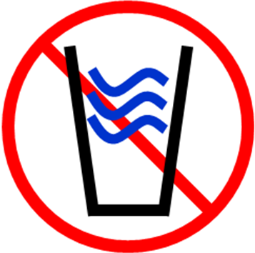
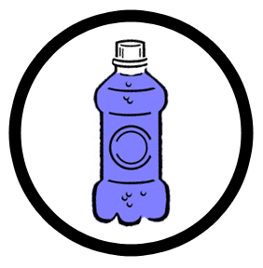
[System] did not take a confirmation sample
to determine if the water has high levels of nitrate
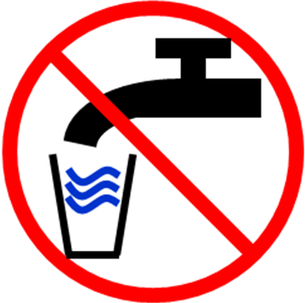

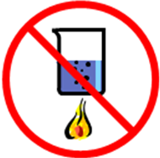
DO NOT GIVE THE WATER TO
INFANTS UNDER 6 MONTHS OLD.
DO NOT USE IT TO MAKE INFANT FORMULA.

We are required to monitor your drinking water for nitrate on a regular basis. Results of regular monitoring are an indicator of whether or not our drinking water meets health standards. During [compliance period] we [‘did not monitor or test’ or ‘did not complete all monitoring or testing’] for nitrate and therefore cannot be sure of the quality of your drinking water during that time.
On [give date], we received notice that the sample collected on [give date] showed nitrate levels above the nitrate standard, or maximum contaminant level (MCL), of 10 mg/l. We were required to take a confirmation sample within 24 hours. We did not complete the required confirmation sample monitoring. Nitrate in drinking water is a serious health concern for infants less than six months old.

What should I do? What does this mean?

- DO NOT GIVE THE WATER TO INFANTS. Infants below the age of six months who drink water containing nitrate in excess of the MCL could become seriously ill and, if untreated, may die. Symptoms include shortness of breath and blue baby syndrome. Blue baby syndrome is indicated by blueness of the skin. Symptoms in infants can develop rapidly, with health deteriorating over a period of days. If symptoms occur, seek medical attention immediately.

- Water, juice, and formula for children under six months of age should not be prepared with tap water. Bottled water or other water low in nitrates should be used for infants until further notice.

- DO NOT BOIL THE WATER. Boiling, freezing, filtering, or letting water stand does not reduce the nitrate level. Excessive boiling can make the nitrates more concentrated, because nitrates remain behind when the water evaporates.

- Adults and children older than six months can drink the tap water (nitrate is a concern for infants because they can not process nitrates in the same way adults can). However, if you are pregnant or have specific health concerns, you may wish to consult your doctor.

What happened? What is being done?

Nitrate in drinking water can come from natural, industrial, or agricultural sources (including septic systems and run-off). Levels of nitrate in drinking water can vary throughout the year. We will let you know when the amount of nitrate is again below the limit.

[Describe corrective action, seasonal fluctuations, and when system expects to return to compliance.]

For more information, please contact [name of contact] at [phone number] or [mailing address].

Please share this information with all the other people who drink this water, especially those who may not have received this notice directly (for example, people in apartments, nursing homes, schools, and businesses). You can do this by posting this notice in a public place or distributing copies by hand or mail.

This notice is being sent to you by [system]; PWS ID# [xxxxxxx] Date distributed: [date] _______________ ______________

