Problem Corrected Template 1-6

Instructions: (template on following page)

It is a good idea to issue a notice when a serious violation or situation has been resolved. Although MassDEP regulations do not require such notices, your regional MassDEP office may require you to issue one. You should coordinate with your local board of health or health department as well.

You must also include the following italicized language in all notices, where applicable. Use of this language does not relieve you of your obligation to take steps reasonably calculated to notify all persons served:

Please share this information with all the other people who drink this water, especially those who may not have received this notice directly (for example, people in apartments, nursing homes, schools, and businesses). You can do this by posting this notice in a public place or distributing copies by hand or mail.

Delivery - You should use the same delivery methods you used for the original notice.
- Radio
- Television
- Hand or direct delivery
- Posting in conspicuous locations
- In addition to one (or more) of the above methods, you must publish the Tier 1 public notice within your local newspaper as a one-day advertisement no later than 14 days after the violation. A copy must be submitted to MassDEP no later than the time published.

You may wish to use additional methods (e.g., newspaper, delivery of multiple copies to hospitals, clinics, or apartment buildings), since notice must be provided in a manner reasonably calculated to reach all persons served. If you post or hand-deliver, print your notice on letterhead, if available.

Note – The notice on the following template is very general and can be used for any violation or situation. However, to help restore consumer's confidence in the water system, you should modify the notice to fit your situation. Although the public should have seen your initial notice, there may be additional information you learned after the notice was issued. Therefore, you should describe the violation or situation again and discuss how the problem was solved.
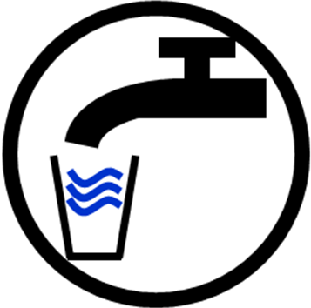

DRINKING WATER PROBLEM CORRECTED

Customers of [system] were notified on [date] of a problem with our drinking water and were advised to [describe recommended action]. We are pleased to report that the problem has been corrected and that it is no longer necessary to [describe recommended action]. We apologize for any inconvenience and thank you for your patience.

[Add further details here when appropriate.]

As always, you may contact [contact name] at [phone number] or [mailing address] with any comments or questions.

Please share this information with all the other people who drink this water, especially those who may not have received this notice directly (for example, people in apartments, nursing homes, schools, and businesses). You can do this by posting this notice in a public place or distributing copies by hand or mail.

This notice is being sent to you by [system]. PWS ID#:[xxxxxxx] Date distributed: [date]

