The Commonwealth of Massachusetts

Executive Office of Health and Human Services

Department of Public Health

Bureau of Environmental Health

250 Washington Street, Boston, MA 02108-4619

MARYLOU SUDDERS

Secretary

MONICA BHAREL, MD, MPH Commissioner

**Tel: 617-624-6000**

**www.mass.gov/dph**

Phone: 617-624-5757 Fax: 617-624-5777

TTY: 617-624-5286



CHARLES D. BAKER

Governor

KARYN E. POLITO

Lieutenant Governor

**MEMORANDUM**

**TO:** Radiation Control Program

**FROM:** Environmental Toxicology Program

**CC:** Bureau of Environmental Health (BEH) Director; BEH Deputy Director

**DATE:** May 8, 2017

**SUBJECT:** Pilgrim Nuclear Power Station Tritium in Groundwater Investigation Update

**INTRODUCTION**

This document describes monitoring results for tritium in groundwater and surface water at the Pilgrim Nuclear Power Station located in Plymouth, MA during the last six months of 2016. The investigation history which dates back to 2010 and six years of previous update reports are available online[1].

Entergy collects samples at 23 groundwater wells and two surface water locations on-site at PNPS. The sampling intervals range from weekly to quarterly and are based on past monitoring results and analysis of possible groundwater tritium pathways. Well and surface water samples are sent by Entergy to an independent analytical lab, Teledyne, and duplicate (or “split”) samples are provided to MDPH for analysis at the Massachusetts Environmental Radiation Lab (MERL). Entergy regularly reports the Teledyne results to MDPH, MEMA, and NRC officials. Summaries of both laboratory results are on the MDPH website2.

This letter updates results from both Entergy and MERL for sampling performed during the final six months of 2016. Results were compared to a conservative, health protective screening level of 3,000 picocuries per liter (pCi/L), (or 1/10th the NRC-approved level of 30,000 pCi/L tritium in non-drinking water sources); and the US Environmental Protection Agency (EPA) drinking water standard for tritium of 20,000 pCi/L. The closest municipal drinking water wells are 2.5 miles from PNPS and are not expected to be impacted by on-site tritium sources.

**SUMMARY**

* Of the 23 groundwater wells that are routinely sampled, results for 7 indicate no detectable activity above background, and 14 of the remaining 16 showed stabilization in tritium levels.
* MW-216 showed a cyclic increase consistent with historical results with a higher peak than seen in 2015, but lower than 2013 and 2014. Entergy is working with their consultant, ERM, to evaluate contributing sources to these results.
* Minor modifications were made to the sampling frequency of one well.
* On-site efforts by Entergy have focused on identifying sources of tritium and monitoring for new sources, with emphasis on surveillance for leaks in the Condenser Bay area.
* Staff from the MDPH Bureau of Environmental Health continue to review new information from the monitoring efforts and to maintain regular contact with the Massachusetts Emergency Management Agency (MEMA), the Nuclear Regulatory Committee (NRC), and Entergy.

**Results**

Sampling results for all on-site wells and surface water samples are summarized on the MDPH website[2]. Of the 23 on-site groundwater wells that are routinely monitored, only MW-216 and MW-218 had levels of tritium detected above 3,000 pCi/L. All results were well below the EPA drinking water standard of 20,000 pCi/L. **Figure 1** shows sampling results in 2016 for three weekly sampled wells of interest where tritium levels reached 2,000 pCi/L (1/10th of the EPA drinking water standard), and historic results for these wells (MW-216, MW-218, and MW-211). Two additional wells, MW-215 and MW-206, are sampled weekly due to their location in preferential pathways of water from seismic gaps; both have low tritium levels (ranging from non-detectable to 1,192 pCi/L).

Sixteen wells, not shown in **Figure 1,** are sampled on a less frequent basis. Results for wells sampled monthly ranged from 608 to 1,279 pCi/L, and from no detection to 877 pCi/L for quarterly sampled wells. Sampling frequency at MW-210 was adjusted from quarterly to every third week following an increase from 597 pCi/L on August 3rd to 1,180 pCi/L on November 14th. No tritium was detected in surface water samples collected during the latter half of 2016.

In February, Entergy sampled three flex wells (deep wells used for emergency cooling water) and no tritium was identified above the minimum detectable concentration levels. Although these wells are not part of the routine tritium monitoring program, they provide additional perspective on deeper on-site groundwater tritium levels. These wells are discussed in an earlier [update report.](http://www.mass.gov/eohhs/docs/dph/environmental/radiationcontrol/tritium/2015-updates/pnps-update-05-12-15.pdf) In May, Entergy analyzed the routine groundwater wells for hard-to-detect radionuclides and found no detection of radionuclides of concern.

**Discussion**

Monitoring results for the second six months of 2016 showed stabilization in groundwater tritium levels with the exception of MW-210 and MW-216. Increased surveillance for MW 210 will continue until the results stabilize. MDPH monitors weekly results for MW-216 which has historically shown a pattern of cyclic fluctuations characterized by September-November increases. This pattern repeated in 2016, with peak levels of 5,820 pCi/L (which was 1,740 pCi/L higher than seen in 2015, but lower than 2013 and 2014 (see Figure 1.b)). Entergy is working with their consultant, ERM, to understand the cause of these trends, and theorizes residual tritium in the seismic gap may be migrating to this well.

MDPH monitors weekly results for MW-218 and MW-211. Tritium levels in both wells continued to stabilize after a leak in the Condenser Bay area, contributing to elevated levels in both, was detected and repaired in the beginning of 2016. Recent results are near previous levels and Entergy continues to monitor the Condenser Bay area for leaks. The high-rad Condenser Bay area is monitored by camera during operations, and was entered and examined for leaks during two down powers.

Staff from the MDPH Bureau of Environmental Health will continue to review groundwater monitoring results, and maintain contact with MEMA, NRC, and Entergy to discuss on-going tritium in groundwater activities at PNPS.

**a) 2016 Weekly wells of interest**

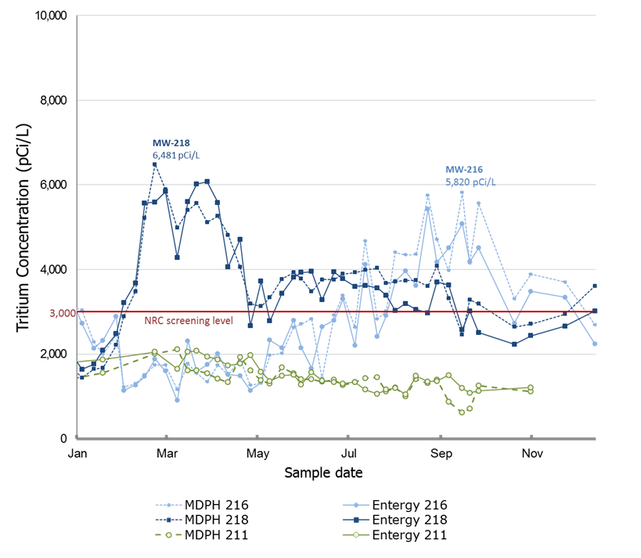

**b) MW-216 c) MW-218 d) MW-211**



2012-2016 2013-2016 2010-2016

Sample dates

**Figure 1**. Calendar year 2016 and historical results for three wells of interest, MW-216, MW-218 and MW-211, from tritium in groundwater samples collected from Pilgrim Nuclear Power Station (PNPS). Data are plotted separately based on PNPS operator (solid lines) or MDPH (dotted lines) produced results. The solid red line at 3,000 pCi/L represents the screening level which is 1/10th of the 30,000 pCi/L NRC level of concern. **a)** Results from samples collected during 2016 at wells with tritium levels above 2,000 pCi/L (MW-218, MW-216, and MW-211) showing a maximum level of 6,481 on March 7, 2016 at MW-216. **b-d)** Historical monitoring results for MW-216, MW-218 and MW-211.

1. Previous PNPS Tritium in Groundwater Investigation Updates are available here:

   [mass.gov/eohhs/gov/departments/dph/programs/environmental-health/exposure-topics/radiation/environmental-monitoring](http://www.mass.gov/eohhs/gov/departments/dph/programs/environmental-health/exposure-topics/radiation/environmental-monitoring.html)
2. Sampling results for all on-site wells and surface water samples are summarized on the MDPH website: <http://www.mass.gov/eohhs/gov/departments/dph/programs/environmental-health/exposure-topics/radiation/environmental-monitoring.html>