
The Commonwealth of Massachusetts
Executive Office of Health and Human Services
Department of Public Health
Bureau of Environmental Health
250 Washington Street, Boston, MA 02108-4619
Phone: 617-624-5757 Fax: 617-624-5777
TTY: 617-624-5286

CHARLES D. BAKER
Governor
KARYN E. POLITO
Lieutenant Governor

MARYLOU SUDDERS
Secretary
MONICA BHAREL, MD, MPH Commissioner

Tel: 617-624-6000
www.mass.gov/dph

MEMORANDUM
TO: Radiation Control Program
FROM: Environmental Toxicology Program
CC: Bureau of Environmental Health (BEH) Director; BEH Deputy Director
DATE: October 27, 2017
SUBJECT: Pilgrim Nuclear Power Station Tritium in Groundwater Investigation Update

PURPOSE

This document updates the results of on-going tritium in groundwater and surface water monitoring at Pilgrim Nuclear Power Station (PNPS) in Plymouth, MA for the first six months of 2017.

Introduction

This document describes monitoring results for tritium in groundwater and surface water at the Pilgrim Nuclear Power Station located in Plymouth, MA during the first six months of 2017. The history of the investigation, which began in 2010, and previous update reports are available online.

Entergy collects samples at 23 groundwater wells and one surface water location on-site at PNPS. The sampling intervals range from every third week to quarterly, and are based on past monitoring results and analysis of possible groundwater tritium pathways. Well and surface water samples are sent by Entergy to an independent analytical lab, Teledyne, and duplicate (or “split”) samples are provided to MDPH for analysis at the Massachusetts Environmental Radiation Lab (MERL). Entergy regularly reports the Teledyne results to MDPH, MEMA, and NRC officials. Summaries of both laboratory results are on the MDPH website².

This letter updates results from both Entergy and MERL for sampling performed during the first six months of 2017. Results were compared to a conservative, health protective screening level of 3,000 picocuries per liter (pCi/L), (or 1/10th the NRC-approved level of 30,000 pCi/L tritium in non-drinking water sources) and to the US Environmental Protection Agency (EPA) drinking water standard for tritium of 20,000 pCi/L. The closest municipal drinking water wells are 2.5 miles from PNPS and are not expected to be impacted by on-site tritium sources.

OVERVIEW

- Sampling results for 6 of 23 routinely sampled groundwater wells indicate no detectable activity above background. The remaining 17 wells showed stabilization and reduction in tritium levels; no detectable tritium was measured in surface water samples.

- Following stabilization in tritium levels in 2016, Entergy adjusted the sampling frequency of five weekly sampled wells to every third week and the monthly sampled wells to quarterly. Additionally in June, Entergy readjusted the sampling frequency at MW-210 from every third week to quarterly following three consecutive samples with reduced tritium levels.

- On-site efforts by Entergy have focused on identifying sources of tritium and monitoring for new sources, with emphasis on surveillance for leaks in the Condenser Bay area.

- Staff from the MDPH Bureau of Environmental Health continues to review new information from the monitoring efforts and to maintain regular contact with the Massachusetts Emergency Management Agency (MEMA), the Nuclear Regulatory Committee (NRC), and Entergy.

Results

Of the 23 on-site groundwater wells that are routinely monitored, two (MW-216 and MW 218) had levels of tritium detected above 3,000 pCi/L during the first half of the year. All results were well below the EPA drinking water standard of 20,000 pCi/L. Figure 1 shows sampling results in 2017 for the two wells (MW-216, MW-218) where tritium levels reached 2,000 pCi/L (1/10th of the EPA drinking water standard), and historic results for these wells.

Two additional wells, MW-215 and MW-206, are sampled every third week due to their location in preferential pathways of water from seismic gaps; MW-210 was temporarily sampled every third week following a rise in tritium results in December 2016. All three have low tritium levels ranging from non-detectable to 1,220 pCi/L. Results for the 18 quarterly sampled wells ranged from no detection to 1,660 pCi/L. No tritium was detected in surface water samples collected during the first half of 2017.

Discussion

Monitoring results for the first six months of 2017 showed stabilization in groundwater tritium levels at all wells. During this period the plant was shut down for refueling for six weeks which allowed additional access to the Condenser Bay area for inspections and timely repairs. Sampling frequency at MW-210 was re-adjusted to quarterly from every third week following three consecutive samples under 1,000 pCi/L.

MW-216 has historically shown a pattern of cyclic fluctuations characterized by September-November increases; the first half year results were comparable to previous year trends.
MW-218 had a high reading in January, and the remainder of the year has been below the screening level of 3,000 pCi/L.

Entergy continues to monitor the high-radiation Condenser Bay area for leaks. The Condenser Bay is monitored by camera during operations, and was entered and examined for leaks during down powers (<50% power), two planned snowstorm shutdowns, and during the refueling outage in April. A condenser tube leak and leaking valve were identified and repaired in February. The five tri-weekly wells were sampled less frequently during this period as equipment to support refueling was blocking the well heads.

Staff from the MDPH Bureau of Environmental Health will continue to review groundwater monitoring results, and maintain contact with MEMA, NRC, and Entergy to discuss on-going tritium in groundwater activities at PNPS.

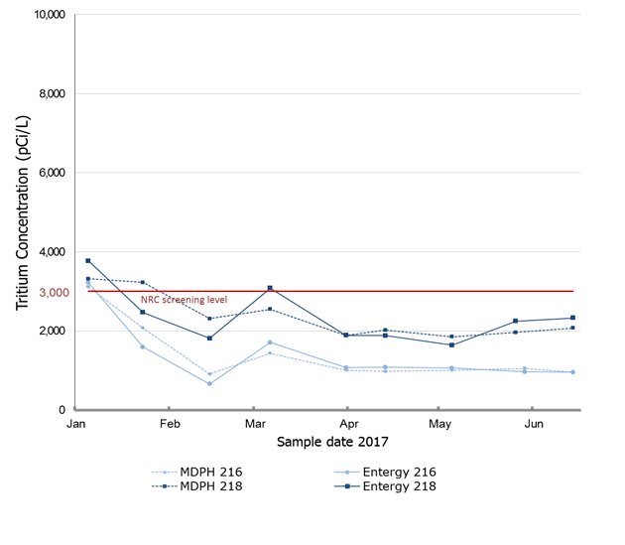

- 2017 Wells of interest

b) MW-216 c) MW-218
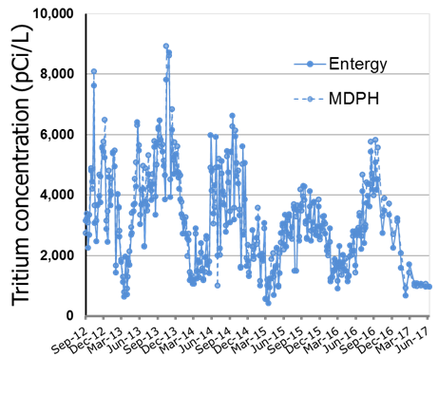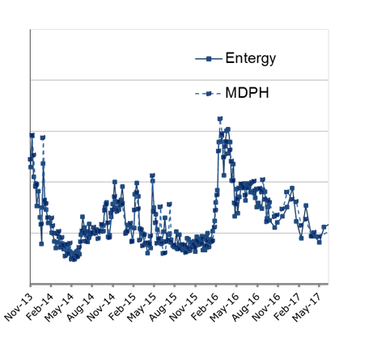
2012-2017 2013-2017

Figure 1. First six months 2017 and historical results for two wells of interest, MW-216, MW-218, from tritium in groundwater samples collected from Pilgrim Nuclear Power Station (PNPS). Data are plotted separately based on PNPS operator (solid lines) or MDPH (dotted lines) produced results. The solid red line at 3,000 pCi/L represents the screening level which is 1/10th of the 30,000 pCi/L NRC level of concern. a) Results from samples collected from January through June 2017 at wells with tritium levels above 2,000 pCi/L (MW-218, MW-216) showing a maximum level of 3,770 on January 19, 2017 at MW-218. b and c) Historical monitoring results for MW-216 and MW-218.

Previous PNPS Tritium in Groundwater Investigation Updates are available here: https://www.mass.gov/lists/environmental-monitoring-data-for-tritium-in-groundwater-at-pilgrim-nuclear-power-station
Summary tables of groundwater and surface water monitoring results are on the MDPH website: https://www.mass.gov/lists/environmental-monitoring-data-for-tritium-in-groundwater-at-pilgrim-nuclear-power-station

