The Commonwealth of Massachusetts

Executive Office of Health and Human Services

Department of Public Health

Bureau of Environmental Health

250 Washington Street, Boston, MA 02108-4619

MARYLOU SUDDERS

Secretary

MONICA BHAREL, MD, MPH Commissioner

**Tel: 617-624-6000**

**www.mass.gov/dph**

Phone: 617-624-5757 Fax: 617-624-5777

TTY: 617-624-5286



CHARLES D. BAKER

Governor

KARYN E. POLITO

Lieutenant Governor

**MEMORANDUM**

**TO:** Radiation Control Program

**FROM:** Environmental Toxicology Program

**CC:** Bureau of Environmental Health (BEH) Director; BEH Deputy Director

**DATE:** May 1, 2018

**SUBJECT:** Pilgrim Nuclear Power Station Tritium in Groundwater Investigation Update

**PURPOSE**

This document updates the results of on-going tritium in groundwater and surface water monitoring at Pilgrim Nuclear Power Station (PNPS) in Plymouth, MA for the last six months of 2017.

**Introduction**

This document describes monitoring results for tritium in groundwater and surface water at the Pilgrim Nuclear Power Station located in Plymouth, MA during the last six months of 2017. The history of the investigation, which began in 2010, and previous update reports are available online[1].

Entergy collects samples at 23 groundwater wells and one surface water location on-site at PNPS. The sampling intervals range from every third week to quarterly, and are based on past monitoring results and analysis of possible groundwater tritium pathways. Well and surface water samples are sent by Entergy to an independent analytical lab, Teledyne, and duplicate (or “split”) samples are provided to MDPH for analysis at the Massachusetts Environmental Radiation Lab (MERL). Entergy regularly reports the Teledyne results to MDPH, MEMA, and NRC officials. Summaries of both laboratory results are on the MDPH website2.

This letter updates results from both Entergy and MERL for sampling performed during the last six months of 2017. Results were compared to a conservative, health protective screening level of 3,000 picocuries per liter (pCi/L), (or 1/10th the NRC-approved level of 30,000 pCi/L tritium in non-drinking water sources) and to the US Environmental Protection Agency (EPA) drinking water standard for tritium of 20,000 pCi/L. The closest municipal drinking water wells are 2.5 miles from PNPS and are not expected to be impacted by on-site tritium sources.

**OVERVIEW**

* Sampling results for 7 of 23 routinely sampled groundwater wells indicate no detectable activity above background. With the exception of MW-219, the remaining 15 wells showed stabilization and reduction in tritium levels; no detectable tritium was measured in surface water samples.

* Sampling frequency for MW-219 was increased from quarterly to every third week following a rise in tritium levels identified in August. Results remained elevated between 1,750 and 6,030 pCi/L through the end of December 2017. Increased surveillance will continue at MW-219.
* On-site efforts by Entergy have focused on identifying sources of tritium and monitoring for new sources, with emphasis on surveillance for leaks in the Condenser Bay area.
* Staff from the MDPH Bureau of Environmental Health continues to review new information from the monitoring efforts and to maintain regular contact with the Massachusetts Emergency Management Agency (MEMA), the Nuclear Regulatory Committee (NRC), and Entergy.

**Results**

Of the 23 on-site groundwater wells that are routinely monitored[2], two (MW-216 and MW 219) had levels of tritium detected above 3,000 pCi/L during 2017. All results were well below the EPA drinking water standard of 20,000 pCi/L. Figure 1 shows sampling results in 2017 for the three wells (MW-216, MW-218, MW-219) where tritium levels reached 2,000 pCi/L (1/10th of the EPA drinking water standard), and historic results for these three wells of interest.

Two additional wells, MW-215 and MW-206, are sampled every third week due to their location in preferential pathways of water from seismic gaps; both have low tritium levels ranging from non-detectable to 1,410 pCi/L. Results for the 17 quarterly sampled wells ranged from no detection to 1,780 pCi/L. No tritium was detected in surface water samples collected during the second half of 2017.

**Discussion**

Monitoring results for 2017 showed stabilization in groundwater tritium levels at most wells. MW-216 has historically shown a pattern of cyclic fluctuations characterized by September-November increases; the second half year results were comparable to previous year trends. MW-218 had a higher reading in January 2017, and the remainder of the year has been below the screening level of 3,000 pCi/L.

MW-219 had an unexplained increase in August and the sampling frequency was increased to every third week to more closely monitor this well. Entergy reviewed plant records and is working with their environmental consultant to identify sources. Possibilities include a recent change in surface water flow to Catch Basin 10 just upstream of MW-219, and migration of tritium present in subsurface soil from a discharge line separation issue previously identified in 2013. Increased surveillance will continue at MW-219 until results stabilize.

Periodic reduced power events at the plant have continued to allow entry to the high-radiation Condenser Bay area to check and repair any leaks and inspect the seismic gap areas that were previously sealed.

Staff from the MDPH Bureau of Environmental Health will continue to review groundwater monitoring results, and maintain contact with MEMA, NRC, and Entergy to discuss on-going tritium in groundwater activities at PNPS.

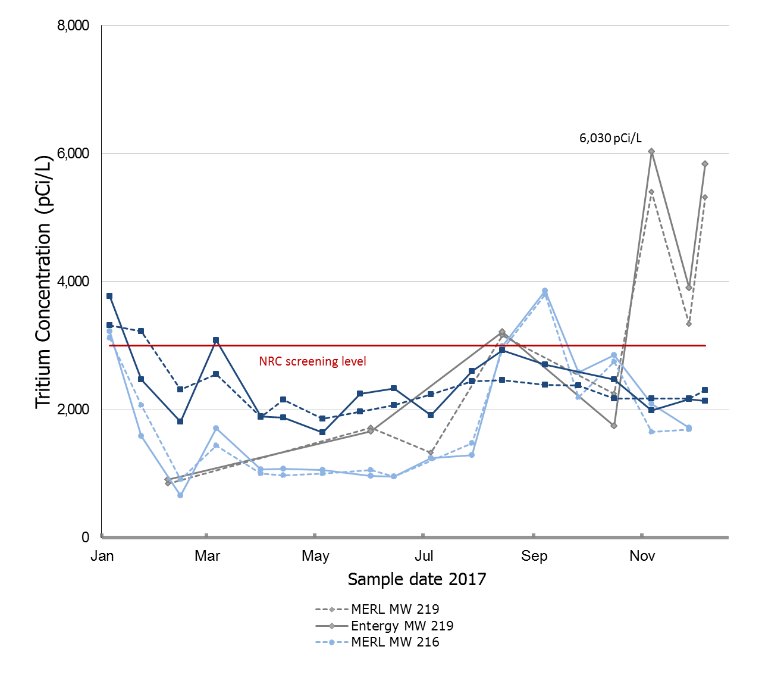

1. **2017 Wells of interest**



1. **MW-216 c) MW-218 d) MW-219**

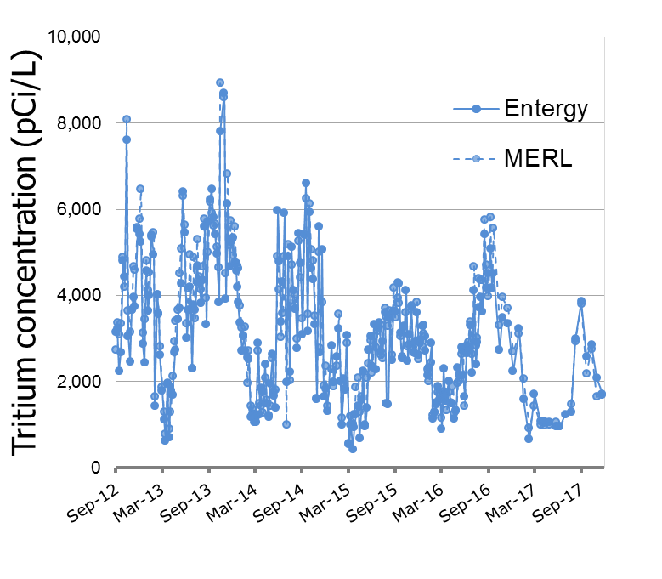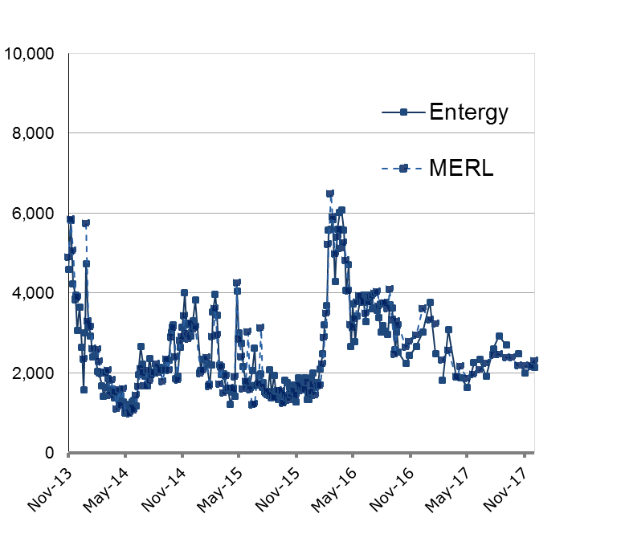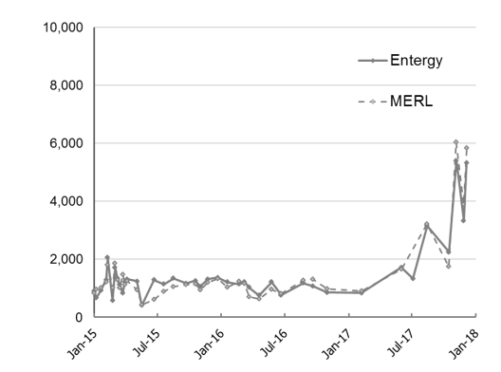

2012-2017 2013-2017 2015-2017

**Figure 1**. 2017 and historical results for three wells of interest, MW-216, MW-218, MW-219 from tritium in groundwater samples collected from Pilgrim Nuclear Power Station (PNPS). Data are plotted separately based on PNPS operator (solid lines) or MDPH (dotted lines) produced results. The solid red line at 3,000 pCi/L represents the screening level which is 1/10th of the 30,000 pCi/L NRC level of concern. **a)** Results from samples collected from January through December 2017 at wells with tritium levels above 2,000 pCi/L (MW-216, MW-218, MW-219) showing a maximum level of 6,030 in November, 2017 at MW-219. **b -d)** Historical monitoring results for MW-216 MW-218, and MW-219.

1. Previous PNPS Tritium in Groundwater Investigation Updates are available here:

   <https://www.mass.gov/lists/environmental-monitoring-data-for-tritium-in-groundwater-at-pilgrim-nuclear-power-station>
2. Summary tables of groundwater and surface water monitoring results are on the MDPH website:

   [mass.gov/eohhs/gov/departments/dph/programs/environmental-health/exposure-topics/radiation/environmental-monitoring](http://www.mass.gov/eohhs/gov/departments/dph/programs/environmental-health/exposure-topics/radiation/environmental-monitoring.html)