

Introduction
Massachusetts is known for its excellent public higher education system, which drives innovation and strengthens our economy. Yet our campuses’ capital infrastructure requires significant new resources to both address mounting deferred maintenance needs and to ensure safe, modern, decarbonized campuses that meet the demands of current and future students. To address these challenges, the Healey-Driscoll Administration filed An Act to Build Resilient Infrastructure to Generate Higher-Ed Transformation (the BRIGHT Act), which leverages $125 million in annual Fair Share surtax revenues to unlock significant new capital funding for Massachusetts’ public higher education institutions.
Meeting the Critical Needs of Our Public Higher Education System Massachusetts’ public colleges, universities, and community colleges are vital to ensuring equitable access to education and for preparing students to succeed in today’s
high demand industries. However, much of the infrastructure on these campuses, built
in the 1970s, is aging and increasingly unable to meet modern demands. The result is an inventory of outdated academic buildings and infrastructure in need of significant upgrades and deferred maintenance repairs.

The following horizontal stacked bar chart titled ‘Projected Capital Funding Needs by Sector’ compares three higher-education sectors: Community Colleges, State Universities, and the University of Massachusetts System. Each bar is divided into four funding categories: Deferred Maintenance, Decarbonization, Programmatic Modernization, and Formula-adjusted Programmatic Modernization. Community Colleges show the smallest overall need, at just under $6 billion. State Universities have a moderate total, at roughly $6–7 billion. The University of Massachusetts System has the largest projected need, exceeding $14 billion, with especially large portions for Decarbonization and Programmatic Modernization. Across all sectors, Deferred Maintenance is the smallest component, while modernization and decarbonization drive the majority of projected costs.

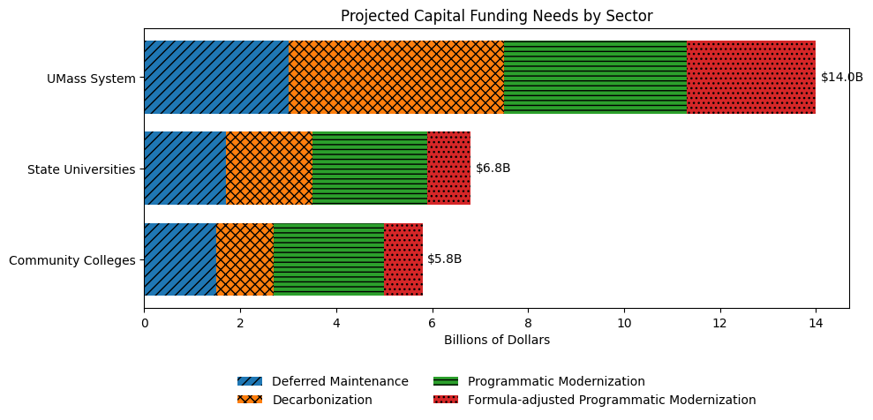
Addressing deferred maintenance, modernizing and decarbonizing facilities, and constructing state-of-the-art academic spaces are essential to helping these schools and their students achieve their full potential. Yet construction costs continue to rise for these projects, further complicated by enrollment pressures, decarbonization mandates, regulatory requirements, labor shortages, and material price increases. As a result, the needs on our public higher education campuses are growing well beyond what traditional capital funding sources can accommodate.

A Bold Solution to Expand the Pie of Available Resources
To meet this challenge, the Healey-Driscoll Administration’s House 1 budget proposes to securitize $125 million in Fair Share surtax revenues annually to issue special obligation bonds, unlocking approximately $2.5 billion in new capital resources for our public higher education institutions. This financing method, modeled on the successful Commonwealth Transportation Fund (CTF) strategy, expands the pie of available capital funds without having any impact on existing credits of the Commonwealth’s General Obligation debt capacity.

Model of Total Funding Unlocked Over 10 Fiscal Years, Based on Fair Share Pledge Assumption and Current Market Conditions

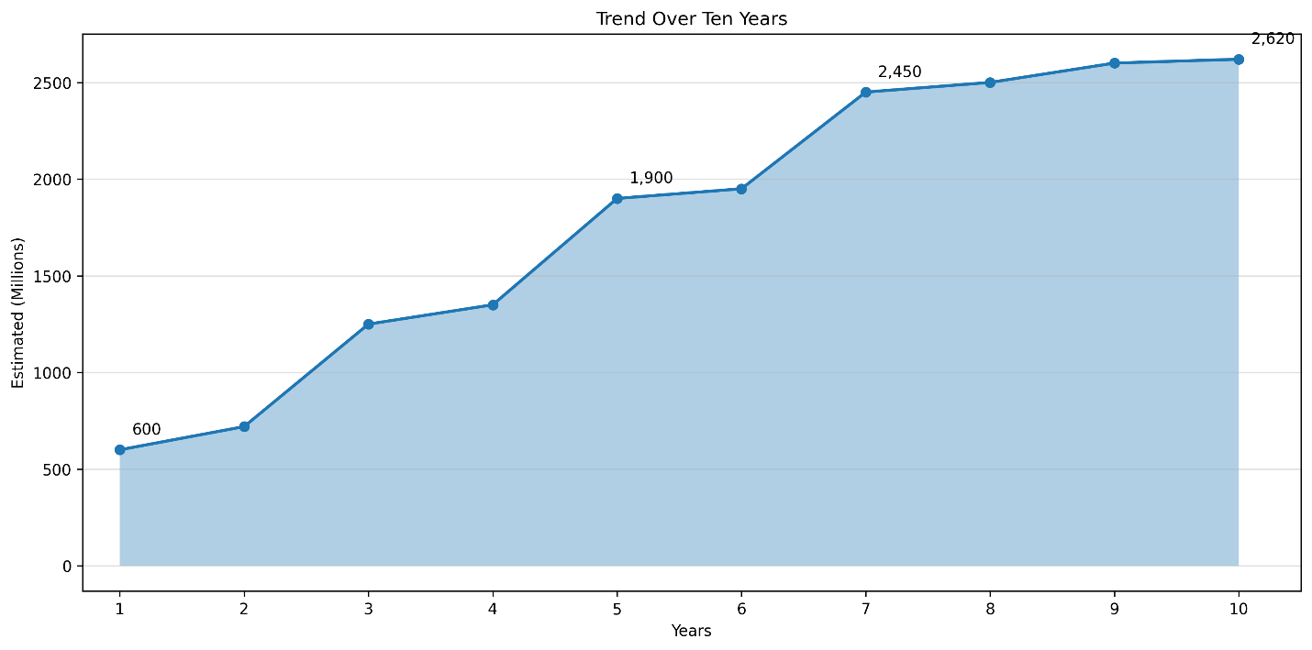

The proposed Fair Share pledge will cover debt service on these bonds and, in years when the full $125 million isn’t needed for that purpose, allow for debt defeasance that will reduce pressure on our higher education operating budgets and relieve some of the upward pressure on student fees and costs.

Putting New Resources to Use
The BRIGHT Act works in tandem with this proposal, authorizing up to $3 billion in investments for public higher education, ensuring the state has the authorization and flexibility it needs to support critical repairs and transformations on our campuses.
Specifically, the proposed bond bill includes up to $2.5 billion for the University of Massachusetts system, state universities, and community colleges to address deferred maintenance, modernize and decarbonize facilities, and construct major capital projects–breathing new life into proven capital improvement programs.
The bill also supports other critical capital investments, including:
- Planning costs associated with the disposition and acquisition of land and buildings for the purposes of housing development to help address the Commonwealth’s urgent housing needs.

- Modernization projects, such as the renovation and modernization of labs, including furnishing, equipping, and improving safety standards.
- Support regional secondary and higher education partnerships that strengthen our workforce.
- Modernization of facilities related to student health, mental health, wellness, and safety.
- Development of master plans to align campus investments with long-term goals to ensure these new resources are used optimally and thoughtfully.
- Incentives and supports for campus investments in technology capital projects, including improvements in buildings and online or hybrid workspaces and shared enterprise systems.
- Workforce Skills Capital Grants, an existing and successful grant program that helps align our higher education and workforce efforts.
The investments in this bill will also have secondary effects that benefit the people of Massachusetts; this bill will create approximately 15,000 construction-related jobs. In addition to funding authorizations, the bill includes several policy proposals related to an expansion of the authority and abilities of the Massachusetts State College Building Authority (MSCBA) to strengthen that authority’s ability to borrow for a wider range of project types and contribute additional resources to complement the state’s transformational investments. It also includes measures allowing DCAMM to dispose of surplus property from higher education institutions at the request of a higher education chancellor or president, with proceeds directed to a dedicated fund for transaction costs or capital projects. Additionally, the bill exempts building projects under $500,000 from the statutory certified study requirement, reducing administrative hurdles for smaller projects.

An Informed Approach
This legislation is informed by the work of the Higher Education Capital Working Group, which was established in the FY25 General Appropriations Act. The Working Group included members from relevant state agencies, legislators from the joint committees for higher education and bonding, designees of the public higher education sectors in Massachusetts, and other stakeholders. That group's report confirms the necessity and viability of the proposed financing structure and the investments contained in the BRIGHT Act. The report also documents the mounting capital needs at our public higher education campuses and the limitations of traditional General Obligation bonds to address these challenges.
The BRIGHT Act will provide the type of transformational investment our public higher education campuses need to best serve their students, our workforce, and the state. By leveraging Fair Share surtax revenues, the Commonwealth can expand the pie of available resources to help repair and modernize its campuses, ensuring that our public higher education institutions can provide Massachusetts’ students, educators, and workforce with the tools they need to succeed in the decades to come.

