WARNING!
No Swimming!

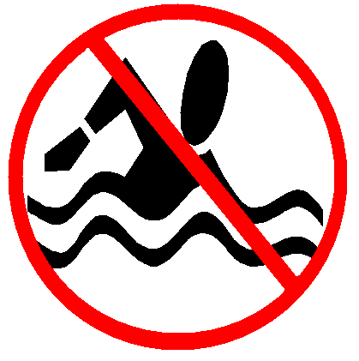

Swimming may cause Illness

Reason:

Date of Posting:

Board of Health

Telephone #

