Bureau of Infectious Disease and Laboratory Sciences
Massachusetts State Public Health Laboratory
305 South St.
Jamaica Plain, MA 02130

Powassan Virus (POWV) Surveillance in Massachusetts, 2013-2018
Background and Surveillance Highlights
- Powassan virus (POWV) is a rare tick-borne flavivirus that can cause neuroinvasive disease in humans. It is closely related to West Nile virus but is spread by ticks and not mosquitoes. According to the CDC, approximately 100 cases were reported in the United States over the last 10 years. In Massachusetts, the virus is primarily transmitted by the black-legged (deer) tick (Ixodes scapularis). Data are obtained during the collection of clinical and exposure information through investigation of suspect cases of POWV infection.
- Although at least one case of Powassan virus was identified in Massachusetts before 2013, testing for the disease became more common in 2013.
- Between 2013 and 2018, 23 cases of Powassan virus infection were detected in Massachusetts residents.
- Twenty-one of those cases (91%) were between the ages of 51 and 82. Twenty (87.0%) of cases were male.
- Fifteen (65%) cases were diagnosed with encephalitis, six (26%) with meningoencephalitis and 2 (9%) cases with meningitis.
- Sixteen (69.0%) cases reported known tick-bites before the onset of symptoms. This is in contrast to other tick-borne diseases where tick bites are not usually recognized.
- All 23 cases required hospitalization and there were 6 deaths.
- For more information about Powassan virus and other tick-borne diseases, please visit www.mass.gov/dph/tick.

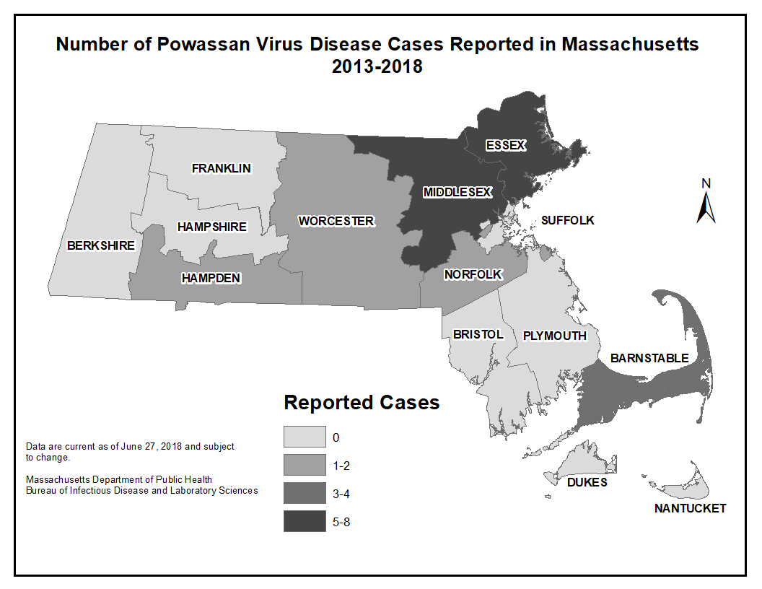
County | Confirmed Cases  (2013-2018)
Middlesex | 8
Essex | 7
Barnstable | 4
Hampden | 2
Norfolk | 1
Worcester | 1
Berkshire | 0
Hampshire | 0
Franklin | 0
Suffolk | 0
Bristol | 0
Plymouth | 0
Dukes | 0
Nantucket | 0

Map 1 and Table 1: Number of Powassan virus disease cases in Massachusetts residents reported between 2013 and 2018 by county of residence.

Figure 2: Number of Powassan virus disease cases reported by year, Massachusetts 2013-2018.

Figure 3: Number of Powassan virus disease cases by month of diagnosis, Massachusetts 2013-2018

Frequency of Symptoms Reported Among Powassan virus Cases, Massachusetts 2013 – 2018
Reported Symptoms | Frequency  N (%) | Reported Symptoms | Frequency  N (%)
Fever | 22 (95.7) | Vomiting | 10 (43.5)
Altered mental status | 16 (70.0) | Muscle weakness | 9 (39.0)
Mental confusion | 15 (65.2) | Stiff neck | 3 (13.0)
Headache | 15 (65.2)
Table 2: Frequency of symptoms reported among Powassan virus disease cases, Massachusetts 2013-2018

