New Protocol 6.18: Buprenorphine for Opioid Withdrawal
OEMS Supplemental Materials

Emergency Protocol Change
- ‘Medical Director Option’ protocol
  - Requires active opt-in
  - Requires training
  - Requires 100% QA
- Carrying buprenorphine preparations
  - Sublingual film in combination with naloxone
  - Usually 8 mg. buprenorphine per strip
  - Schedule III controlled substance
  - Service needs an appropriate MCSR from Drug Control Program
  - No longer a need for an ‘X waiver’ from DEA

Medication for Opioid Use Disorders

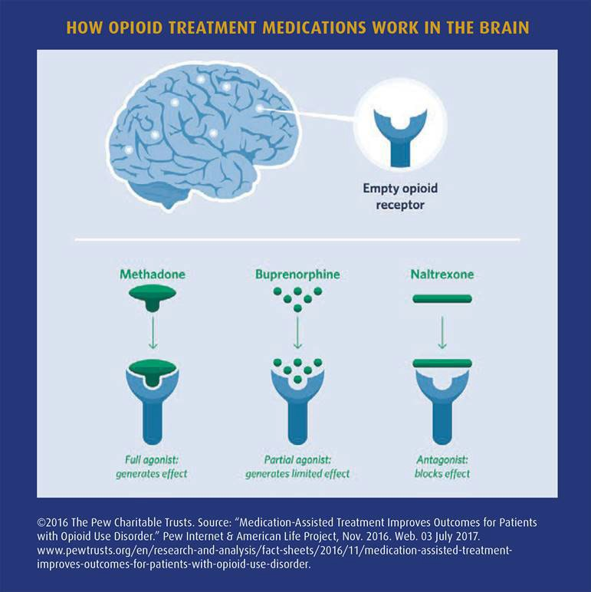
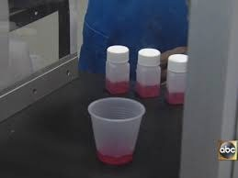
Methadone
3
Delivered by Opioid Treatment Providers (OTPs)

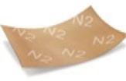
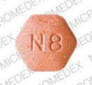
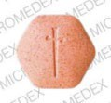
Buprenorphine
This protocol's medication

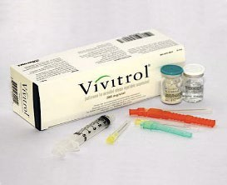
Naltrexone
Delivered by providers in office-based practice

Why Use Buprenorphine?
- Withdrawal symptoms often cause patient agitation
  - May cause them to refuse further care (which IS legal in MA)
- Treating withdrawal symptoms may calm the patient
  - Making them more likely to accept care and transport
- Studies so far indicate that approximately 1 in 3 people who get EMS buprenorphine will continue it, reducing opioid use
- Seems to be true for each EMS contact, so eventually perhaps patient’s Substance Use Disorder improves even if there are repeat events

When to Use Buprenorphine
- For patients who have just received naloxone
  - Clearly in withdrawal
- For patients who called EMS for withdrawal symptoms
  - Establish that they haven’t taken any opioids recently
    - Timing depends on med – e.g. 3 days for methadone
- Goal is to block withdrawal symptoms, not precipitate them
- Protocol requires calculation of COWS score to assess degree of withdrawal

How to Use Buprenorphine
- The 16 mg. dose is on the higher end of typical doses
  - The reason is to try to sufficiently stimulate receptors so as not to cause withdrawal inadvertently
  - Give as noted in protocol and package insert
- Half dose may be repeated en-route if needed, by COWS assessment
- Ideally the receiving hospital will continue buprenorphine or another Medication-Assisted Therapy
  - Discuss with your AHMD
  - No change in Point of Entry
- If withdrawal is worsened (rare), may contact OLMC for treatment
  - IV fentanyl, IV midazolam

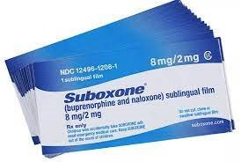
Buprenorphine/Naloxone

- To be given as sublingual combination strips for this protocol

Buprenorphine/Naloxone
  - Agonist/Antagonist
    - Attaches to the opioid receptors
    - Prevents withdrawal symptoms
      - Can cause withdrawal RARELY if a patient has large amounts of opioids in system already
    - Does NOT cause respiratory depression
  - Combined with naloxone
    - Naloxone is poorly absorbed by GI – does not affect patient
    - If the film is instead dissolved and injected IV or IM, prevents opioid effects

