Personal Protective Equipment

The following equipment is required in this work area:

Task | Eye Protection | Ear Plugs or  Ear Muffs | Gloves | Feet | Apron | Respirator | ANSI  Hi-Vis clothing  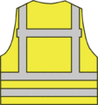 | Hard Hat  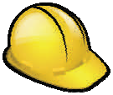 | Fall Protection  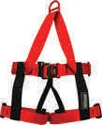 | Other
For example: Chainsaw operations | X Safety glasses with faceshield | X | X | X |  |  |  |  |  | X—Kevlar Chaps
For example: Electroplating operations | X goggles |  | X nitrile | X | X
This certifies that the workplace has been evaluated for hazards in order to determine if personal protective equipment is required.
Signature of person conducting the assessment: Date:

This summary is an optional format intended to help communicate PPE requirements to employees. Each employer may develop their own format. You may add PPE icons that apply to your worksite. A certification statement is required. Based on workplace hazards, other programs, such as a Respirator Program, Hazard Communication, or Hearing Conservation Program, may also be required.

