CERTIFICATION OF HAZARD ASESSMENT
FOR SELECTION OF PPE

Purpose: Employers are required to evaluate hazards in the workplace to determine if Personal Protective Equipment (PPE) is required. This optional worksheet can be used by employers to assist the evaluation process. Employers may use their own format. However, the employer must be able to certify that a hazard assessment has been conducted, through a certification statement. The statement is provided at the end of this worksheet.

Work Area Evaluated: _________________________________________________________

Can tasks in this work area affect the following? | Examples of Hazards | PPE REQUIRED  (check all that apply)
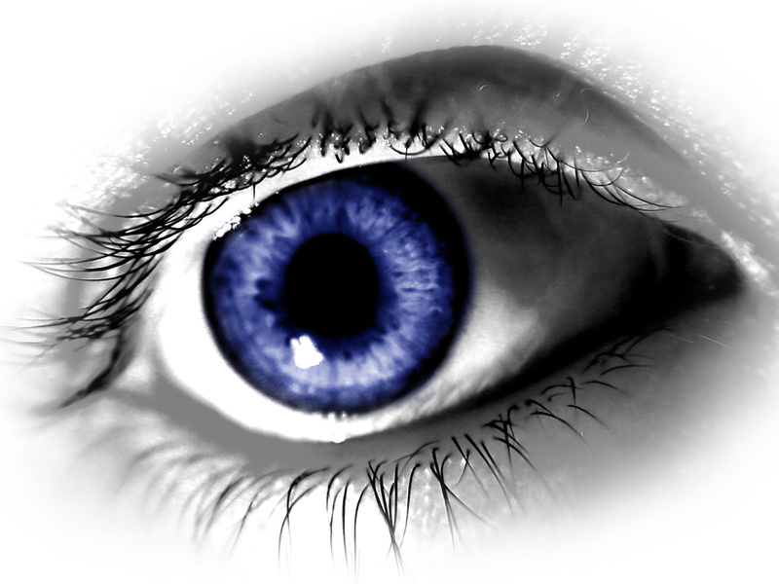  Eyes and Face | - Dust  - Projectiles  - Twigs, stray objects  - Chemicals  - Blood  - Other: _______________ | - Safety glasses with side shields  - Splash-proof goggle  - Faceshield  - Other: ___________________
Hands | - Tools  - Chemicals  - Splinters  - Poison ivy  - Sharp objects  - Cold / Heat  - Blood  - Other: __________________ | - Canvas gloves  - Chemical-resistant gloves  - Healthcare gloves  - Food-prep gloves  - Cut-resistant gloves  - Heat-resistant gloves  - Cryogenic gloves  - Other: ____________________
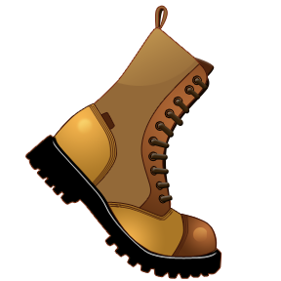  Feet | - Impact  - Compression by heavy objects  - Sharp objects  - Slippery area  - Chemical  - Heat/Cold  - Other: __________________ | - Closed-toe shoe  - Closed-toe boot  - Safety-toe shoe  - Safety-toe boot  - Chemical-resistant overboot  - Slip-resistant closed toe shoe  - Other: __________________
Lungs | - Nuisance dust  - Chemical dust  - Chemical liquid  - Lack of oxygen  - Other: ______________ | - N95 dust mask  - Tight-fitting elastomeric respirator with the following filters:_____________________  - SCBA  Note: A written Respirator Program may be required based on type of respirator worn.

Can tasks in this work area affect the following? | Examples of Hazards | PPE REQUIRED  (check all that apply)
Head | - Falling objects  - Working underneath scaffolding or other activity  - Other:_____________ | - Hardhat
Hearing | - Noise at or above 85 decibels  - Other:_____________ | - Ear plugs  - Earmuffs  - Both plugs and muffs at same time (i.e., Noise is above 100 decibels)
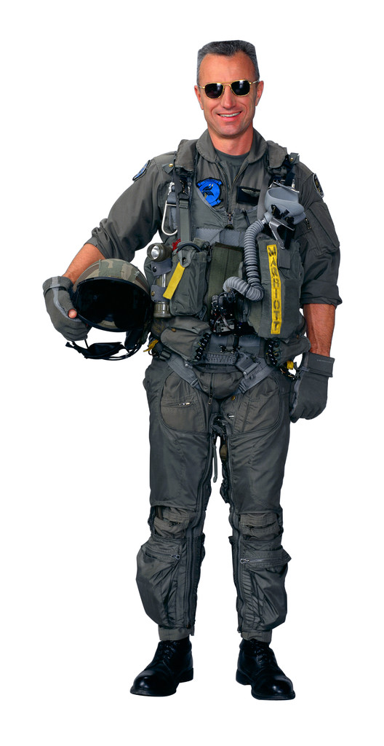  Torso | - Chemical splash  - Chemical dust  - Laceration  - Heat  - Cold  - Abrasion  - Other ________________ | - Long-sleeve shirt  - Long pants  - Kevlar chaps  - Cotton coverall  - Fire-resistant coverall  - Tyvek coverall  - Chemical-resistant coverall  - Other_________________
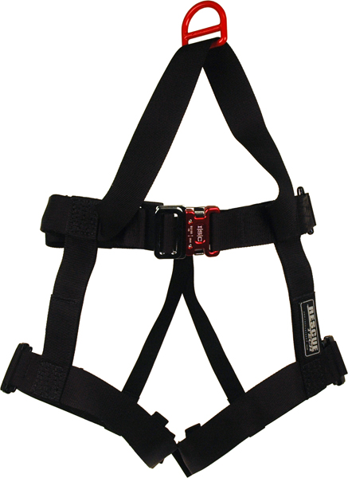  Fall Protection | - Fall from height  - Work in bucket truck  - Roofing  - Other______________ | - Full body harness  - Lanyard  - Anchor point

Certification:
This certifies that the workplace has been evaluated for hazards to determine if personal protective equipment is required.

Name of workplace: _________________________________________________________
Name of person certifying evaluation: ___________________________________________
Signature: _____________________________________________ Date: _______________

