**The Commonwealth of Massachusetts**

**Office of the State Treasurer and Receiver General**



**PPS Replacement Project**

**Request for Information (RFI)**

**For**

**Enterprise Payment Software and Implementation**

Posted: 1/3/2017

Table of Contents

1 Introduction 3

1.1 RFI Purpose 3

1.2 Agency Background 4

1.3 Project Background 4

2 PPS System Overview 5

3 External Source Systems Uploads 5

4 A Typical PPS Process 6

5 Requirements 9

6 Samples 12

6.1 HRCMS Employee Check 12

6.2 HRCMS Employee ACH 13

6.3 HRCMS Vendor Check 14

6.4 Industrial Accidents Check 15

6.5 MMARS Warrant - BFC 105 Overflow Check – Front 16

6.6 MMARS Warrant - BFC 105 Overflow Check – Page 2 17

6.7 MMARS Warrant - BFC 312 Regular Check 18

6.8 SRB Refund Check 19

6.9 TRB Pension ACH 20

7 The RFI Process 20

7.1 Vendor Responses 20

7.2 General Instructions 20

8 Response Costs 22

9 Review Rights 22

10 Public Record 22

Appendix A – Glossary and Terms 22

Appendix B – Links to Commonwealth of MA Technical Requirements 24

Commonwealth of Massachusetts – Request for Information

**Issued by the Office of the State Treasurer and Receiver General (TRE)**



*Respondents to this Request for Information (RFI) are invited to respond to any or all of the questions in this document. Responses to this RFI shall serve solely to assist the Commonwealth in understanding the current state of the marketplace as it applies to the solicited information and to inform the possible future development of a Request for Responses (RFR) or Request for Quotes (RFQ). This RFI does not in any way obligate the Commonwealth to issue or amend a solicitation or to include any of the RFI provisions or responses in any solicitation. Responding to this RFI is entirely voluntary, and will in no way affect the Commonwealth’s consideration of any proposal submitted in response to any subsequent solicitation, nor will it serve as an advantage or disadvantage to the respondent in the course of any RFR or RFQ that may be subsequently issued or amended.*

# Introduction

## RFI Purpose

The Office of the State Treasurer and Receiver General (TRE) is issuing this Request for Information (RFI) to solicit information regarding commercial off-the-shelf (COTS) software and services to replace the TRE’s current payment backbone, the Payment Processing System (PPS). This project is known as TRE’s PPS Replacement Project. The COTS system should be configurable, customizable and robust enough to handle a large volume of checks, payment advice, employee stubs and ACH transactions.

The purpose of this RFI is to elicit the advice and best analysis of knowledgeable persons in the vendor community to enable TRE to create a potential future solicitation for the PPS Replacement Project. Responses to this RFI should include information that will be useful to TRE in subsequently drafting more detailed procurement solicitation(s) related to this project.

TRE is looking for proven COTS vendors who can provide a mature software product and who possess strong business knowledge of payment processes. In conjunction with the COTS software, is the need for System Integration (SI) services to provide for configuration, implementation and training. TRE is amenable to purchasing the SI services from the COTS software vendor or from a separate SI vendor. Therefore, COTS application software vendors who have implemented their own solution as well as SI vendors are all encouraged to respond to this RFI.

TRE would further like to encourage all interested COTS vendors to respond to the RFI, even if their COTS product is unable to meet all of the listed requirements. Since the purpose of an RFI is to elicit information, it would be beneficial to learn the limitations of the currently available COTS products. Eventually, TRE may determine that some requirements are better satisfied by a third party product or vendor. By gaining an understanding of what is commercially available, TRE expects to create a more realistic RFR.

## Agency Background

The mission at the Office of the State Treasurer is to prudently manage and safeguard the Commonwealth’s public deposits and investments through sound business practices for the exclusive benefits of its citizens, and perform these duties with integrity, excellence, and leadership.

## Project Background

TRE is in the process of replacing its payment backbone, PPS. PPS is a custom application hosted on a Unisys mainframe, built using WFL, COBOL, DMSII database, and utilizing Xerox DJDE files and Xerox NUVERA 120 MX printers. Commonwealth payments for payroll, pensions, and vendors all go through PPS.

The current functions of the PPS system are:

* Accept data files in various formats and store the data from those files in tables in the PPS database
* Create and assign check numbers and check dates to check payments
* Create and assign trace numbers and settlement dates to ACH payments
* Print checks, payment advice and employee pay stubs
* Create check register files
* Create reconciliation files
* Create issue files for banks
* Generate ACH files or forward ACH Files from source systems
* Generate return files for the source systems
* Create reports for quality control
* Maintain 10 days’ worth of data to facilitate check reprinting and other tasks
* Hide underlying bank and account information through the use of business function codes (disbursement codes) passed into PPS from source systems
* Provide a graphical user interface for managing PPS configuration information
* Provide a graphical user interface for TRE to identify checks to pull
* Create check issue and ACH files for banks
* Create reports for charge backs for postage and stock

The objective of this new project is to deploy a system that will handle all of the TRE’s payment and printing needs. At a very high level, the goals for the new system are to:

* Reduce maintenance costs by using current technology
* Reduce operational costs
* Reduce disaster recovery costs
* Provide a better user experience

# PPS System Overview

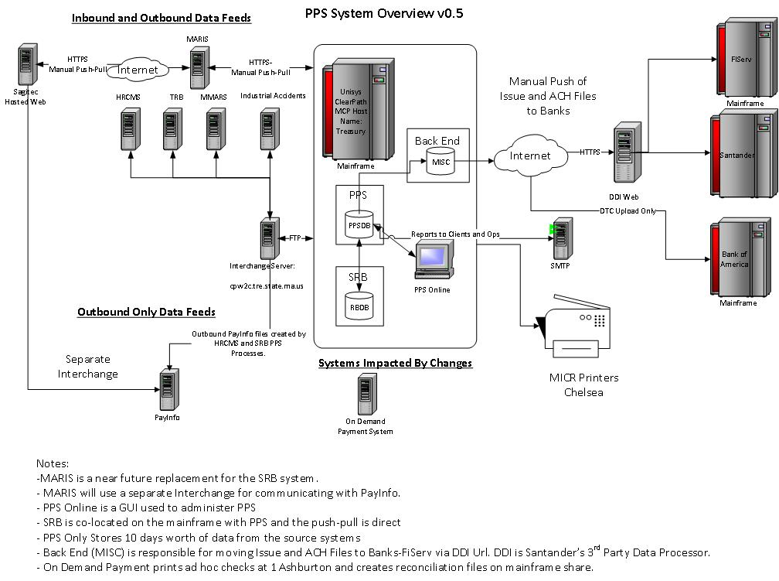

# External Source Systems Uploads

* MMARS Warrant File
  + Vendor Payments and other info for reporting
  + File is uploaded daily by the Office of the State Comptroller
  + Generates check and ACH payments
  + Contains information indicating whether or not funding has been made for

other PPS processes (HRCMS, IA, MTRS, SRB)

* HRCMS Payroll Files
  + Files are uploaded twice monthly
  + HRCMS-generated ACH and Check Payment Files uploaded
  + Check Payments generated - ACH Files are uploaded as is unless there are invalid characters
  + In addition to return files, this process generates PayInfo files so that employees can view payment info online
* HRCMS Pre-Note Files
  + Tests the validity of bank account information entered into HRCMS
  + File is uploaded monthly
  + File is validated for invalid characters and $0 amounts
* Industrial Accidents
  + Workers Comp Indemnity
  + Files are uploaded twice monthly
  + Check payments generated
* MTRS Pension Payments
  + Payments for retired teachers
  + Files are uploaded once per month
  + ACH and check payments generated
* MTRS Refund Payments
  + Refunds or rollover of contributions to the Teachers' Retirement System
  + Files are uploaded weekly
  + Check Payments are generated
* MTRS Pre-Notes
  + Tests the validity of bank account information entered into HRCMS
  + File is uploaded monthly
  + File is validated for invalid characters and $0 amounts
* State Retirement Board System – Current System/MARIS Near Future Replacement System
  + Payments for Retirees
  + Monthly
  + ACH and check payments generated

# A Typical PPS Process

* The source system administrators for MMARS, HRCMS, MTRS, SRB, IA generate payment files containing check and ACH payments. In some cases, ACH files are generated from their systems.
* Source system administrators upload files. This is usually done via InterChange, an MQSeries message queue.
* The source system administrators email the PPS system administrators, Chelsea Ops, to notify Chelsea Ops that files are in transit and provide balancing information. The balancing information consists of the total number of checks, the amount of each check, ACH transactions and sometimes dates. These numbers and amounts are verified against the data in the files uploaded.
* The data files arrive and are uploaded to the current PPS system.
* In some cases, the files are validated against themselves: e.g. the number of records and dollar amounts in the detail records are compared to footer records, pre-formatted ACH files are validated for detail and addenda record counts and amounts against footer values, and ACH files are checked for invalid characters.
* PPS generates pre-load and load reports. The pre-load reports are load reports that are not saved in the database and are a legacy of earlier slower processing times. The pre-load and load reports are generally used as a first look at the data to start the process of reviewing the balancing information earlier rather than waiting until the end of processing.
* As part of the load, the PPS database creates an IFS-TRACKING-SET record to track the upload and loads basic payment data into a generic PAYMENT table and additional data into other tables (hours, earnings, deductions, and pass through info for return files).
* Any special processing is done.
* Payment records are assigned check numbers, check dates, ACH trace numbers and settlement dates.
* Register, reconciliation, ACH and print files are created. Separate print files are created for different business function codes (BFCs), department codes, document types, and special handling flags.
* After the files, the PPS system generates a summary report. The summary report is the primary means for validating the actual data file contents against the balancing information provided by source system administrators. The Chelsea Ops managers either manually compare the balancing information provided by the source system administrators against the data provided by the report or the managers enter the balancing and the summary report data into spreadsheets that validate the data. This is done by at least two senior people to minimize the chance of mistakes.
* The system prompts the Chelsea Ops team to generate return files. If balancing is successful, the return files are generated and, generally, returned to the source system administrators via InterChange. The return files have check numbers, dates, and pass through information that is not used by PPS.
* As the Chelsea Ops managers do the balancing, other operators have started printing. The operators pull print files off a queue and route the files to specific printers. Each file has a print template or form associated with it.
* The printed items are loaded onto carts and moved to the sealer.
* The mail room operator selects the proper fold and the items are fed into the sealer.
* If balancing completes successfully, the return files are created and returned to the source systems via InterChange.
* At this stage, funding of the accounts are verified by Chelsea Ops. Typically, this is done via reports generated from the MMARS Daily Warrant file. In addition to check and ACH information for specific BFCs, the warrant file contains totals for other PPS processes. Verification of funding also results in the physical release of printed items.
* Chelsea Ops staff now creates the issue files for the bank. The reconciliation files created earlier are consolidated and the consolidated file is converted to the bank’s issue file format. Chelsea Ops staff creates a coversheet with the account numbers, the check numbers, and the total amount. The issue file is transferred to Santander’s 3rd party data processor, DDI, via an https file upload and the coversheet is emailed to Santander. DDI sends Chelsea Ops a confirmation email confirming the number of checks and the totals.
* To move the ACH files to the bank, Chelsea Ops uploads the ACH file to DDI and emails FiServ, the company that ultimately processes ACH files, the last page of the ACH Summary Report containing record counts and amounts. DDI confirms the numbers and amounts by email.
* The printed items are then distributed. Some are moved to Central Mail in Chelsea and then couriered to USPS. Others are returned via courier to TRE’s office at 1 Ashburton Place, Boston, where the items are picked up by other Commonwealth agencies or distributed to TRE’s Cash Management department. In a small number of cases, FedEx is used to convey the checks to a remote location and so that item can be manually distributed to staff.

# Requirements

This RFI includes descriptions, at a very high level, of the project requirements. The purpose of these requirements is to guide the vendor when responding to this RFI. TRE reserves the right to change requirements in any subsequent solicitation. These requirements represent TRE’s understanding of the project’s needs at this time.

|  |  |  |
| --- | --- | --- |
| Id | Category | Description |
| 305 | Input Data File Processing | The replacement system should be able to translate files from one format to another |
| 456 | Input Data File Processing | The replacement system must be able to generate summary and detail reports from input data |
| 320 | Check Creation | The replacement system must be able to assign and track check numbers |
| 424 | Check Creation | The replacement system should be able to calculate valid check dates by BFC (Disbursement Code) |
| 316 | Payment Processing | The replacement system should be able to validate ACH settlement dates via BFC (Disbursement Code) |
| 321 | Payment Processing | The replacement system must be able to assign Trace Numbers for ACH transactions |
| 322 | Payment Processing | The replacement system must be able to assign settlement dates for ACH transactions by BFC (Disbursement Code) |
| 286 | Registers and Reconciliation Files | The replacement system must create check registers |
| 325 | Registers and Reconciliation Files | The replacement system must be able to generate check register reports |
| 419 | Registers and Reconciliation Files | The replacement system should offer a web interface for searching check registers |
| 474 | File Creation | The replacement system must be able to create NACHA compliant files (PPD, CTX, CCD+) |
| 387 | Printing | The replacement system must support blank check stock |
| 454 | Printing | The replacement system must support special physical handling flags for printed items |
| 379 | Printing | The replacement system should allow distributed check printing |
| 281 | Return File Processing | The replacement system should be able to generate return files containing check numbers, check dates and pass through information |
|  |  |  |
| 273 | Interface with Banks | The replacement system will need to be able to generate issue files in bank specific formats |
| 385 | Interface with Banks | The replacement system should support positive pay connectivity to banks |
|  |  |  |
| 367 | Manage Accounts | The replacement system must be able to define account types (ACH, ACH Pass through, Checking) |
| 371 | Manage Accounts | The replacement system must provide a user interface for managing bank account information |
| 267 | Manage Banks | The replacement system must provide a user interface for managing bank information |
| 326 | Manage Holidays | The replacement system must provide a user interface for managing holidays |
| 271 | Manage Signatures and Titles | The replacement system must provide a user interface for maintaining check signature images for different types of checks |
| 278 | Manage Standard and Substitute Text | The replacement system should provide a user interface for managing standard and substitute text messages for printed items |
|  |  |  |
| 299 | Reports | The replacement system must be able to generate custom reports |
| 300 | Reports | The replacement system must be able to email custom reports and other files |
| 339 | Reports | The replacement system standard output formats should include standard outputs such as Excel, Access, ASCII, PDF,XML, MS WORD |
| 340 | Reports | The replacement system should provide GUI-based end-user report viewing and query tools |
|  |  |  |
| 288 | Security | The replacement system must be able to secure social security numbers and other Personally Identifiable Information at rest and during transmission |
| 333 | Security | The replacement system should enforce security for each application\module with the ability to restrict levels of access by individual, role to field and function level |
| 337 | Security | The replacement system must have configurable audit trails |
|  |  |  |
| 460 | System Integration | The system integrator must provide data migration and conversion services |
| 461 | System Integration | The system integrator must configure the replacement system to fit TRE's needs |
| 462 | System Integration | The system integrator must be able to customize the replacement system to TRE's needs |
| 463 | System Integration | The system integrator must provide training to IT and end users |
|  |  |  |
| 336 | General Technical | The replacement system must have automated e-mail notification for specific events and/or intervals |
|  |  |  |
| 268 | Configuration and Customization | The Replacement System must provide a facility for plugging in custom processing |
| 346 | Configuration and Customization | The replacement system will have a customizable workflow |
| 347 | Configuration and Customization | The replacement system will have customizable database entities and fields |
| 348 | Configuration and Customization | The replacement system will have a customizable user interface |
| 378 | Configuration and Customization | The replacement system must allow the creation of custom business rules |
|  |  |  |
| 440 | Resiliency | The replacement system should have a secondary fallback system if the primary system fails. |
|  |  |  |
| 426 | Scalability | Any replacement system must be able to print 70,000 checks per month |
| 427 | Scalability | Any replacement system will need to process 600,000 ACH transactions per month |
| 428 | Scalability | Any replacement system should be able to print 70,000 ACH pay advice and stubs per month |

# Samples

## HRCMS Employee Check

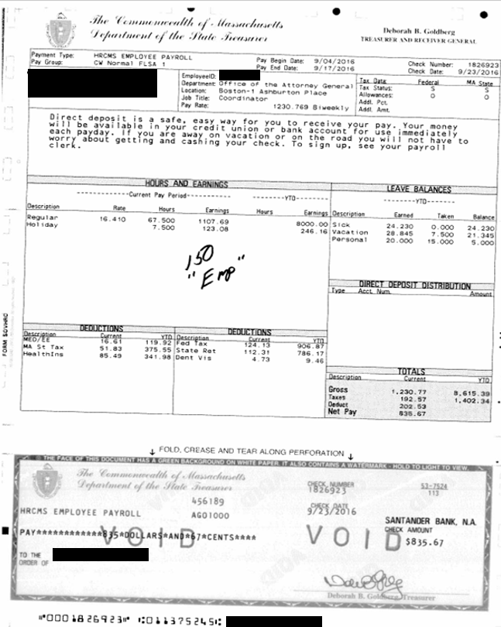

## HRCMS Employee ACH

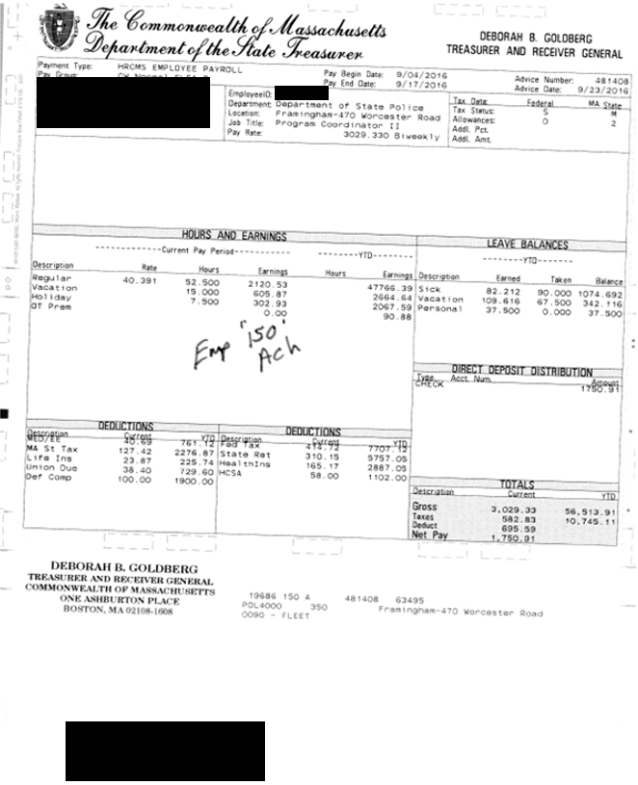

## HRCMS Vendor Check

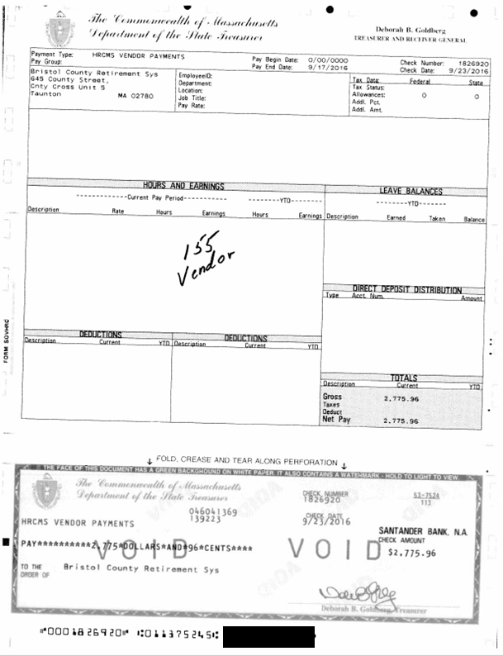

## Industrial Accidents Check

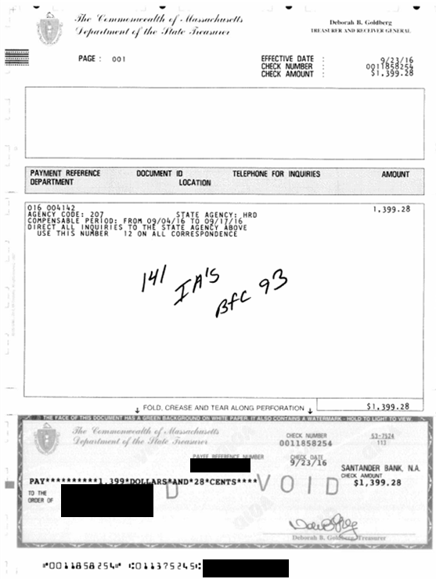

## MMARS Warrant - BFC 105 Overflow Check – Front

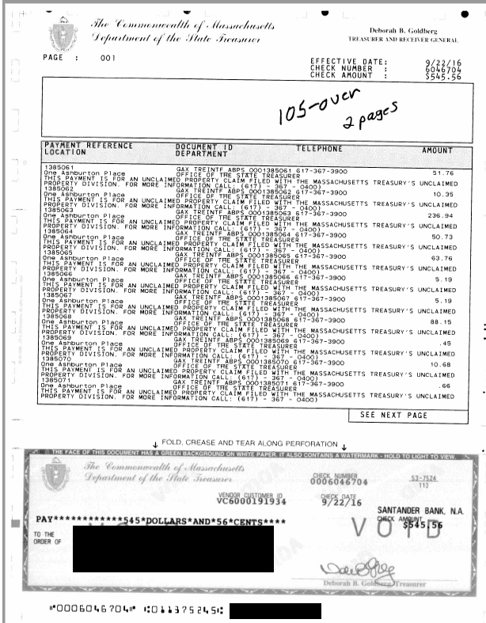

## MMARS Warrant - BFC 105 Overflow Check – Page 2

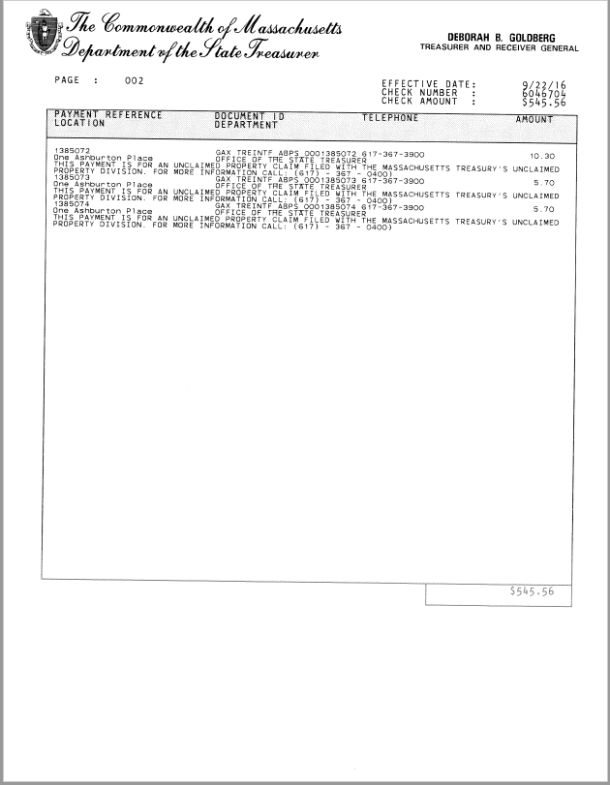

## MMARS Warrant - BFC 312 Regular Check

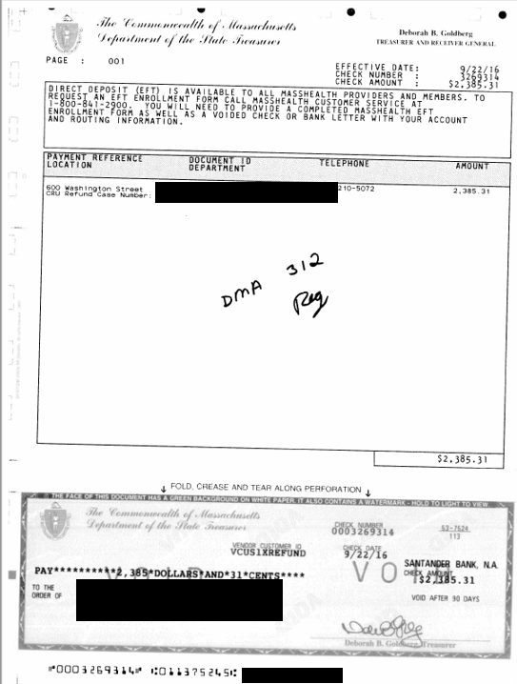

## SRB Refund Check

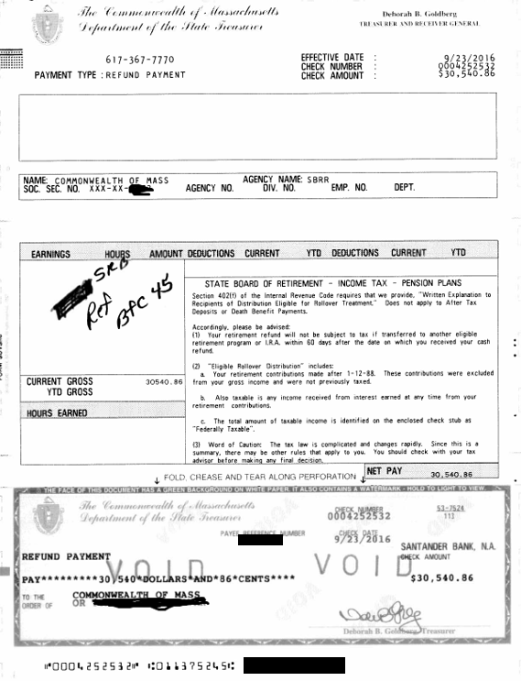

## TRB Pension ACH

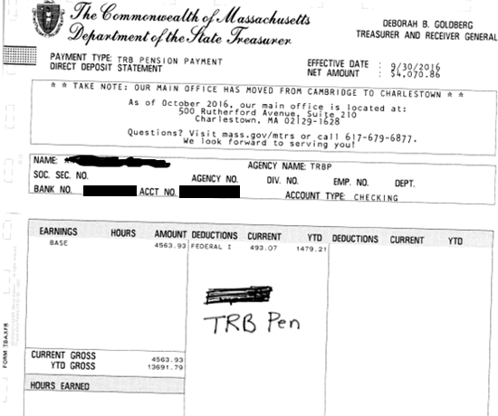

# The RFI Process

## Vendor Responses

Vendor must respond to this RFI using the PPS_Replacement_RFI_Response.docx. This ensures that we receive common data from all vendors who participate. Vendors may also provide an additional narrative in a separate MS Word document (12pt font, single-spaced). System screen-shots may also be included in the response as well as any marketing materials that would be helpful in the evaluation process. These RFI responses will help TRE to make a comparison between the different COTS products, which are currently on the market and will inform TRE as it develops a possible future RFR and/or RFQ for vendor services.

## General Instructions

This RFI is issued solely for the purpose of obtaining information. Nothing in this RFI shall be interpreted as a commitment on the part of TRE to issue an RFR or RFQ, include any of the RFI provisions or responses in any RFR or RFQ, or enter into a contract with any respondent .

Once submitted to TRE, all responses and accompanying materials are the sole property of TRE and will not be returned.

This RFI has been posted on Massachusetts’ procurement and solicitation system, COMMBUYS(<http://www.commbuys.com>), on 1/3/2017. The instructions for responding to this RFI are as follows:

* Vendor Questions - Potential respondents who have questions regarding this RFI may e-mail them to the contact listed below by 1/13/2017. Respondents may only make inquiries and request clarification concerning this RFI by written questions via e-mail with the subject line “PPS RFI QUESTIONS.” Responses to inquiries and clarification questions will be provided electronically to all interested parties via a posting on COMMBUYS on 1/20/2017.
* Informational Sessions - There will be no informational session associated with this RFI.
* Vendor Presentations – If desired by the vendor and at the discretion of TRE, TRE will schedule an oral presentation, to be given by the vendor at the TRE’s office, 1 Ashburton Place, 12th Floor, Boston, MA 02108, at a mutually agreed upon date and time. All schedules will be finalized within three weeks of the response due date.
* Response Submissions - All responses to this RFI are due no later than **2/10/2017-4:00 PM**. Respondents should submit one electronic copy via e-mail and submit a hard copy to the contact listed below. All responses must include the official name of the firm or entity submitting the response on the first page of the response and in the footer of the response document.
* TRE Contact Information - Please direct all communications, questions, and responses via email to the following contact:

Jameel Moore, Esq., Procurement Analyst/Associate General Counsel  
(Email) procurements@tre.state.ma.us

Office of the State Treasurer and Receiver General  
1 Ashburton Place, 12th Floor  
Boston, MA  02108

* Additional Information – TRE retains the right to request additional information from respondents. TRE may, at its sole discretion, elect to request formal presentations from certain vendors and/or create an RFR or RFQ, which will include the detailed requirements and key success criteria for the procurement, which may be based, at least in part, on the responses received from this RFI. TRE may request further explanation or clarification from any or all respondents during the review process.

# Response Costs

By submitting a response, respondents agree that any cost incurred in responding to this RFI, or in support of activities associated with this RFI, shall be the sole responsibility of respondent. TRE shall not be held responsible for any costs incurred by respondents in preparing their respective responses to this RFI.

# Review Rights

Responses to this RFI may be reviewed and evaluated by any person(s) at the discretion of TRE, including independent consultants retained by TRE now or in the future.

# Public Record

All responses to this RFI will be public record under the Commonwealth’s Public Records Law, Mass. Gen. L. ch. 66 s. 10, regardless of confidentiality notices set forth on such writings to the contrary.

# Appendix A – Glossary and Terms

|  |  |
| --- | --- |
| BFC | Business Function Code. This is the equivalent of a disbursement category in the Office of the State Comptroller’s MMARS accounting system. Helps hide bank account information from source systems and encapsulates check stock and post-processing instructions |
| CTX | Corporate Trade Exchange –ACH format which allows for up to 9,999 addenda records with approximately 800,000 characters. The addenda records allow full remit advice to be included with a payment. |
| DDI | http://www.datadist.com/ 3rd Party that receives ACH and Issue Files (checks) from PPS on behalf of Santander. |
| HRCMS | Commonwealth of Massachusetts Human Resources Compensation Management System |
| Intercepts | These are checks that have money held back. For a vendor, this may be money held back for taxes or missing some performance goal on a project. For an employee, this may be back child support. Any payments that are intercepted become checks regardless of whether they were originally intended to be ACH. |
| Interchange | A secure file transfer system used by state agencies. Utilizes MQSeries. |
| IRIS | Information Reporting and Initiation Service - Santander’s Web-based treasury management system |
| MMARS | Massachusetts Management Accounting Reporting System |
| Overflow | Checks and ACH with more than 45 lines of remit advice. |
| PayInfo | Provides a web interface for viewing state employee payroll information. PayInfo receives some of the return files from HRCMS |
| Pre-Note | Zero amount ACH transactions used to verify that a new payee’s bank account ABA and number are valid. |
| Pulls | Checks that have been marked "Do not mail". There are special labels in Chelsea that are attached to green bags that have a label for each department. These are returned to TRE at 1 Ashburton for pickup |
| SRB | Massachusetts State Retirement Board |
| MTRS | Massachusetts Teachers’ Retirement System. Owns one of the systems with a bi-directional interface with PPS |
| Warrant File | Disbursement File |
| WC | Warrant Checks |
| WFL | Work Flow Language |

# Appendix B – Links to Commonwealth of MA Technical Requirements

The following links are included to provide complete information regarding the Commonwealth of MA technical requirements.

1. **Enterprise IT Accessibility Standards:**

<http://www.mass.gov/anf/research-and-tech/policies-legal-and-technical-guidance/it-policies-standards-and-procedures/ent-pols-and-stnds/accessibility-standards/enterprise-it-accessibility-standards.html>