PRC Payment Status Report Submitted Versus Paid Report

PRC Payment Status Report Submitted Versus Paid – Input screen
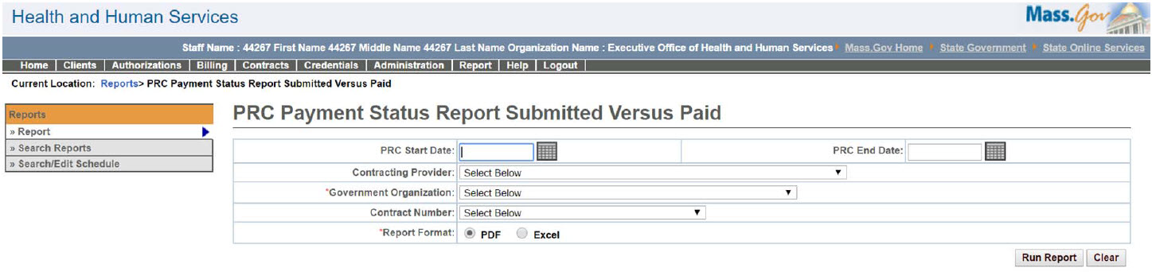

PRC Payment Status Report Submitted Versus Paid – Output screen
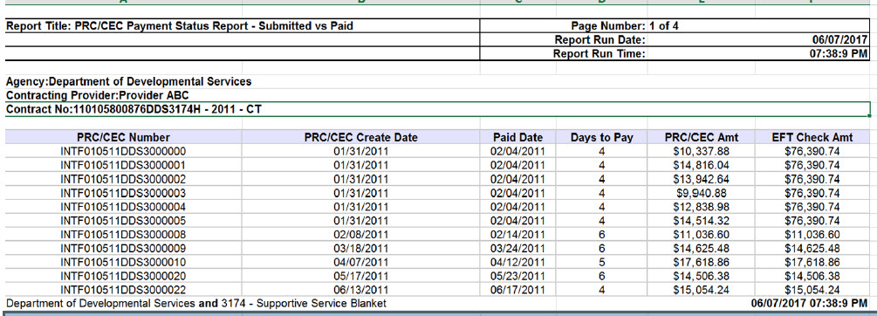
Report Description
Provides payment dates for PRCs to show lag time between submission and payment.

Report Benefit

Helps a user to analyze if payments are being done in a timely manner.

Required Parameters

Government Organization

Report Format

Scheduling
Yes

Agency Roles
CR Reports, UR Reports

Provider Roles

Contract and Payment Reviewer

Operation Roles
N/A
This information is provided by the Virtual Gateway within Health and Human Services.

