Note: this form is for members only. If you are looking for the provider EFT, please click on this box to access the form.

COMMONWEALTH OF MASSACHUSETTS AUTHORIZATION FOR ELECTRONIC FUNDS TRANSFER PAYMENTS

"I, , hereby authorize the Commonwealth of Massachusetts, through the State Treasurer, to deposit funds due into the account at the bank named below. The State Treasurer is also authorized to debit my account only to adjust any over deposit which
it has caused to be made to my account."

Request Type must be checked: □ Initial Request □ Changing Existing Request □ Closing Account

MEMBER BANK INFORMATION:

Bank Name:

Bank Transit Routing Number:

Bank Account Number:

(Please Check Account Type): Checking Account (attach voided check)
Savings Account (attach a bank issued memo with routing and account information)

MEMBER INFORMATION:

Social Security Number:

Name:

Telephone: ( )

Address:

City: State: Zip:

This authorization will remain in effect until either canceled in writing or an updated form changing information is sent to:

Executive Office of Health and Human Services MassHealth Accounting Unit – EFT
600 Washington Street
Boston, MA 02111

SIGNATURE:

Print Name: Date:
Attach voided check here.

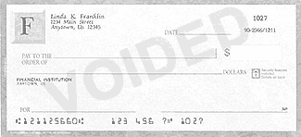
EFT-M (Rev. 12/11)

