MassHealth Standing Order for Dispensing Over-the-counter Prenatal Vitamins

This MassHealth standing order is issued pursuant to M.G.L. c. 118E, § 84, which provides that a qualified physician designated by the assistant secretary for MassHealth may issue a standing order that may be used for a licensed pharmacist to dispense an over-the-counter (OTC) prenatal vitamin to a MassHealth member or Health Safety Net (HSN) patient.

This standing order authorizes licensed pharmacists to dispense over-the-counter prenatal vitamins or multivitamins containing ≥ 400 mcg of folic acid to any MassHealth member or HSN patient of reproductive age who states that they are capable of becoming pregnant, considering pregnancy, attempting to become pregnant, are pregnant, or are nursing as directed below.

M.G.L. c. 118E, §84 protects the physician signing this standing order, and all practitioners prescribing or dispensing OTC prenatal vitamins in good faith, from criminal or civil liability or any professional disciplinary action except for gross negligence or willful misconduct.

**For oral administration:**

* **Any covered prenatal or multivitamin containing ≥ 400 mcg of folic acid**

Dispense up to 90-day supply

Directions for use: See **Prenatal Vitamin Recommendation Flow Chart** below

Contraindication: Known hypersensitivity to folic acid or any component of the formulation (in which case, prenatal or multivitamin should not be dispensed)

Every individual dispensed a prenatal vitamin under this standing order shall receive education regarding the use of prenatal vitamins, including appropriate initiation/discontinuation and when to anticipate a dose adjustment as directed in the flowchart below. The pharmacist should always counsel the individual to follow up and consult with their primary care physician or obstetrician/gynecologist. Records of dispensing must be maintained in the patient profile of the pharmacy dispensing system.

January 27, 2025

**Physician Signature Date**

Viveka Prakash-Zawisza, MD, MS, MBA, FACOG                MA 250333

**Physician’s Name and MA License No.**

**Prenatal Vitamin Recommendation Flow Chart1-3**

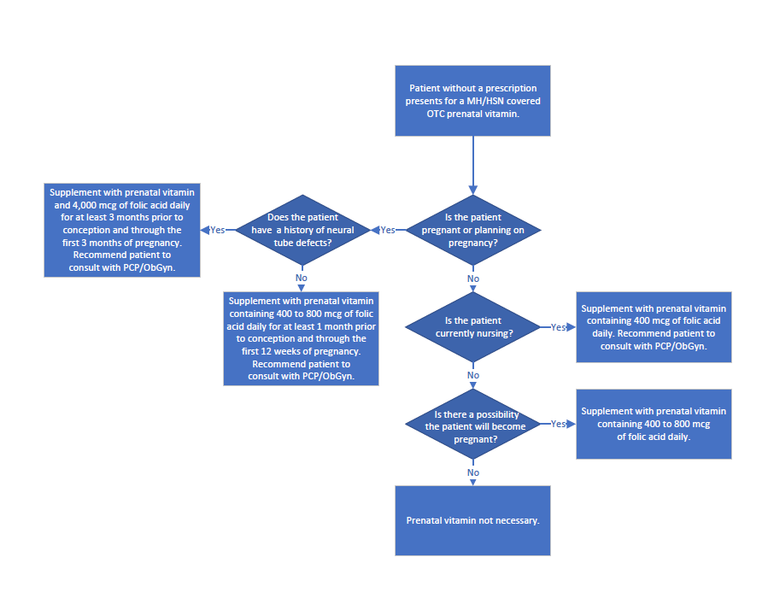

References:

1. Centers for Disease Control and Prevention. Folic Acid: Facts for Clinicians. Accessed Aug 21, 2024. Available from: [cdc.gov/folic-acid/hcp/clinical-overview/](https://www.cdc.gov/folic-acid/hcp/clinical-overview/)
2. Mother To Baby | Fact Sheets [Internet]. Brentwood (TN): Organization of Teratology Information Specialists (OTIS); 1994-. Folic Acid | Folate. 2024 Jan. Available from: [ncbi.nlm.nih.gov/books/NBK582717/](https://www.ncbi.nlm.nih.gov/books/NBK582717/)
3. The American College of Obstetricians and Gynecologists. FAQs: Nutrition During Pregnancy. Accessed Aug 21, 2024. Available from: [acog.org/womens-health/faqs/nutrition-during-pregnancy](https://www.acog.org/womens-health/faqs/nutrition-during-pregnancy)