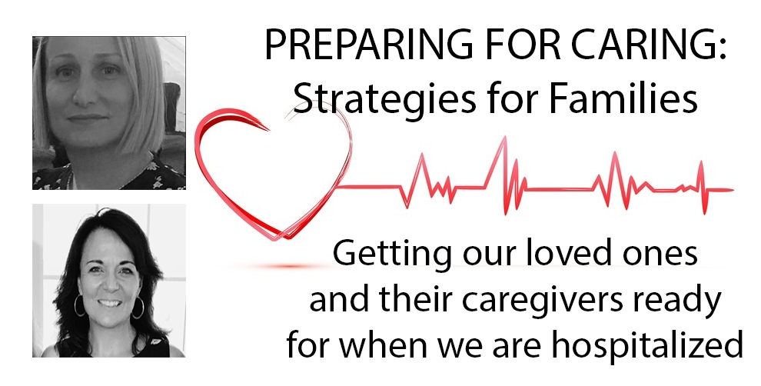

This document has been prepared to support the planning for families. It is not meant to take the place of any medical or legal advice you have in place; it’s simply meant to fill in the gaps that might exist in your preparation. We are NOT legal attorneys, medical specialists or hold any certification that makes us legally responsible for this information. We can guarantee we do not have all the answers. There may be parts of our presentation that are incorrect. We cannot be held liable for providing our opinions and the resources in this document or discussed on the webinar video.

We have created this document to support families during the COVID-19 pandemic. We believe the advice we give in this guide will remain relatively stable through each stage and change of the pandemic. This document can also be used if for whatever reason, your ability to care for your loved one is impacted by illness, accident, or other unforeseen circumstances during or after the pandemic. It’s a great planning tool to have ready so that you can work to be prepared for the unexpected.

Please take what you need from this and discard the rest. We, the authors, are family members who recognize and appreciate all information, resources and support we can find in any form.

Finally, If you don’t, or can’t, do all that we outline in this document, please let it go. You know your child best, so although it sounds like common sense, you are the expert! Think of your child and your specific situation as you make your way through this document.

IN THIS GUIDE

- Strategies for planning ahead for care for your loved one
- Step-by-step instructions
- Tools
- Other Resources
- Important Messages from the Authors

A. PLANNING AHEAD FOR CARE FOR YOUR CHILD IN THE EVENT OF YOUR HOSPITALIZATION
This is a scenario that is just as frightening as having your loved one hospitalized, so PREPARATION IN ADVANCE IS THE KEY! Having a plan can dramatically reduce your stress and anxiety about when the time comes. Your loved one is going to become dependent on others in your absence; decision-making will be in the hands of others. Caregivers who step in need to be provided the support and information to care for your loved one, and that’s up to you to provide. Here are the ways you can plan and prepare, and things you need to know.

CREATING A GUIDE FOR CAREGIVERS WHO STEP IN
Many families have created documents that are similar to a LOI; their own ‘guide to
their child.’ If you haven’t or need to update your guide, do it now!

PREPARATION STRATEGY: Create a Letter of Intent (LOI). According to Special Needs Financial Planning, a special needs practice located in Massachusetts under Affinia Financial Group:
  - The Letter of Intent (LOI) is not a legally binding document, however it is perhaps the most valuable document you can prepare for the future well-being of your child.
  - An LOI outlines, in detail, the people, places and services your child receives and requires.
  - An LOI is a guide for future caregivers in making the most appropriate life decisions for your child, and helping to provide direction to their trustee in fulfilling his or her fiduciary responsibilities.
We found the downloadable sample LOI form provided by Affinia FG to be an excellent resource. We have provided the link to the form and web page explaining more under “Tools” provided with this document (Section E, #7).
A quick, simplified version of a letter that gives the most vital information about your loved one is also available online, provided by an organization called “A Courageous Parent Network.” The link to download and complete this form is under “Tools” provided with this document (Section E, #8).
PREPARATION STRATEGY: Make some videos. Using your phone camera, demonstrate any method you use consistently throughout your day to communicate, create schedules, provide assistance (hand-over-hand, verbal prompts, etc) with ADLs or other activities. Make each video short and to the point. Upload them to a computer, name them (“night routine,” “laundry,” “meals,” “getting dressed,” etc). Have them on a desktop on a computer or email them to the substitute caregiver ahead of time.
PREPARATION STRATEGY: Practical things we don’t think about providing - this is a partial list we included under “are there others in need of care in your home while this is happening?” in section “A” of this document.
  - A routine schedule for the day - morning, bedtime, and in between.
  - A medication schedule
  - Directions to prepare food
  - Cash for a pickup or delivery meal
  - Your phone number and those of other family members or friends who might also be able to help
  - Instructions on how to use the remote for the TV, Roku, computer screen passwords/logins

CALLING ON YOUR CIRCLE OF SUPPORT
TO SUPPORT SUBSTITUTE CAREGIVERS IN YOUR ABSENCE
None of us truly provide care in a vacuum, even though that point could be argued by many. We all have others we rely on, from family to friends to people paid to be in our lives. This is the concept of a Circle of Support, but to simplify it for this purpose, here are some strategies to set up and transfer the supports you use to the substitute caregiver; and even add a little extra.
  - PREPARATION STRATEGY: Find some shoppers and errand runners. Even if you need to pay them (if you can). If your loved one prefers not to go to the store, and/or everyone’s quarantined, your substitute caregiver is going to need help getting essential supplies, meds, etc. Who in your Circle or your community might be willing to play that role? Find them, ask them, and put that into place. Account for how they will be paid and how they will pay for what they are buying: Venmo? Receipt and reimbursement? Cash stashed in an envelope to be provided as needed? Paid online so there’s no need for them to pay? Plan! Make a list of the names and phone numbers of your shopper, give it to the caregiver.
  - PREPARATION STRATEGY: Make a list of the other things that need to be attended to. Lawn care, pool maintenance, etc. Who else can do these things in your absence? Identify them, do the ask, and plan!

STAYING CONNECTED WITH YOUR CASE MANAGER
Please don’t keep your case manager out of the loop, regardless of your current status or relationship with them. This holds true for DDS (Department of Developmental Disabilities) case managers, as well as those for families of all children and youth with special health needs, children with medical complexity, DMH (Department of Mental Health) or any other related services your child may have.
Children and youth with special health needs (CSHCN) “have or are at increased risk for chronic physical, developmental, behavioral or emotional conditions and who also require health and related services of a type or amount beyond that required by children generally.”
Children and youth with special health care needs and their families often need services from multiple systems – health care, public health, education, mental health, and social services.
Nearly 20% of U.S. children under age 18 years of age have a special health care need; One in five U.S. families have a child with a special health care need.

PREPARATION STRATEGY: Call your case manager right now and talk to them about the scenario. Find out about emergency placements in the event that there is no appropriate substitute caregiver, notify them of the documents you have ready and your own plan of action.
PREPARATION STRATEGY: Find some shoppers and errand runners. Even if you need to pay them (if you can). If your loved one prefers not to go to the store, and/or everyone’s quarantined, your substitute caregiver is going to need help getting essential supplies, meds, etc. Who in your Circle or your community might be willing to play that role? Find them, ask them, and put that into place. Account for how they will be paid and how they will pay for what they are buying: Venmo? Receipt and reimbursement? Cash stashed in an envelope to be provided as needed? Paid online so there’s no need for them to pay? Plan! Make a list of the names and phone numbers of your shopper, give it to the caregiver.
PREPARATION STRATEGY: Make a list of the other things that need to be attended to. Lawn care, pool maintenance, etc. Who else can do these things in your absence? Identify them, do the ask, and plan!

IMPORTANT TO KNOW: ARE YOU THE GUARDIAN
OF A CHILD OR AN ADULT?
- Parents or guardians of Minors (under 18): if you are a single parent or sole custodial parent, make sure you provide the caregivers of your child with a letter of consent to make medical decisions in your absence. See the links to 2 versions of letters you can use under “Tools” (Section E, #6) provided in this document.
- Parents or guardians of Adults (18 and over):
  - Is there a co-guardian?
    - If yes, make sure the co-guardian is kept updated on all of the information and decisions you’re making, because that person will be called upon in your absence.
    - If no, there is a TEMPORARY but legal solution.
      - “Guardian’s Appointment of Temporary Agency” is a document provided in this document. It has been created and used extensively by the Special Needs Law Group located in Framingham, MA. All credit for this document and this information goes to this attorney group. They have graciously provided this document free of charge because of the pandemic. They strongly urge users to seek guidance from an attorney before invoking this document. As a courtesy for their generosity, we recommend you seek guidance from Special Law Group, by calling the number on their website at www.specialneeds-law.com.

Here’s what you need to know:
      - This appointment is only good for 60 days; every 60 days you must print out and re-sign this document.
      - This appointment only allows the temporary guardian to have the same level of authority as the permanent guardian; no more, no less.
      - You can anticipate that you will be questioned and doubted by the institutions to whom you present this document, because it is a small and obscure part of Massachusetts statute and very few places are familiar with it. In fact, very few law groups are familiar with this particular procedure.

PREPARING TO HELP YOUR LOVED ONE UNDERSTAND
If you are suddenly gone from the places where your loved ones expect you to be, their anxiety, fear and worry will take over. Now is the time to prepare the best, most appropriate and meaningful method that substitute caregivers can communicate and provide reassurance to your loved one.
PREPARATION STRATEGY: Prepare the dialogue. First, start with the method of communication your loved one uses. Consider reaching out to school teachers/team members, clinicians, etc for some help creating a dialogue that will be the most effective. Instruct the caregiver to be patient with the number of times your loved one may need to have this conversation about where you are, and tell them to keep it consistent. Don’t make it about what’s happening to you as much as what’s going to happen to them while you’re away (unless knowing what’s happening to you is important to them).
PREPARING WAYS FOR YOUR LOVED ONE TO HAVE SOME LEVEL OF CONTROL WHILE YOU’RE AWAY
When we are in a time of crisis, we all hold on to the things we can count on. When there is a substitute caregiver, our loved one may not feel they can count on that person right away. Now, more than ever, they need to have consistency AND they need to be allowed to participate in decision-making in their own homes! Make sure whatever home routine you have right now is articulated to the substitute caregiver.
Regarding your loved one, remember that every chance we have to make our own decisions and choices builds confidence and self-esteem, and sends a message that our opinion is valued. These are key to helping your loved one adjust to new situations. Start now expanding their ability to make their own choices. Of course we all do our best to support this concept, but sometimes just doing it is the easiest way to get things done. Right now, we’ve all got a lot more time on our hands than usual. So stop and think if there’s an opportunity for your loved one to help make a choice; what to wear, what to eat, what activity to do, what chore to do, when to go to bed (within reason), what to read, what to watch...get them used to being a part of the decisions.
PREPARATION STRATEGY: Create tools now that can be used while you’re away, and train the substitute caregivers how to use them. Even if your loved one doesn’t use visuals, in a time of high anxiety consider if some visuals might help. Use calendars to count off days, schedules that include video time with you, things they can count on, activity schedules of routines, photographs of favorite and important things, etc. Even if they already know the routine, the substitute caregiver might not. By having these visually available, your loved one could become the teacher, showing off what they can do. Get a white board and hang it up; if there is a choice to be made, write them down or use a picture, and have your loved one think about it as they look at it to allow for processing time. Remember to demonstrate these methods to the caregivers or write them down!
DESENSITIZATION STARTS NOW
Are there sensory concerns or triggers that your child has that you already know of? If they are going into the hospital, they may be asked to wear a mask, gloves and have their temperature taken with the kind of thermometer that goes across the forehead and down to the ear. Without triggering your child, you may want to work to desensitize them to this process.

PREPARATION STRATEGY: You could let them try on different kinds of gloves and explain they are a “have to” and that they will keep germs out (or in). Do you have a mask or something similar to a mask (a bandana) that you could have your child try and get used to? The intent of these exercises is to desensitize, not to trigger and provoke anxiety so use your best judgement.

In planning ahead, remember, your child may be seen at a traditional hospital, or in a non-traditional field hospital. These sites may include outdoor tents, churches, ships (depending on your location in the country) or any other site they have deemed a “hospital”. Those providers may also be covered from head to toe in “ppe”or personal protective equipment. This may feel overwhelming to them (it is to all of us).

PREPARATION STRATEGY: Show them images online, or if you think it will be helpful, and you have the time, you can show them social stories.

You may want to do this generally, so they can understand what is happening right now and it may help them to understand why their schedule and life has been turned upside down--that it may not make sense and may make them angry, but that we are all doing our part to keep our country healthy. Find a link to pre-made social stories on COVID-19 under “Tools” in this document.

WHAT IF YOUR LOVED ONE NEEDS TREATMENT WHILE YOU ARE HOSPITALIZED OR ILL?
If you are being treated for COVID, this will prevent you from being able to go with your child if they need their own treatment. Without proper preparation, you would have to advocate by phone (if you are well enough to).
PREPARATION STRATEGY: Identify someone who is willing to go to the hospital and be the support person for your loved one (this may be different from the caregiver in the home while you are away, especially if there are other children or individuals in the home in need of care. Go over the information in this guide, provide them with one set of all of the documents in the list provided in advance of your being in the emergency.

PREPARATION STRATEGY: Identify someone who is willing to come to your home, and can respond immediately if there is an emergency. Think through what you can do to provide a smoother transition. These things may include:

- A routine schedule for the day - morning, bedtime, and in between.
- A medication schedule
- Directions to prepare food
- Cash for a pickup or delivery meal
- Your phone number and those of other family members or friends who might also be able to help
- Instructions on how to use the remote for the TV, Roku, computer screen passwords/logins

Go over these things with the person ahead of time, when nothing else is going on. Also, identify a second and third backup to the first person and prepare them as well (if you are able to do so).

B. STEP-BY-STEP INSTRUCTIONS TO PREPARE
YOUR ALTERNATE CAREGIVERS IF YOU ARE HOSPITALIZED
- Create the packet of information as described in “List of Forms and Documents to have ready.” These are for the caregivers in your absence.

- Place this packet somewhere where the caregivers can find it. Consider a 3-ring binder clearly labeled “Care Plan.”

- Download and complete the Letter of Intent form. Find the link to this tool on the “Tools” page of this document (Section C, #7). Add it to your Care Plan binder.

- Download and complete the “Be Prepared for an Emergency” form. Find the link to this tool on the “Tools” page of this document (Section C, #8). Add it to your Care Plan binder.

- Write and sign the Medical Authorization naming the people you give decision-making power to in your absence, for all MINORS under 18. Find the form on the “Tools” page of this document (Section C, #6). Add it to your Care Plan binder.

- Create a list of trusted family and friends the caregivers can contact in your absence. Add it to your Care Plan binder.

- Leave a list of logins and passwords for computers, house alarms, voicemail on house phones (remember those?). Add it to your Care Plan binder.

  - For security, you can create a new user profile on a computer in the home, with its own password, so that your private login is not accessible. Put all the information they need on the desktop under that profile.

C. Tools

TOOLS INCLUDED IN THIS DOCUMENT
- The safety bell curve
- List of Forms and Documents to Have Ready
- Sample sign to be used in a hospital room for a disabled patient

LINKS TO TOOLS DISCUSSED IN THIS DOCUMENT
- Patient Summary Form for a person with DD
https://www.mass.gov/doc/patient-summary-form-for-a-person-entering-a-health-care-facility/download
- Social Stories about COVID-19 (premade)
https://www.autismresourcecentral.org/social-stories-for-young-and-old-on-covid-19/
- CBHI Advanced Communication To Treatment Providers:
https://www.masspartnership.com/provider/CrisisPlanning.aspx
- Medical Consent for MINORS link to download
  - Reliant Medical Group specific
    - https://reliantmedicalgroup.org/pdfs/forms_auth_medical_decision_minor.pdf
  - General within Massachusetts
    - https://www.mass.gov/files/documents/2016/08/ul/caregiverauthorizationaffidavitform.pdf
- Fillable Letter of Intent Form link to download from Affinia Financial Group
  - https://info.specialneedsplanning.com/download-a-sample-letter-of-intent
- A Courage Parents Network form: “Be Prepared In Case of Emergency” to provide to caregivers in your absence
  - htts://api.courageousparentsnetwork.org/app/uploads/2020/04/EmergencyPlan-.pdfp
- Form for Guardianship Delegation (Guardian’s Appointment of Temporary Agency)
  - https://www.slideshare.net/cherylryanchan/full-guardianship-delegation-blank-form
- Visual Communication tools about COVID, hospitalization and more, by Randi Sargent of “Say It With Symbols.”
  - https://bit.ly/2Zb3K7U

THIS DOCUMENT CAN BE FOUND AT
www.slideshare.net/cherylryanchan (under “documents”)

OUR WEBINAR PRESENTED IN MAY 2020, which includes strategies if your loved one is hospitalized, CAN BE VIEWED AT
https://youtu.be/PYzeYbU26t0

THE BEHAVIORAL BELL CURVE
A VISUAL TO SUPPORT YOU AS YOU ADVOCATE

As was already mentioned, you know your child best, but sometimes, it’s difficult to explain their needs to others. But if you need an alternate caregiver for your child while you are seeking treatment, it’s important to be able to communicate your child’s needs in a way to ensure as close to a seamless transition as possible. Co-author Carrie Noseworthy developed this visual tool to help families to do just that. Please utilize it as you best see fit, or if you have a pen and a piece of paper, you can draw your own.
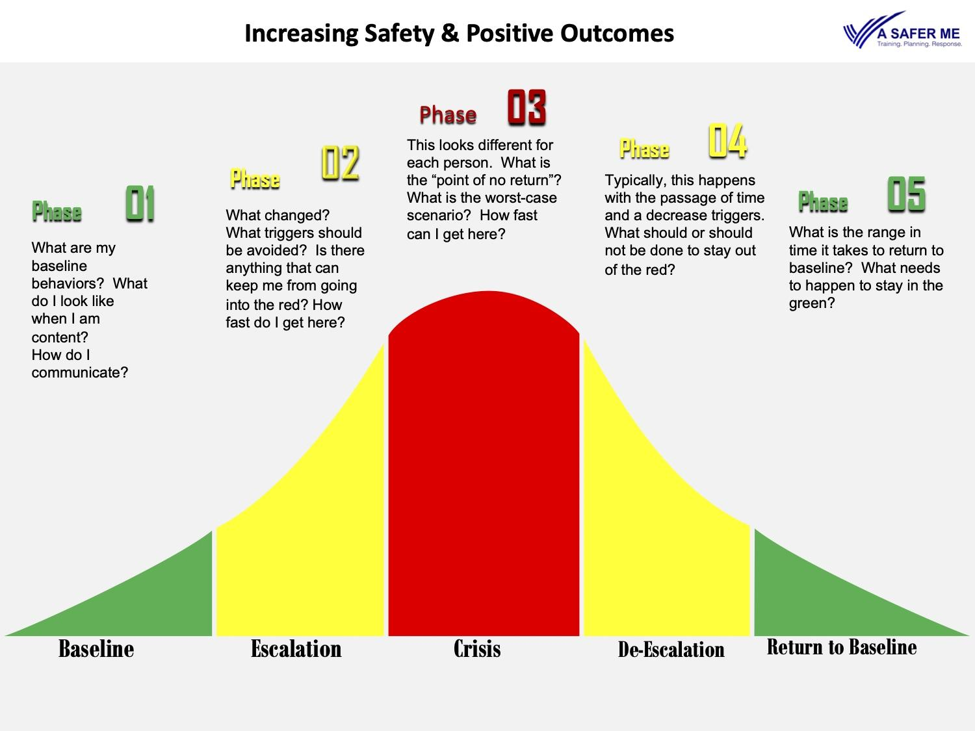

This is a bell curve, but I want you to be able to use it as a visual way to represent how best to keep your child at their safe baseline (and to explain what that looks like). The green to the left of the curve is your child’s baseline when they are calm. Yellow to the left of the red is what they look like if they are escalating but are in a place where they can come back to their baseline and the red is the point of no return. The red middle and tip of the curve is the “nightmare scenario” which will mean different things to each family. Anything to the right of the curve will only be helped with the passage of time, and a lessening of triggers. You can make notes directly on and under the bell curve, and or verbally explain things as you point to the tool.

We may not always know what to share that works, but we sure do know the triggers and what to avoid (and which nonverbal cues to watch out for). And if that is what you have to work with, use it! Use it to help providers and alternate caregivers understand how they can best keep your loved one as close to their “sweet spot” (which is the green and yellow to the left of the red) so that they can be safe and those providing them care can be safe as well.

You can print this tool out, scribble notes on it specific to the situation (home, school, community) or keep it general to your child’s behaviors. This is also something that you may want to make a few copies of in case it’s misplaced, or situations change. It’s not meant to make more work for you, but to make the communication of your loved one’s needs easier for the provider/alternate caregiver to understand and follow.

If you can’t print or don’t have the tool with you, you can always grab a piece of paper and a pencil or pen, and draw the bell curve with the notes you need and share that with your alternate caregiver/s.. If you draw something and have an “aha” moment, if you have a smart phone with you, snap a picture of it before handing it to the alternate caregiver so you don’t lose that new information that you have come up with.

This tool was created to be used in any and all situations when communication of behavior is needed with the expressed purpose of increasing positive outcomes. This tool could be used if you accompany your loved one in for treatment of COVID 19 or any other medical interventions for them, educators, providers or anyone else who is caring for your loved one if you are not available. It’s also a great tool to communicate day to day needs for your loved one with their alternate caregiver to increase the likelihood of better outcomes.
LIST OF FORMS AND DOCUMENTS TO HAVE READY IF YOUR LOVED ONE IS HOSPITALIZED OR NEEDS CARE WHILE YOU ARE ILL

These should be in a document-size manila envelope, labeled on the front:
“Guardianship, Health Care Proxy, Advanced Communication to Treatment Providers, and Safety Plan for <NAME>, a Person with Disabilities”

3 COPIES of each that apply:
- “Patient Summary Form for a person with a disability”(see link to this pdf under “Tools” in this document).
- BRIEF Letter stating:
  - that your loved one has X disabilities, is unable to make their own medical decisions and has legal guardianship or invoked Health Care Proxy.
    - State that the person is not authorized to sign a Health Care Proxy at the medical facility if there is guardianship over the patient. If the patient is their own guardian or decision-maker and a HCP is in place, instruct your loved one not to sign a new HCP at the hospital. See “7” below.
  - Patient’s full name, Date of Birth, SSI number
  - Patient’s Primary Care Physician and all specialists currently caring for them, and their contact information
- Copy of State-issued ID or driver’s license
- Copies of Insurance cards, including private and MassHealth
- Guardianship Declaration, with a date and judge signature
- Guardian’s appointment of temporary agency, no more than 60 days old
- Health Care Proxy document, signed by the patient or guardian, dated and signed by attorney
  - An additional piece of paper that gives the name, address and phone number of the attorney in case they have any questions
  - IMPORTANT INFORMATION ABOUT HCP’s:
    - DO NOT ALLOW YOUR LOVED ONE TO BE FORCED TO SIGN A HCP AT A HOSPITAL if you have one prepared by an attorney. The Proxy document with the most recent date and signature is the one that will be followed, no matter what.
- Advanced Communication To Treatment Providers. See this link under “tools” in this document.
  - List of Current Medications & Allergies
    - Include any medications that may not be allergies but person has adverse reactions to.

SAMPLE SIGN
<PLEASE BRING THIS TO THE ATTENTION OF THE TREATING NURSE, AS TO POST ON BED/WALL IN TREATMENT AREA IF HOSPITAL POLICY ALLOWS.>

PATIENT HAS INTELLECTUAL DISABILITIES AND COMMUNICATION LIMITATIONS.

PLEASE USE
- CALM, LOW VOICE
- MINIMAL, SIMPLE LANGUAGE
- MINIMUM NUMBER OF PERSONNEL NECESSARY

LEGAL DOCUMENTS ACCOMPANY PATIENT. PATIENT HAS LEGAL GUARDIAN OR HCP FOR MEDICAL DECISIONS.
PLEASE BE PREPARED FOR POSSIBLE AGGRESSIVE BEHAVIOR

D. Other Resources

- MA Division for Children & Youth with special health needs
  - https://www.mass.gov/orgs/division-for-children-youth-with-special-health-needs
  - https://www.mass.gov/doc/division-for-children-youth-with-special-health-needs-brochure-in-english/download

- MA Developmental Disabilities Council web page of resources for people with Developmental Disabilities
https://www.mass.gov/service-details/covid-19-resources-for-people-with-developmental-disabilities

- The Arc of Massachusetts webinars and updates on COVID-19
https://thearcofmass.org/covid19

- Massachusetts Association of Developmental Disabilities Providers COVID-19 resources
https://www.addp.org/covid-19-updates-and-information

- MA DDS COVID-19 resources and support
https://www.mass.gov/dds-covid-19-resources-and-support

- Legislative initiatives and updates
  - Center for Public Representation's website https://www.centerforpublicrep.org/covid-19-medical-rationing/
  - Disability Law Center
https://www.dlc-ma.org/

6. Lower cost legal documents to create wills, trust, and health care proxies:
www.legalzoom.com

7. 5 Wishes: planning for end of life needs and wants.
www.fivewishes.org

8. Online guide for building a plan for a person’s future. The plan resides online,
and is shareable and printable.
www.futureplanning.thearc.org

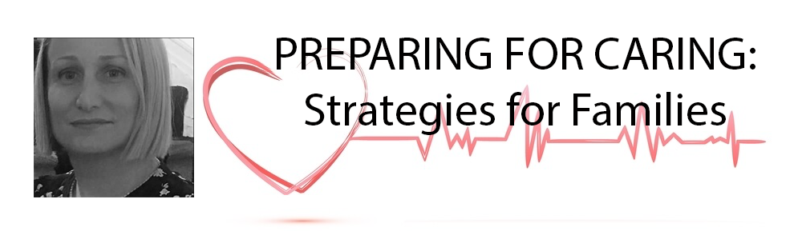Message from Carrie Noseworthy, Founder of A Safer Me
Safety Plans (notes) from A Safer Me
Safety should look at the entire person, with all of their intersections, within the context of an ever-changing environment.

How can we increase the safety of the individual within their environment(s) in a meaningful way? My recommendation is that whenever possible we all work towards inclusivity regarding safety. Although there may be exceptions to rules for people with disabilities, I urge you not to go to the exception as your first option. The safety rules are in place for a reason and if the individual cannot access them due to an escalation or acute mental health crisis, that makes sense. But if you have the time, in advance, to attempt using desensitization to a mask, social stories, or utilizing a mask with a preferred print, I urge you to try. I am not suggesting you trigger your loved one or purposely cause them distress! I am just urging you to attempt to help them access wearing the mask before the decision is made not to wear one. It may be quite some time before the pandemic is over. So, it makes sense, even if it takes some time, to try and and help your loved one access everything they can that will help them have an easier time accessing help if they need to.

You may want to create a safety plan for your loved one as part of your preparation for your alternative caregiver/s. What would that look like? I am including some guidelines for a a thoughtful safety plan:
1. What, specifically, do you want the outcomes of the plan to be and to address?
2. No plan can address every scenario, you need to learn from each scenario. But having a plan will decrease anxiety and increase the chances of better outcomes. You don’t need a “perfect” starting point.
3. It should be written simply, be concise and short enough to be easily followed. Should it be word, words and pictures? Pecs? What would best translate to the individual and their stakeholders?
4. It should be a living document and tweaked whenever necessary. Safety should be thought of as an ongoing cycle, ever changing within each environment. People’s needs change. Environments change. So should the plan.
5. All stakeholders need to have buy in and access for it to work.
6. The individual needs to have the same buy in and access or it will definitely not work.
7. There should also be an advanced form of communication to providers to complement the needs of the individual (medications, do’s, don’t, drilled down a bit from the safety plan).

There is no way to plan for everything. But it’s helpful to plan in advance to decrease your stress and anxiety and increase the odds that you have thought things through. Advance planning is also helpful because you are coming from a place of clear thought and less emotion. You can always change a plan if you need to, if circumstances change, but left with no plan, it’s hard to know what you will remember and what you will forget.

All any of us can do is our best in the moment. I am wishing you and your loved ones health and positive outcomes.

You can find more information about Carrie and A Safer Me on her Facebook Page, @asaferme.
https://www.facebook.com/pg/ASaferMe/about/?ref=page_internal

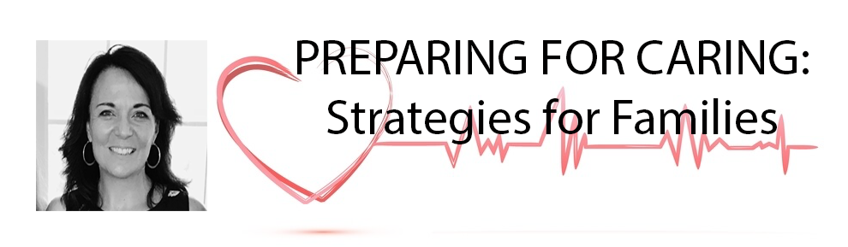

Message from Cheryl Ryan Chan, Professional Facilitator, Community Leader

As a person-centered practitioner and planning facilitator, and most importantly as a Mom, I have seen and experienced the results of a lack of planning and preparation. It’s never good. I also understand how overwhelming it can be to have lots of information thrown at you, but be lost as to how to organize it into something you can use. It’s frustrating and scary. Finally, I know exactly what it’s like to face an emergency with my son; in the moment, trying to organize our thoughts and remain calm is impossible.

It’s for all of these reasons that we wanted to provide this guide. We are hoping that it simplifies the planning and preparations we all need to make right now, to make that moment far easier for us, far more helpful to responders and the medical team, and far more streamlined. We want you to feel empowered and as ready as you can be. Following these recommendations, we believe, will reduce your anxiety and bring you the clarity you need to face whatever may happen during this pandemic and the restrictions being placed in hospitals.

It is a mistake to assume that others will know and take care of the things necessary to effectively care for those we love. It is up to us to prepare, not to play victim or blame others for our lack of preparedness. As Carrie said, we cannot plan for absolutely everything, but we can play our role to increase success.

You can learn more about Cheryl at https://about.me/cherylryanchan or on her website at www.personcenteredplanning.com.

