INDOOR AIR QUALITY ASSESSMENT

Prescott Elementary School
145 Main Street
Groton, Massachusetts

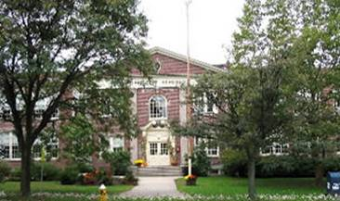

Prepared by:
Massachusetts Department of Public Health
Center for Environmental Health
Emergency Response/Indoor Air Quality Program
March 2007

Background/Introduction
At the request of a parent, the Massachusetts Department of Public Health (MDPH), Center for Environmental Health (CEH) provided assistance and consultation regarding indoor air quality at the Prescott Elementary School (PES), 145 Main Street, Groton, Massachusetts. Concerns about indoor air quality, particularly in basement level areas prompted the request.
On February 7, 2007, a visit was made to this school by Michael Feeney, Director of CEH’s Emergency Response/Indoor Air Quality (ER/IAQ) Program, to conduct an indoor air quality assessment. The school is a two-story brick structure with an occupied basement, constructed in 1927. Energy efficient windows and a new roof were installed during the summer of 2006. Windows are openable in most classrooms in the building. Windows in the basement band and art rooms are not openable.

Methods
Air tests for carbon dioxide, carbon monoxide, temperature and relative humidity were taken with the TSI, Q-TRAK™ IAQ Monitor, Model 8551. Air tests for airborne particle matter with a diameter less than 2.5 micrometers were taken with the TSI, DUSTTRAK™ Aerosol Monitor Model 8520. Screening for total volatile organic compounds (TVOCs) was conducted using an HNu, Model 102 Snap-on Photo Ionization Detector (PID). In addition to taking various IAQ tests, CEH staff performed a visual inspection of building materials for water damage and/or microbial growth.

Results
The school has a kindergarten through 4th grade student population of 200 and a staff of approximately 30. The tests were taken during normal operations at the school. Test results appear in Table 1.

Discussion
Ventilation
It can be seen from the Table 1 that carbon dioxide levels were elevated above 800 parts per million (ppm) in eleven of twenty areas surveyed, indicating inadequate air exchange in slightly more than half of the areas surveyed. It is important to note that a number of areas with carbon dioxide levels below 800 ppm had open windows and/or were sparsely populated during the assessment, which can greatly reduce carbon dioxide levels. Rooms B101, B117, 209, 215 and 308 were all over 800 ppm carbon dioxide without occupancy, indicating little or no air movement.
Fresh air is supplied by a unit ventilator (univent) system that appears to have been installed when the building was originally constructed (1927) (Picture 1). Within each univent is a fan and set of moveable louvers through which fresh air enters (Figure 1). Each of these louver systems appears to be set by hand to regulate fresh air intake into the univent. [Please note that efficient function of such aged equipment is difficult to maintain, since compatible replacement parts are often unavailable.]
At this time, with the exception of restrooms, the building has no functioning mechanical exhaust system in rooms as originally designed. The original exhaust ventilation system was reportedly provided by a turbine vent on the roof. The original system drew air through grated holes or by closet vents located at floor level in classrooms. The exhaust vent system was sealed during the roof replacement. Without sufficient supply and exhaust ventilation, environmental pollutants can build up and lead to indoor air quality/comfort complaints. In an effort to improve air movement in the building, an exhaust vent fan was installed in a hallway window on the second floor (Picture 2).
During the course of the assessment, cooking odors were detected in classrooms and hallways. The kitchen stove does not have a hood to draw and eject cooking odors from the building, therefore they vent into the cafeteria and basement hallway. In an effort to increase air circulation in the basement, ceiling-mounted heater fans were activated (Picture 3) and fire doors were wedged open in the cafeteria. In this configuration, cooking odors and associated particulates were drawn up the stairs by the second floor exhaust fan, aided by the cafeteria heater fans and the open fire doors (see PM2.5 section of this report). Exhaust ventilation of cooking areas is important to prevent the distribution of airborne pollutants throughout the building.
The building was originally configured in a manner to use cross-ventilation to provide for the comfort of building occupants with windows on opposing exterior walls. In addition, the building had hinged windows located above the hallway doors. This hinged window (called a transom) enables the classroom occupant to close the hallway door while maintaining a pathway for airflow. The design allows for airflow to enter an open window, pass through a classroom, pass through the open transom, enter the hallway, pass through the opposing open classroom transom, into the opposing classroom and exit the building on the leeward side (opposite the windward side) (Figure 2). With all windows and transoms open, airflow can be maintained in a building regardless of the direction of the wind. This system fails if the windows or transoms are closed (Figure 3). All of the transoms at the PES were sealed which inhibits airflow.
A number of areas originally designed as storage, janitorial or other non-educational rooms appear to have been converted into classrooms or other school-related space. Some of these spaces do not have mechanical fresh air supply systems or openable windows (e.g., band and art rooms). Restrooms did appear to have motorized vents, however it could not be determined if these vents were ducted to the outside or into the suspended ceiling system. Rest room exhaust vents should be vented to the outside to prevent the accumulation of moisture in the ceiling plenum and/or the migration of odors into surrounding areas.
To maximize air exchange, the MDPH recommends that both supply and exhaust ventilation operate continuously during periods of school occupancy. In order to have proper ventilation with a mechanical supply and exhaust system, the systems must be balanced to provide an adequate amount of fresh air to the interior of a room while removing stale air from the room. In its current condition, the HVAC system in this building cannot be balanced.
The Massachusetts Building Code requires a minimum ventilation rate of 15 cubic feet per minute (cfm) per occupant of fresh outside air or have openable windows in each room (SBBRS, 1997; BOCA, 1993). The ventilation must be on at all times that the room is occupied. Providing adequate fresh air ventilation with open windows and maintaining the temperature in the comfort range during the cold weather season is impractical. Mechanical ventilation is usually required to provide adequate fresh air ventilation.
Carbon dioxide is not a problem in and of itself. It is used as an indicator of the adequacy of the fresh air ventilation. As carbon dioxide levels rise, it indicates that the ventilating system is malfunctioning or the design occupancy of the room is being exceeded. When this happens a buildup of common indoor air pollutants can occur, leading to discomfort or health complaints. The Occupational Safety and Health Administration (OSHA) standard for carbon dioxide is 5,000 parts per million parts of air (ppm). Workers may be exposed to this level for 40 hours/week based on a time weighted average (OSHA, 1997).
The MDPH uses a guideline of 800 ppm for publicly occupied buildings. A guideline of 600 ppm or less is preferred in schools due to the fact that the majority of occupants are young and considered to be a more sensitive population in the evaluation of environmental health status. Inadequate ventilation and/or elevated temperatures are major causes of complaints such as respiratory, eye, nose and throat irritation, lethargy and headaches. For more information concerning carbon dioxide, please see Appendix A.
Temperature readings on the day of the assessment ranged from 67º F to 74 º F, which were within or slightly below the lower end of the MDPH recommended comfort guidelines. The MDPH recommends that indoor air temperatures be maintained in a range of 70 º F to 78 º F in order to provide for the comfort of building occupants. In many cases concerning indoor air quality, fluctuations of temperature in occupied spaces are typically experienced, even in a building with an adequate fresh air supply. In addition, it is often difficult to control temperature and maintain comfort without operating the ventilation equipment as designed (i.e., the building’s original exhaust ventilation system has been abandoned) and/or if the space is used for purposes different than the original design.
The relative humidity measurements ranged from 11 to 20 percent, which were below the MDPH recommended comfort range in all areas surveyed during the assessment. The MDPH recommends that indoor air relative humidity is comfortable in a range of 40 to 60 percent. During the heating season, relative humidity levels would be expected to drop below the recommended comfort range. The sensation of dryness and irritation is common in a low relative humidity environment. For buildings in New England, periods of low relative humidity during the winter are often unavoidable.

Microbial/Moisture Concerns
Classroom 308 had water-damaged wall plaster (Picture 4), which can indicate leaks through the window system. It is likely that this occurred prior to the replacement of the original windows. Water-damaged wall plaster can provide a medium for mold growth especially if wetted repeatedly. These types of materials should be repaired/replaced after a water leak is discovered and repaired.
Plants were noted in several classrooms. Plants can be a source of pollen and mold, which can be respiratory irritants for some individuals. Plants should be properly maintained and equipped with drip pans. Plants should also be located away from ventilation sources (e.g., air intakes, univent diffusers) to prevent the entrainment and/or aerosolization of dirt, pollen or mold.

Other IAQ Evaluations
Indoor air quality can be negatively influenced by the presence of respiratory irritants, such as products of combustion. The process of combustion produces a number of pollutants. Common combustion emissions include carbon monoxide, carbon dioxide, water vapor and smoke (fine airborne particle material). Of these materials, exposure to carbon monoxide and particulate matter with a diameter of 2.5 micrometers (μm) or less (PM2.5) can produce immediate, acute health effects upon exposure. To determine whether combustion products were present in the school environment, CEH staff obtained measurements for carbon monoxide and PM2.5.
Carbon monoxide is a by-product of incomplete combustion of organic matter (e.g., gasoline, wood and tobacco). Exposure to carbon monoxide can produce immediate and acute health affects. Several air quality standards have been established to address carbon monoxide and prevent symptoms from exposure to these substances. The MDPH established a corrective action level concerning carbon monoxide in ice skating rinks that use fossil-fueled ice resurfacing equipment. If an operator of an indoor ice rink measures a carbon monoxide level over 30 ppm, taken 20 minutes after resurfacing within a rink, that operator must take actions to reduce carbon monoxide levels (MDPH, 1997).
The American Society of Heating Refrigeration and Air-Conditioning Engineers (ASHRAE) has adopted the National Ambient Air Quality Standards (NAAQS) as one set of criteria for assessing indoor air quality and monitoring of fresh air introduced by HVAC systems (ASHRAE, 1989). The NAAQS are standards established by the US EPA to protect the public health from six criteria pollutants, including carbon monoxide and particulate matter (US EPA, 2006). As recommended by ASHRAE, pollutant levels of fresh air introduced to a building should not exceed the NAAQS levels (ASHRAE, 1989). The NAAQS were adopted by reference in the Building Officials & Code Administrators (BOCA) National Mechanical Code of 1993 (BOCA, 1993), which is now an HVAC standard included in the Massachusetts State Building Code (SBBRS, 1997). According to the NAAQS, carbon monoxide levels in outdoor air should not exceed 9 ppm in an eight-hour average (US EPA, 2006).
Carbon monoxide should not be present in a typical, indoor environment. If it is present, indoor carbon monoxide levels should be less than or equal to outdoor levels. On the day of assessment, outdoor carbon monoxide concentrations were non-detect (ND). Carbon monoxide levels measured in the school were also ND (Table 1).
The US EPA has established NAAQS limits for exposure to particulate matter. Particulate matter is airborne solids that can be irritating to the eyes, nose and throat. The NAAQS originally established exposure limits to particulate matter with a diameter of 10 μm or less (PM10). According to the NAAQS, PM10 levels should not exceed 150 microgram per cubic meter (μg/m³) in a 24-hour average (US EPA, 2006). These standards were adopted by both ASHRAE and BOCA. Since the issuance of the ASHRAE standard and BOCA Code, US EPA proposed a more protective standard for fine airborne particles. This more stringent PM2.5 standard requires outdoor air particle levels be maintained below 35 μg/m³ over a 24-hour average (US EPA, 2006). Although both the ASHRAE standard and BOCA Code adopted the PM10 standard for evaluating air quality, MDPH uses the more protective proposed PM2.5 standard for evaluating airborne particulate matter concentrations in the indoor environment.
Particulate matter is composed of airborne solids that can be irritating to the eyes, nose and throat. Outdoor PM2.5 concentrations were measured at 12 μg/m³. PM2.5 levels measured in the school ranged from 5 to 93 μg/m³, with the majority of areas above the NAAQS of 35 μg/m³ (Table 1). The highest PM2.5 measurement was taken in the cafeteria during food preparation. During the course of the assessment, CEH staff detected cooking odors throughout the upper floor of the building, particularly in the second floor hallway where an exhaust fan was installed (Picture 2). No local exhaust was observed for the kitchen stove and, as discussed previously, heater fans in the cafeteria were activated and hallway doors were all propped open in order to increase airflow (Picture 5). Thus the most likely source of PM2.5 measured during the assessment was from cooking odors/particulates in the kitchen being drawn to the upper floor by the newly installed fan. To confirm this hypothesis, particulate matter was re-sampled in the cafeteria and upper floor after cooking had ceased, and the cafeteria heater fans were deactivated. The highest particle level dropped to 18 μg/m³, which would indicate that cooking in the kitchen was the likely source of the PM2.5 level measured.
Frequently, indoor air levels of particulates can be higher than those measured outdoors. A number of mechanical devices and/or activities that occur in schools can generate particulates during normal operation. Sources of indoor airborne particulate may include but are not limited to particles generated during the operation of fan belts in the HVAC system, cooking in the cafeteria stoves and microwave ovens; use of photocopiers, fax machines and computer printing devices, operating an ordinary vacuum cleaner and heavy foot traffic indoors.
Indoor air quality can also be negatively influenced by the presence of materials containing volatile organic compounds (VOCs). VOCs are carbon-containing substances that have the ability to evaporate at room temperature. Frequently, exposure to low levels of total VOCs (TVOCs) may produce eye, nose, throat and/or respiratory irritation in some sensitive individuals. For example, chemicals evaporating from a paint can stored at room temperature would most likely contain VOCs. In an effort to determine whether VOCs were present in the building, air monitoring for TVOCs was conducted. An outdoor air sample was taken for comparison. Outdoor TVOC concentrations were ND. Indoor TVOC concentrations were also ND.
Please note, that the TVOC air measurements are only reflective of the indoor air concentrations present at the time of sampling. Indoor air concentrations can be greatly impacted by the use TVOC containing products. While TVOC levels measured were non-detectable, materials containing VOCs were present in the school.
The faculty workroom contains photocopiers and lamination machines. Lamination machines can produce irritating odors during use. VOCs and ozone can be produced by photocopiers, particularly if the equipment is older and in frequent use. Ozone is a respiratory irritant (Schmidt Etkin, 1992). No local exhaust ventilation was installed in this area to help reduce excess heat and odors.
In an effort to reduce noise from sliding chairs, tennis balls had been sliced open and placed on chair legs. Tennis balls are made of a number of materials that are a source of respiratory irritants. Constant wearing of tennis balls can produce fibers and lead to off-gassing of VOCs. Tennis balls are made with a natural rubber latex bladder, which becomes abraded when used as a chair leg pad. Use of tennis balls in this manner may introduce latex dust into the school environment. Some individuals are highly allergic to latex (e.g., spina bifida patients) (SBAA, 2001). It is recommended that the use of materials containing latex be limited in buildings to reduce the likelihood of symptoms in sensitive individuals (NIOSH, 1997). A question and answer sheet concerning latex allergy is attached as Appendix B (NIOSH, 1998).
Several other conditions that can potentially affect indoor air quality were also identified. Open utility holes were observed in several areas (Picture 6). Open utility holes can provide pathways for drafts, dust, odors and moisture between rooms and floors. One classroom contained an abandoned chemical hood (Picture 7). The termini of this hood (Picture 8) should be permanently sealed to prevent backdrafting into the classroom.
Finally, of note was the amount of materials stored in some classrooms. Items were observed on windowsills, tabletops, counters, bookcases and desks. The large number of items stored in classrooms provides a source for dusts to accumulate. These items, (e.g., papers, folders, boxes) make it difficult for custodial staff to clean. Items should be relocated and/or be cleaned periodically to avoid excessive dust build up.

Conclusions/Recommendations
Based on observations made at the PES, a number of steps were taken to increase air circulation in the building, such as repairing classroom univents and the installation of the exhaust fan in the second floor hallway. In addition, CEH supports the school department’s decision to close the band and art rooms until adequate ventilation (either natural or mechanical) is provided.
However, the conditions noted at the PES raise a number of indoor air quality issues. The installation of a new roof resulted in the exhaust ventilation system being rendered inoperable. Without exhaust ventilation, normally occurring environmental pollutants will tend to build up within the building. In addition, the general building conditions, maintenance, work hygiene practices and the age/condition of HVAC equipment, if considered individually, present conditions that could degrade indoor air quality. When combined, these conditions can serve to further degrade indoor air quality. Some of these conditions can be remedied by actions of building occupants. Other remediation efforts will require alteration to the building structure and equipment. For these reasons, a two-phase approach is suggested for remediation. The first consists of short-term measures to improve air quality and the second consists of longer-term measures that will require planning and resources to adequately address the overall indoor air quality concerns.

In view of the findings at the time of the visit, the following short-term recommendations are made:
- To maximize air exchange, the CEH recommends that univents operate continuously during periods of school occupancy independent of classroom thermostat control.
- Use openable windows in conjunction with classroom univents to increase air exchange. Care should be taken to ensure windows are properly closed at night and weekends to avoid the freezing of pipes and potential flooding.
- Continue with plans to install openable windows in the band and art rooms.
- Install appropriate local exhaust ventilation for the kitchen stove.
- During cooking in the kitchen, keep all hallway and kitchen doors closed to prevent the migration of cooking odors to upper floors.
- Do not operate the pottery kiln during school hours until ventilation equipment has been assessed and determined to be operating properly.
- For buildings in New England, periods of low relative humidity during the winter are often unavoidable. Therefore, scrupulous cleaning practices should be adopted to minimize common indoor air contaminants whose irritant effects can be enhanced when the relative humidity is low. To control for dusts, a high efficiency particulate arrestance (HEPA) filter equipped vacuum cleaner in conjunction with wet wiping of all surfaces is recommended. Drinking water during the day can help ease some symptoms associated with a dry environment (throat and sinus irritations).
- Ensure all plants are equipped with drip pans. Examine drip pans for mold growth and disinfect areas of water leaks with an appropriate antimicrobial where necessary. Move plants away from air intakes and univent air diffusers in classrooms.
- Discontinue the use of tennis balls on classroom chairs and desks.
- Ensure that all restroom exhaust systems are vented directly outdoors.
- Seal utility holes in walls.
- Seal former chemical hood.
- Ensure leaks are repaired and repair damaged wall plaster in room 308.
- Relocate or consider reducing the amount of materials stored in classrooms to allow for more thorough cleaning. Clean items regularly with a wet cloth or sponge to prevent excessive dust build-up.
- Consider adopting the US EPA (2000) document, “Tools for Schools”, to maintain a good indoor air quality environment on the building. This document can be downloaded from the Internet at: http://www.epa.gov/iaq/schools/index.html.
- Refer to resource manuals and other related indoor air quality documents for further building-wide evaluations and advice on maintaining public buildings. These materials are located on the MDPH’s website: http://mass.gov/dph/indoor_air.

Long Term Recommendations
- Consult with a HVAC engineer concerning the best method to restore exhaust ventilation to classrooms.
- Consult with a HVAC engineer concerning the provision of mechanical supply and exhaust ventilation for all occupied rooms in the basement.
- Consider installing local exhaust ventilation in teacher’s room to remove excess heat and odors.
- Consult with a HVAC engineer concerning the replacement of the existing univent system.
References

ACGIH. 1989. Guidelines for the Assessment of Bioaerosols in the Indoor Environment. American Conference of Governmental Industrial Hygienists, Cincinnati, OH.

ASHRAE. 1989. Ventilation for Acceptable Indoor Air Quality. American Society of Heating, Refrigeration and Air Conditioning Engineers. ANSI/ASHRAE 62-1989
BOCA. 1993. The BOCA National Mechanical Code/1993. 8th ed. Building Officials & Code Administrators International, Inc., Country Club Hills, IL.

MDPH. 1997. Requirements to Maintain Air Quality in Indoor Skating Rinks (State Sanitary Code, Chapter XI). 105 CMR 675.000. Massachusetts Department of Public Health, Boston, MA.
NIOSH. 1997. NIOSH Alert Preventing Allergic Reactions to Natural Rubber latex in the Workplace. National Institute for Occupational Safety and Health, Atlanta, GA.
NIOSH. 1998. Latex Allergy A Prevention. National Institute for Occupational Safety and Health, Atlanta, GA.
OSHA. 1997. Limits for Air Contaminants. Occupational Safety and Health Administration. Code of Federal Regulations. 29 C.F.R 1910.1000 Table Z-1-A.

SBAA. 2001. Latex In the Home And Community Updated Spring 2001. Spina Bifida Association of America, Washington, DC.
SBBRS. 1997. Mechanical Ventilation. State Board of Building Regulations and Standards. Code of Massachusetts Regulations. 780 CMR 1209.0

Schmidt Etkin, D. 1992. Office Furnishings/Equipment & IAQ Health Impacts, Prevention & Mitigation. Cutter Information Corporation, Indoor Air Quality Update, Arlington, MA.

US EPA. 2000. Tools for Schools. Office of Air and Radiation, Office of Radiation and Indoor Air, Indoor Environments Division (6609J). EPA 402-K-95-001, Second Edition. http://www.epa.gov/iaq/schools/tools4s2.html
US EPA. 2006. National Ambient Air Quality Standards (NAAQS). . US Environmental Protection Agency, Office of Air Quality Planning and Standards, Washington, DC. http://www.epa.gov/air/criteria.html.
Picture 1

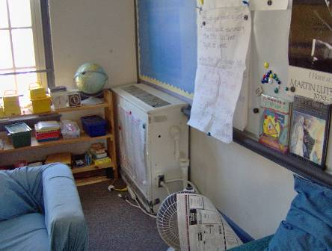

Univent

Picture 2

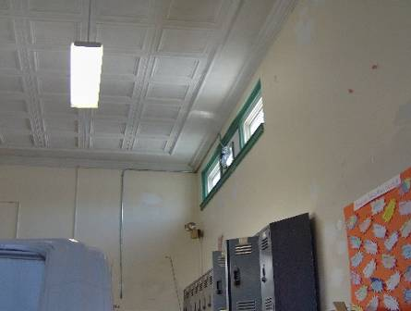

Fan Installed In 2nd Floor Hallway to Provide Exhaust Ventilation

Picture 3

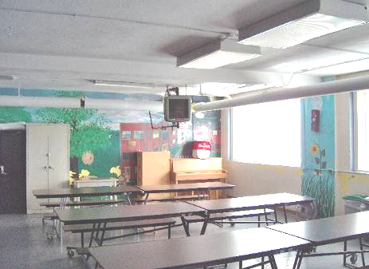

Heater Fans in Cafeteria

Picture 4

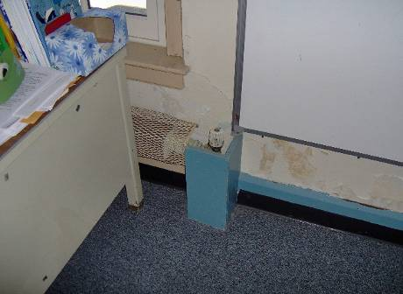

Classroom 308 Had Water-Damaged Wall Plaster
Picture 5

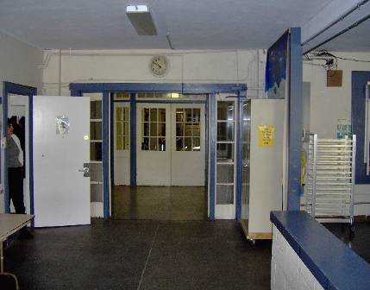

Cafeteria Hallway Doors Propped Open

Picture 6

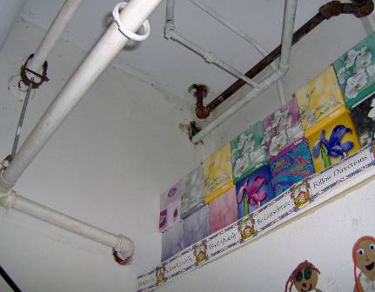

Example Of Open Pipe Hole In Wall

Picture 7

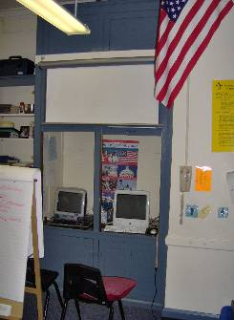

Former Chemical Hood

Picture 8

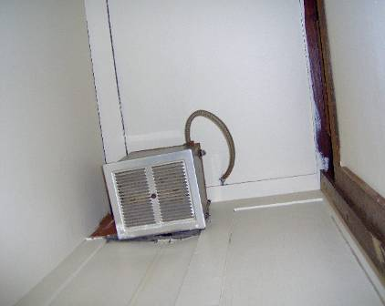

Vent In Former Chemical Hood
Location/ Room | Occupants  in Room | Temp  (°F) | Relative  Humidity  (%) | Carbon  Dioxide  (ppm) | Carbon Monoxide  (ppm) | TVOCs  (ppm) | PM2.5  (µg/m3) | Windows  Openable | Ventilation |  | Remarks
 |  |  |  |  |  |  |  |  | Supply | Exhaust | Remarks
background |  | < 32 | 16 | 347 | ND | ND | 12
203 main office | 3 | 72 | 13 | 743 | ND | ND | 5 | Y | Y | N | Supply blocked with furniture  Exhaust blocked with wood sheet  PC
309 | 24 | 72 | 15 | 1164 | ND | ND | 58 | Y | Y | Y | Exhaust blocked with furniture  TB
301 | 0 | 70 | 13 | 739 | ND | ND | 55 | Y | Y | Y | DEM
308 | 0 | 72 | 16 | 929 | ND | ND | 69 | Y | Y | Y
306 | 26 | 72 | 17 | 1111 | ND | ND | 69 | Y | Y | Y | Windows open
303 | 20 | 73 | 15 | 732 | ND | ND | 58 | Y | Y | Y | Windows open
2nd floor hallway | - | 72 | 15 | 755 | ND | ND | 57 | N | N | Y* | Newly installed exhaust fn in hall operating  Food odors from cafeteria in basement
Gym | 21 | 69 | 17 | 1108 | ND | ND | 90 | Y | Y | Y
208 | 1 | 69 | 11 | 660 | ND | ND | 53 | Y | Y | Y | 23 computers
217 | 0 | 69 | 15 | 710 | ND | ND | 57 | Y | Y | Y
215 | 0 | 69 | 15 | 939 | ND | ND | 54 | Y | N | N
205 | 0 | 70 | 11 | 616 | ND | ND | 53 | Y | Y | Y
204 | 26 | 74 | 15 | 1116 | ND | ND | 59 | Y | Y | Y
202 | 0 | 67 | 12 | 646 | ND | ND | 80 | Y | Y | Y
Principal’s office | 0 | 71 | 15 | 735 | ND | ND | 78 | Y | N | N
Nurse’s Office | 1 | 73 | 18 | 1000 | ND | ND | 53 | Y | Y | Y
B101 | 0 | 71 | 15 | 816 | ND | ND | 58 | Y | Y | Y | Supply disconnected
B116 | 1 | 71 | 18 | 1204 | ND | ND | 84 | N | N | N | Holes in walls
B117 | 0 | 72 | 18 | 1233 | ND | ND | 62 | Y | N | N | PF on
Cafeteria | 969 | 68 | 20 | 1258 | ND | ND | 93 | N | N | N | Ceiling heating fans on; measurements taken while kitchen appliances on
2nd floor hallway after cafeteria fans deactivated |  |  |  |  |  |  | 15
1st floor hallway after cafeteria fans deactivated |  |  |  |  |  |  | 6
Cafeteria |  |  |  |  |  |  | 18 |  |  |  | measurements taken while kitchen appliances off

