MassPAT
MA PMP Prescriber Report User Guide

This document is a guide to interpreting your Prescriber Report. Please see the additional attachment for your actual report, or log into the PDMP and navigate to Menu > RxSearch > Prescriber Report to download a copy. Report images below are examples and not a reflection of your prescribing history.

The Prescriber Report is intended to give prescribers insight into their controlled substance prescribing patterns. Reports are provided quarterly to all registered PMP users with an active account, a defined role and specialty, and who have written at least one opioid, sedative, or stimulant prescription during the prior 6-month period. The data represented includes Schedule II-V drugs as reported to the state PDMP, by the dispensers and pharmacies, during the report period listed. The following includes information on how to interpret each section of the prescriber report.

Disclaimer: Comparisons with peer groups are meant to give prescribers a point of reference. The PDMP recognizes that no two practice settings are identical. Additionally, this report is not intended to be an indication that the prescriber or his/her patients have done something wrong.

Report Header
The “Specialty” field represents the Healthcare Specialty chosen by you upon registration with the PMP. If you feel your specialty is misrepresented, you may update it within your PMP account, and these changes will be reflected in the next distribution of your prescriber report.

To update your Specialty in the PMP, please log-in to the PMP system. Under the “Menu” tab, select “My Profile” and update your Healthcare Specialty. For additional details on how to do this, please see the Q&A section of this document.

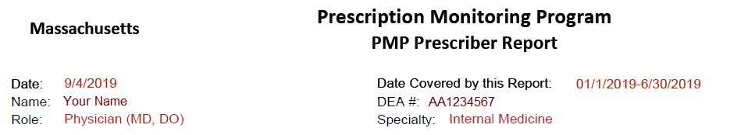
SAMPLE

Peer Groups
Most metrics include comparisons to median values of your prescriber peer groups. Only those prescribers who are registered with the PMP with an active account, a defined role and specialty, and who have written at least one opioid, sedative, or stimulant prescription during the prior 6-month period are included in the comparisons.

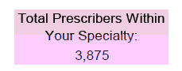
SAMPLE

Peer Specialty Comparison: The same healthcare specialty as the prescriber. For example, comparison with all other roles (physicians, nurse practitioners, physician assistants, etc.) practicing in family practice. Throughout the report, the blue bar chart represents your prescribing activity, while the peer specialty comparison is displayed as the pink line.

The specialty as selected by the prescriber at the time of registration is used for this comparison. If the number of peers in Specialty Level 3 is too small for a statistically valid comparison, Specialty Level 2 is used. If Specialty Level 2 is too small for a statistically valid comparison, Specialty Level 1 is used.

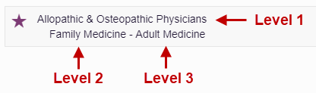

Top Medications Prescribed
This metric represents the top three Schedule II-V drugs (listed by generic name) based on the number of prescriptions prescribed by you and reported to the PMP during the 6-month reporting period.

SAMPLE

Opioids*

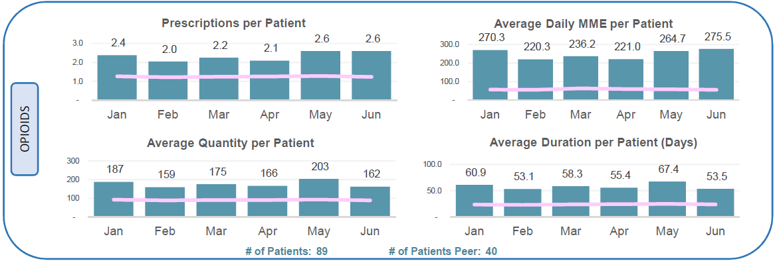
SAMPLE
*This section excludes drugs containing buprenorphine

Prescriptions per Patient: The average number of opioid prescriptions dispensed per unique patient during each month.
Daily MME per Patient: The average daily MME for opioids dispensed per patient during each month. Daily MME is the total MME divided by days supplied for each dispensation.
Average Quantity per Patient: The average quantity of opioid doses dispensed per unique patient during each month.
Average Duration per Patient: The average days supplied of opioids dispensed per unique patient during each month. The days’ supply in the reporting period is not necessarily consecutive (e.g., two 5-day opioid prescriptions written two weeks apart would count as 10 days).
Unique Patients: Distinct count of patients prescribed opioids by physician during the 6-month reporting period.
Unique Patients Peer: Average Distinct count of patients prescribed opioids per physician, within peer specialty comparison, during the 6-month reporting period.

The Morphine Milligram Equivalent (MME) is the amount of morphine an opioid dose is equal to when prescribed. Buprenorphine is excluded from MME calculations in this report. The Centers for Disease Control and Prevention (CDC) recommends that prescribers should reassess evidence of the benefits and risks to the patient when increasing dosage to ≥ 50 MME/day (e.g., ≥ 50 mg hydrocodone; ≥ 33 mg oxycodone) and avoid increasing to ≥ 90 MME/day (≥ 90 mg hydrocodone; ≥ 60 mg oxycodone) when possible due to an increased risk of complications.

The CDC’s Opioid Guideline Mobile App summarizes key recommendations on opioid prescribing and includes an MME calculator: https://www.cdc.gov/drugoverdose/prescribing/app.html

Buprenorphine**

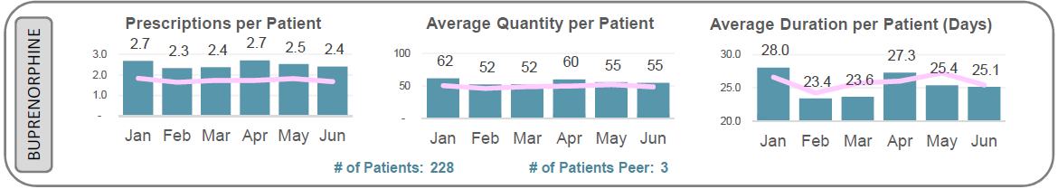
SAMPLE
**This section includes only drugs containing buprenorphine

Prescriptions per Patient: The average number of buprenorphine prescriptions dispensed per unique patient during each month.
Average Quantity per Patient: The average quantity of buprenorphine doses dispensed per unique patient during each month.
Average Duration per Patient: The average days supplied of buprenorphine dispensed per unique patient during each month. The days’ supply in the reporting period is not necessarily consecutive (e.g., two 5-day opioid prescriptions written two weeks apart would count as 10 days).
Unique Patients: Distinct count of patients prescribed buprenorphine by physician during the 6-month reporting period.
Unique Patients Peer: Average Distinct count of patients prescribed buprenorphine per physician, within peer specialty comparison, during the 6-month reporting period.

Sedatives***

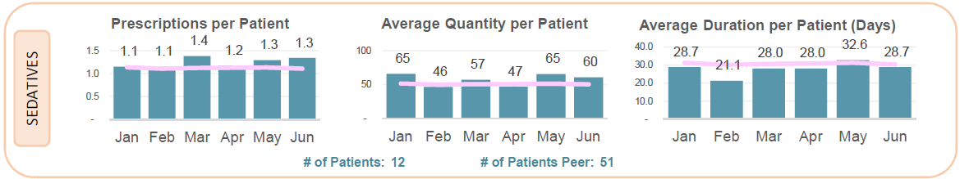
SAMPLE
***This section includes all Anxiolytic/Sedative/Hypnotic dispensations

Prescriptions per Patient: The average number of sedative prescriptions dispensed per unique patient during each month.
Average Quantity per Patient: The average quantity of sedatives dispensed per unique patient during each month.
Average Duration per Patient: The average days supplied of sedatives dispensed per unique patient during each month. The days’ supply in the reporting period is not necessarily consecutive (e.g., two 5-day opioid prescriptions written two weeks apart would count as 10 days).
Unique Patients: Distinct count of patients prescribed sedatives by physician during the 6-month reporting period.
Unique Patients Peer: Average Distinct count of patients prescribed sedatives per physician, within peer specialty comparison, during the 6-month reporting period.

Stimulants
SAMPLE
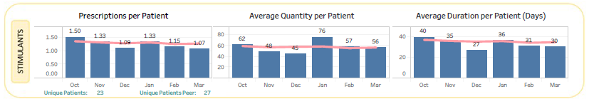

Prescriptions per Patient: The average number of stimulant prescriptions dispensed per unique patient during each month.
Average Quantity per Patient: The average quantity of stimulants dispensed per unique patient during each month.
Average Duration per Patient: The average days supplied of stimulants dispensed per unique patient during each month. The days’ supply in the reporting period is not necessarily consecutive (e.g., two 5-day opioid prescriptions written two weeks apart would count as 10 days).
Unique Patients: Distinct count of patients prescribed stimulants by physician during the 6-month reporting period.
Unique Patients Peer: Average Distinct count of patients prescribed stimulants per physician, within peer specialty comparison, during the 6-month reporting period.

At Risk Patients
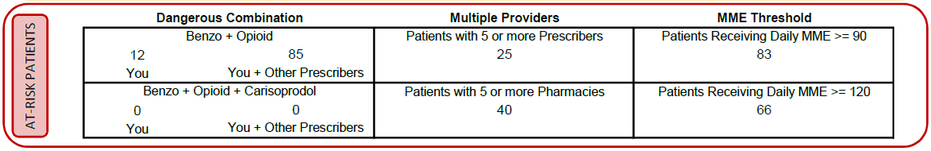
SAMPLE

Dangerous Combination Therapy:
This metric represents the number of patients in the 6-month reporting period receiving a prescription for both an opioid and a benzodiazepine (or an opioid, benzodiazepine, and carisoprodol) for an overlapping period within the reporting period. The metric “You” represents cases in which you wrote prescriptions for each of the drugs for the same patient. The metric “You + Other Prescribers” represents cases in which you wrote at least one of the prescriptions (this metric is inclusive of the “You” metric). Benzodiazepine prescriptions include any other anxiolytic, sedative, and hypnotic medications. According to the CDC, concurrent benzodiazepine, opioid, and/or carisoprodol prescriptions should be avoided, given the high risk of adverse drug interactions, specifically respiratory depression and death.
Patients Exceeding Multiple Provider Thresholds:
This metric represents the number of your patients who received controlled substance prescriptions from 5 or more prescribers/pharmacies, including you, within 6-month reporting period.
Patients Exceeding Daily MME Thresholds:
This metric represents the number of patients who received a daily MME value of ≥ 90 or ≥ 120 for dispensations prescribed by you during the 6-month reporting period.

PDMP Usage
This metric represents the total number of PDMP patient report requests made within the reporting period by you and/or your delegates.
SAMPLE

Questions and Answers (Q&A)

How can I update my Specialty so that it is represented correctly in this report?
The “specialty” in the prescriber report represents the specialty level 2 as chosen by you upon registration with the PDMP. If you feel your specialty is misrepresented, you may update it within your PDMP account and these changes will be reflected in the next distribution of your prescriber report.

To update your specialty, follow the steps below.
- Login to MassPAT at http://massachusetts.pmpaware.net
- Click on your name in the top right corner of the PMP and then click My Profile.

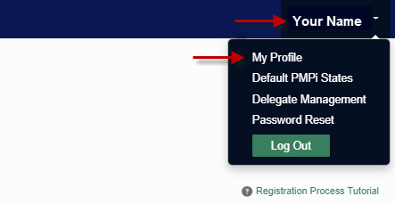

- Under My Profile you will find Specialty which displays the currently selected Healthcare Specialty.

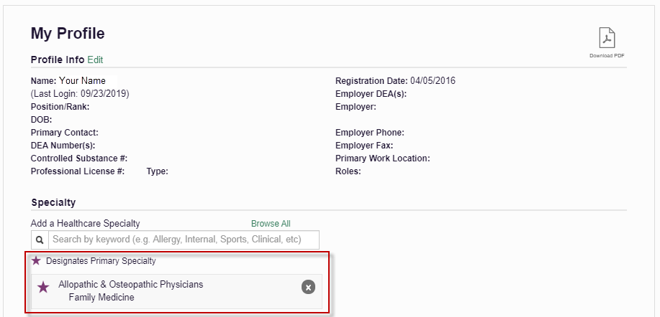

You may add additional specialties, if applicable, by clicking within the “Add a Healthcare Specialty” field and begin typing the name of your preferred specialty.

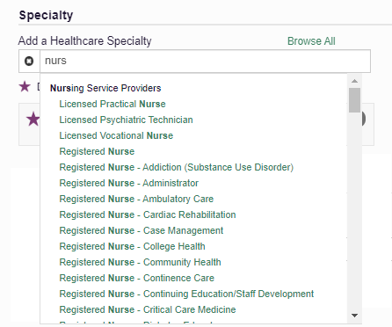

- To delete an existing Healthcare Specialty click the “X” to the right of the specialty you wish to delete.

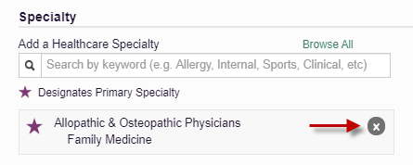

My DEA number is incorrect. How can I fix that?
You can validate or update your DEA number by visiting the DEA website: https://apps.deadiversion.usdoj.gov/webforms/jsp/regapps/common/updateLogin.jsp

How can I look up my prescribing history?
You may further review your PMP prescription details by following the below steps.
- Login to MassPAT at http://massachusetts.pmpaware.net
- Click Menu from the top menu bar to expand the options
- Click MyRx below RxSearch
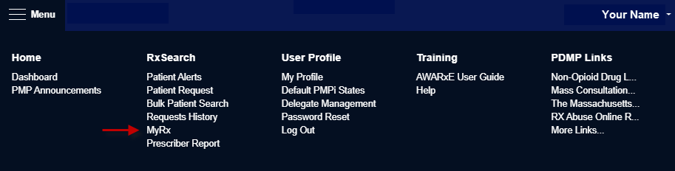
- MyRx will allow you to search for prescriptions written by you that have been dispensed to the patient and reported to MassPAT.

How can I learn more about opioid prescribing, tapering and referring substance use disorder patients to treatment?

CDC Guideline for Prescribing Opioids for Chronic Pain

Please familiarize yourself with these valuable SUD resources:
Massachusetts Substance Use Helpline
Bureau of Substance Addiction Services

Why did I receive this report when my peer prescriber has not received it?
Only prescribers that are registered with the PMP, have a defined role and specialty, and have written at least controlled substance prescription during the prior six-month period will receive a report.

What are some of the limitations of the Prescriber Report?

1. The Report is not able to account for variations in clinical hours or patient volume. Some practitioners may see many more patients during the reporting period than others. The characteristics of your practice should be taken into consideration when viewing comparisons with prescribers within your specialty and like prescribers within your specialty (e.g., NPs, PAs, or MDs).
2. Certain specialties can have a small number of practitioners and, therefore, an outlier can significantly influence the number of patients, prescriptions, and the averages in several of the data fields included in the Report.
3. Comparisons exclude practitioners within your specialty that have not issued a prescription for at least one opioid, sedative, or stimulant prescription during the six-month reporting period. Therefore, in certain specialties you are being compared to the subset of practitioners who have prescribed a controlled substance in those categories during the reporting window rather than to all practitioners within that specialty.

