

**MA Prescription Monitoring Program County-Level Data Measures**

**(Calendar Year 2020 Quarter 2 and 3)**

*Massachusetts Department of Public Health, Bureau of Health Professions Licensure October 2020*

The Department of Public Health’s (DPH) Prescription Drug Monitoring Program (PMP) serves as a repository of data for all prescription drugs dispensed statewide, including those prescriptions that are sought after for illicit and non-medical use and thus represent the highest potential for abuse (federal Schedules II – V, including certain narcotics, stimulants and sedatives). The PMP also enables prescribers and dispensers to access a patient’s prescription history and can be used as a clinical decision-making tool, allowing the provider to have a holistic view of the patient’s medications.

When interpreting PMP county-level data, it is important to emphasize that increases or decreases in a single measure may not indicate an increase or decrease in prescription misuse or abuse. Put simply, use does not always equate to abuse. There are many factors that might explain an unusually high rate of prescribing in a given area. For instance, an area which contains a large number of residents in long-term care facilities may result in a high rate of opioid prescribing.

These datasets inform critical discussions about opioid prescribing, provide an important baseline to better inform future policy decisions and allow the state and stakeholders to more meaningfully measure whether policy initiatives are effective.

Effective October 6, 2014, all hydrocodone combination drug (HCD) products (e.g., Vicodin) were reclassified from Schedule III to Schedule II. This reclassification during the last quarter of 2014 makes comparisons over time difficult to interpret. Beginning with CY 2015 data, reports of Schedule II products will include all HCD prescriptions.

Individuals with activity of concern "thresholds" for this report are based on a 3-month time period. MDPH has previously released annual county-level reports that provide thresholds based on a 12-month time period. Although the numbers (or rates) generated may appear to be comparable, they represent different time periods and are **NOT** an apples-to-apples comparison. The results are only comparable when the thresholds (e.g., 4 different providers and 4 different pharmacies), time interval (e.g. over a three-month period), and drug products analyzed (e.g. Schedule II opioids) are the same. Meaning, the total number (or rates) of individuals who received Schedule II-V opioid prescriptions from 4 or more providers and had them filled at 4 or more pharmacies in a 3-month period cannot and should not be compared with the total number of individuals (or rates) who received Schedule II-V opioid prescriptions from 4 or more providers and had them filled at 4 or more pharmacies in a 12-month period.

MA Prescription Monitoring Program: April – June 2020 and July – September 2020

# April – June 2020 (Quarter 2)

|  |  |  |  |  |  |  |  |
| --- | --- | --- | --- | --- | --- | --- | --- |
| **County**  (County classifications are by patient zip code; patient state must also = MA) | **Census Population\*** | **Total Schedule II**  **Opioid**  **Prescriptions** | **Total Number of**  **Schedule II**  **Opioid Solid Dosage Units** | **Individuals**  **Receiving**  **Schedule II Opioid**  **Prescription** | **% of Individuals**  **Receiving Schedule II**  **Opioid Prescription**  **(of total population)** | **Individuals with Activity of Concern** | **Rate of Individuals with Activity of**  **Concern**  **(per 1,000)** |
| Barnstable | 216,806 | 17,507 | 981,787 | 6,968 | 3.2 | <5 | NR |
| Berkshire | 127,740 | 10,495 | 572,534 | 4,390 | 3.4 | 0 | 0 |
| Bristol | 570,972 | 51,908 | 3,285,275 | 19,357 | 3.4 | 6 | 0.3 |
| Dukes | 17,365 | 1,065 | 63,766 | 465 | 2.7 | <5 | NR |
| Essex | 800,017 | 49,968 | 2,743,515 | 21,109 | 2.6 | 10 | 0.5 |
| Franklin | 71,814 | 6,707 | 417,985 | 2,513 | 3.5 | 0 | 0 |
| Hampden | 475,366 | 40,254 | 2,433,212 | 16,117 | 3.4 | <5 | NR |
| Hampshire | 164,136 | 12,332 | 800,001 | 4,607 | 2.8 | <5 | NR |
| Middlesex | 1,632,505 | 68,482 | 3,808,964 | 30,938 | 1.9 | 14 | 0.5 |
| Nantucket | 11,332 | 726 | 34,899 | 311 | 2.7 | 0 | 0 |
| Norfolk | 714,526 | 35,907 | 2,168,164 | 15,290 | 2.1 | 11 | 0.7 |
| Plymouth | 524,799 | 36,075 | 2,247,996 | 15,019 | 2.9 | 7 | 0.5 |
| Suffolk | 810,212 | 31,950 | 2,042,844 | 13,288 | 1.6 | 10 | 0.8 |
| Worcester | 839,112 | 56,623 | 3,664,498 | 22,784 | 2.7 | 12 | 0.5 |
| MA | 6,976,702 | 419,999 | 25,265,439 | 173,156 | 2.5 | 79 | 0.5 |
| Note 1: Individuals with activity of concern "thresholds" for this report are based ONLY on a 3-month time period; see notes on previous page; CY2020-Q2 | | | | | | | |
| Note 2: Counts greater than 0 but less than 5 are not reported. Rates based on these small values also are not reported (NR). | | | | | | |  |
| Note 3: Rates of individuals with activity of concern are based on the population of individuals who have received one or more Schedule II opioid | | | | | | | |
| prescriptions during the specified time period. | | |  |  |  |  |  |
| Note 4: Totals for all counties combined exclude a small number of prescription records that could not be assigned a county due to inaccurate | | | | | | | |
| zip code/city town information reported to the program. | | |  |  |  |  |  |
| Note 5: The total sum for the "Number of Individuals Receiving Schedule II Opioid Prescription" will be slightly different than the sum presented for the | | | | | | | |
| state in Figure 2 due to a small number of double counting of individuals moving from one county to another during the specified time period. | | | | | | | |
| Note 6: PMP data are preliminary and subject to updates. The MA PMP database is continuously updated to allow for prescription record correction data | | | | | | | |
| submitted by pharmacies. This data were extracted on 07/13/2020; Release Date: July 2020. | | | | |  |  |  |
| Note 7: Beginning in 3rd quarter of 2016 the Department of Veteran's Affairs (VA) facilities began submitting data to the MA PMP. | | | | | | |  |
| Note 8: Population estimates used for years following the decennial census were developed by the University of Massachusetts Donahue Institute (UMDI) | | | | | | | |
| in partnership with the Massachusetts Department of Public Health, Bureau of Environmental Health. | | | | | |  |  |

# July – September 2020 (Quarter 3)

|  |  |  |  |  |  |  |  |
| --- | --- | --- | --- | --- | --- | --- | --- |
| **County**  (County classifications are by patient zip code; patient state must also = MA) | **Census Population\*** | **Total Schedule II**  **Opioid**  **Prescriptions** | **Total Number of**  **Schedule II**  **Opioid Solid Dosage Units** | **Individuals**  **Receiving**  **Schedule II Opioid**  **Prescription** | **% of Individuals**  **Receiving Schedule II**  **Opioid Prescription**  **(of total population)** | **Individuals with Activity of Concern** | **Rate of Individuals with Activity of**  **Concern**  **(per 1,000)** |
| Barnstable | 216,629 | 20,694 | 1,063,426 | 9,070 | 4.2 | 10 | 1.1 |
| Berkshire | 126,398 | 11,871 | 602,008 | 5,152 | 4.1 | <5 | NR |
| Bristol | 571,424 | 57,675 | 3,400,783 | 23,164 | 4.1 | 12 | 0.5 |
| Dukes | 17,404 | 1,223 | 65,645 | 585 | 3.4 | 0 | 0 |
| Essex | 796,916 | 58,550 | 2,928,962 | 27,064 | 3.4 | 16 | 0.6 |
| Franklin | 71,169 | 7,334 | 428,064 | 2,911 | 4.1 | <5 | NR |
| Hampden | 470,869 | 44,452 | 2,493,728 | 19,017 | 4.0 | 11 | 0.6 |
| Hampshire | 163,997 | 13,696 | 822,866 | 5,492 | 3.3 | <5 | NR |
| Middlesex | 1,626,553 | 82,731 | 4,078,069 | 40,915 | 2.5 | 22 | 0.5 |
| Nantucket | 11,416 | 856 | 38,776 | 369 | 3.2 | <5 | NR |
| Norfolk | 715,271 | 42,538 | 2,295,895 | 19,955 | 2.8 | 15 | 0.8 |
| Plymouth | 527,689 | 42,878 | 2,396,204 | 19,409 | 3.7 | 11 | 0.6 |
| Suffolk | 809,594 | 37,964 | 2,143,529 | 17,721 | 2.2 | 17 | 1.0 |
| Worcester | 839,053 | 65,591 | 3,843,874 | 28,391 | 3.4 | 12 | 0.4 |
| MA | 6,964,382 | 488,053 | 26,601,828 | 219,215 | 3.1 | 126 | 0.6 |
| Note 1: Individuals with activity of concern "thresholds" for this report are based ONLY on a 3-month time period; see notes on previous page; CY2020-Q3 | | | | | | | |
| Note 2: Counts greater than 0 but less than 5 are not reported. Rates based on these small values also are not reported (NR). | | | | | | |  |
| Note 3: Rates of individuals with activity of concern are based on the population of individuals who have received one or more Schedule II opioid | | | | | | | |
| prescriptions during the specified time period. | | |  |  |  |  |  |
| Note 4: Totals for all counties combined exclude a small number of prescription records that could not be assigned a county due to inaccurate | | | | | | | |
| zip code/city town information reported to the program. | | |  |  |  |  |  |
| Note 5: The total sum for the "Number of Individuals Receiving Schedule II Opioid Prescription" will be slightly different than the sum presented for the | | | | | | | |
| state in Figure 2 due to a small number of double counting of individuals moving from one county to another during the specified time period. | | | | | | | |
| Note 6: PMP data are preliminary and subject to updates. The MA PMP database is continuously updated to allow for prescription record correction data | | | | | | | |
| submitted by pharmacies. This data were extracted on 10/09/2020; Release Date: Oct 2020. | | | | |  |  |  |
| Note 7: Beginning in 3rd quarter of 2016 the Department of Veteran's Affairs (VA) facilities began submitting data to the MA PMP. | | | | | | |  |
| Note 8: Population estimates used for years following the decennial census were developed by the University of Massachusetts Donahue Institute (UMDI) | | | | | | | |
| in partnership with the Massachusetts Department of Public Health, Bureau of Environmental Health. | | | | | |  |  |

**MA Prescription Monitoring Program Data**

# Trend Analyses for Schedule II Opioids Only

* In the 3rd Quarter of 2020, there were approximately 488,000 Schedule II opioid prescriptions reported to the MA PMP; this is a small increase from the previous quarter and just over a 42% decrease from the 1st Quarter of 2015 (n = 841,990 Schedule II opioid prescriptions).

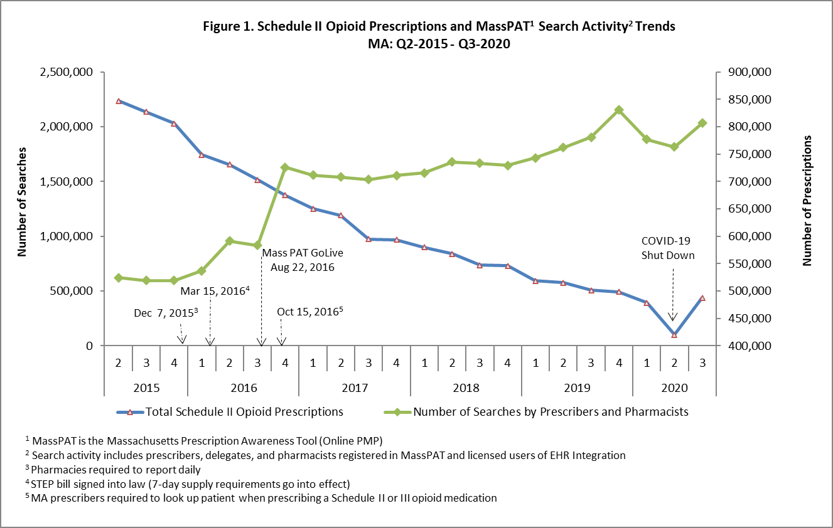

**Note:**

* + PMP data are subject to updates. The MA PMP database is continuously updated to allow for prescription record correction data submitted by pharmacies. The data for CY-2020 Q3 were extracted on 10/13/2020.
  + Some discrepancies were identified in search counts reported by data vendor. Reports prior to Q2 CY23 were inflated due to overrepresenting the number of Gateway (i.e., Integration) searches. Archived PMP reports going back to Q3 CY 2018

(beginning of Gateway or Integrated searches) are now updated to reflect the accurate counts. (Dated: March 2024)

* Just over 219,000 individuals in MA received prescriptions for Schedule II opioids in the 3rd Quarter of 2020; this is a slight increase from the previous quarter (about 46,000 individuals) and over a 43% decrease from the 1st Quarter of 2015 (n = 390,532).

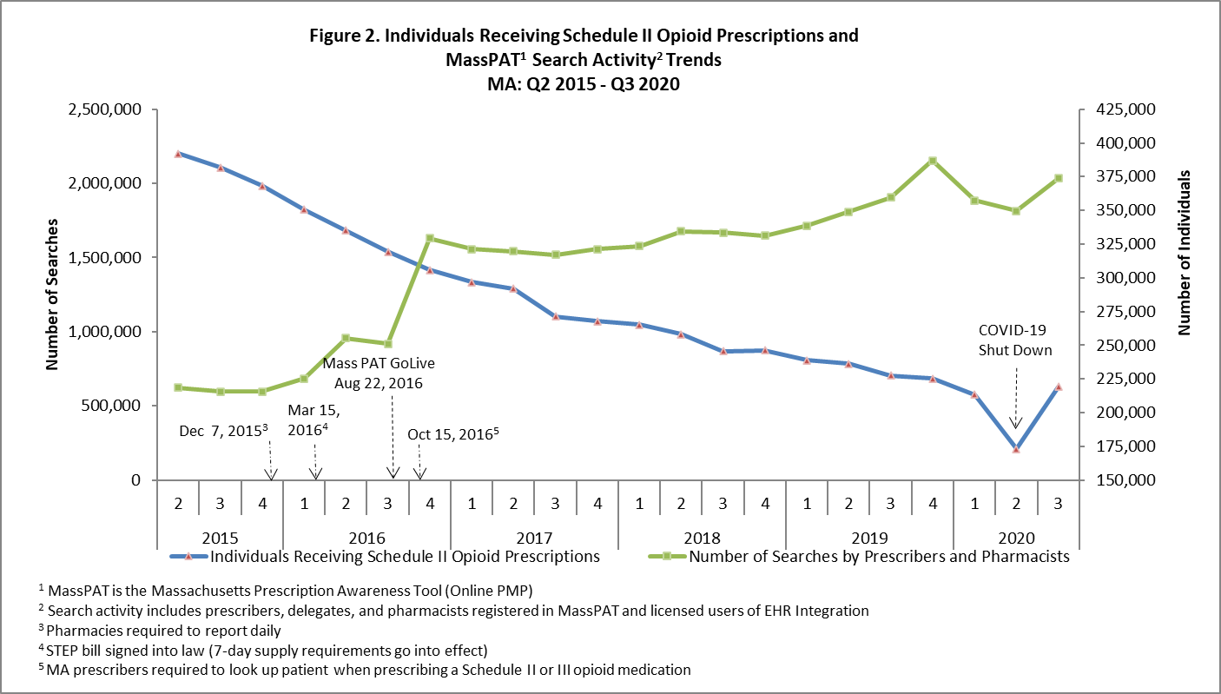

**Note:**

* + PMP data are subject to updates. The MA PMP database is continuously updated to allow for prescription record correction data submitted by pharmacies. The data for CY-2020 Q3 were extracted on 10/13/2020.
  + Some discrepancies were identified in search counts reported by data vendor. Reports prior to Q2 CY23 were inflated due to overrepresenting the number of Gateway (i.e., Integration) searches. Archived PMP reports going back to Q3 CY 2018 (beginning of Gateway or Integrated searches) are now updated to reflect the accurate counts. (Dated: March 2024)

* The rate of individuals with activity of concern (also referred to as multiple provider episodes) decreased from 14.3 to 5.5 per 1,000 individuals between CY 2013 and CY 2019, a 61% reduction in activity of concern. Between CY 2018 and CY 2019 the rates of individuals with activity of concern decreased from 6.3 to 5.5 per 1,000 patients.

0

2

4

6

8

10

12

14

16

2013

2014

2015

2016

2017

2018

2019

**Rate per 1,000**

**Figure 3. Rate of Individuals with Activity of Concern for MA**

**(**

**per 1,000 Schedule II Opioid Recipients)**

**Note:** PMP data are subject to updates. The MA PMP database is continuously updated to allow for prescription record correction data submitted by pharmacies. The data for CY-2019 were extracted on 01/17/2020.

**Source**

* Prescription Drug Monitoring Program, Bureau of Health Professions Licensure, MDPH