

POSTED: FEBRUARY 2017

Massachusetts Department of Public Health

**MA Prescription Monitoring Program County-Level Data Measures (2016 Quarter 4)**

The Department of Public Health’s (DPH) Prescription Drug Monitoring Program (PMP) serves as a repository of data for all prescription drugs dispensed statewide, including those prescriptions that are sought after for illicit and non-medical use and thus represent the highest potential for abuse (federal Schedules II – V, including certain narcotics, stimulants and sedatives). The PMP also enables prescribers and dispensers to access a patient’s prescription history and can be used as a clinical decision-making tool, allowing the provider to have a holistic view of the patient’s medications.

When interpreting PMP county-level data, it is important to emphasize that increases or decreases in a single measure may not indicate an increase or decrease in prescription misuse or abuse. Put simply, use does not always equate to abuse. There are many factors that might explain an unusually high rate of prescribing in a given area. For instance, an area which contains a large number of residents in long-term care facilities may result a high rate of opioid prescribing.

These datasets inform critical discussions about opioid prescribing, provide an important baseline to better inform future policy decisions and allow the state and stakeholders to more meaningfully measure whether policy initiatives are effective.

Effective October 6, 2014, all hydrocodone combination drug (HCD) products (e.g., Vicodin) were reclassified from Schedule III to Schedule II. This reclassification during the last quarter of 2014 makes comparisons over time difficult to interpret. Beginning with CY 2015 data, reports of Schedule II products will include all HCD prescriptions.

Individuals with activity of concern "thresholds" for this report are based on a 3-month time period. MDPH also releases an annual county-level report that provides thresholds that are based on a 12-month time period. Although the numbers (or rates) generated may appear to be comparable, they represent different time periods and are NOT an apples-to-apples comparison. The results are only comparable when the thresholds (e.g., 4 different providers and 4 different pharmacies), time interval (e.g. over a three-month period), and drug products analyzed (e.g. Schedule II opioids) are the same. Meaning, the total number (or rates) of individuals who received Schedule II-V opioid prescriptions from 4 or more providers and had them filled at 4 or more pharmacies in a 3-month period cannot and should not be compared with the total number of individuals (or rates) who received Schedule II-V opioid prescriptions from 4 or more providers and had them filled at 4 or more pharmacies in a 12-month period.

MA Prescription Monitoring Program: October 2016 – December 2016

|  |  |  |  |  |  |  |  |
| --- | --- | --- | --- | --- | --- | --- | --- |
| **County**  (County classifications are by patient zip code; patient state must also = MA) | **Census Population** | **Total Schedule II Opioid Prescriptions** | **Total Number of Schedule II Opioid Solid Dosage Units** | **Individuals Receiving Schedule II Opioid Prescription** | **% of Individuals Receiving Schedule II Opioid Prescription**  **(of total population)** | **Individuals with Activity of Concern** | **Rate of Individuals with Activity of Concern**  **(per 1,000)** |
| Barnstable | 214,333 | 25,079 | 1,447,290 | 11,477 | 5.4 | 10 | 0.9 |
| Berkshire | 127,828 | 14,433 | 808,390 | 6,460 | 5.1 | 6 | 0.9 |
| Bristol | 556,772 | 72,346 | 4,456,020 | 30,808 | 5.5 | 16 | 0.5 |
| Dukes | 17,299 | 1,670 | 104,292 | 815 | 4.7 | < 5 | NR |
| Essex | 776,043 | 73,972 | 4,115,063 | 34,559 | 4.5 | 22 | 0.6 |
| Franklin | 70,601 | 9,756 | 596,312 | 4,066 | 5.8 | 5 | 1.2 |
| Hampden | 470,690 | 60,608 | 3,642,267 | 26,030 | 5.5 | 25 | 1.0 |
| Hampshire | 161,292 | 16,917 | 1,092,669 | 7,042 | 4.4 | < 5 | NR |
| Middlesex | 1,585,139 | 105,074 | 5,774,170 | 53,112 | 3.4 | 47 | 0.9 |
| Nantucket | 10,925 | 1,068 | 45,536 | 505 | 4.6 | < 5 | NR |
| Norfolk | 696,023 | 56,772 | 3,269,906 | 27,827 | 4.0 | 33 | 1.2 |
| Plymouth | 510,393 | 54,861 | 3,290,129 | 25,609 | 5.0 | 23 | 0.9 |
| Suffolk | 778,121 | 50,374 | 3,075,123 | 24,140 | 3.1 | 29 | 1.2 |
| Worcester | 818,963 | 85,041 | 5,466,276 | 38,382 | 4.7 | 41 | 1.1 |
| **MA** | **6,794,422** | **627,971** | **37,183,442** | **290,832** | **4.3** | **263** | **0.9** |

Note 1: Individuals with activity of concern "thresholds" for this report are based ONLY on a 3-month time period; see notes on previous page; CY16-Q4 Note 2: Counts greater than 0 but less than 5 are not reported. Rates based on these small values also are not reported (NR).

Note 3: Rates of individuals with activity of concern are based on the population of individuals who have received one or more Schedule II opioid prescriptions during the specified time period.

Note 4: PMP data are preliminary and subject to updates. The MA PMP database is continuously updated to allow for prescription record correction data submitted by pharmacies. This data were extracted on 01/05/2017; Release Date: January 2017.

Note 5: Beginning in 3rd quarter of 2016, the Department of Veterans Affairs (VA) facilities began submitting data to the MA PMP.

Note 6: National Center for Health Statistics. Postcensal estimates of the resident population of the United States for July 1, 2010-July 1, 2015, by year, county, single-year of age (0, 1, 2, .., 85 years and over), bridged race, Hispanic origin, and sex (Vintage 2015).



POSTED: FEBRUARY 2017

Massachusetts Department of Public Health

**Opioid-related EMS Transports Massachusetts Residents: 2013-2016**

# Enhancement of Opioid Overdose Surveillance

MATRIS, the Massachusetts Ambulance Trip Reporting Information System, is a statewide database for collecting emergency medical service data from licensed ambulance services. It was not specifically designed to track opioid overdose incidents. DPH is currently working with all Emergency Medical Services (EMS) providers to improve the quality and completeness of these data especially with respect to opioid overdose incidents. To more accurately identify ambulance trips that are opioid-related, several pieces of information from MATRIS are combined such as: a notation that a trip was listed as a poisoning, that there was an administration of naloxone, or that the patient admitted to drug use. In combination, this information allows DPH to more accurately count opioid overdose incidents. Data for Boston came from applying this algorithm to events identified by Boston EMS as “Narcotic Related Incidents” (NRI). Not all services have reported their 2016 Q1-Q3 data yet so the numbers cited here are underestimates. Counts will be updated on a quarterly basis.

# Results

Since 2013, there has been an increasing trend in the percentage of EMS incidents that are considered opioid- related. In the first three quarters of 2016 EMS services reported an opioid-related incident in 280 of the 351 MA cities and towns (80%). Overall, there was a 37% increase in the number of opioid-related EMS transport incidents compared with the first three quarters of 2015.

In the first three quarters of 2016, the greatest number of suspected opioid overdose incidents was among males aged 25-34 (25% of opioid-related incidents). There is an increasing trend in the quantity of Naloxone being dispensed during each opioid-related incident. On average, EMS administered Naloxone 1.4 times per opioid-related incident in the first three quarters of 2016. Almost one third of opioid-related incidents required more than one dose of Naloxone.

|  |  |  |  |  |  |  |  |  |
| --- | --- | --- | --- | --- | --- | --- | --- | --- |
| **All Suspected Opioid Related Incidents: 2016 (Quarter 1)** | | | | | | | | |
|  | **11-14** | **15-24** | **25-34** | **35-44** | **45-54** | **55-64** | **65+** | **Total** |
| Male | <7 | 384 | 1268 | 767 | 488 | 315 | 136 | 3359 |
| Female | <7 | 235 | 560 | 313 | 239 | 156 | 107 | 1614 |
| **Total** | **<7** | **619** | **1828** | **1080** | **727** | **471** | **243** | **4973** |

|  |  |  |  |  |  |  |  |  |
| --- | --- | --- | --- | --- | --- | --- | --- | --- |
| **All Suspected Opioid Related Incidents: 2016 (Quarter 2)** | | | | | | | | |
|  | **11-14** | **15-24** | **25-34** | **35-44** | **45-54** | **55-64** | **65+** | **Total** |
| Male | <7 | 438 | 1603 | 904 | 724 | 401 | 178 | 4250 |
| Female | <7 | 244 | 730 | 424 | 302 | 178 | 141 | 2024 |
| **Total** | **7** | **682** | **2333** | **1328** | **1026** | **579** | **319** | **6274** |

|  |  |  |  |  |  |  |  |  |
| --- | --- | --- | --- | --- | --- | --- | --- | --- |
| **All Suspected Opioid Related Incidents: 2016 (Quarter 3)** | | | | | | | | |
|  | **11-14** | **15-24** | **25-34** | **35-44** | **45-54** | **55-64** | **65+** | **Total** |
| Male | 1 | 499 | 1553 | 948 | 610 | 389 | 186 | 4187 |
| Female | 0 | 278 | 838 | 441 | 295 | 189 | 118 | 2159 |
| **Total** | **1** | **777** | **2391** | **1389** | **905** | **578** | **304** | **6346** |

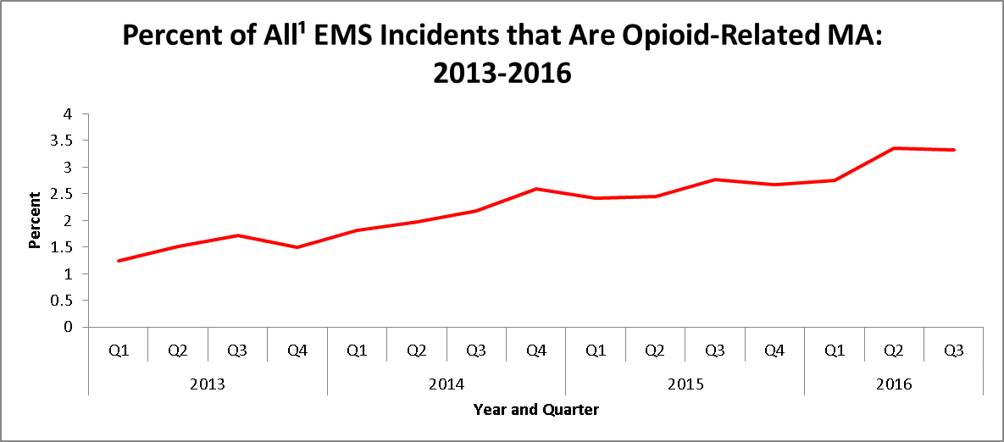

1. Includes all incidents where the patient was 11 years old or older.

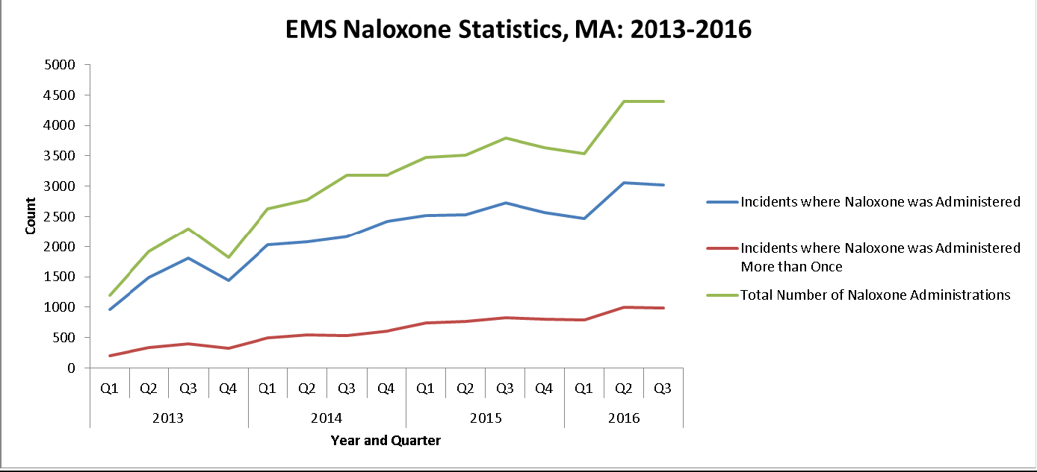

# Technical Notes

This data brief was supported by funds made available from the Centers for Disease Control and Prevention, Office for State, Tribal, Local and Territorial Support, under B01OT009024. The findings of this data brief are those of the authors and do not necessarily represent the official position of or endorsement by the Centers for Disease Control and Prevention.