

POSTED: MAY 2018 (initial) / UPDATED: AUGUST 2018

Massachusetts Department of Public Health

**MA Prescription Monitoring Program County-Level Data Measures (2018 Quarter 1)**

The Department of Public Health’s (DPH) Prescription Drug Monitoring Program (PMP) serves as a repository of data for all prescription drugs dispensed statewide, including those prescriptions that are sought after for illicit and non-medical use and thus represent the highest potential for abuse (federal Schedules II – V, including certain narcotics, stimulants and sedatives). The PMP also enables prescribers and dispensers to access a patient’s prescription history and can be used as a clinical decision-making tool, allowing the provider to have a holistic view of the patient’s medications.

When interpreting PMP county-level data, it is important to emphasize that increases or decreases in a single measure may not indicate an increase or decrease in prescription misuse or abuse. Put simply, use does not always equate to abuse. There are many factors that might explain an unusually high rate of prescribing in a given area. For instance, an area which contains a large number of residents in long-term care facilities may result a high rate of opioid prescribing.

These datasets inform critical discussions about opioid prescribing, provide an important baseline to better inform future policy decisions and allow the state and stakeholders to more meaningfully measure whether policy initiatives are effective.

Effective October 6, 2014, all hydrocodone combination drug (HCD) products (e.g., Vicodin) were reclassified from Schedule III to Schedule II. This reclassification during the last quarter of 2014 makes comparisons over time difficult to interpret. Beginning with CY 2015 data, reports of Schedule II products will include all HCD prescriptions.

Individuals with activity of concern "thresholds" for this report are based on a 3-month time period. MDPH also releases an annual county-level report that provides thresholds that are based on a 12-month time period. Although the numbers (or rates) generated may appear to be comparable, they represent different time periods and are NOT an apples-to-apples comparison. The results are only comparable when the thresholds (e.g., 4 different providers and 4 different pharmacies), time interval (e.g. over a three-month period), and drug products analyzed (e.g. Schedule II opioids) are the same. Meaning, the total number (or rates) of individuals who received Schedule II-V opioid prescriptions from 4 or more providers and had them filled at 4 or more pharmacies in a 3-month period cannot and should not be compared with the total number of individuals (or rates) who received Schedule II-V opioid prescriptions from 4 or more providers and had them filled at 4 or more pharmacies in a 12-month period.

MA Prescription Monitoring Program: January 2018 – March 2018

|  |  |  |  |  |  |  |  |
| --- | --- | --- | --- | --- | --- | --- | --- |
| **County**  (County classifications are by patient zip code; patient state must also = MA) | **Census Population\*** | **Total Schedule II Opioid Prescriptions** | **Total Number of Schedule II Opioid Solid Dosage Units** | **Individuals Receiving Schedule II Opioid Prescription** | **% of Individuals Receiving Schedule II Opioid Prescription (of total population)** | **Individuals with Activity of Concern** | **Rate of Individuals with Activity of Concern**  **(per 1,000)** |
| Barnstable | 214,276 | 24,007 | 1,279,033 | 11,135 | 5.2 | 24 | 2.2 |
| Berkshire | 126,903 | 14,556 | 755,220 | 6,567 | 5.2 | < 5 | NR |
| Bristol | 558,324 | 66,710 | 4,017,385 | 28,007 | 5.0 | 16 | 0.6 |
| Dukes | 17,246 | 1,505 | 82,901 | 779 | 4.5 | <5 | NR |
| Essex | 779,018 | 68,964 | 3,664,962 | 32,169 | 4.1 | 18 | 0.6 |
| Franklin | 70,382 | 9,251 | 541,377 | 3,810 | 5.4 | <5 | NR |
| Hampden | 468,467 | 56,334 | 3,244,139 | 24,071 | 5.1 | 23 | 1.0 |
| Hampshire | 161,816 | 16,004 | 980,309 | 6,663 | 4.1 | 5 | 0.8 |
| Middlesex | 1,589,774 | 97,215 | 5,053,821 | 49,158 | 3.1 | 39 | 0.8 |
| Nantucket | 11,008 | 897 | 37,359 | 435 | 4.0 | <5 | NR |
| Norfolk | 697,181 | 51,373 | 2,849,959 | 24,945 | 3.6 | 22 | 0.9 |
| Plymouth | 513,565 | 50,291 | 2,906,652 | 23,258 | 4.5 | 23 | 1.0 |
| Suffolk | 784,230 | 46,088 | 2,737,627 | 21,635 | 2.8 | 25 | 1.2 |
| Worcester | 819,589 | 77,095 | 4,753,795 | 34,322 | 4.2 | 24 | 0.7 |
| MA | 6,811,779 | 580,290 | 32,904,539 | 266,954 | 3.9 | 223 | 0.8 |

Note 1: Individuals with activity of concern "thresholds" for this report are based ONLY on a 3-month time period; see notes on previous page; CY18-Q1 Note 2: Counts greater than 0 but less than 5 are not reported. Rates based on these small values also are not reported (NR).

Note 3: Rates of individuals with activity of concern are based on the population of individuals who have received one or more Schedule II opioid prescriptions during the specified time period.

Note 4: Totals for all counties combined exclude a small number of prescription records that could not be assigned a county due to inaccurate zip code/city town information reported to the program.

Note 5: The total sum for the "Number of Individuals Receiving Schedule II Opioid Prescription" will be slightly different than the sum presented for the state in Figure 2 due to a small number of double counting of individuals moving from one county to another during the specified time period.

Note 6: PMP data are preliminary and subject to updates. The MA PMP database is continuously updated to allow for prescription record correction data submitted by pharmacies. This data were extracted on 07/09/2018; Updated Release Date: August 2018.

Note 7: Beginning in 3rd quarter of 2016 the Department of Veteran's Affairs (VA) facilities began submitting data to the MA PMP.

*National Center for Health Statistics. Postcensal estimates of the resident population of the United States for July 1, 2010-July 1, 2016, by year, county, single-year of age (0, 1, 2, .., 85 years and over), bridged race, Hispanic origin, and sex (Vintage 2016).

**MA Prescription Monitoring Program Data**

**Trend Analyses for Schedule II Opioids Only**

* Registered MassPAT providers conducted nearly 1.6 million searches in the 1st Quarter of 2018; there was an increase of approximately 27,000 searches from the previous quarter.
* In the 1st Quarter of 2018 there were just over 580,000 Schedule II opioid prescriptions reported to the MA PMP; this is a small decrease from the previous quarter and greater than a 30% decrease from the 1st Quarter of 2015 (n = 841,990 Schedule II opioid prescriptions).



**Figure 1. Schedule II Opioid Prescriptions and MassPAT1 Search Activity2 Trends**

**MA: Q1 2015 - Q1 2018**

1,800,000 900,000

1,600,000

850,000

1,400,000

800,000

1,200,000

750,000

1,000,000

700,000

800,000

650,000

600,000

400,000

Mass PAT GoLive

Aug 22, 2016

600,000

200,000 Dec 7, 20153 Mar 15, 20164

Oct 15, 20165

550,000

0 500,000

1 2 3 4 1 2 3 4 1 2 3 4 1

2015

Total Schedule II Opioid Prescriptions

2016

2017

2018

Number of Searches by Prescribers and Pharmacists

1 MassPAT is the Massachusetts Prescription Awareness Tool (Online PMP)

2 Search activity includes prescribers, delegates, and pharmacists registered in MassPAT and in the previous MA Online PMP system

3 Pharmacies required to report daily

4 STEP bill signed into law (7-day supply requirements go into effect)

5 MA prescribers required to look up patient when prescribing a Schedule II or III opioid medication

**Number of Searches**

**Number of Prescriptions**

**Note:** PMP data are subject to updates. The MA PMP database is continuously updated to allow for prescription record correction data submitted by pharmacies. The data for the quarterly trends were extracted on 4/12/2018.

* Just over 265,000 individuals in MA received prescriptions for Schedule II opioids in the 1st Quarter of 2018; this is a small decrease from the previous quarter and greater than a 30% decrease from the 1st Quarter of 2015 (n = 390,532).

1,800,000

**Figure 2. Individuals Receiving Schedule II Opioid Prescriptions and**

**MassPAT1 Search Activity2 Trends MA: Q1 2015 - Q1 2018**

410,000

1,600,000

390,000

1,400,000

370,000

1,200,000

350,000

1,000,000

330,000

800,000

310,000

600,000

400,000

Mass PAT GoLive

Aug 22, 2016

290,000

200,000

Dec 7, 20153 Mar 15, 20164

Oct 15, 20165

270,000

0 250,000

1 2 3 4 1 2 3 4 1 2 3 4

2015 2016 2017

1

2018

Individuals Receiving Schedule II Opioid Prescriptions Number of Searches by Prescribers and Pharmacists

1 MassPAT is the Massachusetts Prescription Awareness Tool (Online PMP)

2 Search activity includes prescribers, delegates, and pharmacists registered in MassPAT

3 Pharmacies required to report daily

4 STEP bill signed into law (7-day supply requirements go into effect)

5 MA prescribers required to look up patient when prescribing a Schedule II or III opioid medication

**Number of Searches**

**Number of Individuals**

**Note:** PMP data are subject to updates. The MA PMP database is continuously updated to allow for prescription record correction data submitted by pharmacies. The data for the quarterly trends were extracted on 4/12/2018.

* The rate of individuals with activity of concern (also referred to as multiple provider episodes) decreased from 14.3 to 6.3 per 1,000 individuals between CY 2013 and CY 2017, a 56% reduction in activity of concern.

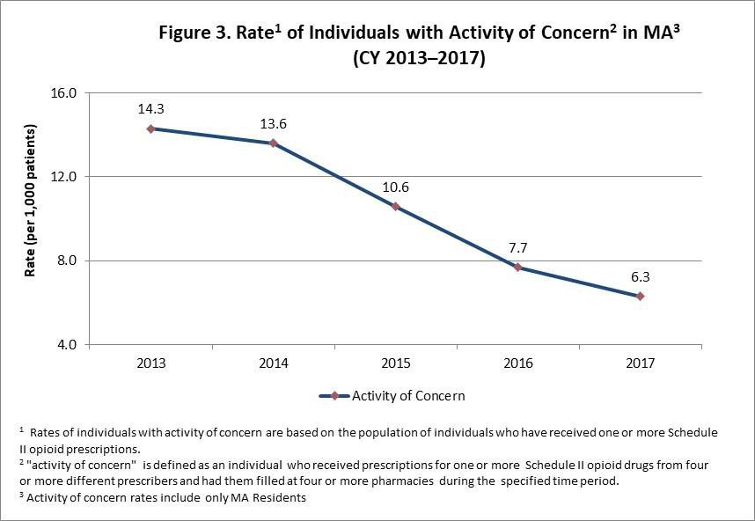

Note: PMP data are subject to updates. The MA PMP database is continuously updated to allow for prescription record correction data submitted by pharmacies. The data for CY 2017 were extracted on 01/12/2018.