
Massachusetts Department of Public Health, Bureau of Health Professions Licensure, April 2023
MA Prescription Monitoring Program County-Level Data Measures (Calendar Year 2022 Quarter 4 and 2023 Quarter 1)

The Department of Public Health’s (DPH) Prescription Drug Monitoring Program (PMP) serves as a repository of data for all prescription drugs dispensed statewide, including those prescriptions that are sought after for illicit and non-medical use and thus represent the highest potential for abuse (federal Schedules II – V, including certain narcotics, stimulants and sedatives). The PMP also enables prescribers and dispensers to access a patient’s prescription history and can be used as a clinical decision-making tool, allowing the provider to have a holistic view of the patient’s medications.
When interpreting PMP county-level data, it is important to emphasize that increases or decreases in a single measure may not indicate an increase or decrease in prescription misuse or abuse. Put simply, use does not always equate to abuse. There are many factors that might explain an unusually high rate of prescribing in a given area. For instance, an area which contains a large number of residents in long-term care facilities may result in a high rate of opioid prescribing.
These datasets inform critical discussions about opioid prescribing, provide an important baseline to better inform future policy decisions and allow the state and stakeholders to more meaningfully measure whether policy initiatives are effective.
Effective October 6, 2014, all hydrocodone combination drug (HCD) products (e.g., Vicodin) were reclassified from Schedule III to Schedule II. This reclassification during the last quarter of 2014 makes comparisons over time difficult to interpret. Beginning with CY 2015 data, reports of Schedule II products will include all HCD prescriptions.
Individuals with activity of concern "thresholds" for this report are based on a 3-month time period. MDPH has previously released annual county-level reports that provide thresholds based on a 12-month time period. Although the numbers (or rates) generated may appear to be comparable, they represent different time periods and are NOT an apples-to-apples comparison. The results are only comparable when the thresholds (e.g., 4 different providers and 4 different pharmacies), time interval (e.g. over a three-month period), and drug products analyzed (e.g. Schedule II opioids) are the same. Meaning, the total number (or rates) of individuals who received Schedule II-V opioid prescriptions from 4 or more providers and had them filled at 4 or more pharmacies in a 3-month period cannot and should not be compared with the total number of individuals (or rates) who received Schedule II-V opioid prescriptions from 4 or more providers and had them filled at 4 or more pharmacies in a 12-month period.

MA Prescription Monitoring Program: October – December 2022 and January – March 2023

October - December 2022 (Quarter 4)

January – March 2023 (Quarter 1)

MA Prescription Monitoring Program Data
Trend Analyses for Schedule II Opioids Only

- In the 4th Quarter of 2022, there were approximately 445,000 Schedule II opioid prescriptions reported to the MA PMP; this is a small decrease from the previous quarter and over a 47% decrease from the 1st Quarter of 2015 (n = 841,990 Schedule II opioid prescriptions).
- In the 1st Quarter of 2023, there were approximately 438,000 Schedule II opioid prescriptions reported to the MA PMP; this is a small decrease from the previous quarter and almost 48% decrease from the 1st Quarter of 2015.

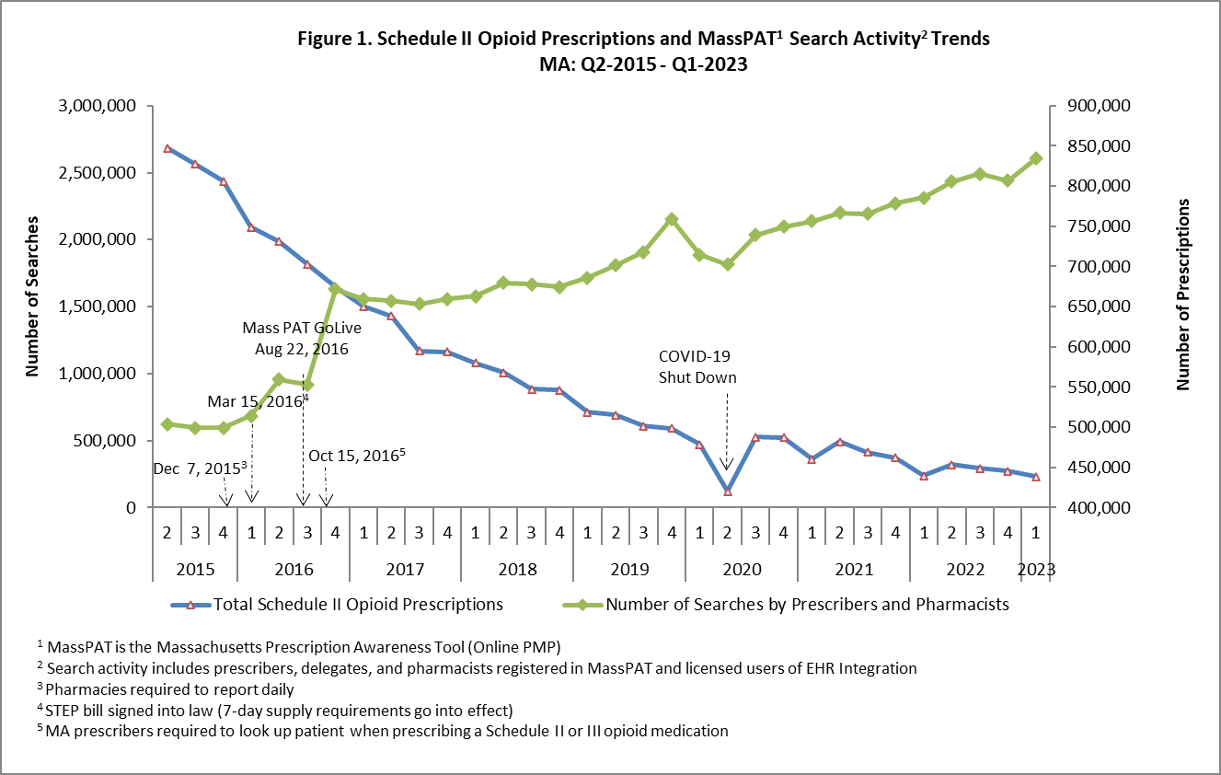

Note:
- PMP data are subject to updates. The MA PMP database is continuously updated to allow for prescription record correction data submitted by pharmacies. The data for CY2022 Q4 and CY2023 Q1 data were extracted on 04/18/2023.
- Some discrepancies were identified in search counts reported by data vendor. Reports prior to Q2 CY23 were inflated due to overrepresenting the number of Gateway (i.e., Integration) searches. Archived PMP reports going back to Q3 CY 2018 (beginning of Gateway or Integrated searches) are now updated to reflect the accurate counts. (Dated: March 2024)

- Approximately 205,000 individuals in MA received prescriptions for Schedule II opioids in the 4th Quarter of 2022; this is a slight increase from the previous quarter (an increase of about 2,400 individuals), but over a 47% decrease from the 1st Quarter of 2015 (n = 390,532).
- Approximately 201,000 individuals in MA received prescriptions for Schedule II opioids in the 1st Quarter of 2023; this is a slight decrease from the previous quarter (a decrease of about 3,600 individuals) and over a 48% decrease from the 1st Quarter of 2015.

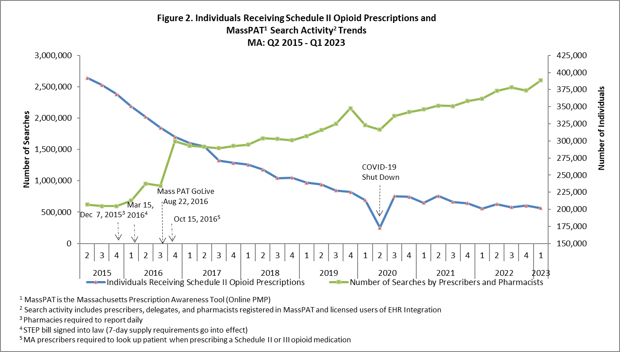

Note:
- PMP data are subject to updates. The MA PMP database is continuously updated to allow for prescription record correction data submitted by pharmacies. The data for CY2022 Q4 and CY2023 Q1 were extracted on 04/18/2023.
- Some discrepancies were identified in search counts reported by data vendor. Reports prior to Q2 CY23 were inflated due to overrepresenting the number of Gateway (i.e., Integration) searches. Archived PMP reports going back to Q3 CY 2018 (beginning of Gateway or Integrated searches) are now updated to reflect the accurate counts. (Dated: March 2024)

- The rate of individuals with activity of concern (also referred to as multiple provider episodes) decreased from 14.3 to 3.4 per 1,000 individuals between CY 2013 and CY 2022, more than a 76% reduction in activity of concern. Between CY 2021 and CY 2022 the rates of individuals with activity of concern decreased from 3.5 to 3.4 per 1,000 patients.

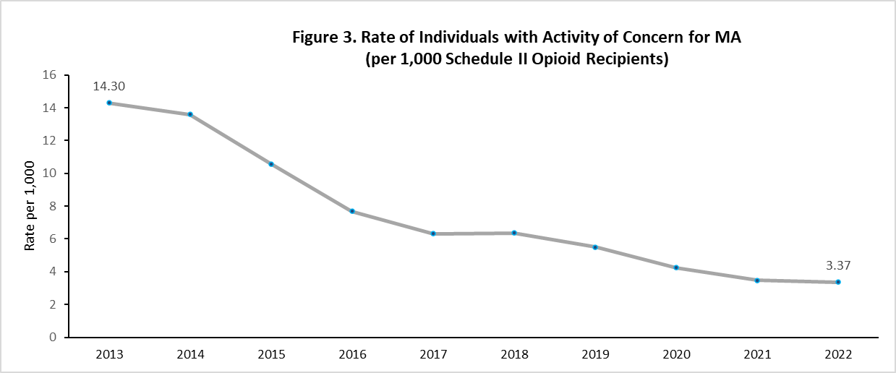

Note: PMP data are subject to updates. The MA PMP database is continuously updated to allow for prescription record correction data submitted by pharmacies. The data for CY2022 were extracted on 04/06/2023.

Source
- Prescription Drug Monitoring Program, Bureau of Health Professions Licensure, MDPH

