Fostering Continuity of Care for MA Long-Term Care Residents on Medication for Opioid Use Disorder (MOUD)

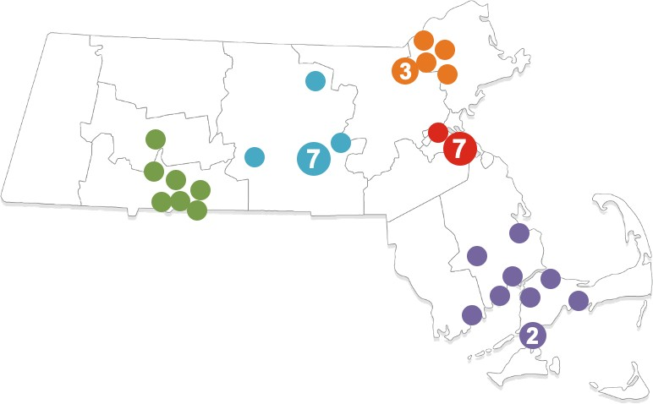
Background Methods Findings

Rosanna M. Bertrand¹, Chiara S. Moore², Katherine Fillo², Katherine Saunders², Stephanie Baker3, Amy Berninger1, Teresa Mota1, Nicole Keane1.

Discussion

Opioid Use Disorder (OUD) affects people of all ages, races, ethnicities, income levels, and in all geographic regions.

- The Centers for Disease Control and Prevention (CDC) estimates that two million Americans had OUD in 2018.1
- Upon hospital discharge with an unrelated diagnosis, some patients with OUD need continued long-term care facility (LTCF) care.
- The Massachusetts Department of Public Health issued a 2016 Circular Letter advising that LTCF administrators are expected to admit individuals with OUD and to provide medication for opioid use disorder, as prescribed (MOUD).
  - Failure to provide care is a violation of the Americans with Disability Act.
  - Many facilities still express concern for admitting residents with OUD.
- MOUD is an evidence-based treatment, supporting long-term recovery.
- MOUD is highly regulated, and a stay in a LTCF can pose challenges to providing coordination between LTCFs and

Site Selection
- Criteria: Quality scores on MA Nursing Home Survey Performance Tool, history of residents admitted with OUD, and geographic spread.
- 42 LTCFs (nursing homes and rest homes) selected with intention: half admitted residents with OUD, half had not.
- Facilities divided into five communities of practice (CoP) centered around a local OTP and OBOT.
Participating Facilities
by CoP
  - Springfield
  - Worcester
  - Lowell
  - Boston
  - Wareham/Plymouth

Program Components
- Pre-program staff interviews.
- In-person learning session offered in each of the five CoPs.
- Topic-specific discussions led by subject matter experts.
- Pre-post session assessments.
- Event evaluations.
- Virtual site visits
- A series of six ECHO sessions

Baseline Interview Results
- Baseline interviews completed with 5 OTPs and 5 OBOTs (one each, in each CoP).
- 137 baseline interviews completed with staff from all 42 LTCFs – 38 in-person, 99 via telephone.
- Six of 42 facilities admitted residents in need of MOUD within the past year.
- Four of 28 medical directors interviewed had obtained a waiver to prescribe certain MOUD.

Types of Training Staff Reported Receiving

12 0 Yes No
10 0
Number of Responses

80

60

40

20

0
Narcan

Post-Learning Session Evaluation Results

Number of Facilities Represented at the Learning Sessions per CoP

CoP | Number of Attending Facilities/Total Number Participating Facilities*
Boston | 4/8
Springfield | 7/7
Worcester | 7/10
Wareham | 7/10
Lowell | 7/7
Total | 31/42
*Note. Multiple staff from most facilities attended, as did representatives from corporate offices.

Extent to Which Learning Session Objectives Were Met
Met Partially Met No t Met
10 0
Percent of Responses

80

60

40
OUD as a Di sease
OUD Stigma/Myths

Pre-Post Learning Session Assessment Results

Percent Correctly Understanding Overall OUD and MOUD Before and After the Learning Session*

80 %
60 %
40 %
20 %
0%
Pre-Test Score Post-Test Sco re
*Note. t = 9.28013, p<0.0001

Percent Correctly Recognizing Stigmatizing Words Before
and After the Learning Session*

80 %

60 %

40 %

20 %

- It was clear that very few facilities were prepared to admit and provide proper care for residents in need of MOUD. They lacked a general understanding of OUD and MOUD.
- SMEs led topic-specific discussions in the learning session to educate on OUD/MOUD and address stigma, help make community connections, and provide resources.
- Core Competencies identified during the interviews as important were covered in the learning session.
- The learning sessions were very well received; attendance was often over capacity.
- Participants agreed that the session met the objectives.
- There was a significant increase in overall understanding of OUD/MOUD.
- The learning sessions were considered hugely successful. Attendees were enthusiastic and asked for more similar training.
- To sustain improvement and encourage facilities to admit residents with OUD additional, similar training events and technical support activities are planned.
- The MOUD Toolkit developed for this project and disseminated to participating LTCFs is available online: https://www.mass.gov/info- details/medication-for-opioid-use-disorder-in-long- term-care-moud-in-ltc-toolkit

treatment centers:
Trauma-Informed Care
Withdrawal/Overd ose
  - Opioid treatment program (OTP)
  - Office-based opioid treatment (OBOT)
- Misconceptions about OUD present
- Post-session evaluations
- Post-program staff surveys

Study Design
Note. Components in grey are not included in the current study
20

0
Understand OUD as a Chronic

Recognize OUD
Stigma

Knowledge of Treatment Including

Identify
Bi-Directional Strategies to
0%
Pre-Test Post Test
*Note. t = 4.42595, p<0.0001

Limitations
- Due to COVID-19, additional training/technical support changed from in-person to virtual.

barriers.

Study Purpose
- Cross-Sectional and Pre-Post Evaluation

Data Sources
- Most common challenges reported at baseline:
– Transportation
Disease
MOUD
Enhance Best Practices

Percent of Attendees Noting that MOUD can be a Long-Term Solution*
- After an overwhelmingly positive reaction to the first learning session, it was difficult to maintain engagement because LTCFs had to

The purpose of this study was to:
- Characterize the state of LTCFs’ admission of residents with OUD and their understanding of OUD and MOUD.
- Report on the impact of the first training session on educating LTCF staff on OUD/MOUD, addressing stigma, and making community connections with OTPs/OBOTs.

1 Centers for Disease Control and Prevention. 2019 Annual Surveillance Report of Drug-Related Risks and Outcomes — United States Surveillance Special Report. Centers for Disease Control and Prevention, U.S. Department of Health and Human Services. Published November 1, 2019. Accessed May 22, 2020 from https://www.cdc.gov/drugoverdose/pdf/pubs/2019-cdc-drug- surveillancereport.pdf.
- Pre-Program Staff Interviews (Baseline)
  - Administrators, Directors of Nursing, Medical Directors and other staff (e.g., certified nursing assistants, staff developers):
  - Fourteen core questions regarding admission, policies/ procedures, training, and barriers to admission.
  - Analyses: Descriptive analyses of key questions.
- Post-Learning Session Evaluations:
  - Eleven question survey to elicit participant feedback on the value of the learning session.
  - Administered after the learning session.
  - Analysis: Descriptive analyses of key questions.
- Pre- and Post-Learning Session Assessments:
  - Nine question survey to assess OUD/MOUD knowledge gained.
  - Administered before and after each of the five learning sessions.
  - Analysis: Two sample t-tests.
  - Lack of Training/knowledge of OUD and MOUD
  - “Risky/difficult” population (behavior, combativeness)
  - Mixing perceived younger population with frail elderly
- Core competencies reported at baseline by staff as necessary to care for residents with OUD:
  - Recognizing signs & symptoms of OUD, misuse and relapse
  - Understanding MOUD
  - Understanding/managing behaviors
  - Dispelling myths and addressing stigma
Attendees Reporting on the Positive Value of the Learning Session

Strongly Agree Agre e
26%
74%
Di sagre e
Strongly Disa gree
10 0%
80 %
60 %
40 %
20 %
0%

Pre-Test Post Test

*Note. t = 3.73879, p=0.0003
prioritize emergency response and
management of COVID-19.

1Abt Associates Inc., Cambridge, MA; 2MA Department of Public Health, Boston, MA; 3Healthcentric Advisors

This project is funded by a cooperative agreement from the Substance Abuse Mental Health Services Administration (SAMHSA) to the Massachusetts Department of Public Health.

