Slide 1
Review of the Drug Formulary Commission

Bureau of Health Care Safety and Quality
Department of Public Health

September 8, 2015

Topics

•Follow-up from August 6th Meeting
–Chairman’s Introduction and Commission’s Purpose
–Information on Other States
•Evaluation and Review Process
•Draft Formulary Development
•Timeline
•Stakeholder Engagement

Slide 2 Topics

Commission’s Purpose

Slide 3
•Maintain the Massachusetts List of Interchangeable Drugs.
•Pursuant to Chapter 258 of the Acts of 2014, prepare a drug formulary of chemically equivalent substitutions for Schedule II or III opiates that the Commission has determined have a “heightened level of public health” risk due to the drugs’ potential for abuse and misuse.

Commission’s Purpose

Slide 4
Information on Other States

•Massachusetts
–First state that is taking the steps to develop an opioid formulary that identifies drugs that have a heightened public health risk and their therapeutic substitutions.
•Select states have developed formularies to help reduce opioid use in workman’s compensation programs:
–Louisiana
–Ohio
–Texas
–Washington State
Slide 5

Data: PMP Dispensing and Reporting Data: Schedule II and III Opioids

Slide 6
Data: PMP Dispensing and Reporting Data: Schedule II and III Opioids
Source: BHCSQ, MA PMP. This list is derived from all prescriptions dispensed and reported to the Prescription Monitoring Program during CY 2014. This list represents 100% of all Schedule II and III opioids, and 68% of all of the Schedule II and III drug products (including opioids and non-opioids), dispensed and reported to the PMP.

KEY TERMS
Slide 7

•Bioequivalent Drug Products

“Means drug products whose rate and extent of absorption do not show a significant difference when administered at the same molar dose of therapeutic moiety under similar conditions. Some drug products may be equivalent in the extent of their absorption but not in their rate of absorption are not essential to the attainment of effective body drug concentrations or are considered medically insignificant for the particular drug product studies.” 105 CMR 720.020
Slide 8

KEY TERMS

K
•Therapeutically equivalent drug products

“Means drug products which are pharmaceutically equivalent; meet applicable standards for strength, quality, purity and identity; are bioequivalent in that:

a.) they do not present a known or potential bioequivalence problem, and they do meet an acceptable in vitro standard; or

b.) if they do present such a known or potential problem, they are shown to meet an appropriate bioequivalence standards matching both rate and extent of absorption; are adequately labeled; and are manufactured in compliance with cGMP.” 105 CMR 720.020
Slide 9

KEY TERMS

•Interchangeable Drug Products

“Means a product containing a drug in the same amounts of the same active ingredients in the same dosage form as the other drug products with the same generic or chemical name.” 105 CMR 720.020

Slide 10

KEY TERMS

Key Terms
•Pharmaceutically equivalent drug products

“Means drug products which contain the same active ingredients, and are identical in strength or concentration, dosage form, and route of administration.” 105 CMR 720.020

Slide 11

Stages: Evaluation and Review Process Overview Stages:
Slide 12
Draft Formulary
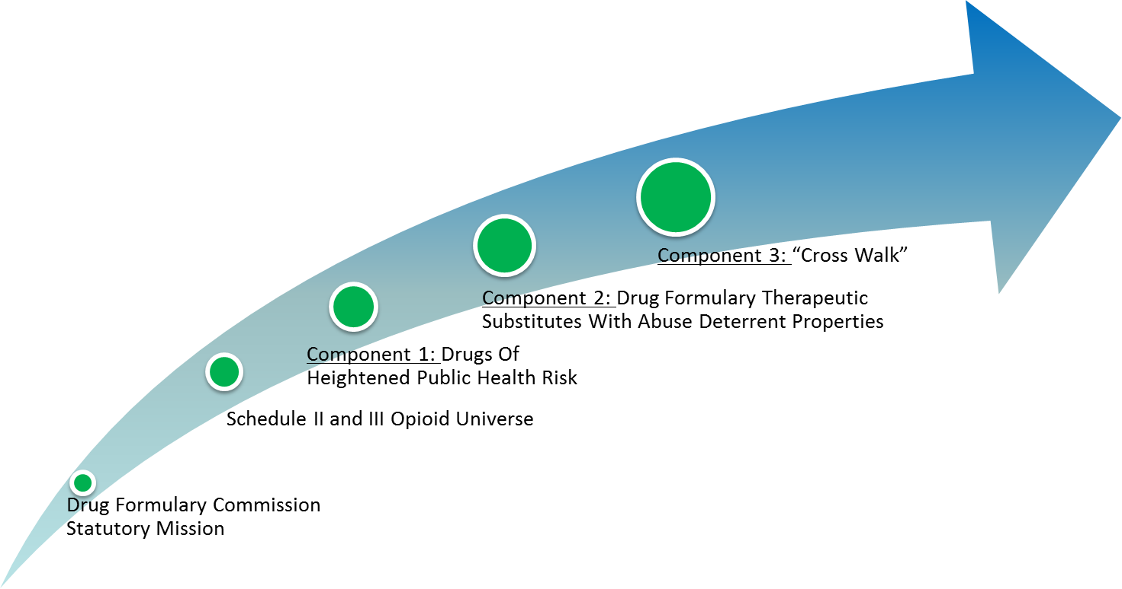
Draft Formulary

Evaluation and Review Process
Overview

Slide 13
•The Commission’s task is to develop a formulary that consists of three components:
–Component 1: Heightened Public Health Risk: The Commission will determine which groups of drugs should be designated as having a heightened public health risk.
–Component 2: Substitute: The Commission will determine which drugs should be identified as therapeutically equivalent substitutes to the drugs that have a heightened public health risk.
–Component 3: Cross-Walk: The Commission will develop a formulary of therapeutically equivalent substitutes for drugs determined to be having a heightened public health risk.

•Following completion of these components, the Commission will have a draft Formulary.

Evaluation and Review Process
Overview

Slide 14
•How will we complete the work associated with each component?
–To identify the drugs that have a heightened public health risk, all groups of Schedule II and III opioids will be evaluated using a standardized set of evaluation criteria, developed and voted by this Commission.

–To identify the drugs that are therapeutically equivalent substitutes for drugs that have a heightened public health risk, the potential drugs will be evaluated using a standardized set of evaluation criteria, developed and voted by this Commission.

•The Department will apply the Commission-approved criteria to each group/individual drug and then present the results to this Commission for review.
Evaluation and Review Process Overview

Slide 15
•The Commission will discuss and analyze the results presented by the Department.
–Some drugs may require extensive deliberation.

•Following the discussion, the Commission will vote to place a drug group or individual drug on the heightened public health risk or substitute list.

•While this Commission will review all prescribed Schedule II and III opioids, there may be some drugs that the Commission determines should not be placed on the list of drugs that have a heightened public health risk.
Component 1: Drugs Of Heightened Public Health Risk
Slide 16

Component 1: Drugs Of Heightened Public Health Risk
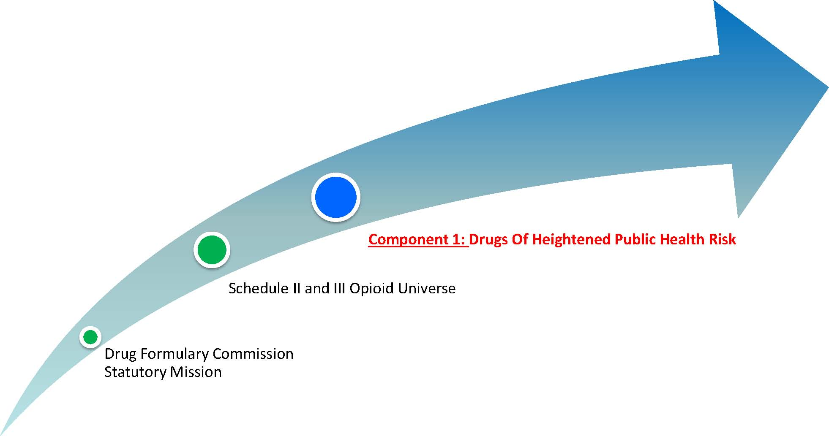

Overview Component 1: Heightened Public Health Risk
Group Review-

Slide 17
•To determine which opiates are designated as having a heightened public health risk, we will follow a process consisting of three initial steps.

–Step 1: Criteria: The Commission will develop specific criteria for determining what constitutes a heightened public health risk.
–Step 2: Review: The Department will apply these criteria to all 28 groups of Schedule II and III opiates.

–Step 3: Vote: The results of this review will be presented to the Commission for discussion and evaluation. Following the Commission’s evaluation, there will be a vote on each drug group.

Overview -Component 1:
Heightened Public Health Risk

Slide 18
•If the vote is to place a drug group on the heightened public health risk list, the following steps will be taken:

–Step 1: Review: The Department will provide a detailed analysis of all drug products making up the group.
–Step 2: Recommendation: The Commission will then review each drug product, (e.g. dose form, volume of dispensing) to determine if the individual drug product has a heightened public health risk.

–Step 3: Vote: Following the Commission’s review, there will be a vote on each individual drug.

Overview -Component 1: Heightened Public Health Risk

Slide 19
•Once the full evaluation and vote has taken place on all 28 groups of drugs and the individual drugs that make up each group, the Commission will have completed one component of the Draft Formulary.
•This completed component may look like the following:
Heightened Public Health Risk (HPHR)
HPHR Group A – Drug Product 1
Drug Product 2
HPHR Group B - Drug Product 1
HPHR Group C – Drug Product 1
Drug Product 3
HPHR Group D – Drug Product 1
HPHR Group E – Drug Product 2
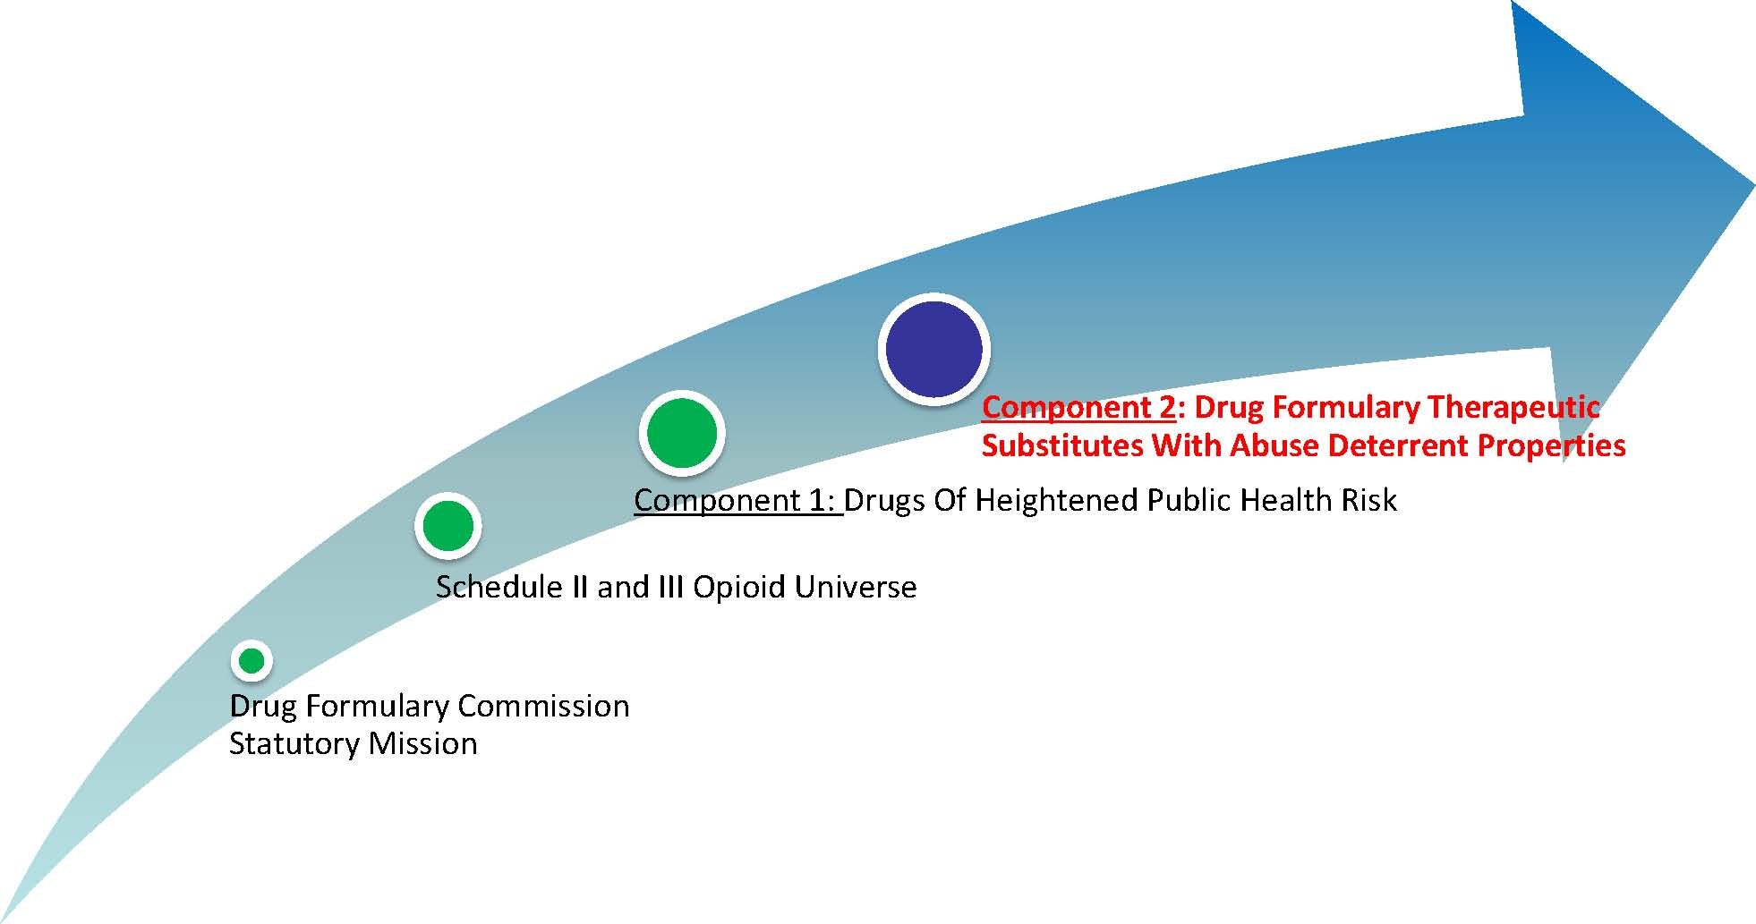
Component 2: Therapeutically Equivalent Substitutes

Slide 20

Overview-Component 2: Factors for Consideration
Slide 21
Per the statute, in considering whether a drug should be placed on the formulary as a therapeutically equivalent substitution, the Commission shall consider:

Efficacy/ Effectiveness

Effectiveness of its Abuse -Deterrent Properties

Accessibility

Is it Cost
Prohibitive

Overview-Component 2:

Therapeutically Equivalent Substitutes

Slide 22
•To determine which opiates will be designated as therapeutically equivalent substitutes for other drugs, we will follow a process consisting of three steps.

–Step 1: Criteria: The Commission will develop criteria for determining what constitutes a therapeutically equivalent substitute.
•Per the statute, the Commission shall consider:
–Efficacy/Effectiveness
–Effectiveness of its Abuse-Deterrent Properties
–Accessibility
–Cost

Overview-Component 2:
Therapeutically Equivalent Substitutes

Slide 23
–Step 2: Review: The Department will apply these criteria to all drugs that may potentially meet the Commission’s established set of criteria.

–Step 3: Vote: The results of this review will be presented to the Commission for discussion and evaluation. Following the Commission’s review, there will be a vote on each drug that might be a therapeutic equivalent substitution.

Overview-Component 2:
Therapeutically Equivalent Substitutes

Slide 24
•The Commission will also need to evaluate drugs that have current FDA labeling as having abuse deterrent properties. The established criteria will be applied to these drugs and the Commission will vote on the results of the Department’s review.

•Once the full evaluation and vote has taken place on all drugs for consideration, the Commission will have completed the second component of the Formulary.
•This completed component may look like the following:
Therapeutically Equivalent Substitutes (TES)
TES Drug A
TES Drug B
TES Drug C
TES Drug D

Draft FormularyOverview

Slide 25
•Following completion of the first two components, the Commission will put each list of drugs side-by-side to create an initial draft Formulary.
•The FDA labeled drugs will be noted separately, as shown in the example below:
Heightened Public Health Risk  Groups of Drugs and  their Component Drug Products | FDA Approved Labeled Individual Drugs  (ADF) | Therapeutically Equivalent Substitute Drugs  (TES)
HPHR Group A – Drug Product 1  Drug Product 2 | FDA Drug 1 | TES Drug A
HPHR Group B – Drug Product 1 | FDA Drug 2 | TES Drug B
HPHR Group C – Drug Product 1  Drug Product 2  Drug Product 3 | FDA Drug 3 | TES Drug C
HPHR Group D – Drug Product 1 | FDA Drug 4 | TES Drug D
HPHR Group E – Drug Product 2 |  | TES Drug E

Draft Formulary
Overview

Component 3: Cross Walk
Slide 26
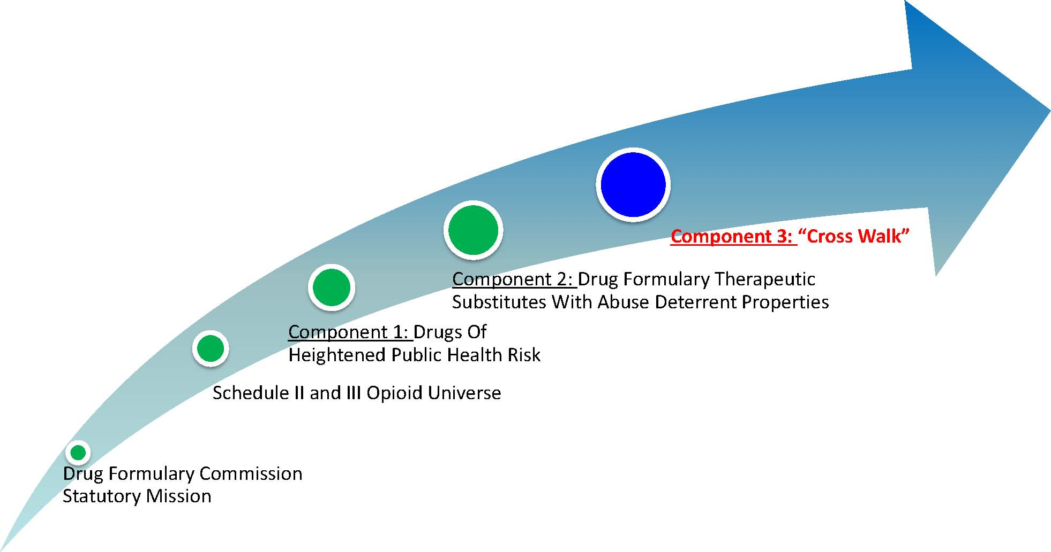

Overview-Component 3: Crosswalk

Slide 27
•After the initial draft Formulary is developed, the Commission will need to complete the final component: approving a “crosswalk” linking drug products that are determined as having a heightened public health risk with an FDA approved labeled drug or a drug designated as a therapeutically equivalent substitute.

•This final component process will consist of three steps:

–Step 1: Subcommittee: A subcommittee will be created to review each drug product that has a heightened public health risk and “crosswalk” it with an FDA approved labeled drug and/or a drug designated as a therapeutically equivalent substitute.

–Step 2: Recommendation: The subcommittee will facilitate a list of recommended “crosswalks” for review by the Commission.
–Step 3: Vote: Following the Commission’s review, there will be a vote on each “crosswalk” recommendation.

Overview-Component 3: Crosswalk

Slide 28
•Following completion of the crosswalk, the Commission will have draft Formulary.

•The final component will provide direction for substitution of certain prescribed drugs for others, unless otherwise noted by the prescriber.
•Drugs that are determined to be of a heightened public health risk without having a therapeutic substitute will be placed on a list and provided to the Commissioner.

Overview-Component 3: Crosswalk
Slide 29
•The draft Formulary may look like the following:
All Heightened Public Health Risk Groups of Drugs and  their Component Drug Products | Therapeutically Equivalent Substitute Drugs
HPHR Group A – Drug Product 1  Drug Product 2 | Drug A
HPHR Group B – Drug Product 1 | Drug A, Drug B
HPHR Group C – Drug Product 1  Drug Product 2  Drug Product 3 | Drug C
HPHR Group D – Drug Product 2 | No Recommendation
HPHR Group E – Drug Product 1 | Drug D

Schedule II Opioid Drugs Prescription / Dispensing Data Slide 30

Source: BHCSQ, MA PMP. This list is derived from all prescriptions dispensed and reported to the Prescription Monitoring Program during CY 2014.

Schedule III Opioid Drugs Prescription / Dispensing Data
Slide 31

Source: BHCSQ, MA PMP. This list is derived from all prescriptions dispensed and reported to the Prescription Monitoring Program during CY 2014.

Slide 32

Timeline

Slide 33

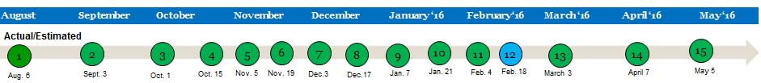
Timeline

Draft Formulary:

•Component 1 – Heightened Public Health Risk:
–Draft formulary will include the Commission’s recommendations related to all Schedule II and III 28 groups of drugs.
–Full evaluation and vote has been completed on all 28 groups of drugs and the individual drugs that make up each group.

•Component 2 – Therapeutically Equivalent Substitutes:
–Draft formulary will include review of the four individual drugs with current FDA labeling.

•Component 3 – Cross- Walk:
–The Commission will begin the crosswalk linking drug products that are determined as having a heightened public health risk with an FDA approved labeled drug.

Slide 34

Stakeholder Engagement

Slide 35

•In order to make the most relevant, timely and beneficial information available, it is important to hear from experts and those with direct experience in developing drug formularies, having drugs approved to be labeled by the FDA as abuse deterrent and other key topics.

•To facilitate this information sharing, the agenda for the October 1 meeting will be an informational hearing.

•Pursuant to Chapter 258 of the Acts of 2014, experts will be invited to testify and respond to specific questions that would most inform your work. The Commission will have the opportunity to ask questions and make comments in response to testimony.

Stakeholder Engagement:
Who to invite

Slide 36
Stakeholder Engagement: Who to invite
•Invitees will fall into the following panels of expertise:
–Addiction Experts
–Health Plan Associations
–FDA / other governmental agencies
–Medical Associations
–Pain Management Experts
–Patient Advocates
–Pharmaceutical Industry (manufacturers with ADF technology / drugs)
–Pharmacy Associations

Stakeholder Engagement: What Question Categories

Slide 37
•Pursuant to the statute the questions will fall into the following areas:
–Chemical and laboratory testing data
–Clinical proof of bioequivalence
–Therapeutic equivalence

Stakeholder Engagement:
Discussion The How

•Each invited expert will be given a time limit for remarks and the goal is to keep the subject matter as relevant and beneficial for the Commission members as possible. Therefore, we will request that experts tailor their remarks to respond to a small number of questions.
•Experts will be invited to provide testimony.
•The Commission will accept written comment(s) from individuals who do not have an opportunity to speak.
•The Commission will accept written comment(s) from an individual/group not invited to the hearing.
•The Commission will accept written comment(s) from an individual/group that presented who wishes to provide additional information.

Slide 38

Stakeholder Engagement:
Discussion The How

Discussion:

•Expert Invitation:
•Questions:
•Other:

Slide 39

Stakeholder Engagement:
Discussion The How

Discussion:
Slide 40

Evaluation Criteria

Slide 41

Preliminary Discussion of the Evaluation Criteria

Heightened Public Health Risk

Slide 42

•Component 1: Heightened Public Health Risk: The Commission will determine which groups of drugs should be designated as having a heightened public health risk.

•What does having a heightened public health risk mean to you?

•What would the Commission like to use for sources to help with establishing the criteria for having a heightened public health risk?

•Possible sources:
–Massachusetts PMP Information
»Prescriptions written (Prescribers)
»High Prescriber Utilizers (Prescribers)
»Dosage forms dispensed (Pharmacies)
»High Multiple Provider Episodes (Doctor Shopping)
–DEA Diversion Data
–Substance Abuse and Mental Health Services Administration (SAMHSA) Data
–Post Marketing Data from Manufacturers
Heightened Public Health Risk: Draft Criteria

Slide 43
Heightened Public Health Risk: Draft Criteria
Heightened Public Health Risk: Draft Criteria
Slide 44

Substitution Criteria

- Component 2: Substitute: The Commission will determine which drugs should be placed as therapeutically equivalent substitutes on the formulary.

- In order for the Commission to do this, the Commission needs to develop criteria to determine what constitutes a drug being therapeutically equivalent.
- By Statute, we know four criteria must be met:
  - Efficacy/Effectiveness
  - Effectiveness of its Abuse-Deterrent Properties
  - Accessibility
  - Cost
Slide 45

Substitution Criteria

Efficacy (Effectiveness)
- USP & Supplements
- FDA Orange Book
- Manufacturer Data
  - Laboratory Testing Data
  - Bioequivalence Data
  - Therapeutic Equivalence
- Other
  - Onset of Action
  - Duration of Action
  - Morphine Equivalence
  - Side Effects
  - Adverse Reactions
  - Dose Form
  - Other
  - How many of these elements must we compare and consider equal for the Commission to consider a criteria for inclusion?
Slide 46

Substitution Criteria

Effectiveness of its Abuse Deterrent Properties
- As outlined in M.G.L. Chapter 17, Section 13, the Formulary shall include formulations of drugs that the Commission has determined can be appropriately substituted and that incorporate any of the following abuse deterrent properties:
  - Physical or chemical barrier
  - Agonist or antagonist combination
  - An Aversion Quality
  - Delivery system
  - Prodrug
  - Any other technique
  - How many properties must a drug have for the Commission to consider a criteria for inclusion?

Slide 47

Substitution Criteria

Accessibility
- Hospital formularies
- Insurance Company formularies and Preferred Drug Lists
- How shall we define availability? What/whom shall we look to, to help us with determination?

Slide 48

Substitution Criteria

Cost
- How do we determine cost?
- What/whom should we look to, to help us with this determination?

Slide 49

Substitute: Draft Criteria
Slide 50

Substitute: Draft Criteria
Slide 51

Final Discussion

