ARE YOU PREGNANT OR



PLANNING TO BECOME PREGNANT?

 **Congenital cytomegalovirus (cCMV)** is the leading infectious cause of birth defects.

 **About 1 in 200 babies** are born with cCMV.

 Living or working with young children while pregnant puts you at a **higher risk for cCMV**.

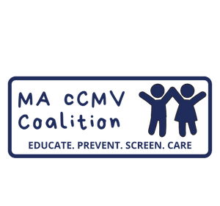

For more information

[**www.cmvmass.org**](http://www.cmvmass.org/)

**CMV spreads mainly through saliva and urine. You can reduce your risk for cCMV through simple steps that reduce contact with these body fluids, such as:**

Not sharing food, drinks, cups, or utensils with young children

Kissing young children on the forehead instead of the mouth or nose area



Washing your hands often, especially after changing diapers or wiping faces

Disinfecting objects that come in contact with children’s urine or saliva



Not putting pacifiers in your mouth