Choking Prevention
Choking is a leading cause of unintended injury in children under age 4.
Injury and death from choking are preventable. The risk of choking depends on the size, shape and consistency of the object, as well as the developmental age of the child.

The most common items on which children choke are food, coins, balloons, and other toys.
If an item can fit inside a cardboard toilet tube roll, it can become lodged inside a child’s airway.
*Caregivers should be educated about choking hazards.

Steps to Avoid Choking Include:
- Learn CPR (basic life support).
- Be aware that balloons pose a choking risk to children of any age.
- Insist that children eat at the table, or at least while sitting down. They should not walk, run, play, laugh or lie down with food in their mouths.
- Cut food for infants and young children into pieces no larger than one-half inch, and teach them to chew their food well.
- Supervise mealtimes for infants and young children.
- Be aware of older children’s actions. Many choking incidents occur when older siblings give dangerous foods, toys or other objects to younger children.
- Follow the age recommendations on toy packages. Age guidelines reflect the safety of the toy based on possible choking hazards as well as a child’s physical and mental abilities at various ages.
- Check under furniture and between cushions for small items that children find and put in their mouths.
- Do not let infants and young children play with coins.
- Do not prop bottles. This can cause choking and aspiration.
- Don’t feed children while driving. It is difficult to drive and supervise eating.
- If using a rub-on teething medication, watch toddler closely as the medicine can numb his throat and interfere with swallowing.

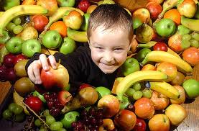

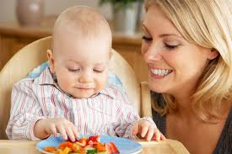

Tips To Make Food Safer
- Cut into quarters lengthwise, then into small pieces.
- Peel fruits and cut in half lengthwise.
- Chop finely or into thin strips.
- Spread peanut butter thinly on crackers or bread.
- Avoid round or tube-shaped foods.
Remember: never leave children unattended while eating.

Never Let Young Children Play With
Latex balloons | Coins
Marbles | Small balls
Pen or marker caps | Small button-type batteries
Medicine syringes | Jewelry
Toys with small parts | Crayon pieces
Toys that can be compressed to fit entirely into a child’s mouth

Dangerous Foods

Do NOT serve these foods to children under 4 years of age:

Hot dogs | Sausages
Chunks of meat or cheese | Whole grapes
Fish or meat with bones | Raisins
Marshmallows and marshmallow fluff | Popcorn
Hard, gooey or sticky candy | Chewing gum
Chunks of peanut butter | Lollipops
Raw vegetables | Nuts and seeds
Whole olives | Ice cubes
Potato / corn chips | Pretzels

This list is provided for information purposes only. Please consult resources on the back of the brochure for more information about dangerous food and non-food items.

For Addition Information:
Caring for Our Children, National Health and Safety Performance Standards, Guidelines of Out-of-Home Child Care (3rd Ed.). American Academy of Pediatrics, American Public Health Association, and National Resource for Health and Safety in Child Care (2011).
American Academy of Pediatrics http://pediatrics.aappublications.org/content/125/3/601.full
http://www.aap.org
Center for Disease Control and Prevention. National Center for Injury Prevention and Control: www.cdc.gov/injury/ .
USDA Food Safety: www.foodsafety.gov
Department of Early Education and Care
51 Sleeper St. 4th Floor
Boston, MA 02210
(617) 988-6600
www.mass.gov/eec

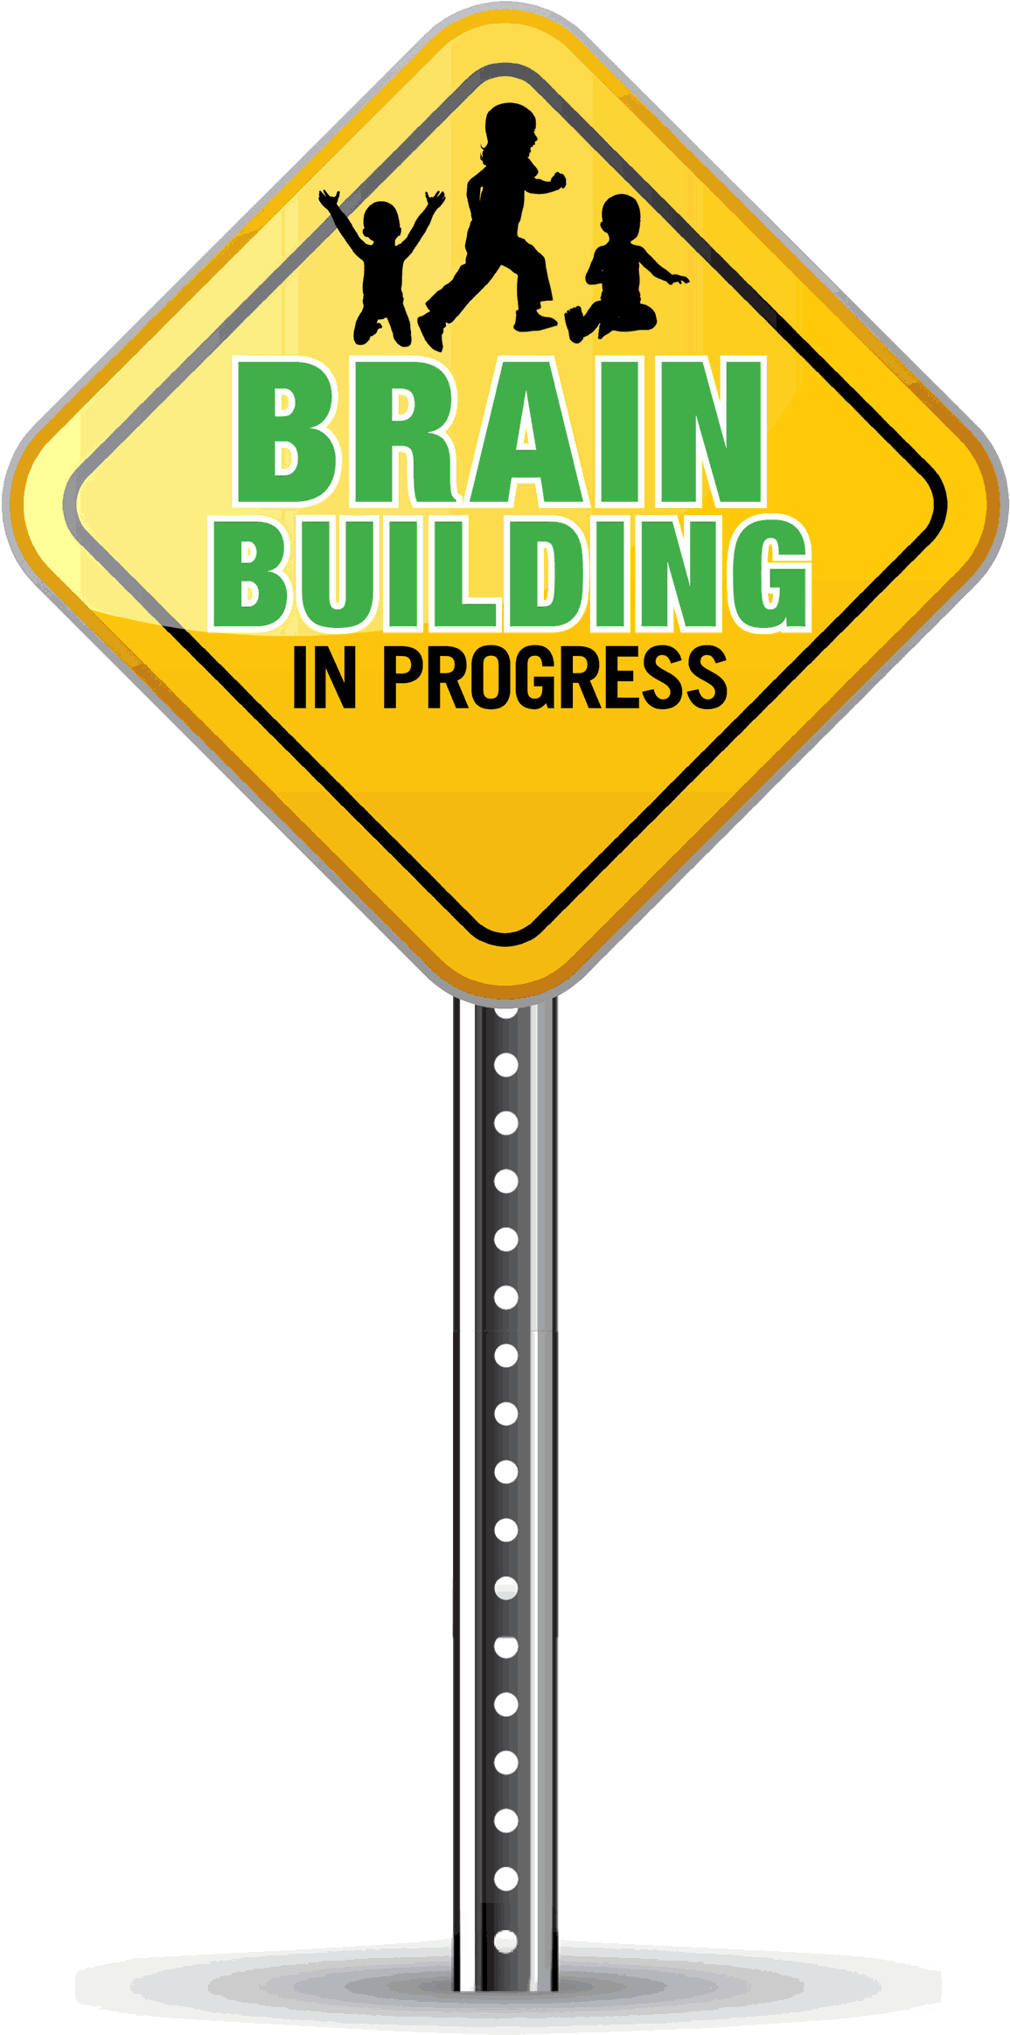

Preventing
Choking
In Our
Children

