
Prevention of Problem Gambling

Regional Planning Process—Everett/Eastern Massachusetts (Region A)

December, 2018

Table of Contents
Executive Summary 3
Introduction 16
Health Equity 17
Community Profile 17
Outreach and Network Building 19
Stakeholder Meeting 20
Key Informant Interviews 21
Priority Populations 21
Youth and Caregivers 21
Men of Color Who Have a History of Substance Misuse 21
Data Collection 22
Data Analysis 23
Results: Gambling Knowledge, Attitudes, and Behaviors 24
Summary of Data Gathered from Youth 24
Summary of Data Gathered from Caregivers 26
Summary of Data Gathered from Men in Recovery 29
Summary of Data Gathered from Key Informants 31
Messages and Strategies 34
Message Development 34
Messages to Impact Youth and Caregivers 35
Existing Approaches to Gambling Prevention and Advocacy for Youth 36
Strategy to Impact Youth and Caregivers 37
Messages to Impact Men of Color Who Have a History of Substance Misuse 41
Existing Peer Education Models 42
Strategy to Impact Men of Color Who Have a History of Substance Misuse 43
Theory of Change 46
Implications and Recommendations 46
Appendix A: Focus Group and Key Informant Interview Questions 52
Key Informant Interview Questions 52
Youth Focus Group Questions 53
Caregiver Focus Group Questions 54
Caregiver Focus Group Questions (Spanish) 55
Men in Recovery Focus Group Questions 56
Men in Recovery Focus Group Questions (Spanish) 57
Note: This report is one of a set of three, each focusing on one region of Massachusetts.
Some sections have been adapted from the report focusing on Region C.

Executive Summary
Detailed in this report is a regional planning process for the prevention of problem gambling that was carried out by the Massachusetts Technical Assistance Partnership for Prevention (MassTAPP) at Education Development Center, Inc. (EDC). The regional planning process was funded by the Massachusetts Department of Public Health (DPH) and focused on the city of Everett, where the Encore Boston Harbor casino is scheduled to open in 2019, and its surrounding communities. Most of this regional planning process took place in Everett, but many of the assessments and recommendations documented throughout this report may also be relevant to other communities that have Surrounding Community Agreements with Everett (Boston, Cambridge, Lynn, Malden, Medford, Melrose, and Somerville) and are likely to be impacted by the casino.^{i}
After the Public Health Trust Fund Executive Committee adopted the Strategic Plan: Services to Mitigate the Harms Associated with Gambling in Massachusetts^{ii} (the statewide Strategic Plan) in April 2016, two of the plan’s key recommendations were operationalized:
- Reach youth and parents with appropriate prevention messaging, and enhance environmental strategies to increase protective factors and decrease risk factors^{iii}
- Develop and distribute culturally appropriate campaigns and services for high-risk populations
For each recommendation, a planning process was designed and conducted to develop culturally appropriate prevention strategies that take into account the principles of health equity. The concept of equity moves beyond access to health care for all community residents; it calls for recognition of the inequities and obstacles faced by some (including poverty, discrimination, and disparities in housing, education, and economic opportunity) and a willingness to address these issues in order to achieve positive health outcomes for all. Most importantly, equity can only be achieved when the values and priorities of the populations most impacted by an issue, such as problem gambling, are integrated into planning and decision-making.
This regional planning process included outreach to community members and service providers; the convening of local stakeholders concerned about the potential impact of gambling in their region; the identification of community assets and resources, and of gaps in services; and the conducting of more formal key informant interviews and focus groups. Collection and analysis of this qualitative data informed the development of messages and strategies that directly addressed the local context and concerns, which aimed to promote equity by impacting two priority populations in the region:
- Youth ages 12–18 and their caregivers
- Men of color who have a history of substance misuse
Overall, this regional planning process directly engaged 80 community members through key informant interviews and focus groups, and also reached 8 community members who attended a community meeting. Community members and key informants agreed that populations at high risk for problem gambling included people of color, people with a history of substance misuse, and men.

Priority Populations

Youth and Caregivers
Youth who begin gambling early in life are more likely to experience problem gambling later in life.^{iv} Therefore, youth ages 12–18 were identified as the “targets of change”^{v} for this strategy. Research also shows that youth are less likely to experience problem gambling if they have protective factors in their lives, such as strong family support and realistic boundaries and expectations, which buffer the risks of developing problems with alcohol and other substances.^{vi} Therefore, caregivers of adolescents were identified as “agents of change”^{v} and an audience for problem gambling prevention messages and strategies.

High Risk Populations
Research has indicated that men are at higher risk than the general population for problem gambling,^{vii} as are people of color and people with a history of substance misuse.^{vi} Based on these findings, conversations with key stakeholders in the region, and the availability and readiness of substance use treatment and recovery support providers to incorporate messages about gambling into their services, the priority population for this strategy was defined as men of color who have a history of substance misuse. This priority population aligns well with results from the Social and Economic Impacts of Gambling in Massachusetts (SEIGMA) study, which showed significantly higher problem gambling rates among men compared to women, and among Black adults compared to white adults in Massachusetts.^{viii} This study also indicates that adults who engage in problem gambling are significantly more likely to have engaged in binge drinking in the past month than adults who gamble recreationally.^{viii} Additionally, men of color who have a history of substance misuse are at higher risk for being held in jail or prison. According to national research, not only do more than half of individuals in jail and prison have substance use disorders (58% of state prisoners and 63% of sentenced jail inmates),^{ix} but people in jail and prison are also disproportionately people of color.^{x} These national statistics were supported by focus group conversations with men in recovery, who spoke often about jail and prison, indicating a greater need for prevention strategies for both problem gambling and substance misuse.

Community Engagements

Key Informants
To gain a broad community perspective, key informant interviews were conducted with well-informed, well-connected members of the community who have expertise in local issues and how to address them.
- Eleven key informants participated in interviews in person or by phone.

Youth and Caregivers
To develop messages and prevention strategies that resonate with youth and their caregivers (including parents, grandparents, and other guardians), focus groups were conducted with youth and caregivers, engaging 28 people.
- Sixteen youth participated in two focus groups (held at the Cambridge Health Alliance Everett Care Center in Everett and at Maverick Landing in East Boston). One youth leader participated in a key informant interview.
- Eleven caregivers participated in two focus groups (held at Parenting Journey in Somerville and La Comunidad in Everett). One focus groups was conducted in Spanish. This ensured that Spanish speakers who do not speak English have equitable access to participate in the prevention initiative design.

Men of Color Who Have a History of Substance Misuse
To develop a message and prevention strategy that resonates with men of color who have a history of substance misuse, focus groups were conducted throughout the region with men in recovery, engaging 41 people.
- Forty-one men in recovery participated in three focus groups (held at the Boston Public Health Commission Engagement Center in Boston, Boston Public Health Commission Safe & Sound Recovery Center in Boston, and STEPRox Recovery Support Center in Boston). One focus group was conducted in Spanish, to ensure equitable access to participate in the prevention initiative design.

Messages and Strategies

Knowledge, Attitudes, and Behaviors: Youth
Youth in the Everett area described their extensive exposure to gambling but seemed to have little experience personally gambling. They spoke of many benefits of the activity, including economic, making money, and having fun, and described multiple risks. However, they rarely mentioned first-hand familiarity with the negative outcomes that gambling can lead to. Overall, some youth have negative attitudes about gambling, but most youth who participated in focus groups believe that some types and contexts of gambling are acceptable. Despite their understanding that gambling can have risks, and their beliefs that some (if not all) types of gambling are not acceptable, youth spoke about the easy access they have to gambling, if they wanted to engage in it. The prevention messages that were developed based on these findings are illustrated below.
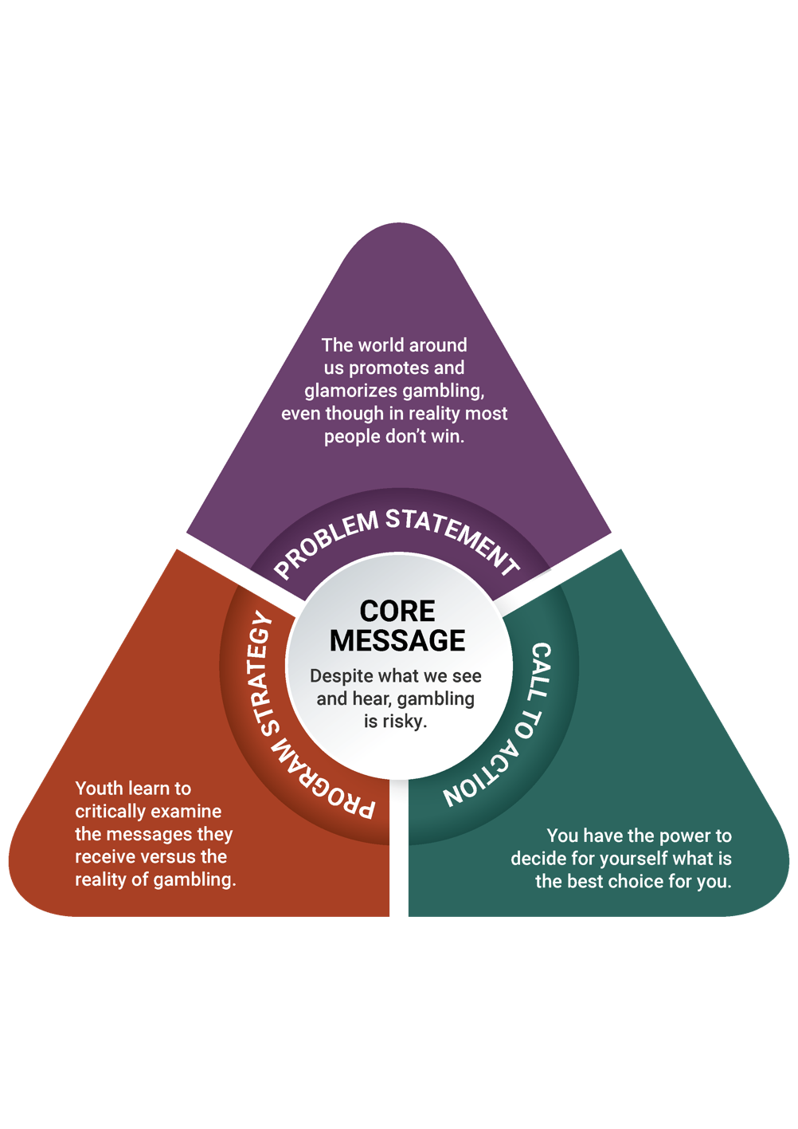

Knowledge, Attitudes, and Behaviors: Caregivers
Caregivers in the Everett area who participated in focus groups described their significant, and often difficult, experiences with gambling, particularly relating to their close proximity to familial, environmental, and personal issues related to gambling. They did not commonly mention worries about their children’s exposure to gambling, and most caregivers said that they would engage their children in conversations about gambling from a perspective of trust and moderation: teaching their children that gambling is important to control, and trusting their children to make safe choices. These insights, along with others that are described in more detail in the full report, informed the creation of a message triangle for caregivers.
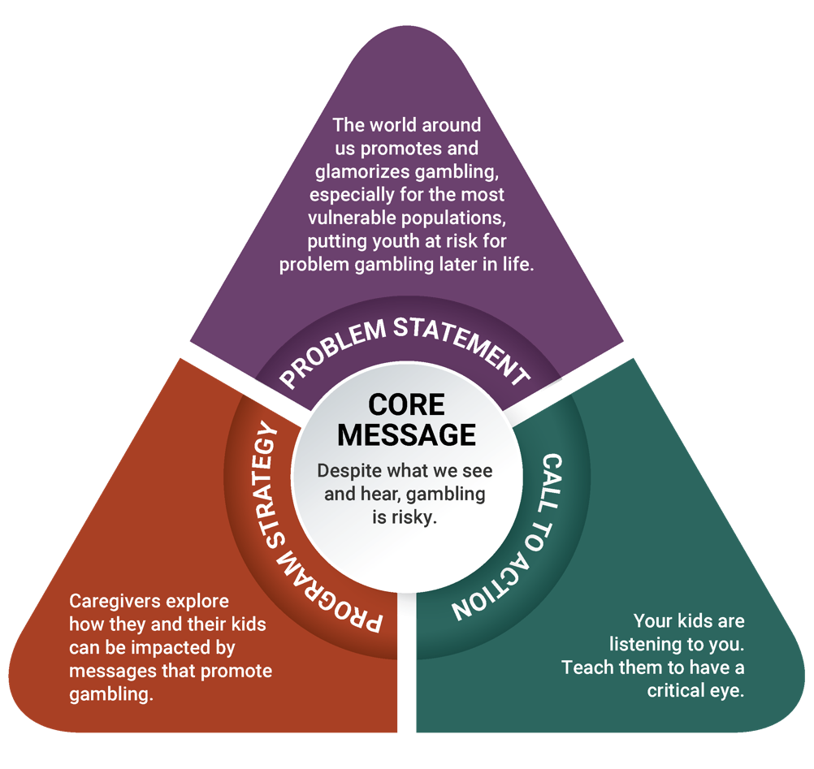

Prevention Strategy
Based on the significant value of youth’s insights and experiences, and the opportunity for youth to play an active role in assessing their community’s strengths and needs, the photovoice approach that is being used in the Plainville/Southeastern Massachusetts region and the Springfield/Western Massachusetts region will also be appropriate for use in this region. (A full discussion of the process for arriving at this strategy is included in the full report; see page 36).
Photovoice is an approach to community change-making that places youth, particularly those who experiences disparities and inequitable balances of power, at the center of community change. As a strategy, photovoice involves youth taking photographs that record and reflect their community’s strengths and concerns, engaging in group-based critical dialogue about important community issues, and presenting their findings and experiences externally to the broader community. Beyond impacting community members who participate in the photovoice process, this approach can also reach policymakers and other key stakeholders who do not participate actively in the photography and discussion process.^{xi}
Despite the use of the same strategy as in the Plainville/Southeastern Massachusetts region and the Springfield/Western Massachusetts region, photovoice in the Everett area has differences that set it apart from the others. In Everett and the surrounding communities, the objectives of the youth photovoice project are to:
- increase youth’s recognition of the risks of gambling
- increase youth’s awareness about the level of exposure to gambling in everyday life
- increase youth’s perception of the harm of gambling
- increase youth’s sense of empowerment to have a voice on community issues
Youth will first learn about gambling, ethics in photography, technical photography skills, and visual literacy.^{xii} After individually taking photographs based on a prompt, youth will discuss photographs as a group (including their thoughts, feelings, and assessments about gambling in their community). The photography and discussions will culminate in a community exhibition, during which youth will present their photographs, findings, thoughts, and feelings.
Backed by the understanding that caregivers have a significant influence over youth behavior, the caregiver strategy is connected to the youth’s photovoice project. The objectives of the caregiver strategy are to:
- increase caregivers’ awareness of what gambling is and its presence in youth’s everyday lives
- increase caregivers’ understanding of youth brain development, executive functioning, and self-regulation
- increase intentions to talk to youth about gambling
- increase caregivers’ perception of effectiveness when talking to youth about gambling
Caregivers will participate in one session, during which they will hear youth present some of their photographs and then discuss underage gambling broadly and the ways to prevent it. The gambling prevention education topics will include what gambling is and what types exist, the importance of showing disapproval of underage gambling and how to do so, and ways in which caregivers can support youth in managing their emotions and behaviors.

Regional Comparison: Prevention Strategy for Youth and Caregivers
The photovoice methodology was also recommended in the Springfield/Western Massachusetts region and the Plainville/Southeastern Massachusetts region. Being a participatory strategy that allows for adaptation based on community needs and experiences, photovoice is easily tailored to suit the needs of participants from the Everett area. The primary difference between each iteration of photovoice is in the objectives intended for each region.
In this region, the objectives of photovoice for youth are related to recognizing their exposure to gambling and understanding its risks, and ultimately increasing their sense of empowerment to have a voice on issues in their community. The conversations inherent to the participatory nature of photovoice will allow youth to engage in community issues through photography, learn about gambling, and gain skills in being advocates for their community.
Similarly, photovoice in the Springfield/Western Massachusetts region has objectives for youth that are related to increasing their perception of harm of gambling and their critical thinking skills to navigate pressures to gamble. Youth in the Springfield/Western Massachusetts region have a lot of exposure to gambling and cited money as a reason for, and a benefit of, gambling : “If you came from nothing and you’re broke, and you put in $20 and won $500, you won $480—that’s great.” Similarly, the photovoice project in Region B will engage youth in community issues through photography and educate them about underage gambling, and it will also support them in developing the ability to think critically about the messages around them.
In contrast, in the Plainville/Southeastern Massachusetts region, the objectives for youth are related to increasing their awareness about gambling exposure and increasing their perception of harm of underage gambling. Youth in the Plainville/Southeastern Massachusetts region had limited direct experience of gambling. One youth reported that “People sometimes bet on fighting people. People get in a fight, and others bet on who will win. I see that on TV shows.” These youth also reported understanding that there can be harm involved in gambling: “It’s hyped up to be this great thing, with all the lights and stuff. When you take a step back and look at it objectively, you realize it’s not that great.” The photovoice project will help them make personal connections with the underage gambling around them through photography, and educate them about underage gambling and its risks.
The objectives for the caregiver component of photovoice in all regions also show parallels: in all regions, some objectives center on caregivers’ understanding of youth brain development and the vulnerability of youth in the face of risky behaviors. In the Plainville/Southeastern Massachusetts region, the photovoice component for caregivers was largely educational; in the Springfield/Western Massachusetts region there are educational components but the strategy stems beyond transfer of information: caregivers learn about the importance of underage gambling prevention, and also discuss and gain skills in talking to their children about gambling.

Knowledge, Attitudes, and Behaviors: Men in Recovery
Men in recovery in the Everett area described in detail their experiences with gambling, sometimes in connection to use or misuse of other substances, which they believe to be similar to gambling. Men spoke about the myriad negative impacts of gambling that they or people they know have experienced, including loss of money, loss of judgment, and trouble with the law. Despite this, the men in focus groups explained a number of reasons that people may gamble, including traditions of gambling in some cultures, superstition, the chance of winning, and financial necessity. In all, men were excited to share personal experiences and prevention strategies with others. These ideas and motivations led to the creation of a message triangle for men of color with a history of substance misuse.
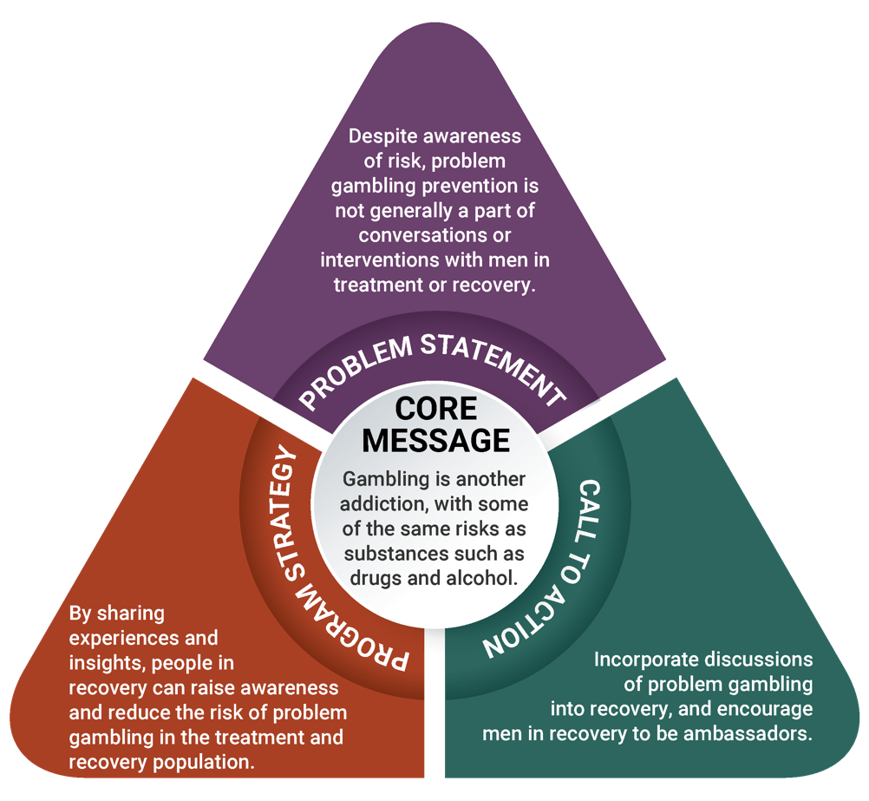

Prevention Strategy
Based on these messages and the culture of recovery support centers, which promote peer leadership and peer support, the ambassador strategy is recommended for men of color with a history of substance misuse. (A full discussion of the process for arriving at this strategy is included in the full report; see page 43). This strategy stems from the participatory process model that is used in the 10 DPH-funded recovery centers across Massachusetts.^{xiii} This model requires that people engage one another through lived experience, accept all paths to recovery, and empower peers to become productive members of society.
The objectives of the ambassador strategy are to:
- increase understanding of the connections between gambling and other addictions
- increase awareness of what gambling is and where it is present in everyday life
- increase perception of risk of developing a gambling disorder when one has experienced a substance use disorder
- increase self-efficacy to facilitate discussions about gambling with peers
Ambassadors, typically select members of recovery centers, will learn about all aspects of gambling (e.g., definitions, examples, how gambling can impact recovery), research on who is most at risk for problem gambling, and the importance of addressing health inequities. Ambassadors will then strengthen their group facilitation skills, and lead both individual and group interactions that focus on gambling and prevention. Individual interactions include speaking with someone at a recovery center, on the street, or during a private conversation at a program run by the center; group interactions may occur at the recovery centers or partner organizations that serve populations at high risk and who request peer gambling prevention groups or presentations.
In addition, recovery support providers will establish systems for supervision so that both ambassadors and supervisors can benefit from it, and so that recovery centers can build capacity to manage peer gambling prevention services and promote a gambling-free culture.

Regional Comparison: Prevention Strategy for Men of Color with a History of Substance Misuse
The ambassador project uses a participatory peer education model that can easily be adapted across regions, populations, and community concerns. As a result, it has been recommended as a strategy for men of color with a history of substance misuse across the state.
As previously described, the ambassador strategy has objectives that are centered on increasing understanding of gambling’s connections to other behavioral health disorders, increasing the perception of risk related to gambling, and increasing ambassadors’ self-efficacy to facilitate conversations about gambling with their peers. In the Everett area, men in recovery understood the close connections between gambling and substance use, and reported on the risks that gambling poses after experiencing a substance use disorder: “It becomes an addition like the heroin, the cocaine, and the crack. These are habits that are not easy to stop. You start, but you don’t know how to stop. You create a dependency. You can end up in jail due to this dependency you create.” Men in the Springfield/Western Massachusetts region spoke similarly about this connection, saying that “You exchange one for the other. If you want to stop getting high, you go to gambling to think it’s going to be a quick fix. You start gambling, start feeling the same state of thought. When you feel depressed with one, you go back to the other hoping for a benefit from one.” There are parallels with men in recovery in the Plainville/Southeastern Massachusetts region as well. These men spoke clearly about the connections between substance use and gambling as well: “It goes hand in hand because it’s obsession and compulsion. Personally, I don’t know anyone who just gambles. And where I come from, I don’t know anyone who just uses. We all gambled, even in active addiction.” The ambassador strategy builds on this knowledge, sharpens ambassadors’ leadership skills, and encourages them to use their experience to teach other men with substance use disorders about the risks of gambling.
A benefit of their past participation in treatment programs and current membership in recovery centers, individuals in recovery have a vast understanding of substance use disorders. This strategy in all three regions aims to support ambassadors in expanding the conversation on substance use disorders by incorporating problem gambling into it, and in increasing their capacity to have conversations about gambling with their peers.
The largest difference across regions is in the demographics. In the Springfield area there are many places and opportunities to reach men of color, as the majority of Springfield residents are people of color. It may be more of a challenge to reach men of color in the other regions, as these regions’ demographics show primarily white residents. Specifically, the Plainville/Southeastern Massachusetts region is predominantly white, with at least 89% white residents, and the Everett area has an
approximately equal makeup of white residents and residents of color. These demographics may mean that implementing the ambassador strategy with men of color may be more of a challenge in the Plainville/Southeastern Massachusetts region and the Everett area. As a result, a more focused means of reaching participants may be needed. Some examples of where to reach men of color include substance use treatment facilities, shelters, houses of corrections, and community-based organizations. Additionally, in these regions, once the priority population in systems and programs has been reached, outreach may have to begin on the streets, in barber shops, and at social gatherings and homes. This will allow ambassadors to reach the priority population where they are.

Implications and Recommendations
This regional planning process may have a variety of implications for the Everett region and for the state of Massachusetts as a whole. Below are implications of the assessment process findings, aside from those that directly informed the strategies proposed in this report, along with recommendations to DPH and the Office of Problem Gambling Services for ways to continue to support problem gambling prevention beyond the scope of this planning process.

Implication 1
Youth in focus groups had knowledge of gambling, its impacts on their community, and their lack of power as minority youth. The youth programs they participate in provide them with a foundation in substance use prevention and social justice.
Recommendation: Promote opportunities for youth to learn about the intersection of various types of public health prevention (including gambling prevention) and social justice, so that they can develop a broad understanding of their communities’ needs and feel empowered to make choices for themselves and to participate in making changes in their communities.

Implication 2
In focus groups, few caregivers reported explicitly talking to their children about underage gambling, despite reporting awareness of their children’s participation in gambling.
Recommendation: Create a communications campaign and educational materials for caregivers on how to support youth in becoming healthy adults.

Implication 3
Youth discussed having easy access to gambling through family, community members, and strangers.
Recommendation: Encourage local organizations and partners to decrease social access to gambling for youth in the region through policies and organizational practices.

Implication 4
In focus groups, men in recovery described problem gambling as another addiction. Men in recovery have a unique experience that allows them to connect substance misuse and problem gambling.
Recommendation: Provide opportunities for men in recovery to inform policies and initiatives that make connections between substance misuse and problem gambling.

Implication 5
Many adult participants in focus groups reported gambling for financial reasons; the economic profile of Everett confirms the challenges of the area. Focus group participants also reported being concerned about increasing prices in the community. Baseline results from the SEIGMA study report that financial stress puts individuals at higher risk for problem gambling.
Recommendation: Provide financial support and resources to communities to manage financial stress, particularly in the face of increasing cost of living. This may have both direct impacts on improving residents’ quality of life and broad impacts on increasing protective factors to prevent problem gambling.

Implication 6
In general, adult and youth participants had limited information about risk factors, impacts, and the progression of problem gambling. Immigrants, particularly those who do not speak English, may have even more difficulty obtaining information. All residents in the region should be able to access education about gambling prevention and gambling-related services within their local community.
Recommendation: Create local, community-based, and accessible spaces where people can access culturally relevant education about gambling prevention and gambling-related services in their own languages.

Implication 7
Overall, providers seem to hold negative attitudes about gambling, people in recovery seem to hold negative or neutral attitudes, and the community as a whole seems to hold positive attitudes. In general, understanding about gambling is limited, and different groups, sectors, and stakeholders can help broaden this conversation.
Recommendation: Actively involve a variety of stakeholders in strategy design and dissemination, and find ways to broaden the conversation to extend beyond the potential positive impacts of casinos.

Implication 8
A health equity lens throughout this regional planning process helped identify populations who are most impacted by these issues and ensured that these groups informed the data gathered in this assessment. Using a health equity lens is important to understand the realities and nuances of gambling and problem gambling across Massachusetts.
Recommendation: Continue to assess the health and racial disparities in areas where gambling increases, and include the people who are experiencing the most significant disparities.

Implication 9
In the Everett area, stakeholders and key informants shared their thoughts about the populations they are most concerned about in terms of problem gambling, particularly in light of the opening of the Encore Boston Harbor casino. Two new populations that emerged from these conversations are older adults and individuals with a history of incarceration.
Recommendation: Explore how older adults and individuals with a history of incarceration are impacted by problem gambling, and provide opportunities to engage them in prevention strategies.

Executive Summary: End Notes
- Massachusetts Gaming Commission. (2018). Surrounding community & related agreements. Retrieved from https://massgaming.com/about/community-mitigation-fund/host-surrounding-communities/surrounding-community-agreements/
- Massachusetts Technical Assistance Partnership for Prevention. (2016). Strategic plan: Services to mitigate the harms associated with gambling in Massachusetts. Waltham, MA: EDC. Funded by the Bureau of Substance Addiction Services. Retrieved from http://www.mass.gov/eohhs/docs/dph/com-health/problem-gambling-strategic-plan.pdf
- This strategy was later broadened to include all types of primary guardians, or “caregivers.”
- Kessler, R. C., Hwang, I., LaBrie, R., Petukhova, M., Sampson, N. A., Winters, K. C., & Shaffer, H. J. (2008). The prevalence and correlates of DSM-IV pathological gambling in the National Comorbidity Survey Replication. Psychological Medicine, 38(9), 1351–1360.
- Work Group for Community Health and Development. (2016). Section 3. Identifying Targets and Agents of Change: Who Can Benefit and Who Can Help. In Community Tool Box. Retrieved from http://ctb.ku.edu/en/table-of-contents/analyze/where-to-start/identify-targets-and-agents-of-change/main
- Johansson, A., Grant, J. E., Kim, S. W., Odlaug, B. L., & Götestam, K. G. (2009). Risk factors for problematic gambling: A critical literature review. Journal of Gambling Studies, 25, 67–92.
- Petry, N. M., Stinson, F. S., & Grant, B. F. (2005). Comorbidity of DSM-IV pathological gambling and other psychiatric disorders: Results from the National Epidemiologic Survey on Alcohol and Related Conditions. Journal of Clinical Psychiatry, 66, 564–574.
- Volberg, R. A., Williams, R. J., Stanek, E. J., Houpt, K. A., Zorn, M., & Rodriguez-Monguio, R. (2017). Gambling and problem gambling in Massachusetts: Results of a baseline population survey. Amherst, MA: School of Public Health and Health Sciences, University of Massachusetts Amherst.
- Bronson, J., Stroop, J., Zimmer, S., & Berzofsky, M. (2017). Drug use, dependence, and abuse among state prisoners and jail inmates, 2007-2009. Washington, DC: Bureau of Justice Statistics. Retrieved from https://www.bjs.gov/content/pub/pdf/dudaspji0709.pdf
- Minton, T. D., & Zeng, Z. (2016). Jail inmates in 2015. Report prepared for the Office of Justice Programs, U.S. Department of Justice. Retrieved from https://www.bjs.gov/content/pub/pdf/ji15.pdf
- Wang, C., & Burris, M. (1997). PhotoVoice: Concept, methodology, and use for participatory needs assessment. Health Education and Behavior, 24(3), 369–387.
- Rutgers. (2018). Facilitator’s guide. Retrieved from https://www.rutgers.international/our-products/tools/photovoice/facilitators-guide#Presentations
- The Massachusetts Substance Use Helpline. (2016, December 29). Paths to recovery: Recovery coaches. Retrieved from https://helplinema.org/2016/12/29/paths-to-recovery-recovery-coaches/

Introduction
Detailed in this report is a regional planning process for the prevention of problem gambling that was carried out by the Massachusetts Technical Assistance Partnership for Prevention (MassTAPP) at Education Development Center, Inc. (EDC). The regional planning process was funded by the Massachusetts Department of Public Health (DPH) and focused on the city of Everett, where the Encore Boston Harbor casino is scheduled to open in 2019, and its surrounding communities.
After the Public Health Trust Fund Executive Committee adopted the Strategic Plan: Services to Mitigate the Harms Associated with Gambling in Massachusetts¹ (the statewide Strategic Plan) in April 2016, two of the plan’s key recommendations were operationalized:
- Reach youth and parents with appropriate prevention messaging, and enhance environmental strategies to increase protective factors and decrease risk factors²
- Develop and distribute culturally appropriate campaigns and services for high-risk populations
A parallel planning process was conducted for each recommendation, in order to develop prevention strategies that are both culturally appropriate and take into account the principles of health equity. The stages of this regional planning process are outlined below:
- Stage 1: A review of local demographics
- Stage 2: Community outreach and identification of key stakeholders
- Stage 3: Convening and facilitation of a regional stakeholder meeting
- Stage 4: Identification of community assets and local resources
- Stage 5: Key informant interviews with individuals who understand and/or may influence the behavior of these populations
- Stage 6: Focus groups with priority populations
- Stage 7: Development of messages and prevention strategies
This report describes the regional and community assessment process used in this region, along with a summary of data collected from priority populations, a description of the proposed prevention strategies, and implications of the work.
Similar regional planning processes in the Plainville/Southeastern Massachusetts (Region C) and the Springfield/Western Massachusetts region (Region B) were conducted in 2017 and 2018, respectively. The first regional planning process yielded multiple lessons: build and establish partnerships early; provide a timeline and clear expectations to partners and identify communication channels; ensure that information and referral sources are available to all partners and participants; and ensure inclusion of participants from a wide range of backgrounds. These lessons were priorities in this regional planning process, and the differences between the three regions were noted and considered throughout the process. Building upon the lessons learned, MassTAPP communicated with key individuals and organizations throughout the process, informed partners of next steps and expected timelines, and invited and included a wide range of participants in meetings, interviews, and focus groups. Involving a diverse array of participants was important in this regional planning process, given the diversity of Everett. Everett is a city whose residents are about 50% people of color, and about 50% people who speak a non-English language at home (most commonly Spanish, Portuguese, and French Creole). Many of Everett’s residents also experience health- and income-related challenges.
Considering these aspects of the area, this regional planning process included connecting with multiple community organizations that work towards building equity in health and income, and engaging primarily people of color. This regional planning process shows a significant increase in engagement of people of color over the first region, where primarily white community members were engaged. In the Everett area, 88 community members were engaged, a majority of whom are people of color (80 community members participated in key informant interviews and focus groups, and 8 community members attended a community meeting). This engagement allowed for a fuller understanding of community issues and resources, a more accurate representation of the community, and a greater potential for future sustainability of prevention strategies.

Health Equity
The concept of equity means that everyone has the ability to reach their highest level of health.3 Equity goes beyond providing access to health care for all individuals and communities; it suggests allocating resources in a way that supports people in reaching the same, optimal outcomes. It also demands a recognition of the inequities and obstacles faced by some (including poverty, discrimination, and disparities in housing, education, and economic opportunity) and a willingness to address these issues and knock down these barriers. Most importantly, equity can only be achieved when the values and priorities of the populations most impacted by an issue, such as problem gambling, are integrated into planning and decision-making.
Decreasing health inequities, or the disparities in health that some individuals or communities face that is closely linked with social, economic, and/or environmental disadvantage, supports building equity. Disparities often build upon each other, with each additional barrier to health amplifying the effects on an individual or community beyond the effects of a single barrier. This compounding effect speaks to the concept of intersectionality.
Sustainable community engagement also builds health equity. It occurs when community members feel empowered to advocate for the change they want to see in their community. Engaging the community honors residents, supports assessment, strengthens capacity, enhances the effectiveness of interventions, and promotes sustainability. Communities know what needs, resources, and readiness their neighborhoods need most, and they are best positioned to identify networks, resources, and strategies to reach priority populations.

Community Profile
This report focuses on Everett and its surrounding communities in Eastern Massachusetts, particularly those cities and towns with which Everett has a Surrounding Community Agreement related to the establishment of the Encore Boston Harbor casino (Boston, Cambridge, Lynn, Malden, Medford, Melrose, and Somerville.)⁴ Most of this regional planning process took place in Everett, as the goal of this assessment is to understand the subjective experiences and concerns of communities that undergo the effects of expanded gaming in their area. The methodology used in this assessment – namely, qualitative interviews and focus groups – lends itself to focusing deeply on individual perspectives. Yet, this type of concentrated engagement has challenges in assessing an entire region with accuracy and fidelity. The community profile below and the majority of this report focuses on Everett, but many of the assessments and recommendations documented throughout this report may also be relevant to other communities that have Surrounding Community Agreements with Everett and are likely to be impacted by the casino.
Everett, Massachusetts, is located in Middlesex County, the most populous county in New England.⁵ As of 2017, Everett is estimated to have a population of 46,324, with females comprising 51.5% of the residents.⁶ The median age of Everett residents is 34.9 years old, with 34% of the population under age 24, similar to 32% for Massachusetts as a whole (32%).⁷ The city of Everett is relatively diverse despite a white majority, with slightly over half the population identifying as non-white. According to the U.S. Census Bureau, Everett is a majority white community, with 48% of residents identifying as white, non-Hispanic or Latino; 21.9% as Hispanic or Latino; 19.7% as Black or African American; 6.9% as Asian; 0.3% as American Indian or Alaska Native; and 5.1% reporting two or more races.⁸
About half the population of Everett speaks a non-English language at home, which far exceeds the national average of 21.1%.⁸ The most common non-English language spoken in Everett is Spanish, which in 2015 was spoken by 17.5% of residents, followed by Portuguese (14.6%) and French Creole (9.3%).⁸ Compared to the national average of 93%, 75.8% of residents are U.S. citizens. Foreign-born residents are most likely to have roots in Brazil, El Salvador, and Haiti. Key informants who contributed to an understanding of Everett’s profile said that families have outreach from community centers and schools and that some organizations focus specifically on immigration and health within immigrant communities. Some key informants emphasized the need to go into the community to engage people who may not otherwise be at the table, and described knowing of some outreach that occurs in laundromats, bodegas, and parks—in other words, in areas that may not be the traditional locations for prevention or health outreach.
Educational levels in Everett are lower than that in the state overall, with an estimated 80.8% of Everett residents having at least a high school degree, compared to 90.1% at the state level.⁹ In the past five years, high school graduation rates in Everett have mostly remained steady, ranging from 75.4% in 2012 to 79.6% in 2013. In 2017, 77.5% of seniors graduated from high school.
The median income of Everett residents is $52,457,¹⁰ which trails national ($55,322), state ($70,954), and county ($89,019) figures.⁸ As of 2016, Everett’s unemployment rate of 6.6% exceeded state (4.6%) and national (4.7%) levels.⁸ Health care and social assistance, retail trade, and accommodation and food service are the most popular employment sectors.6 Key informants described some programs and services in the area that may have impacts on educational and economic outcomes. Some groups provide job search outreach, advocacy to connect Everett residents to promising jobs, and youth development opportunities. The youth development opportunities include teen health ambassador programs with policy and advocacy components, youth groups learning about and opposing substance use, peer-to-peer outreach, interactive financial literacy and future planning trainings, and female-specific health groups.
Everett’s poverty rate of 14.6% includes the 27.9% of children under age 5 who live under the poverty line, along with 20.3% of Hispanic or Latino residents and 13.8% of Black or African American residents.⁸ This reflects the need for a deep assessment of the demographics of Everett’s sub-groups as compared to a broad look at Everett’s average statistics.
Substance misuse rates also have strong associations with crime, depression, poverty, and poor health. In 2008, 29% of Everett adults self-identified as current smokers, nearly double the state rate of 15%.⁸ In addition to high tobacco use, among the individuals seeking substance misuse treatment in 2014, the majority (65.3%) reported heroin as their primary drug, with alcohol a distant second at 23.1%.¹¹ Although rates of alcohol treatment have slightly declined since 2005, heroin treatment rates have climbed more than 15%.11 Most commonly, those seeking treatment for substance use in Everett are male (67.1%), white (81.4%), unemployed (81.0%), and not homeless (81.6%), and they have no history of prior mental health treatment (60.8%).¹¹ This does not necessarily suggest that these individuals are at highest need; rather, it may simply suggest greater access to treatment by people who match the aforementioned demographics.
Fortunately, there are organizations in the Everett area that are committed to combating these economic and health inequities and to creating lasting, positive impacts on the community. In their 2014 Everett Health Assessment Report, the Everett Community Health Partnership highlights a number of community assets that contribute positively to social determinants of health, including support for education opportunities ranging from pre-K to adult education, public and private employment and professional development initiatives, resources for accessing affordable housing, investment in the natural and built environment, and vibrant religious institutions, especially among immigrant-groups.¹² Specifically, key informants interviewed as part of this regional planning process identified other organizations, programs, and individuals that are impacting the community. These included programs for seniors on “aging wisely,” collaborations with and presentations by health centers, and community-building activities for people in recovery and their families. Notably, key informants also mentioned knowing about campaigns that seek to support people in preventing problem gambling, recovery center-housed groups and events that increase access to resources about gambling, and attempts to incorporate gambling into conversations on recovery.

Outreach and Network Building
In the Everett area, the community outreach process began with the creation of eight broad categories of sectors that serve the region: treatment/prevention/recovery, community-based organizations, health, education, criminal justice, mental health, faith-based organizations, and workforce development. This categorization ensured that organizations and key contacts in the region would be invited to the table to provide input on problem gambling prevention efforts in the region. Specific individuals and organizations were added to each category through the expertise, connections, and research of two MassTAPP staff who have extensive experience in community-level prevention across the state.
The list of contacts significantly expanded after further research on other organizations, as well as conversations with leaders and stakeholders in the region who recommended other key contacts for further outreach. Initial contact occurred through phone or email, and a scheduled network-building conversation followed each phone or email contact. These conversations also served to inform stakeholders about MassTAPP’s regional planning and community engagement process.

Stakeholder Meeting
This categorized list of stakeholders and organizations was used to broaden the conversation across the region and to connect with regional stakeholders. Direct contact through email and phone was made with over 80 stakeholders to invite them to a preliminary meeting in Everett at the end of 2017 to discuss the issue of problem gambling and to explore the ways in which it affects Everett and its surrounding communities. Invitees included coordinators of substance use prevention coalitions, directors and staff of community-based organizations, directors and staff of afterschool programs and organizations, directors of recovery centers and career centers, leaders of faith-based organizations, and mental health providers who serve the Everett area. Invitees were free to share the invitation to this stakeholder meeting with their networks. Eight people attended this meeting. This number demonstrates the need for community engagement in this area.
Attendees provided input that directly informed the direction of the regional planning process, particularly in terms of community context and concerns, populations at high risk for problem gambling, and prevention strategies that could be effective. Specifically, attendees discussed their thoughts on the following questions:
- Is problem gambling a topic of concern or discussion among residents of Everett and surrounding communities?
- Where do you see gambling in the communities in which you work and live?
- What groups seem to be at risk for problem gambling?
- Who is engaged in the prevention of problem gambling, and is there overlap with those involved in substance use prevention?
- Which groups could most benefit from prevention efforts?
- How (if at all) are data about gambling being collected?
These guiding questions, paired with the unique perspectives and backgrounds of attendees, encouraged extensive conversation on the particular history and needs of the Everett area. A few topics that were particularly relevant to this assessment are the lack of conversation and concern about gambling, the potential changes in Everett’s demographics due to the casino opening and housing cost increases, and the easy access to casino gambling via public transportation. Attendees also discussed populations who may be most impacted by expanded gaming, including seniors, people who have other substance use or psychiatric disorders, and people recently released from jail who lack the support of re-entry programs. Youth were not identified as a population that may be most impacted, but stakeholders’ responses did directly inform the selection of a second priority population. The conversation around populations of need, combined with data from the SEIGMA study,¹⁷ supported defining this second priority population as men of color who have a history of substance misuse. The comments and concerns of stakeholders also reaffirmed the need to approach problem gambling prevention through a lens of health equity, and with an understanding of specific community dynamics.

Key Informant Interviews
Eleven key informant interviews were conducted via face-to-face meetings or phone conversations. These interviews were conducted to gain knowledge of the local landscape in terms of gambling behaviors, co-occurrence of gambling and substance use and/or mental health disorders, geographic regions and sub-populations experiencing health inequities, and available services.
Key informants were selected based on suggestions from stakeholders, who shared which community experts’ input would be the particularly important for a comprehensive assessment of the region. Through this process, names of certain individuals emerged multiple times as key leaders in the region; these individuals were interviewed as key informants. All key informants interviewed are well-informed, well-connected members of the community who have expertise in community issues and how to address them. These individuals have vast knowledge about the community, both through their residence in the community itself and through their work with marginalized populations. These backgrounds enabled them to speak simultaneously from the perspective of a community member and a provider serving a population (or multiple populations) that experience(s) health inequities. During this regional planning process, key informant interviews were semi-structured (see Appendix A for core questions) so that key informants could share about the gambling-related attitudes, beliefs, and experiences of marginalized populations, and the community contexts in which they live and work. Key informants agreed that populations at high risk for problem gambling included people of color, people with a history of substance misuse, and men.

Priority Populations

Youth and Caregivers
Youth who begin gambling early in life are more likely to experience problem gambling later in life.¹³ Based on this, youth ages 12–18 were identified as the “targets of change”¹⁴ for this prevention strategy. Research also shows that youth are less likely to experience problem gambling if they have protective factors in their lives, such as strong family support and realistic boundaries and expectations, which buffer the risks of developing problems with alcohol and other substances.¹⁵ Therefore, caregivers of adolescents were identified as “agents of change”⁴ and an audience for gambling prevention messages and strategies.

Men of Color Who Have a History of Substance Misuse
Men of color who have a history of substance misuse were selected as a priority population at high risk for problem gambling through conversation around populations of need with both key informants and stakeholders, along with data from the SEIGMA study.⁸ Research has indicated that men are at higher risk than the general population for problem gambling,¹⁶ as are people of color¹⁵ and people with a history of substance misuse.¹⁵ Based on these demographic categories, conversations with key stakeholders in the region, and the availability and readiness of treatment and recovery support providers to incorporate messages about gambling into their services, the priority population for this strategy was defined as men of color who have a history of substance misuse. Each individual characteristic (being male, being a person of color, and having a history of substance misuse) suggests an inequity in problem gambling rates; taken together, these characteristics amplify one another and create a compounding effect. This priority population matches results from the Social and Economic Impacts of Gambling in Massachusetts (SEIGMA) study, which shows significantly higher problem gambling rates among men compared to women, and among Black adults compared to white adults in Massachusetts.¹⁷ This research also indicates that adults who engage in problem gambling are significantly more likely to have engaged in binge drinking in the past month compared to adults who gamble recreationally.¹⁷ Additionally, men of color who have a history of substance misuse are at incredibly higher risk for being held in jail or prison. Not only do more than half of individuals in jail and prison have substance use disorders (64% in 2006),¹⁸ but people in jail and prison are also disproportionately people of color.¹⁹ These statistics amplify the adverse experiences that men of color who have a history of substance misuse already experience. In this regional planning process, these statistics were supported by comments from men in recovery who participated in focus group, who spoke often about jail and prison, indicating a great need for prevention strategies for both problem gambling and the consequences of substance misuse.

Data Collection
Following the key informant interview process, focus groups with members of both priority populations (youth and caregivers, and men of color who have a history of substance misuse) occurred. MassTAPP staff who have experience in community-based engagement connected with community organizations in the region that serve that serve populations that experience inequities. Organizations were offered a stipend to recruit for and host focus groups using the methods they have previously found successful. MassTAPP facilitated the focus groups, provided consent forms, and provided stipends to participants.
Eighty people participated in the data collection process, either as key informants or focus group participants, enabling a deeper understanding of the priority populations who would receive prevention messaging. In addition to learning from priority populations and the people who work with them, the high percentage of Everett’s speakers of non-English languages at home (about half of Everett’s population) made clear the need for conducting assessments and providing prevention services in at least one non-English language.⁸ Approximately 17.5% of Everett’s residents speak Spanish, so two focus groups were conducted in Spanish to learn from Spanish speakers who live in the region but may not speak English.⁸ These focus groups were supported by note-taking and translation help from consultants. (See Appendix A for key informant interview and focus group questions in English and Spanish.)
Key Informants
- Eleven key informants participated in individual interviews. All key informants interviewed are well-informed, well-connected members of the community who have expertise in community issues and how to address them.
Youth and Caregivers
- Sixteen youth participated in two focus groups (held at the Cambridge Health Alliance Everett Care Center in Everett and at Maverick Landing in East Boston). One youth leader participated in a key informant interview; this youth leader’s interview was analyzed with other youth data.
  - Race/ethnicity: 35% Latino, 24% Black, 6% Asian, 35% unknown
  - Gender: 53% female, 12% male, 35% unknown
  - City of residence: 35% Everett, 29% Boston, 35% unknown
  - Average age: 15.5
- Eleven caregivers participated in two focus groups (held at Parenting Journey in Somerville and La Comunidad in Everett). One focus group was conducted in Spanish. This ensured that Spanish speakers who do not speak English have equitable access to participate in the prevention initiative design.
  - Race/ethnicity: 73% Latino, 18% Black, 9% white
  - Gender: 91% female, 9% male
  - City of residence: 73% Everett, 9% Somerville, 9% Boston, 9% Chelsea
  - Average age: 54.6
Men of Color Who Have a History of Substance Misuse
- Forty-one men in recovery participated in three focus groups (held at the Boston Public Health Commission Engagement Center in Boston, Boston Public Health Commission Safe & Sound Recovery Center in Boston, and STEPRox Recovery Support Center in Boston)*. One of these focus groups was conducted in Spanish, to ensure equitable access to participate in the prevention initiative design.
  - Race/ethnicity: 66% Black, 32% Latino, 2% biracial
  - Gender: 100% male
  - City of residence: 93% Boston, 5% Weymouth, 2% Quincy (*there is a lack of recovery centers in Everett, and men interviewed were members of recovery centers based in Boston)
  - Average age: 52.3

Data Analysis
A rigorous analysis of the data gathered from key informant interviews and focus groups was completed using thematic analysis, a widely used qualitative research method that allows people to make sense of large amounts of data from sources such as interviews and focus groups, to ultimately understand the perspectives of different participants, note similarities and differences, and shed light on unexpected concepts.²⁰
Data analysis using this method includes the core phases of familiarizing oneself with the data, generating initial codes, searching for themes, reviewing themes, defining and naming themes, and producing a report; however, these steps are not necessarily linear, and instead are components of an iterative process that requires occasionally returning to an earlier step.²¹
Thematic analysis for the purposes of strategy design in this regional planning process first required a separation of data into categories relevant for each main priority population (youth and caregivers, and men of color who have a history of substance misuse). Data were further separated into the following categories: youth, caregivers, men in recovery, and key informants. This categorization allowed for the comparison between people with similar backgrounds (such as age or experience with substance use), and also enabled the merging of data at a later time, if the need arises (as data are easier to combine from distinct parts than to separate once they are combined).
These methods were applied across all three regions of Massachusetts to ensure consistency in data analysis. In the regional planning process for the Plainville/Southeastern Massachusetts region, multiple themes were generated that served as a base for analyzing data from the Everett region.²² Based on other ideas shared by interview and focus group participants, other themes were added and then reviewed to see if any could be combined, re-named, or clarified. Next, familiarization with the themes and establishment of a clear definition for each theme was necessary to analyze the data consistently across documents and for reliable analysis. One step that was added beyond the core phases of thematic analysis mentioned above was writing brief summaries of each theme that included key illustrative quotations from the data; this step could be considered part of the report-writing phase. This detailed analysis process, and the resulting analyses described below, informed the development of messaging and prevention strategies tailored to each priority population.

Results: Gambling Knowledge, Attitudes, and Behaviors

Summary of Data Gathered from Youth
Among this group, youth described a large amount of exposure to gambling, most commonly through their environment and through family members.
- “I see gambling everywhere at my school, especially betting on sports and games.”
- “I see a lot of older people when I go to the store. They buy a lot of scratch tickets and lottery tickets. People from their 20s to 60s. When they get something to eat, they buy a lot of scratch tickets.”
- “My mom gets the lottery ticket once a day, and I know a lot of people are doing that too. I think it’s part of the everyday life.”
- “You can’t just say ‘a certain person’—a lot of people do it.”
Despite having significant exposure to gambling, most youth said that they do not personally participate, although some youth mentioned that gambling would be easy for them to access if they were interested in it.
- “[Some] gambling is as simple as, how about whoever talks to the other person first will get $20 dollars. I have actually won $20 like that.”
- “The Super Bowl . . . and yeah, I put in a bet . . . That was my first time.”
- “I don’t see a lot of betting with youth.”
- “You could [play the slot machines] easily.”
- “There are [youth] that I know that paid homeless people to get them scratch tickets or alcohol.”
Attitudes about gambling were mixed and fell primarily into three categories: positive, negative, and attitudes that depend on factors such as legality, context, what you learn, and types of gambling.
- “I heard about something to do with that casino. They said that if the mayor was there and a few other people, they’ll be doing something that gives back to the community.”
- “I would promote it, but I would tell people not to spend all of their money.”
- “I think it’s hypocritical to have illegal gambling. People try to justify it as illegal and legal.”
- “In school they make it try to seem innocent. They try to teach you at a young age how to gamble.”
- “I don’t support casinos, while revenue is good. But it’s risky business . . . it becomes something that you become accustomed to; it’s dangerous for a lot of people.”
Youth described various benefits of gambling, including winning money, benefits to the community, learning skills, fun, and reputation.
- “It’s cool to be rich, and everyone has their own thing.”
- “Revenue—there are agreements with cities and towns to get revenue.”
- “You get better. You learn strategy.”
Youth also spoke about multiple risks of gambling, including danger or violence, physical and mental health, and loss of money. However, only two youth spoke about the consequences that people close to them have faced.
- “People use the wrong money that they need to survive to gamble. They end up homeless and not able to support their families.”
- “When I think of the illegal, I think of thugs and mafia people, people dying . . . If you gamble and owe money to people with lots of power, it can be your life. You’re putting your family and friends at risk.”
- “It’s like a drug. You waste your money on it over and over. Like buying it more and more.”
- “My friend almost got shot because he won a game of blackjack.”
A few of the youth interviewed advocated for listening to the voices that are not commonly heard. They expressed concerns that members of demographic groups they are a part of (namely, youth and people of color) often do not have a chance to speak up or speak out.
- “Families of minorities are affected.”
- “It’s not good. A lot of bad things come out of gambling. I don’t think that stuff should be in our environment. We are all minorities, and we have so many problems in our community already. Why make those problems worse?”
- “Whoever gets this information, hopefully it impacts us positively, because us minorities we don’t have chances to speak up. We can’t vote against casinos and stuff like that. I think we should have those.”
- “Give us a voice, and don’t treat young adults and teenagers like kids.”

Regional Comparison: Data Gathered from Youth
Youth differed significantly between regions. In the Plainville/Southeastern Massachusetts region, youth had a distant understanding of gambling: they understood it as a theoretical concept, with some risks and similarities to substance use, but also some level of acceptability. They also believed that some gambling can be innocent or not harmful: “It can vary. I agree that it can be very bad, but also it can’t be that harmful sometimes. But it matters what you’re betting on or gambling on.” In the Springfield/Western Massachusetts region, many youth have witnessed gambling firsthand or have even participated in it themselves: “I see friends do it, grandparents, parents, aunts, I see my uncle do it a lot.” Youth in the Springfield/Western Massachusetts region have a much greater awareness of the risks of gambling, and some youth choose to refrain from it, while others keep the risks in mind: “It’s kind of like a video I was watching, gambling is kind of an odds factor. It leads to other violence and corruption in cities that casinos are at.”
Like youth from the Springfield/Western Massachusetts region, youth from the Everett area also referenced significant exposure to gambling; however, they said that they do not often participate. In contrast to youth in the Springfield/Western Massachusetts region, but similar to youth in the Plainville/Southeastern Massachusetts region, these youth focused more on the benefits of gambling than the risks, and believed that not all types of gambling can be harmful. These positive perspectives could be related to a few factors: the higher unemployment rates and lower educational levels in the area that may make gambling more enticing, the youth’s lack of seeing the negative effects of gambling firsthand despite seeing gambling around them, and the cultural roots of some residents that may be favorable to gambling.

Summary of Data Gathered from Caregivers
Caregivers also described multiple areas of exposure to gambling, including through their family (partners, siblings, and children), their community, and their own experiences.
- “I have a brother who is addicted to buying scratch tickets. You could give him a thousand dollars today, [and] he could spend it on scratch tickets. [It’s] depression. If he has money to buy them, he’s in a good mood, but if he doesn’t, he’s in a bad mood . . . We’ve been in counseling together as a family, and whenever that subject comes up, he gets explosive. No one wants to be caught on their addiction.”
- “For me it’s a touchy subject because I have a son who’s playing poker on a regular basis, because he says his job is now poker. As a mom it’s really killing me, I can’t see anything good coming from it.”
- “I work at a convenience store/gas station . . . I see this every day. I also see people at 5 in the morning spending a lot of money as soon as the machine goes on, but I like it because I get to talk to them.”
- “I gamble. I play scratch tickets. I’ve won. I know when to stop.”
- “I am a person who knows how to control myself. I can play and stop at any time. There are times where I play a dollar or two on a scratch ticket and win three or four dollars. I tell myself that is it. But I must admit that there have been other occasions that I have played and lost everything. After all, we are all human.”
Caregivers spoke little about youth exposure to or participation in gambling. Some caregivers mentioned trusting their children to make good judgments about gambling safety and limits, but few had explicitly spoken with their children about the topic.
- “These days, there are a lot of young people gambling. For example, young people like to play cards. I have seen lots of them playing where money was involved.”
- “I have a 17-year-old grandson who loves playing video games on his phone. I advised him not to play these video games so much. I do not have much technological knowledge to really know what he is playing. I must say that I personally don’t really bring up the subject of gambling to avoid giving him any ideas. Although he still is not the age to go to a casino.”
- “I have an older daughter who likes to go to the casino. Sometimes she invites me, but it does not feel right going with my child to a casino. I do not like her to gamble. She however is not naïve, she knows how to control herself. Apart from gambling, we sit and eat at a restaurant. That serves as a distraction.”
Attitudes about gambling were evenly split between caregivers, some of whom believe gambling is overall negative, and others who believe gambling is fine in moderation and in certain contexts. Caregivers did not specify negative attitudes toward youth gambling.
- “I feel all games are the same. Gambling should not be acceptable.”
- “You’d rather blow your money than having a place to live and pay your bills, that’s something the person will have to figure out in the end. Be cold, or have a roof over your head. Be smart, or be dumb.”
- “I’d let him know to spend it wisely, he has a good-paying job and I can’t control it, if he chooses to listen, he chooses to listen. He’ll learn the hard way. But don’t come to Mommy if you don’t take my good advice and have to learn the hard way. He’s never been to a casino yet, but if it’s something he wants to do for the first time, he does. But if he doesn’t go and try it, I’ll be so proud of him if he can spend it wisely.”
- “I don’t think a group of elderly people going to play bingo is as shady as my son going to the casino or poker rooms up in Hampton. If he has a thousand dollars in his pocket, will people be watching him? It’s not like my mom and me going to play bingo.”
Similar to youth, caregivers spoke extensively about the negative consequences of gambling. They most commonly mentioned loss of money, loss of material things, harm to relationships, mental health, and skewed priorities (prioritizing gambling over other responsibilities). Caregivers also mentioned the danger that can come with gambling, such as robberies and assault, and the casino’s potential to destroy the community.
- “In my opinion it can lead to all sorts of problems like health, such as drug and alcohol problems. They can lose all their money and not even have money to eat, or meet their responsibilities.”
- “People with gambling addictions can suffer from health problems, anxiety, and depression, as well as physical problems. I see some women cry at the supermarket after gambling all their money. It can be sad. They don’t have any money left for their groceries.”
- “Some people can enjoy gambling without it becoming a problem, but over time, some people develop a gambling addiction that can ruin their lives . . . When they develop an addiction, they don’t care about values or limits. It is when they start losing their personal belongings like their homes, cars, spouses, and other personal belongings that they then begin to realize it is a problem.”
- “I see the Everett casino. I’ve lived in Chelsea all my life. Chelsea used to be prostitutes and gang-banging and everything back then. And now they’re just putting a casino in the middle of it. Yeah, they tried to clean it up, it’s the FBI building, whatever, but I’m like, they’re just going to destroy the community.”
On the other end, caregivers mentioned a few reasons for gambling. For individuals, primary reasons are trying to win and make money, and having a problem with gambling; for the community, caregivers expect economic benefits.
- “Most like to play and try their luck. Some believe that if they play, they can obtain a benefit.”
- “Anything that feeds the addiction of trying to get money faster and believing that if not this time then next time. The gambling becomes more intensified when the person participating becomes more overwhelmed by it and not able to stop. I see it as a negative thing, not a positive.”
- “My understanding is that there will be benefits financially for the state. Some of the earnings will be used to fix the streets, etc.”
- “I’m thinking of working there, no lie. I think I’d make a lot of money.”
Caregivers’ ideas for prevention messages that may be effective for youth also centered on a theme of presenting youth with information and allowing them to ultimately make their own decisions. Multiple caregivers suggested telling youth about the potential risks of gambling, encouraging them to be smart about gambling, and teaching them what gambling is. Only two caregivers discussed telling youth directly not to gamble.
- “My mom didn’t really explain then the risks of gambling. If I was going to talk to my son, I’d do the nurturing: you work hard for your money, you can do anything with your money, it’s a piece of paper, you’re not guaranteed to win. I think that’s what was missing [in what my mom said]—the ‘what do you want to do with your life?’ speech.”
- “My son wants to go to the casino for his 21st to get the feel for it. I said, once you start something, you may not be able to stop, you have to have your head on correctly and be smart about it. If you want to do it, I’ll go and see how he reacts.”
- “The word gambling throws it off because I think about all the money I spent at Chuck E. Cheese. As early as they can learn about moderation, you talk about it. At 6, here’s your Chuck E. Cheese card, that’s all you’re going to get. After that you can stay, but you’re going to play on the other games. Talking about moderation and limits as early as you can, maybe not with the words gambling or scratch tickets.”
- “I was winning, my mom saw me, and she said I have to stop. When your mom says it, you listen. So I did, for like a year. And then I played again, and I was cool with not playing any more. I stopped.”

Regional Comparison: Data Gathered from Caregivers
Caregivers in this region differed significantly from caregivers in the other regions. Caregivers in the Plainville/Southeastern Massachusetts region were not aware of the risks of gambling and did not believe gambling to be a concern for youth: “I’m more concerned about the Internet than gambling with my kids.” In contrast, caregivers in the Springfield/Western Massachusetts region said that youth see gambling around them and participate in it, but that they as parents do not want their children to gamble: “None of us wants to see our kids bet, regardless of what it is. We don’t want to see them get involved. I would never motivate my kids to game, to be near games or do anything similar.”
In the Everett area, caregivers discussed in far more depth their own exposure to and experience with gambling, than the exposure youth have to gambling. Although they believe that gambling has risks and consequences, they view it more as a concern for adults; related to youth gambling, these caregivers said they believe their children will make good judgements and be safe. Overall, caregivers in the Springfield/Western Massachusetts region had the most expansive awareness of the nuances of gambling and risk behaviors, and believed most strongly in the importance of prevention for youth.

Summary of Data Gathered from Men in Recovery
Almost all, if not all, men in recovery shared personal experiences of gambling, ranging from occasional participation to having a problem with gambling along with another substance use disorder. Men also talked about exposure to gambling through family and/or people close to them and through their environment.
- “I’ve been gambling since 8 years old, with old men in the alley. I was addicted to playing pinball. I didn’t get to deal with it until I was in recovery. Now I can gamble . . . sometimes.”
- “What I have learned in my seeking help [is that] my gambling is a secondary addiction. Secondaries can be difficult because it’s legal, I work, and it’s my money.”
- “I have always seen it, like being out when my mother was a card dealer . . . so she was raised on dealing numbers. It was embedded in me that gambling was OK. When I got a little bigger, I would go to bingo.”
- “When I was in prison, I saw a lot of gambling. The correctional officer on your unit would turn a blind eye, but if someone went and ratted you out, they would go look at the camera, and I would end up in the hole.”
Men in recovery commented on a variety of reasons for gambling. They most commonly noted the chance of winning; they also mentioned having become accustomed to gambling through their upbringing and the ways in which the gambling industry draws people in.
- “I always felt like I had to survive because I needed the means, I had to rely on myself, I would think I’m a card player or whatever, despite that the odds were against me.”
- “It can be heads or tails or if your hand is itching, automatically people will play thinking they will win. Some people will bet on the results, thinking they will guess right.”
- “Some of us, it’s learned behavior, some of us came up in that environment and one day wanted to fit in and one day got caught up in the madness.”
- “What they do is to sell you a dream. You think you are going to be a winner, but instead you lose more and hook yourself.”
The attitudes about gambling described by men in recovery often acknowledged the negative consequences of gambling. Most men either had negative attitudes about gambling or viewed gambling on a spectrum. For those who view it negatively, some mentioned the inevitability of losing money and of creating other problems in life. Those who view it on a spectrum specified differences in gambling based on whether it is legal or illegal and whether or not someone has control over their behavior.
- “I used to play the machines, then I will ask myself, why did I play? After losing, you think the game is telling you [that] you will recover everything you lost. That is a lie. You look for more money to recover yourself from what you lost, and all it does is that the debt keeps adding up . . . Many gamblers lose their home, everything they own. It is a sickness, an addiction. I know of several people who have committed suicide because of their gambling debts.”
- “There are social and antisocial games as well as legal and illegal games. The legal are better, because your chances are less negative when you play legal games. I feel that the recreational games are better than others.”
- “If I decide to go to the casino and I invest $5 or $10 and I win $500 or $1,000, what people need to do is to be smart and walk away. If you don’t have control of your decisions, you will not prosper. I realize that it is like the person that consumes drugs or drink alcohol; if they don’t have control, they won’t move forward and will not succeed.”
Men in recovery spoke extensively about the relationship between substance misuse and gambling, and almost all men connected gambling to substance use. Men talked about engaging in both gambling and substance use (sometimes having problems with both), and about gambling creating the same kinds of dependence, rush, and consequences as substance misuse.
- “There is a strong connection between gambling and addiction. People who gamble tend to use more drugs or alcohol.”
- “I used to go to the casino. If I get some, I can’t get enough, like drugs.”
- “It becomes an addition like the heroin, the cocaine, and the crack. These are habits that are not easy to stop. You start, but you don’t know how to stop. You create a dependency. You can end up in jail due to this dependency you create.”
- “Gambling affects me like drugs and alcohol. When I win I get a euphoric rush, and when I lose I am depressed. It helped develop characteristics of lying.”
Regarding effective messages to prevent problem gambling, men in recovery shared ideas about telling others to be aware (i.e., make decisions consciously and responsibly), not to play because of certain risks, and sharing personal experiences. One person also mentioned asking people what they need to make a change and sharing religious outlooks that may prevent gambling.
- “If the person maintains control, you can benefit from having a good time. But if you don’t control yourself, you will end up with more problems. You are your own owner of your life, and you control your own actions.”
- “I will tell them of my experience. This is what I will advise them. For example, if you want to gamble, be conscious and smart about your decision.”
- “This strategy presupposes that the person is rational; there is also value of sharing an experience.”
- “If I was to talk to someone, I would advise them not to play. I will tell them that they risk losing their money. The house never loses.”

Regional Comparison: Data Gathered from Men in Recovery
The men in recovery who were interviewed shared similar insights across regions. In all three regions, men described a variety of risks associated with gambling, the parallels between gambling and substance use, and their personal experiences with gambling. They also all shared desires to talk with others about the risks, parallels, and their own stories. Some of the similarities in insights may stem from these individuals’ involvement in settings such as treatment centers, recovery centers, and community organizations, all of which promote sharing of stories, peer learning, and empowerment.

Summary of Data Gathered from Key Informants
Most key informants claimed that there is very little talk about gambling around the community, but that conversations about gambling that do happen center on the economic benefits and job opportunities that the casino may bring. Other key informants said that gambling is sometimes talked about among providers who are aware of the risks. In general, though, individuals said that the conversations about gambling are recent and sparked by the building of the Encore Boston Harbor casino, that there is far less talk about gambling than there should be, and that even professionals lack substantial gambling background.
- “In terms of the casino, it’s only about jobs and the economy. I know better because there will be a lot of people suffering, you know. There are a lot of people that have positive things to say, but that’s because they didn’t grow up in my house, or they don’t work with my clients.”
- “I think that . . . sometimes if it’s not right in the middle of your community, [then] it’s not talked about. Opioid crisis and homelessness are front and center. I’m not so sure that people are talking about the connectedness of it all.”
- “People didn’t really talk about it before the casino. If we’re talking about addiction, it’s usually about other things, but recently gambling has become part of those conversations.”
- “I went to a conference and learned a lot, but there [weren’t] a lot of Hispanics there.”
- “We talk about many topics, and sometimes we have talk about gambling, but many of the staff don’t know about it. The people that come to outpatient can also learn about this, but it goes back to training staff.”
Multiple key informants described the close relationship between gambling and substance use (including the frequency of co-occurring disorders), and the challenges the casino will bring for people who are already dealing with substance use disorders.
- “The people that I work with have mental health disorders, and that places them at higher risk for developing a problem. Already a large portion of them [are] also dealing with addiction as a co-occurring disorder—and now this challenge.”
- “Of course our members are addicted to drugs, and that puts them at high risk for gambling. Many have relapsed because of it. Drugs, including alcohol, and gambling go hand in hand.”
- “My clients know that gambling doesn’t resolve problems, but they still try to win. Addiction is crazy like that; you think you can beat it, and deep down inside you know you can’t.”
Key informants also spoke about their ideas for prevention strategies that may be effective for youth and their caregivers. Their ideas primarily centered on education (e.g., peer-to-peer, mentorship, medical professionals). Other ideas were to teach safe alternatives, use social media, use community organizations as channels, and change policies and the built environment.
- “I could see how it could be implemented to certain evidence-based prevention curricula, like Strengthening Families. I’d connect with the authors and creators of those curriculums and ask if they could integrate gambling into that curriculum.”
- “Using youth to be the voice to help other youth understand that. We’ve been most successful when it’s the youth delivering the message, not adults.”
- “You know, most moms take their kids to the doctor’s office, so let’s educate doctors and nurses. They get information from the doctor’s office through the mail, and we can include gambling information. They should talk about it at every appointment, at every chance we get.”
- “We [Somerville, Malden, Chelsea, Everett] have a lot of unaccompanied minors from Central American counties. They’re fleeing because of violence, they get sent here to live with an aunt or uncle, but [their relatives] don’t have the resources to keep them. I hear them become part of the street families, calling it that as a prevention measure. Because youth who go into that are looking for a family structure, but people talk about how we need more police on the street. The conversation needs to move more towards how do we make these youth feel safer, maybe by having youth spaces. We have only one space for youth in Everett.”
When asked about the best ways to reach people with information about problem gambling, key informants showed overwhelming support for education, particularly peer education. One or two key informants also suggested training for community-based professionals, hanging posters in often-frequented spaces, using social media, and providing alternate recreational activities.
- “I think that the one-on-one works really good, but groups are a great way to get them to hear that they are not alone.”
- “I know that there is nothing like one addict talking to another addict. That really works. When a person is not in recovery, they know right away. Then you hear it, ‘They don’t understand us,’ and things like that.”
- “We have groups about addiction and recovery every day of the week. We talk about many topics, and sometimes we have talked about gambling, but many staff don’t know about it. The people that come to outpatient can also learn about this, but it goes back to training staff. We also have a halfway house, and we can give them information there. It’s all about education. We talk to people about overdoses and Narcan, so why not include this also?”
One particularly interesting theme that key informants emphasized are their suggestions for sustaining prevention initiatives, including steps that ought to be taken before engaging communities. The most common suggestion was to recognize and use the wisdom of the community; other suggestions were to create safe spaces and safe alternatives to gambling, avoid judgement and be aware of individuals’ barriers to engaging in prevention, start early (i.e., with youth), and partner with organizations doing related work.
- “Working directly with the people at risk works best.”
- “There need to be more ways to have the youth voice represented. If there’s a committee, there needs to be a youth on there—not just one token youth, but a few youth . . . Have them involved in the conversations at all times and have them know, not just feel like, they are the experts on youth in Everett. Because they are the youth in Everett. They’re the best ones to know the answer to that.”
- “If I have a safe place to live and I’m not using drugs, then we can do education.”
- “I don’t judge them, and I try to make them feel comfortable. A lot of people judge them and try to tell them what to do. I try to meet them where they are at and go from there.”
- “That said, prevention has to start early. If not, we will always be reacting. I don’t know too much about prevention because I’m a clinician, but I do know that we need to create more opportunities for people to go and have safe fun.”
- “Important to utilize some of the current supports we have in the state and the community… Forming a statewide coalition with local stakeholders, plus young people, parents, casinos, especially those that are going to be from around where the casinos will be built.”

Regional Comparison: Data Gathered from Key Informants
Similarities among key informants interviewed in all regions are in their beliefs that problem gambling is an issue of concern particularly among the populations they serve, that the community does not always have the same awareness of risk, and that it is crucial to understand a community before beginning prevention initiatives.
Although not mentioned in this region, key informants in the other regions described the pressures that gambling places on communities of color and low income communities. In the Plainville/Southeastern Massachusetts region, some key informants said that much of the gambling is located in low income areas, where the people are further taken advantage of: “We should talk to the owner [of Tedeschi] and say, ‘I know this is your business and how you make you money, but do you realize the impact these tickets have on the poor community?’” In the Springfield/Western Massachusetts region, key informants shared that people in power promote a positive narrative about gambling, which they interpret as a lack of commitment to communities that will be impacted, including communities of color: “All the talk has been about the construction jobs and the other jobs and how that is going to save Springfield. It’s not going to save anybody. The politicians just want to look good, and our people will be most affected.”
Key informants in this region did not talk about disparity or oppression in this way, but they did share suggestions for community engagement more broadly, such as having the voices of diverse participants and at-risk groups represented, entering communities with humility, and recognizing existing structures of support. Issues of disparity are not absent in the Everett area; however, key informants may have been less prepared to speak about disparity related to the casino a year before it is set to open – a contrast to key informants in the Plainville/Southeastern Massachusetts region where a slots parlor already existed at the time of interviews, and key informants in the Springfield/Western Massachusetts region where a casino was well on its way to opening at the time of interviews.

Messages and Strategies

Message Development
Data from the focus groups and interviews were analyzed regarding the knowledge, attitudes, and behaviors of the priority populations, and the MassTAPP Communications Toolkit’s message triangle model²³ was used to develop key messages for each priority population. As illustrated below, a core message is the center and starting point of a message triangle. The points of the triangle consist of three elements: a problem statement that describes the problem to be addressed and its importance; a program strategy that describes how the problem will be addressed in an effective way for the audience; and a call to action that describes the steps that the audience can take to effect the desired outcome(s).
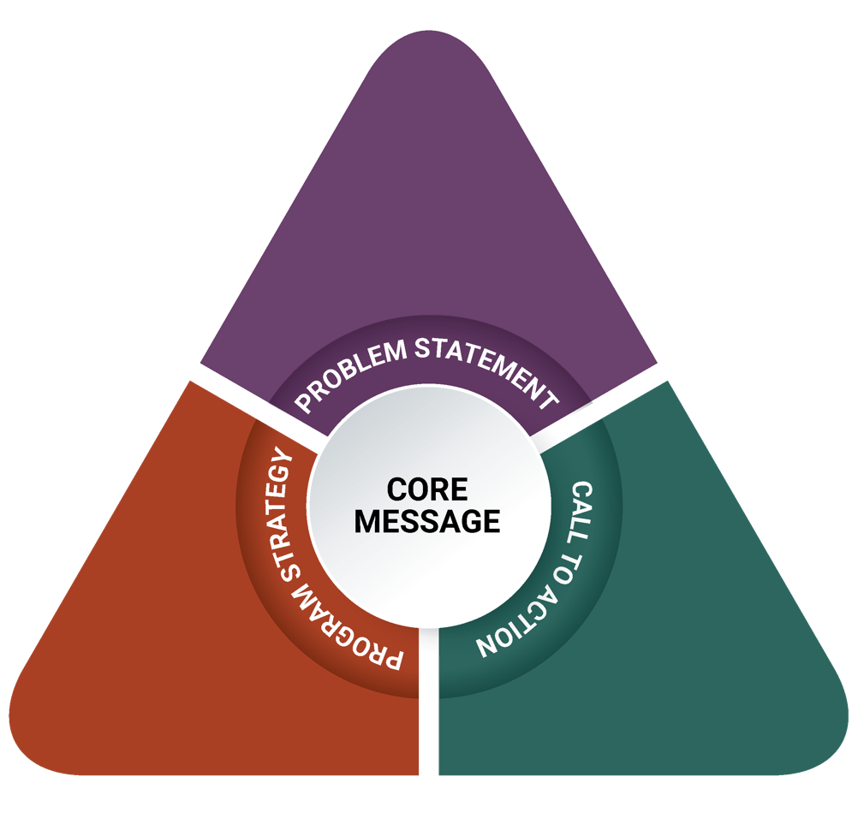
Ultimately, three message triangles were developed: for youth, for caregivers, and for men of color who have a history of substance misuse. Each message triangle informed the design of an activity that transmits these messages and operationalizes the call to action.

Messages to Impact Youth and Caregivers
Conversations with youth in focus groups showed that many youth see gambling around them but do not necessarily engage in it. Despite being aware of the risks of gambling, most (but not all) youth who participated in focus groups believe that some types of gambling are not harmful. Not having clear beliefs about something being harmful—or, in this case, viewing some gambling as acceptable—may lead youth to be more likely to engage in it. Research shows that perceiving fewer consequences and higher rewards from alcohol use may make youth more likely to misuse alcohol in the future.²⁴ This may be true for gambling as well. Coupled with youth’s descriptions of the benefits of gambling and their claims that gambling is easy to access in their community, these risk factors suggest that youth in this region may be more likely to engage in underage gambling and have later problems with gambling. This assessment and research show the importance of youth learning about the risks gambling poses. With that, the core message of the youth strategy is: Despite what we see and hear, gambling is risky. The call to action directed at youth is: You have the power to decide for yourself what is the best choice for you. The message triangle below shows the components of the development process for the youth strategy.
The focus groups and interviews with caregivers suggest that adults have significant, and often difficult, experiences relating to gambling, including through personal, familial, and environmental exposure to it. However, despite these experiences and caregivers’ clear comments about the risks of gambling, caregivers overall were not concerned about underage gambling. Instead, they viewed youth gambling through a lens of trust, believing that their children would independently make smart decisions and only gamble in moderation. Two risk factors for youth are having parents who have experienced gambling problems and having parents who approve of gambling.²⁵ Although not all parents interviewed have experienced gambling problems or approve of gambling, participating in gambling, having neutral attitudes about it, or believing that it is sometimes harmless may also be a risk. Based on these findings, the core message of the caregiver strategy is the same as the message for youth: Despite what we see and hear, gambling is risky. The call to action is: Your kids are listening to you. Teach them to have a critical eye. The message triangle below shows the components of the development process for the caregiver strategy.

Existing Approaches to Gambling Prevention and Advocacy for Youth
Some promising gambling prevention programs are being implemented across the country with youth. Although their effectiveness is not yet proven, they show promise for youth prevention. The four programs below, outlined by the Oregon Department of Human Services and the National Council on Problem Gambling, informed the design of the strategy for youth and caregivers that is recommended for the Plainville/Southeastern Massachusetts region and the Springfield/Western Massachusetts region.^{26,27}
- SMART Choices, which engages youth who live in close proximity to casinos.
- G.A.M.E.S., which focuses on personally developing youth and empowering them to work on making their community a healthy place.
- Smart Bet, which helps youth gain the knowledge and skills necessary to make healthy choices about whether or not to gamble, and when and how much to gamble. The program is designed to allow participants to explore the role of gambling in society and in their lives, the risks and benefits of gambling, as well as examine their own attitudes, feelings, and opinions around whether or not to gamble.
- Betting On Our Future, which supports and empowers young people to create positive change by raising the profile of problem gambling and the effects it has on youth, their families, and their community. Youth use this information to create a final product like a public service announcement, a play, or another artistic medium that illustrates important community messages.
In addition to the approaches above that informed the design of the strategy for youth and caregivers in the other regions, youth in the Everett area spoke candidly about how their voices, and the voices of people like them, are not being heard: “Whoever gets this information, hopefully it impacts us positively, because us minorities we don’t have chances to speak up. We can’t vote against casinos and stuff like that. I think we should have those.” The youth in this region were well aware of the issues around them and suggested wanting to change their environment. This interest also lends itself to youth advocacy, for which there are some existing approaches, including those below that have been selected by the United States Department of Health & Human Service’s Office of Adolescent Health:²⁸
- SparkAction, which trains youth in communications techniques, including technology, so that they can communicate with local, state, and federal policymakers to advocate for policy change and improvement.
- Youth Invincibles, which engages youth in speaking about issues of concern to them that they may not have had a voice in, and taking action for social change.
- Youth in Focus, which teaches urban youth to use photography to notice community issues and develop their own voice, unique creativity, and confidence, and then present their final work.
Along with the gambling prevention models and youth advocacy approaches above, and the message triangles for youth and caregivers, photovoice is recommended.

Strategy to Impact Youth and Caregivers
Based on these messages, the recommended strategy to decrease underage gambling in the Everett area is photovoice, a pioneering approach to gambling education. For the past two decades, qualitative researchers have used this photography-based research method to better understand political and social issues and to drive policy change. This method is based on work by sociologist Paulo Freire, who advocated for giving a voice to the oppressed and marginalized in society as a means of balancing dynamics with those in power.²⁹
Photovoice as a method has three main goals: enable people to record and reflect their community’s strengths and concerns, promote critical dialogue and knowledge about important issues through large- and small-group discussion of the photographs, and reach policymakers.³⁰
This type of participatory, socially shared photography creates myriad opportunities for innovative health and wellness programming with teens and young adults, and lends itself to dissemination and conversations in spaces that are not traditionally public health or learning spaces. In one example, researchers investigated the link between college students’ smartphone photography use with feelings of happiness. They found that being asked to take and share a daily photograph of something that made students feel happy increased their feelings of overall happiness and well-being, and increased their sense of reflectively engaging with the world.³¹
In recent years, photovoice has been repurposed as an educational tool for teens and young adults. With their dominant use of photography on smartphones, photovoice educational and prevention programs have shown tremendous promise in reaching and engaging with this population, whom the prevention community often struggles to reach. Photovoice has been effectively used to explore the community impact of substance use among adolescents,³² to explore perceptions of multiculturalism among teens in communities,³³ to change public policy around safety and physical education,³⁴ and to better understand barriers to health care in low-income communities.³⁵

Photovoice for Underage Gambling Prevention
Photovoice is carried out in three phases: planning the project, carrying out the project, and exhibiting the final photographs. This is an eight-week project that is easily incorporated into existing youth leadership programs. Photovoice in the Everett area has four objectives:
Aside from the objectives related to the prevention of underage gambling, photovoice in the Everett area will focus on empowering youth to have a voice on community issues. Youth advocacy creates opportunities for youth to express themselves, voice their ideas, and provide input into projects or programs.³⁶ Similarly, youth activism helps youth organize around a common goal in order to harness collective power for a specific outcome.³⁷ Both of these concepts will be used to guide and inspire youth participating in this project.
- increase youth’s recognition of the risks of gambling
- increase youth’s awareness about the level of exposure to gambling in everyday life
- increase youth’s perception of the harm of gambling
- increase youth’s sense of empowerment to have a voice on community issues

Planning a Photovoice Project
Youth are introduced to gambling by discussing what gambling is, the various kinds of gambling, who participates in gambling, where they see gambling around them, and the impact gambling has on their community. This intentional exploration allows youth to learn from each other, share power, and develop a collective experience. Youth will also be introduced to youth activism and youth advocacy by learning about real examples of youth leading change in their community and identifying causes or topic that are important to them. Photovoice will then be introduced as an opportunity for youth to get involved in their own community action.

Carrying Out a Photovoice Project
Youth will receive cameras and will be trained on technical photography skills, including focus, frame, lighting/flash, and movement when taking photographs. Youth will also practice visual literacy, including how to tell a story through photographs by linking images, taking reality photographs, using symbolism, and arranging scenes to create a specific message.³⁸ Youth will continue to explore leading change in communities by identifying whether they are interested in youth activism or youth advocacy and then identify components of the one they like.
Three or more sessions of the project should focus on taking photographs. Before these sessions, the youth will receive a question to respond to when taking photographs. For example:
- What are examples of gambling in your life or community?
- Why do youth participate in underage gambling in your community?
- How can youth get involved in addressing community needs related to gambling?
During the week following each photography assignment, youth will discuss the photographs as a group using the SHOWed method.³⁹ “SHOWed” is an acronym that guides youth while discussing their pictures:
- S: What do you see?
- H: What happened or is happening in the picture?
- O: How does this relate to our lives?
- W: Why does this happen?
- E: How could this image educate others?
- D: What can we do about it?
In these sessions, youth will dialogue with one another about gambling, their community, and their thoughts and feelings. The adult facilitator will infuse education into the session as youth ask questions and make connections.
Eventually, youth will select their best photographs from the project and develop captions using excerpts from their SHOWeD descriptions. The discussions can also be transcribed and used to develop descriptions. Photograph captions can illustrate an idea in a photograph, raise awareness about an issue, or advocate for a particular change. This gives youth an opportunity to decide how they want to influence their community.

Exhibiting the Photographs to Create Social Change
Photographs will be professionally printed on large card stock in preparation for an exhibition. While photographs are being printed, youth will prepare to present their photographs to their community. Youth will practice public speaking, prepare any public remarks, and be prepared to lead the event. The exhibition of photographs (which should be held in an easily accessible location, so that everyone is welcome) is an opportunity for youth to use their photography as a vehicle for sharing their thoughts and feelings with the community. It is well-documented in prevention research that feeling like an active member of a community is a protective factor for youth.^{40, 41}

Caregiver Component of the Photovoice Project
Understanding that caregivers have a significant influence over youth behavior, the caregiver strategy is connected to the youth photovoice project. The objectives of this strategy are to:
- increase caregivers’ awareness of what gambling is and its presence in youth’s everyday lives
- increase caregivers’ understanding of youth brain development, executive functioning, and self-regulation
- increase intentions to talk to youth about gambling
- increase caregivers’ perception of effectiveness when talking to youth about gambling

Caregivers will participate in one session, run by an adult facilitator who is preferably also a caregiver. During this session, caregivers will view photographs from the youth photovoice project and participate in a discussion about youth gambling and supporting youth in avoiding risky behaviors. Youth will present photographs from the photovoice project and describe why the project was important and what they learned from it. After this portion of the meeting, youth will leave to allow caregivers to discuss their thoughts and reflections about what the youth shared. Understanding what new information caregivers learned, what they heard from youth that they already knew, and what questions they have will help the adult facilitator lead a conversation with the group.
The adult facilitator will transition into gambling prevention education, when appropriate, and will cover the following topics:
- What gambling is and what types exist, to help caregivers understand how much youth are exposed to gambling
- Youth brain development, executive functioning, and self-regulation, to provide caregivers with information about why youth make risky decisions and how they can support youth development
- The importance of talking to youth about underage gambling, to let caregivers know that they can talk to youth about underage gambling and that doing so is a protective factor
This section should be as interactive as possible. To encourage participation from caregivers who may not feel comfortable speaking up in large groups, opportunities for individual or small-group conversations should be offered as well. It is important that the facilitator normalize this conversation so that the caregivers who attend feel comfortable discussing this information with their children at home. Caregivers should leave the session informed, energized, and with educational materials they can use to practice what they learned during the session.

Regional Comparison: Prevention Strategy for Youth and Caregivers
The photovoice methodology was also recommended in the Springfield/Western Massachusetts region and the Plainville/Southeastern Massachusetts region. Being a participatory strategy that allows for adaptation based on community needs and experiences, photovoice is easily tailored to suit the needs of participants from the Everett area. The primary difference between each iteration of photovoice is in the objectives intended for each region.
In this region, the objectives of photovoice for youth are related to recognizing their exposure to gambling and understanding its risks, and ultimately increasing their sense of empowerment to have a voice on issues in their community. The conversations inherent to the participatory nature of photovoice will allow youth to engage in community issues through photography, learn about gambling, and gain skills in being advocates for their community.
Similarly, photovoice in the Springfield/Western Massachusetts region has objectives for youth that are related to increasing their perception of harm of gambling and their critical thinking skills to navigate pressures to gamble. Youth in the Springfield/Western Massachusetts region have a lot of exposure to gambling and cited money as a reason for, and a benefit of, gambling: “If you came from nothing and you’re broke, and you put in $20 and won $500, you won $480—that’s great.” Similarly, the photovoice project in the Springfield/Western Massachusetts region will engage youth in community issues through photography and educate them about underage gambling, and it will also support them in developing the ability to think critically about the messages around them.
In contrast, in the Plainville/Southeastern Massachusetts region, the objectives for youth are related to increasing their awareness about gambling exposure and increasing their perception of harm of underage gambling. Youth in the Plainville/Southeastern Massachusetts region had limited direct experience of gambling. One youth reported, “People sometimes bet on fighting people. People get in a fight, and others bet on who will win. I see that on TV shows.” These youth also reported understanding that there can be harm involved in gambling: “It’s hyped up to be this great thing, with all the lights and stuff. When you take a step back and look at it objectively, you realize it’s not that great.” The photovoice project will help them make personal connections with the underage gambling around them through photography, and educate them about underage gambling and its risks.
The objectives for the caregiver component of photovoice in all regions also show parallels: in all regions, some objectives center on caregivers’ understanding of youth brain development and the vulnerability of youth in the face of risky behaviors. In the Plainville/Southeastern Massachusetts region, the photovoice component for caregivers was largely educational; in the Springfield/Western Massachusetts region there are educational components but the strategy stems beyond transfer of information: caregivers learn about the importance of underage gambling prevention, and also discuss and gain skills in talking to their children about gambling.

Messages to Impact Men of Color Who Have a History of Substance Misuse
Focus group conversations with men in recovery overwhelmingly centered on their experiences with drug and alcohol use and gambling, and the connections between these activities. Men in recovery view gambling as closely intertwined with drug and alcohol use, both in the tendencies they and their peers have to participate and the resulting negative consequences. Despite sharing myriad negative consequences they have personally experienced or have seen others experience, men in recovery had deep insights into why people may gamble. These conversations are in line with research showing that using illicit drugs is a risk factor for problem gambling,25 and other work showing that someone with a substance use disorder has higher odds of developing a problem with gambling than someone without a substance use disorder.42 Therefore, the core message of this strategy is: Gambling is another addiction, with some of the same risks as substances such as drugs and alcohol. Based on participants’ interest in sharing their experiences and teaching others, the call to action is: Become an ambassador for problem gambling prevention by leading individual and group conversations about gambling among your peers who struggle with substance use. The message triangle below shows the components of the development process for the strategy to impact men of color who have a history of substance misuse.
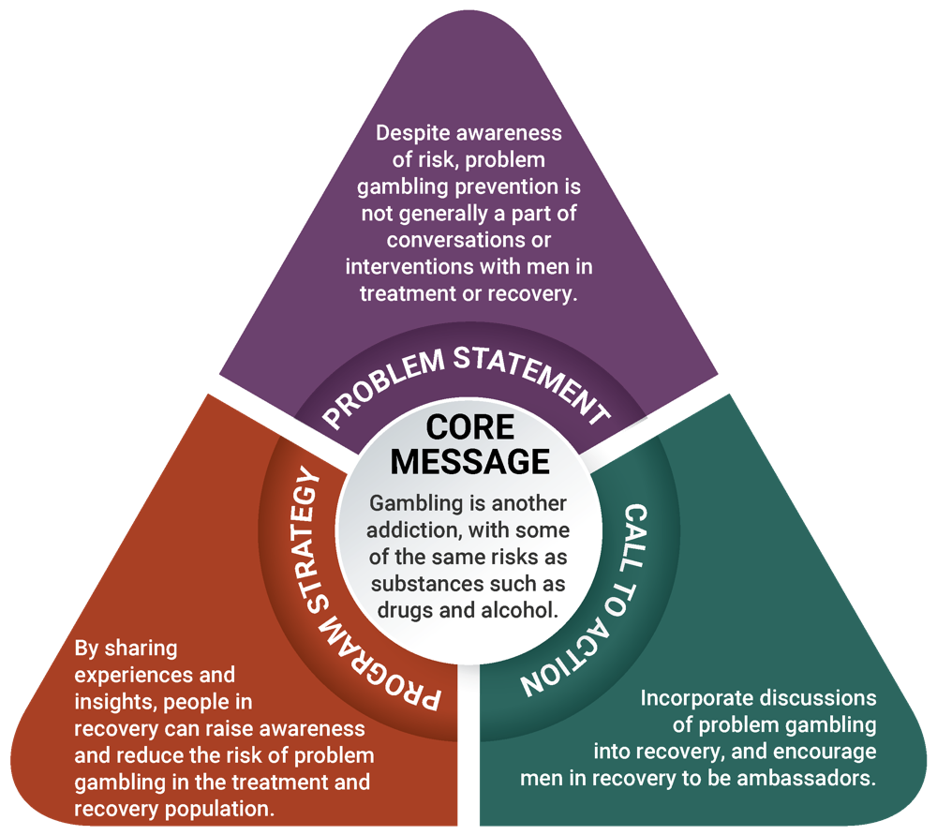

Existing Peer Education Models
Peer education models have been used in various types of prevention, including HIV prevention, mental health work, and substance use prevention. Below are three examples that lay a foundation for peer education strategies in other areas of prevention.
- The International Center for AIDS Care and Treatment Programs at Columbia University promotes peer education to support HIV programs around the world. Peer educators provide family-centered HIV education and are part of a multidisciplinary team. This work is based in the belief that the relationships and insights gained through peer education work are invaluable.⁴³
- The National Alliance on Mental Health has a system of peer services that include mutual support groups, peer-run programs, and services in traditional mental health agencies provided by peer support specialists. Peer support groups can be composed entirely of people who have learned through their own experiences, or can also include other types of peer providers who undergo training and certification to qualify. In addition to direct services, many peer-run organizations advocate to improve opportunities for people recovering from mental illnesses.⁴⁴
- The Massachusetts Department of Public Health’s Bureau of Substance Addiction Services has developed a peer support workforce of individuals called recovery coaches. Recovery coaches have lived experience of substance use and are currently in recovery, and support others in reaching a stable recovery through their chosen path to recovery.⁴⁵
Along with the peer education models above, the message triangle for men of color with a history of substance misuse and the peer-oriented culture of recovery centers informed the design of the ambassador strategy.

Strategy to Impact Men of Color Who Have a History of Substance Misuse
DPH funds 10 substance use peer recovery support centers across the state. These centers use the Massachusetts Peer Participatory Process Model,⁴⁶ which requires that people engage with one another through lived experience, accept all paths to recovery in order to build healthy relationships, and empower peers to become productive members of society. This model connects people in recovery by building a community where everyone has a voice in the programming, services, and functioning of each center.
All center members, known as “the community,” have the ability to generate ideas, voice their thoughts and concerns, raise important questions, and identify needs and gaps within the center. Each center has regular community meetings that provide a mechanism for the community to share input into recovery activities, community groups, center initiatives, and/or policies.⁴⁷ These decisions pass to a leadership committee, also made up of center members, who prioritize center needs and identify the feasibility of any proposed services and policies; the leadership committee then makes recommendations to center staff.⁴⁸
Recovery support center staff are also in recovery, and their role is to coordinate, oversee, and facilitate activities identified by the center community. Each center has between two and three staff, including the program director and volunteer coordinator. In addition to staff, recovery centers are run by volunteers, who can play various roles, including setting up programming, preparing meals, facilitating groups and events, providing support, leading activities, and supporting administrative tasks. Volunteering is an important part of being in recovery, and volunteer roles provide an opportunity for people to give back, enhance their skills, and connect with others.⁴⁸

Ambassador Strategy for Problem Gambling Prevention
The ambassador strategy is a participatory, peer-to-peer strategy that trains men of color who are in recovery to have gambling prevention conversations with other men of color with a history of substance misuse. According to SAMHSA, research has shown that peer support facilitates “recovery and reduces health care costs . . . [by promoting] a sense of belonging within the community. . . . [peer to peer] the development of self-efficacy through role modeling and assisting peers with ongoing recovery through mastery of experiences and finding meaning, purpose, and social connections in their lives.”⁴⁹
The objectives of the ambassador strategy are to:
- increase understanding of the connections between gambling and other addictions
- increase awareness of what gambling is and where it is present in everyday life
- increase perception of risk of developing a gambling disorder when one has experienced a substance use disorder
- increase self-efficacy to facilitate discussions about gambling with peers
Ambassadors will be identified by the community and staff of each recovery center. Ambassadors should be members who have already shown leadership qualities at the center and regularly take initiative. While ambassadors are peers, they will be additionally trained on the importance of conducting themselves with integrity and professionalism in this role. Recovery centers will identify how to fit ambassadors into the organizational structure so they have access to formal support systems.

Gambling Education
Ambassadors will be trained in all aspects of gambling, including various definitions, examples of gambling, the gambling continuum,⁷ and how gambling can impact recovery. Ambassadors will learn about the data available in Massachusetts and what they say about the communities most at risk for problem gambling. Lastly, ambassadors will learn about the importance of ensuring that everyone has the ability to attain good health; this includes being able to recognize community indicators that exacerbate problem gambling.

Leadership Development and Communication
Although the ambassadors will already have leadership skills before coming into their ambassador role, this strategy will enhance those skills and help ambassadors build on them. Ambassadors will learn about the Stages of Change Model and how it applies to having gambling prevention conversations.^{50, 51} They will also learn the facilitation skills needed to plan and facilitate groups, how to develop a positive group culture, and how to manage difficult conversations.
Individual and group interactions can occur as part of the ambassador strategy. Examples of individual interactions are speaking with someone at a recovery center, on the street, or during a private conversation at a program run by the center. Group interactions can occur at the recovery centers or at partner organizations that serve high-risk populations and who request peer gambling prevention groups or presentations.

Supervision and Organizational Policies
Supervisory systems will be established at all levels. These systems, used across the recovery center, will support productive, effective, and consistent supervision time. This will ensure success at both the ambassador and supervisor levels, and will help the organization build capacity to manage peer gambling prevention services.
Organizational leaders have the important role of reviewing the policies and activities of the recovery centers and its parent organization (if applicable) to assess if the organization promotes a gambling-free culture. If the organization already has policies against gambling, this review can ensure that they are being enforced.

Regional Comparison: Prevention Strategy for Men of Color with a History of Substance Misuse
The ambassador project uses a participatory peer education model that can easily be adapted across regions, populations, and community concerns. As a result, it has been recommended as a strategy for men of color with a history of substance misuse across the state.
As previously described, the ambassador strategy has objectives that are centered on increasing understanding of gambling’s connections to other behavioral health disorders, increasing the perception of risk related to gambling, and increasing ambassadors’ self-efficacy to facilitate conversations about gambling with their peers. In the Everett area, men in recovery understood the close connections between gambling and substance use, and reported on the risks that gambling poses after experiencing a substance use disorder: “It becomes an addition like the heroin, the cocaine, and the crack. These are habits that are not easy to stop. You start, but you don’t know how to stop. You create a dependency. You can end up in jail due to this dependency you create.” Men in the Springfield/Western Massachusetts region spoke similarly about this connection, saying, “You exchange one for the other. If you want to stop getting high, you go to gambling to think it’s going to be a quick fix. You start gambling, start feeling the same state of thought. When you feel depressed with one, you go back to the other hoping for a benefit from one”. There are parallels with men in recovery in the Plainville/Southeastern Massachusetts region as well. These men spoke clearly about the connections between substance use and gambling as well: “It goes hand in hand because it’s obsession and compulsion. Personally, I don’t know anyone who just gambles. And where I come from, I don’t know anyone who just uses. We all gambled, even in active addiction.” The ambassador strategy builds on this knowledge, sharpens ambassadors’ leadership skills, and encourages them to use their experience to teach other men with substance use disorders about the risks of gambling.
A benefit of their past participation in treatment programs and current membership in recovery centers, individuals in recovery have a vast understanding of substance use disorders. This strategy in all three regions aims to support ambassadors in expanding the conversation on substance use disorders by incorporating problem gambling into it, and in increasing their capacity to have conversations about gambling with their peers.
The largest difference across regions is in the demographics. In the Springfield area there are many places and opportunities to reach men of color, as the majority of Springfield residents are people of color. It may be more of a challenge to reach men of color in the other regions, as these regions’ demographics show primarily white residents. Specifically, the Plainville/Southeastern Massachusetts region is predominantly white, with at least 89% white residents, and the Everett area has an approximately equal makeup of white residents and residents of color. These demographics may mean that implementing the ambassador strategy with men of color may be more of a challenge in the Plainville/Southeastern Massachusetts region and the Everett area. As a result, a more focused means of reaching participants may be needed. Some examples of where to reach men of color include substance use treatment facilities, shelters, houses of corrections, and community-based organizations. Additionally, in these regions, once the priority population in systems and programs has been reached, outreach may have to begin on the streets, in barber shops, and at social gatherings and homes. This will allow ambassadors to reach the priority population where they are.

Theory of Change
Below is a logic model that illustrates the theory of change and the path to desired short-term, intermediate, and long-term outcomes for each strategy. In addition to the expectation that the strategies (and their short-term and intermediate outcomes) will impact rates of underage gambling and problem gambling in the long term, these strategies also have the potential to build health equity in the region. In the logic model below, orange boxes indicate strategies for youth and caregivers, green boxes indicate strategies for men of color who have a history of substance misuse, and blue boxes indicate where both strategies overlap.
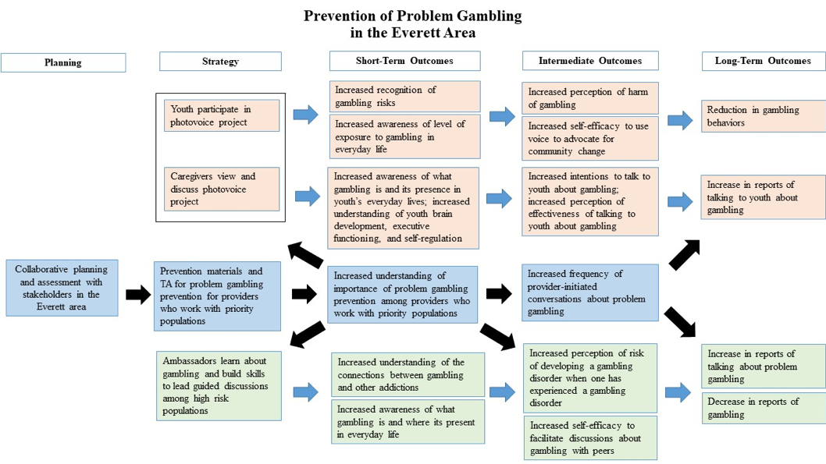

Implications and Recommendations
This regional planning process may have a variety of implications for the Everett region and for the state of Massachusetts as a whole. Below are implications of the assessment process findings (aside from those that directly informed the strategies proposed in this report), along with recommendations to DPH and the Office of Problem Gambling Services for ways to continue to support problem gambling prevention beyond the scope of this planning process.

Implication 1
Youth in focus groups had knowledge of gambling, its impacts on their community, and their lack of power as minority youth. The youth programs they participate in provide them with a foundation in substance use prevention and social justice.
Recommendation: Promote opportunities for youth to learn about the intersection of various types of public health prevention (including gambling prevention) and social justice so that they can develop a broad understanding of their communities’ needs and feel empowered to make choices for themselves and to participate in making changes in their communities.

Implication 2
In focus groups, few caregivers reported explicitly talking to their children about underage gambling, despite reporting awareness of their children’s participation in gambling.
Recommendation: Create a communications campaign and educational materials for caregivers on how to support youth in becoming healthy adults.

Implication 3
Youth discussed having easy access to gambling through family, community members, and strangers.
Recommendation: Encourage local organizations and partners to decrease social access to gambling for youth in the region through policies and organizational practices.

Implication 4
In focus groups, men in recovery described problem gambling as another addiction. Men in recovery have a unique experience that allows them to connect substance misuse and problem gambling.
Recommendation: Provide opportunities for men in recovery to inform policies and initiatives that make connections between substance misuse and problem gambling.

Implication 5
Many adult participants in focus groups reported gambling for financial reasons; the economic profile of Everett confirms the challenges of the area. Focus group participants also reported being concerned about increasing prices in the community. Baseline results from the SEIGMA study report that financial stress puts individuals at higher risk for problem gambling.
Recommendation: Provide financial support and resources to communities to manage financial stress, particularly in the face of increasing cost of living. This may have both direct impacts on improving residents’ quality of life and broad impacts on increasing protective factors to prevent problem gambling.

Implication 6
In general, adult and youth participants had limited information about risk factors, impacts, and the progression of problem gambling. Immigrants, particularly those who do not speak English, may have even more difficulty obtaining information. All residents in the region should be able to access education about gambling prevention and gambling-related services within their local community.
Recommendation: Create local, community-based spaces where people can access culturally relevant education about gambling prevention and gambling-related services in their own languages.

Implication 7
Overall, providers seem to hold negative attitudes about gambling, people in recovery seem to hold negative or neutral attitudes, and the community as a whole seems to hold positive attitudes. In general, understanding of gambling is limited, and different groups, sectors, and stakeholders can help broaden this conversation.
Recommendation: Actively involve a variety of stakeholders in strategy design and dissemination, and find ways to broaden the conversation to extend beyond the potential positive impacts of casinos.

Implication 8
A health equity lens throughout this regional planning process helped identify populations who are most impacted by these issues and ensured that these groups informed the data gathered in this assessment. Using a health equity lens is important to understand the realities and nuances of gambling and problem gambling across Massachusetts.
Recommendation: Continue to assess the health and racial disparities in areas where gambling increases, and include the people who are experiencing the most significant disparities.

Implication 9
In the Everett area, stakeholders and key informants shared their thoughts about the populations they are most concerned about in terms of problem gambling, particularly in light of the opening of the Encore Boston Harbor casino. Two new populations that emerged from these conversations are older adults and individuals with a history of incarceration.
Recommendation: Explore how older adults and individuals with a history of incarceration are impacted by problem gambling, and provide opportunities to engage them in prevention strategies.

ENDNOTES
- Massachusetts Technical Assistance Partnership for Prevention. (2016). Strategic plan: Services to mitigate the harms associated with gambling in Massachusetts. Waltham, MA: EDC. Funded by the Bureau of Substance Addiction Services. Retrieved from http://www.mass.gov/eohhs/docs/dph/com-health/problem-gambling-strategic-plan.pdf
- This strategy was later broadened to include all types of primary guardians, or “caregivers.”
- American Public Health Association. (2015). Better health through equity: Case studies in reframing public health work. Retrieved from https://www.apha.org/-/media/files/pdf/topics/equity/equity_stories.ashx?la=en&hash=DB7341D9CA82547EAFD8DF9DCAE718A0CD6B92DC
- Massachusetts Gaming Commission. (2018). Surrounding community & related agreements. Retrieved from https://massgaming.com/about/community-mitigation-fund/host-surrounding-communities/surrounding-community-agreements/
- DataUSA. (n.d.). Middlesex County, MA. Retrieved from https://datausa.io/profile/geo/middlesex-county-ma/
- United States Census Bureau. (2017, July 1). Quickfacts: Everett city, Massachusetts. Retrieved from https://www.census.gov/quickfacts/fact/table/everettcitymassachusetts/PST045217
- United States Census Bureau. (n.d.). 2012–2016 American Community Survey 5-year estimates. Retrieved from https://factfinder.census.gov/faces/nav/jsf/pages/community_facts.xhtml#
- DataUSA. (n.d.). Everett, MA. Retrieved from https://datausa.io/profile/geo/everett-ma/
- Massachusetts Department of Elementary and Secondary Education. (n.d.). Cohort 2017 graduation rates. Retrieved from http://profiles.doe.mass.edu/grad/grad_report.aspx?orgcode=00930000&orgtypecode=5&&fycode=2017
- DataUSA. (n.d.). Essex County, MA. Retrieved from https://datausa.io/profile/geo/essex-county-ma/
- Bureau of Substance [Addiction] Services. (2015). Description of admissions to BSAS contracted/licensed programs: FY 2014. Boston, MA: Author. Retrieved from https://www.mass.gov/files/documents/2016/07/vi/state-and-city-town-admissions-fy14.pdf
- Cambridge Health Alliance. (2014). The well-being of Everett: 2014 health assessment report. Retrieved from http://www.challiance.org/Resource.ashx?sn=Everett_Wellbeing_Report_2014
- Kessler, R. C., Hwang, I., LaBrie, R., Petukhova, M., Sampson, N. A., Winters, K. C., & Shaffer, H. J. (2008). The prevalence and correlates of DSM-IV pathological gambling in the National Comorbidity Survey Replication. Psychological Medicine, 38(9), 1351–1360.
- Work Group for Community Health and Development. (2016). Deciding where to start. In Community Tool Box (section 3). Retrieved from http://ctb.ku.edu/en/table-of-contents/analyze/where-to-start/identify-targets-and-agents-of-change/main
- Johansson, A., Grant, J. E., Kim, S. W., Odlaug, B. L., & Götestam, K. G. (2009). Risk factors for problematic gambling: A critical literature review. Journal of Gambling Studies, 25, 67–92.
- Petry, N. M., Stinson, F. S., & Grant, B. F. (2005). Comorbidity of DSM-IV pathological gambling and other psychiatric disorders: Results from the National Epidemiologic Survey on Alcohol and Related Conditions. Journal of Clinical Psychiatry, 66, 564–574.
- Volberg, R. A., Williams, R. J., Stanek, E. J., Houpt, K. A., Zorn, M., & Rodriguez-Monguio, R. (2017). Gambling and problem gambling in Massachusetts: Results of a baseline population survey. Amherst, MA: School of Public Health and Health Sciences, University of Massachusetts Amherst.
- Center on Addiction. (2010, February). Behind bars II: Substance abuse and America’s prison population. Retrieved from https://www.centeronaddiction.org/addiction-research/reports/behind-bars-ii-substance-abuse-and-america%E2%80%99s-prison-population
- Minton, T. D., & Zeng, Z. (2016). Jail inmates in 2015. Report prepared for the Office of Justice Programs, U.S. Department of Justice. Retrieved from https://www.bjs.gov/content/pub/pdf/ji15.pdf
- Braun, V., & Clarke, V. (2006). Using thematic analysis in psychology. Qualitative Research in Psychology, 3, 77–101.
- Nowell, L. S., Norris, J. M., White, D. E., & Moules, N. J. (2017). Thematic analysis: Striving to meet the trustworthiness criteria. International Journal of Qualitative Methods, 16, 1–13.
- Massachusetts Technical Assistance Partnership for Prevention. (2017). Prevention of problem gambling: Regional planning process—Plainville/Southeastern Massachusetts (region C). Waltham, MA: EDC. Funded by the MA DPH Office of Problem Gambling Services. Retrieved from https://www.mass.gov/files/documents/2017/12/18/Final%20Report_Problem%20Gambling%20Prevention%20Region%20C.PDF
- MassTAPP. (n.d.). Communications toolkit. Retrieved from http://masstapp.edc.org/communications-toolkit
- Guo, J., Hawkins, J. D., Hill, K. G., & Abbott, R. D. (2001). Childhood and adolescent predictors of alcohol abuse and dependence in young adulthood. Journal of Studies on Alcohol, 62(6), 754–762.
- Wilber, M. K., & Potenza, M. N. (2006, October). Adolescent gambling: Research and clinical implications. Psychiatry (Edgmont), 3(10), 40–48.
- Marotta, J. J., & Hynes, J. (2003). Problem gambling prevention resource guide for prevention professionals. Salem, OR: Oregon Department of Human Services, Office of Mental Health & Addiction Services. Retrieved from: http://www.kdads.ks.gov/docs/default-source/CSP/CSP-Documents/bhs-documents/provider_reports/problem_gambling_prevention_guide.pdf?sfvrsn=6
- Buzzelli, M., Winters, A., & Poggenburg, A. (2017). National Council on Problem Gambling Prevention Committee – program repository. Retrieved from: http://ncpgprevention.preventionlane.org/wp-content/uploads/2018/07/NCPG_Prevention_Committee-Repository_Booklets_V1-2017.pdf
- Office of Adolescent Health. (2018, March 7). Eight successful youth engagement approaches. Retrieved from https://www.hhs.gov/ash/oah/tag/game-plan-for-engaging-youth/eight-approaches/index.html
- Freire, P. (1972). Pedagogy of the oppressed. New York: Herder and Herder.
- Wang, C., & Burris, M. (1997). PhotoVoice: Concept, methodology, and use for participatory needs assessment. Health Education and Behavior, 24(3), 369–387.
- Chen, Y., Mark, G., Ali, S., & Ma, X. (2017). Unpacking happiness: Lessons from smartphone photography among college students. Proceedings of the Fifth IEEE International Conference on Healthcare Informatics.
- Brazg, T., Bekemeier, B., Spigner, C., & Huebner, C. E. (2011). Our community in focus: The use of PhotoVoice for youth-driven substance abuse assessment and health promotion. Health Promotion Practice, 12(4), 502–511.
- Johansen, S., & Le, T. N. (2014). Youth perspective on multiculturalism using PhotoVoice methodology. Youth & Society 46(4), 548–565.
- Hannay, J., Dudley, R., Milan, S., & Leibovitz, P. K. (2013). Combining PhotoVoice and focus groups: Engaging Latina teens in community assessment. American Journal of Preventive Medicine, 44(3), S215–S224.
- Massengale, K. E. C., Strack, R. W., Orsini, M. M., & Herget, J. (2016, May). PhotoVoice as pedagogy for authentic learning: Empowering undergraduate students to increase community awareness about issues related to the impact of low income on health. Pedagogy in Health Promotion, 2(2), 117–126.
- Office of Adolescent Health, U.S. Department of Health and Human Services. (2018, March 7). Eight successful youth engagement approaches. Retrieved from https://www.hhs.gov/ash/oah/tag/game-plan-for-engaging-youth/eight-approaches/index.html
- Advocates for Youth. (2013). Youth Activist’s Toolkit [PDF]. Washington, DC: Advocates for Youth. Retrieved from http://www.advocatesforyouth.org/storage/advfy/documents/Activist_Toolkit/activisttoolkit.pdf
- Rutgers. (2018). Facilitator’s guide. Retrieved from https://www.rutgers.international/our-products/tools/photovoice/facilitators-guide#Presentations
- Wang, C. C., Yi, W. K., Tao, Z. W., Carovano, K. (1998). Photovoice as a participatory health promotion strategy. Health Promotion International, 13(1), 75–86.
- Oman, R. F., Vesely, S., Aspy, C. B., McLeroy, K. R., Rodine, S., & Marshall, L. (2004). The potential protective effect of youth assets on adolescent alcohol and drug use. American Journal of Public Health, 94(8), 1425–1430.
- Tobler, A. L., Livingston, M. D., & Komro, K. A. (2011). Racial/ethnic differences in the etiology of alcohol use among urban adolescents. Journal of Studies on Alcohol & Drugs, 72(5), 799–810.
- Kessler, R. C., Hwang, I., LaBrie, R., Petukhova, M., Sampson, N. A., Winters, K. C., & Shaffer, H. J. (2008). DSM-IV pathological gambling in the National Comorbidity Survey Replication. Psychological Medicine, 38(9), 1351–1360.
- International Center for AIDS Care and Treatment Programs. (n.d.) Comprehensive peer educator training curriculum: Trainer manual. New York, NY: Author. Retrieved from http://files.icap.columbia.edu/files/uploads/Peer_Ed_TM_Complete.pdf
- National Alliance on Mental Illness. (n.d.). Peer support resources. Retrieved from https://namimass.org/programs/peer-support-resources
- Bureau of Substance Addiction Services. (2018). Peer recovery coaches – April 2018. Boston, MA: Author. Retrieved from http://commcorp.org/wp-content/uploads/2018/07/BSAS-RC-one-pager-3.15-3-25-18-Vetted.pdf
- The Massachusetts Substance Use Helpline. (2016, December 29). Paths to recovery: Recovery coaches. Retrieved from https://helplinema.org/2016/12/29/paths-to-recovery-recovery-coaches/
- A New Way Recovery Center [Website]. (n.d.). Retrieved from https://anewwayrecoveryctr.org/
- Grasmere, J., Martell, J., Andersen, R., & Parker, D. (2006). How to build your own peer-to-peer recovery center from the ground up! Retrieved from http://facesandvoicesofrecovery.org/file_download/inline/8345d2db-0c3f-4c92-adaa-9f7948459ada
- Substance Abuse and Mental Health Services Administration. (2015, July 2). Peer support and social inclusion (¶ 2). Retrieved from https://www.samhsa.gov/recovery/peer-support-social-inclusion
- Velasquez, M. M., von Sternberg, K., Dodrill, C. L., Kan, L. Y., & Parsons, J. T. (2005). The transtheoretical model as a framework for developing substance abuse interventions. Journal of Addictions Nursing, 16, 31–40. Retrieved from https://www.researchgate.net/publication/230754128_The_Transtheoretical_Model_as_a_Framework_for_Developing_Substance_Abuse_Interventions
- DiClemente, C. (1999). Motivation for change: Implications for substance abuse treatment. Psychological Science, 10, 209–213. Retrieved from https://www.researchgate.net/publication/247781208_Motivation_for_Change_Implications_for_Substance_Abuse_Treatment

Appendix A: Focus Group and Key Informant Interview Questions

Key Informant Interview Questions
1. When you hear the word gambling, what does that mean to you? What do you think of?
2. How much talk about problem gambling in your community have you heard or learned about?
a. Do you think people have positive or negative associations with gambling?
b. Do you think people consider problem gambling an issue of concern?
c. Why do you think this?
3. How prevalent is problem gambling among the population you serve?
a. What are the types of gambling you see among this group?
4. Do you think gambling is more of a risk for certain populations than others?
5. Is there anything we can do to prevent people in your community from developing a problem with gambling?
6. Is there anything we can do to prevent youth from developing a problem with gambling?
7. Do you have any thoughts on how problem gambling prevention can be integrated into other conversations on health and well-being?
a. Which conversations?
b. What methods work best?
8. Does your organization educate or create awareness among people in your community?
a. Can you describe that?
b. What methods work best?
9. Is there anything else you think is important to add to this discussion?

Youth Focus Group Questions
1. When you hear the word gambling, what does that mean to you? What do you think of?
2. What types of gambling are there?
3. Where do you see gambling in your life?
a. Are there adults or other youth you know who gamble?
b. What are their roles in your life?
c. Do you gamble?
4. Have you ever heard of problem gambling?
a. What do you think it means?
b. Have you ever seen problem gambling? Tell me about it.
5. What benefits are there to gambling?
6. What risks are there to gambling?
a. How harmful do you think gambling is?
7. Do you think some types of gambling seem better or worse than others?
a. In what way?
b. What makes you say that?
8. Have you ever seen any messages about gambling, for example, on billboards, on TV ads, or in magazines?
a. What are they?
b. Where did you see them?
c. What did you think when you saw them?
9. If you were going to talk to your friend about gambling or addiction, what would you say?
10. How do you usually get information—online, TV, word of mouth?
11. Is there anything else you think is important to add to this discussion?

Caregiver Focus Group Questions
1. When you hear the word gambling, what does that mean to you? What do you think of?
2. Where do you see gambling in your life?
a. Are there adults or youth you know who gamble?
b. What are their roles in your life?
c. Do you gamble?
3. How do you feel about your kid(s) gambling?
4. What benefits are there to gambling?
5. What risks are there to gambling?
a. How harmful do you think gambling is?
6. Do you think some types of gambling seem more OK or less OK for youth?
a. In what way?
b. What makes you say that?
7. Have you ever talked to your kid(s) about gambling or addiction?
a. What prompted the conversation/why?
b. How many times did you talk about it?
c. What did you say?
d. How did it go?
e. What would you do differently, if you were to do it again?
8. How do you usually get information—online? TV? word of mouth?
9. Is there anything else you think is important to add to this discussion?

Caregiver Focus Group Questions (Spanish)
1. Cuando escucha la frase “jugar al azar”, ¿qué significa esto para usted? ¿En qué piensa?
2. En su vida, ¿Dónde ve jugar al azar en su vida?
a. Algunos de los adultos o jóvenes que conoce, ¿juegan al azar?
b. ¿Qué rol tienen esta personas en su vida?
c. ¿Usted juega al azar?
3. ¿Cómo se siente con relación a que sus hijos o menores a su cuidado jueguen al azar?
4. ¿Qué beneficios tiene el jugar al azar?
5. ¿Cuáles son los riesgos de jugar al azar?
a. ¿Cuán perjudicial usted cree que es jugar al azar?
6. ¿Piensa usted que algunos tipos de juegos al azar son más aceptables menos aceptables para los jóvenes?
a. ¿De qué manera?
b. ¿Qué le hace decir eso?
7. En alguna ocasión, ¿Ha hablado con sus hijos/menores a su cuidado sobre jugar al azar o sobre adicción?
a. ¿Qué motivó esa conversación/por qué?
b. ¿Cuántas veces ha hablado sobre eso?
c. ¿Qué dijo usted?
d. ¿Cómo le fue?
e. Si fuera a hacerlo nuevamente, ¿qué haría diferente?
8. Usualmente, ¿Cómo obtiene información?
a. ¿En la Internet?
b. ¿Televisión?
c. ¿En conversaciones con otras personas?
9. ¿Hay algo adicional que considera importante añadir a esta discusión?

Men in Recovery Focus Group Questions
1. When you hear the word gambling, what does that mean to you? What do you think of?
2. What types of gambling are there—legal and illegal?
3. Where do you see gambling in your life?
a. Are there friends, relatives, or other people in your life who gamble?
b. What are their roles in your life?
c. Do you gamble?
4. Have you ever heard of problem gambling?
a. What do you think it means?
b. Have you ever seen problem gambling? Tell me about it.
5. What benefits are there to gambling?
6. What risks are there to gambling?
a. How harmful do you think gambling is?
7. Do you think there are any connections between gambling and substance use?
a. What are they?
8. Do you think some types of gambling seem better or worse than others?
a. In what way?
b. What makes you say that?
9. Have you ever seen any messages about gambling, for example, on billboards, on TV ads, or in magazines?
a. What are they?
b. Where did you see them?
c. What did you think when you saw them?
10. If you were going to talk to someone you know about gambling or addiction, what would you say?
11. How do you usually get information—online, TV, word of mouth?
12. Is there anything else you think is important to add to this discussion?

Men in Recovery Focus Group Questions (Spanish)
1. Cuando escucha la frase “juego al azar ó jugar al azar”, ¿qué significa esto para usted? ¿En qué piensa?
2. ¿Cuáles tipos de juegos al azar existen?
3. ¿Dónde ve juego o jugar al azar en su vida?
a. En su vida, ¿tiene amigos, familiares, u otras personas que juegan al azar?
b. ¿Qué rol tienen en su vida?
c. ¿Usted juega al azar?
4. ¿En alguna ocasión ha escuchado hablar de juego al azar problemático?
a. ¿Qué piensa esto significa?
b. ¿Ha visto juego al azar problemático? Hábleme sobre eso.
5. ¿Qué beneficios tiene el jugar al azar?
6. ¿Cuáles son los riesgos de jugar al azar?
a. ¿Cuán perjudicial usted cree que es jugar al azar?
7. ¿Cree usted que existen algunas conexiones entre el jugar al azar y el uso de sustancias?
a. ¿Cuáles son?
8. ¿Considera que algunos tipos de juegos de azar son mejores o peores que otros?
a. ¿De qué manera?
b. ¿Qué le hace decir eso?
9. En alguna ocasión, ¿Ha visto algún mensaje sobre jugar al azar, por ejemplo, en vallas publicitarias (“billboards”), anuncios en la televisión, o en revistas?
a. ¿Cuáles son?
b. ¿Dónde los vio?
c. ¿Qué pensó cuando los vio?
10. Si fuera a hablar con alguien que conoce sobre jugar al azar o adicción, ¿Qué le diría?
11. Usualmente, ¿Cómo obtiene información?
a. ¿En la Internet?
b. ¿Televisión?
c. ¿En conversaciones con otras personas?
12. ¿Hay algo adicional que considera importante añadir a esta discusión?

