
Prevention of
Problem Gambling
Regional Planning Process—Plainville/Southeastern Massachusetts (Region C)

June 30, 2017

Table of Contents
Executive Summary 3
Introduction 10
Priority Populations 11
Community Assessment 12
Demographics 12
Community Assets 12
Outreach and Network Building 14
Data Collection and Analysis 15
Results: Knowledge, Attitudes, and Beliefs About Gambling 15
Data Gathered from Youth (Strategy 1) 15
Data Gathered from Parents and Youth Service Providers (Strategy 1) 17
Data Gathered from Men in Recovery or Seeking Recovery (Strategy 2) 18
Data Gathered from Recovery Support Providers (Strategy 2) 20
Messages and Pilot Interventions 21
Message Development 21
Messages to Impact Youth (Strategy 1) 21
Pilot Intervention to Impact Youth (Strategy 1) 23
Messages to Impact Men of Color Who Have a History of Substance Misuse (Strategy 2) 24
Pilot Intervention to Impact Men of Color Who Have a History of Substance Misuse (Strategy 2) 25
Evaluation 26
Intervention to Impact Youth (Strategy 1) 27
Intervention to Impact Men of Color Who Have a History of Substance Misuse (Strategy 2) 29
Next Steps 30
Lessons Learned 31
Recommendations 32
Appendix A: Focus Group and Key Informant Interview Questions 33
Strategy 1: Youth Focus Group Questions 33
Strategy 1: Parent Key Informant Interview and Focus Group Questions 34
Strategy 2: Men in Recovery or Seeking Recovery Focus Group Questions 35
Strategy 1 and Strategy 2: Non-Parent Key Informant Interview Questions 36
Appendix B: Youth Gambling Prevention Project Guidance for Youth Workers and Facilitators 37
Talking Points: Talking to Youth About Gambling 40
Intro to PhotoVoice: Project Description Handout 42
Talking Points: Talking to Parents About the Youth Photo Exhibit 43
Handout for Parents: Executive Functioning 45
Pre-Event Survey for Youth 48
Post-Event Survey for Youth 48
Pre-Event Survey for Parents 49
Post-Event Survey for Parents 49
Appendix C: Documents for Recovery Support Providers 50
Guidance for Providers Working at Recovery Support Centers 50
Addressing Problem Gambling: What Substance Use Disorder Service Providers Should Know 51
Evaluation/Documentation Form for Recovery Support Providers 53

Background
This report describes a regional planning process for the prevention of problem gambling carried out by the Massachusetts Technical Assistance Partnership for Prevention (MassTAPP) at Education Development Center, Inc. (EDC). The regional planning process, funded by the Massachusetts Department of Public Health (DPH), focused on the Plainville/Southeastern Massachusetts region, where the Plainridge Park Casino is located.
After the Public Health Trust Fund Executive Committee adopted the Strategic Plan: Services to Mitigate the Harms Associated with Gambling in Massachusetts (the statewide Strategic Plan) in April 2016, MassTAPP operationalized two of the plan’s key recommendations:
- Strategy 1: Reach youth and parents with appropriate prevention messaging, and enhance environmental strategies to increase protective factors and decrease risk factors
- Strategy 2: Develop and distribute culturally appropriate campaigns and services for high-risk populations
For each strategy, MassTAPP engaged in a planning process to develop and pilot culturally appropriate prevention initiatives to impact two priority populations in the region:
- Youth ages 12–18
- Men of color who have a history of substance misuse
In addition, this project serves to document and evaluate MassTAPP’s planning process so that it can be replicated in or adapted for other regions of Massachusetts.

Priority Populations

Youth and Parents (Strategy 1)
Youth who begin gambling early in life are more likely to experience problem gambling later in life. Therefore, youth ages 12–18 were identified as the “targets of change” for this intervention. Research also shows that youth are less likely to experience problem gambling if they have protective factors in their lives, such as strong family support and realistic boundaries and expectations, which buffer the risks of developing problems with alcohol and other substances. Therefore, parents of adolescents were identified as “agents of change”iii and are an audience for problem gambling prevention messages and interventions.

Men of Color Who Have a History of Substance Misuse (Strategy 2)
Research has indicated that men are at higher risk of problem gambling than the general population, as are people of coloriv and people with a history of substance misuse.iv Based on these demographic categories, conversations with key stakeholders in the region, and the availability and readiness of substance use treatment and recovery support providers, the priority population for this strategy was defined as men of color who have a history of substance misuse. This priority population matches results from the Social and Economic Impacts of Gambling in Massachusetts (SEIGMA) study, which showed significantly higher problem gambling rates among men compared to women, and among Black adults compared to white adults in Massachusetts.vi This research also indicates that adults who engage in problem gambling are significantly more likely to have engaged in binge drinking in the past month compared to adults who gamble recreationally.

Planning Process
MassTAPP conducted the regional planning process in several stages:
- Stage 1: Review of local demographics
- Stage 2: Community outreach and identification of key stakeholders
- Stage 3: Convening and facilitation of a regional stakeholder meeting
- Stage 4: Identification of community assets and local resources
- Stage 5: Focus groups with priority populations
- Stage 6: Key informant interviews with individuals who understand and/or may influence the behavior of these populations
- Stage 7: Development of messages and interventions
Stage 8: Piloting of interventions
Stage 9: Evaluation and follow-up

Messages and Interventions

Youth and Parents (Strategy 1)
In order to develop messages and interventions that resonate with youth and their parents, MassTAPP conducted focus groups with youth and parents, and key informant interviews with youth service providers and parents, throughout the region.
- Twenty-six youth participated in three focus groups (held at the Old Colony YMCA in Brockton, Hockomock Area YMCA in Foxborough, and Boys & Girls Club of Taunton).
- Fifteen parent and youth provider key informants participated in interviews (this includes one focus group of six parents at Old Colony YMCA in Plymouth).

Knowledge, Attitudes, and Beliefs
Youth participants identified many types of gambling, demonstrated a broad understanding of what it means to gamble, and made connections to the concepts of chance, waste, and addiction. Youth also discussed the degree to which gambling can be harmful. Multiple youth expressed the belief that there are different levels of gambling, that some types are not harmful, and that they do not consider the types of gambling they participate in to be “bad” gambling. Although some parents and youth service providers had very negative opinions about gambling, others were more ambivalent about the negative consequences or did not see gambling as an issue that is prevalent in the lives of youth.

Key Messages
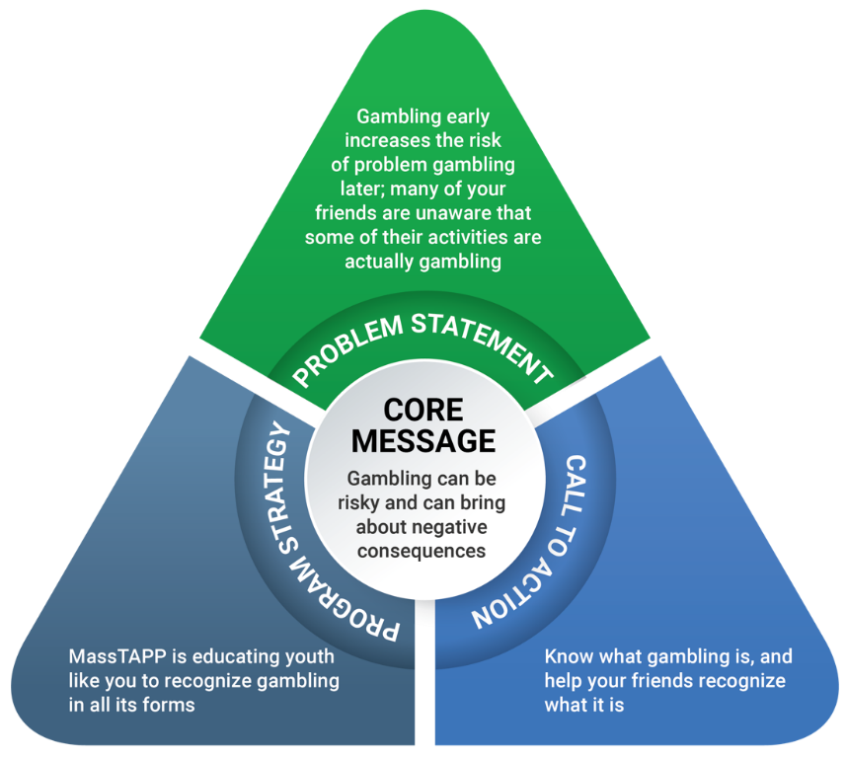
MassTAPP analyzed the data from the focus groups and interviews regarding the knowledge, attitudes, and beliefs of the priority populations, and used the MassTAPP Communications Toolkit’s message triangle model to develop key messages for each priority population (see full report for details). Data from youth focus groups suggested that many young people are aware that gambling is risky and can lead to serious problems later in life, similar to the use of alcohol and other drugs. At the same time, youth do not always make the connection between the term gambling and some of the activities they see around them. Based on this and research showing that a risk factor for the development of a gambling disorder is gambling early in life,ii the core message of MassTAPP’s youth intervention is that gambling can be risky and can bring about negative consequences. The call to action directed at youth is to know what gambling is and help your friends recognize what it is.
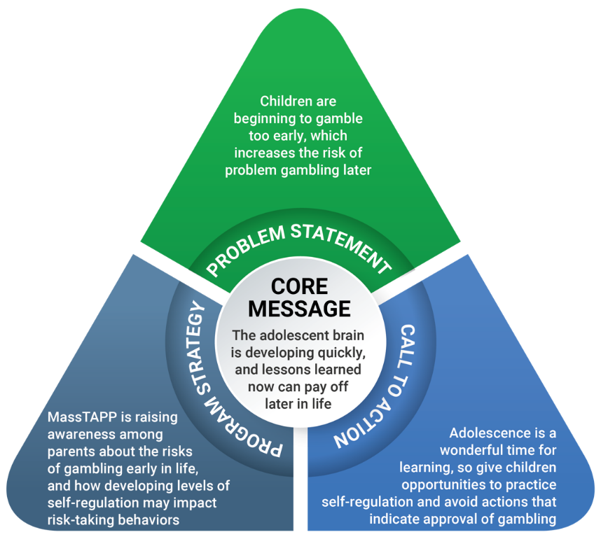
The focus groups and interviews with parents and youth providers suggest that adults are less aware of gambling activities in the daily lives of youth than young people are. Adult participants also did not articulate a recognition that adolescence can be a particularly risky period, during which youth are more likely to make impulsive or impractical choices. Based on these observations—along with research that suggests that having parents who are permissive of or approve of gambling is a risk factor for youth developing a gambling disorder —MassTAPP determined that a parallel activity for parents was necessary. The core message of MassTAPP’s parent activity is that the adolescent brain is developing quickly, and lessons learned now can pay off later in life. The call to action is that adolescence is wonderful time for learning, so it is beneficial that parents give their children opportunities to practice self-regulation and avoid actions that indicate approval of gambling.

Intervention
After creating these messages, MassTAPP developed an intervention to address the call to action for both youth and parents, to build on existing knowledge, raise awareness, and increase feelings of empowerment to bring about change. Aiming to create an impactful and engaging activity, MassTAPP designed an intervention with several components to take place in an afterschool setting over a period of approximately one week. This intervention uses the PhotoVoice research methodology, which involves participants taking photographs that represent an idea or issue and then discussing them with their peers. PhotoVoice fosters dialogue; it has been useful in enabling youth and their parents to feel empowered to discuss issues and promote change in their communities. Therefore, MassTAPP selected this strategy as a useful and engaging method of understanding and representing the views of youth, and an illuminating activity for parents to see where their children encounter gambling in their daily lives.
MassTAPP piloted this intervention in three YMCAs located in the Plainville/Southeastern Massachusetts region. Adolescents took photographs of gambling and gambling imagery around them, and then participated in a facilitated discussion using the images to explore the many forms that gambling takes and the ways that young people are exposed to it. A session for parents followed this workshop, in which parents viewed a display of the young people’s photographs and explanations, and then participated in a discussion about youth exposure to gambling. As designed, this session also includes a facilitated discussion of adolescent brain development, executive functioning, and self-regulation, with an emphasis on how these factors may relate to gambling-related behaviors, and how parents can support the development of these skills in their youth.
Youth and parents completed pre- and post-intervention surveys, and youth workers who facilitated the activities provided commentary and feedback, all of which MassTAPP used to measure the results of this pilot. Across three YMCAs, 64 youth completed pre-intervention surveys, and 35 of these youth completed post-intervention surveys. Across two of these YMCAs, where the parent session was run, 15 parents completed the pre-event survey, and 13 completed the post-event survey. Considering the small number of participants, any analysis of the impact of this strategy is inconclusive. However, survey results indicated that young people who participated in this program gained a slightly broader understanding of the definition of gambling and of the types of gambling they see in their everyday lives, while parents indicated an increase in their perception of the importance of prevention of gambling behaviors among youth.

Men of Color Who Have a History of Substance Misuse (Strategy 2)
In order to develop a message and intervention that resonates with men of color who have a history of substance misuse, MassTAPP conducted focus groups and key informant interviews throughout the region. Nineteen men in recovery or seeking recovery, selected by recovery center staff, participated in two focus groups. Five recovery support provider key informants participated in interviews.

Knowledge, Attitudes, and Beliefs
Focus group data indicated that people in recovery have a broad concept of gambling; discussion ranged from Powerball and scratch tickets to sports betting, dice games, casinos, and “gambling with your life” (i.e., addiction). Focus group participants were very aware of the connection between gambling and other addictions. Several participants talked about the impact that gambling has had on family members or friends, and how they wanted to be able to help somehow. Recovery support providers indicated an awareness of gambling as an issue among the populations they serve. In particular, some providers were very aware of the financial impact of gambling and spoke of the prevalence of lottery vendors in low-income neighborhoods. Despite this awareness, recovery support providers seldom mentioned prevention during interviews.

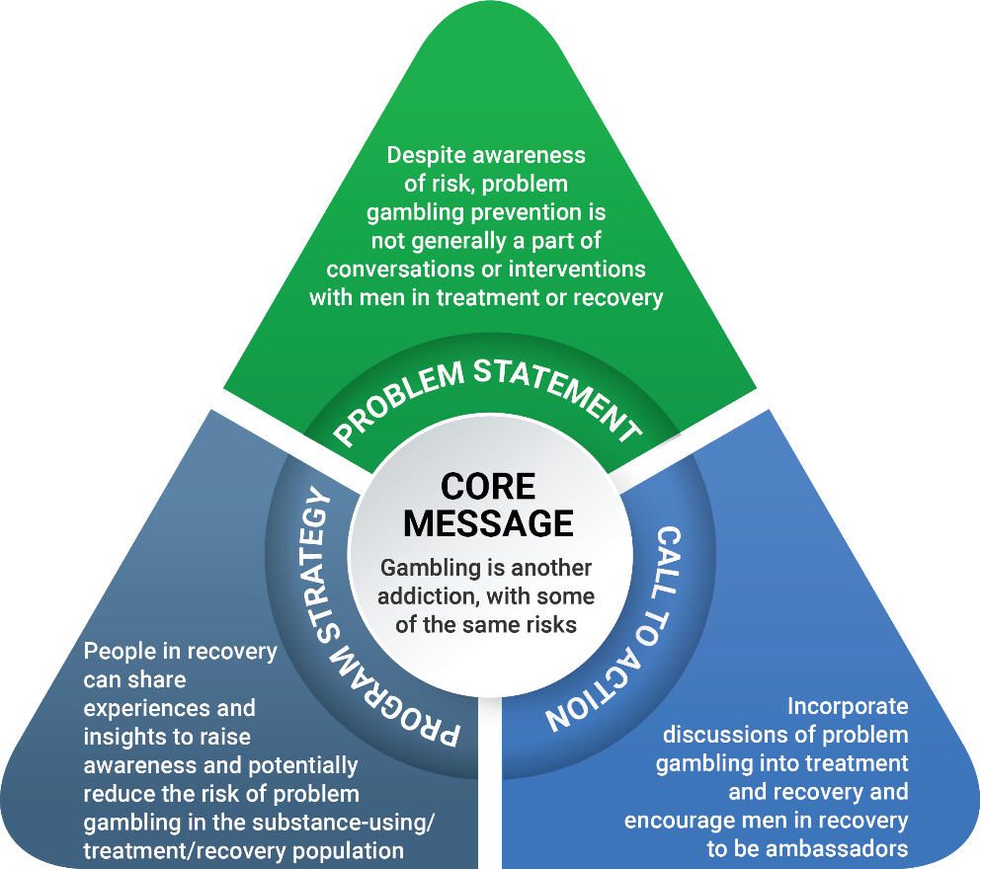
Key Messages
Results of focus groups with men in recovery or seeking recovery show that these men view gambling as closely intertwined with the use of alcohol and other drugs, in terms of both the contexts in which these substances and activities can be found and the people who use or participate in them. Based on these results, along with claims from focus group participants and recovery support providers that personal stories are particularly impactful, the core message of this pilot intervention is that gambling is another addiction, with some of the same risks as substances such as alcohol and other drugs. The call to action is to incorporate discussions of problem gambling into treatment and recovery and to encourage men in recovery to be ambassadors, bringing a discussion of gambling into conversations among their peers outside the recovery center.
Results of interviews with recovery support providers suggest that gambling is prevalent but seldom recognized as a problem. Therefore, in its intervention, MassTAPP aimed to increase the awareness and readiness of recovery and treatment support providers to reduce gambling-related harms among center members. The core messages for providers are that gambling is an issue for the population they serve and that there are clear parallels between problem gambling and substance misuse.

Intervention
After listening to men in recovery (in the context of focus groups) share insights about their experiences with gambling and describe their desire to help others avoid the harms that they had encountered, MassTAPP developed a coaching method for the prevention of problem gambling. Peer-to-peer coaching is a commonly used strategy in substance misuse treatment and recovery programs. In this context, men in recovery (“ambassadors”) would initiate conversations with people they know to share their knowledge and experiences, thereby supporting problem gambling prevention. MassTAPP intended for this intervention to impact two distinct groups: the ambassadors, who receive coaching and encouragement in preparation for their coaching role, and the individuals who are brought into these conversations.
To support this process, MassTAPP developed a guidance document to assist recovery support providers in engaging a group of men in recovery from substance misuse in serving as ambassadors for problem gambling prevention. After convening a group and leading a conversation and skill-building session, facilitators requested that members have a conversation with at least one person about the impact of gambling on their lives, the impact on their family and friends, and how gambling affects recovery. Approximately one week later, recovery support providers convened the group and facilitated a discussion about the conversations and their outcomes.
MassTAPP piloted this intervention in two recovery centers in the Plainville/Southeastern Massachusetts region, with a total of 8 men in recovery (4 men at each location), who spoke with a total of twenty-six individuals through peer-to-peer outreach. These men participated in a follow-up discussion led by recovery center staff, who also documented their comments. Ambassadors shared that after putting some thought into the setting and how to have the conversations, they felt good about being in this role and received positive feedback from their peers.
In a separate component of the intervention to impact men with a history of substance misuse, providers also received a handout developed by MassTAPP (see Appendix C), which was designed to increase their knowledge about gambling, its prevalence, and its connection to substance use. The handout, which includes impactful quotes about gambling that were collected during focus groups, has the potential to reach and impact providers and others in the broader treatment and recovery communities.

Recommendations
Based on the piloting of prevention initiatives for two priority populations in the Plainville/Southeastern Massachusetts region, MassTAPP has several recommendations:
- Considerations of health equity should be primary in selecting priority populations for interventions, to clearly identify gaps in health outcomes and local resources for certain populations, and to ensure a stronger impact on the region and state.
- Consultation and collaboration with local community members, including members of priority populations and key stakeholders, should be ongoing throughout the intervention’s development and implementation to support maximum participation by and feedback from the community.
- Collaboration with other groups funded by DPH to conduct parallel efforts (such as the Community Health Worker Initiative and the statewide communications campaign for the prevention of problem gambling) should be ongoing.
- Linkages with local prevention coalitions should be cultivated, including those funded by BSAS that already receive technical assistance from MassTAPP for their substance use prevention initiatives.
- All efforts must be evaluated as thoroughly as possible to assess impact and support the sustainability and modification of strategies being implemented. An evaluation plan should be incorporated into all strategies prior to implementation.
- To ensure sustainability, messaging should be integrated into existing programs, and partnerships with local resources should be developed and maintained.

Introduction
This report describes a regional planning process for the prevention of problem gambling carried out by the Massachusetts Technical Assistance Partnership for Prevention (MassTAPP) at Education Development Center, Inc. (EDC). The Massachusetts Department of Public Health (DPH) funded the regional planning process, which focused on the Plainville/Southeastern Massachusetts region, where the Plainridge Park Casino is located. The slot parlor at the Plainridge Park Casino was the first establishment to open in the wake of the Expanded Gaming Act of 2011.
After researching and writing the Strategic Plan: Services to Mitigate the Harms Associated with Gambling in Massachusetts (the statewide Strategic Plan), DPH requested that MassTAPP operationalize two of the plan’s key recommendations:
- Strategy 1: Reach youth and parents with appropriate prevention messaging, and enhance environmental strategies to increase protective factors and decrease risk factors
- Strategy 2: Develop and distribute culturally appropriate campaigns and services for high-risk populations
MassTAPP conducted this regional planning process in several stages:
- A review of local demographics
- Community outreach and identification of key stakeholders
- Convening and facilitation of a regional stakeholder meeting
- Identification of community assets and local resources
- Focus groups with priority populations
- Key informant interviews with individuals who understand and/or may influence the behavior of these populations
- Development of messages and interventions
- Piloting and evaluation of interventions

As a result of this process, MassTAPP developed and piloted two initiatives to prevent problem gambling among two priority populations in the Plainville/Southeastern Massachusetts region. MassTAPP also documented and evaluated its planning process so that it can be replicated or adapted in other regions of Massachusetts.
This report includes the process that MassTAPP used in the Plainville/Southeastern Massachusetts region, along with a summary of data collected from priority populations, a description of the pilot interventions, and the intended next steps to finalize pilot efforts in the region. Following these sections is a series of lessons learned and a formal list of recommendations.

Priority Populations
After defining the desired outcomes of the planning process, MassTAPP clarified the priority populations who would be the recipients of messages and/or interventions to be developed.

Strategy 1
Youth who begin gambling early in life are more likely to experience problem gambling later in life. Based on this, MassTAPP identified youth ages 12–18 as the “targets of change” for this intervention. Research also shows that youth are less likely to experience problem gambling if they have protective factors in their lives, such as strong family support and realistic boundaries and expectations, which buffer the risks of developing problems with alcohol and other substances. Therefore, MassTAPP identified parents of adolescents as “agents of change”3 and an audience for gambling prevention messages and interventions.

Strategy 2
Research has indicated that men are at higher risk than the general population for problem gambling, as are people of color4 and people with a history of substance misuse.⁴ Based on these demographic categories, conversations with key stakeholders in the region (see the Outreach and Network Building: Stakeholder Meeting section below), and the availability and readiness of treatment and recovery support providers to incorporate messages about gambling into their services, MassTAPP defined the priority population for this strategy as men of color who have a history of substance misuse. This priority population matches results from the Social and Economic Impacts of Gambling in Massachusetts (SEIGMA) study, which shows significantly higher problem gambling rates among men compared to women, and among Black adults compared to white adults in Massachusetts. This research also indicates that adults who engage in problem gambling are significantly more likely to have engaged in binge drinking in the past month compared to adults who gamble recreationally.6

Community Assessment

Demographics
MassTAPP reviewed basic demographic data about the Plainville/Southeastern Massachusetts region in order to select communities and organizations representative of the overall population of the region. MassTAPP’s considerations involved comparisons of urban/rural status, racial and ethnic composition, and income. The four main cities in the region—Taunton, Brockton, New Bedford, and Fall River—have more racial and ethnic diversity and a higher percentage of low-income residents than other parts of the region. Plainville and the surrounding communities are primarily suburban, consisting of a mix of upper-, middle-, and lower-income towns.⁷ Other parts of the region are quite rural. MassTAPP determined that although it is important to reach out to a mix of urban, suburban, and rural communities, many of the higher-risk populations are concentrated in some of the urban areas, so MassTAPP made efforts to represent those areas well.

Community Assets
As MassTAPP began exploring and learning about the Plainville/Southeastern Massachusetts region, it became evident that many communities already have significant assets that could incorporate the issue of problem gambling into their messages and services. Key informants with whom MassTAPP spoke described a number of other, potentially useful, local resources and infrastructures, for example:
- Several strong public health districts in the region
- Multiple DPH prevention grantees (focused on the prevention of opioids, underage drinking, prescription drug misuse, and tobacco use)
- Suicide prevention coalitions
- Community access to local radio stations, print media, and social media through emergency response networks
The Plainville Problem Gambling Services Assessment and Interim Plan, presented to the Massachusetts Gaming Commission on June 11, 2015, describes other problem gambling-related prevention infrastructures and services in the Plainville/Southeastern Massachusetts region. A survey conducted as part of the assessment during the plan’s development showed that compared to organizations in other parts of the state, prevention organizations in the Plainville/Southeastern Massachusetts region are more prepared to respond to a potential rise in problem gambling in the state. These prevention organizations have a greater awareness of problem gambling and greater initiation and stabilization of programs and strategies to address the issue.
The plan also indicated that resources are already in place to support prevention in different sectors of the population. In prevention work, practitioners can apply strategies or interventions at different levels; typically, they are classified as universal, selective, or indicated. Universal strategies focus on impacting the general population, without accounting for individual risk factors; selective strategies focus on impacting a sub-group of the population that is at higher risk for a disorder or condition than the general population; and indicated strategies focus on impacting individuals who are engaging in high-risk behavior. Below are some examples of gambling-related prevention strategies at each of these levels.

Universal Strategies
These can reach non-gamblers and recreational gamblers with low risk of problem gambling. Some examples:
- The Massachusetts Council on Compulsive Gambling provides training to Employee Assistance Programs and unions to improve the safety and support of workplaces, promote a nurturing environment, and create an organizational climate that does not foster addictive behavior.
- The Massachusetts Council on Compulsive Gambling and the Massachusetts Gaming Commission are implementing GameSense, a casino-based responsible gambling program designed to educate players and help them make informed, responsible decisions around gaming. GameSense also has an outreach component.

Selective Strategies
These can reach individuals and groups who gamble and are at risk for problem gambling. Some examples:
- The Massachusetts Problem Gambling Helpline provides a screening regarding problem behaviors, and information about problem gambling resources for individuals in need of support.
- Some Bureau of Substance Abuse Services (BSAS) treatment programs to address driving under the influence include screening for problem gambling.
- The Massachusetts Council on Compulsive Gambling has trained the Massachusetts Parole Board on the issue of gambling within parole.

Indicated Strategies
These can reach people who are already experiencing problem gambling. Some examples:
- BSAS has explicit Gambling-Free Policy Guidelines for all BSAS-funded substance abuse programs, including recovery centers, to keep gambling activities out of their substance-free social activities.
- Gamblers Anonymous and Bettors Anonymous are self-help meetings based on the same 12-step concept as Alcoholics Anonymous. Gam-Anon is a support group specifically for families and loved ones of people experiencing problems with gambling.
- The Massachusetts Organization for Addiction Recovery provides support and advocacy for individuals in recovery from gambling addiction as well as substance use and/or mental health disorders.
It is important to note that the list of indicated strategies consists primarily of treatment and recovery services, rather than programs or services to prevent progression to gambling disorders for those who are experiencing addiction.

Outreach and Network Building
Outreach began by connecting with key stakeholders in the prevention and treatment communities in the Plainville/Southeastern Massachusetts region, with the goal of learning more about the local landscape in terms of gambling behaviors, co-occurrence of gambling and substance use and/or mental health disorders, geographic regions and sub-populations experiencing health disparities, and available services. These stakeholders included a diverse array of coordinators of substance use prevention coalitions, technical assistance (TA) providers who serve the Plainville/Southeastern Massachusetts region, leaders of faith-based organizations, and directors of recovery centers that serve people with substance use and/or mental health disorders. Staff also conducted outreach to local youth-serving organizations throughout the region, such as YMCAs and Boys & Girls Clubs. These conversations yielded names of other key contacts and recommendations for further outreach. In addition, MassTAPP met by phone with Terry Mason (a public health consultant for DPH, who is examining the role of community health workers in problem gambling prevention) on February 3, 2017, to coordinate outreach efforts and share contacts in the region.

Stakeholder Meeting
MassTAPP invited over 60 potential partners to a preliminary meeting in Taunton, a city centrally located in the region, on April 3, 2017, to discuss the issue of problem gambling and to explore the ways in which it affects the Plainville/Southeastern Massachusetts region. Invitees included directors of recovery centers and professionals who provide substance use and/or mental health disorder services in the region. Although these individuals focus primarily on the impact of the current opioid overdose crisis, many also have interest in and knowledge about gambling. Invitees also included youth service providers and representatives of local District Attorneys’ offices.
Thirteen people attended this meeting and provided input on the following questions:
- Is problem gambling a topic of concern or discussion among residents of the Plainville/Southeastern Massachusetts region?
- Where do you see gambling in the communities in which you work and live?
- What groups seem to be at risk for problem gambling?
- Who is engaged in the prevention of problem gambling, and is there overlap with those involved in substance use prevention?
- Which groups could most benefit from prevention efforts?
- How (if at all) are data about gambling being collected?
Outcomes of this meeting included the following:
- Seven attendees from five organizations (Inter-Church Council, Steppingstone, PIER Recovery Support Center, Stanley Street Treatment and Resources, and the City of Fall River) agreed to be part of an advisory group that will contribute to the development and dissemination of prevention messaging and activities.
- Five attendees offered to host focus groups to collect information from priority populations.
- MassTAPP used information gathered from this group, as well as data from the SEIGMA study,⁶ to define one priority population: men of color who have a history of substance misuse.

Partnerships
Through this process, MassTAPP established strong working partnerships with several key partners: PIER Recovery Support Center, Stairway to Recovery, Old Colony YMCA (Plymouth, Brockton), Hockomock Area YMCA (Foxborough), and Boys & Girls Club of Taunton.

Data Collection and Analysis

Data Collection
In order to learn about the attitudes, beliefs, and experiences of the priority populations with regard to gambling and to learn about the contexts in which they live and work, MassTAPP conducted focus groups and key informant interviews. A total of 56 people participated, contributing to an understanding of the groups that would receive prevention messaging and/or interventions. (See Appendix A for focus group and key informant questions.)
Youth and Parents (Strategy 1):
- Twenty-six youth participated in three focus groups, held at the Old Colony YMCA in Brockton, Hockomock Area YMCA in Foxborough, and Boys & Girls Club of Taunton
- Fifteen parent and youth provider key informants participated in interviews, including as part of one focus group of six parents at Old Colony YMCA in Plymouth
Men of Color Who Have a History of Substance Misuse (Strategy 2):
- Nineteen men in recovery or seeking recovery participated in two focus groups
- Five recovery support provider key informants participated in individual interviews

Data Analysis
Two MassTAPP staff conducted analyses of the data. Analysis of key informant interviews and focus group data began with the development of a preliminary theme list, based on questions posed during interviews and focus groups. The analysts then read two focus group transcripts to identify additional themes from the conversations and added them to the theme list. The analysts reviewed and coded focus group and key informant interview data by each theme, coding quotes to multiple themes when appropriate, and then reviewed the codes to ensure consistency and logic. After coding, the analysts summarized data relevant to each theme and identified direct quotes to illustrate the summarized points. These summaries informed the development of messaging and prevention activities tailored to each priority population.

Results: Knowledge, Attitudes, and Beliefs About Gambling

Data Gathered from Youth (Strategy 1)
Youth participants identified many types of gambling, including dice, casinos, racetracks, scratch tickets, and fantasy sports. They had a broad understanding of what it means to gamble, and made connections to the concepts of chance, waste, and addiction. Selected quotes:
- “To me, [as] my father explained it, it means basically eating more than you can chew. Or just playing by luck, or cheating life. I know this happens at a lot of casinos . . . if you’re playing against someone for more money because you’re hoping you can get more, you can bet off your house hoping you’d win.”
- “Obsession, without thinking about anything else.”
- “In Vegas there are a lot of homeless people who lose everything. You gamble ’til you’re broke.”
- “You can’t help yourself, you think about it all the time when you have money, and you gamble ’til you’re out of money.”
Youth’s knowledge of gambling came from a number of sources and with multiple messages. One student mentioned seeing prevention messages at school, and others talked about how the media portrays gambling:
- “It’s hyped up to be this great thing, with all the lights and stuff. When you take a step back and look at it objectively, you realize it’s not that great. But it’s painted as this wonderful thing.”
- “People sometimes bet on fighting people. People get in a fight, and others bet on who will win. I see that on TV shows.”
Participants discussed the degree to which gambling can be harmful. Multiple participants expressed the belief that there are different levels of gambling, that some types aren’t harmful, and that they don’t consider the types of gambling they participate in to be “bad” gambling:
- “It can vary. I agree that it can be very bad, but also it can’t be that harmful sometimes. But it matters what you’re betting on or gambling on.”
- “I only bet against people I know I’m going to win with.”
- “It wasn’t a real gamble thing, but me and my brother bet on the football playoffs. My papa set it up, and we won the same amount of money.”
- “I bet for the Super Bowl that the Falcons were going to win, but if they lost I had to ask a girl out. But then the Falcons got destroyed. It didn’t turn out that well, the girl kept saying no.”
- “If it’s a really bad problem, I would tell them to stop because it’ll be a bigger problem.”
- “[It can be] like a sickness.”
Several youth compared gambling with substance use, but with significant differences in opinion:
- “Casinos, that’s the lowest on my list, but alcohol and drugs is playing with your life.”
- “But it’s still bad. You’re putting away that money you could have used for something else . . . There’s always going to be some kind of catch with gambling. To avoid that, just avoid gambling.”
When asked about personal experiences with or exposure to gambling, responses varied widely. Some participants noted that they don’t see it much and that they “see addiction to drugs and alcohol way more.” Others described gambling taking place in school, within the family, or as part of arcade gaming:
- “Also, the paper things [scratch tickets] that you get for a dollar, my mom gets them and spends like a dollar every week, so it’s not that bad as spending $100 every day.”
- “I see kids bet sometimes: ‘I bet I can do this for $20.’ If they lose, they have to [pay] $20, and if they win, they get [$20].”
- “It’s kind of like with tokens, and this one game I got 1,000 tickets, and so I kept using that thing, and I didn’t even notice how much tokens I had left. When I reached back into my cup, I didn’t have any tokens.”

Data Gathered from Parents and Youth Service Providers (Strategy 1)
Parents and youth service providers who participated in focus groups and key informant interviews live in Plainville/Southeastern Massachusetts communities, including Plymouth, Harwich, and Attleboro. Similar to youth participants, they identified various types of gambling, although there was a lot more variation among parent groups. One group did not mention lottery/scratch tickets or raffles/bingo until prompted; another participant described the investment market as a type of gambling.
Some parents and youth service providers (key informants) had very negative opinions about gambling. For example:
- “Someone who’s willing to waste the use of their funds or their own income and gamble with their life, per se, gambling with their life and future.”
- “With gambling, it’s just trouble . . . I lived right near Reno, Nevada, where gambling is legal, for a long time. I saw a lot of devastation coming from it—suicide and substance abuse—and I never saw anything good coming from it.”
- “I just see it as flushing money down the toilet. I don’t see any benefit to it, I don’t see why people would constantly do it and lose their house, lose their job. It’s an addiction, I get that, but I just can’t wrap my head around it.”
A few parents and key informants were more ambivalent about the negative consequences, or did not see gambling as an activity that is prevalent in the lives of their children:
- “My parents put scratch tickets in their [grandchildren’s] birthday cards, we’re not anti . . . I don’t think with my children my strategy is ‘no, never’; they just need to be aware of where the money goes.”
- “I’m more concerned about the Internet than gambling with my kids.”
- “It’s never been on my radar as being a problem.”
- “I don’t hear my kids’ friends talking so much about gambling or going to casinos; it’s more about partying.”
- “We don’t hear much about it in the public. It doesn’t come up very much that I’ve noticed.”
- “I don’t have any kids that have come to me talking about their parents gambling. I don’t really have any staff that have brought high school kids to me with that problem. I’m not saying it doesn’t happen, but I haven’t seen it much.”
Some parents mentioned a shift in their perception of gambling risks after participating in a focus group:
- “That’s interesting, because it’s all around us and I never really thought of it. You don’t think your little ones are exposed.”
- “I haven’t been fully aware of it. As we’re having this conversation now, I’m going, ‘Oh, maybe I should talk to them about it,’ but I haven’t thought about that yet. You opened my eyes that these conversations do need to start happening.”
- “I just think there should be more focus on this because it’s something I never thought about. I never even thought it would be a concern.”
Similar to youth, parents (some of whom are also youth service providers) expressed awareness of a connection between gambling and substance use, and several discussed addiction as a broader concept:
- “It’s such a slippery slope that if you’re not aware or you don’t understand the ramifications . . . you can get yourself in trouble pretty quickly.”
- “Like with any addiction, you can lose everything. It’s different from drugs in that drugs can kill you, but with both you can lose everything and end up homeless. I think for people who have an addictive personality that are drawn to drugs or alcohol or gambling, whatever the addiction of their choice, [gambling] will become just as problematic for them. It’s equally as dangerous.”
- “I think if you’re talking about gambling, you want to talk about gambling AND. Gambling and drinking, gambling and other substances. I think with the zeal to get money to substance abuse, some folks might consider gambling a way to get it, although I think there’s more house break-ins and stealing Grandma’s medication out of her cabinet. You want to couple these things with other substance abuse and other kinds of addictive behaviors.”
- “In regard to addiction, I haven’t really talked to [my kids] about it except to say that sometimes they have seen people who have been under the influence, and I’ll say to them, because that’s an addiction as well, ‘They just didn’t use their good judgment. Sometimes people do that, and we don’t know why, but we’re not here to judge. Sometimes people don’t use their best judgment when deciding how much to have. You guys might want five ice cream cones, but that might not be the best decision for you to make.’”

Data Gathered from Men in Recovery or Seeking Recovery (Strategy 2)
MassTAPP conducted two focus group with members of recovery centers in the region, and found participants to be very willing to talk about their experiences and perceptions, as well as the connection between gambling and other types of addiction. Based on participants’ responses, it seems that people in recovery have broad experience with gambling; discussion ranged from Powerball and scratch tickets to sports betting, dice games, casinos, and “gambling with your life” (i.e., addiction). Members made the distinction between legal and illegal forms of gambling, and commented on the added risk associated with debt from illegal gambling (i.e., “death if you can’t pay a bookie”).
A few members commented on occasional benefits of gambling, such as winning a big jackpot, and others described types of gambling on a continuum of risk, seeing little or no potential harm in gambling small amounts:
- “If my mother was here and she knew I was spending $3 a day on a daily number, she’d think I was crazy. But I see it as $21 a week—that’s not a problem to me. But I’m going on vacation and can’t play my number, so someone else has to play it for me. But I’m not at a point where I’m losing my house and job and need support to stop.”
- “When I say I don’t gamble, I mean . . . I do fantasy football every year, but it doesn’t seem I’m throwing dice, pulling slots. The loss isn’t as great, but it seems different in my book. It’s different from putting up your paycheck in the casino.”
- “My mom goes once a month. She only brings $100 and she loses, but she comes home when she finishes, [and] she’s not thinking about wanting to bring more money. She’s fine, she has fun.”
But the overwhelming majority of comments focused on the risks or negative consequences of gambling:
- “Even if I buy a few scratch tickets, the big lotteries, I think about the money and winning the jackpot. Gives me adrenaline; I’ve got to go to the store and buy the ticket, otherwise, I will be thinking all night about it. I have a problem.”
- “I risked having a roof over my head.”
- “Last year I thought, maybe if I win a lot of money, I can buy a lot of gifts for my family. I didn’t see it coming, but what happened is it became an addiction. I had false hope, I thought that this ticket might be it, and I kept telling that lie to myself that it might be the one. I found myself spending all my money and not having food in the house.”
- “Inability to be able to control or stop when you want to stop, and take responsibility for your actions.”
- “[Gambling can impact your] health, spending money on gambling and not taking care of yourself like you should be. Not feeding yourself, emotional risk, not winning, [you] start getting more depressed. I’ve seen that with my sister.”
Recovery center members were very aware of the connection between problem gambling and other addictions, specifically substance use and/or mental health disorders:
- “It’s not too much separate . . . It goes hand in hand because it’s obsession and compulsion. Personally, I don’t know anyone who just gambles. And where I come from, I don’t know anyone who just uses. We all gambled, even in active addiction. I think it’s one.”
- “It’s like chasing the high, like a drug: ‘I’m going to win—if I win, my problems are done.’”
- “I went to Las Vegas . . . I played a machine I liked. I won and put the money in my pocket. I went upstairs and went back down, and the machine was calling my name. I saw the disease wheels turning, and I left. My wife wanted to go back to the casino after dinner. I went to another machine and won again. I got that feeling that I was going to win again, but the voice in my head told me I had to stop doing it, I knew where I would go with it. I’m a substance user, I could never put it down, and I worked myself through the situation in my head.”
- “The more I lost, the more I used.”
- “Feeding the beast . . . when it gets big, you have to be careful. It’s like drugs—[you] come down and then you need more. Just like with drugs. Can’t control it—not just $1 ticket, let me have the $5. Scratch tickets and drugs—gambling my life.”
- “There was a time last year before Christmas that I hit a $100 scratch ticket, and I went and lost it all in five seconds, and I felt the same way as when I was using . . . That caught my attention, and I said, ‘Whoa.’ I play cards sometimes when I go see my family. We bet 50 cents a hand, and sometimes I lose $30; I just keep playing.”
- “[I] used to buy the scratch tickets by the bundle. [In] 1999 I quit, and I have yet to buy another scratch ticket. Always 50-50 about getting my money back. I came to the point where I said, ‘I quit,’ but I switched from one addiction to another, started to use more cocaine.”
Several focus group participants talked about the impact that gambling has had on family members or friends and how they wanted to be able to help them and others:
- “I think about my family; they were affluent people, but they gambled their land on games, paid off their debts that way.”
- “Loss of family, loss of trust. I’ve seen guys sit and be afraid to go home because they’ve gambled the mortgage money. I felt their pain—they didn’t know what to do about it. I always thought what I’d feel like in that situation.”
- “I talked to my sister until she was blue in the face: ‘If you didn’t gamble, you would have the money for the things that you need.’”
- “I saw my father lose a lot of money on horses. He spent his whole check. Gets paid, broke the next day, trying to combine horses . . . I was present through that and saw how that affected his relationship with my mom. [I’m] not attracted to gambling because of this. My father had a big problem with the horses.”
- “I’ve seen the progression of gambling with the typical symptoms of progression. A lot of justification for how much time he was spending there and how much money he spent. Until I got a call that my dad didn’t think through how he was going to get home from the casino, and I had to get him. Things like that helped me appreciate how much of a grip gambling had on his life.”
Discussion of this theme led to the “ambassador” strategy, described further in the Messages and Pilot Interventions section below.

Data Gathered from Recovery Support Providers (Strategy 2)
Among the five recovery support providers interviewed, there was definitely an awareness of gambling as an issue among the populations they serve. In particular, the financial impact of gambling was very evident to some of the recovery support providers:
- “We see a lot of people who cannot pay their bills and have no money because they gamble and use drugs. They tell us this a lot, and many times there are no services for them. They don’t see it as a problem, but it is.”
- “Some people might gamble socially, but we see the negative consequences of gambling. If you don’t ask, you wouldn’t know what’s going on. When we see people with addiction problems, we tend to think it’s because of drugs and alcohol only. It’s not, and many times it’s because people are throwing away their money on gambling.”
- “The problem with gambling has been crazy, very high, in this population of homeless and members who have substance use issues.”
Several providers also talked about the prevalence of opportunities to gamble in local communities, and the businesses that tend to be located in low-income neighborhoods, where they can take advantage of the population:
- “I had to start going to the Dunkin Donuts (it’s inside Tedeschi) . . . We should talk to the owner and say, ‘I know this is your business and how you make you money, but do you realize the impact these tickets have on the poor community?’ He doesn’t put a ticket of people who lost money [in the store window]; he puts tickets of the people who won.”
- “Having worked in the Brockton area for the last 17 years, I had to use stores in the community, and every time you go into stores there is a line of people, especially Latinos and [people of color], buying a scratch ticket. And you think they are there to buy a soda or food, but every time I get surprised. There’s a $10 ticket, a $5 ticket, and if you walk out you can see on the sidewalk all the scratch tickets on the floor and everywhere. So I believe it’s a problem, especially in this town.”
Despite this awareness, recovery support providers made little mention of prevention. One key informant explained that although treatment and recovery centers screen program participants for problem gambling and often refer people to specialists, there are few, if any, messages to the general population about how to avoid problem gambling:
- “I believe they need to work by making more awareness, bringing more education into these places. To the outpatient clinics and centers like this one, all pathways to recovery as well. And making sure that that happens, that it’s part of the continuum of care, the gambling problems. Starting from the detox.”

Messages and Pilot Interventions

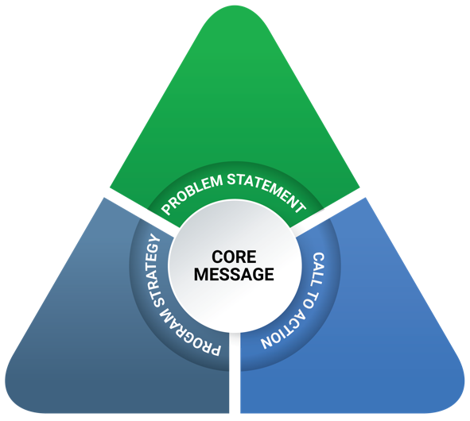
Message Development
MassTAPP analyzed the data from the focus groups and interviews regarding the knowledge, attitudes, and beliefs of the priority populations, and used the MassTAPP Communications Toolkit’s Message Triangle model to develop key messages for each priority population. As illustrated to the right, a core message is the center and starting point of a message triangle. The points of the triangle consist of three elements: a problem statement that describes the problem to be addressed and its importance; a program strategy that describes how the problem will be addressed in a way that will be effective for the audience; and a call to action that describes the steps that the audience can take to effect the desired outcome(s).
MassTAPP ultimately developed three message triangles (two for Strategy 1 and one for Strategy 2). Each message triangle informed the design of an activity that transmits these messages and operationalizes the call to action. The intervention to impact youth (Strategy 1) is a two-step process, involving youth in step 1 and parents in step 2. The effort to impact men of color who have a history of substance misuse (Strategy 2) involves a multi-level intervention in which recovery center members participate in a peer-to-peer outreach strategy. Each intervention is described in more detail below.

Messages to Impact Youth (Strategy 1)
The focus groups confirmed that many youth are aware that gambling is risky and can lead to serious problems later in life, similar to the use of alcohol and other drugs. At the same time, youth do not always make the connection between the term gambling and some of the activities they see around them (such as making “fun bets,” betting with objects such as candy, and betting on sports). Based on this and research showing that a risk factor for the development of a gambling disorder is gambling early in life,² the core message of MassTAPP’s youth intervention is that gambling can be risky and can bring about negative consequences. The call to action directed at youth is to know what gambling is and help your friends recognize what it is. The message triangle below shows the components of the development process for the youth pilot intervention.
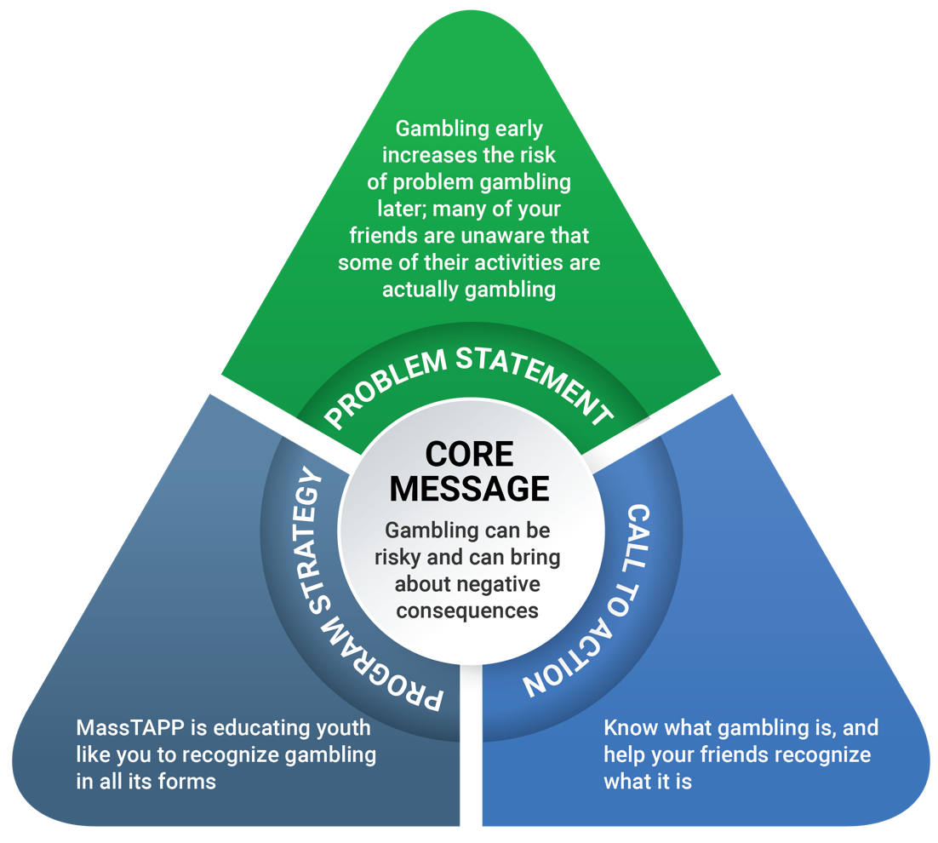
The focus groups and interviews with parents and youth providers suggest that adults are less aware of gambling activities in the daily lives of youth than youth are. Adult participants also did not articulate a recognition that adolescence can be a particularly risky period, during which youth are more likely to make impulsive or impractical choices. Based on these observations—along with research that suggests that having parents who are permissive of or approve of gambling is a risk factor for youth developing a gambling disorder—MassTAPP determined that a parallel activity for parents was necessary.
The core message of MassTAPP’s parent activity is that the adolescent brain is developing quickly, and lessons learned now can pay off later in life. The call to action is that adolescence is a wonderful time for learning, so it is beneficial that parents give their children opportunities to practice self-regulation and avoid actions that indicate approval of gambling. The message triangle below shows the components of the development process for the adult intervention.
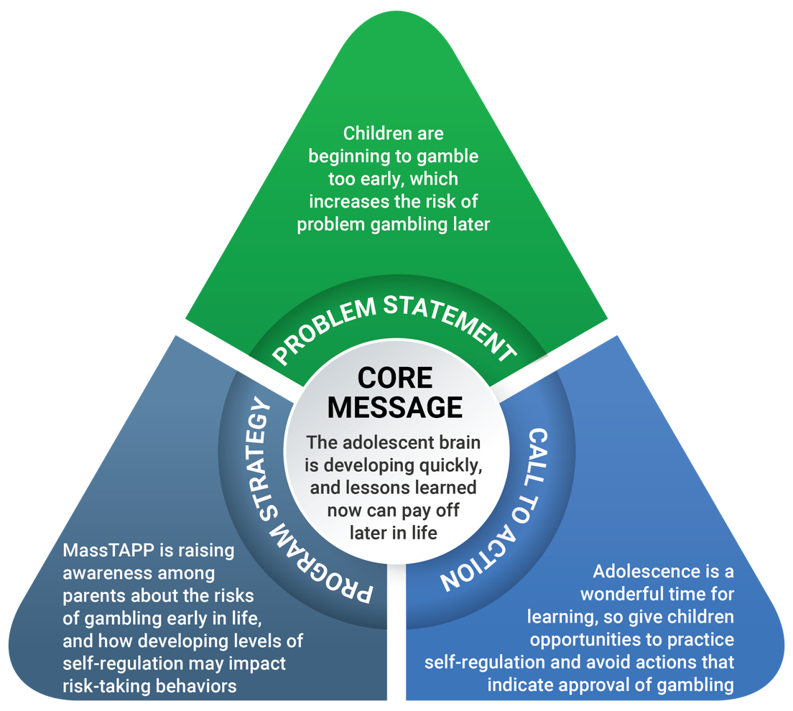
Note: The adolescent brain development component of this message triangle has the potential for positive impacts that include—but also go beyond—gambling behaviors.

Pilot Intervention to Impact Youth (Strategy 1)
To engage both youth and parents around the issue of problem gambling, MassTAPP designed and piloted a PhotoVoice intervention with several components to take place in an afterschool setting over a period of approximately one week. The intervention uses the PhotoVoice research methodology, in which participants take photographs that represent an idea and then explain their photographs in a way that can be shared publicly, either by writing an explanation or by saying aloud (and recording) an explanation of the image and its meaning. Group discussions, centering on the photographs and their explanations, follow. PhotoVoice has been useful in enabling youth and their parents to feel empowered to discuss issues and promote change in their communities.
In this case, adolescents who attend an afterschool program observed examples of gambling in their lives, and used the cameras on their phones to take between one and three photographs of gambling and gambling imagery around them. Students then sent the photographs to the afterschool program staff member who served as facilitator of the PhotoVoice activity. During an in-person session, youth explained why they took each photograph and how it represents gambling, and discussed their responses to each photograph, while the facilitator or other staff member recorded the young people’s explanations in writing. The facilitator then led a group discussion, using the images to explore the many forms that gambling takes and the ways that young people are exposed to it. MassTAPP evaluated the impact of this workshop through pre- and post-event surveys. (See the Evaluation section of this report for more details, and see Appendix B for a detailed project guide, talking points for program staff, and evaluation forms.)
The youth intervention had two objectives:
- Increase awareness of gambling exposure in the everyday lives of youth
- Reinforce the perceived harm of youth gambling
A session for parents and guardians (including but not limited to families of the youth who participated in the PhotoVoice activity) followed this workshop. After inviting the adults to view a display of the youth’s photographs and explanations, facilitators led them in a discussion about youth exposure to gambling and how they can help their children build resilience. Discussion points included what the adults see in the photographs, where gambling exists in youth’s lives, why that exposure might be problematic, and whether their impressions and observations match those of the youth participants. Next, facilitators discussed adolescent brain development, executive functioning, and self-regulation skills, with an emphasis on how these factors might impact gambling-related behaviors and other potential addictions. (See the Evaluation section of this report for more details, and see Appendix B for talking points for parent sessions and evaluation forms.)
The parent intervention had three objectives:
- Increase awareness of what gambling is and where it is present in youth’s everyday lives
- Strengthen understanding of the changes occurring in the brain during adolescence and why gambling may be risky for youth
- Develop concrete ideas of ways to build youth resilience
After the two sessions, MassTAPP followed up with program staff to discuss participant engagement, session highlights, implementation challenges, and impact. MassTAPP also provided TA to program staff to help them think about how they might improve the activity the next time they run it and to think about how it aligns with their organizational goals. MassTAPP will use this information to refine the intervention for future groups and settings.
This potentially impactful activity may be of broad interest, since it comes as a complete package (all supporting materials are included) and can be implemented over a relatively short time. Currently, MassTAPP is working in partnership with three YMCAs in the region, but anticipates that the activity can be carried out in other youth settings, including afterschool programs, summer programs, and schools.

Messages to Impact Men of Color Who Have a History of Substance Misuse (Strategy 2)
Results of focus groups with men in recovery or seeking recovery show that these men view gambling as closely intertwined with drug and alcohol use, in terms of both the contexts in which these substances and activities are found, and the people who use or participate in them. Multiple participants noted their own tendencies toward gambling and the addictive power of gambling on them, even if they did not consider themselves to have a gambling disorder.
The core message of this pilot intervention is that gambling is another addiction, with some of the same risks as substances such as drugs and alcohol. Based on observations by participants about the potential impact of personal stories, MassTAPP determined that the call to action would be to incorporate discussions of problem gambling into treatment and recovery and to encourage men in recovery to be ambassadors, bringing a discussion of gambling into conversations among their peers outside the recovery center. The message triangle below shows the components of the development process for the pilot intervention to impact men of color who have a history of substance misuse.
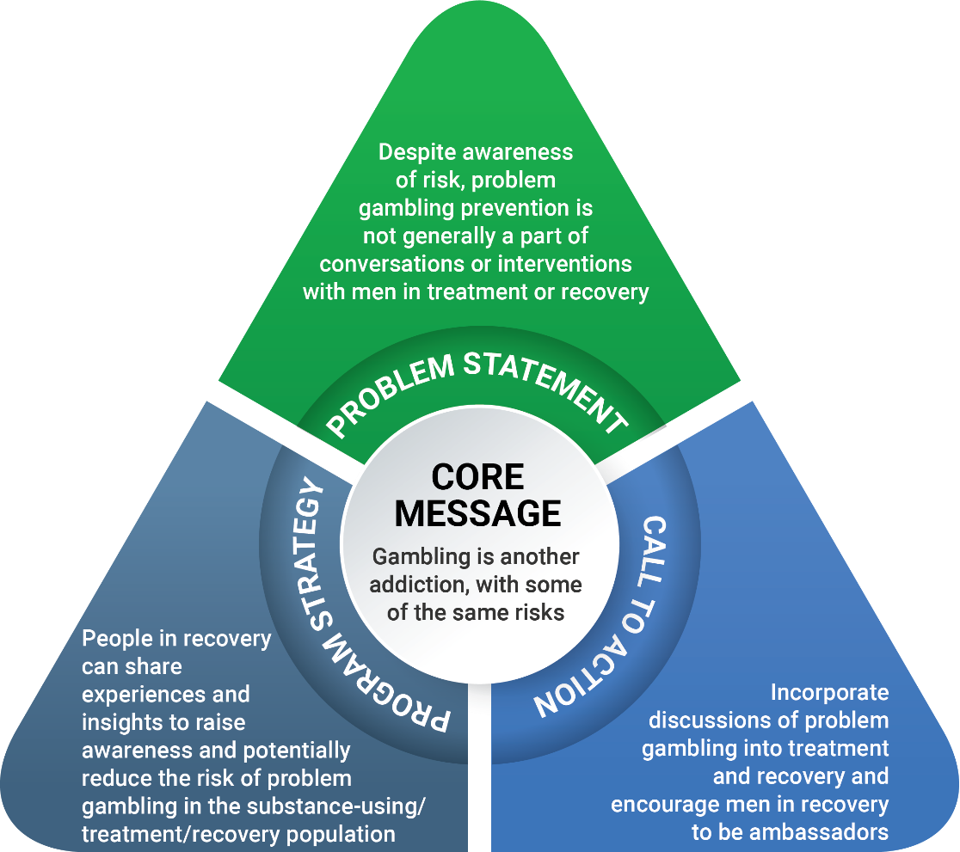
Conversations with recovery support providers suggest that the public does not widely discuss or often recognize gambling as a problem. Some recovery support providers discussed the importance of incorporating conversations about gambling and problem gambling into the recovery center curriculum and of generally including gambling in the conversations on substance use and misuse. MassTAPP’s intervention goal, therefore, was to increase the awareness and readiness of recovery support providers to support members in reducing gambling-related harms. The core messages for providers are that gambling is an issue for the population you serve and that there are clear parallels between problem gambling and substance misuse.

Pilot Intervention to Impact Men of Color Who Have a History of Substance Misuse (Strategy 2)
Applying these findings, MassTAPP developed a two-part pilot intervention to reach men of color who have a history of substance misuse: a peer-to-peer outreach component that directly involved this population, and a handout to impact the approaches taken by recovery support providers.
The intervention had three objectives:
- Increase understanding of the connections between gambling and other addictions among both providers and recovery center members
- Promote self-efficacy and peer-to-peer advocacy
- Decrease rates of problem gambling among males who have a history of substance misuse
MassTAPP developed a guidance document to assist recovery support providers in engaging a group of men in recovery from substance misuse in serving as “ambassadors” for problem gambling prevention. After convening a group and leading a conversation and skill-building session, facilitators requested that over the next week members have a conversation with at least one person in their lives (such as someone at the recovery center but outside the group) about the impact of gambling on their lives, on their family and friends, and on recovery. Approximately one week later, recovery support providers convened the group and facilitated a discussion about the conversations and their outcomes. Group members filled out a documentation form to reflect on the conversations they had had about gambling. Two recovery centers completed this process.
In addition to leading these sessions, recovery support providers also received a handout (see Appendix C) that MassTAPP developed to increase their knowledge about gambling, its prevalence, and its connection to substance use. Impactful quotes about gambling from the focus groups bring these points to life. This handout has the potential to reach and impact providers and others in the broader treatment and recovery communities.

Evaluation
Below is a logic model MassTAPP developed to illustrate the theory of change and the path to desired short-term, intermediate, and long-term outcomes for each strategy. Orange boxes indicate interventions to impact youth; green boxes indicate interventions to impact men of color who have a history of substance misuse; and blue boxes indicate an overlap of both strategies.
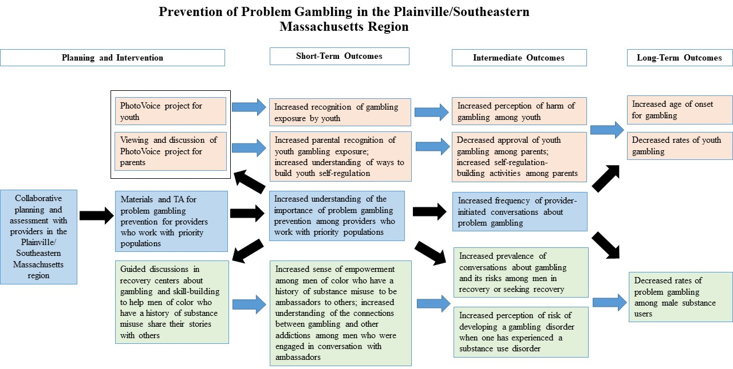

Intervention to Impact Youth (Strategy 1)
As the above logic model illustrates, MassTAPP designed the PhotoVoice project and related discussion sessions with youth and parents to address the indicated short-, intermediate-, and long-term outcomes. However, this brief intervention took place over one to two weeks, so only the short-term outcomes could realistically be measured.

Increased Recognition of Gambling Exposure By Youth
Staff at three YMCAs piloted the youth PhotoVoice project and evaluation (see Appendix B for the pre- and post-event evaluations). Across the three YMCAs, 64 youth completed the pre-event survey, and 35 of these youth completed the post-event survey. In the surveys, youth gave their definitions of gambling and reported on the kinds of gambling they see around them. They also rated the importance of the prevention of problem gambling on a scale from one to five.
Based on the answers the youth gave to the open-response survey questions, it appears that youth who participated in this program gained a slightly broader understanding of the definition of gambling and of the types of gambling they see in their everyday lives. The seven youth who completed the pre-event survey at one YMCA reported, on average, that it is slightly less than somewhat important to prevent problem gambling (2.71 on a 5-point scale); the seven youth who completed the post-event survey reported a higher average perceived importance of prevention (2.86 on a 5-point scale). In this YMCA, youth’s perceived importance of preventing problem gambling increased by 5.5%. In a second YMCA, the 19 youth who completed the pre-event survey reported, on average, that it is more than somewhat important to prevent problem gambling (3.37 on a 5-point scale); the 14 youth who completed the post-event survey reported a lower average importance of prevention (3.14 on a 5-point scale). Here, youth’s perceived importance of preventing problem gambling decreased by 6.82%. Similarly, in the last YMCA, the 38 youth who completed the pre-event survey reported, on average, that it is somewhat important to prevent problem gambling (3.32 on a 5-point scale). Post-event survey reports of importance of the prevention of problem gambling, based on 14 youth who completed the post-event survey, are not statistically different from the pre-event survey results (3.31 on a 5-point scale, a 0.3% decrease).
At one site, about half the youth participants reported an increase in their understanding of gambling as prevalent, and an increase in their perception of gambling as a problem; the other half reported no change in their thinking about gambling. At the other location, almost all (12 of 14) of the youth reported no change in their thinking about gambling after the PhotoVoice project, either because they always thought of gambling as an issue or because they have a lot of exposure to gambling in their day-to-day lives. Two youth did report a change in their thinking about gambling. At the last center, most (10 of 14) youth said that they do not think differently about gambling because they already knew about gambling and its harms, or because they do not participate in gambling. Three youth reported thinking previously that gambling was not an issue, but realized during the session that it can be dangerous.
It is important to note that considering the small number of participants, any analysis of the impact of this strategy is inconclusive. The fact that identifying information was not included on the surveys further complicates the results, as there was no way of knowing whether particular individuals benefited from the intervention, and no way to exclude from analyses youth who completed only a pre-event (but not a post-event) survey. Conducting a more formal evaluation is necessary and will yield more conclusive results about the intervention’s effectiveness. See the Lessons Learned and Recommendations sections of this report for further explanation of these concerns.

Increased Parental Recognition of Youth Gambling Exposure
Two afterschool centers, one located in an urban area and the other in a suburban area, ran the parent follow-up session. Across these centers, 15 parents completed a pre-event survey, and 13 completed a post-event survey, to test changes in parents’ knowledge and beliefs about gambling. Before the event, the five parent participants from one center reported that they see prevention of problem gambling as more than moderately important (4.2 on a 5-point scale); their post-event surveys indicate an increase in their perception of the importance of prevention (4.4 on a 5-point scale). In this group of parents, there was a 4.76% increase in the perceived importance of prevention. They also reported on the usefulness of the session, ranking the session on average as moderately to very useful (4.6 on a 5-point scale). During the pre-event survey, the 10 parents from the other center reported that prevention of problem gambling is between moderately and very important (4.7 on a 5-point scale); the 8 parents who completed post-event surveys reported, on average, that prevention is marginally more important than they reported before the session (4.75 on a 5-point scale). The difference is marginal, but calculations show a 1.06% increase in perceived importance.
Again, small participant numbers make it impossible to draw any conclusions in terms of impact. However, a MassTAPP observer noted that there was an animated discussion among parents about the risks of gambling and ways in which parents’ behavior influences their children. A comparison of discussions at the two centers highlights notable differences in parents’ experience with and approaches to gambling. More parents from the urban area personally participate in gambling, citing behaviors such as buying scratch tickets regularly and saving them for times of need, and going to casinos with the hope of winning a free room so that their children could enjoy a stay in a hotel. Parents from the suburban area were less frequently involved in gambling and did not suggest that gambling, for them, was connected to hope.

Parents’ Increased Understanding of Ways to Build Youth Self-Regulation
Staff leading the parent session at both afterschool centers did not complete the segment on opportunities to support development of youth self-regulation skills. In one center, the decision to omit this section was related to the mismatch of the participants’ English language ability and culture, and the handout’s academic language. In the other afterschool center, a staff member who had not participated in MassTAPP’s orientation session conducted one of the parent sessions and, without guidance on methods for presenting the material, did not facilitate a discussion about youth self-regulation. MassTAPP intends to modify this component of the intervention so that it is more relevant to participating parents at each site.

Youth Service Providers’ Increased Skills and Knowledge
All providers who agreed to participate in the pilot received the guidance document Youth Gambling Prevention Project Guidance for Youth Workers/Facilitators and talking points for leading discussions with youth and parent participants (see Appendix B). They also received individualized support and guidance from MassTAPP staff about the project’s goals and expectations for implementation. YMCA staff responded positively to this input, but a tool to measure changes in their skills and/or knowledge has not yet been developed. MassTAPP expects to gather qualitative data about this desired outcome in follow-up meetings within the next month or two.

Debrief with Program Staff
MassTAPP conducted a post-intervention debrief with staff at each pilot site to learn more about the impact of the interventions and to discuss any challenges the sites experienced with the process. Staff were overall very pleased with the youth PhotoVoice intervention, saying it was age- and culturally appropriate and describing how much the youth enjoyed the activities and discussions. Staff provided helpful critiques of the follow-up session with parents, describing suggestions such as allowing more time to plan the session, providing interpreters for different languages and translating materials, providing food, aiming content at younger children as well as adolescents, and simplifying the parent handout to make the language more relevant and accessible.
These suggestions will inform the revision of materials developed for this intervention, and will help MassTAPP conduct a smoother planning process in other regions.

Intervention to Impact Men of Color Who Have a History of Substance Misuse (Strategy 2)
Similar to the Strategy 1 intervention, the intervention developed for this priority population is brief and limited in scope; thus, it is only possible to examine short-term outcomes at this time.
Two recovery centers hosted the pilot intervention for men in recovery. After selecting a group of men, recovery center staff encouraged them to be ambassadors and to talk to others about problem gambling; MassTAPP used follow-up discussions with these ambassadors to evaluate the short-term impact of incorporating discussions of problem gambling into peer-to-peer conversations. It is important to note that this intervention served to impact two distinct groups: the ambassadors who have received coaching and encouragement to share their knowledge and values with their peers, and the individuals brought into these conversations by the ambassadors. MassTAPP gathered some feedback from the ambassadors but not from the second group, whose changes in knowledge, skill, or behavior were not readily accessible.

Recovery Support Providers’ Increased Skills and Knowledge
After conducting focus groups and key informant interviews in each of the recovery centers, MassTAPP developed a handout, titled Addressing Problem Gambling: What Substance Use Disorder Service Providers Should Know, which staff at each participating site received. Staff also received Guidance for Providers Working at Recovery Support Centers, which provides a step-by-step description of the intervention. MassTAPP staff met with recovery center staff to explain the activity and how it relates to problem gambling prevention, and provided support and coaching as needed. MassTAPP expects to be able to gather qualitative data about this desired outcome in follow-up meetings over the next month or two.

Increased Sense of Empowerment Among Men in Recovery to be Ambassadors to Others
In one recovery center, 4 recovery center members (“ambassadors”) had conversations with 12 other men about gambling. In the other recovery center, 4 ambassadors had conversations with 14 other men about gambling. Rather than complete a written survey, these members participated in a follow-up discussion led by recovery center staff; a MassTAPP representative was present to gather qualitative data from the discussion.
Ambassadors shared that after putting some thought into how and where to have the conversation, they felt prepared to approach and speak with their peers. The men took different approaches to preparing for the conversations; at least one ambassador stated that he needed to have information and resources on hand so that he could answer any questions from someone with a gambling disorder. Overall, several members said that they felt good about being in this role and received good feedback from their peers. For some, it provided a “flashback” to their own experience with an addiction disorder. At least one ambassador reported feeling intrusive asking gambling-related questions of a familiar person, but others were quite comfortable with the role. One member stated that he was excited to talk about gambling because “no one talks about it.” Another described the positive feelings that come from doing something good and having others pay attention.

Increased Understanding of the Connections Between Gambling and Other Addictions
The ambassadors reported that the men they spoke with had a variety of reactions. A few refused to talk about the topic at all, but others were happy to be part of the discussion. A few ambassadors noted that the men who felt upset or did not want to participate may have been struggling with gambling. Some of the men they spoke with did not see the connection between gambling and substance use or did not see gambling as a problem; ambassadors were eager to share information about the relationship between addiction and the potential consequences of problem gambling. One comment was that those in long-term recovery have a better understanding of the connection between substance use disorders and gambling.
The ambassadors had a number of suggestions about how to increase awareness and opportunity for discussions about problem gambling in order to have a greater impact on this population, for example:
- Strive for more media focus on gambling: television ads, newspaper articles, and other communications that focus on personal stories and the “trials and tribulations” associated with gambling
- Treatment and recovery programs should do more to educate members about the connection between substance use disorders and gambling and should give people resources they need; funds should be dedicated for buying and distributing materials
- Focus on youth and provide needed resources and supports
- Offer more support groups and treatment facilities that address gambling

Intermediate and Long-Term Outcomes
Although the hope and expectation of the piloted initiative was that it would ultimately increase the age of onset for youth gambling and reduce rates of problem gambling among men of color who have a history of substance misuse, the scope and timeline of the pilot made it difficult to track many of the intermediate and long-term impacts. The lack of baseline data is also a challenge. Some city- and town-level youth surveys capture youth gambling rates, but there were no such surveys for the Plainville/Southeastern Massachusetts region during the pilot period. The SEIGMA study collected information about gambling rates among youth ages 18–22 across Massachusetts, but does not include data about younger youth and does not specify the region in which the sampled youth live.⁶
Although evaluating intermediate and long-term outcomes is beyond the scope of the current project, there is hope that data collected in the near future will help to assess the impact of these interventions. In the meantime, MassTAPP will continue to document implementation practices and collect data on short-term outcomes to inform future initiatives.

Next Steps
MassTAPP will carry out the following activities during the next few months, in order to wrap up and further document the planning and piloting process for the Plainville/Southeastern Massachusetts region.

Pilot Activities for Strategy 1
As described earlier in this report, the Foxboro YMCA was unable to schedule the parent portion of the intervention during the month of June. They are committed to holding the parent workshop sometime this year, and someone from the MassTAPP team will observe this session.

Convene an Advisory/Stakeholder Group
MassTAPP will convene an advisory group consisting of representatives from organizations that serve the two priority populations. This group will provide input on strategy implementation to MassTAPP and at the same time will benefit from information and resources to take back to their respective organizations. In addition, this may provide a forum for linking or collaboration with substance use prevention coalitions in the region, to discuss common risk and protective factors and comorbidities.

Revise and Refine Materials
Based on feedback from implementers and stakeholders, as well as the analysis of outcomes from the pilot implementations, MassTAPP will revise and refine the materials and resources developed for this project, including guidance for strategy implementation, handouts for providers and parents, and evaluation forms, all of which may require some editing after analyzing responses from the pilots.

Lessons Learned
This first iteration of a regional planning process has offered multiple lessons that will foster a smoother, more efficient process in Regions A and B. These lessons are discussed below.

Build Relationships and Establish Partnerships Early
It is essential to request input from community-level practitioners at the beginning of the planning process. Raising awareness of the issue is key, especially when addressing problem gambling in the midst of an opioid overdose crisis. In addition, the earlier the process begins, the more likely it is that community organizations will be able to collect baseline data.

Provide a Timeline and Clear Expectations to Partners, and Identify Communication Channels
The pilot implementation is not overly complex or time-consuming, but bringing together groups of youth and parents, training staff, and ensuring that evaluation forms are completed does take some planning and vigilance. The earlier that MassTAPP can explain these expectations and present a clear timeline, the more likely the avoidance of roadblocks (such as the rescheduling of the parent workshop in Foxboro due to a last-minute staff transition).

Ensure that Information and Referral Sources are Available to all Partners and Participants
This came up in particular when considering Strategy 2, as ambassadors may encounter questions, resistance, or instances of individuals feeling triggered by discussing substance misuse. It is important for Strategy 1 as well, because youth could disclose a pattern of problem gambling that they see at home.

Ensure Inclusion of Participants from a Wide Range of Backgrounds
Results from the implementation of Strategy 1 indicate that there are differences in exposure to gambling and participation in gambling between participants in urban and suburban areas. In the pilot interventions, this was particularly true for parents’ exposure to and approaches to gambling. Including a diverse array of participants, with different cultural and racial backgrounds, income levels, urban-rural classifications, gender identities, ages, and so on, will support a more nuanced and more complete understanding of gambling in Massachusetts. Similarly, modifying materials while taking into account their applicability and acceptability to members of different communities and regions may ensure that appropriate and effective prevention work reaches a wider audience across the state.

Recommendations
After carrying out a regional planning process and piloting of prevention initiatives for two priority populations in the Plainville/Southeastern Massachusetts region, MassTAPP has several recommendations:
- Considerations of health equity should be primary in selecting priority populations for interventions, to clearly identify gaps in health outcomes and local resources for certain populations, and to ensure a stronger impact on the region and state.
- Consultation and collaboration with local community members, including members of priority populations and key stakeholders, should be ongoing throughout the intervention’s development and implementation to support maximum participation by and feedback from the community.
- Collaboration with other groups funded by DPH to conduct parallel efforts (such as the Community Health Worker Initiative and the statewide communications campaign for the prevention of problem gambling) should be ongoing.
- Linkages with local prevention coalitions should be cultivated, including those funded by BSAS that already receive TA from MassTAPP for their substance use prevention initiatives.
- All efforts must be evaluated as thoroughly as possible to assess impact and support the sustainability and modification of strategies being implemented. An evaluation plan should be incorporated into all strategies prior to implementation.
- To ensure sustainability, messaging should be integrated into existing programs, and partnerships with local resources should be developed and maintained.

Appendix A:
Focus Group and Key Informant Interview Questions

Strategy 1: Youth Focus Group Questions
- When you hear the word gambling, what does that mean to you? What do you think of?
- What types of gambling are there?
- Where do you see gambling in your life?
  - Are there adults or other youth you know who gamble?
  - What are their roles in your life?
  - Do you gamble?
- Have you ever heard of problem gambling?
  - What do you think it means?
  - Have you ever seen problem gambling? Tell me about it.
- What benefits are there to gambling?
- What risks are there to gambling?
  - How harmful to do you think gambling is?
- Do you think some types of gambling seem better or worse than others?
  - In what way?
  - What makes you say that?
- Have you ever seen any messages about gambling, for example, on billboards, on TV ads, or in magazines?
  - What are they?
  - Where did you see them?
  - What did you think when you saw them?
- If you were going to talk to your friend about gambling or addiction, what would you say?
- How do you usually get information? (Online, TV, word of mouth?)
- Is there anything else you think is important to add to this discussion?

Strategy 1: Parent Key Informant Interview and Focus Group Questions
- When you hear the word gambling, what does that mean to you? What do you think of?
- Where do you see gambling in your life?
  - Are there adults or youth you know who gamble?
  - What are their roles in your life?
  - Do you gamble?
- How do you feel about your kid(s) gambling?
- What benefits are there to gambling?
- What risks are there to gambling?
  - How harmful to do you think gambling is?
- Do you think some types of gambling seem more OK or less OK for youth?
  - In what way?
  - What makes you say that?
- Have you ever talked to your kid(s) about gambling or addiction?
  - What prompted the conversation/why?
  - How many times did you talk about it?
  - What did you say?
  - How did it go?
  - What would you do differently, if you were to do it again?
- How do you usually get information?
  - Online?
  - TV?
  - Word of mouth?
- Is there anything else you think is important to add to this discussion?

Strategy 2: Men in Recovery or Seeking Recovery Focus Group Questions
- When you hear the word gambling, what does that mean to you? What do you think of?
- What types of gambling are there?
- Where do you see gambling in your life?
  - Are there friends, relatives, or other people in your life who gamble?
  - What are their roles in your life?
  - Do you gamble?
- Have you ever heard of problem gambling?
  - What do you think it means?
  - Have you ever seen problem gambling? Tell me about it.
- What benefits are there to gambling?
- What risks are there to gambling?
  - How harmful to do you think gambling is?
- Do you think there are any connections between gambling and substance use?
  - What are they?
- Do you think some types of gambling seem better or worse than others?
  - In what way?
  - What makes you say that?
- Have you ever seen any messages about gambling, for example, on billboards, on TV ads, or in magazines?
  - What are they?
  - Where did you see them?
  - What did you think when you saw them?
- If you were going to talk to someone you know about gambling or addiction, what would you say?
- How do you usually get information? (Online, TV, word of mouth?)
- Is there anything else you think is important to add to this discussion?

Strategy 1 and Strategy 2: Non-Parent Key Informant Interview Questions
- Do you think problem gambling is an issue in the Plainville/Southeastern Massachusetts region?
  - Why/why not?
- How prevalent is problem gambling in the Southeast?
  - How do you know/where does this information come from?
- How much talk about problem gambling in the Southeast have you heard or learned about?
  - Do you think people have positive or negative associations with gambling?
  - Do you think people consider problem gambling an issue of concern?
  - Why do you think this?
- What do you think should be done to integrate problem gambling prevention into other conversations on health and well-being?
  - Which conversations?
  - How could that be done?
- What are some ideas you have for communications strategies or message dissemination?
- Is there anything else you think is important to add to this discussion?

Appendix B:
Youth Gambling Prevention Project Guidance for Youth Workers and Facilitators

Purpose
In response to the legal expansion of gambling in Massachusetts (slot parlor open in Plainville, casinos scheduled to open in the next few years), as well as data about current youth gambling practices, the Department of Public Health has prioritized the development of messages and materials for youth in order to reduce the risk of problem gambling.
Many young people are surrounded by a culture of gambling without even realizing that this is the case. Because youth’s brains are still developing the capacity for reasoning and judgment, adolescence is a time when individuals are more impulsive, more likely to engage in high-risk behavior, and more likely to focus on short-term payoff than long-term consequences.
Parents and caregivers may also be unaware of the prevalence of gambling in their children’s lives, so this activity includes a parent information component.

Objectives
For youth:
- Increase awareness of what gambling is and where it is present in their everyday lives
- Strengthen their understanding of why gambling can be risky
- Develop concrete ideas about other ways to have fun and make money
For parents:
- Increase awareness of what gambling is and where it is present in their children’s everyday lives
- Strengthen their understanding of the changes occurring in the brain during youth and why gambling is risky for youth
- Develop concrete ideas about how to talk to their children about gambling

Overview
This project is inspired by PhotoVoice, a participatory and community-based type of research. PhotoVoice creates space for participants to document their lives through photography and present their experiences, and supports participants in feeling empowered and prepared to bring about change in their community.
The youth gambling prevention project uses PhotoVoice principles and techniques to illustrate youth participants’ perspective on gambling, which will serve as a starting point for a facilitated discussion of the issue. Photos taken by students will also be used to initiate a discussion with parents and caregivers.

Project Guide
- Introduce project to youth
  - At least two days before the session (up to one week before is OK), have youth complete the Pre-Event Survey for Youth (provided). Collect surveys.
  - Ask youth to take one to three photos of what gambling means to them and where they see it in their lives. Try to keep the instructions and discussion as brief as possible, so that youth can come up with their own perceptions of what gambling looks like to them.
  - Distribute Intro to PhotoVoice: Project Description Handout (provided) to youth as a reminder of the assignment.
  - Remind youth to send photos to you via e-mail by a designated deadline.
- Prep for workshop with youth
  - Compile the photos from the youth.
  - If possible, print photos in color (as large as possible), and hang them up around the room. Do not add names to the photos.
  - If this is not possible, prepare to project photos onto a screen or wall during the session.
- Conduct workshop with youth
  - Use Talking Points: Talking to Youth About Gambling (provided) to facilitate a conversation about the youth’s photos and their perspectives on gambling.
  - Give youth the opportunity to describe their photos to the group, recording their explanations on an audio recorder or in writing as accurately as possible.
  - Ask youth to fill out the Post-Event Survey for Youth (provided).
- Prep for workshop with parents
  - Set up an exhibit of their photos along with their descriptions/explanations (transcribed from a recording if necessary).
  - Display the photos from the youth session around the room, with the corresponding caption next to or below each photo.
- Conduct workshop with parents
  - Invite parents to the photo exhibit.
  - Ask parents to fill out a Pre-Event Survey for Parents (provided).
  - Give parents some time to view the exhibit of photos and captions.
  - Use Talking Points: Talking to Parents About the Youth Photo Exhibit (provided) to facilitate a discussion with parents about what they see, where gambling occurs in their children’s lives, and why that might be problematic.
  - Discuss the power that parents have to provide opportunities for their children to practice self-regulation and self-control.
  - Give parents a chance to brainstorm together about ways to give these opportunities to their kids.
  - Give parents the Executive Function Activities for Adolescents handout (provided).
  - Ask parents to fill out the Post-Event Survey for Parents (provided).

- Follow-up/lessons learned
  - Take a look at the pre- and post-event surveys, if you want to, and then send them to MassTAPP (scan and send if possible, or speak to us about other means of transmission). MassTAPP staff will compile the results and share the summary with you.
  - Kitty Bowman (or someone else from MassTAPP) will schedule a follow-up meeting to discuss the following:
- What went well in terms of implementing this activity, and what would you do differently next time?
- Is there any feedback from the evaluations that is surprising or different from your experience with this project?
- Based on your observations and existing relationships with participants, what do you think they learned?
- Do you think they will change their behavior in any way?
- Have you heard any comments about the activity since it ended?
- Would you conduct this activity again in the future with different participants? Why or why not?

Talking Points: Talking to Youth About Gambling

Introduction
We’re excited to have you all here and ready for an interesting discussion about gambling. Just so you have a little bit of background, this project is part of the Massachusetts Technical Assistance Partnership for Prevention’s efforts to prevent problem gambling.
A few days ago, we asked you to take photos of where you see gambling in your life and what gambling means to you. You all sent in your photos, and you can see that they’re hung up around the room [or: being shown on the screen].

What is gambling overall, and what do youth say about it?
- Overall, gambling can be defined as betting money, material goods, or something of value on an event with an uncertain outcome in the hopes of winning additional money, material goods, or something of value.
- We have a lot of examples from you all of gambling and where you see it day to day, and we will get to discussing your photos and experiences in just a few minutes.
- In another part of this project, a lot of youth participated in focus groups about gambling, and they often said that they think gambling is risky and can be dangerous. They said things like:
  - “[You] get broke. If you lose your money, your house, your job. You could steal money. Affects relationships.”
  - “Gambling is never really good. Yeah, you might be able to win money every once in a while, but most of the time you will lose, even just on buying scratch tickets.”
  - “Honestly, the casino scene looks fun, but when you think ahead you realize, ‘This’ll happen, this’ll happen,’ and you realize it looks fun sitting down from here, and I’ll just watch it in the movies.”
  - “It’s from gambling that everything starts. You get in debt, you want to relieve yourself, you get more in debt. It’s what brings you to that path.”
- Another thing that came out of the project is that even though many youth think gambling is dangerous, sometimes people your age do things that really are gambling, even if not everyone realizes it. The other youth we talked to said they realized that they’re gambling when they’re:
  - Betting on sports, like with fantasy football
  - Using claw machines or token games at arcades
  - Betting on tests or other everyday things
  - Getting and scratching scratch tickets
  - Playing certain video games
- So, it looks like people your age think that gambling is bad, but it turns out that gambling is part of everyday life—at home, at school, and with friends.

Where do you see gambling in your life or community?
- Now let’s get to your photos! From what those groups said and from what you all took photos of, it’s clear that you know what gambling is and that you see it in a lot of parts of your life.
- We’d like to hear about everyone’s photos, whether you sent in one, two, or three, because everyone’s experiences and stories are incredibly valuable. The way we share our stories is up to you. [Facilitator should take five or so minutes to discuss the format with youth so that everyone agrees. Youth should take the lead on this and make the final decision. Let youth know that an audio recording or notes will be taken.]
  - Some ideas:
    - Look around the room and have each person talk about their photo in the order it comes up on the wall/screen
    - Volunteer for who goes first
    - Others say what they see in a photo, and then the photographer describes it
- Proceed with the discussion as agreed. Audio-record or write down descriptions and responses.
- Ask: What does this photo mean to you? Why did you take it? Does it remind you of anything? What were you feeling in the moment?
- If anyone has comments on or questions about a certain photo, interpretation, or story, you can raise them when the photographer has finished talking about their message. We hope this will be a great discussion, but remember that if the photographer doesn’t feel comfortable sharing something, that’s OK too.

How was that experience for you?
- Thanks so much for sharing about your photos.
- Ask: What did you think about the activity of going out and taking pictures of things you see in your community, and then talking about it with the group?
- Ask: Do you think anything should be done about gambling in your community? What will you do?
- Ask: What are some alternatives to gambling that you can think of?

Closing
- Thank you for participating! Your photos and insights were really helpful, and they will definitely get the conversation started about gambling—and get people learning about what it is and where it exists in their lives.
- Later on, we’ll also hold a parent session, where parents will view the photos and descriptions that we recorded and then respond to what they hear.
- Ask: Is there anything else you think is important for them to know? Do you have any closing thoughts?

Intro to PhotoVoice: Project Description Handout
You’ve been chosen to participate in a photography and discussion project! Our topic for this project is gambling. We want to see and hear from you what gambling means to you and where you see it in your life. What better way for us to see what you see than through photographs?
We’re asking that you use a phone or camera to take up to three pictures of where you see gambling in your life or neighborhood. If you do not have a phone or camera, see if you can borrow one from a friend or family member, or talk to a YMCA staff member for help with accessing one. If you take a picture where you can see a person’s face, you must ask this person for permission and explain to them why you are taking a picture.
For each picture, write a short blurb (up to four sentences) about what you see, why you took the picture, and how it relates to the topic.
Send your pictures and blurbs to the YMCA staff member facilitating this project by the date they specify.
In a group of other youth, you will look at all the photos, share your experiences participating in the photography portion of this project, and talk about what gambling means to you.
We can’t wait to see your photos and hear your thoughts!

Talking Points: Talking to Parents About the Youth Photo Exhibit

Welcome
- This exhibit is part of the Massachusetts Technical Assistance Partnership for Prevention’s efforts to prevent problem gambling.
- It was created by YMCA youth ages 13 to 19 who used cell phones or cameras to photograph images related to gambling, wrote captions for their pictures, and discussed gambling as portrayed by their images.
- We are grateful to the youth for their contributions to efforts to prevent problem gambling. We also thank you, the parents, for participating in this event.

Exhibit or Presentation of Pictures and Captions
- Ask: What do you see in the pictures?
- Discuss: Definition of gambling
- Gambling is betting money, material goods, or something of value on an event or action with an uncertain outcome in the hopes of winning additional money, material goods, or something of value.
- Ask: What do you think about the examples of gambling that you saw and read about in the exhibit? Do you agree with them? Did they miss anything?
- Discuss: Youth’s perceptions of gambling [share this information if it hasn’t come up in discussion]
- Youth in focus groups were asked to identify different types of gambling activities and where they occur.
- Their examples of gambling activities included dice, casinos, racetracks, scratch tickets, and fantasy sports.
- The youth saw gambling activities in their homes, schools, and communities, and on the Internet and television (casinos advertisements, television programs, movies).
- Most of the youth said they saw more alcohol and drug use than gambling.

Adolescent Development
- Adolescent brains are still developing.
  - Adolescence is a critical period in brain development, second in importance to the first five years of life.
  - During this time, individuals become better at planning, controlling their impulses, and weighing the benefits and costs of their decisions before they act.
- Ask: How do you think these ideas are connected to gambling?
- Ask: How do your teens make decisions?
- Discuss: [share this information if it hasn’t come up in discussion] Adolescents:
- Are especially sensitive to rewards
- Focus on short-term rather than long-term consequences
- Have a weaker orientation to the future, and are more likely to pay attention to the immediate and short-term drawbacks of their choice
- Are highly susceptible to peer influence, particularly during early and middle adolescence
- Are less able than adults to regulate their behavior, due to lack of maturity in the brain region associated with cognitive control
- May have a hard time making decisions if emotions or social influences are strong

To summarize:
- Youth are surrounded by a culture of gambling, just as their brains are still developing and their capacity for reasoning and judgment is not fully developed.
- Adolescence is a time when individuals are more likely to engage in high-risk behavior, are more impulsive, and are more likely to focus on short-term payoffs than on long-term consequences.
- On the other hand, this period of brain development also provides an important window of opportunity for teens to develop new skills.
- Ask: Can you think of some examples of things that your teens are learning, or skills they are developing, that are particularly suited to this stage of their lives?
- Ask: How can you help your teens develop stronger executive functioning and/or self-regulation skills?
Distribute the Executive Function Activities for Adolescents handout.

Pre-Event Survey for Youth
- How important do you think it is to prevent problem gambling (circle one)?
Not important at all 1 2 3 4 5 Very important
- What is gambling?
- What kinds of gambling do you see around you?
- Did you participate in a focus group about gambling last month?
Yes No

Post-Event Survey for Youth
- How important do you think it is to prevent problem gambling (circle one)?
Not important at all 1 2 3 4 5 Very important
- What is gambling?
- What kinds of gambling do you see around you?
- What did you learn from this project?
- Do you feel differently or think differently about gambling than you did before this project?
Why or why not?
- Is there anything that you think you will do differently now? If so, what?

Pre-Event Survey for Parents
- How important do you think it is to prevent problem gambling (circle one)?
Not important at all 1 2 3 4 5 Very important
- What kinds of gambling do your kids see around them?
- Did you participate in a focus group about gambling last month?
Yes No

Post-Event Survey for Parents
- How important do you think it is to prevent problem gambling (circle one)?
Not important at all 1 2 3 4 5 Very important
- How useful was this session (circle one)?
Not useful at all 1 2 3 4 5 Very useful
- What kinds of gambling do your kids see around them?
- What did you learn from this event?
- Do you feel differently or think differently about gambling than you did before this event?
Why or why not?
- Is there anything that you think you will do differently now? If so, what?

Appendix C:
Documents for Recovery Support Providers

Guidance for Providers Working at Recovery Support Centers
Goal: To help men in recovery from substance misuse see themselves as ambassadors for problem gambling prevention in order to help prevent escalation of gambling and gambling-related harms among their friends and family members.
Core Message: From the focus groups we facilitated at the Recovery Support Centers (RSCs), and from additional research that has been conducted with people who have substance use disorders (SUDs), we have learned that gambling has affected the population you serve. We also know that there are parallels between problem gambling and SUDs.
Problem: A significant number of people with SUDs have also experienced problems with gambling during their active drug use and during their recovery processes. For example, they have experienced financial hardships, incarceration, relapse, loss of employment, and impacts on family and other relationships. Simply put, there’s a correlation between gambling and SUDs.
Immediate Actions at the RSC: During this week, we would like you to convene a group of between five and seven male RSC members and volunteers and ask them to engage in a conversation about gambling and how it affects recovery with at least one person who comes to the center, or someone else in their lives who has an SUD. The main focus of these conversations should be to raise awareness about the correlation between gambling and recovery and to provide support and guidance where possible.
Follow-Up: Next week, we would like you to convene the group and facilitate a discussion about how the conversations went. Guiding questions for the meeting can include the following: Were people open to the conversation? What were the central points of the conversations? What do they recommend the RSC do to continue raising awareness? Did they learn anything new?
Possible Actions in the Future: We can include information about gambling in SUD treatment and recovery support processes. For example, we can ask specific questions about people’s experiences with gambling, and design and deliver recovery support services that take gambling into account. At the RSC, you can include problem gambling information in the orientation process for new members. Gambling can also be incorporated into peer education activities and recovery support groups. The RSCs can also include gambling information in the library and on the webpage and social media sites.

Addressing Problem Gambling: What Substance Use Disorder Service Providers Should Know

What is gambling?
The Social and Economic Impacts of Gambling in Massachusetts (SEIGMA), a research initiative at UMass Amherst, defines gambling as “betting money, material goods, [or something of value] on an event or action with an uncertain outcome in the hopes of winning additional money, material goods, [or something of value]. This includes activities such as lottery games, bingo, betting against a friend on a game of skill or chance, and betting on horse racing or sports.”¹

How common is gambling?
Although many people (about three out of four adults in Massachusetts) participate casually in some kind of gambling each year, for some of these people gambling can become a serious problem.¹ Like those with a substance use disorder, people with a gambling disorder have weakened control over their gambling and have to deal with negative consequences as a result.
Data from 2015 show that 1.7% of the population of Massachusetts (over 115,000 people) classify as problem gamblers, and another 7.5% (about 510,000 people) have gambling habits that put them at risk of developing a gambling problem or addiction.¹

Are substance users at higher risk for developing a gambling problem?
According to SEIGMA results, at-risk and problem gamblers are more likely to report serious problems with depression and anxiety, and are more likely to consume large amounts of alcohol at one time.¹ Other research shows that problem gamblers are at higher risk for substance misuse and suicide.^{2,3,5}
A significant number of people with substance use disorders also have problems with gambling during their active drug use and during their recovery process. As a result, they experience issues such as financial hardships, incarceration, relapse, loss of work, and impacts on family and other relationships.

What do people in recovery say about gambling in their lives?
Participants in the focus groups we conducted shared the following:
“It’s not too much separate . . . It goes hand in hand because it’s obsession and compulsion. Personally, I don’t know anyone who just gambles. And where I come from, I don’t know anyone who just uses. We all gambled, even in active addiction. I think it’s one.”
“It’s like chasing the high, like a drug. ‘I’m gonna win—if I win my problems are done.’”
“Last year, I thought maybe if I win a lot of money, I can buy a lot of gifts for my family. I didn’t see it coming, but what happened is it became an addiction. I had false hope, I thought that this ticket might be it, and I kept telling that lie to myself that it might be the one. I found myself spending all my money and not [having] food in the house.”
“I went to Las Vegas. I played a machine I liked, I won, and put the money in my pocket. I went upstairs and went back down, and the machine was calling my name. I saw the disease wheels turning, and I left. My wife wanted to go back to the casino after dinner. I went to another machine and won again. I got that feeling that I was going to win again, but the voice in my head told me I had to stop doing it, I knew where I would go with it. I’m a substance user, I could never put it down, and I worked myself through the situation in my head.”
“The more I lost, the more I used.”
“Even just walking into a convenience store, and what’s in front of you but a wall of scratch tickets?
. . . And they’re good with the news stations, when someone wins they have a story on them . . . I don’t think you can go through the day without seeing something about gambling. I watch the weather on the weather channel, and there’s a little thing that scrolls at the bottom, ‘numbers game, Powerball’; on the radio it’s advertisements, billboards.”
“Feeding the beast . . . when it gets big, you have to be careful. It’s like drugs—come down and then you need more. Just like with drugs. Can’t control it—not just $1 ticket, let me have the $5. Scratch tickets and drugs—gambling my life.”
“There was a time last year before Christmas that I hit a $100 scratch ticket and I went and lost it all in five seconds, and I felt the same way as when I was using . . . That caught my attention, and I said, ‘Whoa.’ I play cards sometimes when I go see my family. We bet 50 cents a hand, and sometimes I lose $30; I just keep playing.”
“[I] used to buy the scratch tickets by the bundle. [In] 1999 I quit, and I have yet to buy another scratch ticket. Always 50-50 about getting my money back. I came to the point where I said ‘I quit,’ but I switched from one addiction to another, started to use more cocaine. I think it is possible to quit . . .”
“Even if I buy a few scratch tickets—the big lotteries, I think about the money and winning the jackpot. Gives me adrenaline—got to go to the store and buy the ticket, otherwise will be thinking all night about it. I have a problem.”

Endnotes

¹ Volberg, R. A., Williams, R. J., Stanek, E. J., Houpt, K. A., Zorn, M., & Rodriguez‐Monguio, R. (2015). Gambling and Problem Gambling in Massachusetts: Results of a Baseline Population Survey. Amherst, MA: School of Public Health and Health Sciences, University of Massachusetts Amherst.
² Crockford, D. N., & el-Guebaly, N. (1998). Psychiatric comorbidity in pathological gambling: A critical review. Canadian Journal of Psychiatry, 43(1), 43–50.
³ Newman, S. C., & Thompson, A. H. (2007). The association between pathological gambling and attempted suicide: Findings from a national survey in Canada. Canadian Journal of Psychiatry, 52, 605–612.
⁴ Petry, N. M., Stinson, F. S., & Grant, B. F. (2005). Comorbidity of DSM‐IV pathological gambling and other psychiatric disorders: Results from the National Epidemiologic Survey on Alcohol and Related Conditions. Journal of Clinical Psychiatry, 66, 564–574.
⁵ Shaffer, H. J., Hall, M. N., & Vander Bilt, J. (1999). Estimating the prevalence of disordered gambling behavior in the United States and Canada: A research synthesis. American Journal of Public Health, 89(9), 1369–1376.

Evaluation/Documentation Form for Recovery Support Providers

Who was approached/talked to? Why?

What kind of conversation(s) happened?

What worked well?

What would have made the process better?

What impacts did you notice?

Massachusetts Technical Assistance Partnership for Prevention. (2016, April). Strategic plan: Services to mitigate the harms associated with gambling in Massachusetts. Waltham, MA: EDC. Funded by the Bureau of Substance Abuse Services. Retrieved from http://www.mass.gov/eohhs/docs/dph/com-health/problem-gambling-strategic-plan.pdf
Kessler, R. C., Hwang, I., LaBrie, R., Petukhova, M., Sampson, N. A., Winters, K. C., & Shaffer, H. J. (2008). The prevalence and correlates of DSM-IV pathological gambling in the National Comorbidity Survey Replication. Psychological Medicine, 38(9), 1351–1360.
Work Group for Community Health and Development. (2016). Deciding where to start. In Community Tool Box (section 3). Retrieved from http://ctb.ku.edu/en/table-of-contents/analyze/where-to-start/identify-targets-and-agents-of-change/main
Johansson, A., Grant, J. E., Kim, S. W., Odlaug, B. L., & Götestam, K. G. (2009). Risk factors for problematic gambling: A critical literature review. Journal of Gambling Studies, 25, 67–92.
Petry, N. M., Stinson, F. S., & Grant, B. F. (2005). Comorbidity of DSM-IV pathological gambling and other psychiatric disorders: Results from the National Epidemiologic Survey on Alcohol and Related Conditions. Journal of Clinical Psychiatry, 66, 564–574.
Volberg, R. A., Williams, R. J., Stanek, E. J., Houpt, K. A., Zorn, M., & Rodriguez-Monguio, R. (2015). Gambling and problem gambling in Massachusetts: Results of a baseline population survey. Amherst, MA: School of Public Health and Health Sciences, University of Massachusetts Amherst.
MassTAPP. (n.d.). Communications toolkit. Retrieved from http://masstapp.edc.org/communications-toolkit
Leeman, R. F., Patock-Peckham, J. A., Hoff, R. A., Krishnan-Sarin, S., Steinberg, M. A., Rugle, L. J., & Potenza, M. N. (2014). Perceived parental permissiveness toward gambling and risky behaviors in adolescents. Journal of Behavioral Addictions, 3(2), 115–123.
Hannay, J., Dudley, R., Milan, S., & Leibovitz, P. K. (2013). Combining PhotoVoice and focus groups: Engaging Latina teens in community assessment. American Journal of Preventive Medicine, 44(3), S215–S224.
U.S. Department of Health and Human Services, Substance Abuse and Mental Health Services Administration, Center for Substance Treatment. (2009). What are peer recovery support services? (HHS Publication No. (SMA) 09-4454). Retrieved from https://store.samhsa.gov/shin/content/SMA09-4454/SMA09-4454.pdf
Massachusetts Technical Assistance Partnership for Prevention. (2016, April). Strategic plan: Services to mitigate the harms associated with gambling in Massachusetts. Waltham, MA: EDC. Funded by the Bureau of Substance Abuse Services. Retrieved from http://www.mass.gov/eohhs/docs/dph/com-health/problem-gambling-strategic-plan.pdf
Kessler, R. C., Hwang, I., LaBrie, R., Petukhova, M., Sampson, N. A., Winters, K. C., & Shaffer, H. J. (2008). The prevalence and correlates of DSM-IV pathological gambling in the National Comorbidity Survey Replication. Psychological Medicine, 38(9), 1351–1360.
Work Group for Community Health and Development. (2016). Deciding where to start. In Community Tool Box (section 3). Retrieved from http://ctb.ku.edu/en/table-of-contents/analyze/where-to-start/identify-targets-and-agents-of-change/main
Johansson, A., Grant, J. E., Kim, S. W., Odlaug, B. L., & Götestam, K. G. (2009). Risk factors for problematic gambling: A critical literature review. Journal of Gambling Studies, 25, 67–92.
Petry, N. M., Stinson, F. S., & Grant, B. F. (2005). Comorbidity of DSM-IV pathological gambling and other psychiatric disorders: Results from the National Epidemiologic Survey on Alcohol and Related Conditions. Journal of Clinical Psychiatry, 66, 564–574.
Volberg, R. A., Williams, R. J., Stanek, E. J., Houpt, K. A., Zorn, M., & Rodriguez-Monguio, R. (2015). Gambling and problem gambling in Massachusetts: Results of a baseline population survey. Amherst, MA: School of Public Health and Health Sciences, University of Massachusetts Amherst.
Onboard Informatics. (2017). City-Data: Massachusetts Bigger Cities (Over 6000 Residents) [Interactive map showing Massachusetts demographics]. Retrieved from http://www.city-data.com/city/Massachusetts.html
Massachusetts Technical Assistance Partnership for Prevention. (2015). The Plainville problem gambling services assessment and interim plan. Unpublished manuscript.
National Research Council, & Institute of Medicine. (2009). Defining the scope of prevention. In M. E. O’Connell, T. Boat, & K. E. Warner (Eds.), Preventing mental, emotional, and behavioral disorders among young people: Progress and possibilities (p. 66). Washington, DC: The National Academies Press.
MassTAPP. (n.d.). Communications toolkit. Retrieved from http://masstapp.edc.org/communications-toolkit
Leeman, R. F., Patock-Peckham, J. A., Hoff, R. A., Krishnan-Sarin, S., Steinberg, M. A., Rugle, L. J., & Potenza, M. N. (2014). Perceived parental permissiveness toward gambling and risky behaviors in adolescents. Journal of Behavioral Addictions, 3(2), 115–123.
Hannay, J., Dudley, R., Milan, S., & Leibovitz, P. K. (2013). Combining PhotoVoice and focus groups: Engaging Latina teens in community assessment. American Journal of Preventive Medicine, 44(3), S215–S224.

