Prevention of Problem Gambling

Regional Planning Process—Springfield/Western Massachusetts (Region B)

December, 2018

Table of Contents

Executive Summary 3
Introduction 15
Health Equity 16
Community Profile 16
Outreach and Network Building 18
Stakeholder Meeting 19
Key Informant Interviews 19
Priority Populations 20
Youth and Caregivers 20
Men of Color Who Have a History of Substance Misuse 20
Data Collection 21
Data Analysis 22
Results: Gambling Knowledge, Attitudes, and Behaviors 23
Summary of Data Gathered from Youth 23
Summary of Data Gathered from Caregivers 25
Summary of Data Gathered from Men in Recovery 28
Summary of Data Gathered from Key Informants 30
Messages and Strategies 33
Message Development 33
Messages to Impact Youth and Caregivers 34
Strategy to Impact Youth and Caregivers 36
Messages to Impact Men of Color Who Have a History of Substance Misuse 41
Strategy to Impact Men of Color Who Have a History of Substance Misuse 42
Theory of Change 45
Implications and Recommendations 45
Appendix A: Focus Group and Key Informant Interview Questions 51
Key Informant Interview Questions 51
Youth Focus Group Questions 52
Caregiver Focus Group Questions 53
Caregiver Focus Group Questions (Spanish) 54
Men in Recovery Focus Group Questions 55
Men in Recovery Focus Group Questions (Spanish) 56
Note: This report is one of a set of three, each focusing on one region of Massachusetts.
Some sections have been adapted from the report focusing on Region C.

Executive Summary
This report describes a regional planning process for the prevention of problem gambling carried out by the Massachusetts Technical Assistance Partnership for Prevention (MassTAPP) at Education Development Center, Inc. (EDC). This regional planning process, funded by the Massachusetts Department of Public Health (DPH), focused on Springfield and surrounding communities in Western Massachusetts, where the MGM Casino is scheduled to open in late August, 2018. Most of this regional planning process took place in Springfield, but many of the assessments and recommendations documented throughout this report may also be relevant to other communities that have Surrounding Community Agreements with Springfield (Agawam, Chicopee, East Longmeadow, Holyoke, Longmeadow, Ludlow, Wilbraham, and West Springfield) and are likely to be impacted by the casino.^{i}
After the Public Health Trust Fund Executive Committee adopted the Strategic Plan: Services to Mitigate the Harms Associated with Gambling in Massachusetts^{ii} (the statewide Strategic Plan) in April 2016, MassTAPP operationalized two of the plan’s key recommendations:
- Reach youth and parents with appropriate prevention messaging, and enhance environmental strategies to increase protective factors and decrease risk factors^{iii}
- Develop and distribute culturally appropriate campaigns and services for high-risk populations
For each recommendation, a planning process was conducted to develop culturally appropriate prevention strategies that take into account the principles of health equity. The concept of equity goes beyond providing access to health care for all community residents; it calls for a recognition of inequities and obstacles faced by some (including poverty, discrimination, and disparities in housing, education, and economic opportunity) and a willingness to address these issues in order to achieve positive health outcomes for all. Most importantly, equity can only be achieved when the values and priorities of the populations most impacted by an issue, such as problem gambling, are integrated into planning and decision-making.
This regional planning process included outreach to community members and service providers; the convening of local stakeholders concerned about the potential impact of gambling in their region; the identification of community assets and resources, and of gaps in services; and the conducting of more formal key informant interviews and focus groups. Collection and analysis of this qualitative data informed the development of messages and strategies that directly addressed the local context and concerns, which aimed to promote equity by impacting two priority populations in the region:
- Youth ages 12–18 and their caregivers
- Men of color who have a history of substance misuse
Overall, this regional planning process directly engaged 94 community members through key informant interviews and focus groups, and also reached 20 community members who attended a community meeting. Key informants and community members all described their concern for certain populations that may be at high risk for problem gambling, including men, people of color, and people with a history of substance misuse or comorbid mental health conditions.

Priority Populations

Youth and Caregivers
Youth who begin gambling early in life are more likely to experience problem gambling later in life.^{iv} Therefore, youth ages 12–18 were identified as the “targets of change”^{v} for this strategy. Research also shows that youth are less likely to experience problem gambling if they have protective factors in their lives, such as strong family support and realistic boundaries and expectations, which buffer the risks of developing problems with alcohol and other substances.^{vi} Therefore, caregivers of adolescents were identified as “agents of change”^{v} and an audience for problem gambling prevention messages and strategies.

High Risk Populations
Research has indicated that men are at higher risk than the general population for problem gambling,^{vii} as are people of color and people with a history of substance misuse.^{vi} Based on these demographic categories, conversations with key stakeholders in the region, and the availability and readiness of substance use treatment and recovery support providers to incorporate messages about gambling into their services, the priority population for this strategy was defined as men of color who have a history of substance misuse. This priority population aligns well with results from the Social and Economic Impacts of Gambling in Massachusetts (SEIGMA) study, which shows significantly higher problem gambling rates among men compared to women, and among Black adults compared to white adults in Massachusetts.^{viii} This study also indicates that adults who engage in problem gambling are significantly more likely to have engaged in binge drinking in the past month compared to adults who gamble recreationally.^{viii} Additionally, men of color who have a history of substance misuse are at higher risk for being incarcerated. Not only do more than half of individuals in jail and prison have substance use disorders (58% of state prisoners and 63% of sentenced jail inmates),^{ix} but people in jail and prison are also disproportionately people of color.^{x} These statistics were supported by focus group conversations with men in recovery, who spoke often about jail and prison, and indicated a great need for prevention strategies for both problem gambling and the consequences of substance misuse.

Community Engagements

Key Informants
To broadly understand community needs, resources, and perspectives, key informant interviews were conducted with well-connected community members who have expertise in community issues and how to address them, and who both live and work in the area.
- Ten key informants participated in interviews in person or by phone.

Youth and Caregivers
To inform the development of messages and prevention strategies that resonate with youth and their caregivers (including parents, grandparents, and other guardians), focus groups were conducted with youth and caregivers, engaging 45 people.
- Twenty youth participated in two focus groups at the Boys and Girls Club in Holyoke and the Gandara Center in Springfield. One youth leader participated in a key informant interview.
- Twenty-three caregivers participated in two focus groups at Morgan Elementary School in Holyoke and Open Door Social Services in Springfield. One caregiver participated in a key informant interview. One of these focus groups was conducted in Spanish. This ensured that Spanish speakers who do not speak English have equitable access to participate in the prevention initiative design.

Men of Color Who Have a History of Substance Misuse
To inform the development of a prevention message and prevention strategy that resonate with men of color who have a history of substance misuse, focus groups were conducted throughout the region with men in recovery, engaging 39 people.
- Thirty-nine men at recovery support centers participated in three focus groups at Hope for Holyoke in Holyoke, Open Door Social Services in Springfield, and the Gandara Center in Springfield. One focus group was conducted in Spanish. This ensured that Spanish speakers who do not speak English have equitable access to participate in the prevention initiative design.

Messages and Strategies

Knowledge, Attitudes, and Behaviors: Youth
Youth described significant exposure to gambling in their everyday lives, including a fair amount of personal gambling experience. However, they do not always recognize that the risks of gambling may outweigh the benefits, particularly when they are enticed by the personal benefits (e.g., gaining money) and city- and statewide economic benefits of gambling. Despite a recognition of some of the risks of gambling, some youth believe that gambling is acceptable in certain forms and contexts, while other youth believe that gambling is never acceptable. These insights, and others that the youth shared, informed the messages for youth. The prevention messages that were developed based on the findings are illustrated below.
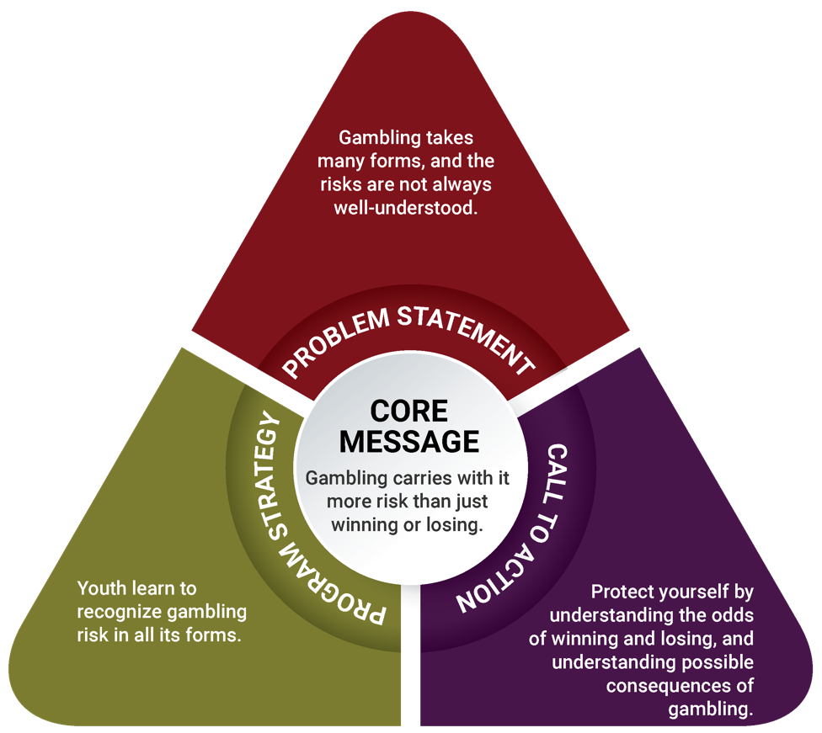

Knowledge, Attitudes, and Behaviors: Caregivers
The focus groups with caregivers suggest that adults also have significant experience with gambling. Like youth, caregivers’ personal attitudes about gambling vary between believing that gambling is never acceptable and believing that it is acceptable in some forms and contexts. Caregivers discussed speaking with their children about gambling and believe that youth understand gambling and its risks; even so, they still fear youth exposure to gambling. Similarly, caregivers fear the potential impact of the MGM casino on the community, particularly in terms of local crime, substance use disorders, local businesses, and individual finances. These insights, and others that are described in more detail in the full report, informed the creation of a message triangle for caregivers.
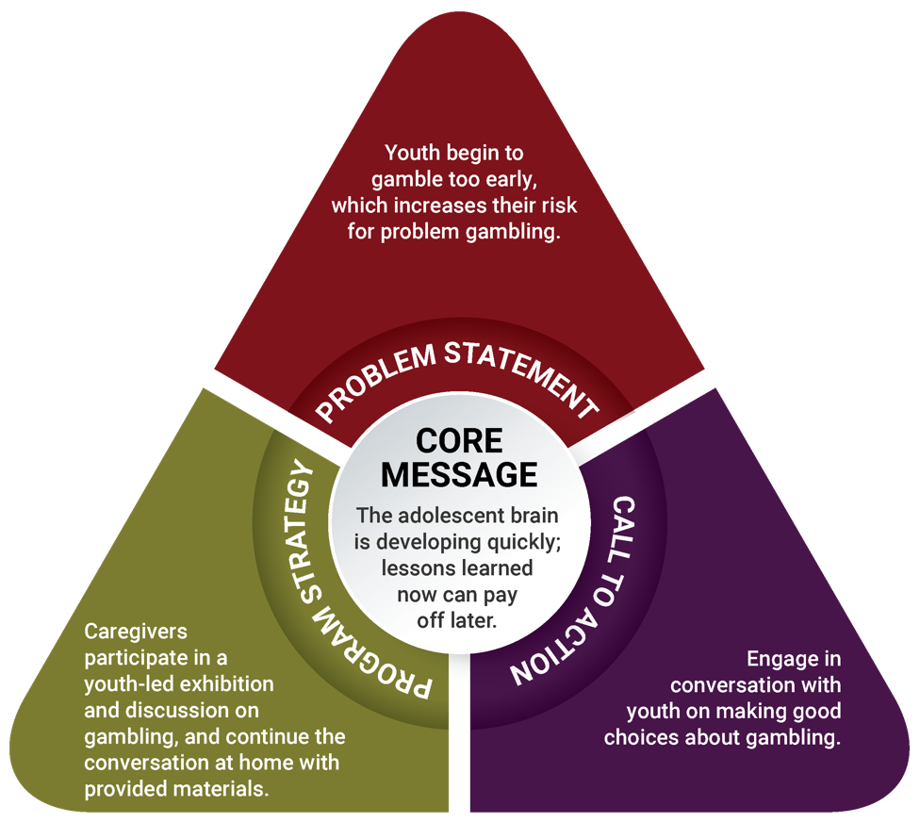

Prevention Strategy
Based on these messages, the recommended strategy to decrease underage gambling is photovoice, a pioneering approach to gambling education. (A full discussion of the process for arriving at this strategy is included in the full report; see page 37). Photovoice is an approach to community change-making that places youth, particularly those who experiences disparities and inequitable balances of power, at the center of community change. As a strategy, photovoice involves youth taking photographs that record and reflect their community’s strengths and concerns, engaging in group-based critical dialogue about important community issues, and presenting their findings and experiences externally to the broader community. Beyond impacting community members who participate in the photovoice process, this approach can also reach policymakers and other key stakeholders who do not participate actively in the photography and discussion process.^{xi}
The objectives of the youth photovoice project in the Springfield and surrounding communities region are to:
Youth will first learn about gambling, ethics in photography, technical photography skills, and visual literacy.^{xii} After individually taking photographs based on a prompt, youth will discuss photographs as a group (including their thoughts, feelings, and assessments about gambling in their community). The photography and discussions will culminate in a community exhibition, during which youth will present their photographs, findings, thoughts, and feelings.
- increase youth’s recognition of the risks of gambling
- increase youth’s ability to analyze and evaluate gambling messages
- increase youth’s perception of the harm of gambling
- increase youth’s development of critical thinking skills related to gambling messages
Backed by the understanding that caregivers have a significant influence over youth behavior, the caregiver strategy is connected to the photovoice project the youth complete. The objectives of the caregiver strategy are to:
- increase caregivers’ understanding of the risks of underage gambling
- increase caregivers’ knowledge of ways to talk to youth about gambling
- increase caregivers’ perception of the importance of underage gambling prevention
- increase caregivers’ intentions to talk to youth about gambling
Caregivers will participate in one session, during which they will hear youth present some of their photographs and then discuss underage gambling broadly and the ways to prevent it. The gambling prevention education topics will include what gambling is and what types exist, the importance of showing disapproval of underage gambling and how to do so, and ways in which caregivers can support youth in managing their emotions and behaviors.

Regional Comparison: Prevention Strategy for Youth and Caregivers
The photovoice methodology was also recommended as a prevention strategy in the Plainville/Southeastern Massachusetts region (Region C). Photovoice is a participatory strategy that allows for tailoring and adapting objectives based on community needs and experiences.
As mentioned, photovoice in the Springfield area has objectives for youth that are centered on increasing their perception of harm of gambling and increasing their critical thinking skills to navigate pressures to gamble. Youth in Springfield have a lot of exposure to gambling and reported the need for money as a benefit of gambling and a reason why people gamble. This is an indication that youth are impacted by high poverty rates, the low household incomes, and/or the high unemployment rates Springfield experiences. The photovoice project will engage them in these issues through photography, educate them about underage gambling, and support them in developing the ability to assess the feasibility of getting positive outcomes though gambling.
In contrast, in the Plainville/Southeastern Massachusetts region, the objectives for youth are related to increasing their awareness about gambling exposure and increasing their perception of harm of underage gambling. Youth in the Plainville area had limited direct experience gambling. One youth reported that “People sometimes bet on fighting people. People get in a fight, and others bet on who will win. I see that on TV shows.” These youth also reported understanding that there can be harm involved in gambling: “It’s hyped up to be this great thing, with all the lights and stuff. When you take a step back and look at it objectively, you realize it’s not that great. But it’s painted as this wonderful thing.” The photovoice project will help them make personal connections with the underage gambling around them through photography, educate them about underage gambling, and the risks associated with it.
The objectives for the caregiver component of photovoice in both regions also show parallels: in both regions, some objectives center on caregivers’ understanding of youth brain development and the vulnerability of youth in the face of risky behaviors. In the Plainville/Southeastern Massachusetts region, the photovoice component for caregivers was largely educational; this iteration of the strategy involves educational components but also stems beyond transfer of information: caregivers learn about the importance of underage gambling prevention, and also discuss and gain skills in talking to their children about gambling.

Knowledge, Attitudes, and Behaviors: Men in Recovery
Men in recovery spoke extensively about their experiences with gambling, sometimes referencing experiences from as far back as childhood. Many men described having problems with gambling, and some described the efforts they make to refrain from gambling; similarly, they believe that gambling is very similar to, or even the same as, substance use. Being in recovery and having experienced problems with gambling, substance use, or both, men in focus groups understand the various negative impacts that gambling can have and are motivated to share their experiences and suggestions for safe gambling or recovery with others. These ideas and motivations led to the creation of a message triangle for men of color with a history of substance misuse.
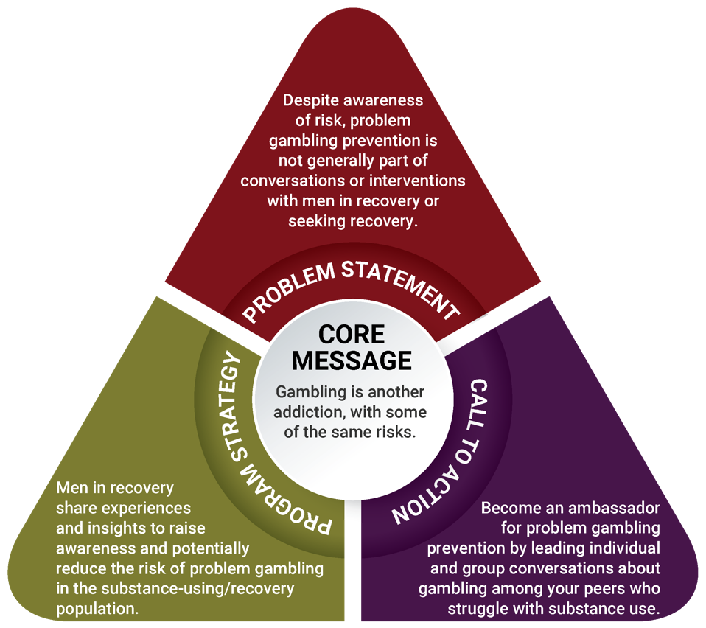

Prevention Strategy
Based on these messages and the culture of recovery support centers, which promote peer leadership and peer support, the ambassador strategy is recommended for men of color with a history of substance misuse. (A full discussion of the process for arriving at this strategy is included in the full report; see page 34). This strategy stems from the participatory process model that is used in the 10 DPH-funded recovery centers across Massachusetts.^{xiii} This model requires that people engage one another through lived experience, accept all paths of recovery, and empower peers to become productive members of society.
The objectives of the ambassador strategy are to:
- increase understanding of the connections between gambling and other addictions
- increase awareness of what gambling is and where it is present in everyday life
- increase perception of risk of developing a gambling disorder when one develops a substance abuse disorder
- increase self-efficacy to facilitate discussions about gambling with peers
Ambassadors, typically select members of recovery centers, will learn about all aspects of gambling (e.g., definitions, examples, how gambling can impact recovery), research on who is most at risk for problem gambling, and the importance of addressing health inequities. Ambassadors will then strengthen their group facilitation skills, and lead both individual and group interactions that focus on gambling and prevention. Individual interactions include speaking with someone at a recovery center, on the street, or during a private conversation at a program run by the center; group interactions may occur at the recovery centers or partner organizations that serve populations at high risk and who request peer gambling prevention groups or presentations.
In addition, recovery support providers will establish systems for supervision so that both ambassadors and supervisors can benefit from supervision, and so that recovery centers can build capacity to manage peer gambling prevention services and promote a gambling-free culture.

Regional Comparison: Prevention Strategy for Men of Color with a History of Substance Misuse
The ambassador strategy was also recommended in the Plainville/Southeastern Massachusetts region (Region C). The ambassador project uses a participatory peer education model that can easily be adapted across regions, populations, and community concerns.
As previously described, the ambassador strategy has objectives that are centered on increasing understanding of gambling’s connections to other behavioral health disorders, increasing the perception of risk related to gambling, and increasing ambassadors’ self-efficacy to facilitate conversations about gambling with their peers.
In the Springfield area, men in recovery had an understanding of how risky gambling can be after experiencing a substance use disorder: “You exchange one for the other. If you want to stop getting high, you go to gambling to think it’s going to be a quick fix. You start gambling, start feeling the same state of thought. When you feel depressed with one, you go back to the other hoping for a benefit from one.” In the Plainville/Southeastern Massachusetts region, men in recovery similarly reported that “It’s not too much separate . . . It goes hand in hand because it’s obsession and compulsion. Personally, I don’t know anyone who just gambles. And where I come from, I don’t know anyone who just uses. We all gambled, even in active addiction. I think it’s one.” The ambassador strategy builds on this knowledge, sharpens leadership skills of ambassadors, and teaches them to use their experience to teach other men with substance use disorders about the risks of gambling.
A benefit of their past participation in treatment programs and current membership in recovery centers, individuals in recovery have a vast understanding of substance use disorders. This strategy in both regions aims to support ambassadors in expanding the conversation on substance use disorders by incorporating problem gambling into it, and to increase their capacity to have conversations about gambling with their peers.
A significant difference in implementation of the ambassador project between regions is in how the priority population is reached. In the Springfield area, there are more places and opportunities to reach men of color since the majority of residents are people of color; conversely, every county in the Plainville/Southeastern Massachusetts region has at least 89% percent white residents, which will make identifying men of color more of challenge. Common locations to reach the priority population include substance use treatment facilities, shelters, houses of corrections, and community-based organizations. In the Plainville/Southeastern Massachusetts region, once the priority population in systems and programs has been reached it will be important to do outreach on the streets, in barber shops, and at social gatherings and homes to meet the population where they are.

Implications and Recommendations
This regional planning process may have a variety of implications for the Springfield region and for the state of Massachusetts as a whole. Below are the primary implications of this work, along with recommendations to DPH and the Office of Problem Gambling Services for ways to continue supporting problem gambling prevention beyond the scope of this planning process.

Implication 1
A large proportion of youth reported gambling in their environment and personal participation in gambling, but at the same time their attitudes show that they are conscious of the harms of gambling. The attitudes and actions of youth are not entirely aligned.
Recommendation: In addition to offering the photovoice strategy to all youth, develop targeted prevention strategies for youth at highest risk for underage gambling that include exploring risks associated with underage gambling and making connections between actions and attitudes.

Implication 2
Caregivers in focus groups described their own exposure to and participation in gambling and their children’s exposure to gambling. Caregivers play a major role in preventing risky behaviors and have an opportunity to support underage gambling prevention.
Recommendation: Identify or develop educational materials for caregivers on how to prevent their children from participating in underage gambling, and make these resources widely available.

Implication 3
In focus groups, men in recovery described problem gambling as another addiction. Men in recovery have a unique experience that allows them to connect substance misuse and problem gambling.
Recommendation: Provide opportunities for men in recovery to inform policies and initiatives that make connections between substance misuse and problem gambling.

Implication 4
Focus group and key informant interview results give insight into the particular nuances of a community and the people who may be most deeply affected, beyond what community- or state-level quantitative data show.
Community residents know their community well, and their insights are invaluable in understanding community context, identifying key leaders and gatekeepers in the area, and developing sustainable prevention strategies.
Recommendation: Ensure that local residents have a voice in the implementation of initiatives for problem gambling prevention in their community.

Implication 5
Community-based social services organizations of all types are interested in learning about gambling. These organizations serve populations at high risk and can benefit from opportunities for strategic capacity building to support problem gambling prevention.
Recommendation: Provide opportunities for community-based social service organizations to build their capacity to engage in problem gambling prevention.

Implication 6
A health equity lens throughout this regional planning process helped identify populations who are most impacted by these issues and ensured that these groups informed the data gathered in this assessment. Using a health equity lens is important to understand the realities and nuances of gambling and problem gambling across Massachusetts.
Recommendation: Assess the health and racial disparities in a given area, and include the people who are experiencing the most significant disparities.

Implication 7
Youth, caregivers, and men in recovery describe gambling as intertwined with violence, community health, sexual exploitation, and poverty. These factors have a compounding effect and create community disorder that supports problem gambling. Effective prevention requires multiple prevention strategies across multiple domains.
Recommendation: Encourage collaboration among multiple public health sectors to integrate problem gambling prevention strategies.

Implication 8
In Springfield and surrounding communities, focus group participants and key informants shared their thoughts regarding the populations they are most concerned about in terms of problem gambling, particularly in light of the opening of the MGM casino. One new population that emerged from these conversations that is not reflected in state-level quantitative data is older adults.
Recommendation: Explore how older adults are impacted by problem gambling, and provide opportunities to engage them in prevention strategies.

Executive Summary: End Notes
- Massachusetts Gaming Commission. (2018). Surrounding community & related agreements. Retrieved from https://massgaming.com/about/community-mitigation-fund/host-surrounding-communities/surrounding-community-agreements/
- Massachusetts Technical Assistance Partnership for Prevention. (2016). Strategic plan: Services to mitigate the harms associated with gambling in Massachusetts. Waltham, MA: EDC. Funded by the Bureau of Substance Abuse Services. Retrieved from http://www.mass.gov/eohhs/docs/dph/com-health/problem-gambling-strategic-plan.pdf
- This strategy was later broadened to include all types of primary guardians, or “caregivers.”
- Kessler, R. C., Hwang, I., LaBrie, R., Petukhova, M., Sampson, N. A., Winters, K. C., & Shaffer, H. J. (2008). The prevalence and correlates of DSM-IV pathological gambling in the National Comorbidity Survey Replication. Psychological Medicine, 38(9), 1351–1360.
- Work Group for Community Health and Development. (2016). Section 3. Identifying Targets and Agents of Change: Who Can Benefit and Who Can Help. In Community Tool Box. Retrieved from http://ctb.ku.edu/en/table-of-contents/analyze/where-to-start/identify-targets-and-agents-of-change/main
- Johansson, A., Grant, J. E., Kim, S. W., Odlaug, B. L., & Götestam, K. G. (2009). Risk factors for problematic gambling: A critical literature review. Journal of Gambling Studies, 25, 67–92.
- Petry, N. M., Stinson, F. S., & Grant, B. F. (2005). Comorbidity of DSM-IV pathological gambling and other psychiatric disorders: Results from the National Epidemiologic Survey on Alcohol and Related Conditions. Journal of Clinical Psychiatry, 66, 564–574.
- Volberg, R. A., Williams, R. J., Stanek, E. J., Houpt, K. A., Zorn, M., & Rodriguez-Monguio, R. (2017). Gambling and problem gambling in Massachusetts: Results of a baseline population survey. Amherst, MA: School of Public Health and Health Sciences, University of Massachusetts Amherst.
- Bronson, J., Stroop, J., Zimmer, S., & Berzofsky, M. (2017). Drug use, dependence, and abuse among state prisoners and jail inmates, 2007-2009. Washington, DC: Bureau of Justice Statistics. Retrieved from https://www.bjs.gov/content/pub/pdf/dudaspji0709.pdf
- Minton, T. D., & Zeng, Z. (2016). Jail inmates in 2015. Report prepared for the Office of Justice Programs, U.S. Department of Justice. Retrieved from https://www.bjs.gov/content/pub/pdf/ji15.pdf
- Wang, C., & Burris, M. (1997). PhotoVoice: Concept, methodology, and use for participatory needs assessment. Health Education and Behavior, 24(3), 369–387.
- Rutgers. (2018). Facilitator’s guide. Retrieved from https://www.rutgers.international/our-products/tools/photovoice/facilitators-guide#Presentations
- The Massachusetts Substance Use Helpline. (2016, December 29). Paths to recovery: Recovery coaches. Retrieved from https://helplinema.org/2016/12/29/paths-to-recovery-recovery-coaches/

Introduction
This report describes a regional planning process for the prevention of problem gambling carried out by the Massachusetts Technical Assistance Partnership for Prevention (MassTAPP) at Education Development Center, Inc. (EDC). The Massachusetts Department of Public Health (DPH) funded this regional planning process, which focused on Springfield and surrounding communities, where the MGM casino is set to open in late August, 2018.
After the Public Health Trust Fund Executive Committee adopted the Strategic Plan: Services to Mitigate the Harms Associated with Gambling in Massachusetts¹ (the statewide Strategic Plan) in April 2016, MassTAPP operationalized two of the plan’s key recommendations:
- Reach youth and parents with appropriate prevention messaging, and enhance environmental strategies to increase protective factors and decrease risk factors²
- Develop and distribute culturally appropriate campaigns and services for high-risk populations
For each recommendation, a planning process was conducted to develop culturally appropriate prevention strategies that take into account the principles of health equity. This regional planning process occurred in several stages:
- Stage 1: A review of local demographics
- Stage 2: Community outreach and identification of key stakeholders
- Stage 3: Convening and facilitation of a regional stakeholder meeting
- Stage 4: Identification of community assets and local resources
- Stage 5: Key informant interviews with individuals who understand and/or may influence the behavior of priority populations
- Stage 6: Focus groups with priority populations and data analysis
- Stage 7: Development of messages and prevention strategies
This report describes the regional and community assessment process used in this region, along with a summary of data collected from priority populations, a description of the proposed prevention strategies, and implications of the work.
A similar regional planning process of the Plainville/Southeastern Massachusetts region (Region C) was conducted in 2017. The first regional planning process yielded multiple lessons: build and establish partnerships early; provide a timeline and clear expectations to partners and identify communication channels; ensure that information and referral sources are available to all partners and participants; and ensure inclusion of participants from a wide range of backgrounds. These lessons were priorities in this regional planning process, and the differences between the Plainville/Southeastern Massachusetts region and the Springfield area (namely, differences in socioeconomic factors such as education, income, race, ethnicity, and urban/rural status among residents) were noted and considered throughout the process. Building upon the lessons learned, MassTAPP communicated with key individuals and organizations throughout the process, informed partners of next steps and expected timelines, and invited and included a wide range of participants in meetings, interviews, and focus groups. Involving a diverse array of participants was particularly important in this regional planning process, as Springfield is a city made up primarily of people of color, and many residents are immigrants and experience health and income-related challenges. These aspects of the area, along with the active community organizations that work towards health and racial equity, were important to understanding and accurately representing the community. The active nature of community members allowed for a broader connection to the community, a deeper understanding of community issues and resources, and a potential for future sustainability of prevention strategies. As a result, this regional planning process engaged 104 community members, a majority of whom are people of color (94 community members participated in key informant interviews and focus groups, and 20 community members attended a community meeting). This is a large increase in engagement over the previous region, where 82, primarily white, community members were engaged.

Health Equity
The concept of equity means that everyone has the ability to reach their highest level of health.³ Equity goes beyond providing access to health care for all individuals and communities; it suggests allocating resources in a way that supports people in reaching the same, optimal outcomes. It also demands a recognition of the inequities and obstacles faced by some (including poverty, discrimination, and disparities in housing, education, and economic opportunity) and a willingness to address these issues and knock down these barriers. Most importantly, equity can only be achieved when the values and priorities of the populations most impacted by an issue, such as problem gambling, are integrated into planning and decision-making.
Decreasing health inequities, or the disparities in health that some individuals or communities face that is closely linked with social, economic, and/or environmental disadvantage, supports building equity. Disparities often build upon each other, with each additional barrier to health amplifying the effects on an individual or community beyond the effects of a single barrier. This compounding effect speaks to the concept of intersectionality.
Sustainable community engagement also builds health equity. It occurs when community members feel empowered to advocate for the change they want to see in their community. Engaging the community honors residents, supports assessment, strengthens capacity, enhances the effectiveness of interventions, and promotes sustainability. Communities know what needs, resources, and readiness their neighborhoods need most, and they are best positioned to identify networks, resources, and strategies to reach priority populations.

Community Profile
This report focuses on Springfield and its surrounding communities in Western Massachusetts, particularly those cities and towns with which Springfield has a Surrounding Community Agreement related to the establishment of the MGM casino (Agawam, Chicopee, East Longmeadow, Holyoke, Longmeadow, Ludlow, West Springfield, and Wilbraham).⁴ Most of this regional planning process took place in Springfield, but many of the assessments and recommendations documented throughout this report may be relevant to other communities that have Surrounding Community Agreements with Springfield and also have a stake in the impacts of the casino. (Specifically, residents and other stakeholders in Holyoke were included in the collection of qualitative data.)
The third largest city in Massachusetts and the fourth largest city in New England, Springfield is located in Hampden County, Massachusetts. As of 2016, Springfield’s total population is 154,074, with females making up 52.7% of residents.⁵ Springfield’s population is younger than that of Massachusetts as a whole, with 40% of the population under age 24, compared to 32% for the state.⁶ Springfield is racially and ethnically diverse, and the majority of residents are people of color, along with a sizeable percentage of foreign-born residents. According to the U.S. Census Bureau, 43.2% of Springfield residents are Hispanic or Latino; 33.2% of residents are white, non-Hispanic or Latino; 21% are Black or African American; 2.1% are Asian; 0.6% are American Indian or Alaska Native; and 4.2% reported two or more races.⁵ Approximately 85% of the Latino population in Springfield is Puerto Rican (35% of the total population).⁷
Almost 40% of people in Springfield speak a language other than English at home. Among residents, Spanish is the most common non-English language spoken (47,400 speakers), followed by Vietnamese (1,658 speakers), and French (889 speakers).⁸ Most commonly, foreign-born residents are from the Dominican Republic, Jamaica, and Vietnam. Springfield also has sizeable number of residents from Zimbabwe, roughly 20 times more than would be expected based on national averages.⁸ Despite the significant ethnic diversity in the city, 95.2% of Springfield residents are U.S. citizens.⁸ Key informants who contributed to an understanding of Springfield’s context described some organizations that have provided culture-specific programs and services in the area, including Jewish Family Services, Lutheran Social Services, and the Vietnamese Civic Association.
Educational levels in Springfield are lower than in the state overall. Estimate are that 77.2% of Springfield residents have at least a high school degree, compared to 90.1% at the state level.⁹ However, Springfield graduation rates are on the rise, as 76.5% of Springfield high school students graduated in 2017, compared to 57% in 2012.¹⁰
Springfield residents experience economic challenges, with a median household income of $35,742—less than half the median household income for the state overall, and 31% less than the median household income for Hampden County.⁵ As of November 2017, Springfield’s unemployment rate was 6.3%, roughly 1.75 times higher than the state’s unemployment rate and 1.5 times higher than the national rate.⁵ However, employment rates between 2015 and 2016 grew from 59,997 employees to 60,847 employees; the most common employment sectors were healthcare and social assistance, retail trade, and manufacturing.¹²
Springfield struggles with high poverty rates, as 29.7% of residents live below the poverty line, a rate nearly three times higher than the state’s and approximately twice as high as the nation’s.¹² Among those living below the poverty line, females ages 24–34 make up the largest demographic, followed by females ages 35–44, and then males ages 6–11.⁸ Economic racial inequities also exist, with Hispanic or Latino residents experiencing significantly higher rates of poverty (40.5%).¹³ According to DPH estimates from the Behavioral Risk Factor Surveillance System, in comparison to the state, Springfield residents reported less frequent engagement in health-promoting behaviors, more frequent participation in health risk behaviors, less access to healthcare, a greater prevalence of physical health conditions, poorer health overall, and poorer mental health.⁹
Fortunately, Springfield is home to many organizations, programs, and individuals who are committed to combating these economic and health inequities and to making wide-ranging positive impacts on the community. Several key informants mentioned the Springfield Partners for Community Action, whose efforts are aimed at assisting people in obtaining economic stability. Other programs and resources identified by community members include New North Citizens Council, the Springfield Parent Academy, afterschool programs, Youth Parental Services, food pantries, various outreach and community events, and public service announcements on the radio (particularly on WTCC, which many community residents look to for information). Another effective and broad-reaching organization is Martin Luther King Jr. Family Services, which key informants spoke about extensively. This organization hosts community events and services, including health expos, MLK Day, community check-ups, a young fathers program, women’s fitness programs, brother-to-brother outreach, and presentations over dinner (e.g., about mental health in the African American community). Martin Luther King Jr. Family Services also houses a youth initiative called the Mason Square Health Task Force that works to eliminate racial health disparities; the advisory board supports collaboration with other community-based organizations and city and state officials.
Key informants described a number of significant assets that are working on health equity and could incorporate problem gambling into their messages and services, including schools in the area, local coalitions, groups of treatment and recovery professionals, community health worker coalitions, the faith community, nonprofit organizations such as the Public Health Institute of Western Massachusetts (formerly Partners for a Healthier Community), recovery rallies, and other community-based organizations that emphasize prevention. Notably, some groups already focus on the prevention of gambling and problem gambling. Key informants noted that there is an active faith-based community concerned with risky behaviors, including problem gambling. Partners for a Healthier Community created a report on the impacts of casinos, and some community coalitions advocated for adding gambling questions to a youth health assessment. Key informants spoke about the value of initiatives led by community coalitions and smaller organizations, as these groups have deeper insights into community needs and necessary resources, and community members may feel more comfortable participating in neighborhood-based initiatives than in larger ones.

Outreach and Network Building
The community outreach for the regional planning process began by creating broad categories of sectors that serve the Springfield area: substance use treatment, prevention, and recovery; community-based organizations; health; education; criminal justice; mental health; faith-based organizations; and workforce development. This categorization ensured that organizations and key contacts in the region would be at the table to provide input related to problem gambling prevention efforts in the region. The categories were filled in through the expertise and connections of two MassTAPP staff who have extensive experience in community-level prevention across the state.
Further research on other organizations, and conversations with leaders and stakeholders in the region, yielded names of other key contacts and recommendations for further outreach, which significantly expanded this list of contacts. Each phone or email contact was followed by a scheduled network-building conversation, which also served to inform stakeholders about MassTAPP’s regional planning and community engagement process. In addition, coordinating with other DPH-funded programs on outreach efforts to share contacts in the region and jointly meet with select stakeholders supported this process.

Stakeholder Meeting
Via email and phone, over 60 stakeholders were invited to a community meeting in Springfield at the end of 2017 to discuss the issue of problem gambling and to explore how it affects Springfield and surrounding communities. Invitees included coordinators of substance use prevention coalitions, professionals working in community-based organizations, school principals, directors of recovery centers and career centers, leaders of faith-based organizations, and technical assistance providers who serve the Springfield area. Invitees were free to share the invitation to this stakeholder meeting with their networks to broaden the range of participants. Twenty people attended this meeting.
Attendees provided input that directly informed the direction of the regional planning process, particularly in terms of community context and concerns, priority populations, and prevention strategies that could be effective. Specifically, attendees discussed their thoughts on the following questions:
- Is problem gambling a topic of concern or discussion among residents of Springfield and surrounding communities?
- Where do you see gambling in the communities in which you work and live?
- What groups seem to be at risk for problem gambling?
- Who is engaged in the prevention of problem gambling, and is there overlap with those involved in substance use prevention?
- Which groups could most benefit from prevention efforts?
- How (if at all) are data about gambling being collected?
These questions, and the unique perspectives and backgrounds of attendees, encouraged extensive conversation on the particular history and needs of Springfield and surrounding communities. Stakeholders pointed out the high number of people of color in the area (particularly in Springfield), concerns about the new casino putting a strain on local resources and leaving residents with the consequences, and the lack of conversation around the casino and gambling in general. Attendees also discussed populations who may be most impacted by expanded gaming, including seniors, people with dual diagnoses or comorbid conditions, people who use drugs, people who are homeless, immigrants, and youth. The comments and concerns of stakeholders reaffirmed the need to approach problem gambling prevention through a lens of health equity, and with an understanding of specific community dynamics.

Key Informant Interviews
Ten key informant interviews were conducted via face-to-face meetings or phone conversations. These interviews were conducted to learn about the gambling-related attitudes, beliefs, and experiences of at risk populations, and to learn more about the community contexts in which they live and work.
Key informants were selected based on suggestions from stakeholders, who shared which community experts’ input would be particularly important for a comprehensive assessment of the region. Through this process, names of certain individuals emerged multiple times as key leaders in the region; these individuals were interviewed as key informants. All key informants interviewed are well-informed, well-connected members of the community who have expertise in community issues and how to address them. These individuals have vast knowledge about the community, both through their residence in the community itself and through their work with populations that experience inequities. These backgrounds enabled them to speak simultaneously from the perspective of a community member and a provider serving a marginalized population (or multiple populations). During this regional planning process, key informant interviews were semi-structured (see Appendix A for core questions) so that key informants could share knowledge of the local landscape in terms of gambling behaviors, co-occurrence of gambling and substance use and/or mental health disorders, geographic regions and sub-populations experiencing health inequities, and available services. Key informants all described their concern for certain populations that may be at high risk for problem gambling, including men, people of color, and people with a history of substance misuse or comorbid mental health conditions.

Priority Populations

Youth and Caregivers
Youth who begin gambling early in life are more likely to experience problem gambling later in life.¹⁴ Based on this, youth ages 12–18 were identified as the “targets of change”¹⁵ for this prevention strategy. Research also shows that youth are less likely to experience problem gambling if they have protective factors in their lives, such as strong family support and realistic boundaries and expectations, which buffer the risks of developing problems with alcohol and other substances.¹⁶ Therefore, caregivers of adolescents were identified as “agents of change”¹⁵ and an audience for gambling prevention messages and strategies.

Men of Color Who Have a History of Substance Misuse
The conversation around populations of need with both key informants and stakeholders, combined with data from the SEIGMA study,¹⁷ yielded the finding that men of color who have a history of substance misuse are a population at high risk for problem gambling. Research has indicated that men are at higher risk than the general population for problem gambling,¹⁸ as are people of color¹⁶ and people with a history of substance misuse.¹⁶ Based on these demographic categories, conversations with key stakeholders in the region, and the availability and readiness of treatment and recovery support providers to incorporate messages about gambling into their services, the priority population for this strategy was defined as men of color who have a history of substance misuse. Each individual characteristic (being male, being a person of color, and having a history of substance misuse) suggests an inequity in problem gambling rates; taken together, these characteristics amplify one another and create a compounding effect. This priority population matches results from the Social and Economic Impacts of Gambling in Massachusetts (SEIGMA) study, which shows significantly higher problem gambling rates among men compared to women, and among Black adults compared to White adults in Massachusetts.¹⁷ This research also indicates that adults who engage in problem gambling are significantly more likely to have engaged in binge drinking in the past month compared to adults who gamble recreationally.¹⁷ Additionally, men of color who have a history of substance misuse are at incredibly higher risk for being held in jail or prison. Not only do more than half of individuals in jail and prison have substance use disorders (64% in 2006),¹⁹ but people in jail and prison are also disproportionately people of color.²⁰ These statistics amplify the adverse experiences that men of color who have a history of substance misuse already experience. In this regional planning process, these statistics were supported by comments from men in recovery who participated in focus group, who spoke often about jail and prison, indicating a great need for prevention strategies for both problem gambling and the consequences of substance misuse.

Data Collection
Following the key informant interview process, focus groups with members of both priority populations (youth and caregivers, and men of color who have a history of substance misuse) occurred. MassTAPP staff who have experience in human services and community organizing connected with community organizations in the region that are interested in the topic and serve marginalized populations. Organizations were offered a stipend to recruit for and host focus groups, using the methods they have previously found successful. MassTAPP facilitated the focus groups, provided consent forms, and provided stipends to participants.
Ninety-four people participated in the data collection process, either as key informants or focus group participants, enabling a deeper understanding of the priority populations who would receive prevention messaging. In addition to learning from priority populations and the people who work with them, the high percentage of Springfield’s speakers of non-English languages (40% of Springfield’s population) made clear the need for conducting assessments and providing prevention services in at least one non-English language, particularly to learn from Spanish speakers who live in the region but may not speak English. Approximately 30.8% of Springfield’s population speaks Spanish,⁸ so two focus groups were conducted in Spanish, with note-taking and translation help from consultants. (See Appendix A for key informant interview and focus group questions in English and Spanish.)
Key Informants
- Ten key informants participated in individual interviews. All key informants interviewed are well-informed, well-connected members of the community who have expertise in community issues and how to address them.
Youth and Caregivers
- Twenty youth participated in two focus groups at the Boys and Girls Club in Holyoke and the Gandara Center in Springfield. One youth leader participated in a key informant interview; this youth leader’s interview was analyzed with other youth data.
  - Race/ethnicity: 52% Latino, 24% Black, 19% biracial, 5% unknown
  - Gender: 62% male, 33% female, 5% unknown
  - City of residence: 67% Springfield, 28% Holyoke, 5% unknown
  - Average age: 15.9
- Twenty-three caregivers participated in two focus groups at the Morgan Elementary School in Holyoke and Open Door Social Services in Springfield. One of these focus groups was conducted in Spanish. This ensured that Spanish speakers who do not speak English have equitable access to participate in the prevention initiative design. One caregiver participated in a key informant interview; this caregiver’s interview was analyzed with other caregiver data.
  - Race/ethnicity: 75% Latino, 9% Black, 4% biracial, 8% white, 4% unknown
  - Gender: 58% female, 38% male, 4% unknown
  - City of residence: 50% Springfield, 42% Holyoke, 4% Enfield, 4% unknown
  - Average age: 41.4
Men of Color Who Have a History of Substance Misuse
- Thirty-nine men in recovery participated in three focus groups at Hope for Holyoke in Holyoke, Open Door Social Services in Springfield, and the Gandara Center in Springfield. One of these focus groups was conducted in Spanish, to ensure equitable access to participate in the prevention initiative design.
  - Race/ethnicity: 74% Latino, 18% Black, 8% biracial
  - Gender: 100% male
  - City of residence: 69% Springfield, 21% Holyoke, 5% Chicopee, 5% Jamaica Plain
  - Average age: 41.4

Data Analysis
A rigorous analysis of the data gathered from key informant interviews and focus groups was completed using thematic analysis, a widely used qualitative research method that allows people to make sense of large amounts of data from sources such as interviews and focus groups, to ultimately understand the perspectives of different participants, note similarities and differences, and shed light on unexpected concepts.²¹
Data analysis using this method includes the core phases of familiarizing oneself with the data, generating initial codes, searching for themes, reviewing themes, defining and naming themes, and producing a report; however, these steps are not necessarily linear and instead are components of an iterative process that requires occasionally returning to an earlier step.²²
Thematic analysis for the purposes of strategy design in this regional planning process first required a separation of data into categories relevant for each main priority population (youth and caregivers, and men of color who have a history of substance misuse). Data were further separated into the following categories: youth, caregivers, men in recovery, and key informants. This categorization allowed for the comparison between people with similar backgrounds (such as age or experience with substance use), and also enabled the merging of data at a later time, if the need arises (as data are easier to combine from distinct parts than to separate once they are combined).
Last year, the thematic analysis method was used to analyze the data collected during the similar regional planning process for the Plainville/Southeastern Massachusetts region.²³ That first round of thematic analysis generated multiple themes that served as a base for analyzing data from the Springfield region. Based on other ideas that participants of interviews and focus groups shared, other themes were added and then reviewed to see if any themes could be combined, re-named, or clarified. The next step—familiarization with the themes and establishing what each theme means—was necessary to analyze the data consistently across documents and to create definitions of each theme for reliable analysis. One step that was added beyond the core phases of thematic analysis mentioned above was writing brief summaries of each theme, including key quotations from the data that illustrated that theme, which provided a clearer and more concise assessment of the data; this step could be considered part of the report-writing phase. This detailed analysis process, and the resulting analyses described below, informed the development of messaging and prevention strategies tailored to each priority population.

Results: Gambling Knowledge, Attitudes, and Behaviors

Summary of Data Gathered from Youth
Youth shared insights into a variety of topics related to gambling, including their exposure to and experience of gambling, their attitudes about gambling, the benefits and negative consequences of gambling, and the illusions they have about gambling.
Among this group, youth described a tremendous amount of exposure to gambling, most commonly through close family members, but also through their environment outside the family.
- “I see friends do it, grandparents, parents, aunts, I see my uncle do it a lot.”
- “My aunt that gambles so much when she gets thick stacks of scratch tickets.”
- “Bingo in my grandma’s building, she also does scratch tickets.”
- “My cousins on basketball teams. Family, my friends.”
- “On the corners all the time, dice. Older people, but sometimes younger too.”
Youth also described their personal experience with gambling online, with dice, and in games; one youth talked about having a problem with gambling, while others talked about not having any personal experience with gambling or choosing to refrain from it.
- “I think young people gamble a lot. They use dice and stuff and play gambling games to win money. They play a game called C-Lo, 7-11, you play them with dice.”
- “A lot of games lately have been a lot of online gambling. The odds of winning something are really low, but people spend a lot of money to get the weapon—you’re spending real money to get the weapons in the games.”
- “You have to know when to stop betting, which—that’s hard for me. When I win a lot of money, I spend more money. I’m really good at slots; when I win online I keep winning and winning. I’m really good at blackjack. When I play with my friends, I win a lot. And sometimes we bet money, pennies, quarters, dimes, this was a long time ago, 95% of the time I would win. I’d keep betting more money. So if the casino comes, it’s not good for me.”
- “[I] tried it before, lost money, didn’t want to do it anymore.”
- “[I don’t gamble] with money, but I do the childish stuff.”
Attitudes about gambling fall primarily into two categories: negative attitudes, and attitudes that depend on factors such as how much money is spent, what the money is used for, whether money is real or in-game currency, whether you grew up with it, and whether the gambling is addictive. Only one youth said that people in the community see gambling as positive, and one said that gambling is not really an issue.
- “No, everything is bad. No matter legal or illegal.”
- “Dog fighting is illegal, but there’s no better or worse. All gambling is bad because you’re still going to get addicted to it. It’s going to get into your brain, and you’ll keep doing it.”
- “Better form of gambling is when you have $20 and win $200, or a bad example is if you have $20 and you double it and then lose it all. If you came from nothing and you’re broke, and you put in $20 and won $500, you won $480—that’s great. Scratch tickets and bingo are better, casino [is] way worse.”
- “Depends on the loss. I lost in-game currency, that’s, whatever, some people lost real money.”
- “If it’s playing for free and just for fun, it’s totally fine.”
- “I don’t think gambling is really an issue. If you have clothes on your back, shoes on your feet, if you want to spend your extra money, then spend it.”
Participants spoke most extensively about the risks associated with gambling. They primarily relate consequences to loss—of money, material things, work, family, and health. Many youth also mentioned dangerous consequences such as crime and violence. Some youth said that gambling can lead people to make decisions they wouldn’t normally make, and can lead to the development of substance use disorders.
- “If they keep on gambling, they’re going to lose all their money.”
- “You’re going to lose everything, you’re going to have a hard career.”
- “[One prevention message can be] a shirt with someone with slots, over it all the effects, the house has been taken away, car has been towed, but you’re there at the slot machine.”
- “More drugs coming back and forth in Springfield because of the casino, and more gang violence.”
- “It’s kind of like a video I was watching, gambling is kind of an odds factor. It leads to other violence and corruption in cities that casinos are at.”
- “You could become addicted.”
Youth also discussed some benefits of gambling, including winning money, the economy and individuals’ work opportunities, the satisfaction that comes with winning, and learning a lesson from the experience of losing.
- “The casino is awesome, I want it to come. Being a dealer, so much money off of tips.”
- “You can win a lot of money.”
- “A lot of cool stores, a lot of jobs opening up, a lot of opportunity for the youth.”
- “Doesn’t some of the gambling money go back to the government?”
- “Short-term emotional fulfillment, the feeling of winning something.”
- “[If you lose] you go broke. It’s a benefit. If you lose, you learn from it . . . You learn not to do it again. You learn that you shouldn’t be spending that much money in that amount of time. You could lose a lot in 30 minutes.”
A particularly interesting concept that came out of the youth’s focus group and interview data relates to the truths that most people don’t know about gambling: namely, that the game is rigged against you and that winning is all based on luck.
- “You’re not supposed to win when you gamble in a casino.”
- “The odds are against you, so it doesn’t matter.”
- “Some you think are easy, and then you go for the big ones and lose everything.”
- “It’s all still a game of chance.”

Regional Comparison: Data Gathered from Youth
Youth differed significantly between regions. In the Plainville/Southeastern Massachusetts region (Region C), youth had a distant understanding of gambling: they understood it as a theoretical concept, with some risks and similarities to substance use, but also some level of acceptability. They also believed that some gambling can be innocent or not harmful: “It can vary. I agree that it can be very bad, but also it can’t be that harmful sometimes. But it matters what you’re betting on or gambling on.” In contrast, many youth in the Springfield area have witnessed gambling firsthand or have even participated in it themselves, and have a much greater awareness of the risks of gambling. Some youth choose to refrain from it; others keep the risks in mind. This greater awareness may be related to the difficulties that Springfield residents face: namely, high poverty and unemployment rates, and higher-than-average participation in health risk behaviors. Youth may have experienced these challenges firsthand, leading to a greater awareness of the risks and reality.

Summary of Data Gathered from Caregivers
Caregivers described multiple areas of exposure to gambling, including through their family, their community, and the media. They also described their personal experiences with gambling.
- “My daughter is dying to play bingo and go to the casino because she sees it around her. She sees the family playing and having fun. Her grandma plays, her mother plays. She can’t wait to turn of age.”
- “I think of my grandfather gambling [on] the horses and roosters. It’s a little bit different than what’s out here now. I also saw the bad side of gambling, shooting craps, coming to collect at my grandmother’s house, the fights. Now it’s modernized and pretty, but it’s the same thing behind the scenes with the slots machines.”
- “Nowadays we see betting and winning . . . made so easy in the TV. All these games out there make it look so easy. Like, Who Wants to Be a Millionaire? . . . Let’s talk about the rules of gaming!”
- “For me it means addiction. On a personal level, I had a relationship where the addiction to the game took over. That cost my relationship. It destroys families.”
Caregivers also shed light on youth exposure to gambling and youth participation in gambling.
- “You talk to kids about addiction, but they see it. They’re smart. Like my mom, they know Grandma buys a lot of scratch tickets, and they say ‘Mom! Grandma is buying too many tickets. That’s not good.’ They worry, they know.”
- “Little kids bet. They bet their sneakers. From the smallest to the biggest. Kids even bet candies. They know the word and how that works. They learn early, and they participate in those activities. They make the connections.”
- “My main concern is [that] my kids can use their phone and play these games. It’s more attainable. I now need to pay attention to what my daughter is doing.”
Attitudes about gambling are split between caregivers, with some believing that all types of gambling are bad, and others believing that different types of gambling have different levels of acceptability.
- “For me, I think there is none that is acceptable. In Puerto Rico, cock fights are legal and normal. And others, to avoid a dog fight, do a cock fight. If you are in the cock-fighting area all the time, then that is wrong. It’s about control. About what you spend. It’s all the same. All betting and gaming is the same.”
- “[I think it is] very negative because it brings addiction and violence and all that other stuff.”
- “For me there are acceptable things. Tickets are acceptable. Dog fights and cock fights are not acceptable. It’s criminal and it’s illegal.”
- “Difference between buying lottery ticket and casino [is] spending hours of time that is wasted that you will never get back. Scratch tickets from time to time is okay.”
Caregivers also specified their attitudes about youth gambling. All who spoke about this topic said that they would not want their children gambling.
- “Thanks to experience, we know it always ends badly. None of us wants to see our kids bet, regardless of what it is. We don’t want to see them get involved. I would never motivate my kids to game, to be near games or do anything similar.”
- “I would not like my child to go through what I went through. I know personally that there is nothing but loss. When you’re involved it becomes an addiction. I can speak to my experience.”
- “My 17-year-old stays over at his friend’s house . . . He said he was tossing quarters [seeing who can toss quarters closest to a particular location, such as a wall, without touching it]. I was like, ‘Where did you learn this from?’ He said his friend’s father. I took that money and had a serious talk with his friend’s father. It won’t happen again.”
Similar to the youth, caregivers spoke extensively about the negative consequences of gambling. They expect increases in gambling addiction with the new casino’s existence, increases in local housing prices, and increases in money lost to gambling. They also mentioned increased crime and losses of relationships, health, business for small organizations, and safety for young people.
- “If it becomes an addiction . . . the person just wants to win regardless of what they lose. If what I have is my kid’s toys . . . [or] . . . my car, that’s what I will bet . . . Even my life. Whatever I have to bet.”
- “I have heard [that] when a casino comes to the community, people gamble and lose their houses. All of the rent down here in the city has gone up. You can’t even find housing. You can[’t get] anything for $800 anymore; they are now asking for $1,300+.”
- “I think it’s a mirage, they want you come spend all your money. Yes, some people need jobs, but how many of those people might gamble after the job and lose their job? So, yes, the building looks beautiful, but it says, ‘I’m just painting a good picture to get you to spend your money.’”
Caregivers mentioned only a few benefits of gambling, in particular citing the economic and recreational benefits.
- “There will be many jobs; about 3,000. There will be benefits financially.”
- “The good part is the economic part, schools and jobs. If high-level people come in, they want their kids to come in and go to good schools. We are getting roads fixed we never thought would be fixed [and] the food trucks. The big picture, there are some benefits.”
- “The only ones that benefit are those that invested in the casino and will reap the benefits.”
- “There’s nothing to do in Springfield. There will be stores, fun things, restaurants. Right now Springfield is a cowboy town!”
- “[For] the person who needs that rush, it’s the feeling they get. When I see my mom walk into a casino, she starts shining. She used to keep a change jar just for it. The energy and endorphins; it’s a drug.”
Caregivers shared their ideas for prevention messages that may be effective with youth, such as describing gambling as an addiction and teaching self-control and restriction.
- “I went through my daughter’s phone, and I found out she tried marijuana, and we spoke about addiction and that it’s in her family. She felt like it wasn’t a big deal. I had her Google the facts in front of me about drugs and addiction in general, and it scared her. I also told her that I know she makes a lot of good choices, and I see them. So, you can’t stop it; you can just educate them about consequences.”
- “It’s teaching my kids about control. You can’t tell a kid, ‘Don’t do this,’ because they will want to do it. Did you take a moment to explain the why and teach them about control? They will want to do it eventually, and then you realize you never told them about the consequences, about having control if they are going to do something.”
- “I want to note [that] prevention helps. Early intervention. It’s better to give them the tools and have them not need them, than leave them without the resource and then they don’t have it when they need it. And prevention needs to be designed according to age. For example, you don’t need a specific age for sex or drugs, or other things. We need to educate them because you never know.”

Regional Comparison: Data Gathered from Caregivers
Like youth, caregivers in the Plainville/Southeastern Massachusetts region (Region C) also differed from their Western Massachusetts peers. These caregivers were not aware of the risks of gambling and did not believe gambling to be a concern for youth: “I’m more concerned about the Internet than gambling with my kids.” In contrast, caregivers in the Springfield/Western Massachusetts region said that youth see gambling around them and participate in it, but that they as parents do not want their children to gamble. Even so, they discussed youth’s ability to notice and assess the world around them. Caregivers in the current region had a more expansive awareness of the nuances of gambling and risk behaviors, and believe in the importance of prevention for youth, perhaps because they wish to protect their children from the difficulties that they face themselves.

Summary of Data Gathered from Men in Recovery
A huge proportion of men in recovery shared personal experiences of their engagement with gambling, a few even talking about beginning to gamble early in life. Some mentioned early exposure to gambling through family and/or people close to them, and others mentioned exposure through the environment around them.
- “When I got really into gambling was when I was in jail . . . When you’re in jail, there are basketball games. And in order to entertain ourselves, we bet. And that’s where we create an addiction in terms of gambling.”
- “They would bet things you could not even think of. As a small kid, I was taught to a bet on cock fights. I was a kid.”
- “Some may have control. I can’t. I don’t. If I play, I will keep playing. If I play and lose, then I will keep playing.”
- “I remember, growing up, people would play cards in the yard of my house. It was a lot of people. It was entertainment. Having fun. But people would drink and things would get violent—it was serious.”
- “I would say that in Puerto Rico you gamble a lot. I remember a friend that used to always pick up the numbers [the lottery]. A lot of people would play a lot of money.”
Men in recovery commented on a variety of reasons for gambling. They most commonly noted a desire to win (not specifically winning money), and mentioned that the industry makes you think you will win. Men also talked about gambling for the entertainment, to counter depression about substance misuse, and to meet women.
- “You have in your mind all the time you are going to win.”
- “I always think I’m going to win. When I wake in the morning and have a few bucks in my pocket, I say I’m going to buy a house, a car.”
- “They sell you a dream. You think there is a benefit, but what they are selling you is a dream.”
The attitudes about gambling held by men in recovery often acknowledge the negative consequences of gambling. Most men either have negative attitudes about gambling or view gambling on a spectrum. For those who view it negatively, some mentioned the risks of loss and the impact on a gambler’s life and family. Those who view it on a spectrum distinguished types of gambling by levels of risk, weight of the consequences, and amount of money lost.
- “I think . . . ‘better’ is an illusion. Gambling opens the door to evil anyways. Even if you win.”
- “I think it’s all the same. Like drugs—what is better than others?”
- “Depends on what you’re gambling on. Will it make your life and others better? Or will it just profit you and destroy other people’s lives? If I want to buy a scratch ticket and I know I need toiletries, am I going to gamble, or am I going to buy those things I need to make sure my house is all set? If one is better than the other, it depends on what you’re going to get out of it.”
- “One of the worst for me is the horse races, it’s too many big dons, they don’t even dress the way that us in the city dress. I have seen a lot of people pull a quarter of a million dollars, but we don’t have that money.”
Men in recovery spoke extensively about the relationship between substance use and gambling. Many individuals described gambling as similar to substance use disorders, and others commented on using one habit or substance use disorder to try to quit or make the other more manageable. A couple of men (whom others agreed with) also commented that gambling and other substances are accessible in the same places, and mentioned staying away from those places in order to stay in recovery.
- “It’s the same as addiction. It’s the obsession and compulsion.”
- “[You can] become powerless, like with drugs, let it take over your life, you start selling stuff to buy drugs or buy scratch tickets.”
- “How do I see gaming in my life? I see it the same as I see my addiction to drugs. I went through the same. The same obsession, the same confusion. The behaviors are so alike.”
- “You exchange one for the other. If you want to stop getting high, you go to gambling to think it’s going to be a quick fix. You start gambling, start feeling the same state of thought. When you feel depressed with one, you go back to the other hoping for a benefit from one.”
- “If you’re an addict, you’re going to gamble. If you’re not, you won’t . . . so you have to ask yourself, What am I going here for? I can say, well, I’m going here to look for . . . something to eat, but if I’m an addict, I’m going to gamble, and I know me, so . . . I shouldn’t even go there.”
The conversation around effective messages to prevent problem gambling included men’s suggestions to share their personal experiences with gambling and the consequences, directly tell others not to gamble, and tell people to use their money and time in a more productive way. A few men suggested talking with others and letting them ultimately come to their own conclusions. One person suggested talking about facts and data.
- “I say, ‘Do you want to pass through the same thing that I passed? Always in jail, doing time, in the hospital, not showering for a week? Do you want to be in the same boat? You only have to maintain yourself clean and focus on what you’re going to do.’”
- “Stop, don’t do it, do something else. I’ll get a coloring book. It’s childish, but it helps.”
- “Is that how you want to live? If you’re happy and that’s what you want to do, that’s you.”
One theme that men in recovery brought up that other groups did not talk about to the same extent is sex and human trafficking. Multiple men mentioned gambling (in casinos or elsewhere) to find a partner. A few men described an illegal or violent aspect of gambling, saying that it can lead to human trafficking and sexual abuse.
- “You’re not there to gamble, you’re really there to get a woman, or whatever your sexual preference happens to be. All the casinos have them.”
- “And the other thing that is definitely going to come is the violence that’s going to come with that casino, there’s no doubt that the violence is going to come, the pimps are going to be arguing over the girls, the drug dealers are going to be fighting over the territory.”

Regional Comparison: Data Gathered from Men in Recovery
The men in recovery who were interviewed shared similar insights across regions. In both regions, men articulated in depth the risks associated with gambling, the parallels between gambling and the use or misuse of other substances, and their experiences with gambling. They also all shared desires to talk with others about the risks, parallels, and their experiences with substance use. Some of the similarities in insights may stem from these individuals’ involvement in settings such as treatment centers, recovery centers, and community organizations, that promote sharing of stories, peer learning, and empowerment. One note-worthy contrast between men in the two regions is the mention of the tie between gambling, and sex and human trafficking, which was discussed in the Springfield area but not the Plainville/Southeastern Massachusetts region.

Summary of Data Gathered from Key Informants
Key informants indicated that although conversation about the casino has increased, the concerns are seldom about problem gambling. Instead, many of the concerns they have heard from the community about the casino are related to traffic, infrastructure, human trafficking, and increased alcohol use. Key informants also shared that the infrequent talk about problem gambling is not related to a low number people who experience problem gambling; instead, the narrative about gambling-related difficulties is private and not shared publicly. One individual also mentioned that adults do not always talk to youth about the full extent of community impact due to the casino—particularly avoiding discussing human trafficking.
- “In Holyoke, the majority of people seem to have a negative view among the people I work with. Their current mayor was elected based on an anti-casino platform. Perceptions are more positive in Springfield than in Holyoke. Not sure why that is . . . People were worried about crime going up and human trafficking going up. Statistics show that these things rise when casinos come in.”
- “Those who aren’t gamblers think it’s negative because it will bring all kinds of scenarios, people robbing people coming out of the facilities, more drinking, people driving under the influence, poor behavior coming from the drinking, and the gambling will hurt different families when they don’t win.”
- “The only talk about the problems with gambling has come from some people who work in counseling, and even that has been limited.”
- “People from my community only think they are going to win money. The people who have lost a lot of money can speak to their misery, but they don’t speak out either.”
- “Sex trafficking is something. We don’t talk about it with the youth because it’s so heavy, but a lot of us are worried about the impact the casino will have on sex trafficking of under-aged kids.”
Community perceptions of gambling seem to be split between positive and negative. Some people are excited about the job and economic gain that they expect the casino to bring, and others (particularly people in recovery and people who work in public health) fear that expanded gambling will lead to increased money loss, drug and alcohol misuse, and harmful impacts on an already distressed community.
- “People don’t think that it’s a big problem in the community. It will bring stuff in; it won’t do things to the community. People think they are above the issues that the casinos will bring.”
- “When it comes to the casino in Springfield and the ones in Connecticut, most people think they are good. As I said before, they mostly think jobs and the economy here.”
- “All the talk has been about the construction jobs and the other jobs and how that is going to save Springfield.”
- “Here in the center, most people have negative associations because they have experienced negative things with gambling. That doesn’t mean that some still don’t gamble. I’m sure they do, just not here because it’s not permitted.”
- “I think people think it’s an issue of concern. Because it doesn’t just impact the person who has the problem, but it impacts so many more people, like the family and your community. It can affect your job, the financial stress on your family, the hardships, your impulse control. And on the community—the more issues with gambling in the community, the higher rates of crime you see, pockets of people searching out loans from other people, people seeking out alternative ways to find gambling rings, playing poker with other people. Then this gambling addiction spreads throughout the community.”
Considering a broad community context, key informants talked openly about inequity and opposing priorities. Many of the individuals interviewed are concerned that long-standing power dynamics will remain and that the casino will benefit the same groups that already have advantages—politicians, white people, and organizations that are most commonly funded.
- “All the talk has been about the construction jobs and the other jobs and how that is going to save Springfield. It’s not going to save anybody. The politicians just want to look good, and our people will be most affected.”
- “For people of color in this city . . . this is going to make things worse. For affluent people, they will continue to benefit.”
- “There are plenty of white organizations in this region that claim they know how to [reach this community], but that’s not true . . . those of us that work with people at the community level know how because we live in the community. If the resources go to the same ol’ people, then we will get the [same] tired results.”
Key informants noted the importance of approaching prevention strategy design and implementation through community engagement and cultural humility: reaching people in ways that are culturally appropriate and through organizations they trust, such as community-based organizations.
- “Most of our people speak Spanish, and we have to reach them in their language, you know. There is a lot of need in the community, and we only focus on overdose.”
- “It has to be basic. Some of our people don’t know how to read . . . Always start where they are at, and never act like you know it all.”
- “Targeted resources, meaning current CBOs [community-based organizations] that are doing prevention work. The smaller organizations . . . need to be identified and provide resources for the populations that they serve.”
- “I think we need resources in the hands of people who know how to reach our folks. There are plenty of white organizations in this region that claim they know how to, but that’s not true. If we get some of the resources, we do education and prevention programs.”
When asked about the best ways to reach people with information about problem gambling, key informants emphasized education: in formal settings such as schools, community centers, and health centers; in informal settings; and through public awareness campaigns via social media or traditional media.
- “If we incorporate some of these into the curriculum, it’d be a great way to have these conversations. . . When you’re hearing it from multiple perspectives and multiple areas, it can affect more people.”
- “We use marketing campaigns, we try to create groups like anti-bullying, and you get them involved in the community to let others know it’s not going to be tolerated, and certainly we have our own models here that mentor our kids and have opportunities through them to have these conversations. We have two different leadership groups. Working with them around peer education works well.”
- “I also teach sex [education], and we talk about healthy relationships and stuff like that. The focus that I use when I’m talking about that is not just, ‘Here’s a condom,’ it’s talking about the other opportunities in life that make risky behavior less appealing. I think it’s a pretty easy fit [with sex education].”
- “It should be done in everyday conversations, and then it will become part of the program. It takes time and patience, but it can be done.”
- “Education, education, education . . . Making the public awareness campaigns. If you reiterate a message long enough, they will get it and respond. It won’t capture everyone, of course, but the messaging is important.”
Multiple key informants described the risks of gambling for people who have histories of substance use. Delving deeper, they described the positive correlation between substance use disorders and gambling, noting that gambling is similar to drug and alcohol use and/or substance use disorders. Individuals also talked about how people frequently struggle with both substance misuse and gambling. Only one individual said that gambling is not similar to drug and alcohol use, and that among people in poverty, the initial motivation to gamble is potential financial gain.
- “These are people with drug problems, you know. I couldn’t give an actual percentage, but I know [the percentage of problem gamblers in recovery centers is] high. With us, people are honest because we get to know them over time, and I believe them. And still, some continue to gamble, just not here.”
- “I think that we should not talk about addiction to drugs and alcohol as if they were different. The same goes for gambling. You know people become addicted to many things, and the process for getting recovery is very similar. We have to talk about addiction in new ways, and we have to talk about the multiple ways that people get better. It’s not just about what worked for me; it’s about what works for the individual.”
- “You know this isn’t like drugs. People here know that if they use, their lives will fall apart. But with gambling it’s a total different thing, because they think they will win money. And all of our people are poor and struggle every day with that, you know.”

Regional Comparison: Data Gathered from Key Informants”
There were similarities among key informants interviewed in both regions. Considering their communities broadly, key informants shared that they believe gambling to be an issue of concern, particularly among the populations they serve, but that the community does not always have the same perspective. Key informants in both regions also described the pressures that gambling places on communities of color and low income communities.
In the Plainville/Southeastern Massachusetts region, some key informants said that much of the gambling is located in low income areas, where the people are further taken advantage of: “We should talk to the owner [of Tedeschi] and say, ‘I know this is your business and how you make you money, but do you realize the impact these tickets have on the poor community?’”
Key informants in the Springfield area spoke even more candidly and expanded on this, sharing that people in power share a positive narrative about gambling. They believe this translates to a lack of commitment to communities that will be impacted, including communities of color, and they believe that local organizations will continue to fail to genuinely reach the populations that they are meant to reach. People of color make up 64% of Springfield’s population and disproportionately experience low socioeconomic levels coupled with significant barriers to health. Key informants spoke about how this same population will now be impacted by having a casino in their community, and shared that community members may feel more urgency in advocating for their community.

Messages and Strategies

Message Development
Data from the focus groups and interviews regarding the knowledge, attitudes, and behaviors of the priority populations were analyzed, and the MassTAPP Communications Toolkit’s²⁴ Message Triangle model was used to develop key messages for each priority population. As illustrated to the right, a core message is the center and starting point of a message triangle. The points of the triangle consist of three elements: a problem statement that describes the problem to be addressed and its importance; a program strategy that describes how the problem will be addressed in an effective way for the audience; and a call to action that describes the steps that the audience can take to effect the desired outcome(s).
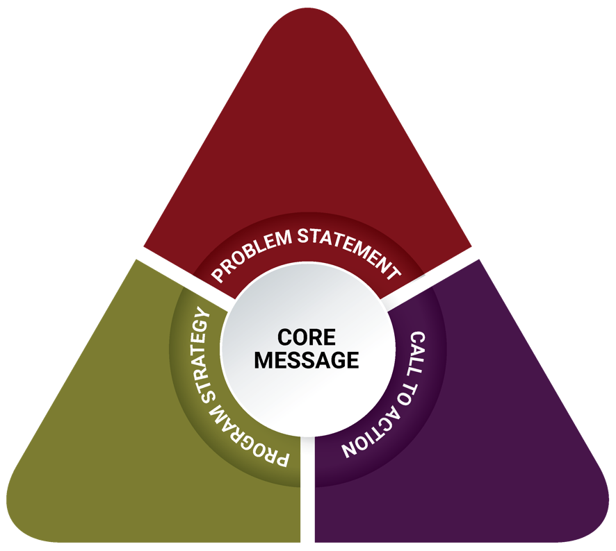
Ultimately, three message triangles were developed: for youth, for caregivers, and for men of color who have a history of substance misuse. Each message triangle informed the design of an activity that transmits these messages and operationalizes the call to action.

Messages to Impact Youth and Caregivers
Conversations with youth in focus groups showed that many youth are aware of gambling around them and their own engagement in it. However, they do not always realize the risks that gambling poses or the ways in which these risks may outweigh gambling’s potential benefits. Youth in Springfield live in an area that is both economically disadvantaged (average incomes in Springfield are among the lowest in the state⁸) and has lower average education levels than the rest of the state.⁹ These factors pose day-to-day challenges for youth and families, and lower socioeconomic status and lower education status are risk factors for developing problems with gambling.^{25, 26} Based on this, and on research showing that a risk factor for developing a gambling disorder is gambling early in life,¹⁴ the core message of the youth strategy is: Gambling carries with it more risk than just winning or losing. The call to action directed at youth is: Protect yourself by understanding the odds of winning and losing, and understanding possible consequences of gambling. The message triangle below shows the components of the development process for the youth strategy.
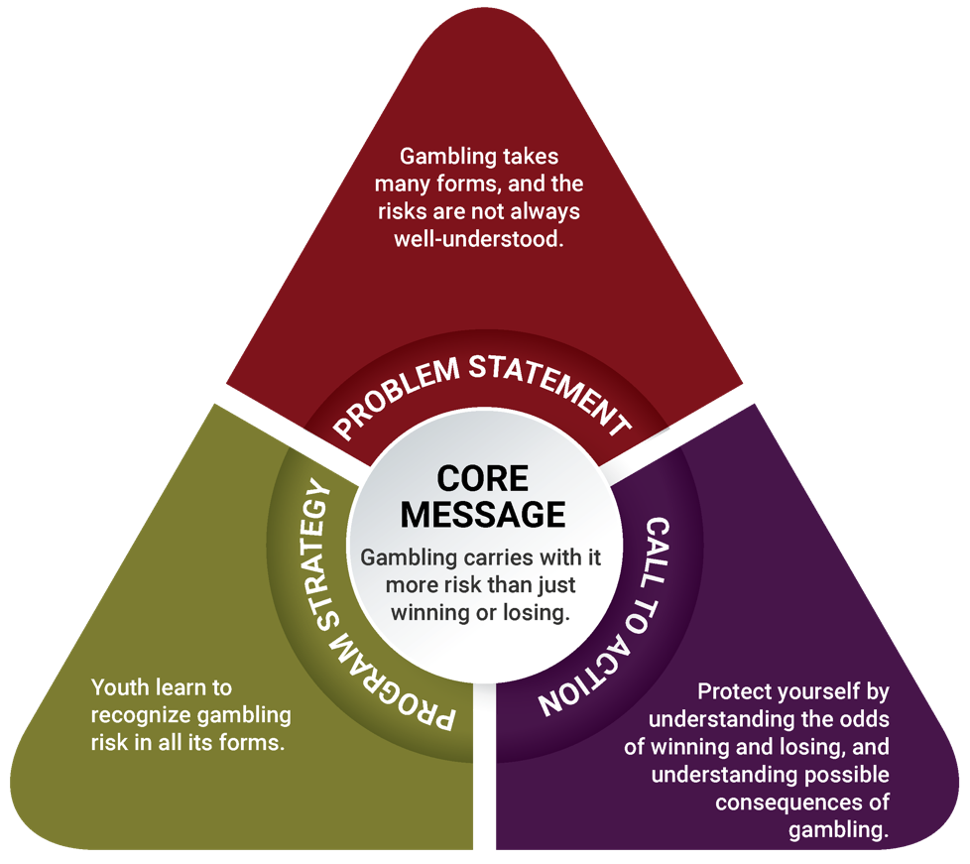

The focus groups and interviews with caregivers suggest that adults have significant personal, familial, and environmental exposure to gambling, and that youth are often exposed to gambling through the same means. Caregivers voiced concern about youth exposure to gambling, but they themselves hold personal attitudes that range from gambling never being acceptable to gambling being acceptable in some forms and situations. Two risk factors for youth are having parents who have experienced gambling problems and having parents who approve of gambling.²⁷ Although not all caregivers interviewed have experienced gambling problems or approve of gambling, participating in gambling or having neutral attitudes about gambling (or believing that it is sometimes harmless) may also be a risk. Based on these findings, the core message of the caregiver strategy is: The adolescent brain is developing quickly, and lessons learned now can pay off later in life. The call to action is: Engage in conversation with youth on making good choices about gambling. The message triangle below shows the components of the development process for the caregiver strategy.
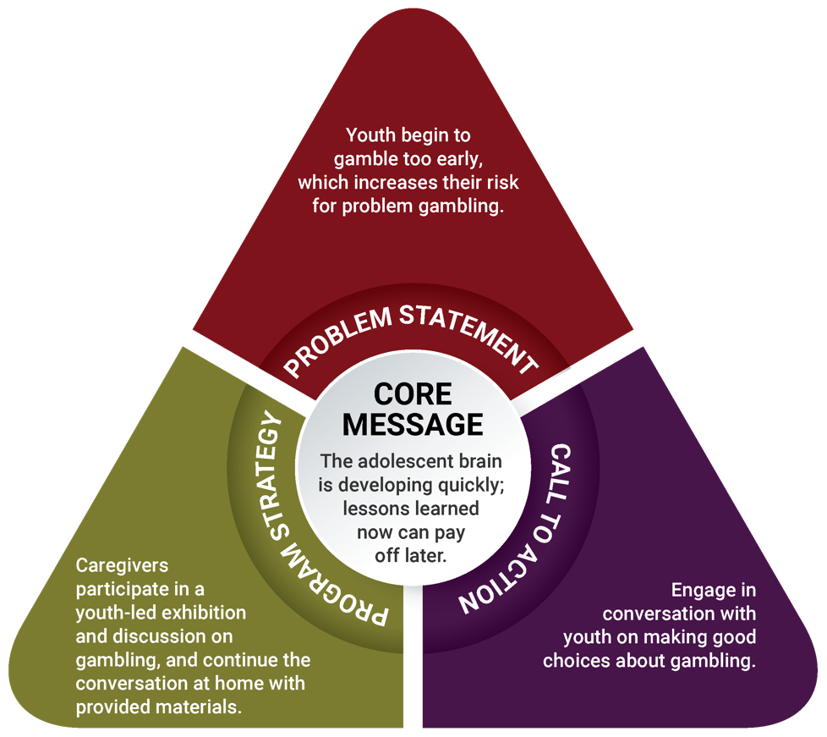

Existing Gambling Prevention Models for Youth
Various gambling prevention programs are being implemented across the country. In 2003, the Oregon Department of Human Services complied the Problem Gambling Prevention Resource Guide for Prevention Professionals, which outlines eight promising problem gambling prevention programs.²⁸ Most recently in 2017, the National Council on Problem Gambling created a program repository of 13 other grassroots problem gambling prevention programs from Canada and 9 other states in the United States.²⁹ The purpose of this report was to encourage program replication, to build enough data for the programs to become evidence-based. Although these programs provide important capacity for problem gambling prevention, none of them provide evidence of effectiveness.
Four programs from the reports mentioned above, along with the message triangles designed for youth and their caregivers in the Springfield area, led to the recommendation of photovoice as a strategy for problem gambling prevention. Photovoice highlights many aspects of the programs in these publications, while using photography, a medium that youth today identify with.
- SMART Choices in Maryland engages youth who live in close proximity to casinos.
- G.A.M.E.S. in Connecticut focuses on personally developing youth and empowering them to work on making their community a healthy place.
- Smart Bet in Ohio is designed to help youth gain the knowledge and skills necessary to make healthy choices about whether or not to gamble, and when and how much to gamble. The program is designed to allow participants to explore the role of gambling in society and in their lives, the risks and benefits of gambling, as well as examine their own attitudes, feelings, and opinions around whether or not to gamble.
- Betting On Our Future in California supports and empowers young people to create positive change by raising the profile of problem gambling and the effects it has on youth, their families, and their community. Youth use to use this information to create a final product like a public service announcement, a play, or another artistic medium that illustrates important community messages.

Strategy to Impact Youth and Caregivers
For the past two decades, qualitative researchers have used a photography-based research method called photovoice to better understand political and social issues and to drive policy change. This method is based on work by sociologist Paulo Freire, who advocated for giving a voice to the oppressed and marginalized in society as a means of balancing dynamics with those in power.³⁰
Photovoice allows participants to take photographs to accomplish three main goals: enable people to record and reflect their community’s strengths and concerns, promote critical dialogue and knowledge about important issues through large- and small-group discussion of photographs, and reach policymakers.³¹
This type of participatory, socially shared photography creates myriad opportunities for innovative health and wellness programming with teens and young adults. In one example, researchers investigated the link between college students’ smartphone photography use with feelings of happiness. They found that being asked to take and share a daily photograph of something that made students feel happy increased their feelings of overall happiness and well-being, and increased their sense of reflectively engaging with the world.³²
In recent years, photovoice has been repurposed as an educational tool for teens and young adults. With their dominant use of photography on smartphones, photovoice educational and prevention programs have shown tremendous promise in reaching and engaging with this population, whom prevention often struggles to reach. Photovoice has been effectively used to explore the community impact of substance use among adolescents,³³ to explore perceptions of multiculturalism among teens in communities,³⁴ to change public policy around safety and physical education,³⁵ and to better understand barriers to health care in low-income communities.³⁶

Photovoice for Underage Gambling Prevention
Photovoice projects have three phases: planning the project, carrying out the project, and exhibiting the final photographs.

Planning a Photovoice Project
Planning a photovoice project includes clearly stating the project objectives to ensure that they are understood and included in all aspects of the planning. The photovoice project in the Springfield area has four objectives:
- increase youth’s recognition of the risks of gambling
- increase youth’s ability to analyze and evaluate gambling messages
- increase youth’s perception of the harm of gambling
- increase youth’s development of critical thinking skills related to gambling messages
This photovoice project is easily incorporated into an existing youth program, which will provide additional opportunities for youth to gain leadership skills and be active in their community. In the Springfield area, this photovoice project is 8 sessions long and should be managed by a comprehensive timeline to ensure that all components are completed during the allotted time.
As part of the preparation for this project, youth are introduced to gambling by discussing what gambling is, the various kinds of gambling, who participates in gambling, where they see gambling, and the impact gambling has on their community. To gain skills in media literacy (the ability to analyze and evaluate how media messages influence one’s own beliefs and behavior),³⁷ youth will also think about the various ways gambling manifests in their lives, the various kinds of messages they receive about it, and how they negotiate their feelings about these things. Next, youth learn that they will continue this exploration through photography and are introduced to photovoice specifically. This introduction will include training on a variety of ethical issues, including informed consent and understanding that they are stewards of their community when taking pictures. Informed consent includes both their own consent (re: allowing their photographs to be used) and the consent others must give before having their picture taken.

Carrying Out a Photovoice Project
Youth will receive cameras and will be trained on technical aspects of camera use, such as focus, frame, lighting/flash, and movement when taking photographs. Youth will also practice visual literacy, including how to tell a story through photographs by linking images, taking reality photographs, using symbolism, and arranging scenes to create a specific message.³⁸ Youth will continue to explore how messages around them are constructed by analyzing various forms of media (e.g., television, video games, computers, cell phones, billboards, advertisements). Youth should be encouraged to explore the questions below.³⁹ As they practice visual literacy and critical analysis of media, they will be able to take photographs incorporating their thoughts about the impact of media.
- Who produced this work?
- Where are they from?
- What are their attitudes and values relative to my own?
- What are they attempting to achieve through this work?
- Are they trying to change my perspective in some way?
- Do I agree with their point of view?
- How can I respond to their work?
At least three sessions of the project should focus on taking photographs. Before these sessions, youth will receive a question to respond to when taking photographs. For example:
- What messages do you receive about gambling in your life or community?
- Why do youth participate in underage gambling in your community?
- What kind of information does your community need about gambling?
During the week following each photography assignment, youth will discuss the photographs as a group using the SHOWed method.⁴⁰ “SHOWed” is an acronym that guides youth in discussing their photographs:
- S: What do you see?
- H: What happened or is happening in the picture?
- O: How does this relate to our lives?
- W: Why does this happen?
- E: How could this image educate others?
- D: What can we do about it?
In these sessions, youth begin to have a dialogue with one another about gambling, their community, and their thoughts and feelings. The adult facilitator is then able to infuse education into the session as youth ask questions and make connections.
Eventually, youth will select their best photographs from the project and develop a caption using an excerpt from their SHOWeD description. The discussions can also be transcribed and then used to develop descriptions or captions based on the words used by youth photographers. Photograph captions can illustrate an idea in a photograph, raise awareness about an issue, or advocate for a particular change. This gives youth an opportunity to decide how they want to influence their community.

Exhibiting the Photographs to Create Social Change
A selection of photographs curated by youth will be professionally printed on large card stock in preparation for an exhibition. This can take two to three weeks, depending on timing and available resources. While photographs are being printed, youth should prepare to present their photographs to their community. Youth should practice public speaking and be well prepared to advocate for the change they want in their community. The exhibition of photographs (which should be held in an easily accessible location, so everyone is welcome) is an opportunity for youth to use their photography as a vehicle for sharing their thoughts and feelings with the community. It is well-documented in prevention research that feeling like an active member of a community is a protective factor for youth.^{41,42}

Caregiver Component of Photovoice Project
Understanding that caregivers have a significant influence over youth behavior, the caregiver strategy is connected to the photovoice project that the youth complete. The objectives of the caregiver strategy are to:
- increase caregivers’ understanding of the risks of underage gambling
- increase caregivers’ knowledge of ways to talk to youth about gambling
- increase caregivers’ perception of the importance of underage gambling prevention
- increase caregivers’ intentions to talk to youth about gambling
Caregivers will participate in one session, run by an adult facilitator who is preferably also a caregiver. During this session, caregivers will view photographs from the youth photovoice project and participate in a discussion about youth gambling and supporting youth in avoiding risky behaviors. Youth will present photographs from the photovoice project and describe why the project was important and what they learned from it. After this portion of the meeting, youth will leave to allow caregivers to discuss their thoughts and reflections about what the youth shared. Understanding what new information caregivers learned, what they heard from youth that they already knew, and what questions they have will help the adult facilitator lead a conversation with the group.
The adult facilitator will transition into gambling prevention education, when appropriate, and will cover the following topics:
- What gambling is and what types exist, to help caregivers understand how much youth are exposed to gambling
- The risks of gambling, to educate caregivers about the groups at high risk for problem gambling
- The importance of talking to youth about underage gambling, to let caregivers know that they can talk to youth about underage gambling and that doing so is a protective factor
This section should be as interactive as possible. To encourage participation from caregivers who may not feel comfortable speaking up in large groups, opportunities for individual or small-group conversations should be offered as well. It is important that the facilitator normalize this conversation so that the caregivers who attend feel comfortable discussing this information with their children at home. Caregivers should leave the session informed, energized, and with educational materials they can use to practice what they learned during the session.

Regional Comparison: Prevention Strategy for Youth and Caregivers
The photovoice methodology was also recommended as a prevention strategy in the Plainville/Southeastern Massachusetts region (Region C). Photovoice is a participatory strategy that allows for tailoring and adapting objectives based on community needs and experiences.
As mentioned, photovoice in the Springfield area has objectives for youth that are centered on increasing their perception of harm of gambling and increasing their critical thinking skills to navigate pressures to gamble. Youth in Springfield have a lot of exposure to gambling and reported the need for money as a benefit of gambling and a reason why people gamble. This is an indication that youth are impacted by high poverty rates, the low household incomes, and/or the high unemployment rates Springfield experiences. The photovoice project will engage them in these issues through photography, educate them about underage gambling, and support them in developing the ability to assess the feasibility of getting positive outcomes though gambling.
In contrast, in the Plainville/Southeastern Massachusetts region, the objectives for youth are related to increasing their awareness about gambling exposure and increasing their perception of harm of underage gambling. Youth in the Plainville area had limited direct experience gambling. One youth reported that “People sometimes bet on fighting people. People get in a fight, and others bet on who will win. I see that on TV shows.” These youth also reported understanding that there can be harm involved in gambling: “It’s hyped up to be this great thing, with all the lights and stuff. When you take a step back and look at it objectively, you realize it’s not that great. But it’s painted as this wonderful thing.” The photovoice project will help them make personal connections with the underage gambling around them through photography, educate them about underage gambling, and the risks associated with it.
The objectives for the caregiver component of photovoice in both regions also show parallels: in both regions, some objectives center on caregivers’ understanding of youth brain development and the vulnerability of youth in the face of risky behaviors. In the Plainville/Southeastern Massachusetts region, the photovoice component for caregivers was largely educational; this iteration of the strategy involves educational components but also stems beyond transfer of information: caregivers learn about the importance of underage gambling prevention, and also discuss and gain skills in talking to their children about gambling.

Messages to Impact Men of Color Who Have a History of Substance Misuse
Focus group conversations with men in recovery show that these individuals view gambling as closely intertwined with drug and alcohol use, in terms of both the effects that substance use and gambling have on a person’s life and the tendencies of individuals to participate in both. Multiple men in recovery noted their attraction to gambling, even if they are in recovery from a substance use disorder rather than a gambling disorder. This is in line with research showing that using illicit drugs is a risk factor for problem gambling,²⁷ and other findings that someone with a substance use disorder has higher odds of developing a problem with gambling than someone without a substance use disorder.¹⁴ Therefore, the core message of this strategy is: Gambling is another addiction, with some of the same risks as substances such as drugs and alcohol. Based on participants’ interest in sharing their experiences and teaching others, the call to action is: Incorporate discussions of problem gambling into recovery, and encourage men in recovery to be ambassadors. The message triangle below shows the components of the development process for the strategy to impact men of color who have a history of substance misuse.
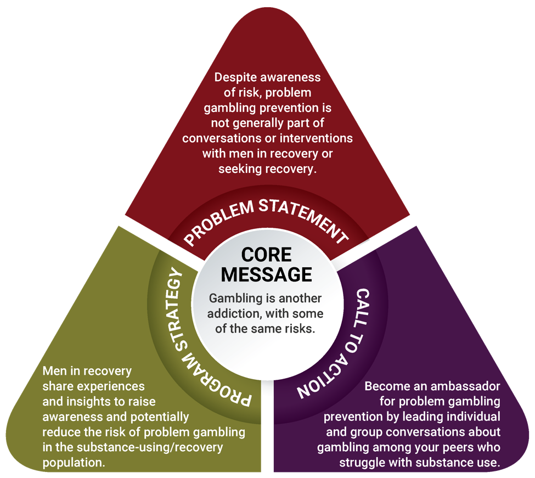

Existing Educational Gambling Prevention Models
Promising gambling prevention programs from across the country informed the development of the ambassador strategy. In particular, three strategies outlined by the Oregon Department of Human Services’ Problem Gambling Prevention Resource Guide for Prevention Professionals²⁸ and the National Council on Problem Gambling’s repository of grassroots problem gambling prevention programs²⁹ supported the design of a prevention strategy for men of color with a history of substance misuse. As mentioned above, although these strategies are promising, concrete evidence of their effectiveness is not yet available.
- Asian Pacific Americans Ambassadors Program: Model Community Change in Connecticut educates and trains adults to be ambassadors in their communities, to educate others about substance use and gambling and encourage others to seek help where needed. This program uses bilingual and bicultural strategies, thereby promoting access to culturally relevant information.
- Catalyst Bystander Intervention Program in Ohio is an educational program that aims to address issues on college campuses including substance use and mental illness, and trains participants to promote health and safety in their environment.
- All Bets Off in Missouri is an educational strategy that educates participants on the connections between, and the risks of, substance use disorders and gambling.
Along with the promising educational strategies above, the message triangle for men of color with a history of substance misuse and the peer-oriented culture of recovery centers informed the design of the ambassador strategy.

Strategy to Impact Men of Color Who Have a History of Substance Misuse
DPH funds 10 substance use peer recovery support centers across the state. These centers use the Massachusetts Peer Participatory Process Model,⁴³ which requires that people engage with one another through lived experience, accept all paths of recovery in order to build healthy relationships, and empower peers to become productive members of society. This model connects people in recovery by building a community where everyone has a voice in the programming, services, and functioning of each center.
All center members, known as “the community,” have the ability to generate ideas, voice their thoughts and concerns, raise important questions, and identify needs and gaps within the center. Each center has regular community meetings that provide a mechanism for the community to share input into recovery activities, community groups, center initiatives, and/or policies.⁴⁴ These decisions pass to a leadership committee, also made up of center members, who prioritize center needs and identify the feasibility of any proposed services and policies; the leadership committee then makes recommendations to center staff.⁴⁵
Recovery support center staff are also in recovery, and their role is to coordinate, oversee, and facilitate activities identified by the center community. Each center has between two and three staff, including the program director and volunteer coordinator. In addition to staff, recovery centers are run by volunteers, who can play various roles, including setting up programming, preparing meals, facilitating groups and events, providing support, leading activities, and supporting administrative tasks. Volunteering is an important part of being in recovery, and volunteer roles provide an opportunity for people to give back, enhance their skills, and connect with others.⁴⁵

Ambassador Strategy for Problem Gambling Prevention
The ambassador strategy is a participatory, peer-to-peer strategy that trains men of color who are in recovery to have gambling prevention conversations with other men of color with a history of substance misuse. According to SAMHSA, research has shown that peer support facilitates “recovery and reduces health care costs . . . [by promoting] a sense of belonging within the community. . . . [peer support also promotes] the development of self-efficacy through role modeling and assisting peers with ongoing recovery through mastery of experiences and finding meaning, purpose, and social connections in their lives.”⁴⁶
The objectives of the ambassador strategy are to:
- increase understanding of the connections between gambling and other addictions
- increase awareness of what gambling is and where it is present in everyday life
- increase perception of risk of developing a gambling disorder when one develops a substance abuse disorder
- increase self-efficacy to facilitate discussions about gambling with peers
Ambassadors will be identified by the community and staff of each recovery center. Ambassadors should be members who have already shown leadership qualities in the center and regularly take initiative. While ambassadors are peers, they will be additionally trained on the importance of conducting themselves with integrity and professionalism in this role. Recovery centers will identify how to fit ambassadors into the organizational structure so they have access to formal support systems.

Gambling Education
Ambassadors will be trained in all aspects of gambling, including various definitions, examples of gambling, the gambling continuum,¹⁷ and how gambling can impact recovery. Ambassadors will learn about the data available in Massachusetts and what they say about the communities most at risk for problem gambling. Lastly, ambassadors will learn about the importance of ensuring that everyone has the ability to attain good health; this includes being able to recognize community indicators that exacerbate problem gambling.

Leadership Development and Communication
Although the ambassadors will already have leadership skills before coming into their ambassador role, this strategy will enhance those skills and help ambassadors build on them. Ambassadors will learn about the Stages of Change Model and how it applies to having gambling prevention conversations.^{47,48} They will also learn the facilitation skills needed to plan and facilitate groups, how to develop a positive group culture, and how to manage difficult conversations.
Individual and group interactions can occur as part of the ambassador strategy. Examples of individual interactions are speaking with someone at a recovery center, on the street, or during a private conversation at a program run by the center. Group interactions can occur at the recovery centers or partner organizations that serve high-risk populations and request peer gambling prevention groups or presentations.

Supervision and Organizational Policies
Recovery support providers will need to make sure that supervision systems are in place so that ambassadors have a supervisor with regular supervision time and that their supervisor has regular supervision time. This will ensure success at both the ambassador and supervisor levels, and will help the organization build capacity to manage peer gambling prevention services.
Organizational leaders have the important role of reviewing the policies and activities of the recovery centers and its parent organization (if applicable) to assess if the organization promotes a gambling-free culture. If the organization already has policies against gambling, this review can ensure that they are being enforced.

Regional Comparison: Prevention Strategy for Men of Color with a History of Substance Misuse
The ambassador strategy was also recommended in the Plainville/Southeastern Massachusetts region (Region C). The ambassador project uses a participatory peer education model that can easily be adapted across regions, populations, and community concerns.
As previously described, the ambassador strategy has objectives that are centered on increasing understanding of gambling’s connections to other behavioral health disorders, increasing the perception of risk related to gambling, and increasing ambassadors’ self-efficacy to facilitate conversations about gambling with their peers.
In the Springfield area, men in recovery had an understanding of how risky gambling can be after experiencing a substance use disorder: “You exchange one for the other. If you want to stop getting high, you go to gambling to think it’s going to be a quick fix. You start gambling, start feeling the same state of thought. When you feel depressed with one, you go back to the other hoping for a benefit from one.” In the Plainville/Southeastern Massachusetts region, men in recovery similarly reported that “It’s not too much separate . . . It goes hand in hand because it’s obsession and compulsion. Personally, I don’t know anyone who just gambles. And where I come from, I don’t know anyone who just uses. We all gambled, even in active addiction. I think it’s one.” The ambassador strategy builds on this knowledge, sharpens leadership skills of ambassadors, and teaches them to use their experience to teach other men with substance use disorders about the risks of gambling.
A benefit of their past participation in treatment programs and current membership in recovery centers, individuals in recovery have a vast understanding of substance use disorders. This strategy in both regions aims to support ambassadors in expanding the conversation on substance use disorders by incorporating problem gambling into it, and to increase their capacity to have conversations about gambling with their peers.
A significant difference in implementation of the ambassador project between regions is in how the priority population is reached. In the Springfield area, there are more places and opportunities to reach men of color since the majority of residents are people of color; conversely, every county in the Plainville/Southeastern Massachusetts region has at least 89% percent white residents, which will make identifying men of color more of challenge. Common locations to reach the priority population include substance use treatment facilities, shelters, houses of corrections, and community-based organizations. In the Plainville/Southeastern Massachusetts region, once the priority population in systems and programs has been reached it will be important to do outreach on the streets, in barber shops, and at social gatherings and homes to meet the population where they are.

Theory of Change
Below is a logic model that illustrates the theory of change and the path to desired short-term, intermediate, and long-term outcomes for each strategy. In addition to the expectation that the strategies (and their short-term and intermediate outcomes) will impact rates of underage gambling and problem gambling in the long term, these strategies also have the potential to build health equity in the region. In the logic model below, orange boxes indicate strategies for youth and caregivers, green boxes indicate strategies for men of color who have a history of substance misuse, and blue boxes indicate where both strategies overlap.
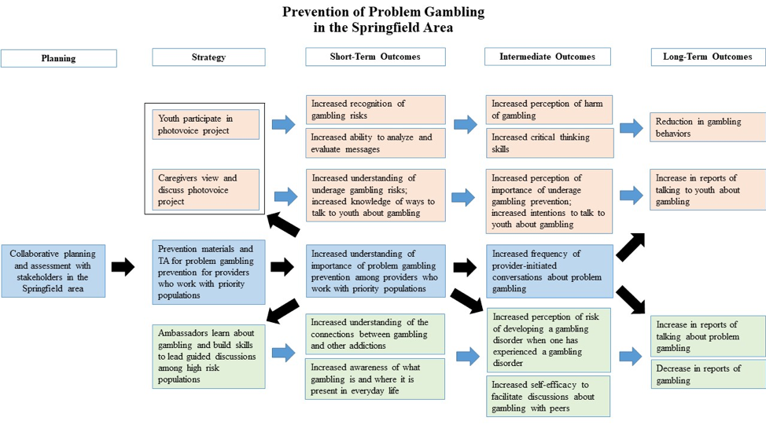

Implications and Recommendations
This regional planning process may have a variety of implications for Springfield and surrounding communities in the region, and for the state of Massachusetts as a whole. Below are the primary implications of this work, along with recommendations for DPH and the Office of Problem Gambling Services for ways to continue supporting problem gambling prevention beyond the scope of this planning process.

Implication 1
A large proportion of youth reported gambling in their environment and personal participation in gambling, but at the same time their attitudes show that they are conscious of the harms of gambling. The attitudes and actions of youth are not entirely aligned.
Recommendation: In addition to offering the photovoice strategy to all youth, develop targeted prevention strategies for youth at highest risk for underage gambling that include exploring risks associated with underage gambling and making connections between actions and attitudes.

Implication 2
Caregivers in focus groups describe their exposure to and participation in gambling, and their children’s exposure to gambling. Caregivers play a major role in preventing risky behaviors and have an opportunity to support underage gambling prevention.
Recommendation: Identify or develop educational materials for caregivers on how to prevent their children from participating in underage gambling, and make these resources widely available.

Implication 3
In focus groups, men in recovery described problem gambling as another addiction. Men in recovery have a unique experience that allows them to connect substance misuse and problem gambling.
Recommendation: Provide opportunities for men in recovery to inform policies and initiatives that make connections between substance misuse and problem gambling.

Implication 4
Focus group and key informant interview results give insight into the particular nuances of a community and the people who may be most deeply affected, beyond what community- or state-level quantitative data show. Community residents know their community well, and their insights are invaluable in understanding community context, identifying key leaders and gatekeepers in the area, and developing sustainable prevention strategies.
Recommendation: Ensure that local residents have a voice in the implementation of initiatives for problem gambling prevention in their community.

Implication 5
Community-based social services organizations of all types are interested in learning about gambling. These organizations serve populations at high risk and can benefit from opportunities for strategic capacity building to support problem gambling prevention.
Recommendation: Provide opportunities for community-based social service organizations to build their capacity to engage in problem gambling prevention.

Implication 6
A health equity lens throughout this regional planning process helped identify populations who are most impacted by these issues and ensured that these groups informed the data gathered in this assessment. Using a health equity lens is important to understand the realities and nuances of gambling and problem gambling across Massachusetts.
Recommendation: Assess the health and racial disparities in a given area, and include the people who are experiencing the most significant disparities.

Implication 7
Youth, caregivers, and men in recovery describe gambling as intertwined with violence, community health, sexual exploitation, and poverty. These factors have a compounding effect and create community disorder that supports problem gambling. Effective prevention requires multiple prevention strategies across multiple domains.
Recommendation: Encourage collaboration among multiple public health sectors to integrate problem gambling prevention strategies.

Implication 8
In Springfield and surrounding communities, focus group participants and key informants shared their thoughts about the populations they are most concerned about in terms of problem gambling, particularly in light of the opening of the MGM casino. One new population that emerged from these conversations that is not reflected in state-level quantitative data is older adults.
Recommendation: Explore how older adults are impacted by problem gambling, and provide opportunities to engage them in prevention strategies.

ENDNOTES
- Massachusetts Technical Assistance Partnership for Prevention. (2016, April). Strategic plan: Services to mitigate the harms associated with gambling in Massachusetts. Waltham, MA: EDC. Funded by the Bureau of Substance Abuse Services. Retrieved from http://www.mass.gov/eohhs/docs/dph/com-health/problem-gambling-strategic-plan.pdf
- This strategy was later broadened to include all types of primary guardians, or “caregivers.”
- American Public Health Association. (2015). Better health through equity: Case studies in reframing public health work. Retrieved from https://www.apha.org/-/media/files/pdf/topics/equity/equity_stories.ashx?la=en&hash=DB7341D9CA82547EAFD8DF9DCAE718A0CD6B92DC
- Massachusetts Gaming Commission. (2018). Surrounding community & related agreements. Retrieved from https://massgaming.com/about/community-mitigation-fund/host-surrounding-communities/surrounding-community-agreements/
- United States Census Bureau. (2016, July 1). Quickfacts: Springfield city, Massachusetts. Retrieved from https://www.census.gov/quickfacts/fact/table/springfieldcitymassachusetts/PST045216#qf-headnote-a
- United States Census Bureau. (n.d.). Sex by age: 2012–2016 American Community Survey 5-year estimates. Retrieved from https://factfinder.census.gov/faces/tableservices/jsf/pages/productview.xhtml?pid=ACS_16_5YR_B01001&prodType=table
- Boston Planning & Development Agency Research Division. (2017, November). Puerto Ricans in Massachusetts, the United States, and Puerto Rico. Retrieved from http://www.bostonplans.org/getattachment/c34c5190-9d26-498c-8a0c-b14dab6da4f7
- DataUSA. (n.d.). Springfield, MA. Retrieved from https://datausa.io/profile/geo/springfield-ma/#intro
- Szegda, K., Robinson, F., Collins, J., & Hudson, S. (2014). Springfield health equity report: Looking at health through race and ethnicity. Springifeld, MA: Partners for a Healthier Community, INC.”
- Massachusetts Department of Elementary and Secondary Education. (n.d.). Cohort 2017 graduation rates. Retrieved from http://profiles.doe.mass.edu/grad/grad_report.aspx?&orgtypecode=5&orgcode=02810000&fcode=2017
- DataUSA. (n.d.). Springfield, MA & Hampden County, MA. Retrieved from https://datausa.io/profile/geo/springfield-ma/?compare=hampden-county-ma
- United States Census Bureau. (n.d.). American Community Survey (ACS). Retrieved from https://www.census.gov/acs/www/data/data-tables-and-tools/
- Pioneer Valley Planning Commission. (2014). Data atlas by neighborhood for the city of Springfield. Springfield, MA: Pioneer Valley Planning Commission. Retrieved from http://www.pvpc.org/sites/default/files/Springfield%20Data%20Atlas%209-23-14-web-reduced.pdf
- Kessler, R. C., Hwang, I., LaBrie, R., Petukhova, M., Sampson, N. A., Winters, K. C., & Shaffer, H. J. (2008). The prevalence and correlates of DSM-IV pathological gambling in the National Comorbidity Survey Replication. Psychological Medicine, 38(9), 1351–1360.
- Work Group for Community Health and Development. (2016). Deciding where to start. In Community Tool Box (section 3). Retrieved from http://ctb.ku.edu/en/table-of-contents/analyze/where-to-start/identify-targets-and-agents-of-change/main
- Johansson, A., Grant, J. E., Kim, S. W., Odlaug, B. L., & Götestam, K. G. (2009). Risk factors for problematic gambling: A critical literature review. Journal of Gambling Studies, 25, 67–92.
- Volberg, R. A., Williams, R. J., Stanek, E. J., Houpt, K. A., Zorn, M., & Rodriguez-Monguio, R. (2017). Gambling and problem gambling in Massachusetts: Results of a baseline population survey. Amherst, MA: School of Public Health and Health Sciences, University of Massachusetts Amherst.
- Petry, N. M., Stinson, F. S., & Grant, B. F. (2005). Comorbidity of DSM-IV pathological gambling and other psychiatric disorders: Results from the National Epidemiologic Survey on Alcohol and Related Conditions. Journal of Clinical Psychiatry, 66, 564–574.
- Center on Addiction. (2010, February). Behind bars II: Substance abuse and America’s prison population. Retrieved from https://www.centeronaddiction.org/addiction-research/reports/behind-bars-ii-substance-abuse-and-america%E2%80%99s-prison-population
- Minton, T. D., & Zeng, Z. (2016). Jail inmates in 2015. Report prepared for the Office of Justice Programs, U.S. Department of Justice. Retrieved from https://www.bjs.gov/content/pub/pdf/ji15.pdf
- Braun, V., & Clarke, V. (2006). Using thematic analysis in psychology. Qualitative Research in Psychology, 3, 77–101.
- Nowell, L. S., Norris, J. M., White, D. E., & Moules, N. J. (2017). Thematic analysis: Striving to meet the trustworthiness criteria. International Journal of Qualitative Methods, 16, 1–13.
- Massachusetts Technical Assistance Partnership for Prevention. (2017). Prevention of problem gambling: Regional planning process—Plainville/Southeastern Massachusetts (region C). Waltham, MA: EDC. Funded by the MA DPH Office of Problem Gambling Services. Retrieved from https://www.mass.gov/files/documents/2017/12/18/Final%20Report_Problem%20Gambling%20Prevention%20Region%20C.PDF
- MassTAPP. (n.d.). Communications toolkit. Retrieved from http://masstapp.edc.org/communications-toolkit
- Welte, J. W., Barnes, G. M., Tidwell, M.-C., & Hoffman, J. H. (2008). The prevalence of problem gambling among U.S. adolescents and young adults: Results from a national survey. Journal of Gambling Studies, 24(2), 119–133.
- Williams, R. J., West, B. L., & Simpson, R. I. (2012, October). Prevention of problem gambling: A comprehensive review of the evidence and identified best practices. Report prepared for the Ontario Problem Gambling Research Centre and the Ontario Ministry of Health and Long Term Care. Retrieved from https://www.uleth.ca/dspace/bitstream/handle/10133/3121/2012-PREVENTION-OPGRC.pdf?sequence=3
- Wilber, M. K., & Potenza, M. N. (2006, October). Adolescent gambling: Research and clinical implications. Psychiatry (Edgmont), 3(10), 40–48.
- Marotta, J. J., & Hynes, J. (2003). Problem gambling prevention resource guide for prevention professionals. Salem, OR: Oregon Department of Human Services, Office of Mental Health & Addiction Services. Retrieved from: http://www.kdads.ks.gov/docs/default-source/CSP/CSP-Documents/bhs-documents/provider_reports/problem_gambling_prevention_guide.pdf?sfvrsn=6
- Buzzelli, M., Winters, A., & Poggenburg, A. (2017). National Council on Problem Gambling Prevention Committee – program repository. Retrieved from: http://ncpgprevention.preventionlane.org/wp-content/uploads/2018/07/NCPG_Prevention_Committee-Repository_Booklets_V1-2017.pdf
- Freire, P. (1972). Pedagogy of the oppressed. New York: Herder and Herder.
- Wang, C., & Burris, M. (1997). PhotoVoice: Concept, methodology, and use for participatory needs assessment. Health Education and Behavior, 24(3), 369–387.
- Chen, Y., Mark, G., Ali, S., & Ma, X. (2017). Unpacking happiness: Lessons from smartphone photography among college students. Proceedings of the Fifth IEEE International Conference on Healthcare Informatics.
- Brazg, T., Bekemeier, B., Spigner, C., & Huebner, C. E. (2011). Our community in focus: The use of PhotoVoice for youth-driven substance abuse assessment and health promotion. Health Promotion Practice, 12(4), 502–511.
- Johansen, S., & Le, T. N. (2014). Youth perspective on multiculturalism using PhotoVoice methodology. Youth & Society, 46(4), 548–565.
- Hannay, J., Dudley, R., Milan, S., & Leibovitz, P. K. (2013). Combining PhotoVoice and focus groups: Engaging Latina teens in community assessment. American Journal of Preventive Medicine, 44(3), S215–S224.
- Massengale, K. E. C., Strack, R. W., Orsini, M. M., & Herget, J. (2016, May). PhotoVoice as pedagogy for authentic learning: Empowering undergraduate students to increase community awareness about issues related to the impact of low income on health. Pedagogy in Health Promotion, 2(2), 117–126.
- Fingar, K. R., & Jolls, T. (2014). Evaluation of a school-based violence prevention media literacy curriculum. Injury Prevention, 20(3), 183–190.
- Rutgers. (2018). Facilitator’s guide. Retrieved from https://www.rutgers.international/our-products/tools/photovoice/facilitators-guide#Presentations
- Adobe Foundation & Education Development Center, Inc. (2014). YouthLearn media literacy toolbox. [PDF]. Retrieved from http://youthlearn.org/wp-content/uploads/YouthLearn-Media-Literacy-Toolbox.pdf
- Wang, C. C., Yi, W. K., Tao, Z. W., Carovano, K. (1998). Photovoice as a participatory health promotion strategy. Health Promotion International, 13(1), 75–86.
- Oman, R. F., Vesely, S., Aspy, C. B., McLeroy, K. R., Rodine, S., & Marshall, L. (2004). The potential protective effect of youth assets on adolescent alcohol and drug use. American Journal of Public Health, 94(8), 1425–1430.
- Tobler, A. L., Livingston, M. D., & Komro, K. A. (2011). Racial/ethnic differences in the etiology of alcohol use among urban adolescents. Journal of Studies on Alcohol & Drugs, 72(5), 799–810.
- The Massachusetts Substance Use Helpline. (2016, December 29). Paths to recovery: Recovery coaches. Retrieved from https://helplinema.org/2016/12/29/paths-to-recovery-recovery-coaches/
- A New Way Recovery Center [Website]. (n.d.). Retrieved from https://anewwayrecoveryctr.org/
- Grasmere, J., Martell, J., Andersen, R., & Parker, D. (2006). How to build your own peer-to-peer recovery center from the ground up! Retrieved from http://facesandvoicesofrecovery.org/file_download/inline/8345d2db-0c3f-4c92-adaa-9f7948459ada
- Substance Abuse and Mental Health Services Administration. (2015, July 2). Peer support and social inclusion (¶ 2). Retrieved from https://www.samhsa.gov/recovery/peer-support-social-inclusion
- Velasquez, M. M., von Sternberg, K., Dodrill, C. L., Kan, L. Y., & Parsons, J. T. (2005). The transtheoretical model as a framework for developing substance abuse interventions. Journal of Addictions Nursing, 16, 31–40. Retrieved from https://www.researchgate.net/publication/230754128_The_Transtheoretical_Model_as_a_Framework_for_Developing_Substance_Abuse_Interventions
- DiClemente, C. (1999). Motivation for change: Implications for substance abuse treatment. Psychological Science, 10, 209–213. Retrieved from https://www.researchgate.net/publication/247781208_Motivation_for_Change_Implications_for_Substance_Abuse_Treatment

Appendix A: Focus Group and Key Informant Interview Questions

Key Informant Interview Questions
1. When you hear the word gambling, what does that mean to you? What do you think of?
2. How much talk about problem gambling in your community have you heard or learned about?
a. Do you think people have positive or negative associations with gambling?
b. Do you think people consider problem gambling an issue of concern?
c. Why do you think this?
3. How prevalent is problem gambling among the population you serve?
a. What are the types of gambling you see among this group?
4. Do you think gambling is more of a risk for certain populations than others?
5. Is there anything we can do to prevent people in your community from developing a problem with gambling?
6. Is there anything we can do to prevent youth from developing a problem with gambling?
7. Do you have any thoughts on how problem gambling prevention can be integrated into other conversations on health and well-being?
a. Which conversations?
b. What methods work best?
8. Does your organization educate or create awareness among people in your community?
a. Can you describe that?
b. What methods work best?
9. Is there anything else you think is important to add to this discussion?

Youth Focus Group Questions
1. When you hear the word gambling, what does that mean to you? What do you think of?
2. What types of gambling are there?
3. Where do you see gambling in your life?
a. Are there adults or other youth you know who gamble?
b. What are their roles in your life?
c. Do you gamble?
4. Have you ever heard of problem gambling?
a. What do you think it means?
b. Have you ever seen problem gambling? Tell me about it.
5. What benefits are there to gambling?
6. What risks are there to gambling?
a. How harmful do you think gambling is?
7. Do you think some types of gambling seem better or worse than others?
a. In what way?
b. What makes you say that?
8. Have you ever seen any messages about gambling, for example, on billboards, on TV ads, or in magazines?
a. What are they?
b. Where did you see them?
c. What did you think when you saw them?
9. If you were going to talk to your friend about gambling or addiction, what would you say?
10. How do you usually get information—online, TV, word of mouth?
11. Is there anything else you think is important to add to this discussion?

Caregiver Focus Group Questions
1. When you hear the word gambling, what does that mean to you? What do you think of?
2. Where do you see gambling in your life?
a. Are there adults or youth you know who gamble?
b. What are their roles in your life?
c. Do you gamble?
3. How do you feel about your kid(s) gambling?
4. What benefits are there to gambling?
5. What risks are there to gambling?
a. How harmful to do you think gambling is?
6. Do you think some types of gambling seem more OK or less OK for youth?
a. In what way?
b. What makes you say that?
7. Have you ever talked to your kid(s) about gambling or addiction?
a. What prompted the conversation/why?
b. How many times did you talk about it?
c. What did you say?
d. How did it go?
e. What would you do differently, if you were to do it again?
8. How do you usually get information—online? TV? word of mouth?
9. Is there anything else you think is important to add to this discussion?

Caregiver Focus Group Questions (Spanish)
1. Cuando escucha la frase “jugar al azar”, ¿qué significa esto para usted? ¿En qué piensa?
2. En su vida, ¿Dónde ve jugar al azar en su vida?
a. Algunos de los adultos o jóvenes que conoce, ¿juegan al azar?
b. ¿Qué rol tienen esta personas en su vida?
c. ¿Usted juega al azar?
3. ¿Cómo se siente con relación a que sus hijos o menores a su cuidado jueguen al azar?
4. ¿Qué beneficios tiene el jugar al azar?
5. ¿Cuáles son los riesgos de jugar al azar?
a. ¿Cuán perjudicial usted cree que es jugar al azar?
6. ¿Piensa usted que algunos tipos de juegos al azar son más aceptables menos aceptables para los jóvenes?
a. ¿De qué manera?
b. ¿Qué le hace decir eso?
7. En alguna ocasión, ¿Ha hablado con sus hijos/menores a su cuidado sobre jugar al azar o sobre adicción?
a. ¿Qué motivó esa conversación/por qué?
b. ¿Cuántas veces ha hablado sobre eso?
c. ¿Qué dijo usted?
d. ¿Cómo le fue?
e. Si fuera a hacerlo nuevamente, ¿qué haría diferente?
8. Usualmente, ¿Cómo obtiene información?
a. ¿En la Internet?
b. ¿Televisión?
c. ¿En conversaciones con otras personas?
9. ¿Hay algo adicional que considera importante añadir a esta discusión?

Men in Recovery Focus Group Questions
1. When you hear the word gambling, what does that mean to you? What do you think of?
2. What types of gambling are there—legal and illegal?
3. Where do you see gambling in your life?
a. Are there friends, relatives, or other people in your life who gamble?
b. What are their roles in your life?
c. Do you gamble?
4. Have you ever heard of problem gambling?
a. What do you think it means?
b. Have you ever seen problem gambling? Tell me about it.
5. What benefits are there to gambling?
6. What risks are there to gambling?
a. How harmful do you think gambling is?
7. Do you think there are any connections between gambling and substance use?
a. What are they?
8. Do you think some types of gambling seem better or worse than others?
a. In what way?
b. What makes you say that?
9. Have you ever seen any messages about gambling, for example, on billboards, on TV ads, or in magazines?
a. What are they?
b. Where did you see them?
c. What did you think when you saw them?
10. If you were going to talk to someone you know about gambling or addiction, what would you say?
11. How do you usually get information—online, TV, word of mouth?
12. Is there anything else you think is important to add to this discussion?

Men in Recovery Focus Group Questions (Spanish)
1. Cuando escucha la frase “juego al azar ó jugar al azar”, ¿qué significa esto para usted? ¿En qué piensa?
2. ¿Cuáles tipos de juegos al azar existen?
3. ¿Dónde ve juego o jugar al azar en su vida?
a. En su vida, ¿tiene amigos, familiares, u otras personas que juegan al azar?
b. ¿Qué rol tienen en su vida?
c. ¿Usted juega al azar?
4. ¿En alguna ocasión ha escuchado hablar de juego al azar problemático?
a. ¿Qué piensa esto significa?
b. ¿Ha visto juego al azar problemático? Hábleme sobre eso.
5. ¿Qué beneficios tiene el jugar al azar?
6. ¿Cuáles son los riesgos de jugar al azar?
a. ¿Cuán perjudicial usted cree que es jugar al azar?
7. ¿Cree usted que existen algunas conexiones entre el jugar al azar y el uso de sustancias?
a. ¿Cuáles son?
8. ¿Considera que algunos tipos de juegos de azar son mejores o peores que otros?
a. ¿De qué manera?
b. ¿Qué le hace decir eso?
9. En alguna ocasión, ¿Ha visto algún mensaje sobre jugar al azar, por ejemplo, en vallas publicitarias (“billboards”), anuncios en la televisión, o en revistas?
a. ¿Cuáles son?
b. ¿Dónde los vio?
c. ¿Qué pensó cuando los vio?
10. Si fuera a hablar con alguien que conoce sobre jugar al azar o adicción, ¿Qué le diría?
11. Usualmente, ¿Cómo obtiene información?
a. ¿En la Internet?
b. ¿Televisión?
c. ¿En conversaciones con otras personas?
12. ¿Hay algo adicional que considera importante añadir a esta discusión?

