Commonwealth of Massachusetts
Board of Registration in Medicine
178 Albion Street, Suite 330 - Wakefield, MA 01880
Telephone: (781) 876-8210 Fax: (781) 876-8383
www.mass.gov/massmedboard

January 2, 2024

To Whom It May Concern:

RE: Primary Source Verification

The Licensing Division of the Board of Registration in Medicine requires primary source verification of the following documents for M.D.’s and D.O.’s prior to issuing a medical license:

- Completion of two years of premedical school education.
- Completion of medical school training.
- Examination scores from USMLE, National Boards, FLEX and or MCCQE
- Completion of two years of postgraduate training from an ACGME, AOA or Canadian accredited program. All years of postgraduate training are collected and primary source verified at the time of initial licensure. Postgraduate training after the license is issued is not primary source verified.
- ECFMG status report (international medical graduates only).
- National Practitioner Data Bank Profile.
- American Medical Association Profile.
- Federation of State Medical Boards Action Profile.

Please be advised that the on-line verification information is maintained by the Massachusetts Board of Registration in Medicine and is updated every evening, in compliance with TJC and the NCQA standards for primary source verification of physician information. The AMA Physician Masterfile is recognized by the NCQA as a primary source to verification of both medical school and postgraduate training. The information on board certification status is provided by the physician on the license application, profile, or renewal application. Board certification is not a requirement for licensure and therefore is not primary source verified. Please access the Board’s website for additional licensing requirements.

Sincerely,
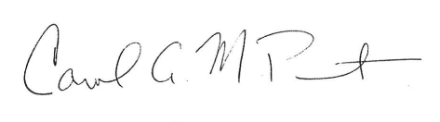
Carol A.M. Purmort
Deputy Director of Licensing

