**INDOOR AIR QUALITY ASSESSMENT**

**Princeton Fire Department**

**8 Town Hall Drive**

**Princeton, Massachusetts**

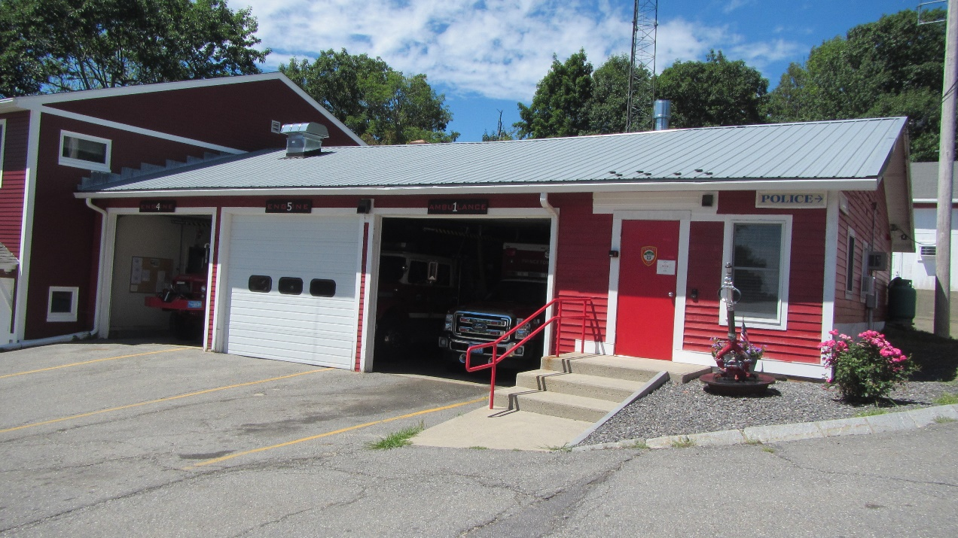

Prepared by:

Massachusetts Department of Public Health

Bureau of Environmental Health

Indoor Air Quality Program

October 2022

# BACKGROUND

|  |  |
| --- | --- |
| **Building:** | Princeton Fire Department (PFD) |
| **Address:** | 8 Town Hall Drive, Princeton, MA |
| **Assessment Requested by:** | Town of Princeton |
| **Reason for Request:** | General indoor air quality (IAQ) concerns |
| **Date of Assessment:** | August 12, 2022 |
| **Massachusetts Department of Public Health/Bureau of Environmental Health (MDPH/BEH) Staff Conducting Assessment:** | Michael Feeney, Director, IAQ Program |
| **Building/Site Description:** | The PFD building is located behind Princeton Town Hall, adjacent to the Princeton Police Department. It is a garage structure with offices that include a dispatch center. |
| **Windows:** | Openable. |

# METHODS

Please refer to the IAQ Manual for methods, sampling procedures, and interpretation of results (MDPH, 2015).

# RESULTS AND DISCUSSION

The following is a summary of indoor air testing results (Table 1). Note that no vehicles were operating in the apparatus bay during the assessment:

* ***Carbon dioxide*** levels were below the MDPH guideline of 800 parts per million (ppm) in all but one area tested, indicating sufficient fresh air for most occupied areas. Note that most areas were unoccupied or had low occupancy. Carbon dioxide levels would likely be higher with higher occupancy.
* ***Temperature*** was within or close to the MDPH recommended range of 70°F to 78°F in occupied areas.
* ***Relative humidity*** was within or close to the MDPH recommended range of 40 to 60% in occupied areas during the assessment.
* ***Carbon monoxide (CO)*** levels were non-detect (ND) in all areas.
* ***Particulate matter (PM2.5)*** concentrations measured were below the National Ambient Air Quality (NAAQS) level of 35 μg/m3 in all areas.

## Ventilation

A heating, ventilating and air conditioning (HVAC) system has several functions. First it provides heating and, if equipped, cooling. Second, it is a source of fresh air. Finally, an HVAC system will dilute and remove normally occurring indoor environmental pollutants by not only introducing fresh air, but by filtering the airstream and ejecting stale air to the outdoors via exhaust ventilation. Even if an HVAC system is operating as designed, point sources of respiratory irritants may exist and cause symptoms in sensitive individuals.

The PFD has a series of small rooms, the exterior of which have openable windows that appear to be the sole sources of fresh air for the building. There is a heating, ventilating, and air conditioning (HVAC) system that recirculates air only. Heating is supplied by baseboard radiators. The following conditions exist in the PFD:

* Baseboard heaters located below windows would be insufficient to heat outdoor air entering openable windows during cold weather.
* Workstations were located within 3 feet of openable windows.
* With windows open, temperature control would not be possible during below freezing (<32°F) weather conditions.
* Windows could not be used during heavy snow.
* Due to security concerns, opening windows is impractical.
* Because of these conditions, PFD windows must remain shut during cold weather, which eliminates the sole source of fresh air that can enter the workspaces.

Also note that window-mounted air conditioners (WAC) are used for cooling in offices. WACs render each window unopenable. Opening windows to supply fresh air with operating AC units is also not recommended for the following reasons:

* With windows open, AC units cannot maintain temperatures.
* AC equipment will continuously operate because it will not be able to reach its set point, which increases wear on machinery that can lead to breakdown.
* AC equipment cannot properly drain accumulated condensation from each unit and can overflow to cause water damage.
* With increased operation, building materials in contact with or beneath AC equipment can become moistened due to temperature at or below the dew point, which can result in mold growth.

With windows closed during hot humid weather or during cold weather, there is no source of fresh air for the building. Without fresh air supply and operating exhaust ventilation, normally occurring indoor air pollutants can build up, which in turn, may cause discomfort to building occupants.

One indicator of this condition was that relative humidity indoors was higher than outdoors in all but one location. Such an increase can indicate a lack of air exchange to remove indoor pollutants, including excess water vapor.

The apparatus bays are equipped with tailpipe exhaust collection systems (Plymovent™) which were in use at the time of the visit. Collecting the exhaust directly at its source is recommended to reduce the migration of gases and particulates to occupied areas of the PFD.

## Microbial/ Moisture Concerns

No active water leaks were noted in the PFD walls or ceiling. Water damage to gypsum wallboard (GW) was noted in several areas. Water penetration through the rear exterior wall has chronically moistened GW in the stairwell (Picture 1). The ceiling in the engine bays has water-damaged GW (Picture 2), which was a result of roof leaks which have been repaired as reported by Princeton Town staff. Fiberglass insulation (Picture 3) rests on top of the engine bay and was likely also wetted by roof leaks. Insulation that become wet loses insulating ability and may also prevent drying of the ceiling GW. Both wet gypsum wallboard and wet insulation may become a medium for mold growth.

It is important to note that Massachusetts has experienced extended periods of high relative humidity over the past several years. For example, the summer of 2021, and July in particular, was the wettest ever recorded in Massachusetts, and the three-month period from June through August, known as the meteorological summer, was the fourth wettest on record, according to the National Oceanic and Atmospheric Administration’s Centers for Environmental Information. That three-month period also was the third warmest ever in the state and was tied for the warmest on record across the United States. (NOAA, 2021). The engine bays are routinely subjected to water vapor exposure during hot, humid weather, which can result in chronic moistening of the engine bay GW and insulation, which in turn may cause mold growth.

Signs of water penetration were also noted in the engine bay rear wall. This is likely due to chronic water accumulation against the exterior wall/slab. The PFD rear wall is located in a rock-lined pit that is formed by a cement retaining wall. A PVC pipe runs along the base of the PFD wall. The PVC pipe is connected to the roof downspout to direct rainwater to a storm drain (Picture 4). The accumulation of water can occur against the walls of the PFD for the following reasons.

* The rock-lined pit does not appear to have a consist pitch to the storm drain.
* The pit likely has soil under stone. Rainwater can compress soil over time, reducing infiltration and allowing accumulation.
* Water and/snow can accumulate between the PVC pipe and the exterior wall.
* The wall/slab junction appears the be buried by the stone lining. Wall/slab junction should by exposed to allow for rapid drying. The side wall of the PFD appears to be similarly buried by soil and grass (Picture 5).
* As the PFD is on a slope of a hill at the base of Mount Wachusett, groundwater runoff likely has a significant impact. Below-grade walls are likely subject to groundwater flow towards the nearest waterbody south/southwest of the building. The back wall of the engine bays may act as a dam, which then may force water through the foundation.

Water penetration caused damage to both floors and walls and can result in mold growth indoors.

## Other IAQ Evaluations

### Vehicle Exhaust/Sources

Under normal conditions, a firehouse can have several sources of environmental pollutants present from the operation of fire vehicles. These sources of pollutants can include:

1. Vehicle exhaust containing carbon monoxide and soot;
2. Vapors from diesel fuel, motor oil and other vehicle liquids which contain volatile organic compounds;
3. Water vapor from drying hose equipment;
4. Rubber odors from vehicle tires; and
5. Residues from fires on vehicles, hoses, and fire-turnout gear.

Of particular importance is vehicle exhaust, which involves the process of combustion. As described above, the engine bays are equipped with a mechanical exhaust system to remove exhaust from vehicles. This equipment should be used each time a vehicle is operated in the bays and maintained in accordance with manufacturer’s instructions.

### Other Issues

There were a large number of items in the station storage areas, including boxes, old equipment, and other items. Stored items can be a source of dust and debris, can provide harborage for pests, and make detection of leaks and other building issues more difficult. Sorting and removal of unneeded items should be conducted regularly.

# CONCLUSION AND RECOMMENDATIONS

To address the building issues, two sets of recommendations are made: **short-term** **measures** that may be implemented as soon as practicable and **long-term measures** that will require planning and resources to address overall IAQ concerns. In view of the findings at the time of the visit, the following recommendations are provided:

## Short-term Recommendations

### Ventilation Recommendations

1. Determine if the HVAC unit has a means to supply fresh air. If it does not, consult with an HVAC contractor to see if a fresh air supply can be added to this system.
2. If there is a fresh air supply, operate the system to supply excess air to occupied areas, so as to *pressurize* occupied areas in comparison to the apparatus bay. This pressurization should take into account the use of exhaust vents in the bathroom and kitchen.
3. If the general exhaust system is not activating automatically whenever vehicles are driven into the apparatus bay, check the settings on the carbon monoxide sensor and/or consider activating this system manually. Ensure there is an adequate amount of make-up air such as through vents or open bay doors, for this vent to operate effectively.
4. Use the Plymovent™ system for capturing vehicle exhaust consistently. Have the system serviced on a regular schedule in accordance with manufacturer’s instructions.
5. Use openable windows and engine bay doors as needed for temperature control and fresh air; however, ensure they are closed during wet weather and when the air conditioning is operating to prevent water infiltration and condensation on cold surfaces. Ensure openable windows have intact screens to prevent pest entry.
6. Ensure that local exhaust vents are operating (e.g., bathrooms) and that exhaust is ejected outside the building.

### Water Damage Recommendations

1. Continue with efforts to seal additional breaches, including keeping the door to the stairs tightly closed at all times.
2. Relocate the PVC pipe to the base of the pit retaining wall.
3. Remove and replace water-damaged gypsum wallboard and insulation wetted by roof leaks. Consider replacing the engine bay system with water-resistant materials to prevent mold growth.

### Other Recommendations

1. Regularly remove unneeded stored materials, and store remaining materials neatly and off the floor.
2. For buildings in New England, periods of low relative humidity during the winter are often unavoidable. Therefore, scrupulous cleaning practices should be adopted to minimize common indoor air contaminants whose irritant effects can be enhanced when the relative humidity is low. To control for dusts, a HEPA filter equipped vacuum cleaner in conjunction with wet wiping of all surfaces is recommended. Avoid the use of feather dusters. Drinking water during the day can help ease some symptoms associated with a dry environment (throat and sinus irritation).
3. Refer to resource manual and other related indoor air quality documents located on the MDPH’s website for further building-wide evaluations and advice on maintaining public buildings. These documents are available at <http://mass.gov/dph/iaq>.

## Long-Term Recommendations

1. Explore the feasibly of installing a mechanical HVAC system that provides fresh air during all times of building occupancy and air chilling capacity during hot, humid weather.
2. Consider re-pitching the rear wall roof gutter in the direction of the storm drain, and installing a downspout.
3. Consider re-grading the pitch of the pit toward the storm drain.
4. Improve drainage at the rear of the building to reduce water impingement on the foundation of the engine bays. Examine the buried exterior wall for water damage and repair as needed.
5. Remove soil and earth from wall shown in Picture 5 to expose the wall/slab junction.
6. Restructure the engine bay floor to direct water to the floor drain.

# REFERENCES

MDPH. 2015. Massachusetts Department of Public Health. Indoor Air Quality Manual: Chapters I-III. Available at: <https://www.mass.gov/lists/indoor-air-quality-manual-and-appendices>.

NOAA. 2021. Summer 2021 neck and neck with Dust Bowl summer for hottest on record. National Oceanic and Atmospheric Administration, 1401 Constitution Avenue NW, Room 5128, Washington, DC 20230. <https://www.noaa.gov/news/summer-2021-neck-and-neck-with-dust-bowl-summer-for-hottest-on-record>,

**Picture 1**

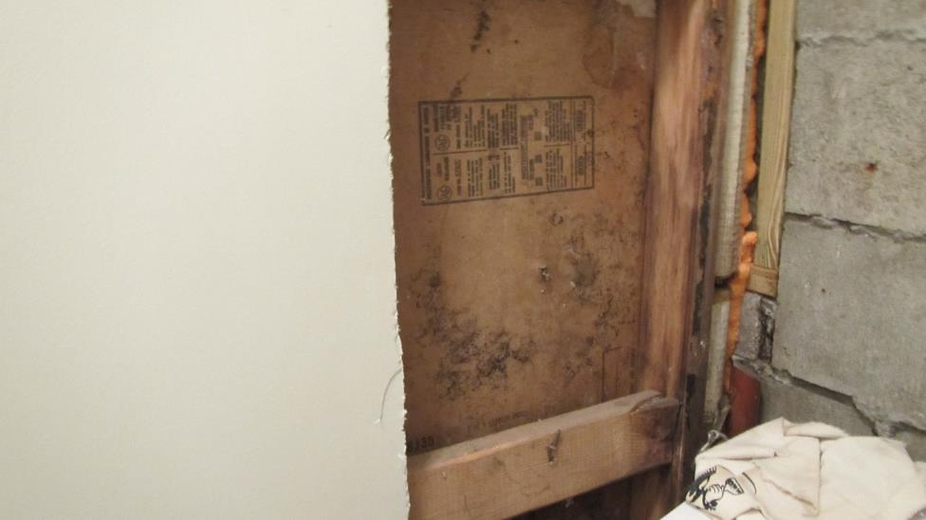

**Water-damaged gypsum wallboard (GW) in the stairwell**

**Picture 2**

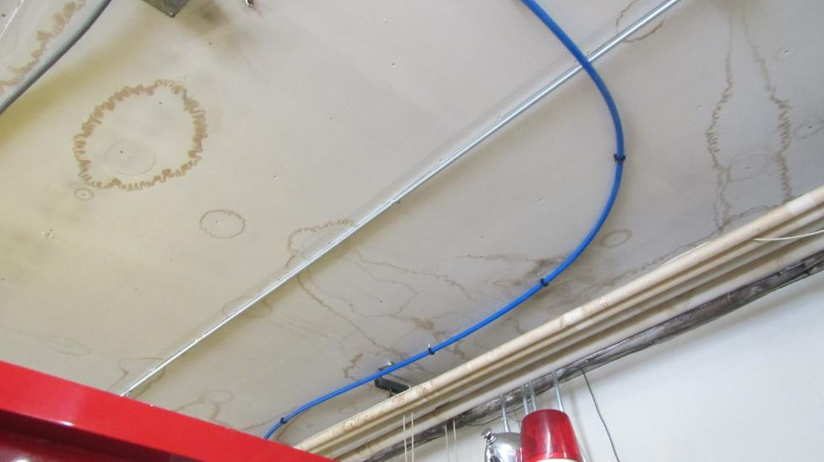

**Water-damaged GW in engine bays**

**Picture 3**

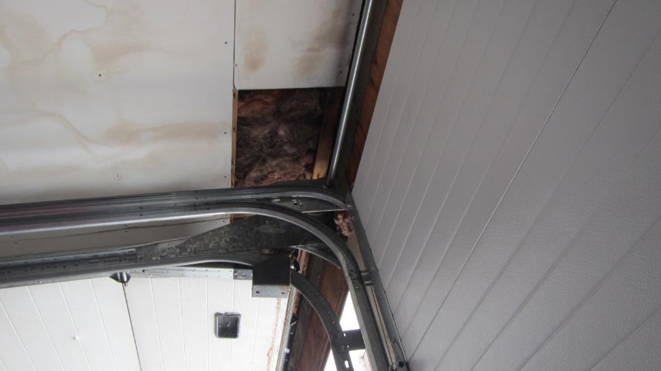

**Damaged insulation above engine bay ceiling**

**Picture 4**

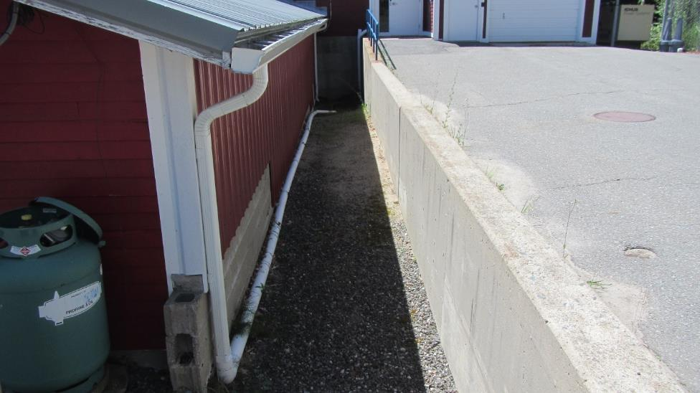

**PVC pipe connected to the roof downspout to direct rainwater to a storm drain**

**Picture 5**

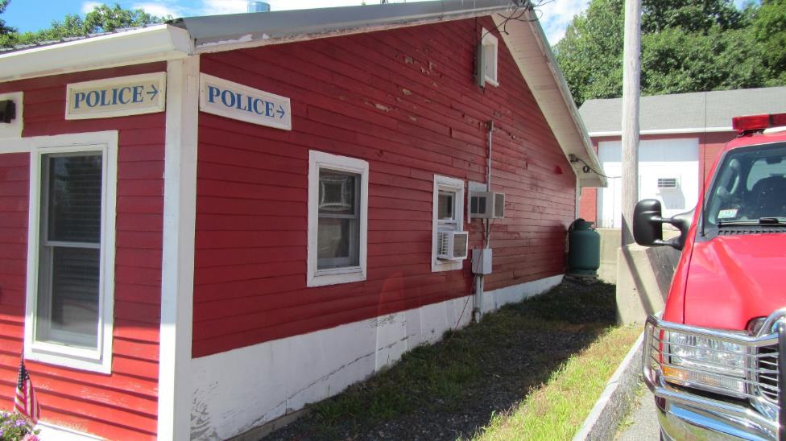

**Side wall buried by soil and grass**

| **Location** | **Carbon**  **Dioxide**  **(ppm)** | **Carbon Monoxide**  **(ppm)** | **Temp**  **(°F)** | **Relative**  **Humidity**  **(%)** | **PM2.5**  **(µg/m3)** | **Occupants**  **in Room** | **Windows**  **Openable** | **Ventilation** | | **Remarks** |
| --- | --- | --- | --- | --- | --- | --- | --- | --- | --- | --- |
| **Supply** | **Exhaust** |
| Background | 318 | ND | 80 | 38 | 1 |  |  |  |  |  |
| Engine bay 1 | 354 | ND | 76 | 47 | 1 | 0 | N | N | N | Plymovent |
| Engine bay 2 | 356 | ND | 75 | 49 | 1 | 0 | N | N | N | Plymovent |
| Engine bay 3 | 318 | ND | 78 | 42 | 1 | 0 | N | N | N | Plymovent |
| Fire chief | 861 | ND | 74 | 37 | 1 | 2 | Y | N | N |  |
| Radio room | 376 | ND | 68 | 52 | 1 | 2 | Y | N | N |  |
| Stairwell | 526 | ND | 76 | 47 | 1 | 0 | N | N | N |  |
| Weight Room | 367 | ND | 73 | 58 | 1 | 0 | N | N | N |  |