**INDOOR AIR QUALITY ASSESSMENT**

**Princeton Police Department**

**8 Town Hall Drive**

**Princeton, MA**

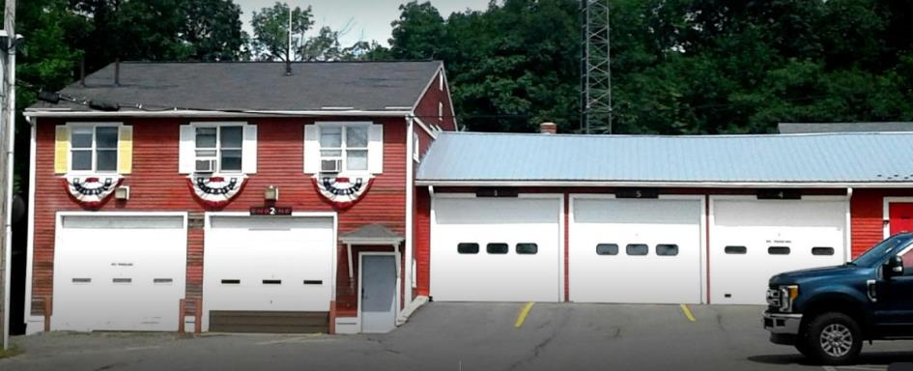

Prepared by:

Massachusetts Department of Public Health

Bureau of Environmental Health

Indoor Air Quality Program

October 2022

# BACKGROUND

|  |  |
| --- | --- |
| Building: | Princeton Police Department (PPD) |
| Address: | 8 Town Hall Drive, Princeton, MA |
| Assessment Requested by: | Michele Powers, Chief of Police, Princeton Police Department |
| Reason for Request: | General indoor air quality (IAQ) concerns |
| Date of Assessment: | August 12, 2022 |
| Massachusetts Department of Public Health/Bureau of Environmental Health (MDPH/BEH) Staff Conducting Assessment: | Michael Feeney, Director, IAQ Program |
| Building Description: | The PPD is located in a building complex that includes Princeton Fire Department (PFD) and Emergency Medical Services (EMS). The building was renovated in the 1980s.  The PPD has a clapboard exterior. The interior is a single floor over a garage that contains PPD equipment. Another ground level garage exists on the same level as the PPD offices, but is not used to house police vehicles. |
| Building Population: | Approximately 3 staff work in the building, with various PPD officers during shifts. |
| Windows: | Openable |

# INTRODUCTION

The PPD was examined due to general IAQ concerns as well as to assess water damage conditions after the extended hot, humid weather of the summer of 2021. IAQ conditions in the PFD portion of the building will be detailed in a separate report.

# METHODS

MDPH IAQ staff conducted a series of visual assessments, temperature, and relative humidity measurements to identify likely areas that could be prone to condensation in hot, humid weather. Please refer to the IAQ Manual for methods, sampling procedures, and interpretation of results (MDPH, 2015).

# RESULTS and DISCUSSION

The following is a summary of indoor air testing results (Table 1).

* ***Carbon dioxide (CO2) levels*** were below the MDPH guideline of 800 parts per million (ppm) in all occupied areas assessed. Please note discussion regarding furnace exhaust vent.
* ***Temperature*** was within the recommended range of 70°F to 78°F.
* ***Relative humidity*** was within the recommended range of 40 to 60% in all areas assessed. Note: indoor relative humidity exceeded outdoor relative humidity by a range of 6 to 18%.
* ***Carbon Monoxide (CO)*** was not detected (ND) in any indoor areas assessed.
* ***Fine particulate matter (PM2.5)*** concentrations measured were below the National Ambient Air Quality Standard (NAAQS) level of 35 μg/m3 in all areas assessed.

## Ventilation

The PPD is located in a space that consists of a series of small rooms that have openable windows that approximately face west and south, which are the sole sources of fresh air. The existing heating, ventilating, and air-conditioning (HVAC) system recirculates air only. The following conditions exist in the PPD:

1. Baseboard heaters located below windows would not have the capacity to heat outdoor air entering openable windows during cold weather.
2. Workstations were located within 3 feet of openable windows.
3. With windows open, temperature control would not be possible during below freezing (<32°F) weather conditions.
4. Windows could not be used during snow conditions.
5. Due to security concerns, use of opening windows is impractical.

Because of these conditions, PPD windows must remain shut during cold weather, which eliminates the sole source of fresh air that can enter work space.

Air chilling during hot, humid weather exists in the PPD. Some nonfunctional wall-mounted air conditioning (AC) equipment (Picture 1) was noted. One functional wall-mounted AC unit was noted in the locker room. Information related to maintenance, filter changing, or repair was not available at the time of this assessment. In an effort to provide heat relief during hot weather, a number of window-mounted ACs were installed, which render each window unopenable. Opening windows to supply fresh air with operating AC units is not recommended for the following reasons:

* With windows open, AC units cannot maintain temperatures.
* Mold can result in wetting of surfaces that have a temperature at or below the dew point.
* AC equipment cannot properly drain accumulated condensation from each unit and can overflow to cause water damage.
* AC equipment will continuously operate in chill mode and its set point temperature to deactivate will not likely be achieved, which increases wear on machinery that can lead to breakdown.
* With increased operation, building materials in contact with or beneath AC equipment can become moistened due to temperature at or below the dew point, which can result in mold growth.

Due to these conditions, it is not recommended to open windows when AC equipment is operating. Under these circumstances, no source of fresh air exists in the PPD during hot, humid weather.

No operating existing ventilation was identified. Without fresh air supply and operating exhaust ventilation, normally occurring indoor air pollutants can build up, which in turn, may cause discomfort to building occupants. An indicator of this condition was relative humidity measurements taken inside the building. It is important to note that indoor relative humidity significantly exceeded outdoor measurements. Such an increase can indicate a lack of air exchange in a building with all windows closed and a lack of mechanical ventilation that supplies fresh air and/or exhausts normally occurring indoor air pollutants (e.g., water vapor).

## Microbial/Moisture Concerns

### Areas Prone to Condensation

It is important to note that Massachusetts has experienced extended periods of relative humidity over the past several years. For example, the summer of 2021 and July in particular, was the wettest ever recorded in Massachusetts, and the three-month period from June through August, known as the meteorological summer, was the fourth-wettest on record, according to the National Oceanic and Atmospheric Administration’s Centers for Environmental Information. The three-month period also was the third-warmest ever in the state and was tied for the warmest on record across the United States. (HG, 2021; NOAA, 2021). These conditions are challenging for buildings, particularly those without air conditioning.

Based on observations, building orientation and the type of floor construction, the garage, and adjacent areas below the PPD office are likely prone to developing condensation during extended (> 24 hours) hot, humid weather. Under certain weather conditions (southerly winds), hot moist air can readily enter the garage through spaces in the garage door and frames, which in turn, can increase relative humidity inside all areas of the PPD. It is important to note that relative humidity inside the PPD was in a range of 6 to 18% higher than outdoor relative humidity measured on the day of assessment. These relative humidity measurements indicate that the PPD has limited means to vent water vapor. Increased relative humidity can have the following effects on buildings and equipment:

* Moisten building materials which may result in mold growth (gypsum wallboard and ceiling tiles),
* Moisten stored materials (paper and other materials) prone to mold growth,
* Cause paper-jams in photocopiers and printers due to paper swelling from moisture exposure, and
* Adversely affect electronic equipment, by causing mold growth on accumulated dust and debris.

These types of problems can increase during extended periods (>2 days) in a building that does not have a means to mechanically reduce relative humidity. An HVAC system typically reduces relative humidity through the use of mechanical exhaust or centralized AC system, which removes water vapor as it condenses on cooling coils, which then is collected and drained out of the building.

According to the American Society of Heating, Refrigerating and Air-Conditioning Engineers (ASHRAE), if relative humidity exceeds 70%, mold growth may occur due to wetting of building materials (ASHRAE, 1989). In this condition, porous materials such as gypsum wallboard, cardboard and other materials may become prone to mold colonization. The United States Environmental Protection Agency (US EPA) and the American Conference of Governmental Industrial Hygienists (ACGIH) recommend that porous materials be dried with fans and heating within 24 to 48 hours of becoming wet (US EPA, 2008; ACGIH, 1989). If porous materials are not dried within this time frame, they should be removed and discarded.

### Water-Damaged Building Interior Walls

The PPD has signs of water penetration in the garage below the offices, the adjacent stairwell, and the mechanical room off the garage (Picture 2). Since the building is built into a slope of a hill at the base of Mount Wachusett, groundwater runoff has a significant impact on the lowest levels of the building. Below grade walls are likely subject to the significant ground water flow towards the nearest water body south/southwest of the building. The back, below grade walls may act as a dam, which then may force water into below grade space, or by water infiltration as demonstrated by water damage to gypsum wallboard, noted in below grade space at the base of a stairwell.

### Unintended Sources of Unconditioned Air Penetration

IAQ staff examined walls shared with occupied space in the mechanical room and garage(s). Visible space around utility pipes and conduits were observed in the garage(s) and mechanical room, which can serve as a means for unconditioned air and water vapor to enter the building, particularly if south, southeasterly wind conditions exist. The lowest level garage door is not airtight and can readily allow for impinging wind to pressurize the garage bay, which then can force unconditioned, moist air to enter occupied space via open seams/spaces around conduits/utility pipes in shared walls as well as interior access doors and their frames. All visible space described should be sealed to the greatest extent possible.

## Other Conditions

Of significant note were conditions noted in the mechanical room. The combustion of fuel produces a number of products including but not limited to CO2, CO, particulate, and water vapor. If the furnace and its flue/chimney are not airtight, products of combustion may be drawn into occupied space through utility holes in walls/floors. The following conditions were noted in the mechanical room.

* Seams in the flue duct did not appear to have sealant on every connection to render it airtight.
* The flue had open holes (Picture 3).
* No combustion air vent for the furnace could be readily identified. In order for a furnace to combust fuel efficiently and to minimize products of combustion, it is recommended that a combustion air vent exist directly to the outdoors in the mechanical room. If not present, combustion air is drawn from the interior of the building, which can lead to incomplete combustion products to enter into the mechanical room.

A properly functioning heating system will vent products of combustion from the building. When oil is combusted, the primary products of combustion produced are CO2 and soot. Dependent on a number of conditions/factors, oil combustion may also produce CO, respirable particulates, and/or nitrogen oxides, which at certain concentrations, can be harmful to health if inhaled.

# CONCLUSIONS and RECOMMENDATIONS

The PPD has a number of issues related to moisture, which is a significant problem given the extreme relative humidity and rain during past summers. Management of buildings in such weather can be challenging. The following documents can provide guidance that can be used to reduce the impact of hot, humid weather in buildings.

* Mold growth Prevention during Hot, Humid Weather <https://www.mass.gov/service-details/preventing-mold-growth-in-massachusetts-schools-during-hot-humid-weather>
* Remediation and Prevention of Mold Growth and Water Damage in Public Schools <https://www.mass.gov/service-details/remediation-and-prevention-of-mold-growth-and-water-damage-in-public-schools-and>
* Methods for Increasing Comfort in Non-air-conditioned Schools <https://www.mass.gov/doc/methods-for-increasing-comfort-in-non-air-conditioned-schools/download>

To remedy building problems, two sets of recommendations are made: **short-term** measures that may be implemented as soon as practicable and **long-term** measures that will require planning and resources to address overall IAQ concerns. Based on the observations made during the visit, the following recommendations are made:

## Short Term Recommendations

### Ventilation Recommendations

1. Consider installing carbon monoxide detectors inside occupied space near interior garage doors and shared wall with mechanical room.
2. Seal all seams and holes around pipes and conduit in shared wall of mechanical room and garage.
3. Install weather-stripping and a door sweep on the garage access door.
4. Determine if inoperable wall-mounted air chilling equipment can be repaired. If not, consider replacement.

### Water Damage/Mold

1. Remediate any water-damaged building materials in accordance with the EPA guideline

“Mold Remediation in Schools and Commercial Buildings” (US EPA, 2008). Clean non-

porous water-stained surfaces, including walls and floors and remove any debris.

1. Have all window-mounted air conditioners serviced, including coils, drip pans and

surfaces in contact with air, in an appropriate manner.

1. During extended periods of hot, humid weather, use of a dehumidifier can be considered.

Please note that dehumidifiers should be configured to drain condensation from the unit

away from the building interior. If the dehumidifiers are purchased, ensure it is properly maintained, including cleaning and drainage.

1. Continue to conduct repairs to prevent water penetration into the mechanical room.
2. Refer to resource manual and other related IAQ documents located on the MDPH’s

website for further building-wide evaluations and advice on maintaining public buildings. These documents are available at: <http://mass.gov/dph/iaq>.

## Long Term Recommendations

1. Explore the feasibly of installing a mechanical HVAC system that provides fresh air

during all times of building occupancy and air chilling capacity during hot, humid

weather.

1. Examine the feasibility of improving draining of ground water entering the mechanical

room.

# REFERENCES

ACGIH. 1989. Guidelines for the Assessment of Bioaerosols in the Indoor Environment. American Conference of Governmental Industrial Hygienists, Cincinnati, OH.

ASHRAE. 1989. Ventilation for Acceptable Indoor Air Quality. American Society of Heating, Refrigeration and Air Conditioning Engineers. ANSI/ASHRAE 62-1989.

HG. 2021. Mold keeps South Hadley High School shuttered. Hampshire Gazette. <https://www.gazettenet.com/South-Hadley-High-School-still-closed-amid-mold-remediation-42413519>.

MDPH. 2015. Massachusetts Department of Public Health. Indoor Air Quality Manual: Chapters I-III. Available at: <https://www.mass.gov/lists/indoor-air-quality-manual-and-appendices#indoor-air-quality-manual->

NOAA. 2021. Summer 2021 neck and neck with Dust Bowl summer for hottest on record. National Oceanic and Atmospheric Administration, 1401 Constitution Avenue NW, Room 5128, Washington, DC 20230 at: <https://www.noaa.gov/news/summer-2021-neck-and-neck-with-dust-bowl-summer-for-hottest-on-record>

US EPA. 2008. “Mold Remediation in Schools and Commercial Buildings”. Office of Air and Radiation, Indoor Environments Division, Washington, DC. EPA 402-K-01-001. September 2008. Available at: <http://www.epa.gov/mold/mold-remediation-schools-and-commercial-buildings-guide>.

**Picture 1**

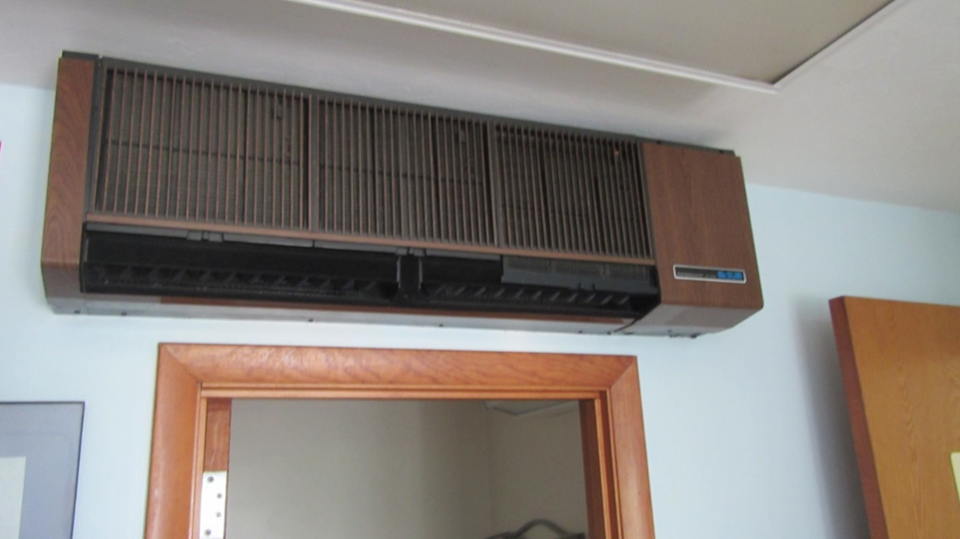

**Nonfunctional wall-mounted air chilling (AC) equipment**

**Picture 2**

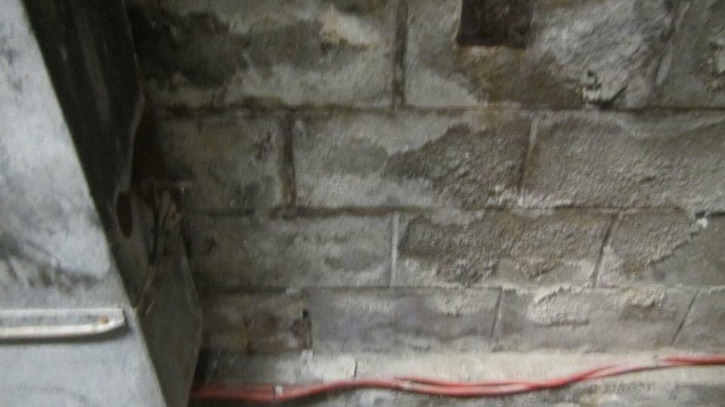

**Mechanical room water damage**

**Picture 3**

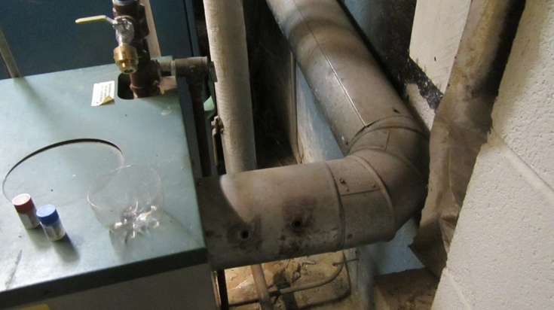

**Open holes in furnace flue (note soot around duct holes)**

| **Location** | **Carbon**  **Dioxide**  **(ppm)** | **Carbon Monoxide**  **(ppm)** | **Temp**  **(°F)** | **Relative**  **Humidity**  **(%)** | **PM2.5**  **(µg/m3)** | **Occupants**  **in Room** | **Windows**  **Openable** | **Ventilation** | | **Remarks** |
| --- | --- | --- | --- | --- | --- | --- | --- | --- | --- | --- |
| **Supply** | **Exhaust** |
| Background (outdoors) | 318 | ND | 80 | 38 | 1 |  |  |  |  |  |
| Booking | 642 | ND | 71 | 47 | 1 | 0 | Y | N | N |  |
| Chief | 725 | ND | 74 | 47 | 1 | 1 | Y | N | N | Window-mounted air conditioner |
| Communication | 723 | ND | 75 | 47 | 1 | 2 | Y | N | N | Window-mounted air conditioner  Wall-mounted air conditioner inoperable |
| Duty office | 643 | ND | 74 | 44 | 1 | 0 | Y | N | N | Photocopier |
| Front door foyer | 770 | ND | 77 | 56 | 1 | 0 | Y | N | N | Soda machine |
| Garage bay | 381 | ND | 74 | 56 | 1 | 0 | Y | N | N |  |
| Kitchen | 626 | ND | 73 | 44 | 1 | 0 | Y | N | N | Refrigerator |
| Locker room | 632 | ND | 71 | 45 | 1 | 0 | Y | N | N |  |
| Sgt. Office | 650 | ND | 71 | 46 | 1 | 0 | Y | N | N |  |