Mold/Water Damage Investigation

Princeton Town Hall
6 Town Hall Drive
Princeton, Massachusetts

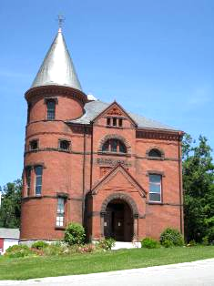

Prepared by:
Massachusetts Department of Public Health
Bureau of Environmental Health
Indoor Air Quality Program
December 2010

Background/Introduction
At the request of Mr. John Lebeaux, Princeton Town Administrator, the Massachusetts Department of Public Health (MDPH), Bureau of Environmental Health (BEH) provided assistance and consultation regarding indoor air quality concerns at the Princeton Town Hall (PTH) located at 6 Town Hall Drive, Princeton, Massachusetts. On June 25, 2010, Michael Feeney, Director of BEH’s IAQ Program and Lisa Hébert, Environmental Analyst/Regional Inspector within BEH’s IAQ Program, visited the building to conduct an assessment. The request was prompted by concerns about intermittent odors and potential mold growth in offices located along the northern wall of the first floor of the building.
The PTH is a two-story red brick building that was constructed in 1884. The building contains office space and a small kitchen on the first floor, and an auditorium on the second floor that is used primarily for storage. BEH staff were informed that a vault was constructed on the west side of the building in the mid 1980s. The basement consists of a stone foundation and dirt floor with exposed ledge outcrops. Windows are openable throughout the building.

Methods
BEH staff performed a visual inspection of building materials for water damage and/or microbial growth.

Results
The building was not open for business the day of the assessment therefore, with the exception of the Town Administrator, the building was unoccupied.

Results and Discussion
As previously mentioned, the assessment was prompted by concerns of odors and possible mold growth within the building. As described by Mr. Lebeaux, musty odors are occasionally reported in offices located along the northern wall of the building. The building does not have a mechanical ventilation system. Originally the first floor consisted of several offices along the north wall with one large open room. Over the years the large room has been subdivided into smaller offices. This subdivision did not take into account the original airflow design of the building.
During summer months, ventilation was originally controlled by the use of openable windows. The building was configured in a manner to use cross-ventilation to provide comfort for building occupants. The building is equipped with windows on opposing exterior walls. This design allows for airflow to enter an open window, pass through the large open room, pass through the open office door and exit the building on the leeward side (opposite the windward side) (Figure 1) if there was a prevailing south/westerly wind. With all windows open, airflow can be maintained in a building regardless of the direction of the wind. This system fails if the windows or doors are closed (Figure 2). The basement also had windows on the opposing north and south exterior walls (Pictures 1 through 4) and would use cross ventilation to reduce moisture accumulation and odors in the dirt floor/natural stone basement (Pictures 5 and 6).
Several renovations over the course of the years( in addition to subdivision of the first floor) have created conditions that allow air from the basement to migrate into offices on the first floor.
- The basement appears to have its north exterior windows sealed/buried. During the assessment, one window in the south wall of the basement was open with a detectable draft entering the basement. The original design would have this air movement pressurize the basement, which would have forced air to exit through the north wall windows, if opened. Since the north wall basement windows are sealed/buried, airflow from the open south wall basement window will pressurize the basement and force basement air through any openings in the floor (e.g., heating pipe openings) resulting in musty/wet/basement odors in first floor offices. This phenomenon also exists in the foyer at the rear of the building where the stairs leading to the basement are located. Upon entering the foyer, strong musty odors were detected emanating from spaces around the basement door frame. Basement odors are more likely to be noticeable in office spaces during significant wind conditions.
- In order to prevent cold air during the winter from entering into occupied space from the front door, a large glass and metal frame door system was installed to separate the front lobby from the workspace (Picture 7). The installation of this door system prevents the natural movement of heated air from the first floor to draft upwards to the second floor via the main staircase in the front of the building. These doors also prevent the natural venting of accumulated odors/particulates that may exist in offices.
- In order to provide for the temperature/comfort of building occupants, window mounted air conditioners are installed in windows seasonally. Therefore windows in office space remain closed during hot humid weather. Window mounted air conditioners do not introduce fresh air or exhaust air from offices. Therefore any odors that exist in the offices will tend to linger and be recirculated when window mounted air conditioners are activated.
Each of these conditions has an additive effect to make basement/musty odors noticeable in the northern offices.
Numerous conditions on the exterior of the building were observed which may contribute to moisture entering the building envelope and play a role in creating musty odors in the basement. BEH staff examined the exterior of the building to identify breaches in the building envelope and other conditions that could provide a source of water penetration. Several potential sources were identified:
- Efflorescence was observed on numerous areas of exterior masonry. Efflorescence is a characteristic sign of water intrusion. As penetrating moisture works its way through mortar around brick, it leaves behind white, powdery mineral deposits (Picture 8). This is not mold, but it is characteristic of chronically moistened materials.
- On the exterior of the building, an extension of the ramp was created by filling in at least one basement ventilation window with cinder blocks and creating a brick walkway (Pictures 9 through 11). As can be seen in Picture 11, a portion of this walkway has settled which creates a trough for water to accumulate. As reported by building occupants, standing water gathers at this location and in the winter freezes.
- The accumulation of water on the brick walkway may be exacerbated by the drainage swale on library property north of the town hall which appears to direct water on to the driveway and down slope toward the town hall walkway (Picture 12).
- Missing mortar and cracked masonry was observed on exterior brickwork.
- The south west corner of the building appears to have settled substantially, likely due to the addition on the west side of the building. This addition has a flat roof and does not appear to have gutters. These conditions may have caused rainwater to be deposited at the base of the building which, over time, may have undermined its structure, placing stress on the masonry and mortar and eventually causing the mortar to shift and deteriorate (Pictures 13 through 15).
- Heavily mulched flower beds were observed on the front and north side of the building (Picture 16). One of the characteristics of mulch is its ability to hold moisture. Moisture accumulation at the base of a building encourages plant growth. Over time, the roots from plants and shrubs in this location can compromise the building’s foundation.
- Moss was observed on the ground on the south side of the building immediately adjacent to the building (Picture 17). Moss is a sign of chronic dampness and can hold moisture against building components which can accelerate their decomposition.
The aforementioned conditions represent several potential water penetration sources. Over time, these conditions can undermine the integrity of the building envelope and provide a means of water entry into the building via capillary action through foundation concrete and masonry (Lstiburek & Brennan, 2001). The freezing and thawing action of water during the winter months can create cracks and fissures in the foundation. In addition, these breaches may provide a means for pests/rodents to enter the building.
Water damage or conditions that can contribute to mold colonization were also observed inside the building.
- On the second floor, severe water damage was evident on ceilings and walls (Pictures 18 and 19). Peeling paint, cracked and broken plaster and heavy particulate deposition were observed on the upper floor.
- In the balcony, windows were in disrepair.
- Immediately upon entering the basement, a strong musty odor was observed by BEH staff, indicating the presence of mold colonization.
- Heavy efflorescence was observed on basement masonry indicating that water often penetrates the building envelope (Picture 20).
- As previously discussed, the PTH is built on top of exposed ledge. As such, it would be expected that groundwater travels close to or on top of ledge outcrops. Therefore, one would expect to see a substantial amount of groundwater in the basement during certain times of the year, such as spring thaw, etc. Moisture entering the basement is evident by the rotted wooden support posts (Picture 21).
- A dehumidifier was noted in the basement. The indicator light revealed that the reservoir was full of water (Picture 22). If not emptied on a routine basis, water in the reservoir will simply evaporate back into the basement.
- Cross ventilation could not be achieved in the basement due to blocked/nonfunctioning windows.
- A leaking water valve was observed in basement (Picture 23).
- A water cooler was observed located on a carpeted area (Picture 24). Overflow of the water basin or spills that often occur can moisten carpeting, which can lead to mold growth. It is important that the catch basin of a water cooler be cleaned regularly as stagnant water can be a source of odors, and materials (i.e., dust) collected in the water basin can provide a medium for mold growth.
Several of the conditions listed above may cause moist air to accumulate in the basement. Lacking adequate ventilation, accumulated moisture in the air, may migrate upward where it will eventually come into contact with the backing of wall-to-wall carpeting in first floor offices. Moistened carpeting can provide suitable conditions for mold colonization to occur. In addition, a moist carpet may also be an additional source of odors within the building.
It appears that the tower of the building was occupied by birds at one point. Screening has been installed in the tower and nesting material can be seen behind it and on the tower stairs (Picture 25). Although no bird waste was observed at the time of the assessment, bird wastes can be a source of particulates that are irritating to the respiratory system. In addition, bird wastes contain bacteria and mold, which can be a source of disease, such as psittacosis and hypersensitivity pneumonitis.
A substantial number of cleaning products were found stored beneath basement stairs (Picture 26). Cleaning products contain VOCs and other chemicals that can be irritating to the eyes, nose and throat of sensitive individuals.

Conclusions/Recommendations
In view of the findings at the time of the visit, the following recommendations are provided:
- Cross ventilation in the basement should be reestablished in order to prevent musty odors from entering into the first floor office space. This may be accomplished by redesigning the walkway to provide a grid over the buried window so that airflow through the basement north wall can be restored.
- Consider contacting an HVAC engineering firm to design a mechanical ventilation system to depressurize the basement.
- All floor penetrations in the office space should be sealed using an appropriate fire-rated sealing compound.
- Seal gaps around basement door to eliminate musty odors from migrating into the occupied space.
- Examine roofing materials and flashing and repair as necessary.
- Repair interior wall and ceiling surfaces and repaint. Be advised if the paint contains lead, it must be abated in conformance with all state and federal remediation/renovation regulations.
- Repair or replace deteriorated windows.
- Consider redesigning brick walkway to eliminate standing water from the base of the ramp.
- Consider consulting a structural engineering firm in order to investigate whether any further movement of the structure has occurred since the last time the mortar was repaired.
- Repair missing, loose mortar and cracked masonry.
- Contact an engineering firm to design and install gutters on the roof of the addition at the rear of the building, ensuring that water is deposited at least five feet away from the building. Ensure the junction of the two buildings is adequately sealed/flashed and is impervious to water.
- Clean/remove moss growth periodically from exterior walls/foundation of building.
- Consider removing mulch from flower beds and relocating shrubs. Cut shrubbery in a manner to maintain a space of 5 feet from the building. Improve the grading of the ground away from the foundation at a rate of 6 inches per every 10 feet (Lstiburek & Brennan, 2001).
- Develop a schedule for maintaining/emptying dehumidifiers.
- Repair leaking water valve in basement.
- Locate water cooler on a surface that is impervious to water.
- Consider contacting an HVAC engineering firm to assess the feasibility of providing an air handling unit capable of ventilating the first floor of the building.
- Consider removing carpet from offices in accordance with EPA Guidelines for Mold Remediation in Schools and Commercial Buildings (US EPA, 2001). Replace with a nonporous material. Prior to commencing carpet removal, determine the composition of underlying floor surface. If underlayment is composed of deteriorated asbestos containing materials, be advised material must be remediated in accordance with all applicable asbestos remediation regulations.
- Ensure exterior penetrations into the building envelope are sealed in order to prevent moisture penetration as well as access to the building by animals and insects.
- Clean/change air conditioner filters as per manufacturer’s instructions.
- Ensure bird screening is intact, inspect periodically.
- Consider storing fewer cleaning products within the building or providing a storage cabinet for these items. Ensure Material Safety Data Sheets (MSDS) are available for every cleaning product at a central location in the event of an emergency.

References
Lstiburek, J. & Brennan, T. 2001. Read This Before You Design, Build or Renovate. Building Science Corporation, Westford, MA. U.S. Department of Housing and Urban Development, Region I, Boston, MA
US EPA. 2001. “Mold Remediation in Schools and Commercial Buildings”. Office of Air and Radiation, Indoor Environments Division, Washington, DC. EPA 402-K-01-001. March 2001. Available at: http://www.epa.gov/iaq/molds/mold_remediation.html
Picture 1

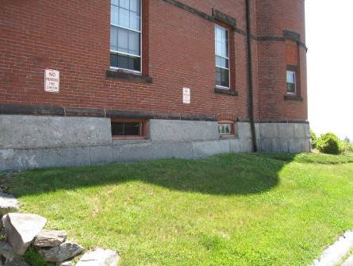

Southern Wall Basement Windows

Picture 2

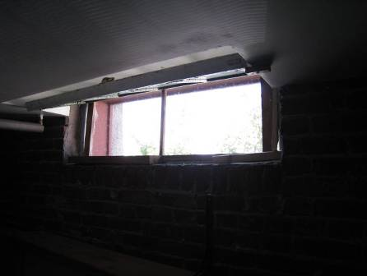

Open Southern Wall Basement Window, Interior

Picture 3

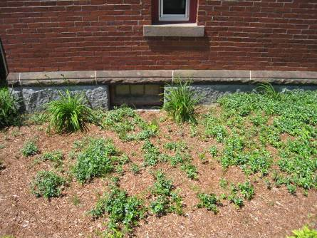

North Wall Basement Window

Picture 4

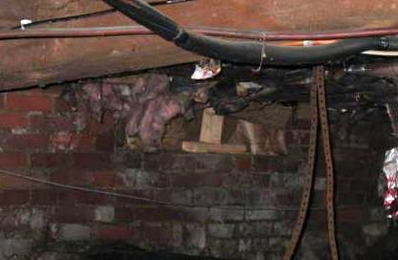

Sealed North Wall Basement Window (Interior view), Note Insulation

Picture 5

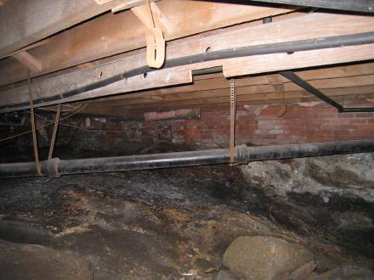

Irregular Stone Basement Floor, Note Moisture

Picture 6

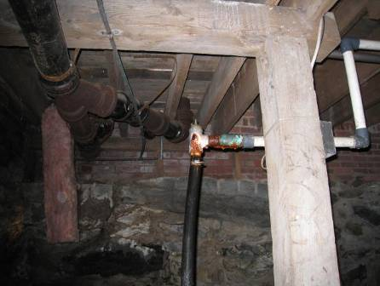

Irregular Basement Floor

Picture 7

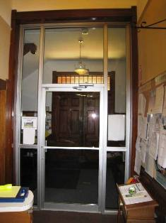

Interior Glass Door

Picture 8

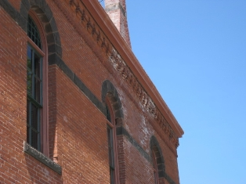

Efflorescence on Exterior Masonry
Picture 9

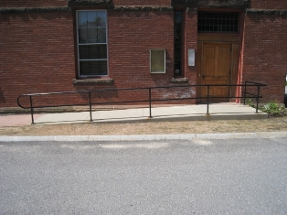

Concrete Ramp to Side Door,
Note Brick Walkway Obscuring Basement Window (Arrow)

Picture 10

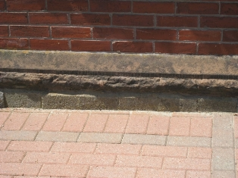

Basement Window Sealed with Blocks behind Brick Walk
Picture 11

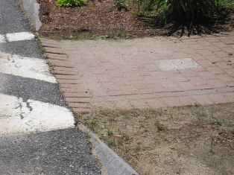

Depression in Brick Walkway,
Note Sand Accumulation

Picture 12

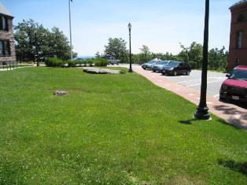

Pathway of Surface Runoff from Adjacent Property (Library)
Picture 13

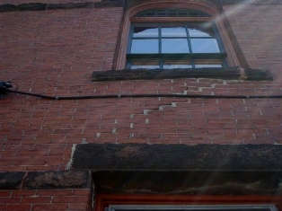

Repairs to Mortar and Stone Window Sill (Arrow)

Picture 14

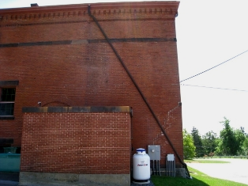

Repairs to Mortar, Note Addition Lacks Gutters

Picture 15

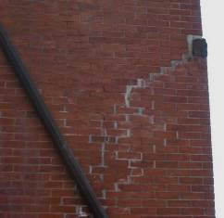

Close-up of Repair to Mortar,
Note Brick Location at Edge of Building

Picture 16

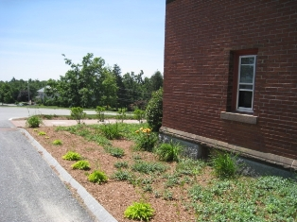

Mulch in Garden Adjacent to Building
Picture 17

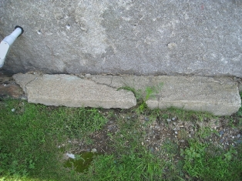

Moss Accumulation at Base of Building

Picture 18

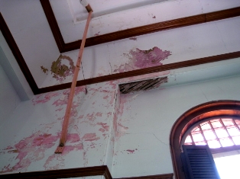

Water Damage on Ceiling and Wall

Picture 19

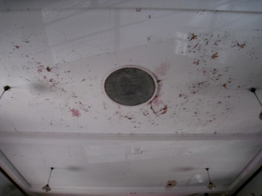

Peeling Paint and Water Damage on Ceiling

Picture 20

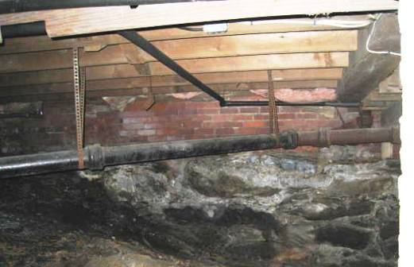

Efflorescence on Brick Basement Wall (Arrow)

Picture 21

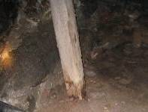

Water-Damaged Wooden Support in Basement

Picture 22

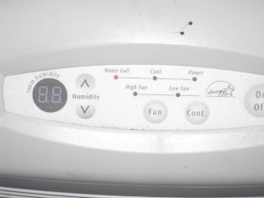

Dehumidifier in Basement,
Note Light Indicates Dehumidifier is Full
Picture 23

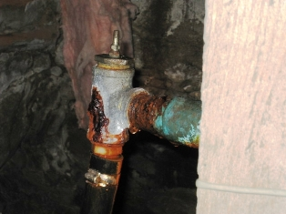

Leaking Water Valve in Basement

Picture 24

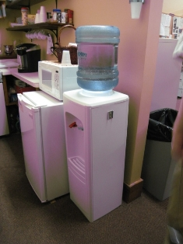

Water Cooler on Carpeted Surface

Picture 25

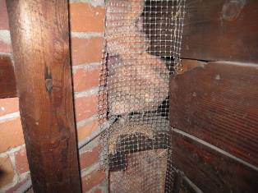

Wire Mesh Installed in Tower to Discourage Birds from Roosting,
Note Nesting Material
Picture 26

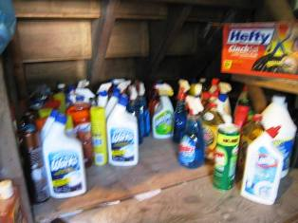

Cleaning Products Stored Under Stairs

Building envelope means the roof, exterior walls, exterior windows, exterior doors and foundation of a building.

