Massachusetts Department of Environmental Protection
Environmental Results Program
Non-Applicability Statement
For Printers

 | A. Facility Information
 | Facility Name |  | Facility SIC Code | Facility ID Number
Important: When filling out forms on the computer, use only the tab key to move your cursor - do not use the return key.  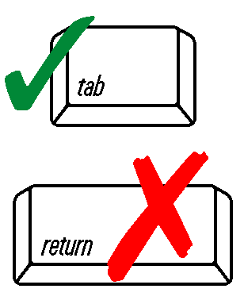 | Facility Street Address
 | City/Town |  | State | Zip Code
 | Phone Number | Fax Number | Federal Employer Identification Number – FEIN/TIN*
 | Contact Person |  | Title | Telephone Number
 |  |  | Contact Email Address
 | *Do not enter a Social Security Number. Email baw.edep@state.ma.us for instructions.
 | B. Do You Need to Certify?
DEP USE ONLY  Date Received | If any of the following conditions apply to your operation, then you are NOT required to submit the ERP Compliance Certification for Printers:  No offset lithographic, screen, flexographic, letterpress or gravure printing is done at this address.  This facility does only photoprocessing at this address.  This facility has actual emissions equal to or greater than 50 tons of volatile organic compounds (VOC’s) per year or actual emissions equal to or greater than 10 tons per year of a single hazardous air pollutant (HAP) or 25 tons per year of a combination of HAPS (see p. 56 of the Workbook for a list of HAPS).  This facility is subject to the Operating Permit program under 310 CMR 7.00 Appendix C.  This facility is a manufacturer and does printing as an auxiliary component of its operations.  This facility was sold. Indicate date of sale (MM/DD/YYYY):  Please mail the completed form to:  MADEP-ERP-PR  P.O. Box 120-165  Boston, MA 02112-0165  Please save a copy of this statement for your records. If you have any questions, please call Marc Cohen at 617-292-5873.
NOTE: Exemption from ERP does not relieve you of your responsibility to comply with other environmental requirements.
 | Signature |  | Date (MM/DD/YYYY)

Place first class stamp here

MADEP-ERP-PR
P.O. Box 120-165
Boston, MA 02112-0165

